Emotions in mathematics learning: A systematic review and meta-analysis
This file includes:

1. Results and Discussion: Study and Methodological Characteristics 2
2. References Cited in Supplementary Material on Results and Discussion 4
3. Table S2 7
4. Table S3 32
5. Table S4 48
6. References of all Studies Included in the Systematic Review and Meta-Analysis 50

Results and Discussion: Study and Methodological Characteristics
Descriptive results regarding study and methodological characteristics are displayed in Table S1. Every year, new empirical evidence from qualitative and quantitative studies was added to the research body on emotions in mathematics education, with 22 publications in 2020, 31 publications in 2021, 17 publications in 2022, and 28 publications through October 2023.
Table S1
Descriptive Findings for Study Characteristics
Category | Characteristics | Number of studies
Publication year | 2020 | 22
 | 2021 | 31
 | 2022 | 17
 | 2023 | 28
Publication type | Journal | 93
 | Conference proceedings | 4
 | Dissertation | 0
 | Book chapter | 1
Research methods | Quantitative methods | 78
 | Qualitative methods | 16
 | Mixed methods | 4
Level of education | Elementary (and earlier) education | 24
 | Secondary education | 56
 | Tertiary education | 18
Total sample size | < 50 participants | 19
 | 50-100 participants | 14
 | 100-500 participants | 22
 | 500-1,000 participants | 18
 | 1,000-5,000 participants | 19
 | > 5,000 participants | 6
The majority of studies used quantitative research methods (80%), and the most prominent emotion assessment method was self-reports via emotion questionnaires. In addition, teacher reports (e.g., Hernández et al., 2023) or automatic emotion recognition were used (e.g., Ocumpaugh et al., 2020) to measure the learners’ trait and state emotions. A proportion of 16% of studies used qualitative research methods, mainly consisting of self-reports via interviews and observations or think-aloud protocols (e.g., Ayalon et al., 2022; Barnes, 2021; Di Leo & Muis, 2020). In some cases, interviews were supported by providing visualizations of facial expressions (e.g., Raccanello et al., 2020) or by asking people to draw an emotion graph (e.g., Satyam et al., 2022). Only 4% combined qualitative and quantitative research methods (e.g., Headrick et al., 2020).
Traditionally, research on emotions in mathematics education has relied on methods and theories from educational psychology (Di Martino & Zan, 2011), as is evident in current research. Existing assessment methods, such as questionnaires, observation, and interviews (Hannula, 2006), continue to be used and are complemented by additional methods, including automatic emotion coding. While automatic emotion and behavior coding allows for linking emotional states to behaviors (Ocumpaugh et al., 2020), the automatic detection of emotions is challenging (Frenzel et al., 2024). For example, automatic tools like analysis of electrodermal activity, heart rate, and pupil dilation primarily measure arousal. Since different emotions can share similar levels of arousal, it is difficult to pinpoint the exact emotion without additional contextual information. For example, a face showing wide eyes and a fast heart rate might indicate fear (high arousal, negative valence) or excitement (high arousal, positive valence).
The reviewed studies investigated emotions in mathematics learning from elementary and earlier (24%) to tertiary education (18%), with the largest proportion conducted with secondary school students (57%).
Regarding sample sizes, 19% of the reviewed studies had fewer than 50 participants, and 14% had between 50 and 100 participants. A total of 22% of the studies had between 100 and 500 participants. A proportion of 18% of studies had between 500 and 1,000 participants, and another 19% had 1,000 to 5,000 participants. Six percent of studies had more than 5,000 participants. These studies utilized data from the Programme for International Student Assessment (PISA; Borgonovi et al., 2023), the Trends in International Mathematics and Science Study in 2011 and 2015 (TIMSS; Basarkod et al., 2023; Tze et al., 2023), national assessments, such as the China Education Panel Survey (Zheng et al., 2020) and the Istituto Nazionale per la Valutazione del Sistema Educativo di Istruzione e Formazione (INVALSI) assessment (Cornoldi et al., 2022), or data from a U.S. online learning platform (Karamarkovich & Rutherford, 2021). All included studies were independent, as they were based on distinct samples.

References Cited in Supplementary Material on Results and Discussion
Ayalon, M., Wilkie, K. J. & Eid, K. H. (2022). Relating students’ emotions during argumentative discourse to their learning of real-life functional situations. Educational Studies in Mathematics, 110(1), 23–48. https://doi.org/10.1007/s10649-021-10121-5
Barnes, A. (2021). Enjoyment in learning mathematics: its role as a potential barrier to children’s perseverance in mathematical reasoning. Educational Studies in Mathematics, 106(1), 45–63. https://doi.org/10.1007/s10649-020-09992-x
Basarkod, G., Marsh, H. W., Guo, J., Parker, P. D., Dicke, T. & Pekrun, R. (2023). The happy-fish-little-pond effect on enjoyment: Generalizability across multiple domains and countries. Learning and Instruction, 85, 101733. https://doi.org/10.1016/j.learninstruc.2023.101733
Cornoldi, C., Giofrè, D., Mammarella, I. C. & Toffalini, E. (2022). Emotional response to testing in gifted and highly gifted children. Gifted Child Quarterly, 66(3), 208–219. https://doi.org/10.1177/00169862211042901
Di Leo, I. & Muis, K. R. (2020). Confused, now what? A Cognitive-Emotional Strategy Training (CEST) intervention for elementary students during mathematics problem solving. Contemporary Educational Psychology, 62, 101879. https://doi.org/10.1016/j.cedpsych.2020.101879
Di Martino, P. & Zan, R. (2011). Attitude towards mathematics: a bridge between beliefs and emotions. ZDM – Mathematics Education, 43(4), 471–482. https://doi.org/10.1007/s11858-011-0309-6
Frenzel, A. C., Dindar, M., Pekrun, R., Reck, C. & Marx, A. K. (2024). Joy is reciprocally transmitted between teachers and students: Evidence on facial mimicry in the classroom. Learning and Instruction, 91, 101896. https://doi.org/10.1016/j.learninstruc.2024.101896
Hannula, M. S. (2006). Motivation in mathematics: Goals reflected in emotions. Educational Studies in Mathematics, 63, 165–178. https://doi.org/10.1007/s10649-005-9019-8
Headrick, L., Wiezel, A., Tarr, G., Zhang, X., Cullicott, C. E., Middleton, J. A. & Jansen, A. (2020). Engagement and affect patterns in high school mathematics classrooms that exhibit spontaneous problem posing: an exploratory framework and study. Educational Studies in Mathematics, 105(3), 435–456. https://doi.org/10.1007/s10649-020-09996-7
Hernández, M. M., Eisenberg, N., Valiente, C., Spinrad, T. L., Berger, R. H., Johns, S. K., Diaz, A., Gal-Szabo, D. E., Thompson, M. S., Southworth, J. & Pina, A. A. (2023). Peers' emotionality and children's academic achievement in second grade: Testing the moderating role of children's behavioral self-regulation. Social development (Oxford, England), 32(3), 793–812. https://doi.org/10.1111/sode.12657
Karamarkovich, S. M. & Rutherford, T. (2021). Mixed feelings: Profiles of emotions among elementary mathematics students and how they function within a control-value framework. Contemporary Educational Psychology, 66, 101996. https://doi.org/10.1016/j.cedpsych.2021.101996
Ocumpaugh, J., Baker, R. S., Karumbaiah, S., Crossley, S. A. & Labrum, M. (2020). Affective sequences and student actions within reasoning mind. In I. I. Bittencourt, M. Cukurova, K. Muldner, R. Luckin & E. Millán (Hrsg.), Lecture Notes in Computer Science. Artificial Intelligence in Education (Bd. 12163, S. 437–447). Springer International Publishing. https://doi.org/10.1007/978-3-030-52237-7_35
Raccanello, D., Brondino, M., Trifiletti, E. & Shamloo, S. E. (2020). Emotions at primary school: Negative achievement emotions and their relation with emotional competencies in ethnic minority and majority students. Journal of Community & Applied Social Psychology, 30(4), 441–458. https://doi.org/10.1002/casp.2451
Satyam, V. R., Bae, Y., Smith, J. P. & Levin, M. (2022). Affect graphing: leveraging graphical representations in the study of students’ affect in mathematics. Educational Studies in Mathematics, 110(3), 481–501. https://doi.org/10.1007/s10649-021-10131-3
Tze, V. M. C., Li, J. C.‑H. & Parker, P. C. (2023). A mediation analysis of emotions based on the control-value theory. Current Psychology: A Journal for Diverse Perspectives on Diverse Psychological Issues, 42(7), 5392–5406. https://doi.org/10.1007/s12144-021-01840-2
Zheng, X., Wang, C., Shen, Z. & Fang, X. (2020). Associations of private tutoring with Chinese students’ academic achievement, emotional well-being, and parent-child relationship. Children and Youth Services Review, 112, 104934. https://doi.org/10.1016/j.childyouth.2020.104934

Table S2
Overview of Studies and Coded Characteristics Included in the Systematic Review
 | Study characteristics |  |  | Emotion and emotion characteristics
Study | N | Methods | Ed. Level | Emotion | Emotion group | Valence | Activation | Stability | Social context | Object
Ayalon et al. (2022) | 6 | Qual | Secon | Tension | Achievement | Negative | Activating | State | individual | Math activity
 | 6 | Qual | Secon | Frustration | Achievement | Negative | Activating | State | individual | Math activity
 | 6 | Qual | Secon | Sadness | Achievement | Negative | Deactivating | State | individual | Math activity
 | 6 | Qual | Secon | Boredom | Achievement | Negative | Deactivating | State | individual | Math activity
 | 6 | Qual | Secon | Joy | Achievement | Positive | activating | State | individual | Math activity
 | 6 | Qual | Secon | Pride | Achievement | Positive | Activating | State | individual | Math activity
Barnes (2021) | 8 | Qual | Secon | Disappointment | Achievement | Negative | Deactivating | State | Individual | Math activity
 | 8 | Qual | Secon | Enjoyment | Achievement | Positive | Activating | State | Individual | Math activity
 | 8 | Qual | Secon | Excitement | Achievement | Positive | Activating | State | Individual | Math activity
 | 8 | Qual | Secon | Frustration | Achievement | Negative | Activating | State | Individual | Math activity
 | 8 | Qual | Secon | Pride | Achievement | Positive | Activating | State | Individual | Math activity
 | 8 | Qual | Secon | Satisfaction | Achievement | Positive | Deactivating | State | Individual | Math activity
 | 8 | Qual | Secon | annoyance | Achievement | negative | Activating | State | Individual | Math activity
Basarkod et al. (2023) | 180,084 | Quan | Elem | Enjoyment | Achievement | Positive | Activating | Trait | Individual, cultural | Math learning
Bieleke, Goetz, Krannich, et al. (2023) | 208 | Quan | Secon | Enjoyment | Achievement | Positive | Activating | State | Individual | Math activity
 | 208 | Quan | Secon | Pride | Achievement | Positive | Activating | State | Individual | Math activity
 | 208 | Quan | Secon | Anger | Achievement | Negative | Activating | State | Individual | Math activity
 | 208 | Quan | Secon | Boredom | Achievement | Negative | Deactivating | State | Individual | Math activity
Bieleke, Goetz, Yanagida, et al. (2023) | 781 | Quan | Secon | Enjoyment | Achievement | Positive | Activating | Trait | Individual | Math learning
 | 781 | Quan | Secon | Pride | Achievement | Positive | Activating | Trait | Individual | Math learning
 | 781 | Quan | Secon | Anger | Achievement | Negative | Activating | Trait | Individual | Math learning
 | 781 | Quan | Secon | Shame | Achievement | Negative | Activating | Trait | Individual | Math learning
 | 781 | Quan | Secon | Hopelessness | Achievement | Negative | Deactivating | Trait | Individual | Math learning
 | 781 | Quan | Secon | Boredom | Achievement | Negative | Deactivating | Trait | Individual | Math learning
Borgonovi et al. (2023) | 76,818 | Quan | Secon | Boredom | Achievement | Negative | Deactivating | State | Individual | Math learning
Borracci et al. (2020) | 47 | Quan | Tert | Frustration | Achievement | Negative | Activating | State | Individual | Math activity
 | 47 | Quan | Tert | Boredom | Achievement | Negative | Deactivating | State | Individual | Math activity
X. Chen (2022) | 2,947 | Quan | Elem | Enjoyment | Achievement | Positive | Activating | Trait | Individual | Math learning
 | 2,947 | Quan | Elem | Boredom | Achievement | Negative | Deactivating | Trait | Individual | Math learning
X. Chen and Lu (2022) | 1,146 | Quan | Secon | Enjoyment | Achievement | Positive | Activating | Trait | Individual | Math learning
 | 1,146 | Quan | Secon | Boredom | Achievement | Negative | Deactivating | Trait | Individual | Math learning
G. W. Chen et al. (2020) | 2,225 | Quan | Secon | Enjoyment | Achievement | Positive | Activating | Trait | Individual | Math learning
X. Y. Chen et al. (2023) | 1,041 | Quan | Elem | Enjoyment | Achievement | Positive | Activating | Trait | Individual | Math learning
Chiu (2021) | 4,163 | Quan | Secon | Frustration | Achievement | Negative | Activating | Trait | Individual | Math learning
Chu et al. (2020) | 8 | Quan | Elem | Negative emotions | Achievement | Negative | na | State | Individual | Math activity
Christensen and Knezek (2020) | 915 | Quan | Secon | Enjoyment | Achievement | Positive | Activating | Trait | Individual | Math learning
Clem, Hirvonen, et al. (2021) | 848 | Quan | Secon | Enjoyment | Achievement | Positive | Activating | Trait | Individual | Math learning
 | 848 | Quan | Secon | Boredom | Achievement | Negative | Deactivating | Trait | Individual | Math learning
Clem, Rudasill, et al. (2021) | 854 | Quan | Secon | Enjoyment | Achievement | Positive | Activating | Trait | Individual | Math learning
 | 854 | Quan | Secon | Boredom | Achievement | Negative | Deactivating | Trait | Individual | Math learning
Cornoldi et al. (2022) | 460,688 | Quan | Elem | Worry | Achievement | Negative | Activating | State | Individual | Math tests
Darmawan (2020) | 3,534 | Quan | Secon | Enjoyment | Achievement | Positive | Activating | Trait | Individual | Math learning
Deale and Lee (2022) | 112 | Quan | Tert | Enjoyment | Achievement | Positive | Activating | Trait | Individual | Math learning
Di Leo and Muis (2020) | 67 | Mixed Methods | Elem | Surprise | Epistemic | Positive | Activating | State | Individual | Knowledge
 | 67 | Mixed Methods | Elem | Enjoyment | Epistemic | Positive | Activating | State | Individual | Knowledge
 | 67 | Mixed Methods | Elem | Curiosity | Epistemic | Positive | Activating | State | Individual | Knowledge
 | 67 | Mixed Methods | Elem | Hope | Epistemic | Positive | Activating | State | Individual | Knowledge
 | 67 | Mixed Methods | Elem | Pride | Epistemic | Positive | Activating | State | Individual | Knowledge
 | 67 | Mixed Methods | Elem | Relief | Epistemic | Positive | Deactivating | State | Individual | Knowledge
 | 67 | Mixed Methods | Elem | Confusion | Epistemic | Negative | Activating | State | Individual | Knowledge
 | 67 | Mixed Methods | Elem | Frustration | Epistemic | Negative | Activating | State | Individual | Knowledge
 | 67 | Mixed Methods | Elem | Hopelessness | Epistemic | Negative | Deactivating | State | Individual | Knowledge
 | 67 | Mixed Methods | Elem | Boredom | Epistemic | Negative | Deactivating | State | Individual | Knowledge
Dietiker et al. (2023) | 2 | Qual | Secon | Positive emotions | na | Positive | na | State | Individual | Math activity
Forsblom et al. (2021) | 548 | Quan | Secon | Enjoyment | Achievement | Positive | Activating | Trait | Individual | Math learning
 | 548 | Quan | Secon | Anger | Achievement | Negative | Activating | Trait | Individual | Math learning
 | 548 | Quan | Secon | Boredom | Achievement | Negative | Deactivating | Trait | Individual | Math learning
Forsblom et al. (2022) | 1716 | Quan | Secon | Enjoyment | Achievement | Positive | Activating | Trait | Individual | Math learning
 | 1716 | Quan | Secon | Boredom | Achievement | Negative | Deactivating | Trait | Individual | Math learning
 | 1716 | Quan | Secon | Anger | Achievement | Negative | Activating | Trait | Individual | Math learning
Galla et al. (2020) | 202 | Quan | Secon | Boredom | Achievement | Negative | Deactivating | State | Individual | Math activity
 | 869 | Quan | Secon | Boredom | Achievement | Negative | Deactivating | Trait | Individual | Math homework
Goetz et al. (2023) | 208 | Quan | Secon | Boredom | Achievement | Negative | Deactivating | Trait | Individual | Math tests
 | 208 | Quan | Secon | Boredom | Achievement | Negative | Deactivating | State | Individual | Math tests
Goetz et al. (2021) | 535 | Quan | Secon | Enjoyment | Achievement | Positive | Activating | Trait | Individual | Math learning
 | 535 | Quan | Secon | Pride | Achievement | Positive | Activating | Trait | Individual | Math learning
 | 535 | Quan | Secon | Anger | Achievement | Negative | Activating | Trait | Individual | Math learning
 | 535 | Quan | Secon | Boredom | Achievement | Negative | Deactivating | Trait | Individual | Math learning
 | 535 | Quan | Secon | Shame | Achievement | Negative | Activating | Trait | Individual | Math learning
 | 535 | Quan | Secon | Positive Emotions | Achievement | Positive | na | Trait | Individual | Math learning
 | 535 | Quan | Secon | Positive Emotions | Achievement | Positive | na | Trait | Individual | Math learning
Greensfeld and Deutsch (2022) | 403 | Quan | Secon | Curious | na | Positive | Activating | State | Individual, cultural | Math tests
 | 403 | Quan | Secon | Enthusiastic | na | Positive | Activating | State | Individual, cultural | Math tests
 | 403 | Quan | Secon | Happy | na | Positive | Activating | State | Individual, cultural | Math tests
 | 403 | Quan | Secon | Relaxed | na | Positive | Deactivating | State | Individual, cultural | Math tests
 | 403 | Quan | Secon | Excited | na | Positive | Activating | State | Individual, cultural | Math tests
 | 403 | Quan | Secon | Surprised | na | Positive | Activating | State | Individual, cultural | Math tests
 | 403 | Quan | Secon | Tense | na | Negative | Activating | State | Individual, cultural | Math tests
 | 403 | Quan | Secon | Disappointed | na | Negative | Deactivating | State | Individual, cultural | Math tests
 | 403 | Quan | Secon | Bored | na | Negative | Deactivating | State | Individual, cultural | Math tests
 | 403 | Quan | Secon | Shy | na | Negative | Deactivating | State | Individual, cultural | Math tests
 | 403 | Quan | Secon | Confused | na | Negative | Activating | State | Individual, cultural | Math tests
 | 403 | Quan | Secon | Hating | na | Negative | Activating | State | Individual, cultural | Math tests
 | 403 | Quan | Secon | Sad | na | Negative | Deactivating | State | Individual, cultural | Math tests
Gutica and Petrina (2021) | 15 | Qual | Secon | Boredom | Achievement | Negative | Deactivating | State | Individual | Math activity
 | 15 | Qual | Secon | Confusion | Epistemic | Negative | Activating | State | Individual | Knowledge
 | 15 | Qual | Secon | Curiosity | Epistemic | Negative | Activating | State | Individual | Knowledge
 | 15 | Qual | Secon | Disappointment | Achievement | Negative | Deactivating | State | Individual | Math activity
 | 15 | Qual | Secon | Excitement | Achievement | Positive | Activating | State | Individual | Math activity
 | 15 | Qual | Secon | Frustration | Achievement | Negative | Activating | State | Individual | Math activity
 | 15 | Qual | Secon | Pride | Achievement | Positive | Activating | State | Individual | Math activity
 | 15 | Qual | Secon | Shame | Achievement | Negative | Activating | State | Individual | Math activity
 | 15 | Qual | Secon | Surprise | Epistemic | Positive | Activating | State | Individual | Knowledge
Guzman et al. (2023) | 1 | Qual | Secon | Enjoyment | Achievement | Positive | Activating | State | Individual | Math activity
 | 1 | Qual | Secon | Anger | Achievement | Negative | Activating | State | Individual | Math activity
 | 1 | Qual | Secon | Frustration | Achievement | Negative | Activating | State | Individual | Math activity
 | 1 | Qual | Secon | Boredom | Achievement | Negative | Deactivating | State | Individual | Math activity
Hanin et al. (2021) | 334 | Quan | Elem | Enjoyment | Achievement | Positive | Activating | Trait | Individual | Math activity
 | 334 | Quan | Elem | Pride | Achievement | Positive | Activating | Trait | Individual | Math activity
 | 334 | Quan | Elem | Hope | Achievement | Positive | Activating | Trait | Individual | Math activity
 | 334 | Quan | Elem | Relief | Achievement | Positive | Deactivating | Trait | Individual | Math activity
 | 334 | Quan | Elem | Shame | Achievement | Negative | Activating | Trait | Individual | Math activity
 | 334 | Quan | Elem | Fear | Achievement | Negative | Activating | Trait | Individual | Math activity
 | 334 | Quan | Elem | Worry | Achievement | Negative | Activating | Trait | Individual | Math activity
 | 334 | Quan | Elem | Nervousness | Achievement | Negative | Activating | Trait | Individual | Math activity
 | 334 | Quan | Elem | Anger | Achievement | Negative | Activating | Trait | Individual | Math activity
 | 334 | Quan | Elem | Frustration | Achievement | Negative | Activating | Trait | Individual | Math activity
 | 334 | Quan | Elem | Hopelessness | Achievement | Negative | Deactivating | Trait | Individual | Math activity
 | 334 | Quan | Elem | Sadness | Achievement | Negative | Deactivating | Trait | Individual | Math activity
 | 334 | Quan | Elem | Boredom | Achievement | Negative | Deactivating | Trait | Individual | Math activity
Hanin and Gay (2023) | 1,505 | Quan | Elem | Enjoyment | Achievement | Positive | Activating | Trait | Individual | Math activity
 | 1,505 | Quan | Elem | Pride | Achievement | Positive | Activating | Trait | Individual | Math activity
 | 1,505 | Quan | Elem | Shame | Achievement | Negative | Activating | Trait | Individual | Math activity
 | 1,505 | Quan | Elem | Anger | Achievement | Negative | Activating | Trait | Individual | Math activity
 | 1,505 | Quan | Elem | Nervousness | Achievement | Negative | Activating | Trait | Individual | Math activity
 | 1,505 | Quan | Elem | Sadness | Achievement | Negative | Deactivating | Trait | Individual | Math activity
 | 1,505 | Quan | Elem | Boredom | Achievement | Negative | Deactivating | Trait | Individual | Math activity
 | 1,505 | Quan | Elem | Fear | Achievement | Negative | Activating | Trait | Individual | Math activity
Hanin and van Nieuwenhoven (2020) | 22 | Qual | Secon | Enjoyment | Achievement | Positive | Activating | State | Individual | Math activity
 | 22 | Qual | Secon | Pride | Achievement | Positive | Activating | State | Individual | Math activity
 | 22 | Qual | Secon | Hope | Achievement | Positive | Activating | State | Individual | Math activity
 | 22 | Qual | Secon | Relief | Achievement | Positive | Deactivating | State | Individual | Math activity
 | 22 | Qual | Secon | Shame | Achievement | Negative | Activating | State | Individual | Math activity
 | 22 | Qual | Secon | Fear | Achievement | Negative | Activating | State | Individual | Math activity
 | 22 | Qual | Secon | Worry | Achievement | Negative | Activating | State | Individual | Math activity
 | 22 | Qual | Secon | Nervousness | Achievement | Negative | Activating | State | Individual | Math activity
 | 22 | Qual | Secon | Anger | Achievement | Negative | Activating | State | Individual | Math activity
 | 22 | Qual | Secon | Frustration | Achievement | Negative | Activating | State | Individual | Math activity
 | 22 | Qual | Secon | Sadness | Achievement | Negative | Deactivating | State | Individual | Math activity
 | 22 | Qual | Secon | Hopelessness | Achievement | Negative | Deactivating | State | Individual | Math activity
 | 22 | Qual | Secon | Boredom | Achievement | Negative | Deactivating | State | Individual | Math activity
Headrick et al. (2020) | 67 | Mixed Methods | Secon | Negative emotions | Social | Negative | na | State | Individual | Others
 | 67 | Mixed Methods | Secon | Negative emotions | Social | Negative | na | State | Individual | Self
 | 67 | Mixed Methods | Secon | Negative emotions | Achievement | Negative | na | State | Individual | Math activity
 | 67 | Mixed Methods | Secon | Positive emotions | Social | Positive | na | State | Individual | Others
 | 67 | Mixed Methods | Secon | Positive emotions | Social | Positive | na | State | Individual | Self
 | 67 | Mixed Methods | Secon | Positive emotions | Achievement | Positive | na | State | Individual | Math activity
Held and Hascher (2022) | 348 | Quan | Secon | Enjoyment | Achievement | Positive | Activating | Trait | Individual | Math learning
 | 348 | Quan | Secon | Anger | Achievement | Negative | Activating | Trait | Individual | Math learning
 | 348 | Quan | Secon | Boredom | Achievement | Negative | Deactivating | Trait | Individual | Math learning
Hernández et al. (2022) | 260 | Quan | Elem | Positive emotions | Achievement | Positive | na | Trait | Individual | Math learning
 | 260 | Quan | Elem | Negative emotions | Achievement | Negative | na | Trait | Individual | Math learning
 | 260 | Quan | Elem | Positive emotions | Achievement | Positive | na | Trait | Student group | Math learning
 | 260 | Quan | Elem | Negative emotions | Achievement | Negative | na | Trait | Student group | Math learning
Hettinger et al. (2021) | 779 | Quan | Secon | Enjoyment | Achievement | Positive | Activating | Trait | Individual | Math learning
Holm, Björn, et al. (2020) | 1,379 | Quan | Secon | Enjoyment | Achievement | Positive | Activating | Trait | Individual | Math learning
 | 1,379 | Quan | Secon | Pride | Achievement | Positive | Activating | Trait | Individual | Math learning
 | 1,379 | Quan | Secon | Anger | Achievement | Negative | Activating | Trait | Individual | Math learning
 | 1,379 | Quan | Secon | Shame | Achievement | Negative | Activating | Trait | Individual | Math learning
 | 1,379 | Quan | Secon | Hopelessness | Achievement | Positive | Deactivating | Trait | Individual | Math learning
 | 1,379 | Quan | Secon | Boredom | Achievement | Negative | Deactivating | Trait | Individual | Math learning
Holm, Korhonen, et al. (2020) | 1,322 | Quan | Secon | Enjoyment | Achievement | Positive | Activating | Trait | Individual | Math learning
 | 1,322 | Quan | Secon | Pride | Achievement | Positive | Activating | Trait | Individual | Math learning
 | 1,322 | Quan | Secon | Anger | Achievement | Negative | Activating | Trait | Individual | Math learning
 | 1,322 | Quan | Secon | Shame | Achievement | Negative | Activating | Trait | Individual | Math learning
 | 1,322 | Quan | Secon | Hopelessness | Achievement | Negative | Deactivating | Trait | Individual | Math learning
 | 1,322 | Quan | Secon | Boredom | Achievement | Negative | Deactivating | Trait | Individual | Math learning
Hou et al. (2020) | 159 | Quant | Secon | Enjoyment | Achievement | Positive | Activating | State | Individual | Math activity
Johnson et al. (2021) | 86 | Quan | Tert | Positive emotions | Achievement | Positive | na | State | Individual | Math tests
 | 86 | Quan | Tert | Negative emotions | Achievement | Negative | na | State | Individual | Math tests
Kanefke and Schukajlow (2023) | 97 | Quan | Tert | Enjoyment | Achievement | Positive | Activating | State | Individual | Math activity
 | 97 | Quan | Tert | Boredom | Achievement | Negative | Deactivating | State | Individual | Math activity
 | 97 | Quan | Tert | Enjoyment | Achievement | Positive | Activating | State | Student group | Math activity
 | 97 | Quan | Tert | Boredom | Achievement | Negative | Deactivating | State | Student group | Math activity
Kang and Wu (2022) | 1,067 | Quan | Secon | Enjoyment | Achievement | Positive | Activating | Trait | Individual | Math learning
 | 1,067 | Quan | Secon | Hope | Achievement | Positive | Activating | Trait | Individual | Math learning
 | 1,067 | Quan | Secon | Pride | Achievement | Positive | Activating | Trait | Individual | Math learning
 | 1,067 | Quan | Secon | Anger | Achievement | Negative | Activating | Trait | Individual | Math learning
 | 1,067 | Quan | Secon | Shame | Achievement | Negative | Activating | Trait | Individual | Math learning
 | 1,067 | Quan | Secon | Boredom | Achievement | Negative | Deactivating | Trait | Individual | Math learning
 | 1,067 | Quan | Secon | Hopelessness | Achievement | Negative | Deactivating | Trait | Individual | Math learning
Karamarkovich and Rutherford (2021) | 5,228 | Quan | Elem | Excited | Achievement | Positive | Activating | Trait | Individual | Math learning
 | 5,228 | Quan | Elem | Happy | Achievement | Positive | Activating | Trait | Individual | Math learning
 | 5,228 | Quan | Elem | Hopeful | Achievement | Positive | Activating | Trait | Individual | Math learning
 | 5,228 | Quan | Elem | Bored | Achievement | Negative | Deactivating | Trait | Individual | Math learning
 | 5,228 | Quan | Elem | Frustrated | Achievement | Negative | Activating | Trait | Individual | Math learning
 | 5,299 | Quan | Elem | Excited | Achievement | Positive | Activating | Trait | Individual | Math learning
 | 5,299 | Quan | Elem | Happy | Achievement | Positive | Activating | Trait | Individual | Math learning
 | 5,299 | Quan | Elem | Hopeful | Achievement | Positive | Activating | Trait | Individual | Math learning
 | 5,299 | Quan | Elem | Bored | Achievement | Negative | Deactivating | Trait | Individual | Math learning
 | 5,299 | Quane | Elem | Frustrated | Achievement | Negative | Activating | Trait | Individual | Math learning
Kaur and Prendergast (2022) | 55 | Mixed methods | Secon | Enjoyment | Achievement | Positive | Activating | Trait | Individual | Math learning
Lahdelma et al. (2021) | 690 | Quan | Secon | Enjoyment | Achievement | Positive | Activating | trait | Individual | Math learning
 | 690 | Quan | Secon | Pride | Achievement | Positive | Activating | Trait | Individual | Math learning
 | 690 | Quan | Secon | Hope | Achievement | Positive | Activating | Trait | Individual | Math learning
 | 690 | Quan | Secon | Anger | Achievement | Positive | Activating | Trait | Individual | Math learning
 | 690 | Quan | Secon | Hopelessness | Achievement | Negative | Deactivating | Trait | Individual | Math learning
 | 690 | Quan | Secon | Shame | Achievement | Negative | Activating | Trait | Individual | Math learning
 | 690 | Quan | Secon | Boredom | Achievement | Negative | Deactivating | Trait | Individual | Math learning
La McCarty and Faulkner (2020) | 20 | Qual | Tert | Enjoyment | Achievement | Positive | Activating | State | Individual | Math activity
Lazarides and Raufelder (2021) | 807 | Quan | Secon | Enjoyment | Achievement | Positive | Activating | Trait | Individual | Math learning
 | 116 | Quan | Secon | Curiosity | Epistemic | Positive | Activating | Trait | Individual | Knowledge
Liang et al. (2023) | 54 | Quan | Elem | Enjoyment | Achievement | Positive | Activating | State | Individual | Math activity
Lichtenfeld et al. (2023) | 670 | Quan | Elem | Enjoyment | Achievement | Positive | Activating | Trait | Individual | Math learning
 | 670 | Quan | Elem | Enjoyment | Achievement | Positive | Activating | Trait | Individual | Math tests
 | 670 | Quan | Elem | Boredom | Achievement | Negative | Deactivating | Trait | Individual | Math learning
 | 670 | Quan | Elem | Boredom | Achievement | Negative | Deactivating | Trait | Individual | Math tests
Marbán et al. (2021) | 1,473 | Quan | Tert | Enjoyment | Achievement | Positive | Activating | Trait | Individual | Math learning
Marmur and Koichu (2023) | 50 | Qual | Tert | Positive emotions | Achievement | Positive | na | State | Individual | Math activity
 | 50 | Qual | Tert | Negative emotions | Achievement | Negative | na | State | Individual | Math activity
Mata et al. (2022) | 71 | Quan | Elem | Enjoyment | Achievement | Positive | Activating | Trait | Individual | Math learning
 | 71 | Quan | Elem | Boredom | Achievement | Negative | Deactivating | Trait | Individual | Math learning
Merrick and Fyfe (2023) | 87 | Quan | Elem | Positive emotions | Achievement | Positive | na | State | Individual | Math activity
 | 87 | Quan | Elem | Negative emotions | Achievement | Negative | na | State | Individual | Math activity
 | 87 | Quan | Elem | Positive emotions | Achievement | Positive | na | State | Individual | Math activity
 | 87 | Quan | Elem | Negative emotions | Achievement | Negative | na | State | Individual | Math activity
Munzar et al. (2021) | 136 | Quan | Elem | Surprise | Epistemic | Positive | Activating | State | Individual | Knowledge
 | 136 | Quan | Elem | Curiosity | Epistemic | Positive | Activating | State | Individual | Knowledge
 | 136 | Quan | Elem | Confusion | Epistemic | Negative | Activating | State | Individual | Knowledge
 | 136 | Quan | Elem | Frustration | Epistemic | Negative | Activating | State | Individual | Knowledge
 | 80 | Quan | Secon | Surprise | Epistemic | Positive | Activating | State | Individual | Knowledge
 | 80 | Quan | Secon | Curiosity | Epistemic | Positive | Activating | State | Individual | Knowledge
 | 80 | Quan | Secon | Confusion | Epistemic | Negative | Activating | State | Individual | Knowledge
 | 80 | Quan | Secon | Frustration | Epistemic | Negative | Activating | State | Individual | Knowledge
Middleton et al. (2023) | 285 | Quan | Secon | Negative emotions | Social | Negative | na | State | Individual | Others
 | 285 | Quan | Secon | Positive emotions | Social | Positive | na | State | Individual | Others
 | 285 | Quan | Secon | Negative emotions | Social | Negative | na | State | Individual | Self
 | 285 | Quan | Secon | Positive emotions | Social | Positive | na | State | Individual | Self
 | 285 | Quan | Secon | Negative emotions | Achievement | Negative | na | State | Individual | Math learning
 | 285 | Quan | Secon | Positive emotions | Achievement | Positive | na | State | Individual | Math learning
Näykki et al. (2021) | 20 | Qual | Tert | Frustration | Achievement | Negative | Activating | State | Individual | Math activity
Ocumpaugh et al. (2020) | 796 | Quan | Elem | Boredom | Epistemic | Negative | Deactivating | State | Individual | Knowledge
 | 796 | Quan | Elem | Confusion | Epistemic | Negative | Ativating | State | Individual | Knowledge
 | 796 | Quan | Elem | Frustration | Epistemic | Negative | Activating | State | Individual | Knowledge
Park et al. (2023) | 201 | Quan | Tert | Boredom | na | Negative | Deactivating | State | Individual | Math activity
 | 201 | Quan | Tert | Frustration | na | Negative | Activating | State | Individual | Math activity
Pekrun et al. (2023) | 11,464 | Quan | Secon | Enjoyment | Achievement | Positive | Activating | Trait | Individual | Math learning
 | 11,464 | Quan | Secon | Pride | Achievement | Positive | Activating | Trait | Individual | Math learning
 | 11,464 | Quan | Secon | Anger | Achievement | Negative | Activating | Trait | Individual | Math learning
 | 11,464 | Quan | Secon | Shame | Achievement | Negative | Activating | Trait | Individual | Math learning
 | 11,464 | Quan | Secon | Boredom | Achievement | Positive | Deactivating | Trait | Individual | Math learning
 | 11,464 | Quan | Secon | Hopelessness | Achievement | Negative | Deactivating | Trait | Individual | Math learning
 | 11,464 | Quan | Secon | Enjoyment | Achievement | Positive | Activating | Trait | Individual | Math learning
 | 11,464 | Quan | Secon | Pride | Achievement | Positive | Activating | Trait | Individual | Math learning
 | 11,464 | Quan | Secon | Anger | Achievement | Negative | Activating | Trait | Individual | Math learning
 | 11,464 | Quan | Secon | Shame | Achievement | Negative | Activating | Trait | Individual | Math learning
 | 11,464 | Quan | Secon | Boredom | Achievement | Negative | Deactivating | Trait | Individual | Math learning
 | 11,464 | Quan | Secon | Hopelessness | Achievement | Negative | Deactivating | Trait | Individual | Math learning
Putwain et al. (2022) | 1,242 | Quan | Elem | Enjoyment | Achievement | Positive | Activating | Trait | Individual | Math learning
 | 1,242 | Quan | Elem | Boredom | Achievement | Negative | Deactivating | Trait | Individual | Math learning
Putwain et al. (2021) | 1,298 | Quan | Elem | Enjoyment | Achievement | Positive | Activating | Trait | Individual | Math learning
 | 1,298 | Quan | Elem | Boredom | Achievement | Negative | Deactivating | Trait | Individual | Math learning
Quintanilla and Gallardo (2022) | 4 | Qual | Tert | Disappointment | Achievement | Negative | Deactivating | State | Individual | Math activity
 | 4 | Qual | Tert | Anger | Achievement | Negative | Activating | State | Individual | Math activity
 | 4 | Qual | Tert | Frustration | Achievement | Negative | Activating | State | Individual | Math activity
 | 4 | Qual | Tert | Worry | Achievement | Negative | Activating | State | Individual | Math activity
 | 4 | Qual | Tert | Shyness | Achievement | Negative | Deactivating | State | Individual | Math activity
 | 4 | Qual | Tert | Joy | Achievement | Positive | Activating | State | Individual | Math activity
 | 4 | Qual | Tert | Surprise | Epistemic | Positive | Activating | State | Individual | Knowledge
 | 4 | Qual | Tert | Relief | Achievement | Positive | Deactivating | State | Individual | Math activity
 | 4 | Qual | Tert | Empathy | Social | Neutral | na | State | Individual | Others
 | 4 | Qual | Tert | Satisfaction | Achievement | Positive | Deactivating | State | Individual | Math activity
 | 4 | Qual | Tert | Tension | Achievement | Negative | Activating | State | Individual | Math activity
 | 4 | Qual | Tert | Tranquillity | Achievement | Positive | Deactivating | State | Individual | Math activity
Raccanello et al. (2020) | 166 | Quan | Elem | Anger | Achievement | Negative | Activating | Trait | Individual, cultural | Math learning
 | 166 | Quan | Elem | Embarassment | Achievement | Negative | Deactivating | Trait | Individual, cultural | Math learning
 | 166 | Quan | Elem | Boredom | Achievement | Negative | Deactivating | Trait | Individual, cultural | Math learning
 | 166 | Quan | Elem | Hopelessness | Achievement | Negative | Deactivating | Trait | Individual, cultural | Math learning
Raccanello et al. (2022) | 715 | Quan | Elem | Enjoyment | Achievement | Positive | Activating | Trait | Individual | Math learning
 | 715 | Quan | Elem | Boredom | Achievement | Negative | Deactivating | Trait | Individual | Math learning
Rawlings et al. (2023) | 266 | Quan | Elem | Enjoyment | Achievement | Positive | Activating | Trait | Individual | Math learning
 | 266 | Quan | Elem | Boredom | Achievement | Negative | Deactivating | Trait | Individual | Math learning
Rebolledo-Mendez et al. (2022) | 53 | Quan | Secon | Frustrated | Achievement | Negative | Activating | State | Individual | Math activity
 | 53 | Quan | Secon | Confused | Epistemic | Negative | Activating | State | Individual | Knowledge
 | 53 | Quan | Secon | Bored | Achievement | Negative | Deactivating | State | Individual | Math activity
Reinhold et al. (2021) | 27 | Quan | Secon | Enjoyment | Achievement | Positive | Activating | Trait | Individual | Math learning
Riegel and Evans (2021) | 91 | Mixed methods | Tert | Enjoyment | Achievement | Positive | Activating | Trait | Individual | Math tests
 | 91 | Mixed methods | Tert | Hope | Achievement | Positive | Activating | Trait | Individual | Math tests
 | 91 | Mixed methods | Tert | Pride | Achievement | Positive | Activating | Trait | Individual | Math tests
 | 91 | Mixed methods | Tert | Hopelessness | Achievement | Negative | Deactivating | Trait | Individual | Math tests
 | 91 | Mixed methods | Tert | Anger | Achievement | Negative | Activating | Trait | Individual | Math tests
 | 91 | Mixed methods | Tert | Shame | Achievement | Negative | Activating | Trait | Individual | Math tests
Ronen (2020) | 47 | Qual | Tert | Empathy | Social | Neutral | na | State | Individual | Others
Rubach et al. (2023) | 1,429 | Quan | Secon | Negative affect | Achievement | Negative | na | Trait | Individual | Math learning
 | 1,429 | Quan | Secon | Negative affect | Achievement | Negative | na | Trait | Individual | Math learning
Sachisthal et al. (2021) | 384 | Quan | Secon | Enjoyment | Achievement | Positive | Activating | Trait | Individual | Math learning
 | 384 | Quant | Secon | Anger | Achievement | Negative | Activating | Trait | Individual | Math learning
 | 384 | Quan | Secon | Boredom | Achievement | Negative | Deactivating | Trait | Individual | Math learning
 | 384 | Quan | Secon | Enjoyment | Achievement | Positive | Activating | State | Individual | Math activity
 | 384 | Quan | Secon | Anger | Achievement | Negative | Activating | State | Individual | Math activity
 | 384 | Quan | Secon | Boredom | Achievement | Negative | Deactivating | State | Individual | Math activity
Sagkal and Sönmez (2022) | 374 | Quan | Secon | Enjoyment | Achievement | Positive | Activating | Trait | Individual | Math learning
Sainio et al. (2021) | 848 | Quan | Secon | Enjoyment | Achievement | Positive | Activating | Trait | Individual | Math learning
 | 848 | Quan | Secon | Hope | Achievement | Positive | Activating | Trait | Individual | Math learning
 | 848 | Quan | Secon | Pride | Achievement | Positive | Activating | Trait | Individual | Math learning
 | 848 | Quan | Secon | Anger | Achievement | Negative | Activating | Trait | Individual | Math learning
 | 848 | Quan | Secon | Shame | Achievement | Negative | Activating | Trait | Individual | Math learning
 | 848 | Quan | Secon | Hopelessness | Achievement | Negative | Deactivating | Trait | Individual | Math learning
 | 848 | Quan | Secon | Boredom | Achievement | Negative | Deactivating | Trait | Individual | Math learning
Sainio et al. (2023) | 848 | QuaN | Secon | Enjoyment | Achievement | Positive | Activating | Trait | Individual | Math learning
 | 848 | Quan | Secon | Hope | Achievement | Positive | Activating | Trait | Individual | Math learning
 | 848 | Quan | Secon | Pride | Achievement | Positive | Activating | Trait | Individual | Math learning
 | 848 | Quan | Secon | Anger | Achievement | Negative | Activating | Trait | Individual | Math learning
 | 848 | Quan | Secon | Shame | Achievement | Negative | Activating | Trait | Individual | Math learning
 | 848 | Quan | Secon | Hopelessness | Achievement | Negative | Deactivating | Trait | Individual | Math learning
 | 848 | Quan | Secon | Boredom | Achievement | Negative | Deactivating | Trait | Individual | Math learning
Sakaki et al. (2023) | 3,425 | Quan | Secon | Enjoyment | Achievement | Positive | Activating | Trait | Individual | Math learning
 | 3,425 | Quan | Secon | Pride | Achievement | Positive | Activating | Trait | Individual | Math learning
 | 3,425 | Quan | Secon | Anger | Achievement | Negative | Activating | Trait | Individual | Math learning
 | 3,425 | Quan | Secon | Shame | Achievement | Negative | Activating | Trait | Individual | Math learning
 | 3,425 | Quan | Secon | Boredom | Achievement | Negative | Deactivating | Trait | Individual | Math learning
 | 3,425 | Quan | Secon | Hopelessness | Achievement | Negative | Deactivating | Trait | Individual | Math learning
Satyam (2020) | 11 | Qual | Tert | Positive emotions | Achievement | Positive | na | State | Individual | Math activity
Satyam et al. (2022) | 1 | Qual | Tert | positive emotions | Achievement | Positive | na | State | Individual | Math activity
 | 1 | Qual | Tert | Negative emotions | Achievement | Negative | na | State | Individual | Math activity
Schubert et al. (2023) | 80 | Quan | Tert | Confusion | Epistemic | Negative | Activating | State | Individual | Knowledge
 | 80 | Quan | Tert | Frustration | Epistemic | Negative | Activating | State | Individual | Knowledge
 | 80 | Quan | Tert | Boredom | Epistemic | Negative | Deactivating | State | Individual | Knowledge
 | 80 | Quan | Tert | Curiosity | Epistemic | Positive | activating | State | Individual | Knowledge
 | 80 | Quan | Tert | Enjoyment | Epistemic | Positive | Activating | State | Individual | Knowledge
 | 80 | Quan | Tert | Surprise | Epistemic | Positive | Activating | State | Individual | Knowledge
Schukajlow et al. (2021) | 220 | Quan | Secon | Enjoyment | Achievement | Positive | Activating | Trait | Individual | Math activity
Schwartze et al. (2020) | 1,404 | Quan | Secon | Boredom | Achievement | Negative | Deactivating | trait | Individual | Math learning
 | 1,404 | Quan | Secon | Positive emotions | Achievement | Positive | na | trait | Individual | Math learning
 | 1,404 | Quan | Secon | Negative emotions | Achievement | Negative | na | trait | Individual | Math learning
Silfver et al. (2020) | 9 | Qual | Elem | Affect | Achievement | na | na | State | Individual | Math tests
Singh and Muis (2021) | 31 | Mixed methods | Secon | Surprise | Epistemic | Positive | Activating | State | Individual | Knowledge
 | 31 | Mixed methods | Secon | Curiosity | Epistemic | Positive | Activating | State | Individual | Knowledge
 | 31 | Mixed methods | Secon | Joy | Epistemic | Positive | Activating | State | Individual | Knowledge
 | 31 | Mixed methods | Secon | Confusion | Epistemic | Negative | Activating | State | Individual | Knowledge
 | 31 | Mixed methods | Secon | Frustration | Epistemic | Negative | Activating | State | Individual | Knowledge
 | 31 | Mixed methods | Secon | Boredom | Epistemic | Negative | Deactivating | State | Individual | Knowledge
 | 31 | Mixed methods | Secon | Embarassness | Social | Negative | Deactivating | State | Individual | Others
 | 31 | Mixed methods | Secon | Guilt | Social | Negative | Activating | State | Individual | Self
 | 31 | Mixed methods | Secon | Shame | Social | Negative | Activating | State | Individual | Self
 | 31 | Mixed methods | Secon | Envy | Social | Negative | Activating | State | Individual | Others
 | 31 | Mixed methods | Secon | Jealusy | Social | Negative | Activating | State | Individual | Others
 | 31 | Mixed methods | Secon | Empathy | Social | Neutral | na | State | Individual | Others
 | 31 | Mixed methods | Secon | Pride | Social | Positive | Activating | State | Individual | Self
D. J. Tang et al. (2021) | 276 | Quan | Tert | Enjoyment | Achievement | Positive | Activating | Trait | Individual | Math learning
X. Tang and Salmela-Aro (2021) | 820 | Quan | Secon | Curiosity | Epistemic | Positive | Activating | Trait | Individual | Knowledge
Tlalpan (2021) | 19 | Quan | Secon | Boredom | Achievement | Negative | Deactivating | State | Individual | Math activity
 | 19 | Quan | Secon | Frustration | Achievement | Negative | Activating | State | Individual | Math activity
 | 19 | Quan | Secon | Loneliness | Social | Negative | Deactivating | State | Individual | Others
 | 19 | Quan | Secon | Embarassment | Social | Negative | Deactivating | State | Individual | Others
 | 19 | Quan | Secon | Anger | Achievement | Negative | Activating | State | Individual | Math activity
 | 19 | Quan | Secon | Sadness | Achievement | Negative | Deactivating | State | Individual | Math activity
 | 19 | Quan | Secon | Tension | Achievement | Negative | Activating | State | Individual | Math activity
 | 19 | Quan | Secon | Tranquility | Achievement | Positive | Deactivating | State | Individual | Math activity
 | 19 | Quan | Secon | Joy | Achievement | Positive | Activating | State | Individual | Math activity
 | 19 | Quan | Secon | Relief | Achievement | Positive | Deactivating | State | Individual | Math activity
 | 19 | Quan | Secon | Enthusiasm | Achievement | Positive | Activating | State | Individual | Math activity
 | 19 | Quan | Secon | Satisfaction | Achievement | Positive | Deactivating | State | Individual | Math activity
 | 19 | Quan | Secon | Pride | Achievement | Positive | Activating | State | Individual | Math activity
Trigueros et al. (2020) | 604 | Quan | Secon | Positive emotions | Achievement | Positive | na | Trait | Individual | Math learning
Tze et al. (2021) | 562,810 | Quan | Elem | Enjoyment | Achievement | Positive | Activating | Trait | Individual, cultural | Math learning
 | 562,810 | Quan | Elem | Boredom | Achievement | Negative | Deactivating | Trait | Individual, cultural | Math learning
van de Weijer-bergsma and van der Ven (2021) | 238 | Quan | Secon | Enjoyment | Achievement | Positive | Activating | State | Individual | Math activity
Vattoy and Gamlem (2023) | 1,695 | Quan | Secon | Enjoyment | Achievement | Positive | Activating | Trait | Individual | Math learning
Wu et al. (2023) | 296 | Quan | Tert | Enjoyment | Achievement | Positive | Activating | Trait | Individual | Math learning
Yazgan and Ulger (2023) | 64 | Qual | Tert | Positive emotions | Achievement | Positive | na | State | Individual | Math activity
 | 64 | Qual | Tert | Negative emotions | Achievement | Negative | na | State | Individual | Math activity
Zivkovic et al. (2023) | 145 | Quan | Elem | Enjoyment | Achievement | Positive | Activating | Trait | Individual | Math learning
Note. N = Total sample size, Methods = Research method, Ed. level = Educational level, Elem = Elementary education and earlier, Secon = Secondary education, Tert = Tertiary education,

Table S3
Overview of Studies Included in Meta-Analysis and Extracted Effect Sizes
Study | Group ID | Effect ID | Emotion | Effect sizes
 |  |  |  | Control | Value | Outcome | Control | Value | Outcome
 |  |  |  | r | r | r | n | n | n
Bieleke, Goetz, Yanagida, et al. (2023) | 1 | 1 | Anger | -0.56 | -0.27 | -0.380 | 781 | 781 | 781
Bieleke, Goetz, Yanagida, et al. (2023) | 1 | 2 | Anger | -0.56 | -0.57 |  | 781 | 781 | 781
Forsblom et al. (2021) | 1 | 1 | Anger | -0.37 | -0.47 |  | 547 | 547 | 547
Forsblom et al. (2021) | 1 | 2 | Anger | -0.43 | -0.51 |  | 544 | 544 | 544
Forsblom et al. (2022) | 1 | 3 | Anger | -0.43 | -0.58 | -0.420 | 1716 | 1716 | 1716
Forsblom et al. (2022) | 1 | 4 | Anger | -0.48 | -0.58 | -0.450 | 1531 | 1531 | 1531
Forsblom et al. (2022) | 1 | 5 | Anger | -0.56 | -0.57 | -0.420 | 1330 | 1330 | 1330
Held and Hascher (2022) | 1 | 1 | Anger | -0.25 | -0.22 | -0.180 | 348 | 348 | 348
Held and Hascher (2022) | 1 | 2 | Anger | -0.42 | -0.41 | -0.150 | 348 | 348 | 348
Held and Hascher (2022) | 1 | 3 | Anger | -0.3 | -0.41 | -0.120 | 348 | 348 | 348
Holm, Korhonen, et al. (2020) | 1 | 1 | Anger |  |  | -0.300 | 1379 | 1379 | 1379
Holm, Korhonen, et al. (2020) | 1 | 1 | Anger |  |  | -0.290 | 1322 | 1322 | 1322
Kang and Wu (2022) | 1 | 1 | Anger |  |  | -0.176 | 1067 | 1067 | 1067
Lahdelma et al. (2021) | 1 | 1 | Anger |  |  | -0.220 | 690 | 690 | 690
Pekrun et al. (2023) | 1 | 1 | Anger |  |  | -0.482 | 3425 | 3425 | 3425
Sachisthal et al. (2021) | 1 | 1 | Anger | -0.14 | -0.34 |  | 384 | 384 | 384
Sachisthal et al. (2021) | 1 | 2 | Anger | -0.16 | -0.13 | -0.090 | 384 | 384 | 384
Sachisthal et al. (2021) | 1 | 3 | Anger | -0.2 | -0.38 |  | 384 | 384 | 384
Sachisthal et al. (2021) | 1 | 4 | Anger | -0.17 | -0.19 | -0.080 | 384 | 384 | 384
Sainio et al. (2023) | 1 | 1 | Anger |  |  | -0.241 | 848 | 848 | 848
Sainio et al. (2023) | 1 | 2 | Anger |  |  | -0.337 | 848 | 848 | 848
Sakaki et al. (2023) | 1 | 1 | Anger | -0.44 | -0.41 | -0.300 | 2053 | 2044 | 1790
Sakaki et al. (2023) | 1 | 2 | Anger |  | -0.03 |  |  | 2044
Sakaki et al. (2023) | 1 | 3 | Anger | -0.5 | -0.42 | -0.300 | 2053 | 2028 | 1730
Sakaki et al. (2023) | 1 | 4 | Anger |  | -0.11 |  |  | 2029
Sakaki et al. (2023) | 1 | 5 | Anger | -0.55 | -0.44 | -0.340 | 2383 | 2349 | 2150
Sakaki et al. (2023) | 1 | 6 | Anger |  | -0.14 |  |  | 2348
Sakaki et al. (2023) | 1 | 7 | Anger | -0.54 | -0.41 | -0.350 | 2397 | 2384 | 2184
Sakaki et al. (2023) | 1 | 8 | Anger |  | -0.17 |  |  | 2383
Sakaki et al. (2023) | 1 | 9 | Anger | -0.56 | -0.39 | -0.420 | 2508 | 2439 | 1763
Sakaki et al. (2023) | 1 | 10 | Anger |  | -0.18 |  |  | 2390
Bieleke, Goetz, Yanagida, et al. (2023) | 1 | 1 | Boredom | -0.37 | -0.4 | -0.170 | 781 | 781 | 781
Bieleke, Goetz, Yanagida, et al. (2023) | 1 | 2 | Boredom | -0.37 | -0.61 |  | 781 | 781 | 781
Chen (2022) | 1 | 1 | Boredom | -0.39 |  | -0.250 | 2947 | 2947 | 2947
Chen (2022) | 2 | 1 | Boredom | -0.42 | -0.33 | -0.250 | 3265 | 3265 | 3265
Chen & Lu (2022) | 1 | 1 | Boredom | -0.36 | -0.26 |  | 1146 | 1146 | 1146
Chen & Lu (2022) | 2 | 1 | Boredom | -0.5 | -0.34 |  | 1981 | 1981 | 1981
Clem, Hirvonen et al. (2021) | 1 | 1 | Boredom | -0.2 |  |  | 841 | 841 | 841
Clem, Hirvonen et al. (2021) | 1 | 2 | Boredom | -0.24 |  |  | 836 | 836 | 836
Clem, Hirvonen et al. (2021) | 1 | 3 | Boredom | -0.3 |  |  | 802 | 802 | 802
Clem, Hirvonen et al. (2021) | 1 | 4 | Boredom | -0.28 |  | -0.040 | 793 | 793 | 793
Clem, Rudasill et al. (2021) | 1 | 1 | Boredom | -0.25 | -0.41 | -0.070 | 854 | 854 | 854
Di Leo and Muis (2020) | 1 | 1 | Boredom | -0.19 |  | -0.110 | 67 | 67 | 67
Forsblom et al. (2021) | 1 | 1 | Boredom | -0.42 | -0.62 |  | 547 | 547 | 547
Forsblom et al. (2021) | 1 | 2 | Boredom | -0.47 | -0.65 |  | 544 | 544 | 544
Forsblom et al. (2022) | 1 | 3 | Boredom | -0.46 | -0.69 | -0.360 | 1716 | 1716 | 1716
Forsblom et al. (2022) | 1 | 4 | Boredom | -0.5 | -0.71 | -0.390 | 1531 | 1531 | 1531
Forsblom et al. (2022) | 1 | 5 | Boredom | -0.57 | -0.67 | -0.400 | 1330 | 1330 | 1330
Galla et al. (2020) | 1 | 1 | Boredom | -0.2 | -0.4 | -0.290 | 202 | 202 | 202
Galla et al. (2020) | 1 | 2 | Boredom |  | -0.28 |  | 202 | 202 | 202
Galla et al. (2020) | 2 | 1 | Boredom | -0.21 | -0.37 |  | 869 | 869 | 869
Galla et al. (2020) | 2 | 2 | Boredom |  | -0.26 |  | 869 | 869 | 869
Goetz et al. (2023) | 1 | 1 | Boredom |  | -0.18 | -0.220 | 180 | 180 | 180
Goetz et al. (2023) | 1 | 2 | Boredom |  | -0.17 | -0.290 | 208 | 208 | 208
Goetz et al. (2023) | 1 | 3 | Boredom |  | -0.23 |  | 180 | 180 | 180
Goetz et al. (2023) | 1 | 4 | Boredom |  | -0.29 |  | 208 | 208 | 208
Goetz et al. (2023) | 1 | 5 | Boredom |  |  | 0.010 | 180 | 180 | 180
Goetz et al. (2023) | 1 | 6 | Boredom |  |  | -0.080 | 208 | 208 | 208
Goetz et al. (2023) | 2 | 1 | Boredom | -0.02 |  | 0.030 | 1612 | 1612 | 1612
Held and Hascher (2022) | 1 | 1 | Boredom | -0.28 | -0.36 | -0.110 | 348 | 348 | 348
Held and Hascher (2022) | 1 | 2 | Boredom | -0.37 | -0.41 | -0.090 | 348 | 348 | 348
Held and Hascher (2022) | 1 | 3 | Boredom | -0.35 | -0.4 | -0.060 | 348 | 348 | 348
Holm, Korhonen, et al. (2020) | 1 | 1 | Boredom |  |  | -0.180 | 1379 | 1379 | 1379
Holm, Korhonen, et al. (2020) | 1 | 1 | Boredom |  |  | -0.190 | 1322 | 1322 | 1322
Kang and Wu (2022) | 1 | 1 | Boredom |  |  | -0.150 | 1067 | 1067 | 1067
Karamarkovich and Rutherford (2021) | 1 | 1 | Boredom | -0.248 | -0.27 | -0.128 | 5228 | 5228 | 5228
Karamarkovich and Rutherford (2021) | 2 | 1 | Boredom | -0.285 | -0.291 | -0.156 | 5299 | 5299 | 5299
Lahdelma et al. (2021) | 1 | 1 | Boredom |  |  | -0.060 | 690 | 690 | 690
Lichtenfeld et al. (2023) | 1 | 1 | Boredom |  |  | -0.250 | 593 | 593 | 593
Lichtenfeld et al. (2023) | 2 | 1 | Boredom |  |  | -0.200 | 534 | 534 | 534
Lichtenfeld et al. (2023) | 3 | 1 | Boredom |  |  | -0.250 | 519 | 519 | 519
Lichtenfeld et al. (2023) | 1 | 2 | Boredom |  |  | -0.110 | 593 | 593 | 593
Lichtenfeld et al. (2023) | 2 | 2 | Boredom |  |  | -0.150 | 534 | 534 | 534
Lichtenfeld et al. (2023) | 3 | 2 | Boredom |  |  | -0.130 | 519 | 519 | 519
Mata et al. (2022) | 1 | 1 | Boredom |  |  | -0.260 | 71 | 71 | 71
Mata et al. (2022) | 1 | 2 | Boredom |  |  | -0.200 | 71 | 71 | 71
Mata et al. (2022) | 1 | 3 | Boredom |  |  | -0.220 | 71 | 71 | 71
Mata et al. (2022) | 1 | 4 | Boredom |  |  | -0.180 | 71 | 71 | 71
Mata et al. (2022) | 1 | 5 | Boredom |  |  | -0.040 | 71 | 71 | 71
Mata et al. (2022) | 1 | 6 | Boredom |  |  | -0.140 | 71 | 71 | 71
Mata et al. (2022) | 1 | 7 | Boredom |  |  | -0.280 | 71 | 71 | 71
Mata et al. (2022) | 1 | 8 | Boredom |  |  | -0.340 | 71 | 71 | 71
Park et al. (2023 | 1 | 1 | Boredom | -0.43 | -0.52 |  | 201 | 201 | 201
Pekrun et al. (2023) | 1 | 1 | Boredom |  |  | -0.279 | 3425 | 3425 | 3425
Putwain et al. (2021) | 1 | 1 | Boredom | -0.35 | -0.61 | -0.170 | 1298 | 1298 | 1298
Putwain et al. (2021) | 1 | 2 | Boredom |  | -0.29 |  | 1298 | 1298 | 1298
Putwain et al. (2021) | 1 | 3 | Boredom |  | -0.39 |  | 1298 | 1298 | 1298
Putwain et al. (2022) | 1 | 1 | Boredom |  |  | -0.170 | 1242 | 1242 | 1242
Putwain et al. (2022) | 1 | 2 | Boredom |  |  | -0.210 | 863 | 863 | 863
Raccanello et al. (2022) | 1 | 1 | Boredom |  |  | -0.160 | 715 | 715 | 715
Rawlings et al. (2023) | 1 | 1 | Boredom |  |  | -0.220 | 266 | 266 | 266
Rawlings et al. (2023) | 1 | 2 | Boredom |  |  | -0.190 | 266 | 266 | 266
Rawlings et al. (2023) | 1 | 3 | Boredom |  |  | -0.220 | 266 | 266 | 266
Rawlings et al. (2023) | 1 | 4 | Boredom |  |  | -0.210 | 266 | 266 | 266
Rawlings et al. (2023) | 1 | 5 | Boredom |  |  | -0.140 | 266 | 266 | 266
Sachisthal et al. (2021) | 1 | 1 | Boredom | -0.11 | -0.3 |  | 384 | 384 | 384
Sachisthal et al. (2021) | 1 | 2 | Boredom | -0.06 | -0.15 | -0.090 | 384 | 384 | 384
Sachisthal et al. (2021) | 1 | 3 | Boredom | -0.22 | -0.29 |  | 384 | 384 | 384
Sachisthal et al. (2021) | 1 | 4 | Boredom | -0.17 | -0.21 | -0.130 | 384 | 384 | 384
Sainio et al. (2023) | 1 | 1 | Boredom |  |  | -0.096 | 848 | 848 | 848
Sainio et al. (2023) | 1 | 2 | Boredom |  |  | -0.191 | 848 | 848 | 848
Sakaki et al. (2023) | 1 | 1 | Boredom | -0.3 | -0.41 | -0.120 | 2061 | 2050 | 1794
Sakaki et al. (2023) | 1 | 2 | Boredom |  | -0.11 |  |  | 2051
Sakaki et al. (2023) | 1 | 3 | Boredom | -0.32 | -0.42 | -0.090 | 2053 | 2028 | 1730
Sakaki et al. (2023) | 1 | 4 | Boredom |  | -0.21 |  |  | 2029
Sakaki et al. (2023) | 1 | 5 | Boredom | -0.35 | -0.43 | -0.150 | 2384 | 2350 | 2150
Sakaki et al. (2023) | 1 | 6 | Boredom |  | -0.26 |  |  | 2349
Sakaki et al. (2023) | 1 | 7 | Boredom | -0.29 | -0.38 | -0.150 | 2399 | 2385 | 2186
Sakaki et al. (2023) | 1 | 8 | Boredom |  | -0.27 |  |  | 2384
Sakaki et al. (2023) | 1 | 9 | Boredom | -0.3 | -0.33 | -0.220 | 2507 | 2437 | 1763
Sakaki et al. (2023) | 1 | 10 | Boredom |  | -0.3 |  |  | 2388
Schubert et al. (2023) | 1 | 1 | Boredom | -0.05 | -0.21 | -0.240 | 1067 | 1067 | 1067
Schwartze et al. (2020) | 1 | 1 | Boredom |  |  | -0.370 |  |  | 1353
Tze et al. (2021) | 1 | 1 | Boredom | -0.407 | -0.391 | -0.224 | 5001 | 5001 | 5001
Tze et al. (2021) | 2 | 1 | Boredom | -0.381 | -0.495 | -0.128 | 3104 | 3104 | 3104
Tze et al. (2021) | 3 | 1 | Boredom | -0.401 | -0.505 | -0.154 | 7453 | 7453 | 7453
Tze et al. (2021) | 4 | 1 | Boredom | -0.415 | -0.433 | -0.197 | 21777 | 21777 | 21777
Tze et al. (2021) | 5 | 1 | Boredom | -0.461 | -0.622 | -0.199 | 6057 | 6057 | 6057
Tze et al. (2021) | 6 | 1 | Boredom | -0.44 | -0.652 | -0.109 | 5404 | 5404 | 5404
Tze et al. (2021) | 7 | 1 | Boredom | -0.42 | -0.534 | -0.223 | 4228 | 4228 | 4228
Tze et al. (2021) | 8 | 1 | Boredom | -0.489 | -0.347 | -0.252 | 4146 | 4146 | 4146
Tze et al. (2021) | 9 | 1 | Boredom | -0.428 | -0.585 | -0.201 | 12283 | 12283 | 12283
Tze et al. (2021) | 10 | 1 | Boredom | -0.396 | -0.505 | -0.206 | 4756 | 4756 | 4756
Tze et al. (2021) | 11 | 1 | Boredom | -0.435 | -0.584 | -0.215 | 4574 | 4574 | 4574
Tze et al. (2021) | 12 | 1 | Boredom | -0.442 | -0.599 | -0.19 | 2798 | 2798 | 2798
Tze et al. (2021) | 13 | 1 | Boredom | -0.376 | -0.376 | -0.211 | 4125 | 4125 | 4125
Tze et al. (2021) | 14 | 1 | Boredom | -0.428 | -0.661 | -0.136 | 5202 | 5202 | 5202
Tze et al. (2021) | 15 | 1 | Boredom | -0.381 | -0.616 | -0.129 | 3948 | 3948 | 3948
Tze et al. (2021) | 16 | 1 | Boredom | -0.399 | -0.687 | -0.173 | 3710 | 3710 | 3710
Tze et al. (2021) | 17 | 1 | Boredom | -0.432 | -0.656 | -0.132 | 4006 | 4006 | 4006
Tze et al. (2021) | 18 | 1 | Boredom | -0.364 | -0.583 | -0.151 | 7764 | 7764 | 7764
Tze et al. (2021) | 19 | 1 | Boredom | -0.432 | -0.709 | -0.15 | 5015 | 5015 | 5015
Tze et al. (2021) | 20 | 1 | Boredom | -0.421 | -0.577 | -0.144 | 4873 | 4873 | 4873
Tze et al. (2021) | 21 | 1 | Boredom | -0.348 | -0.244 | -0.219 | 3919 | 3919 | 3919
Tze et al. (2021) | 22 | 1 | Boredom | -0.409 | -0.583 | -0.188 | 3600 | 3600 | 3600
Tze et al. (2021) | 23 | 1 | Boredom | -0.464 | -0.709 | -0.165 | 3985 | 3985 | 3985
Tze et al. (2021) | 24 | 1 | Boredom | -0.333 | -0.602 | -0.194 | 5036 | 5036 | 5036
Tze et al. (2021) | 25 | 1 | Boredom | -0.371 | -0.234 | -0.315 | 4025 | 4025 | 4025
Tze et al. (2021) | 26 | 1 | Boredom | -0.398 | -0.608 | -0.15 | 4344 | 4344 | 4344
Tze et al. (2021) | 27 | 1 | Boredom | -0.401 | -0.276 | -0.278 | 3823 | 3823 | 3823
Tze et al. (2021) | 28 | 1 | Boredom | -0.661 | -0.658 | -0.121 | 4373 | 4373 | 4373
Tze et al. (2021) | 29 | 1 | Boredom | -0.413 | -0.602 | -0.212 | 4383 | 4383 | 4383
Tze et al. (2021) | 30 | 1 | Boredom | -0.294 | -0.332 | -0.146 | 4702 | 4702 | 4702
Tze et al. (2021) | 31 | 1 | Boredom | -0.504 | -0.684 | -0.262 | 4669 | 4669 | 4669
Tze et al. (2021) | 32 | 1 | Boredom | -0.399 | -0.307 | -0.217 | 3593 | 3593 | 3593
Tze et al. (2021) | 33 | 1 | Boredom | -0.337 | -0.516 | -0.178 | 4529 | 4529 | 4529
Tze et al. (2021) | 34 | 1 | Boredom | -0.382 | -0.165 | -0.282 | 5068 | 5068 | 5068
Tze et al. (2021) | 35 | 1 | Boredom | -0.392 | -0.619 | -0.144 | 3116 | 3116 | 3116
Tze et al. (2021) | 36 | 1 | Boredom | -0.353 | -0.611 | -0.184 | 4515 | 4515 | 4515
Tze et al. (2021) | 37 | 1 | Boredom | -0.425 | -0.642 | -0.155 | 4164 | 4164 | 4164
Tze et al. (2021) | 38 | 1 | Boredom | -0.42 | -0.693 | -0.115 | 4329 | 4329 | 4329
Tze et al. (2021) | 39 | 1 | Boredom | -0.388 | -0.602 | -0.11 | 6322 | 6322 | 6322
Tze et al. (2021) | 40 | 1 | Boredom | -0.369 | -0.205 | -0.259 | 9105 | 9105 | 9105
Tze et al. (2021) | 41 | 1 | Boredom | -0.41 | -0.595 | -0.173 | 4747 | 4747 | 4747
Tze et al. (2021) | 42 | 1 | Boredom | -0.409 | -0.586 | -0.224 | 4693 | 4693 | 4693
Tze et al. (2021) | 43 | 1 | Boredom | -0.465 | -0.351 | -0.233 | 5194 | 5194 | 5194
Tze et al. (2021) | 44 | 1 | Boredom | -0.354 | -0.553 | -0.169 | 4921 | 4921 | 4921
Tze et al. (2021) | 45 | 1 | Boredom | -0.477 | -0.282 | -0.25 | 4337 | 4337 | 4337
Tze et al. (2021) | 46 | 1 | Boredom | -0.364 | -0.585 | -0.174 | 6517 | 6517 | 6517
Tze et al. (2021) | 47 | 1 | Boredom | -0.428 | -0.617 | -0.183 | 4036 | 4036 | 4036
Tze et al. (2021) | 48 | 1 | Boredom | -0.383 | -0.589 | -0.119 | 5773 | 5773 | 5773
Tze et al. (2021) | 49 | 1 | Boredom | -0.438 | -0.648 | -0.208 | 4445 | 4445 | 4445
Tze et al. (2021) | 50 | 1 | Boredom | -0.451 | -0.721 | -0.086 | 4142 | 4142 | 4142
Tze et al. (2021) | 51 | 1 | Boredom | -0.387 | -0.387 | -0.277 | 6456 | 6456 | 6456
Tze et al. (2021) | 52 | 1 | Boredom | -0.374 | -0.627 | -0.21 | 4291 | 4291 | 4291
Tze et al. (2021) | 53 | 1 | Boredom | -0.428 | -0.58 | -0.182 | 10029 | 10029 | 10029
Di Leo and Muis (2020) | 1 | 1 | Confusion | -0.06 |  | -0.010 | 67 | 67 | 67
Munzar et al. (2021) | 1 | 1 | Confusion | -0.31 | -0.15 | -0.080 | 136 | 136 | 136
Munzar et al. (2021) | 2 | 1 | Confusion | -0.48 | -0.31 | 0.070 | 80 | 80 | 80
Schubert et al. (2023) | 1 | 1 | Confusion | -0.23 | -0.24 | -0.200 | 1067 | 1067 | 1067
Di Leo and Muis (2020) | 1 | 1 | Curiosity | 0.16 |  | 0.120 | 67 | 67 | 67
Munzar et al. (2021) | 1 | 1 | Curiosity | 0.17 | 0.2 | 0.190 | 136 | 136 | 136
Munzar et al. (2021) | 2 | 1 | Curiosity | 0.26 | 0.18 | 0.100 | 80 | 80 | 80
Schubert et al. (2023) | 1 | 1 | Curiosity | 0.19 | 0.55 | 0.180 | 1067 | 1067 | 1067
X. Tang and Salmela-Aro (2021) | 1 | 1 | Curiosity | 0.27 | 0.28 | 0.150 | 820 | 820 | 820
X. Tang and Salmela-Aro (2021) | 1 | 2 | Curiosity | 0.22 | 0.28 | 0.150 | 820 | 820 | 820
Basarkod et al. (2023) | 1 | 1 | Enjoyment |  |  | 0.076 | 180084 | 180084 | 180084
Bieleke, Goetz, Yanagida, et al. (2023) | 1 | 1 | Enjoyment | 0.7 | 0.46 | 0.460 | 781 | 781 | 781
Bieleke, Goetz, Yanagida, et al. (2023) | 1 | 2 | Enjoyment | 0.73 | 0.91 |  | 781 | 781 | 781
Chen (2022) | 1 | 1 | Enjoyment | 0.68 |  | 0.250 | 2947 | 2947 | 2947
Chen (2022) | 2 | 2 | Enjoyment | 0.71 | 0.57 | 0.290 | 3265 | 3265 | 3265
Chen & Lu (2022) | 1 | 1 | Enjoyment | 0.71 | 0.51 |  | 1146 | 1146 | 1146
Chen & Lu (2022) | 2 | 1 | Enjoyment | 0.67 | 0.39 |  | 1981 | 1981 | 1981
G. W. Chen et al. (2020) | 1 | 1 | Enjoyment |  |  | 0.237 | 2225 | 2225 | 2225
X. Y. Chen et al. (2023) | 1 | 1 | Enjoyment | 0.49 |  | 0.280 | 1041 | 1041 | 1041
X. Y. Chen et al. (2023) | 1 | 2 | Enjoyment | 0.61 |  | 0.340 | 1041 | 1041 | 1041
Christensen and Knezek (2020) | 1 | 1 | Enjoyment | 0.655 |  |  | 175 | 175 | 175
Clem, Hirvonen et al. (2021) | 1 | 1 | Enjoyment | 0.48 |  |  | 841 | 841 | 841
Clem, Hirvonen et al. (2021) | 1 | 2 | Enjoyment | 0.55 |  |  | 836 | 836 | 836
Clem, Hirvonen et al. (2021) | 1 | 3 | Enjoyment | 0.57 |  |  | 802 | 802 | 802
Clem, Hirvonen et al. (2021) | 1 | 4 | Enjoyment | 0.53 |  | 0.220 | 793 | 793 | 793
Clem, Rudasill et al. (2021) | 1 | 1 | Enjoyment | 0.55 | 0.6 | 0.250 | 854 | 854 | 854
Deale and Lee (2022) | 1 | 1 | Enjoyment | 0.764 |  |  | 112 | 112 | 112
Di Leo and Muis (2020) | 1 | 1 | Enjoyment | 0.15 |  | 0.190 | 67 | 67 | 67
Forsblom et al. (2021) | 1 | 1 | Enjoyment | 0.47 | 0.74 |  | 547 | 547 | 547
Forsblom et al. (2021) | 1 | 2 | Enjoyment | 0.55 | 0.72 |  | 544 | 544 | 544
Forsblom et al. (2022) | 1 | 3 | Enjoyment | 0.52 | 0.81 | 0.350 | 1716 | 1716 | 1716
Forsblom et al. (2022) | 1 | 4 | Enjoyment | 0.57 | 0.82 | 0.540 | 1531 | 1531 | 1531
Forsblom et al. (2022) | 1 | 5 | Enjoyment | 0.67 | 0.76 | 0.460 | 1330 | 1330 | 1330
Held and Hascher (2022) | 1 | 1 | Enjoyment | 0.65 | 0.5 | 0.200 | 348 | 348 | 348
Held and Hascher (2022) | 1 | 2 | Enjoyment | 0.64 | 0.55 | 0.160 | 348 | 348 | 348
Held and Hascher (2022) | 1 | 3 | Enjoyment | 0.69 | 0.42 | 0.160 | 348 | 348 | 348
Hettinger et al. (2021) | 1 | 1 | Enjoyment |  |  | 0.360 | 779 | 779 | 779
Holm, Björn, et al. (2020) | 1 | 1 | Enjoyment |  |  | 0.370 | 1379 | 1379 | 1379
Holm, Korhonen, et al. (2020) | 1 | 1 | Enjoyment |  |  | 0.410 | 1322 | 1322 | 1322
Kang and Wu (2022) | 1 | 1 | Enjoyment |  |  | 0.172 | 1067 | 1067 | 1067
Karamarkovich and Rutherford (2021) | 1 | 1 | Enjoyment | 0.241 | 0.206 | 0.123 | 5228 | 5228 | 5228
Karamarkovich and Rutherford (2021) | 1 | 2 | Enjoyment | 0.222 | 0.177 | 0.137 | 5228 | 5228 | 5228
Karamarkovich and Rutherford (2021) | 2 | 1 | Enjoyment | 0.287 | 0.247 | 0.177 | 5299 | 5299 | 5299
Karamarkovich and Rutherford (2021) | 2 | 2 | Enjoyment | 0.272 | 0.195 | 0.204 | 5299 | 5299 | 5299
Lahdelma et al. (2021) | 1 | 1 | Enjoyment |  |  | 0.330 | 690 | 690 | 690
Lazarides and Raufelder (2021) | 1 | 1 | Enjoyment | 0.63 |  |  | 807 | 807 | 807
Lichtenfeld et al. (2023) | 1 | 1 | Enjoyment |  |  | 0.240 | 593 | 593 | 593
Lichtenfeld et al. (2023) | 2 | 1 | Enjoyment |  |  | 0.300 | 534 | 534 | 534
Lichtenfeld et al. (2023) | 3 | 1 | Enjoyment |  |  | 0.240 | 519 | 519 | 519
Lichtenfeld et al. (2023) | 2 | 2 | Enjoyment |  |  | 0.350 | 534 | 534 | 534
Lichtenfeld et al. (2023) | 3 | 2 | Enjoyment |  |  | 0.360 | 519 | 519 | 519
Lichtenfeld et al. (2023) | 1 | 2 | Enjoyment |  |  | 0.150 | 593 | 593 | 593
Lichtenfeld et al. (2023) | 2 | 3 | Enjoyment |  |  | 0.220 | 534 | 534 | 534
Lichtenfeld et al. (2023) | 3 | 3 | Enjoyment |  |  | 0.180 | 519 | 519 | 519
Lichtenfeld et al. (2023) | 2 | 4 | Enjoyment |  |  | 0.290 | 534 | 534 | 534
Lichtenfeld et al. (2023) | 3 | 4 | Enjoyment |  |  | 0.330 | 519 | 519 | 519
Marbán et al. (2021) | 1 | 1 | Enjoyment | 0.74 | 0.38 |  | 1473 | 1473 | 1473
Mata et al. (2022) | 1 | 1 | Enjoyment |  |  | 0.200 | 71 | 71 | 71
Mata et al. (2022) | 1 | 2 | Enjoyment |  |  | 0.200 | 71 | 71 | 71
Mata et al. (2022) | 1 | 3 | Enjoyment |  |  | 0.250 | 71 | 71 | 71
Mata et al. (2022) | 1 | 4 | Enjoyment |  |  | 0.200 | 71 | 71 | 71
Mata et al. (2022) | 1 | 5 | Enjoyment |  |  | 0.130 | 71 | 71 | 71
Mata et al. (2022) | 1 | 6 | Enjoyment |  |  | 0.180 | 71 | 71 | 71
Mata et al. (2022) | 1 | 7 | Enjoyment |  |  | 0.430 | 71 | 71 | 71
Mata et al. (2022) | 1 | 8 | Enjoyment |  |  | 0.450 | 71 | 71 | 71
Pekrun et al. (2023) | 1 | 1 | Enjoyment |  |  | 0.468 | 3425 | 3425 | 3425
Putwain et al. (2021) | 1 | 1 | Enjoyment | 0.66 | 0.88 | 0.160 | 1298 | 1298 | 1298
Putwain et al. (2021) | 1 | 2 | Enjoyment |  | 0.41 |  | 1298 | 1298 | 1298
Putwain et al. (2021) | 1 | 2 | Enjoyment |  | 0.55 |  | 1298 | 1298 | 1298
Putwain et al. (2022) | 1 | 1 | Enjoyment |  |  | 0.150 | 1242 | 1242 | 1242
Putwain et al. (2022) | 1 | 2 | Enjoyment |  |  | 0.200 | 863 | 863 | 863
Raccanello et al. (2022) | 1 | 1 | Enjoyment |  |  | 0.140 | 715 | 715 | 715
Rawlings et al. (2023) | 1 | 1 | Enjoyment |  |  | 0.130 | 266 | 266 | 266
Rawlings et al. (2023) | 1 | 2 | Enjoyment |  |  | 0.220 | 266 | 266 | 266
Rawlings et al. (2023) | 1 | 3 | Enjoyment |  |  | 0.280 | 266 | 266 | 266
Rawlings et al. (2023) | 1 | 4 | Enjoyment |  |  | 0.190 | 266 | 266 | 266
Rawlings et al. (2023) | 1 | 5 | Enjoyment |  |  | 0.080 | 266 | 266 | 266
Reinhold et al. (2021) | 1 | 1 | Enjoyment | 0.386 |  | 0.058 | 27 |  | 27
Reinhold et al. (2021) | 1 | 2 | Enjoyment |  |  | 0.269 |  |  | 27
Sachisthal et al. (2021) | 1 | 1 | Enjoyment | 0.22 | 0.35 |  | 384 | 384 | 384
Sachisthal et al. (2021) | 1 | 2 | Enjoyment | 0.23 | 0.26 | 0.100 | 384 | 384 | 384
Sachisthal et al. (2021) | 1 | 3 | Enjoyment | 0.2 | 0.26 |  | 384 | 384 | 384
Sachisthal et al. (2021) | 1 | 4 | Enjoyment | 0.24 | 0.26 | 0.120 | 384 | 384 | 384
Sagkal and Sönmez (2022) | 1 | 1 | Enjoyment | 0.46 |  |  | 335 | 335 | 335
Sainio et al. (2023) | 1 | 1 | Enjoyment |  |  | 0.350 | 848 | 848 | 848
Sainio et al. (2023) | 1 | 2 | Enjoyment |  |  | 0.415 | 848 | 848 | 848
Sakaki et al. (2023) | 1 | 1 | Enjoyment | 0.56 | 0.72 | 0.200 | 2060 | 2050 | 1793
Sakaki et al. (2023) | 1 | 2 | Enjoyment |  | 0.25 |  |  | 2050
Sakaki et al. (2023) | 1 | 3 | Enjoyment | 0.6 | 0.71 | 0.250 | 2050 | 2027 | 1727
Sakaki et al. (2023) | 1 | 4 | Enjoyment |  | 0.32 |  |  | 2028
Sakaki et al. (2023) | 1 | 5 | Enjoyment | 0.63 | 0.71 | 0.340 | 2380 | 2349 | 2146
Sakaki et al. (2023) | 1 | 6 | Enjoyment |  | 0.39 |  |  | 2348
Sakaki et al. (2023) | 1 | 7 | Enjoyment | 0.62 | 0.69 | 0.400 | 2398 | 2385 | 2185
Sakaki et al. (2023) | 1 | 8 | Enjoyment |  | 0.44 |  |  | 2384
Sakaki et al. (2023) | 1 | 9 | Enjoyment | 0.64 | 0.71 | 0.450 | 2508 | 2439 | 1763
Sakaki et al. (2023) | 1 | 10 | Enjoyment |  | 0.44 |  |  | 2390
Schubert et al. (2023) | 1 | 1 | Enjoyment | 0.32 | 0.41 | 0.310 | 1067 | 1067 | 1067
Schukajlow et al. (2021) | 1 | 1 | Enjoyment |  |  | 0.040 | 220 | 220 | 220
D. J. Tang et al. (2021) | 1 | 1 | Enjoyment | 0.59 |  |  | 276 | 276 | 276
Tze et al. (2021) | 1 | 1 | Enjoyment | 0.166 | 0.627 | 0.068 | 5001 | 5001 | 5001
Tze et al. (2021) | 2 | 1 | Enjoyment | 0.254 | 0.724 | 0.042 | 3104 | 3104 | 3104
Tze et al. (2021) | 3 | 1 | Enjoyment | 0.308 | 0.682 | 0.09 | 7453 | 7453 | 7453
Tze et al. (2021) | 4 | 1 | Enjoyment | 0.228 | 0.645 | 0.071 | 21777 | 21777 | 21777
Tze et al. (2021) | 5 | 1 | Enjoyment | 0.459 | 0.773 | 0.181 | 6057 | 6057 | 6057
Tze et al. (2021) | 6 | 1 | Enjoyment | 0.474 | 0.745 | 0.107 | 5404 | 5404 | 5404
Tze et al. (2021) | 7 | 1 | Enjoyment | 0.351 | 0.747 | 0.135 | 4228 | 4228 | 4228
Tze et al. (2021) | 8 | 1 | Enjoyment | 0.173 | 0.671 | 0.086 | 4146 | 4146 | 4146
Tze et al. (2021) | 9 | 1 | Enjoyment | 0.433 | 0.757 | 0.189 | 12283 | 12283 | 12283
Tze et al. (2021) | 10 | 1 | Enjoyment | 0.262 | 0.714 | 0.119 | 4756 | 4756 | 4756
Tze et al. (2021) | 11 | 1 | Enjoyment | 0.443 | 0.766 | 0.214 | 4574 | 4574 | 4574
Tze et al. (2021) | 12 | 1 | Enjoyment | 0.428 | 0.722 | 0.151 | 2798 | 2798 | 2798
Tze et al. (2021) | 13 | 1 | Enjoyment | 0.362 | 0.362 | 0.159 | 4125 | 4125 | 4125
Tze et al. (2021) | 14 | 1 | Enjoyment | 0.474 | 0.805 | 0.129 | 5202 | 5202 | 5202
Tze et al. (2021) | 15 | 1 | Enjoyment | 0.498 | 0.781 | 0.149 | 3948 | 3948 | 3948
Tze et al. (2021) | 16 | 1 | Enjoyment | 0.418 | 0.73 | 0.197 | 3710 | 3710 | 3710
Tze et al. (2021) | 17 | 1 | Enjoyment | 0.451 | 0.755 | 0.13 | 4006 | 4006 | 4006
Tze et al. (2021) | 18 | 1 | Enjoyment | 0.313 | 0.727 | 0.119 | 7764 | 7764 | 7764
Tze et al. (2021) | 19 | 1 | Enjoyment | 0.412 | 0.776 | 0.183 | 5015 | 5015 | 5015
Tze et al. (2021) | 20 | 1 | Enjoyment | 0.437 | 0.709 | 0.135 | 4873 | 4873 | 4873
Tze et al. (2021) | 21 | 1 | Enjoyment | 0.155 | 0.621 | 0.096 | 3919 | 3919 | 3919
Tze et al. (2021) | 22 | 1 | Enjoyment | 0.417 | 0.76 | 0.24 | 3600 | 3600 | 3600
Tze et al. (2021) | 23 | 1 | Enjoyment | 0.438 | 0.808 | 0.134 | 3985 | 3985 | 3985
Tze et al. (2021) | 24 | 1 | Enjoyment | 0.375 | 0.785 | 0.158 | 5036 | 5036 | 5036
Tze et al. (2021) | 25 | 1 | Enjoyment | 0.19 | 0.514 | -0.006 | 4025 | 4025 | 4025
Tze et al. (2021) | 26 | 1 | Enjoyment | 0.417 | 0.763 | 0.134 | 4344 | 4344 | 4344
Tze et al. (2021) | 27 | 1 | Enjoyment | 0.163 | 0.564 | 0.047 | 3823 | 3823 | 3823
Tze et al. (2021) | 28 | 1 | Enjoyment | 0.481 | 0.757 | 0.148 | 4373 | 4373 | 4373
Tze et al. (2021) | 29 | 1 | Enjoyment | 0.549 | 0.795 | 0.285 | 4383 | 4383 | 4383
Tze et al. (2021) | 30 | 1 | Enjoyment | 0.281 | 0.379 | 0.118 | 4702 | 4702 | 4702
Tze et al. (2021) | 31 | 1 | Enjoyment | 0.52 | 0.77 | 0.317 | 4669 | 4669 | 4669
Tze et al. (2021) | 32 | 1 | Enjoyment | 0.233 | 0.668 | 0.064 | 3593 | 3593 | 3593
Tze et al. (2021) | 33 | 1 | Enjoyment | 0.368 | 0.714 | 0.173 | 4529 | 4529 | 4529
Tze et al. (2021) | 34 | 1 | Enjoyment | 0.116 | 0.459 | 0.089 | 5068 | 5068 | 5068
Tze et al. (2021) | 35 | 1 | Enjoyment | 0.448 | 0.76 | 0.175 | 3116 | 3116 | 3116
Tze et al. (2021) | 36 | 1 | Enjoyment | 0.366 | 0.716 | 0.184 | 4515 | 4515 | 4515
Tze et al. (2021) | 37 | 1 | Enjoyment | 0.404 | 0.759 | 0.163 | 4164 | 4164 | 4164
Tze et al. (2021) | 38 | 1 | Enjoyment | 0.416 | 0.756 | 0.115 | 4329 | 4329 | 4329
Tze et al. (2021) | 39 | 1 | Enjoyment | 0.362 | 0.768 | 0.062 | 6322 | 6322 | 6322
Tze et al. (2021) | 40 | 1 | Enjoyment | 0.122 | 0.474 | 0.115 | 9105 | 9105 | 9105
Tze et al. (2021) | 41 | 1 | Enjoyment | 0.41 | 0.717 | 0.166 | 4747 | 4747 | 4747
Tze et al. (2021) | 42 | 1 | Enjoyment | 0.402 | 0.729 | 0.21 | 4693 | 4693 | 4693
Tze et al. (2021) | 43 | 1 | Enjoyment | 0.224 | 0.685 | 0.098 | 5194 | 5194 | 5194
Tze et al. (2021) | 44 | 1 | Enjoyment | 0.42 | 0.699 | 0.183 | 4921 | 4921 | 4921
Tze et al. (2021) | 45 | 1 | Enjoyment | 0.197 | 0.659 | 0.058 | 4337 | 4337 | 4337
Tze et al. (2021) | 46 | 1 | Enjoyment | 0.384 | 0.72 | 0.218 | 6517 | 6517 | 6517
Tze et al. (2021) | 47 | 1 | Enjoyment | 0.413 | 0.768 | 0.145 | 4036 | 4036 | 4036
Tze et al. (2021) | 48 | 1 | Enjoyment | 0.379 | 0.743 | 0.052 | 5773 | 5773 | 5773
Tze et al. (2021) | 49 | 1 | Enjoyment | 0.43 | 0.749 | 0.152 | 4445 | 4445 | 4445
Tze et al. (2021) | 50 | 1 | Enjoyment | 0.408 | 0.757 | 0.058 | 4142 | 4142 | 4142
Tze et al. (2021) | 51 | 1 | Enjoyment | 0.279 | 0.523 | 0.086 | 6456 | 6456 | 6456
Tze et al. (2021) | 52 | 1 | Enjoyment | 0.421 | 0.801 | 0.267 | 4291 | 4291 | 4291
Tze et al. (2021) | 53 | 1 | Enjoyment | 0.383 | 0.759 | 0.118 | 10029 | 10029 | 10029
Vattoy and Gamlem (2023) | 1 | 1 | Enjoyment | 0.54 |  |  | 1695 | 1695 | 1695
Wu et al. (2023) | 1 | 1 | Enjoyment | 0.64 |  |  | 296 | 296 | 296
Zivkovic et al. (2023) | 1 | 1 | Enjoyment | 0.174 |  | 0.259 | 145 | 145 | 145
Di Leo and Muis (2020) | 1 | 1 | Frustration | -0.08 |  | -0.210 | 67 | 67 | 67
Karamarkovich and Rutherford (2021) | 1 | 1 | Frustration | -0.252 | -0.186 | -0.170 | 5228 | 5228 | 5228
Karamarkovich and Rutherford (2021) | 2 | 1 | Frustration | -0.298 | -0.212 | -0.254 | 5299 | 5299 | 5299
Munzar et al. (2021) | 1 | 1 | Frustration | -0.33 | -0.27 | -0.010 | 136 | 136 | 136
Munzar et al. (2021) | 2 | 1 | Frustration | -0.27 | -0.26 |  | 80 | 80 | 80
Park et al. (2023) | 1 | 1 | Frustration | -0.66 | -0.53 |  | 201 | 201 | 201
Schubert et al. (2023) | 1 | 1 | Frustration | -0.16 | -0.16 | -0.250 | 1067 | 1067 | 1067
Di Leo and Muis (2020) | 1 | 1 | Hope | 0.1 |  | 0.220 | 67 | 67 | 67
Kang and Wu (2022) | 1 | 1 | Hope |  |  | 0.217 | 1067 | 1067 | 1067
Karamarkovich and Rutherford (2021) | 1 | 1 | Hope | 0.107 | 0.177 | 0.096 | 5228 | 5228 | 5228
Karamarkovich and Rutherford (2021) | 2 | 1 | Hope | 0.124 | 0.1 | 0.108 | 5299 | 5299 | 5299
Lahdelma et al. (2021) | 1 | 1 | Hope |  |  | 0.380 | 690 | 690 | 690
Sainio et al. (2023) | 1 | 1 | Hope |  |  | 0.367 | 848 | 848 | 848
Sainio et al. (2023) | 1 | 2 | Hope |  |  | 0.461 | 848 | 848 | 848
Bieleke, Goetz, Yanagida, et al. (2023) | 1 | 1 | Hopelessness | -0.65 | -0.09 | -0.490 | 781 | 781 | 781
Bieleke, Goetz, Yanagida, et al. (2023) | 1 | 2 | Hopelessness | -0.65 | -0.36 |  | 781 | 781 | 781
Di Leo and Muis (2020) | 1 | 1 | Hopelessness | -0.02 |  | -0.100 | 67 | 67 | 67
Holm, Björn, et al. (2020) | 1 | 1 | Hopelessness |  |  | -0.360 | 1379 | 1379 | 1379
Holm, Korhonen, et al. (2020) | 1 | 1 | Hopelessness |  |  | -0.390 | 1322 | 1322 | 1322
Kang and Wu (2022) | 1 | 1 | Hopelessness |  |  | -0.195 | 1067 | 1067 | 1067
Lahdelma et al. (2021) | 1 | 1 | Hopelessness |  |  | -0.270 | 690 | 690 | 690
Pekrun et al. (2023) | 1 | 1 | Hopelessness |  |  | -0.516 | 3425 | 3425 | 3425
Sainio et al. (2023) | 1 | 1 | Hopelessness |  |  | -0.275 | 848 | 848 | 848
Sainio et al. (2023) | 1 | 2 | Hopelessness |  |  | -0.303 | 848 | 848 | 848
Sakaki et al. (2023) | 1 | 1 | Hopelessness | -0.49 | -0.280 | -0.370 | 2058 | 2049 | 1792
Sakaki et al. (2023) | 1 | 2 | Hopelessness |  | 0.07 |  |  | 2048
Sakaki et al. (2023) | 1 | 3 | Hopelessness | -0.55 | -0.310 | -0.370 | 2048 | 2025 | 1726
Sakaki et al. (2023) | 1 | 4 | Hopelessness |  | 0.03 |  |  | 2027
Sakaki et al. (2023) | 1 | 5 | Hopelessness | -0.57 | -0.300 | -0.390 | 2383 | 2348 | 2149
Sakaki et al. (2023) | 1 | 6 | Hopelessness |  | -0.01 |  |  | 2347
Sakaki et al. (2023) | 1 | 7 | Hopelessness | -0.59 | -0.310 | -0.390 | 2395 | 2383 | 2183
Sakaki et al. (2023) | 1 | 8 | Hopelessness |  | -0.08 |  |  | 2382
Sakaki et al. (2023) | 1 | 9 | Hopelessness | -0.61 | -0.340 | -0.450 | 2504 | 2436 | 1761
Sakaki et al. (2023) | 1 | 10 | Hopelessness |  | -0.08 |  |  | 2388
Headrick et al. (2020) | 1 | 1 | Negative |  |  | -0.093 | 67 | 67 | 67
Headrick et al. (2020) | 1 | 2 | Negative |  |  | 0.128 | 67 | 67 | 67
Headrick et al. (2020) | 1 | 3 | Negative |  |  | -0.221 | 67 | 67 | 67
Hernández et al. (2022) | 1 | 2 | Negative |  |  | 0.020 | 260 | 260 | 260
Merrick and Fyfe (2023) | 1 | 1 | Negative |  |  | -0.110 | 87 | 87 | 87
Merrick and Fyfe (2023) | 1 | 2 | Negative |  |  | -0.630 | 87 | 87 | 87
Middleton et al. (2023) | 1 | 1 | Negative | -0.26 | -0.18 |  | 285 | 285 | 285
Middleton et al. (2023) | 1 | 2 | Negative | -0.3 | -0.03 |  | 285 | 285 | 285
Middleton et al. (2023) | 1 | 3 | Negative | -0.45 | -0.18 |  | 285 | 285 | 285
Rubach et al. (2023) | 1 | 1 | Negative |  | -0.52 |  | 1429 | 1429 | 1429
Rubach et al. (2023) | 1 | 2 | Negative |  | -0.51 |  | 1429 | 1429 | 1429
Schwartze et al. (2020) | 1 | 1 | Negative |  |  | -0.193 |  |  | 1352
Goetz et al. (2021) | 1 | 1 | Positive |  |  | 0.120 | 535 | 535 | 535
Goetz et al. (2021) | 1 | 2 | Positive |  |  | 0.150 | 535 | 535 | 535
Headrick et al. (2020) | 1 | 1 | Positive |  |  | 0.004 | 67 | 67 | 67
Headrick et al. (2020) | 1 | 2 | Positive |  |  | -0.055 | 67 | 67 | 67
Headrick et al. (2020) | 1 | 3 | Positive |  |  | -0.013 | 67 | 67 | 67
Hernández et al. (2022) | 1 | 1 | Positive |  |  | -0.070 | 260 | 260 | 260
Merrick and Fyfe (2023) | 1 | 1 | Positive |  |  | 0.040 | 87 | 87 | 87
Merrick and Fyfe (2023) | 1 | 2 | Positive |  |  | 0.110 | 87 | 87 | 87
Middleton et al. (2023) | 1 | 1 | Positive | 0.07 | -0.17 |  | 285 | 285 | 285
Middleton et al. (2023) | 1 | 2 | Positive | 0.21 | 0.24 |  | 285 | 285 | 285
Middleton et al. (2023) | 1 | 3 | Positive | 0.32 | 0.24 |  | 285 | 285 | 285
Schwartze et al. (2020) | 1 | 1 | Positive |  |  | 0.268 |  |  | 1353
Trigueros et al. (2020) | 1 | 1 | Positive |  |  | 0.630 | 604 | 604 | 604
Bieleke, Goetz, Yanagida, et al. (2023) | 1 | 1 | Pride | 0.66 | 0.44 | 0.430 | 781 | 781 | 781
Bieleke, Goetz, Yanagida, et al. (2023) | 1 | 2 | Pride | 0.67 | 0.8 |  | 781 | 781 | 781
Di Leo and Muis (2020) | 1 | 1 | Pride | 0.28 |  | 0.200 | 67 | 67 | 67
Holm, Björn, et al. (2020) | 1 | 1 | Pride |  |  | 0.400 | 1379 | 1379 | 1379
Holm, Korhonen, et al. (2020) | 1 | 1 | Pride |  |  | 0.540 | 1322 | 1322 | 1322
Kang and Wu (2022) | 1 | 1 | Pride |  |  | 0.235 | 1067 | 1067 | 1067
Lahdelma et al. (2021) | 1 | 1 | Pride |  |  | 0.280 | 690 | 690 | 690
Pekrun et al. (2023) | 1 | 1 | Pride |  |  | 0.424 | 3425 | 3425 | 3425
Sainio et al. (2023) | 1 | 1 | Pride |  |  | 0.310 | 848 | 848 | 848
Sainio et al. (2023) | 1 | 2 | Pride |  |  | 0.392 | 848 | 848 | 848
Sakaki et al. (2023) | 1 | 1 | Pride | 0.53 | 0.55 | 0.180 | 2060 | 2050 | 1793
Sakaki et al. (2023) | 1 | 2 | Pride |  | 0.26 |  |  | 2051
Sakaki et al. (2023) | 1 | 3 | Pride | 0.55 | 0.56 | 0.220 | 2051 | 2027 | 1728
Sakaki et al. (2023) | 1 | 4 | Pride |  | 0.3 |  |  | 2028
Sakaki et al. (2023) | 1 | 5 | Pride | 0.59 | 0.56 | 0.290 | 2375 | 2348 | 2143
Sakaki et al. (2023) | 1 | 6 | Pride |  | 0.34 |  |  | 2347
Sakaki et al. (2023) | 1 | 7 | Pride | 0.58 | 0.58 | 0.360 | 2394 | 2382 | 2182
Sakaki et al. (2023) | 1 | 8 | Pride |  | 0.41 |  |  | 2382
Sakaki et al. (2023) | 1 | 9 | Pride | 0.58 | 0.58 | 0.380 | 2506 | 2438 | 1762
Sakaki et al. (2023) | 1 | 10 | Pride |  | 0.39 |  |  | 2389
Di Leo and Muis (2020) | 1 | 1 | Relief | 0.08 |  | 0.130 | 67 | 67 | 67
Bieleke, Goetz, Yanagida, et al. (2023) | 1 | 1 | Shame | -0.41 | 0.05 | -0.350 | 781 | 781 | 781
Bieleke, Goetz, Yanagida, et al. (2023) | 1 | 2 | Shame | -0.41 | -0.15 |  | 781 | 781 | 781
Holm, Björn, et al. (2020) | 1 | 1 | Shame |  |  | -0.240 | 1379 | 1379 | 1379
Holm, Korhonen, et al. (2020) | 1 | 1 | Shame |  |  | -0.320 | 1322 | 1322 | 1322
Kang and Wu (2022) | 1 | 1 | Shame |  |  | -0.040 | 1067 | 1067 | 1067
Lahdelma et al. (2021) | 1 | 1 | Shame |  |  | -0.200 | 690 | 690 | 690
Pekrun et al. (2023) | 1 | 1 | Shame |  |  | -0.431 | 3425 | 3425 | 3425
Sainio et al. (2023) | 1 | 1 | Shame |  |  | -0.246 | 848 | 848 | 848
Sainio et al. (2023) | 1 | 2 | Shame |  |  | -0.238 | 848 | 848 | 848
Sakaki et al. (2023) | 1 | 1 | Shame | -0.35 | -0.15 | -0.330 | 2059 | 2051 | 1793
Sakaki et al. (2023) | 1 | 2 | Shame |  | 0.1 |  |  | 2050
Sakaki et al. (2023) | 1 | 3 | Shame | -0.38 | -0.13 | -0.340 | 2050 | 2027 | 1727
Sakaki et al. (2023) | 1 | 4 | Shame |  | 0.09 |  |  | 2028
Sakaki et al. (2023) | 1 | 55 | Shame | -0.36 | -0.11 | -0.290 | 2375 | 2348 | 2143
Sakaki et al. (2023) | 1 | 6 | Shame |  | 0.07 |  |  | 2347
Sakaki et al. (2023) | 1 | 7 | Shame | -0.37 | -0.09 | -0.290 | 2397 | 2384 | 2184
Sakaki et al. (2023) | 1 | 8 | Shame |  | -0.01 |  |  | 2384
Sakaki et al. (2023) | 1 | 9 | Shame | -0.35 | -0.1 | -0.290 | 2506 | 2438 | 1762
Sakaki et al. (2023) | 1 | 10 | Shame |  | 0.01 |  |  | 2389
Di Leo and Muis (2020) | 1 | 1 | Surprise | 0.05 |  | -0.160 | 67 | 67 | 67
Munzar et al. (2021) | 1 | 1 | Surprise | -0.1 | -0.03 | 0.070 | 136 | 136 | 136
Munzar et al. (2021) | 2 | 1 | Surprise | 0.03 | -0.09 | -0.210 | 80 | 80 | 80
Schubert et al. (2023) | 1 | 1 | Surprise | -0.07 | 0.17 | 0.100 | 1067 | 1067 | 1067

Table S4
Funnel Plots
Emotions | Correlates
 | Control | Value | Performance
Anger | 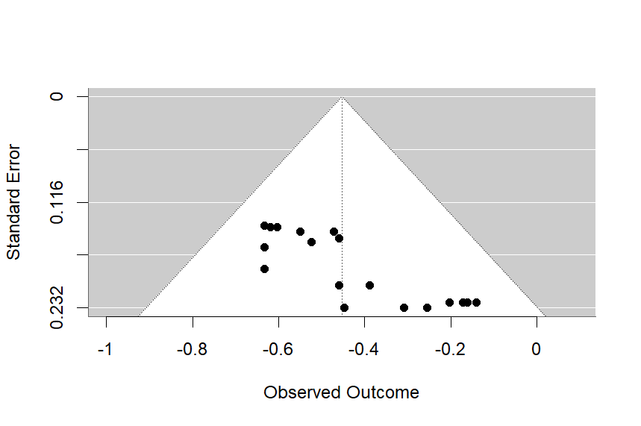 | 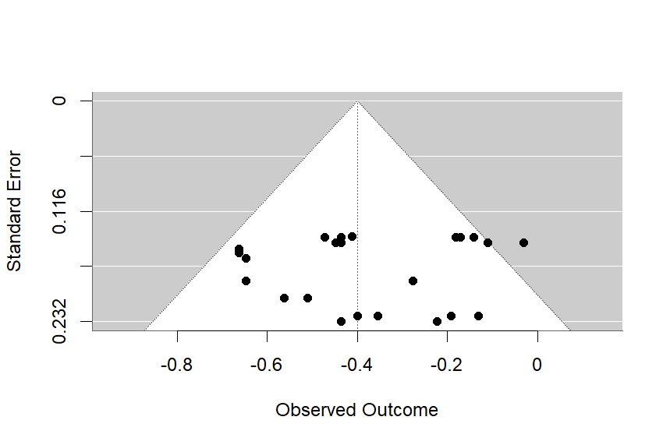 | 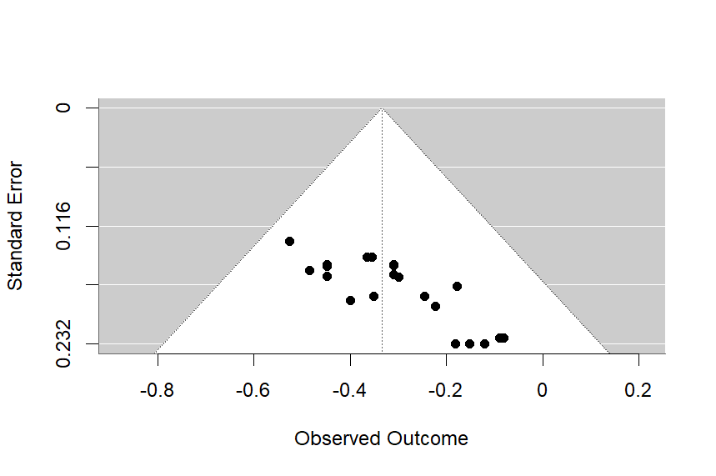
Boredom | 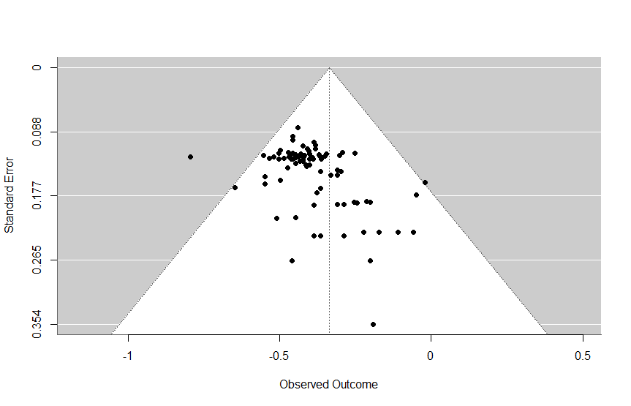 | 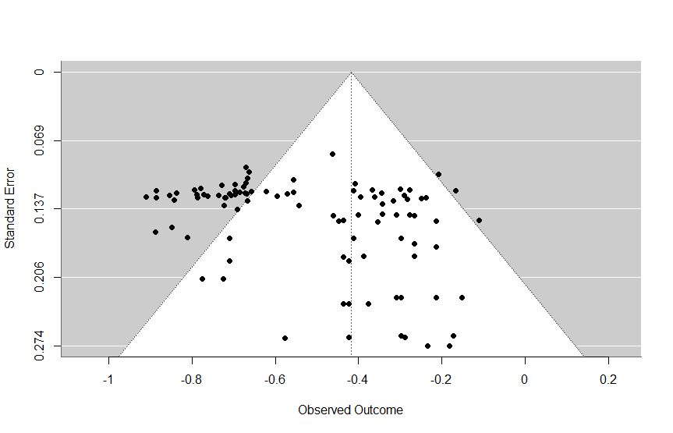 | 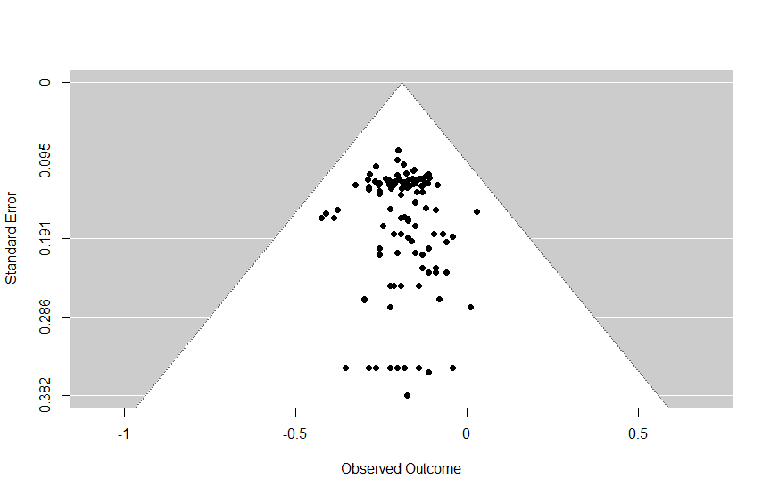
Curiosity | 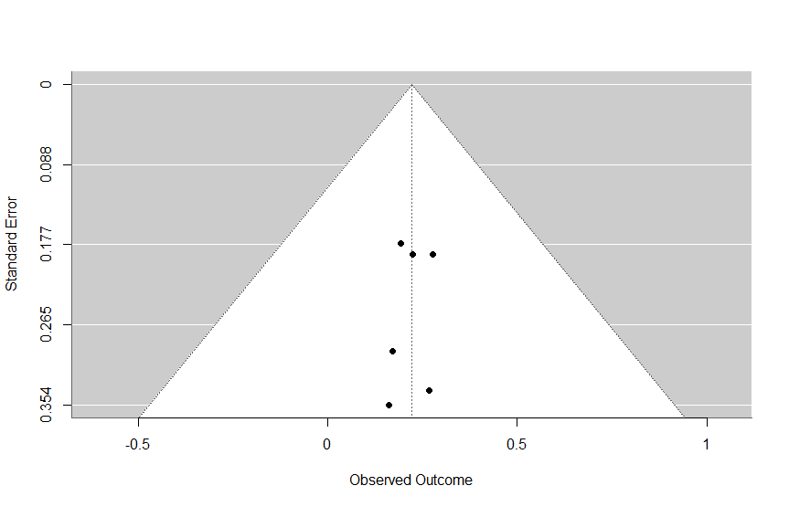 | 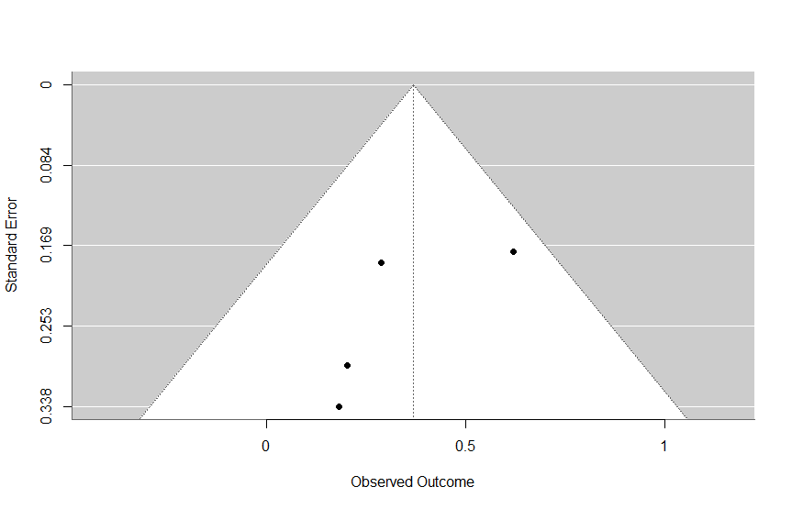 | 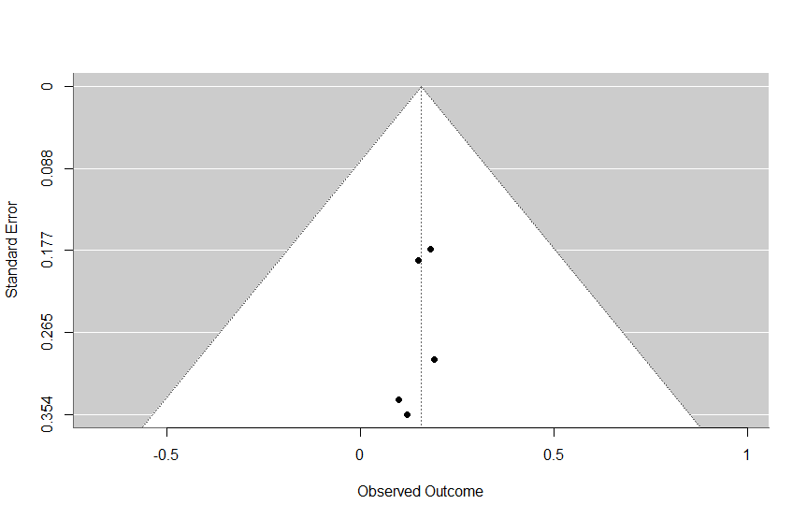
Enjoyment | 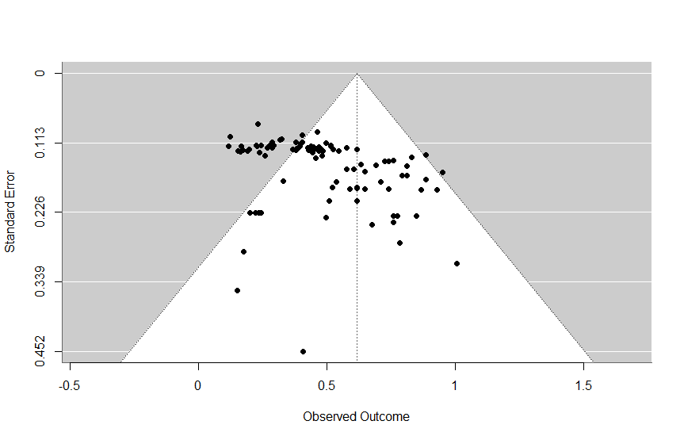 | 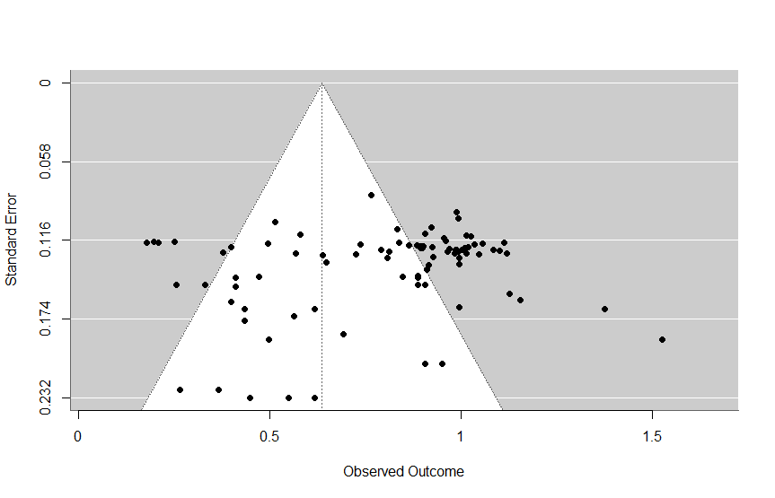 | 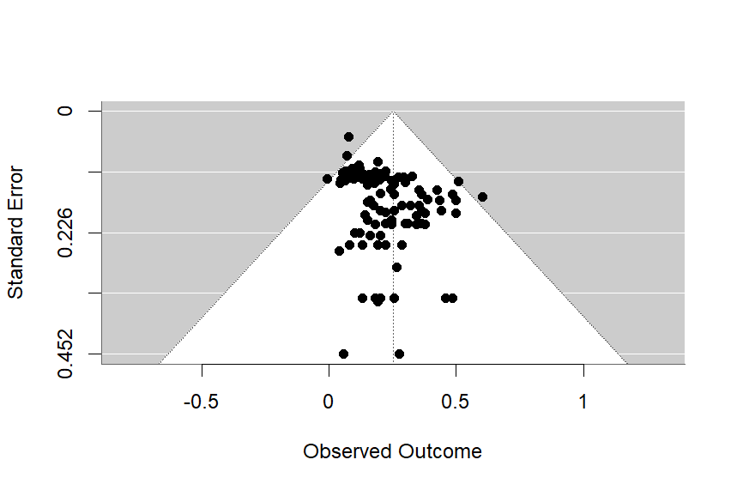
Frustration | 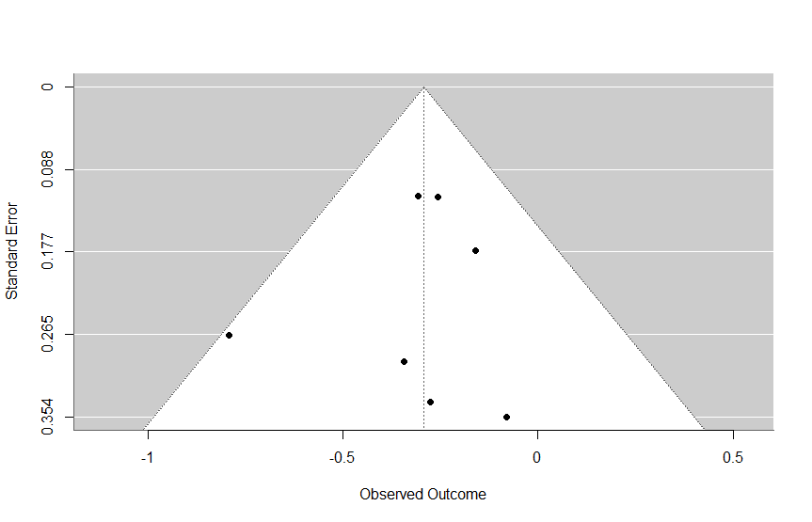 | 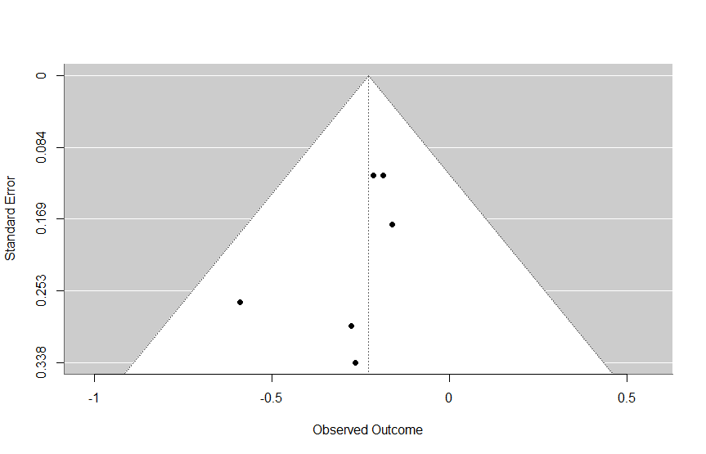 | 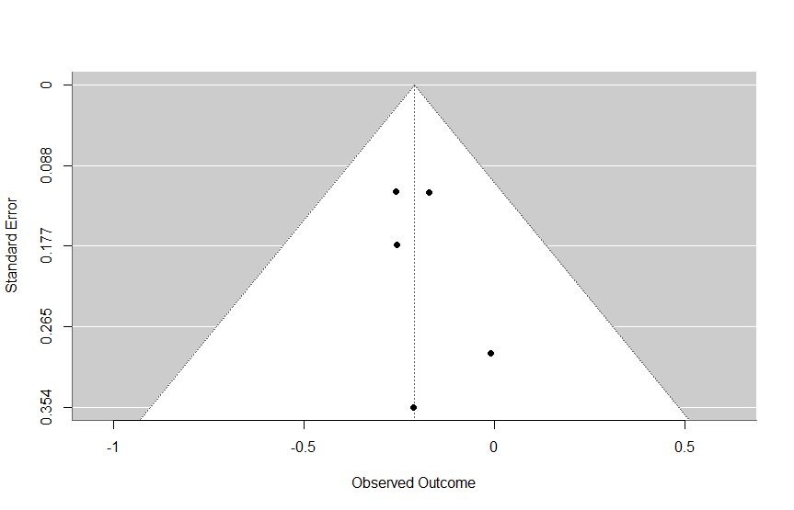
Hope |  |  | 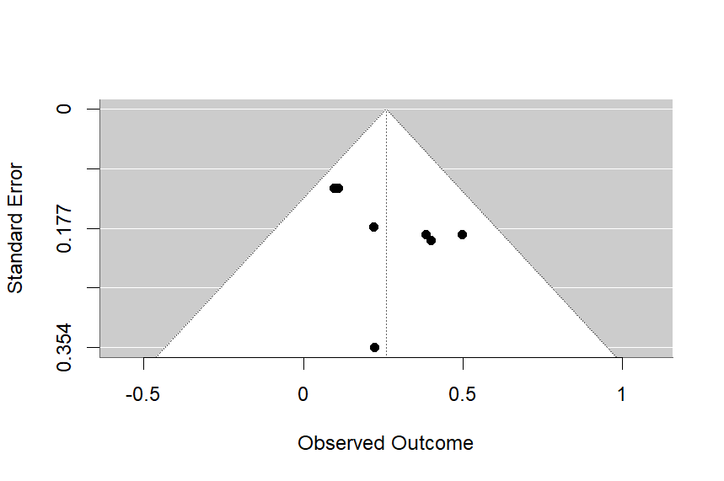
Hopelessness | 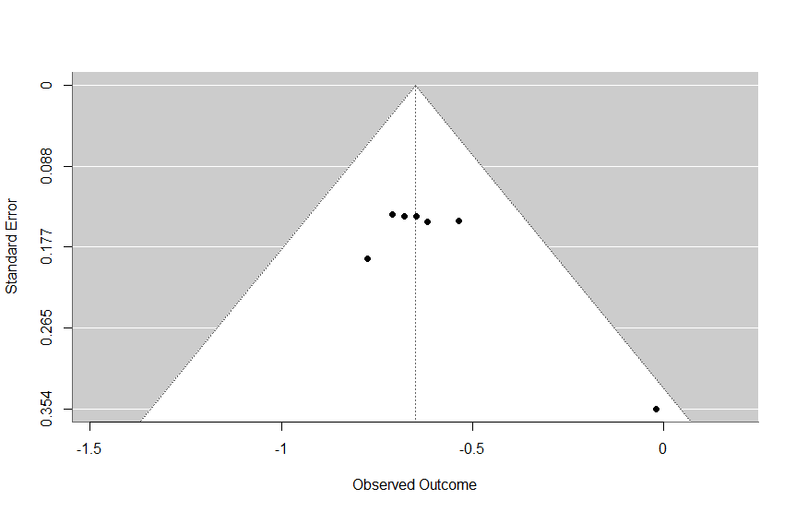 | 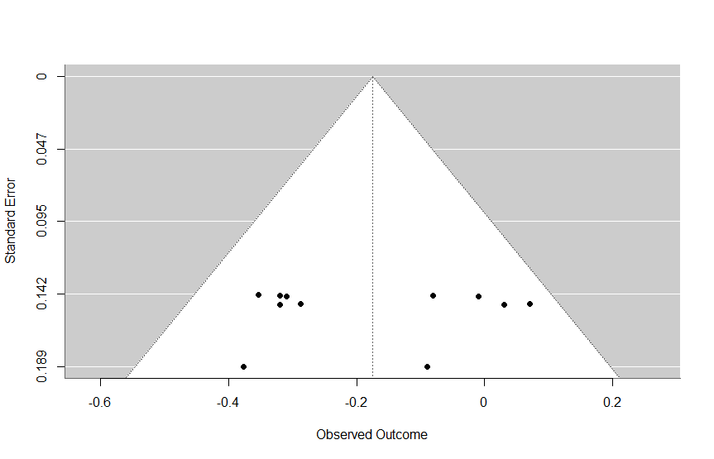 | 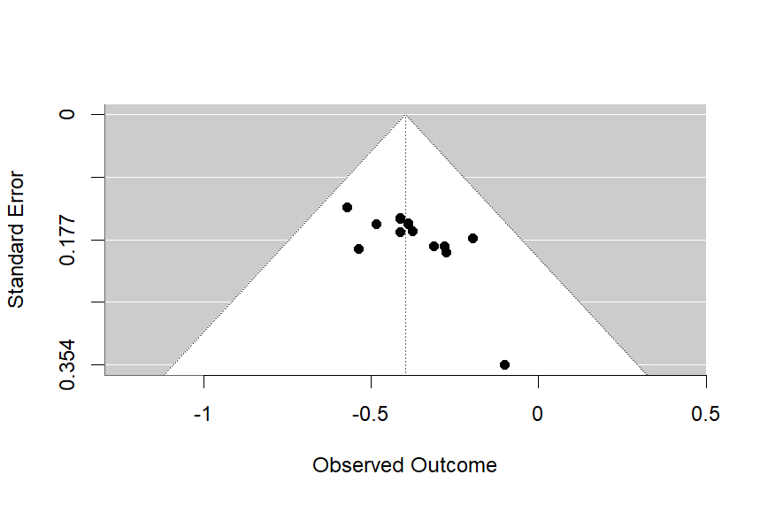
Negative |  | 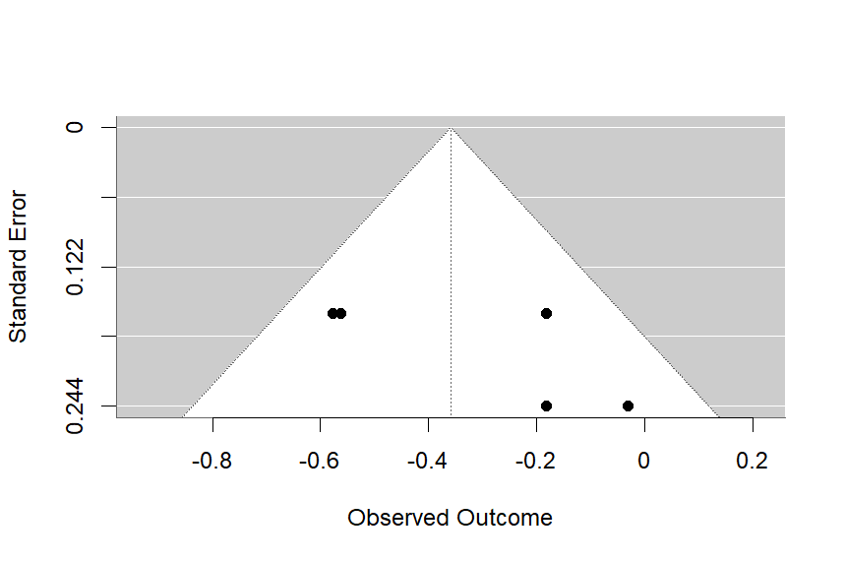 | 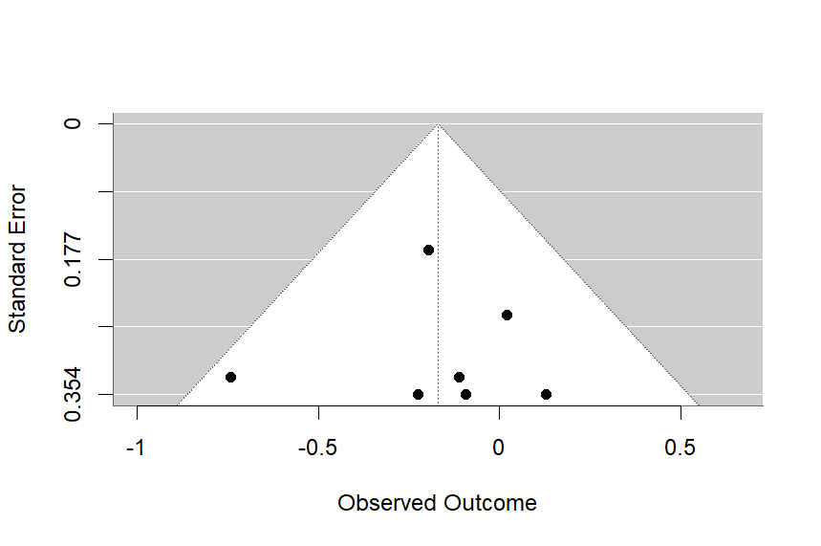
Positive |  |  | 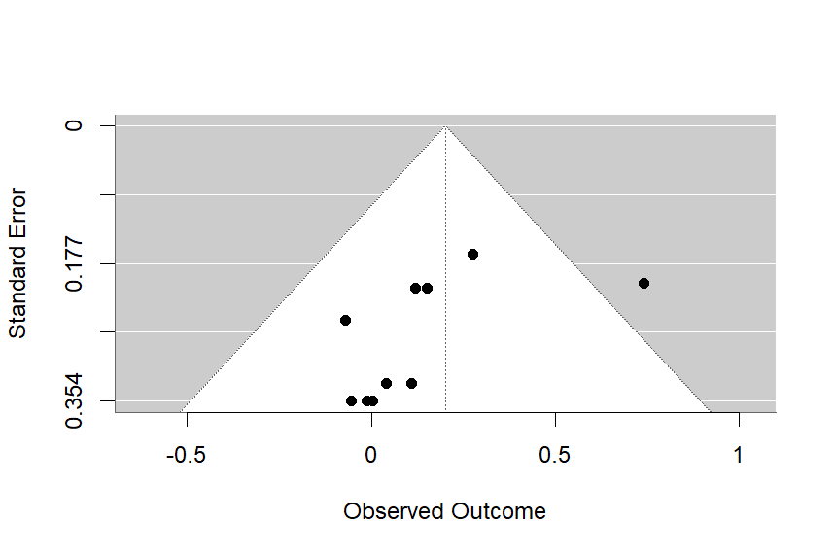
Pride |  | 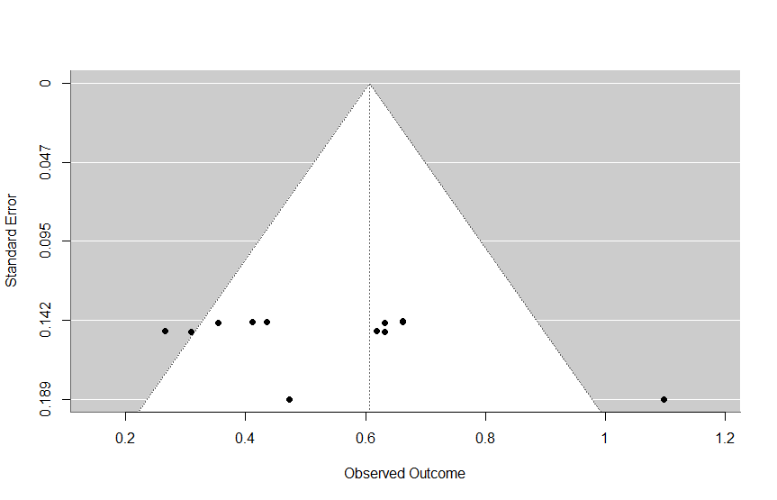 | 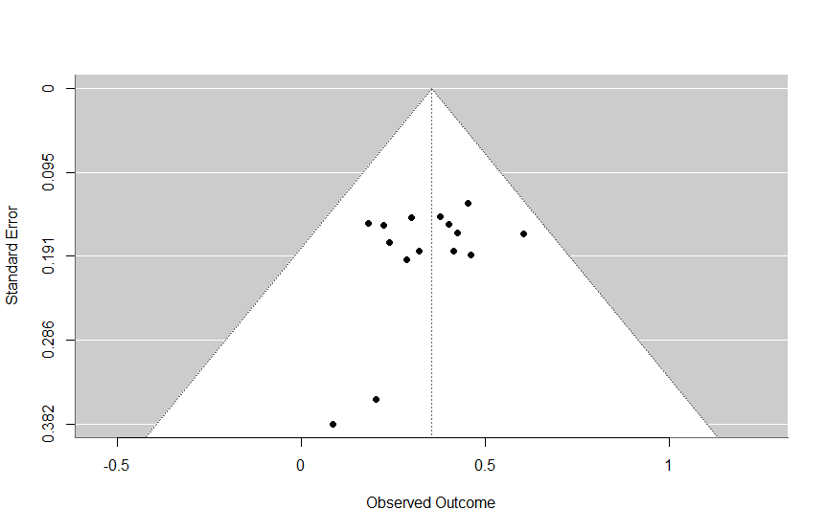
Shame | 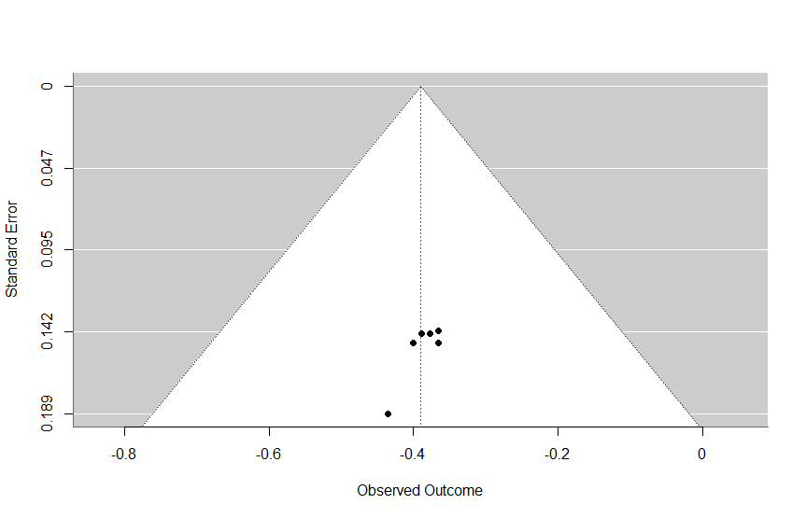 | 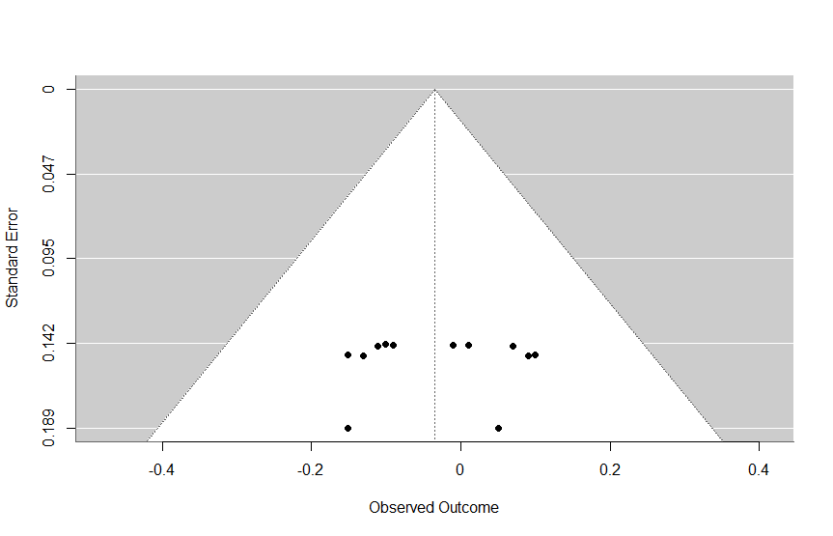 | 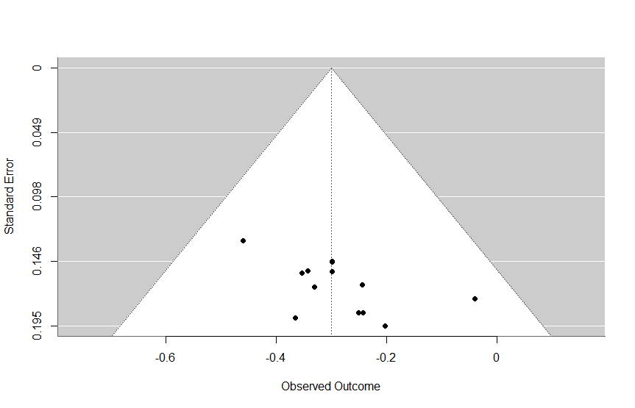
Note. Effect sizes were standardized using Fisher Z, extending the range of extracted effect sizes in the funnel plots beyond -1 to +1.

References of all Studies Included in the Systematic Review and Meta-Analysis
Ayalon, M., Wilkie, K. J., & Eid, K. H. (2022). Relating students’ emotions during argumentative discourse to their learning of real-life functional situations. Educational Studies in Mathematics, 110(1), 23–48. https://doi.org/10.1007/s10649-021-10121-5
Barnes, A. (2021). Enjoyment in learning mathematics: its role as a potential barrier to children’s perseverance in mathematical reasoning. Educational Studies in Mathematics, 106(1), 45–63. https://doi.org/10.1007/s10649-020-09992-x
Basarkod, G., Marsh, H. W., Guo, J. S., Parker, P. D., Dicke, T., & Pekrun, R (2023). The happy-fish-little-pond effect on enjoyment: Generalizability across multiple domains and countries. Learning and Instruction, 85. https://doi.org/10.1016/j.learninstruc.2023.101733
Bieleke, M., Goetz, T., Krannich, M., Roos, A. L., & Yanagida, T. (2023). Starting Tests With Easy Versus Difficult Tasks: Effects on Appraisals and Emotions. Journal of Experimental Education, 91(2), 317–335. https://doi.org/10.1080/00220973.2021.1947764
Bieleke, M., Goetz, T., Yanagida, T., Botes, E., Frenzel, A. C., & Pekrun, R. (2023). Measuring emotions in mathematics: the Achievement Emotions Questionnaire-Mathematics (AEQ-M). ZDM-Mathematics Education, 55(2), 269–284. https://doi.org/10.1007/s11858-022-01425-8
Borgonovi, F., Pokropek, M., & Pokropek, A. (2023). Relations between academic boredom, academic achievement, ICT use, and teacher enthusiasm among adolescents. Computers & Education, 200. https://doi.org/10.1016/j.compedu.2023.104807
Borracci, G., Gauthier, E., Jennings, J., Sale, K., & Muldner, K. (2020). The Effect of Assistance on Learning and Affect in an Algebra Tutor. Journal of Educational Computing Research, 57(8), 2032–2052. https://doi.org/10.1177/0735633118822103
Chen, G. W., Zhang, J. H., Chan, C. K., Michaels, S., Resnick, L. B., & Huang, X. R. (2020). The link between student-perceived teacher talk and student enjoyment, anxiety and discursive engagement in the classroom. British Educational Research Journal, 46(3), 631–652. https://doi.org/10.1002/berj.3600
Chen, X. (2022). The effects of individual- and class-level achievement on attitudes towards mathematics: An analysis of Hong Kong students using TIMSS 2019. Studies in Educational Evaluation, 72. https://doi.org/10.1016/j.stueduc.2021.101113
Chen, X., & Lu, L. H. (2022). How classroom management and instructional clarity relate to students’ academic emotions in Hong Kong and England: A multi-group analysis based on the control-value theory. Learning and Individual Differences, 98. https://doi.org/10.1016/j.lindif.2022.102183
Chen, X. Y., Zhou, J. X., Li, D., Liu, J. S., Dai, Y., & Zhou, T. (2023). Enjoyment of Chinese and mathematics and school performance in Chinese children and adolescents. Child Development, 94(1), 126–141. https://doi.org/10.1111/cdev.13843
Chiu, M.‑S. (2021). An ecological approach to adolescent mathematics ability development: Differences in demographics, parenting, mathematics teaching, and student behaviors and emotions. Educational Studies, 47(2), 155–178. https://doi.org/10.1080/03055698.2019.1672522
Christensen, R., & Knezek, G. (2020). Indicators of middle school students’ mathematics enjoyment and confidence. School Science and Mathematics, 120(8), 491–503. https://doi.org/10.1111/ssm.12439
Chu, H. C., Tsai, W. W., Liao, M. J., Chen, Y. M., & Chen, J. Y. (2020). Supporting E-Learning with Emotion Regulation for Students with Autism Spectrum Disorder. Educational Technology & Society, 23(4), 124–146.
Clem, A. L., Hirvonen, R, Aunola, K., & Kiuru, N. (2021). Reciprocal relations between adolescents’ self-concepts of ability and achievement emotions in mathematics and literacy. Contemporary Educational Psychology, 65. https://doi.org/10.1016/j.cedpsych.2021.101964
Clem, A. L., Rudasill, K. M., Hirvonen, R., Aunola, K., & Kiuru, N. (2021). The roles of teacher-student relationship quality and self-concept of ability in adolescents’ achievement emotions: temperament as a moderator. European Journal of Psychology of Education, 36(2), 263–286. https://doi.org/10.1007/s10212-020-00473-6
Cornoldi, C., Giofrè, D., Mammarella, I. C., & Toffalini, E. (2022). Emotional Response to Testing in Gifted and Highly Gifted Children. Gifted Child Quarterly, 66(3), 208–219. https://doi.org/10.1177/00169862211042901
Darmawan, I. G. (2020). The changes in attitudes of 15-year-old Australian students towards reading, mathematics and science and their impact on student performance. Australian Journal of Education, 64(3), 304–327. https://doi.org/10.1177/0004944120947873
Deale, C. S., & Lee, S. H. (2022). A scholarship of teaching and learning study of hospitality students’ attitudes toward and perceptions of math. Journal of Teaching in Travel & Tourism, 22(2), 126–143. https://doi.org/10.1080/15313220.2021.1978128
Di Leo, I., & Muis, K. R (2020). Confused, now what? A Cognitive-Emotional Strategy Training (CEST) intervention for elementary students during mathematics problem solving. Contemporary Educational Psychology, 62. https://doi.org/10.1016/j.cedpsych.2020.101879
Dietiker, L., Singh, R., Riling, M., Nieves, H. I., & Barno, E. (2023). Narrative characteristics of captivating secondary mathematics lessons. Educational Studies in Mathematics, 112(3), 481–504. https://doi.org/10.1007/s10649-022-10184-y
Forsblom, L., Peixoto, F., & Mata, L. (2021). Perceived classroom support: Longitudinal effects on students’ achievement emotions. Learning and Individual Differences, 85. https://doi.org/10.1016/j.lindif.2020.101959
Forsblom, L., Pekrun, R., Loderer, K., & Peixoto, F. (2022). Cognitive appraisals, achievement emotions, and students’ math achievement: A longitudinal analysis. Journal of Educational Psychology, 114(2), 346–367. https://doi.org/10.1037/edu0000671.
Galla, B. M., Esposito, M. V., & Fiore, H. M. (2020). Mindfulness predicts academic diligence in the face of boredom. Learning and Individual Differences, 81. https://doi.org/10.1016/j.lindif.2020.101864
Goetz, T., Bieleke, M., Gogol, K., van Tartwijk, J., Mainhard, T., Lipnevich, A. A., & Pekrun, R. (2021). Getting along and feeling good: Reciprocal associations between student-teacher relationship quality and students’ emotions. Learning and Instruction, 71. https://doi.org/10.1016/j.learninstruc.2020.101349
Goetz, T., Bieleke, M., Yanagida, T., Krannich, M., Roos, A. L., Frenzel, A. C., Lipnevich, A. A., & Pekrun, R. (2023). Test Boredom: Exploring a Neglected Emotion. Journal of Educational Psychology, 115(7), 911-931. Advance online publication. https://doi.org/10.1037/edu0000807
Greensfeld, H., & Deutsch, Z. (2022). Mathematical challenges and the positive emotions they engender. Mathematics Education Research Journal, 34(1), 15–36. https://doi.org/10.1007/s13394-020-00330-1
Gutica, M., & Petrina, S. (2021). Emotional Agents in Educational Game Design: Heroes of Math Island. International Journal of Game-Based Learning, 11(4), 72–89. https://doi.org/10.4018/IJGBL.2021100104
Guzman, C., Gonzalez, M. D., & Aguilar, M. (2023). Connections between achievement emotions and covariational reasoning: The case of Valeria. International Electronic Journal of Mathematics Education, 18(3). https://doi.org/10.29333/iejme/13180
Hanin, V., Colognesi, S., & van Nieuwenhoven, C. (2021). From perceived competence to emotion regulation: assessment of the effectiveness of an intervention among upper elementary students. European Journal of Psychology of Education, 36(2), 287–317. https://doi.org/10.1007/s10212-020-00481-6
Hanin, V., & Gay, P. (2023). Comparative analysis of students’ emotional and motivational profiles in mathematics in grades 1-6. Frontiers in Education, 8. https://doi.org/10.3389/feduc.2023.1117676
Hanin, V., & van Nieuwenhoven, C. (2020). An Exploration of the Cognitive, Motivational, Emotional and Regulatory Behaviours of Elementary-School Novice and Expert Problem Solvers. Canadian Journal of Science Mathematics and Technology Education, 20(2), 312–341. https://doi.org/10.1007/s42330-020-00092-9
Headrick, L., Wiezel, A., Tarr, G., Zhang, X. X., Cullicott, C. E., Middleton, J. A., & Jansen, A. (2020). Engagement and affect patterns in high school mathematics classrooms that exhibit spontaneous problem posing: an exploratory framework and study. Educational Studies in Mathematics, 105(3), 435–456. https://doi.org/10.1007/s10649-020-09996-7
Held, T., & Hascher, T. (2022). Testing effects of promoting antecedents of mathematics achievement emotions: A change-change model. Learning and Individual Differences, 93. https://doi.org/10.1016/j.lindif.2021.102112
Hernández, M. M., Eisenberg, N., Valiente, C., Spinrad, T. L., Berger, R. H., Johns, S. K., Diaz, A., Gal‐Szabo, D. E., Thompson, M. S., Southworth, J., & Pina, A. A. (2022). Peers’ emotionality and children’s academic achievement in second grade: Testing the moderating role of children’s behavioral self‐regulation. Social Development, 32(3), 793-812. Advance online publication. https://doi.org/10.1111/sode.12657
Hettinger, K., Lazarides, R., Rubach, C., & Schiefele, U. (2021). Teacher classroom management self-efficacy: Longitudinal relations to perceived teaching behaviors and student enjoyment. Teaching and Teacher Education, 103. https://doi.org/10.1016/j.tate.2021.103349
Holm, M. E., Björn, P. M., Laine, A., Korhonen, J., & Hannula, M. S. (2020). Achievement emotions among adolescents receiving special education support in mathematics. Learning and Individual Differences, 79. https://doi.org/10.1016/j.lindif.2020.101851
Holm, M. E., Korhonen, J., Laine, A., Björn, P. M., & Hannula, M. S. (2020). Big-fish-little-pond effect on achievement emotions in relation to mathematics performance and gender. International Journal of Educational Research, 104. https://doi.org/10.1016/j.ijer.2020.101692
Hou, X. Y., Nguyen, H. A., Richey, J. E., & McLaren, B. M. (2020). Exploring How Gender and Enjoyment Impact Learning in a Digital Learning Game. In Bittencourt II, M. Cukurova, K. Muldner, R. Luckin, & E. Millan (Eds.), Artificial Intelligence in Education (AIED 2020), PT I (pp.255-268). Springer.
Johnson, J., Jin, K. R., Sabin, M., & IEEE (2021). Student Emotional Response to Oral Assessments in Computing and Mathematics. In 2021 IEEE Frontiers in Education Conference (FIE) (pp.1-5).
Kanefke, J., & Schukajlow, S. (2023). I find this task interesting, so do you? Preservice teachers’ judgments of students’ enjoyment, boredom, and situational interest regarding tasks with and without a connection to reality. Journal of Mathematics Teacher Education. Advance online publication. https://doi.org/10.1007/s10857-023-09581-8
Kang, X., & Wu, Y. J. (2022). Investigating the Linkage Between School Psychological Capital and Achievement Emotions in Secondary School Mathematics. The Asia-Pacific Education Researcher, 31(6), 739–748. https://doi.org/10.1007/s40299-021-00623-4
Karamarkovich, S. M., & Rutherford, T. (2021). Mixed feelings: Profiles of emotions among elementary mathematics students and how they function within a control-value framework. Contemporary Educational Psychology, 66. https://doi.org/10.1016/j.cedpsych.2021.101996
Kaur, T., & Prendergast, M. (2022). Students’ perceptions of mathematics writing and its impact on their enjoyment and self-confidence. Teaching Mathematics and its Applications, 41(1), 1–21. https://doi.org/10.1093/teamat/hrab008
Lahdelma, P., Tolonen, M., Kiuru, N., & Hirvonen, R. (2021). The role of Adolescents’ and Their Parents’ Temperament Types in Adolescents’ Academic Emotions: A Goodness-of-Fit Approach. Child & Youth Care Forum, 50(3), 471–492. https://doi.org/10.1007/s10566-020-09582-1
Lazarides, R., & Raufelder, D. (2021). Control-value theory in the context of teaching: does teaching quality moderate relations between academic self-concept and achievement emotions? British Journal of Educational Psychology, 91(1), 127–147. https://doi.org/10.1111/bjep.12352
Liang, K., Ma, X., Zhang, J., Zhang, B., Xin, F., Yuan, Q., Zhang, D., Chen, R., & Tang, Y. (2023). A Pilot Movement Integrity with Intelligent Play Program (MIIP): Effects on Math Performance and Enjoyment for Preschoolers in China. Child & Youth Care Forum, 52(3), 703–719. https://doi.org/10.1007/s10566-022-09707-8
Lichtenfeld, S., Pekrun, R., Marsh, H. W., Nett, U. E., & Reiss, K. (2023). Achievement Emotions and Elementary School Children’s Academic Performance: Longitudinal Models of Developmental Ordering. Journal of Educational Psychology, 115(4), 552–570. https://doi.org/10.1037/edu0000748
Marbán, J. M., Palacios, A., & Maroto, A. (2021). Enjoyment of teaching mathematics among pre-service teachers. Mathematics Education Research Journal, 33(3), 613–629. https://doi.org/10.1007/s13394-020-00341-y
Marmur, O., & Koichu, B. (2023). Between expert and student perspectives: on the intersection of affect and heuristic-didactic discourse in the undergraduate classroom. Mathematical Thinking and Learning, 25(1), 115–144. https://doi.org/10.1080/10986065.2021.1940432
Mata, L., Monteiro, V., Peixoto, F., Santos, N. N., Sanches, C., & Gomes, M. (2022). Emotional profiles regarding maths among primary school children - A two-year longitudinal study. European Journal of Psychology of Education, 37(2), 391–415. https://doi.org/10.1007/s10212-020-00527-9
La McCarty, & Faulkner, M. S. (2020). Integrating writing and mathematics: journaling to increase learning and enjoyment while reducing anxiety. Teaching Mathematics and its Applications, 39(3), 145–159. https://doi.org/10.1093/teamat/hrz010
Merrick, M., & Fyfe, E. R. (2023). Feelings on feedback: Children’s emotional responses during mathematics problem solving. Contemporary Educational Psychology, 74. https://doi.org/10.1016/j.cedpsych.2023.102209
Middleton, J. A., Wiezel, A., Jansen, A., & Smith, E. P. (2023). Tracing mathematics engagement in the first year of high school: relationships between prior experience, observed support, and task-level emotion and motivation. ZDM-Mathematics Education, 55(2), 427–445. https://doi.org/10.1007/s11858-022-01432-9
Munzar, B., Muis, K. R, Denton, C. A., & Losenno, K. (2021). Elementary Students’ cognitive and affective responses to impasses during mathematics problem solving. Journal of Educational Psychology, 113(1), 104–124. https://doi.org/10.1037/edu0000460
Näykki, P., Isohätälä, J., & Järvelä, S. (2021). “You really brought all your feelings out”-Scaffolding students to identify the socio-emotional and socio-cognitive challenges in collaborative learning. Learning Culture and Social Interaction, 30. https://doi.org/10.1016/j.lcsi.2021.100536
Ocumpaugh, J., Baker, R. S., Karumbaiah, S., Crossley, S. A., & Labrum, M. (2020). Affective Sequences and Student Actions Within Reasoning Mind. In Bittencourt II, M. Cukurova, K. Muldner, R. Luckin, & E. Millan (Eds.), Artificial Intelligence in Education (AIED 2020), PT I (pp.437-447). Springer.
Park, S. W., Cho, M. H., Lim, S., & Hwang, S. (2023). Predicting students’ negative emotions in college remedial mathematics courses. European Journal of Psychology of Education. Advance online publication. https://doi.org/10.1007/s10212-023-00697-2
Pekrun, R., Marsh, H. W., Suessenbach, F., Frenzel, A. C., & Goetz, T. (2023). School grades and students’ emotions: Longitudinal models of within-person reciprocal effects. Learning and Instruction, 83. https://doi.org/10.1016/j.learninstruc.2022.101626
Putwain, D. W., Schmitz, E. A., Wood, P., & Pekrun, R. (2021). The role of achievement emotions in primary school mathematics: Control-value antecedents and achievement outcomes. British journal of Educational Psychology, 91(1), 347–367. https://doi.org/10.1111/bjep.12367
Putwain, D. W., Wood, P., & Pekrun, R. (2022). Achievement Emotions and Academic Achievement: Reciprocal Relations and the Moderating Influence of Academic Buoyancy. Journal of Educational Psychology, 114(1), 108–126. https://doi.org/10.1037/edu0000637
Quintanilla, V. A., & Gallardo, J. (2022). Interpreting the relationship between emotions and understanding in mathematics: An operational approach applied to measurement with preservice elementary teachers. The Journal of Mathematical Behavior, 68. https://doi.org/10.1016/j.jmathb.2022.101012
Raccanello, D., Brondino, M, & Moe, A. (2022). Malleability beliefs shape mathematics-related achievement emotions: The mediating role of emotion regulation in primary school children. Learning and Individual Differences, 97. https://doi.org/10.1016/j.lindif.2022.102177
Raccanello, D., Brondino, M., Trifiletti, E., & Shamloo, S. E. (2020). Emotions at primary school: Negative achievement emotions and their relation with emotional competencies in ethnic minority and majority students. Journal of Community & Applied Social Psychology, 30(4), 441–458. https://doi.org/10.1002/casp.2451
am Rawlings, Niemivirta, M., Korhonen, J., Lindskog, M., Tuominen, H., & Mononen, R. (2023). Achievement emotions and arithmetic fluency-Development and parallel processes during the early school years. Learning and Instruction, 86. https://doi.org/10.1016/j.learninstruc.2023.101776
Rebolledo-Mendez, G., Huerta-Pacheco, N. S., Baker, R. S., & Du Boulay, B. (2022). Meta-affective Behaviour within an Intelligent Tutoring System for Mathematics. International Journal of Artificial Intelligence in Education, 32(1), 174–195. https://doi.org/10.1007/s40593-021-00247-1
Reinhold, F., Hoch, S., Schiepe-Tiska, A., Strohmaier, A. R., & Reiss, K. (2021). Motivational and Emotional Orientation, Engagement, and Achievement in Mathematics. A Case Study With One Sixth-Grade Classroom Working With an Electronic Textbook on Fractions. Frontiers in Education, 6. https://doi.org/10.3389/feduc.2021.588472
Riegel, K., & Evans, T. (2021). Student achievement emotions: Examining the role of frequent online assessment. Australasian Journal of Educational Technology, 37(6), 75–87. https://doi.org/10.14742/ajet.6516
Ronen, I. K. (2020). Empathy Awareness Among Pre-service Teachers: the Case of the Incorrect Use of the Intuitive Rule “Same A-Same B”. International Journal of Science and Mathematics Education, 18(1), 183–201. https://doi.org/10.1007/s10763-019-09952-9
Rubach, C., Dicke, A.‑L., Safavian, N., & Eccles, J. S. (2023). Classroom transmission processes between teacher support, interest value and negative affect: An investigation guided by situated expectancy-value theory and control-value theory. Motivation and Emotion, 47(4), 575–594. https://doi.org/10.1007/s11031-023-10013-6
Sachisthal, M. S., Raijmakers, M. E., & Jansen, B. R. (2021). Trait and state math EAP (emotion, appraisals and performance) profiles of Dutch teenagers. Learning and Individual Differences, 89. https://doi.org/10.1016/j.lindif.2021.102029
Sagkal, A. S., & Sönmez, M. T. (2022). The effects of perceived parental math support on middle school students’ math engagement: the serial multiple mediation of math self-efficacy and math enjoyment. European Journal of Psychology of Education, 37(2), 341–354. https://doi.org/10.1007/s10212-020-00518-w
Sainio, P., Eklund, K., Hirvonen, R., Ahonen, T., & Kiuru, N. (2021). Adolescents’ Academic Emotions and Academic Achievement Across the Transition to Lower Secondary School: The Role of Learning Difficulties. Scandinavian Journal of Educational Research, 65(3), 385–403. https://doi.org/10.1080/00313831.2019.1705900
Sainio, P., Eklund, K. M., Pakarinen, E. K., & Kiuru, N. H. (2023). The Role of Teacher Closeness in Emotions and Achievement for Adolescents With and Without Learning Difficulties. Learning Disability Quarterly, 46(3), 151–165. https://doi.org/10.1177/07319487221086006
Sakaki, M., Murayama, K., Frenzel, A. C., Goetz, T., Marsh, H. W., Lichtenfeld, S., & Pekrun, R. (2023). Developmental trajectories of achievement emotions in mathematics during adolescence. Child Development, 95(1), 276-295. Advance online publication. https://doi.org/10.1111/cdev.13996
Satyam, V. R. (2020). Satisfying moments during the transition-to-proof: Characteristics of moments of significant positive emotion. Journal of Mathematical Behavior, 59. https://doi.org/10.1016/j.jmathb.2020.100784
Satyam, V. R., Bae, Y., Smith, J. P., & Levin, M. (2022). Affect graphing: leveraging graphical representations in the study of students’ affect in mathematics. Educational Studie in Mathematics, 110(3), 481–501. https://doi.org/10.1007/s10649-021-10131-3
Schubert, S., Pekrun, R., & Ufer, S. (2023). The role of epistemic emotions in undergraduate students’ proof construction. ZDM-Mathematics Education, 55(2), 299–314. https://doi.org/10.1007/s11858-022-01413-y
Schukajlow, S., Blomberg, J., Rellensmann, J., & Leopold, C. (2021). Do emotions and prior performance facilitate the use of the learner-generated drawing strategy? Effects of enjoyment, anxiety, and intramathematical performance on the use of the drawing strategy and modelling performance Contemporary Educational Psychology, 65. https://doi.org/10.1016/j.cedpsych.2021.101967
Schwartze, M. M., Frenzel, A. C., Goetz, T., Marx, A. K. G., Reck, C., Pekrun, R., & Fiedler, D. (2020). Excessive boredom among adolescents: A comparison between low and high achievers. PLOS ONE, 15(11). https://doi.org/10.1371/journal.pone.0241671
Silfver, E., Jacobsson, M., Arnell, L., Bertilsdotter-Rosqvist, H., Hargestam, M., Sjoberg, M., & Widding, U. (2020). Classroom bodies: affect, body language, and discourse when schoolchildren encounter national tests in mathematics. Gender and Education, 32(5), 682–696. https://doi.org/10.1080/09540253.2018.1473557
Singh, C. A., & Muis, K. R. (2021). The role of Social Emotions and Co-Regulation of Learning During Complex Math Problem Solving. In D. Moraitou & P. Metallidou (Eds.), Trends and prospects in metacognition research across the life span: A tribute to Anastasia Efklides (pp. 103–133). Springer Nature Switzerland AG. https://doi.org/10.1007/978-3-030-51673-4_6
Tang, D. J., Fan, W. H., Zou, Y. L., George, R. A., Arbona, C., & Olvera, N. E. (2021). Self-efficacy and achievement emotions as mediators between learning climate and learning persistence in college calculus: A sequential mediation analysis. Learning and Individual Differences, 92. https://doi.org/10.1016/j.lindif.2021.102094
Tang, X., & Salmela-Aro, K. (2021). The prospective role of epistemic curiosity in national standardized test performance. Learning and Individual Differences, 88. https://doi.org/10.1016/j.lindif.2021.102008
Tlalpan, P. R. (2021). The Impact of Augmented Reality on Student Learning and Emotions in Mathematics. In 2021 Machine Learning-Driven Digital Technologies for Educational Innovation Workshop.
Trigueros, R., Aguilar-Parra, J. M., Lopez-Liria, R., Cangas, A. J., González, J. J., & Álvarez, J. F. (2020). The Role of Perception of Support in the Classroom on the Students’ Motivation and Emotions: The Impact on Metacognition Strategies and Academic Performance in Math and English Classes. Frontiers in Psychology, 10. https://doi.org/10.3389/fpsyg.2019.02794
Tze, V. M. C., Li, J. C.‑H., & Parker, P. C. (2021). A mediation analysis of emotions based on the control-value theory. Current Psychology: A Journal for Diverse Perspectives on Diverse Psychological Issues, 42, 5392-5406. Advance online publication. https://doi.org/10.1007/s12144-021-01840-2
van de Weijer-bergsma, E., & van der Ven, S. H. (2021). Why and for whom does personalizing math problems enhance performance? Testing the mediation of enjoyment and cognitive load at different ability levels. Learning and Individual Differences, 87. https://doi.org/10.1016/j.lindif.2021.101982
Vattoy, K. D., & Gamlem, S. M. (2023). Students’ experiences of peer feedback practices as related to awareness raising of learning goals, self-monitoring, self-efficacy, anxiety, and enjoyment in teaching EFL and mathematics. Scandinavian Journal of Educational Research. Advance online publication. https://doi.org/10.1080/00313831.2023.2192772
Wu, X. M., Rambo-Hernandez, K., Fuller, E., & Deshler, J. (2023). Predicting STEM persistence from mathematics affect, pedagogical perceptions and Calculus I setting. International Journal of Mathematical Education in Science and Technology, 54(7), 1207–1228. https://doi.org/10.1080/0020739X.2022.2107957
Yazgan, Y., & Ulger, T. K. (2023). Non-routine problem posing and prospective middle school mathematics teachers: an emotional perspective. International Journal of Mathematical Education in Science and Technology. Advance online publication. https://doi.org/10.1080/0020739X.2023.2217680
Zivkovic, M., Pellizzoni, S., Doz, E., Cuder, A., Mammarella, I., & Passolunghi, M. C. (2023). Math self-efficacy or anxiety? The role of emotional and motivational contribution in math performance. Social Psychology of Education, 26(3), 579–601. https://doi.org/10.1007/s11218-023-09760-8

