Name, family name: ___________________________________________________
Group: _____

Problem posing modelling activity

First part

Below you will find three problems taken from a 6th grade Primary School textbook published by Santillana (La casa del Saber project).
Read the statements of each problem carefully and familiarise yourself with them by trying to solve them.
Then, taking into account the Spanish curricular development of the LOMLOE law and the context in which each of the tasks presented is formulated, design, in each case, a mathematical problem that allows the development of modelling skills, and that involves at least the mathematical contents of the original problem.

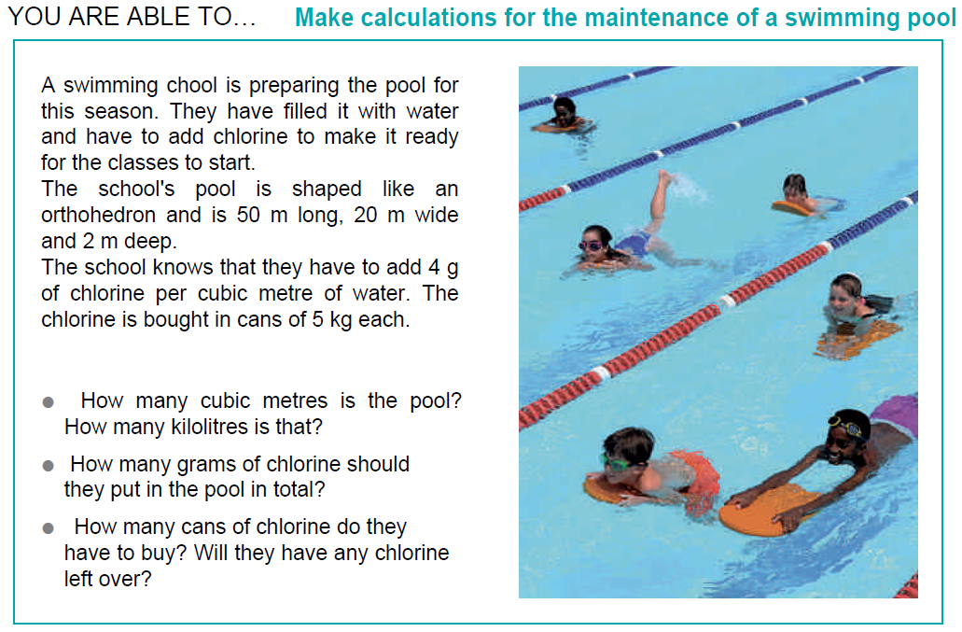
PROBLEM 1

Solve the Problem 1

Pose a modelling problem inspired by problem 1 addressed to 6th grade students that involves at least the same mathematical knowledge.

PROBLEM 2
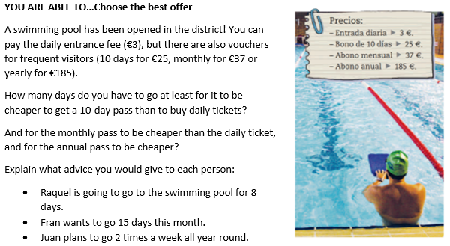

Solve the Problem 2

Pose a modelling problem inspired by problem 2 addressed to 6th grade students that involves at least the same mathematical knowledge.

PROBLEM 3
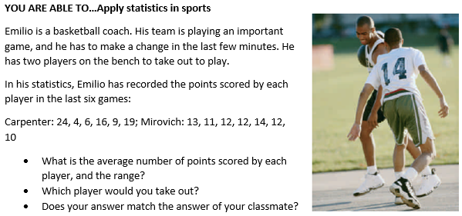

Solve the Problem 3

Pose a modelling problem inspired by problem 3 addressed to 6th grade students that involves at least the same mathematical knowledge.

Name, family name: ___________________________________________________
Group: _____

Problem posing modelling activity

Second part

We will now ask you to solve the three problems you have posed in the first part and to answer some questions about your problems.
PROBLEM 1
Solve here your modelling problem based on problem 1 (Maintenance of a swimming pool)

Indicate whether the problem you have posed meets the following characteristics:
 | Yes, I agree | No, I disagree
The mathematical contents needed to solve the problem I have posed include those I have identified in the original problem.
The problem I have posed allows to use the elements of the real context more than the original problem.
In order to solve the problem I have designed, it is necessary to consider elements of the reality in which it is contextualized (e.g. establishing hypotheses, making estimates...).
The problem I have posed can be solved in more than one way and has no single answer.
The problem I have posed is solved in different stages, by breaking it down into sub-problems.
In the problem I have posed, it would be possible to look for real data to validate the solution.

PROBLEM 2
Solve here your modelling problem based on problem 2 (Swimming pool best price)

Indicate whether the problem you have posed meets the following characteristics:
 | Yes, I agree | No, I disagree
The mathematical contents needed to solve the problem I have posed include those I have identified in the original problem.
The problem I have posed allows to use the elements of the real context more than the original problem.
In order to solve the problem I have designed, it is necessary to consider elements of the reality in which it is contextualized (e.g. establishing hypotheses, making estimates...).
The problem I have posed can be solved in more than one way and has no single answer.
The problem I have posed is solved in different stages, by breaking it down into sub-problems.
In the problem I have posed, it would be possible to look for real data to validate the solution.

PROBLEM 3
Solve here your modelling problem based on problem 3 (Statistics in Sports)

Indicate whether the problem you have posed meets the following characteristics:
 | Yes, I agree | No, I disagree
The mathematical contents needed to solve the problem I have posed include those I have identified in the original problem.
The problem I have posed allows to use the elements of the real context more than the original problem.
In order to solve the problem I have designed, it is necessary to consider elements of the reality in which it is contextualized (e.g. establishing hypotheses, making estimates...).
The problem I have posed can be solved in more than one way and has no single answer.
The problem I have posed is solved in different stages, by breaking it down into sub-problems.
In the problem I have posed, it would be possible to look for real data to validate the solution.

