SI1 The full version of Vignette 1
Mr. Chang is teaching common logarithms to the 10th-grade students. His teaching activity proceeds as follows:
- Mr. Chang asks students to think about what power of 10 equals 3, then asks them to do the activity on the worksheet provided using a calculator.
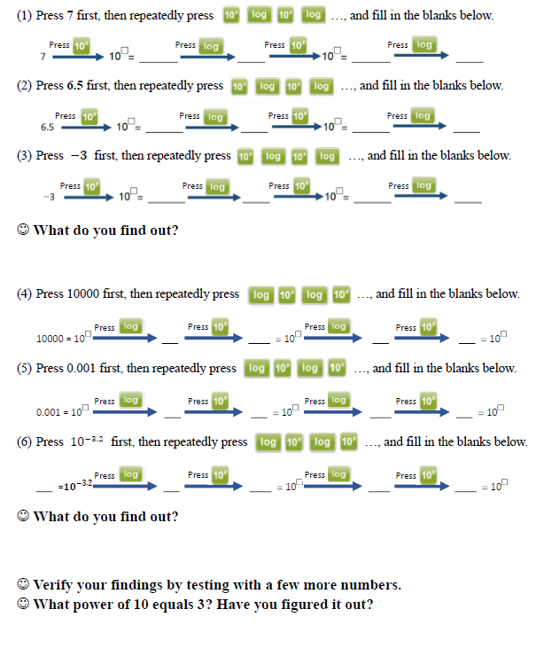
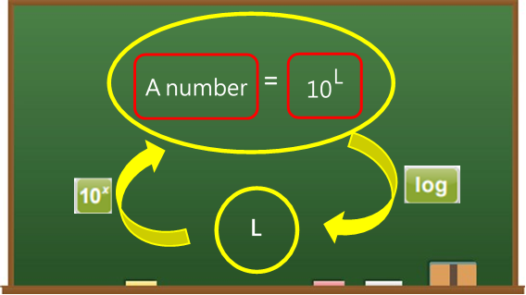
- Mr. Chang invites several students to come to the front to use a computer-based calculator emulator and present their findings. He then summarizes the key points on the blackboard and explains: “Taking the logarithm of a number gives the exponent when the number is expressed as a power of 10. Conversely, if you have the exponent, pressing ${10}^{x}$ will retrieve the original number.”

SI2 Coding rubric for learning objectives
Code | Descriptions
Mathematical competence
Content-oriented mathematical competencies | These are related to specific mathematics topics, including factual knowledge, procedures, and technical skills (Niss, 2003).
Thought-oriented mathematical competencies | These are not tied to specific mathematical topics and include the ability to ask and answer questions within mathematics (e.g, reasoning mathematically), and the ability to manage and use mathematical language (e.g., representing mathematical entities; Niss, 2003).
Mathematical attitude
Attitudes toward mathematics and mathematics learning | These refer to students’ attitudes about liking mathematics, perceiving mathematics as beautiful, understanding that mathematics encompasses more than just formulas or problems, viewing mathematics as a tool, seeing mathematics as a means to model the world’s patterns, and recognizing mathematics as a way to train thought processes, etc. (Hsieh, 2013).
Attitudes toward learning mathematics with integration of technology | These refer to students’ attitudes towards engaging with mathematics through technology, including asking mathematical questions, completing exercises, and understanding concepts on a deeper, more conceptual level, etc. (Hsieh, 2013).
21st-century skills | These include the thinking skills identified by the OECD, such as critical thinking, creativity, research and inquiry, information use, systems thinking, communication, reflection and self-direction, initiative, and persistence (OECD, 2018).

SI3 Coding rubric for opportunities supported by technology integration in mathematics classes
Code | Descriptions
Pedagogical opportunity
Subject: the areas of mathematics being taught
Exploit contrast and synergy of ideal and machine mathematics | Teachers intentionally use “unexpected” error messages, expression formats, graphical displays, or features that were previously unavailable (or not easily accessible) as catalysts for rich mathematical discussions.
Re-balance emphasis on skills, concepts, applications | Teachers adjust their instructional goals by spending less time on routine skills and more time on concepts, applications, mathematical competencies, attitudes, and 21st-century skills. This includes increasing the focus on mathematical thinking, observation, extracting characteristics, and other higher-order skills.
Build metacognition and overview | Teachers provide an overview as either an introduction or a summation, linking concepts through the manipulation of symbolic expressions and the use of multiple representations. This linkage includes connecting concepts currently being learned with those learned previously or those that will be learned in the future.
Classroom: the changes in the interpersonal dynamics of the classroom
Change classroom social dynamics | Teachers shift from dictating to facilitating, encouraging group work, student-initiated discussions, and opportunities for students to share their learning with the class.
Change classroom didactic contract | Teachers allow technology to become a new authority, altering expectations for both students and teachers. This includes permitting or constraining the use of a wide range of available methods and emphasizing the interaction between learners and technology.

SI3 Coding rubric for opportunities supported by technology integration in mathematics classes
Code | Descriptions
Task: the activities assigned to students
Learn pen and paper skills | Utilize instant “answers” as feedback to support learning of processes.
Use real data | Engage with real-world problems that involve calculations which, when done by hand, can be error-prone and time-consuming.
Explore regularity and variation | Strategically vary computations to search for patterns, observe the effects of parameters, and use general forms.
Simulate real situations | Use dynamic diagrams and drag-and-drop features to collect data for analysis, while also employing technology-generated statistical datasets for conducting data fitting.
Link representations | Transition fluidly between geometric, numeric, graphic, and symbolic representations.
Functional opportunity
 | Perform routine mathematical procedures (such as calculating, drawing, solving, etc.) quickly and accurately.

SI4 The questionnaire to investigate dispositions of preservice teachers
The following items are objectives that some teachers believe can be achieved through mathematics learning. How important do you think these objectives are?
Please rate each statement by the value from 1 to 6 based on the given rating criteria.
The importance of the learning objectives
- Understanding mathematical knowledge | □₁
- Abstracting and generalizing mathematical concepts | □₁
- Concretizing and visualizing mathematical concepts | □₁
- Acquiring procedural and routine skills | □₁
- Promoting conceptual transfer | □₁
- Enhancing mathematical competencies | □₁
6a. Mathematical thinking competency | □₁
6b. Problem tackling competency | □₁
6c. Modelling competency | □₁
6d. Reasoning competency | □₁
6e. Representing competency | □₁
6f. Symbol an formalism competency | □₁
6g. Communicating competency | □₁
6h. Aids and tools competency (including technological tools) | □₁
- Developing 21st thinking skills | □₁
7a. Critical thinking | □₁
7b. Creativity | □₁
7c. Communication (Communicate with others) | □₁
7d. Reflection | □₁
7e. Self-direction, initiative, and persistence | □₁
7f. Research and inquiry | □₁
7g. Information use  (e.g., using digital tools or information appropriately) | □₁
7h. Systems thinking  (e.g., considering an object of thought as a system and analyzing the relationships among its components) | □₁
- Cultivating positive attitudes toward mathematics learning | □₁
- Developing recognition of the value of mathematics | □₁
Rating criteria
- Very important 6
- Important 5
- Somewhat important 4
- Somewhat unimportant 3
- Unimportant 2
- Very unimportant 1

