Appendix A:

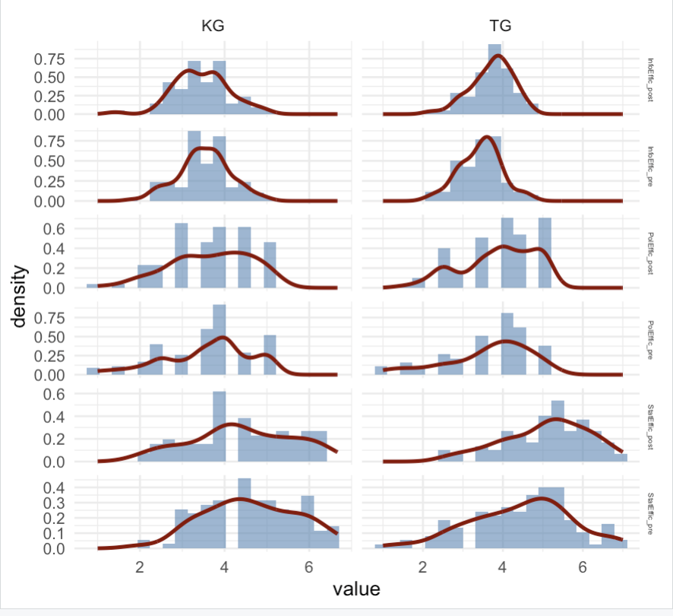

Figure A.1: Histograms and Density Plots of StatEffic, PolEffic, and InfoEffic at Pretest and Posttest by Group.

Appendix B: Exploratory Factor Analysis of StatEffic Items

To build a StatEffic scale, we conducted an exploratory factor analysis (EFA) on 10 items (1 to 10) taken from the SCAS instrument (Gal et al., 1997). We included pre-test data Self
Sampling adequacy was acceptable (KMO = 0.63), with individual MSAs ranging from 0.56 to 0.67. Bartlett’s test of sphericity was highly significant, χ²(45) = 270.07, p < .001, confirming sufficient intercorrelation among items.

- I often use statistical information in forming my opinions or making decisions.
- To be an intelligent consumer, it is necessary to know something about statistics.
- Because it is easy to lie with statistics, I don't trust them at all.
- Understanding probability and statistics is becoming increasingly important in our society, and may become as essential as being able to add and subtract.
- Given the chance, I would like to learn more about probability and statistics.
- You must be good at mathematics to understand basic statistical concepts.
- When buying a new car, asking a few friends about problems they have had with their cars is preferable to consulting an owner satisfaction survey in a consumer magazine.
- Statements about probability (such as what the odds are of winning a lottery) seem very clear to me.
- I can understand almost all of the statistical terms that I encounter in newspapers or on television.
- I could easily explain how an opinion poll works.
We applied principal axis factoring with oblimin rotation, given expected factor correlations. Parallel analysis and the scree plot supported a 3-factor solution (see Figure A1).

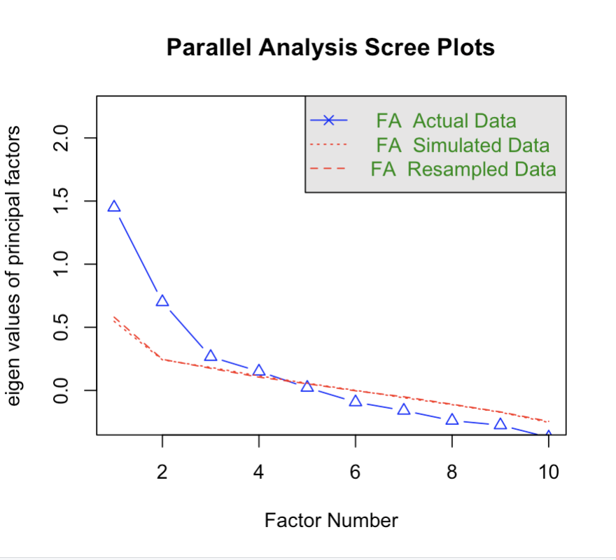
Figure B1. Scree plot and results of parallel analysis

Table B1 presents the pattern matrix with standardized loadings ≥ .30.
Item | PA1 | PA2 | PA3 | h² | u²
1 (pre) |  | 0.44 |  | 0.27 | 0.73
2 (pre) |  | 0.83 |  | 0.71 | 0.29
3 (pre) |  |  |  | 0.03 | 0.97
4 (pre) |  |  | 0.5 | 0.34 | 0.66
5 (pre) |  |  | 0.7 | 0.48 | 0.52
6 (pre) |  |  |  | 0.06 | 0.94
7 (pre) |  |  |  | 0.06 | 0.94
8 (pre) | 0.53 |  |  | 0.28 | 0.72
9 (pre) | 0.81 |  |  | 0.69 | 0.31
10 (pre) | 0.55 |  |  | 0.29 | 0.71
Table B1. Pattern Matrix of Factor Loadings (≥ .30). PA = principal axis factor; h² = communality; u² = uniqueness

The three factors accounted for 32% of the total variance (PA1: 13%, PA2: 11%, PA3: 8%). Inter-factor correlations were modest (PA1-PA2 = .15; PA1-PA3 = .24; PA2-PA3 = .38), supporting the use of oblique rotation.
Only the items loading on PA1 (8, 9, 10) were used to construct the StatEffic scale. These items showed clear and exclusive loadings on the first factor and exhibited acceptable communalities. Other items either failed to load meaningfully or loaded on conceptually distinct factors, and were therefore excluded from the final scale.
The model showed good fit:
- Tucker-Lewis Index (TLI): 0.956
- RMSEA: 0.03 (90% CI: 0.00-0.069)
- BIC: -76.38
- Factor score determinacy (R²): PA1 = 0.76, PA2 = 0.75, PA3 = 0.61

Appendix C: Reliability of Scales

Table 3 Reliability of Scales Across Subgroups (Cronbach’s α)
Scale | Time | Group | n | Items | Cronbach's α
InfoEffic | Pre | CG_M | 50 | 12 | 0.824
InfoEffic | Pre | CG_C | 67 | 12 | 0.912
InfoEffic | Pre | CG_total | 117 | 12 | 0.90
InfoEffic | Pre | TG_M | 53 | 12 | 0.866
InfoEffic | Pre | TG_C | 65 | 12 | 0.758
InfoEffic | Pre | TG_total | 118 | 12 | 0.863
InfoEffic | Post | CG_M | 44 | 12 | 0.89
InfoEffic | Post | CG_C | 53 | 12 | 0.901
InfoEffic | Post | CG_total | 97 | 12 | 0.899
InfoEffic | Post | TG_M | 44 | 12 | 0.866
InfoEffic | Post | TG_C | 50 | 12 | 0.758
InfoEffic | Post | TG_total | 94 | 12 | 0.863
PolEffic | Pre | CG_M | 50 | 2 | 0.795
PolEffic | Pre | CG_C | 67 | 2 | 0.743
PolEffic | Pre | CG_total | 117 | 2 | 0.838
PolEffic | Pre | TG_M | 53 | 2 | 0.805
PolEffic | Pre | TG_C | 65 | 2 | 0.742
PolEffic | Pre | TG_total | 118 | 2 | 0.853
PolEffic | Post | CG_M | 44 | 2 | 0.645
PolEffic | Post | CG_C | 53 | 2 | 0.705
PolEffic | Post | CG_total | 97 | 2 | 0.776
PolEffic | Post | TG_M | 44 | 2 | 0.658
PolEffic | Post | TG_C | 50 | 2 | 0.63
PolEffic | Post | TG_total | 94 | 2 | 0.767
StatEffic | Pre | CG_M | 50 | 3 | 0.483
StatEffic | Pre | CG_C | 67 | 3 | 0.556
StatEffic | Pre | CG_total | 117 | 3 | 0.531
StatEffic | Pre | TG_M | 53 | 3 | 0.712
StatEffic | Pre | TG_C | 65 | 3 | 0.748
StatEffic | Pre | TG_total | 118 | 3 | 0.719
StatEffic | Post | CG_M | 44 | 3 | 0.706
StatEffic | Post | CG_C | 53 | 3 | 0.715
StatEffic | Post | CG_total | 97 | 3 | 0.687
StatEffic | Post | TG_M | 44 | 3 | 0.772
StatEffic | Post | TG_C | 50 | 3 | 0.62
StatEffic | Post | TG_total | 94 | 3 | 0.652
SciencePol | Pre | CG_M | 50 | 3 | 0.482
SciencePol | Pre | CG_C | 67 | 3 | 0.563
SciencePol | Pre | CG_total | 117 | 3 | 0.521
SciencePol | Pre | TG_M | 53 | 3 | 0.736
SciencePol | Pre | TG_C | 65 | 3 | 0.528
SciencePol | Pre | TG_total | 118 | 3 | 0.684
SciencePol | Post | CG_M | 44 | 3 | 0.711
SciencePol | Post | CG_C | 53 | 3 | 0.594
SciencePol | Post | CG_total | 97 | 3 | 0.646
SciencePol | Post | TG_M | 44 | 3 | 0.669
SciencePol | Post | TG_C | 50 | 3 | 0.584
SciencePol | Post | TG_total | 94 | 3 | 0.685

