SUPPLEMENTARY INFORMATION FOR:

Associations between daily mortality in London and combined oxidant capacity, ozone and nitrogen dioxide
Williams M.L.¹, Atkinson R.W.², Anderson H.R.^{1,2}, Kelly F.J.¹
1 – MRC-PHE Centre for Environment and Health, Kings College London
2 – Division of Population Health Sciences and Education and MRC-PHE Centre for Environment and Health, St George’s, University of London, London

Address for correspondence
Professor Martin Williams
MRC-PHE Centre for Environment and Health,
Kings College London
Room 4.129 Franklin Wilkins Building
150 Stamford Street
London SE1 9NH
UK

Email: martin.williams@kcl.ac.uk
Tel.: +44 7765 203 627 or +44 207 848 3844

Keywords: Time series, mortality, oxidants, ozone, nitrogen dioxide

Table S1 Summary statistics for daily maximum 1-hr and mean 24-hr concentrations of ozone (O₃), nitrogen dioxide (NO₂) and combined oxidant (O_{x}) by season

Season/  Measure | Metric  (ppb) | Min¹ | Q1² | Med³ | Q3⁴ | Max⁵ | IQR⁶
Dec-Feb
1-hr | O₃ | 1.7 | 15.9 | 24.2 | 30.6 | 45.2 | 14.7
 | NO₂ | 9.0 | 29.9 | 35.8 | 42.2 | 71.9 | 12.3
 | O_{x} | 30.5 | 41.5 | 44.7 | 48.3 | 77.3 | 6.9
24-hr | O₃ | 0.9 | 5.9 | 11.7 | 18.3 | 31.7 | 12.5
 | NO₂ | 5.9 | 18.0 | 22.8 | 27.8 | 46.7 | 9.8
 | O_{x} | 25.2 | 34.4 | 37.1 | 39.7 | 52.7 | 5.3
Mar-May
1-hr | O₃ | 7.1 | 31.0 | 36.3 | 40.4 | 68.2 | 9.5
 | NO₂ | 11.1 | 28.9 | 35.6 | 42.0 | 78.0 | 13.1
 | O_{x} | 31.2 | 48.7 | 52.1 | 56.8 | 94.7 | 8.0
24-hr | O₃ | 2.2 | 16.2 | 21.1 | 26.6 | 44.6 | 10.4
 | NO₂ | 6.6 | 16.6 | 20.8 | 25.2 | 47.4 | 8.6
 | O_{x} | 21.4 | 40.3 | 42.9 | 46.2 | 67.6 | 5.9
Jun-Aug
1-hr | O₃ | 12.9 | 28.6 | 33.8 | 41.0 | 103.9 | 12.4
 | NO₂ | 12.2 | 24.1 | 30.2 | 35.7 | 66.2 | 11.6
 | O_{x} | 25.0 | 42.8 | 48.7 | 57.3 | 123.5 | 14.5
24-hr | O₃ | 3.9 | 15.2 | 19.0 | 23.2 | 55.2 | 8.0
 | NO₂ | 8.6 | 14.0 | 17.2 | 20.8 | 42.6 | 6.8
 | O_{x} | 17.4 | 33.0 | 37.0 | 42.1 | 77.1 | 9.1
Sep-Nov
1-hr | O₃ | 2.4 | 19.5 | 25.1 | 29.9 | 73.2 | 10.4
 | NO₂ | 12.0 | 29.6 | 35.1 | 40.7 | 81.3 | 11.2
 | O_{x} | 28.4 | 41.4 | 44.5 | 49.1 | 94.5 | 7.7
24-hr | O₃ | 1.1 | 7.5 | 11.8 | 16.6 | 33.6 | 9.1
 | NO₂ | 7.4 | 17.8 | 21.8 | 26.2 | 52.0 | 8.4
 | O_{x} | 23.6 | 33.2 | 35.9 | 38.6 | 71.1 | 5.4
Notes: 1- Minimum; 2 – 25th percentile; 3 – Median; 4 – 75th percentile; 5 – Maximum; 6 – Iterquartile range

Table S2 Spearman rank correlations coefficients between daily maximum 1-hr and mean 24-hr concentrations of ozone (O₃), nitrogen dioxide (NO₂) and combined oxidant (O_{x}) for months December to February

Pollutant | O₃ | NO₂ | O_{X} | O₃ | NO₂ | O_{X}
 | 1-hr |  |  | 24-hr
1-hr
O₃ | 1.00
NO₂ | -0.50 | 1.00
O_{X} | -0.12 | 0.76 | 1.00
24-hr
O₃ | 0.91 | -0.65 | -0.18 | 1.00
NO₂ | -0.73 | 0.89 | 0.61 | -0.84 | 1.00
O_{X} | 0.28 | 0.44 | 0.82 | 0.24 | 0.29 | 1.00

Table S3 Spearman rank correlations coefficients between daily maximum 1-hr and mean 24-hr concentrations of ozone (O₃), nitrogen dioxide (NO₂) and combined oxidant (O_{x}) for months March to May

Pollutant | O₃ | NO₂ | O_{X} | O₃ | NO₂ | O_{X}
 | 1-hr |  |  | 24-hr
1-hr
O₃ | 1.00
NO₂ | -0.11 | 1.00
O_{X} | 0.60 | 0.53 | 1.00
24-hr
O₃ | 0.77 | -0.58 | 0.17 | 1.00
NO₂ | -0.26 | 0.90 | 0.46 | -0.71 | 1.00
O_{X} | 0.66 | 0.39 | 0.88 | 0.39 | 0.33 | 1.00

Table S3 Spearman rank correlations coefficients between daily maximum 1-hr and mean 24-hr concentrations of ozone (O₃), nitrogen dioxide (NO₂) and combined oxidant (O₃) for months June to August

Pollutant | O₃ | NO₂ | O_{X} | O₃ | NO₂ | O_{X}
 | 1-hr |  |  | 24-hr
1-hr
O₃ | 1.00
NO₂ | 0.51 | 1.00
O_{X} | 0.93 | 0.70 | 1.00
24-hr
O₃ | 0.85 | 0.17 | 0.72 | 1.00
NO₂ | 0.45 | 0.92 | 0.67 | 0.08 | 1.00
O_{X} | 0.90 | 0.67 | 0.95 | 0.80 | 0.63 | 1.00

Table S4 Spearman rank correlations coefficients between daily maximum 1-hr and mean 24-hr concentrations of ozone (O₃), nitrogen dioxide (NO₂) and combined oxidant (O_{x}) for months September to November

Pollutant | O₃ | NO₂ | O_{X} | O₃ | NO₂ | O_{X}
 | 1-hr |  |  | 24-hr
1-hr
O₃ | 1.00
NO₂ | -0.13 | 1.00
O_{X} | 0.43 | 0.72 | 1.00
24-hr
O₃ | 0.85 | -0.44 | 0.16 | 1.00
NO₂ | -0.33 | 0.91 | 0.59 | -0.62 | 1.00
O_{X} | 0.57 | 0.57 | 0.91 | 0.39 | 0.44 | 1.00

Table S6 Regression coefficients and standard errors from Poisson regression models for all-year and seasonal, single pollutant models for ozone (O₃), nitrogen dioxide (NO₂) and combined oxidant (O_{x}) and for two-pollutant models for O₃ and NO₂ for maximum 1-hr and mean 24-hr pollutant concentrations lagged 1 day for daily mortality in London
Metric | All-Year |  |  | Dec-Feb |  |  | Mar-May |  |  | Jun-Aug |  |  | Sept-Nov
 | b¹ | se² |  | b¹ | se² |  | b¹ | se² |  | b¹ | se² |  | b¹ | se²
1-hr
Single-pollutant
O₃ | 0.676 | 0.275 |  | -0.357 | 0.389 |  | 1.389 | 0.368 |  | 1.116 | 0.365 |  | 0.759 | 0.383
NO₂ | 0.244 | 0.238 |  | -0.296 | 0.301 |  | 1.055 | 0.316 |  | 0.151 | 0.374 |  | 0.007 | 0.315
O_{x} | 0.416 | 0.269 |  | -0.292 | 0.327 |  | 0.964 | 0.316 |  | 0.645 | 0.320 |  | 0.225 | 0.314
Two-pollutant
O₃ | 0.729 | 0.277 |  | -0.065 | 0.410 |  | 0.843 | 0.421 |  | 1.621 | 0.481 |  | 0.750 | 0.433
NO₂ | 0.331 | 0.240 |  | 0.017 | 0.314 |  | 0.989 | 0.367 |  | -0.630 | 0.522 |  | 0.058 | 0.348
24-hr
Single pollutant
O₃ | 0.871 | 0.339 |  | -0.604 | 0.525 |  | 1.490 | 0.468 |  | 1.950 | 0.561 |  | 1.145 | 0.568
NO₂ | 0.002 | 0.358 |  | -0.701 | 0.440 |  | 1.400 | 0.493 |  | -0.253 | 0.619 |  | -0.403 | 0.483
O_{x} | 1.296 | 0.432 |  | 0.321 | 0.503 |  | 1.908 | 0.480 |  | 1.537 | 0.487 |  | 0.972 | 0.485
Two-pollutant
O₃ | 1.541 | 0.450 |  | 0.379 | 0.635 |  | 1.786 | 0.551 |  | 3.171 | 0.690 |  | 1.570 | 0.643
NO₂ | 1.072 | 0.475 |  | 0.433 | 0.559 |  | 2.434 | 0.608 |  | -0.256 | 0.753 |  | 0.599 | 0.560
Note: Regression coefficient (1) and standard error (2) x1000 per ppb
Figure S1 Hourly average concentrations (µg/m³) of ozone (O₃), nitrogen dioxide (NO₂) and combined oxidant (Ox)and ozone/oxidant ratio during the heatwave in London, August 1st-13th 2003.
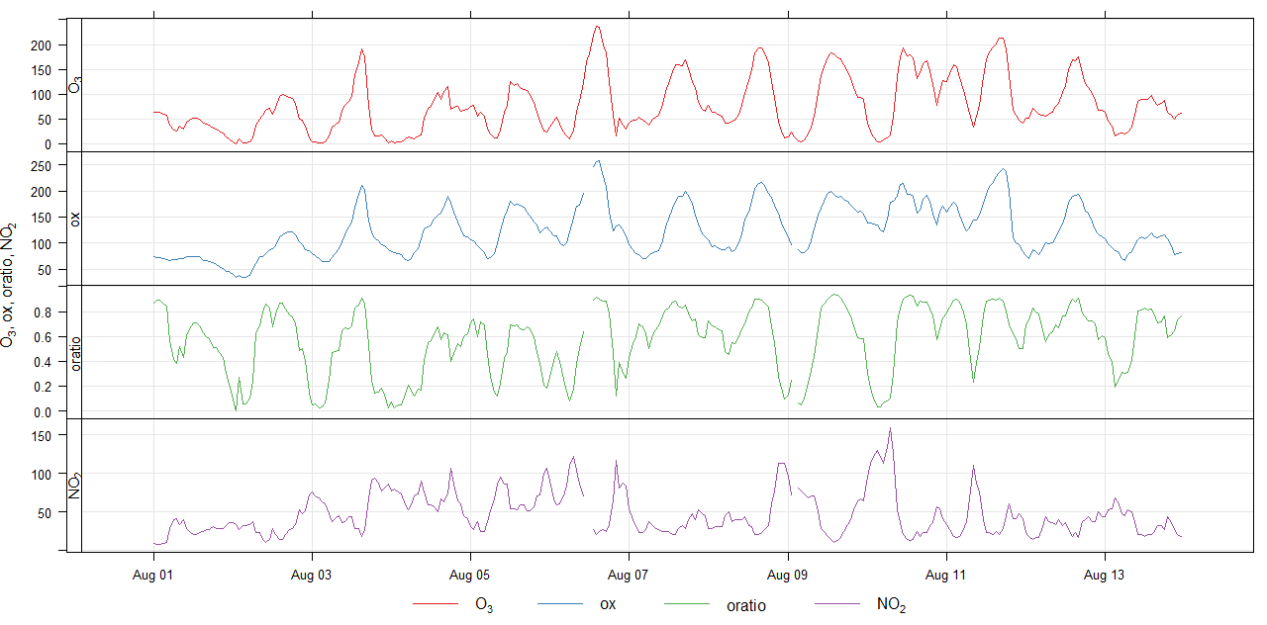

Figure S2 Scatter plots of daily maximum 1-hr and mean 24-hr concentrations of nitrogen dioxide and ozone in London between 1st January 2000 and 31st December 2005 for months December to February

- 1-hr
- 24-hr

Figure S3 Scatter plots of daily maximum 1-hr and mean 24-hr concentrations of nitrogen dioxide and ozone in London between 1st January 2000 and 31st December 2005 for months March to May

- 1-hr
- 24-hr

Figure S4 Scatter plot of daily maximum 1-hr and mean 24-hr concentrations of nitrogen dioxide and ozone in London between 1st January 2000 and 31st December 2005 for months June to August

- 1-hr
- 24-hr

Figure S5 Scatter plot of daily maximum 1-hr and mean 24-hr concentrations of nitrogen dioxide and ozone in London between 1st January 2000 and 31st December 2005 for months September to November

- 1-hr
- 24-hr

Figure S6 Percentage changes (95% confidence intervals) in mortality associated with lag 1 day measures of maximum 1-hr and mean 24-hr concentrations of ozone (O₃), nitrogen dioxide (NO₂) and combined oxidant (O_{x}) in single pollutant models and ozone and nitrogen dioxide in two-pollutant models during December to February

- Per 10 ppb

- Per interquartile range

Figure S7 Percentage changes (95% confidence intervals) in mortality associated with lag 1 day measures of maximum 1-hr and mean 24-hr concentrations of ozone (O₃), nitrogen dioxide (NO₂) and combined oxidant (O_{x}) in single pollutant models and ozone and nitrogen dioxide in two-pollutant models during March to May

- Per 10 ppb

- Per interquartile range

Figure S8 Percentage changes (95% confidence intervals) in mortality associated with lag 1 day measures of maximum 1-hr and mean 24-hr concentrations of ozone (O₃), nitrogen dioxide (NO₂) and combined oxidant (O_{x}) in single pollutant models and ozone and nitrogen dioxide in two-pollutant models during June to August

- Per 10 ppb

- Per interquartile range

Figure S9 Percentage changes (95% confidence intervals) in mortality associated with lag 1 day measures of maximum 1-hr and mean 24-hr concentrations of ozone (O₃), nitrogen dioxide (NO₂) and combined oxidant (O_{x}) in single pollutant models and ozone and nitrogen dioxide in two-pollutant models during September to November

- Per 10 ppb

- Per interquartile range

