Supplemental Material

“Application and validation of a line-source dispersion model to estimate small scale traffic-related particulate matter concentrations across the conterminous US” (by Yanosky et al.)

Geographic coordinates of two IMPROVE monitors

The geographic coordinates of two IMPROVE sites (Hains Point, Washington, DC and Lebec Valley, California) were modified because the original coordinates placed them in unrealistically high-traffic locations. Coordinates for these two sites were instead taken from air quality monitoring network plans and verified based on geocoding of the mailing addresses of these monitoring sites.

Categorization of ADMS-Roads inputs
The categories of the three meteorological parameters wind speed, sensible heat flux, and planetary boundary layer height, as well as the traffic intensity inputs, were categorized based on dividing the range of the parameter into equal intervals given a specified number of categories. To do this, we obtained the range of predicted daily meteorological covariates on a 2 km grid across the conterminous US from 1999-2011, and after removing outliers for wind speed indicative of storms or extreme weather events such as hurricanes. We then specified the number of categories for each parameter, which depended on the spread and skewness of the parameter’s distribution and how influential that parameter was on dispersion characteristics in ADMS-Roads, with more categories being assigned to more influential parameters. As a result of this process, we obtained between 8 and 19 categories for each parameter, as shown in Table 1 of the main text.
The other two ADMS-Roads inputs, surface roughness and the minimum Monin-Obhukov length, were classified into one of six categories according to guidance provided the ADMS-Roads User Guide, using the percent urban land use within 1 km from the 2001 National Land Cover Dataset to describe urban-ness (Table 1 of the main text).

Details on the processing of the traffic count data
We included A1 (primary highways with limited access), A2 (primary roads without limited access), A3 (secondary and connecting roads), A4 (local, neighborhood, and rural roads), and A6 (roads with special characteristics). A6 roads were limited to ramps, exits, and jug handles, and with respect to ADMS-Roads inputs were treated as A4 roads. We spatially averaged these raw values by road class based on a 6 km grid, using the ArcGIS “Point Statistics” tool (see Supplemental Material Figure S4).

Details on the development of the spatial smoothing GAMs of traffic intensity
We created four spatial smoothing GAMs of the traffic intensity data; one spatial smoothing GAM for each road class (A1, A2, A3, and A4/A6). The spatial smoothing GAMs were of the same form as in Equation 1, but with dimensional parameter k set to either 575, 1294, or 2,301 (these values correspond to the number of equally-spaced grid points over the conterminous US for grids with 150, 100, and 75 km cell sizes, respectively). These models provide information on how traffic intensity varied based on location, but assume it is fixed over time.

Processing of external traffic count validation data
We cleaned the Automated Traffic Recorder (ATR) and Weigh in Motion (WIM) data by first removing observations with “low” confidence in the geographic coordinates, those with missing values for traffic volume, those with missing values for functional class, and those outside conterminous US. This process resulted in 2,969 and 3,001 observations for ATR and WIM data, respectively. To match the data on road class, we used functional class to assign a US Census Feature Class Codes; a conversion table is shown in Table S2. These external validation data provided a means to determine the optimum value of k (from among the three values evaluated), for the spatial smoothing GAMs of traffic intensity, which was chosen as 2,301.

Emissions factors used in ADMS-Roads
The ADMS-Roads default PM₁₀ emission factors of 0.021, 0.016, 0.017, and 0.020 g km⁻¹ for A1, A2, A3, and A4/A6 roads, respectively, from the 2003 UK Design Manual for Roads and Bridges emission inventory for light-duty urban vehicles were used to obtain all ADMS-Roads output.

Detailed steps used to obtain ADMS-Roads output
To obtain ADMS-Roads output at prediction locations on an given day, the following steps were taken: 1) The kernel that most closely matched the dispersion and traffic intensity conditions of that location and day was identified from among the set of kernels (12,768 kernels representing differing meteorological and urbanization conditions (19*8*14*6=12,768) for each of 55 road classes (12,768*55=702,240 kernels in total). 2) A spatial join was performed using a custom Python script to identify road source points within 2 km of each prediction location (prediction locations may be irregularly spaced, not on a regular grid). 3) Spatial smoothing GAMs were used to generate the necessary meteorological and traffic intensity inputs at the prediction locations. 4) Finally, the ADMS-Roads output concentrations of the identified kernel on a given day were bi-linearly interpolated from the 2 m kernel grid (with each 10 m source point at the origin) to the prediction location in two ways: the first involved rotation of the kernel based on predicted prevailing wind direction, and is considered a “best-estimate” of ADMS-Roads output; the second was based only on the distance of the prediction point from the source, assuming the prediction point was directly downwind of the source, referred to as “worst-case downwind”. This second method results in a traffic covariate that is symmetric around the roadway and ignores wind direction; it is useful for evaluating the importance of accounting for wind direction in ADMS-Roads output. Because these calculations were performed separately for each road class, we summed ADMS-Roads output for each location and day across road classes, either across 1) A1-A3, or 2) A1, A2, A3, and A4/A6, to obtain two covariates representing near-road traffic-related PM levels.

Details on spatial covariates including county-level population density, elevation, and distance to road covariates
Characteristics of the PM monitoring sites were quantified using a GIS (ArcMap 10.1, Environmental Systems Research Institute (ESRI), Redlands, CA). The Albers Equal Area Conic USGS projection was used for all geographic data.
Spatial covariates that were evaluated in spatio-temporal models of 24-hr average PM_{2.5} EC were as follows. Data on county-level population density (in persons m⁻²) from the 2000 US Census (US Census Bureau 2013) were obtained from ESRI Data and Maps 10.1, natural log transformed, and used to develop a spatial smoothing GAM of the same form as in Equation 1, with dimensional parameter $k=I*0.9=2,798$ (where I represents the number of county centroids). Elevation data (in raster form) were obtained from the USGS National Elevation Dataset (USGS 2013), with a native resolution of approximately 30 m, and averaged using a moving window of radius 300 m using ArcGIS. Distance to nearest road values were also generated for each monitoring site for road classes A1-A4 roads using ESRI StreetMap Pro 2007 road network data. Distance to road values beyond 500 m were truncated at 500 m. As a result, this term represented only micro- to middle-scale local variability in PM levels near roadways. These values were natural-log transformed, after the addition of a constant to obtain a more uniform distribution and improve stability in the estimation of the penalized spline smooth functions, using the formula:
$Z_{i,t}=ln⁡({Z^{*}}_{i,t}-(10-min⁡({Z^{*}}_{i,t}))$ [2]
where $Z_{i.t}$ is the transformed covariate, ${Z^{*}}_{i,t}$ is the covariate on the native scale, and the constant 10 was chosen to reduce the leverage of values near zero.

Formulas for NMBF and NMEF
Formulas for the normalized mean bias factor (NMBF) and normalized mean error factor (NMEF) [Shaocai Yu, personal communication], where ${\hat{y}}_{j}$ represents model predicted values and $y_{j}$ represents observed (i.e., measured) values, for locations indexed by j, and where bars indicate mean values, were as follows:
NMBF:
For $\overline{\hat{y}}$ ≥$\overline{y}$ (i.e., over-prediction): $NMBF=(\frac{\sum_{j=1}^{N}{{\hat{y}}_{j}}}{\sum_{j=1}^{N}{y_{j}}}-1)$ [1]
For $\overline{\hat{y}}$ <$\overline{y}$ (i.e., under-prediction): $NMBF=(1-\frac{\sum_{j=1}^{N}{y_{j}}}{\sum_{j=1}^{N}{{\hat{y}}_{j}}})$ [2]
NMEF:
For $\overline{\hat{y}}$ ≥$\overline{y}$ (i.e., over-prediction): $NMEF=(\frac{\sum_{j=1}^{N}{\left|{\hat{y}}_{j}-y_{j}\right|}}{\sum_{j=1}^{N}{y_{j}}})$ [3]
For $\overline{\hat{y}}$ <$\overline{y}$ (i.e., under-prediction): $NMEF=(\frac{\sum_{j=1}^{N}{\left|{\hat{y}}_{j}-y_{j}\right|}}{\sum_{j=1}^{N}{{\hat{y}}_{j}}})$ [4]

Spatial trends in traffic intensity and performance of the two spatial averaging methods
For A1-A3 roads, Los Angeles, CA, Washington, DC, New York City, NY, Chicago, IL, Atlanta, GA, and the San Francisco Bay, CA area were evident as very high traffic intensity areas. For A4 roads, high levels of traffic intensity corresponded less well to large urban areas: Smoothed traffic intensity was high in several urban areas (e.g., Atlanta, GA), but was also high in the Adirondack region of New York, the pacific northwest, and in northern Minnesota. Elevated levels in these latter areas appear to be artificial; the result of extrapolation due to a lack of sufficiently dense traffic count data. In contrast, the kernel density within 100 km approach shows a different spatial pattern, with the highest levels in central Illinois and, low levels in northern Minnesota. Though many data points are available in Illinois, levels there are not particularly elevated. These features highlight differences in the two methods of spatial aggregation: spatial smoothing interpolates by performing a spatial average (with the bandwidth of this spatial average determined from the data (Wood 2006)). It therefore reduces the influence of extreme values, but where data are insufficiently dense will interpolate. The kernel density approach simply adds values at the locations of the data, and assumes a value of zero where no measurements are available. Therefore, it avoids extrapolation, as it tends to zero with missing data, but can be overly sensitive to extreme values. In our case, the spatial smoothing GAMs produced results more highly correlated with our external validation data.

Degrees of freedom used by the spatial terms in the spatio-temporal PM_{2.5} EC model
The distribution of the df used by the spatial terms $g_{t}\left(s_{i}\right)$ in the first stage model, Equation 4, (across 1,555 days) had 25th, 50th, and 75th percentiles of 6.8, 12.2, and 17.4 df, respectively, with mean and SD of 12.5 and 7.1, respectively. The spatial term $g_{t}\left(s_{i}\right)$in the second stage model, Equation 5, used 202.6 df.

Additional details regarding spatial patterns in PM_{2.5} EC levels in Figures 3 and 4
The year 2008 was arbitrarily chosen to illustrate model output. For Figures 3A and 3B, these near-road areas of high concentration are asymmetrical about the roadway and influenced by the prevailing wind direction. On August 4, 2008 the prevailing wind direction was out of the northwest, with higher levels to the southeast of roadways. On August 10, 2008 the prevailing wind direction was out of the south, with the increases less evident due to the generally north-south orientation of the A1 roads. Annual-average levels across 2008 in 3C also show the effect of prevailing wind direction, though this effect is much less pronounced than in the plots for specific days. Supplemental Material Figure S6 shows traffic-related PM levels from ADMS-Roads output (summed across road classes A1-A3) for the same two days in 2008 as Figure 3 and averaged across that year. Also, Supplemental Material Figure S7 shows mean traffic-related PM levels from ADMS-Roads output (summed across road classes A1-A3) across the conterminous US from 1999-2011.
In Figure 4, as expected, annual-average levels in 2008 were higher in more urbanized areas, and generally lower in areas with lesser elevation. Smaller scale patterns cannot be discerned at the 6 km spatial resolution, but are shown in Figure 3. Predicted annual-average PM_{2.5} EC levels were generally higher in the eastern US than the western. Despite this, several areas in the western US showed increased levels, perhaps due to the influence of wildfires, (e.g., low elevation areas in northwestern Nevada, southeastern Washington, and southwestern Montana). Monitoring data are sparse in these areas, which can lead to increased uncertainty in predicted levels. However, the map of spatio-temporal model predicted standard errors across the conterminous US (Supplemental Material Figure S8) shows uncertainty in predicted levels to be more affected by high concentration areas than sparse monitoring; the spatial pattern in the standard errors is broadly similar to that in predicted annual-average PM_{2.5} EC levels shown in Figure 4.

Modeling Assumptions
Our modeling approach assumes stationary and isotropic spatial variation, that covariate effects are additive, and that model residuals are independent and normally distributed, with mean zero and constant variance. As might be expected with noisy PM_{2.5} EC data (measured in ng m⁻³), some over-fitting of the spatio-temporal model was observed (Table 3; CV R² of 0.532 was lower than model R² of 0.679). This over-fitting was not largely due to the covariate selection process however, as the CV R² among the reserved data was 0.513. Model residuals were approximately normally distributed, though this distribution had long tails, and little evidence of heteroscedasticity was observed. We evaluated temporal autocorrelation in spatio-temporal model residuals on the original scale, and found evidence of only modest autocorrelation (r < 0.25 for the median across sites) at lag times several days decreasing to near zero within about 90 days. However, seasonal dependence in the residuals (at lags < 730 days) was noted at a subset of sites, primarily in the western US, largely from the IMPROVE network and with “Background” as their monitoring objective.

Table S1. Cross-validation statistics for the spatio-temporal prediction model of 24-hr average PM_{2.5} EC levels in the conterminous US for 1999-2011 across US Census Divisions, categories of urban land use, seasons, monitoring networks, and monitoring objectives.
Table S2. Assignment of the US Census Feature Class code based on the Highway Performance Monitoring System’s categories of functional class.

Figure S1. An example kernel for the following high-concentration conditions: an A1 road with traffic count of 5,775, wind speed of 0.75 m s⁻¹, surface roughness of 0.2 m, sensible heat flux of 15 W m⁻², planetary boundary layer height of 70, and a minimum Monin-Obhukov length of 10 m). A theoretical 10 m road segment placed at the origin is the source of traffic-related PM emissions. Units are μg m⁻³.
Figure S2. Roadways displayed by US Census feature class code and 10 m street points surrounding a PM_{2.5} speciation monitor near Linden, New Jersey. Zoomed out relative to Figure 1 to show 2 km circular buffer and surrounding features.
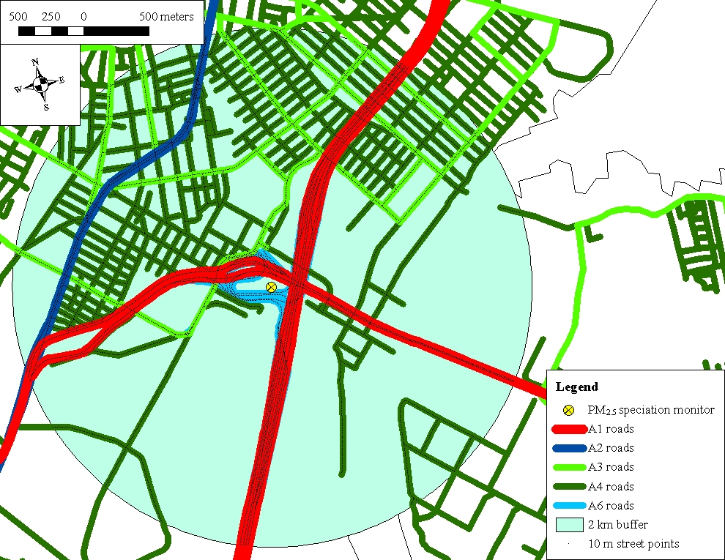

Figure S3. Seven regions of the conterminous U.S. used for development of daily spatial smoothing GAMs of MERRA meteorological data.
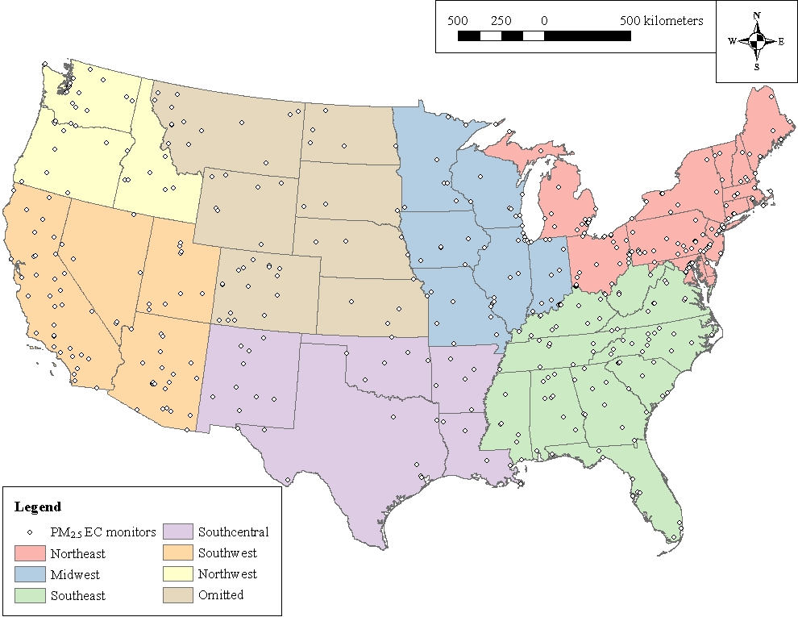
Figure S4. Maps of the traffic intensity data on a 6 km grid by road class. A1a-A1c are the mean traffic counts, spatial smoothing GAM output, and 100 km neighborhood kernel density output, respectively, for A1 roads; similarly for A2a-A2c, A3a-A3c, and A4a-A4c (the 0th to 99.5th percentiles are shown in each) for A2, A3, and A4 roads, respectively. Kernel density output is mean traffic volume per day per square kilometer.
A1a)
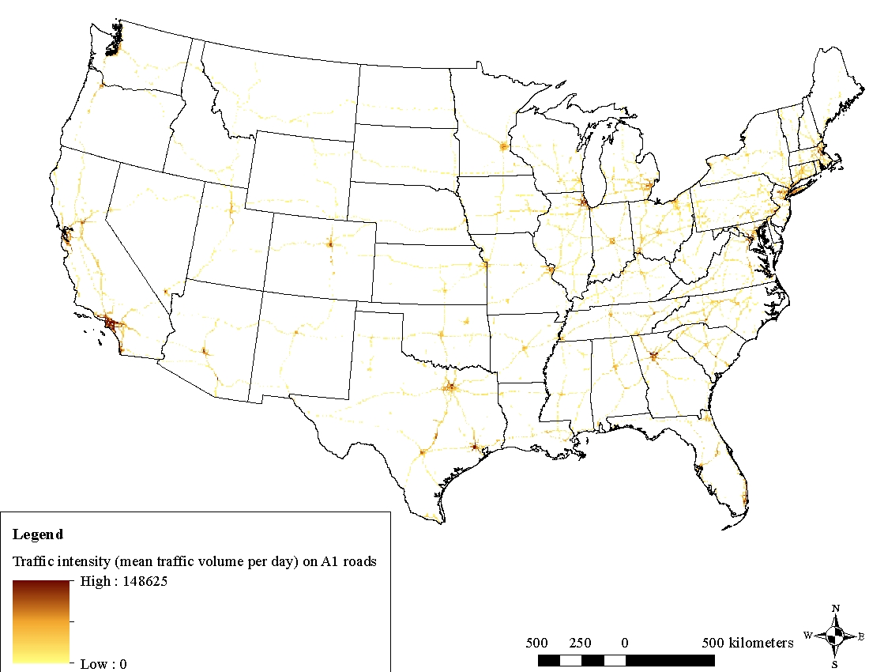
A1b)
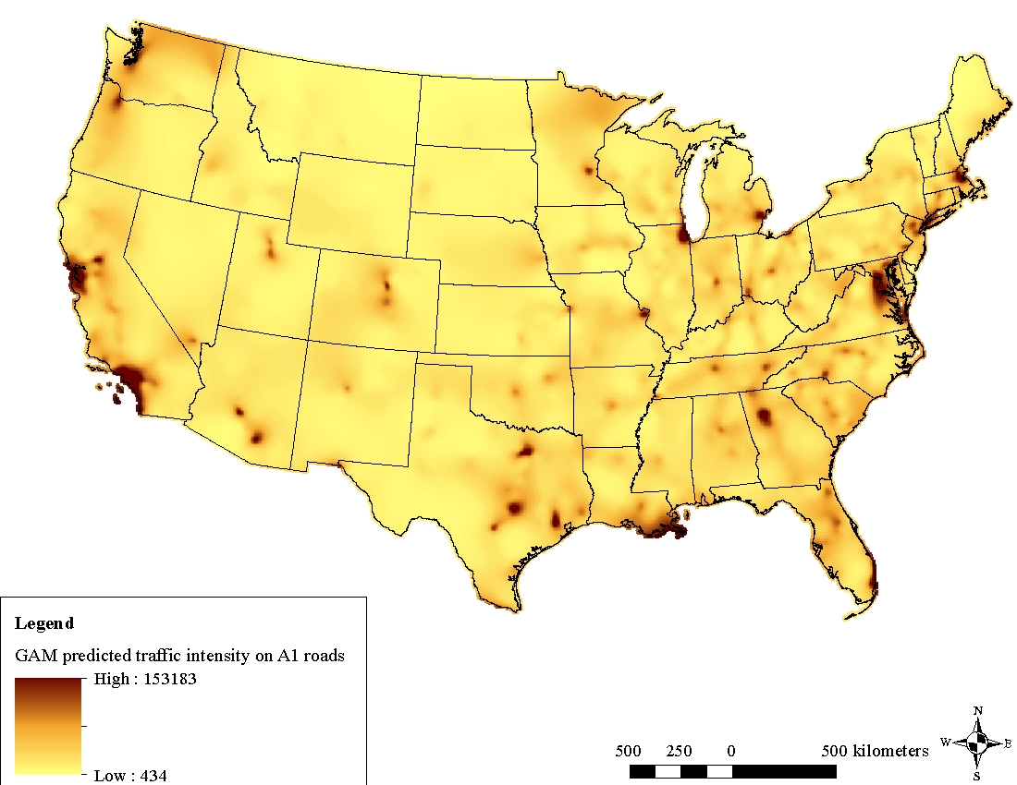
A1c)
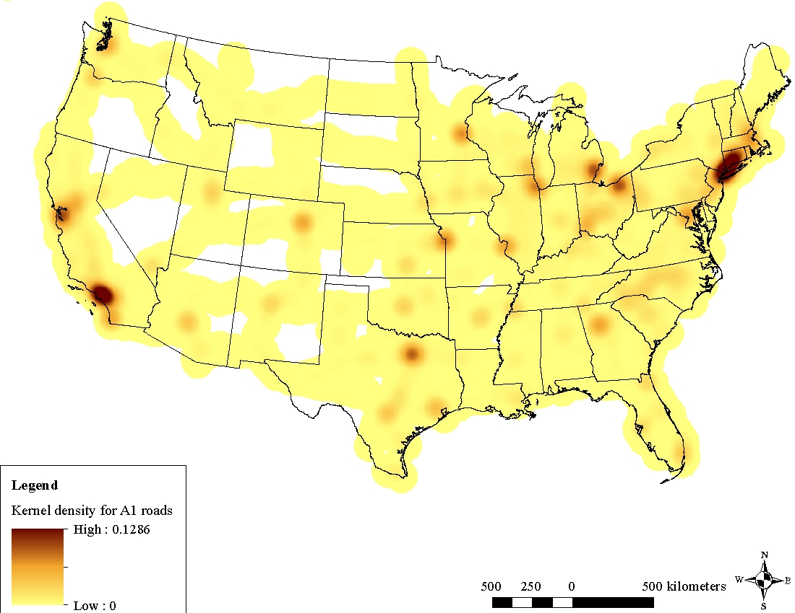
A2a)
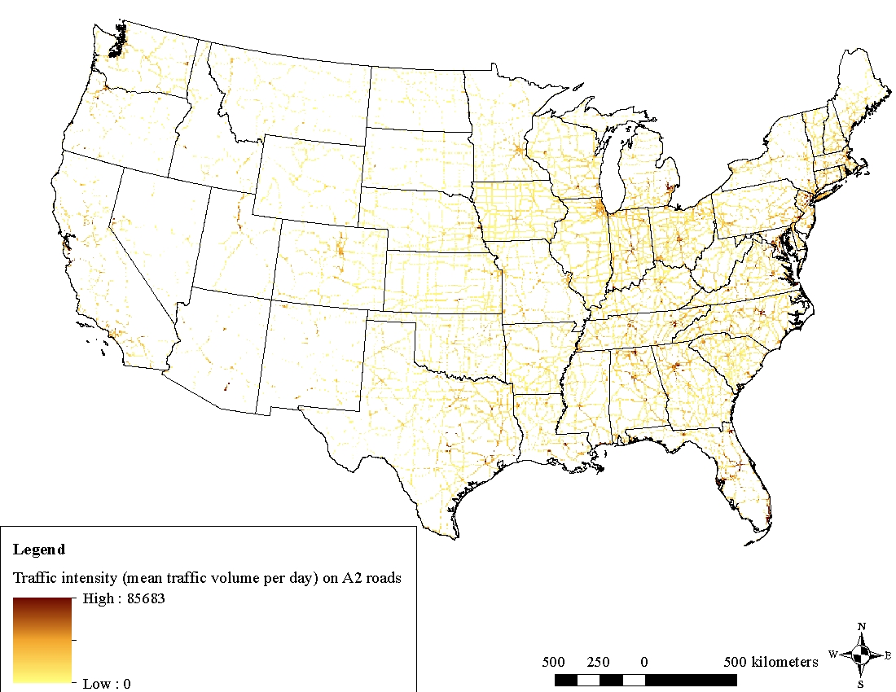
A2b)
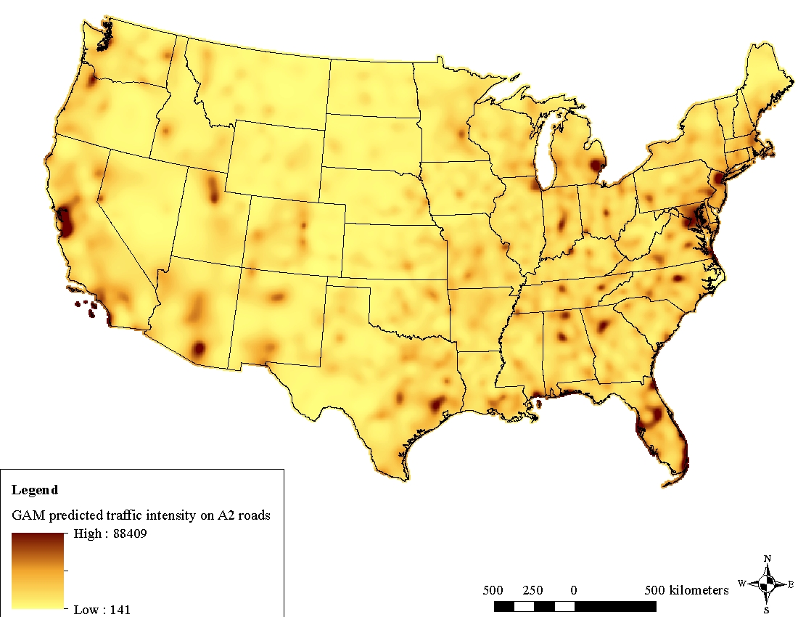
A2c)
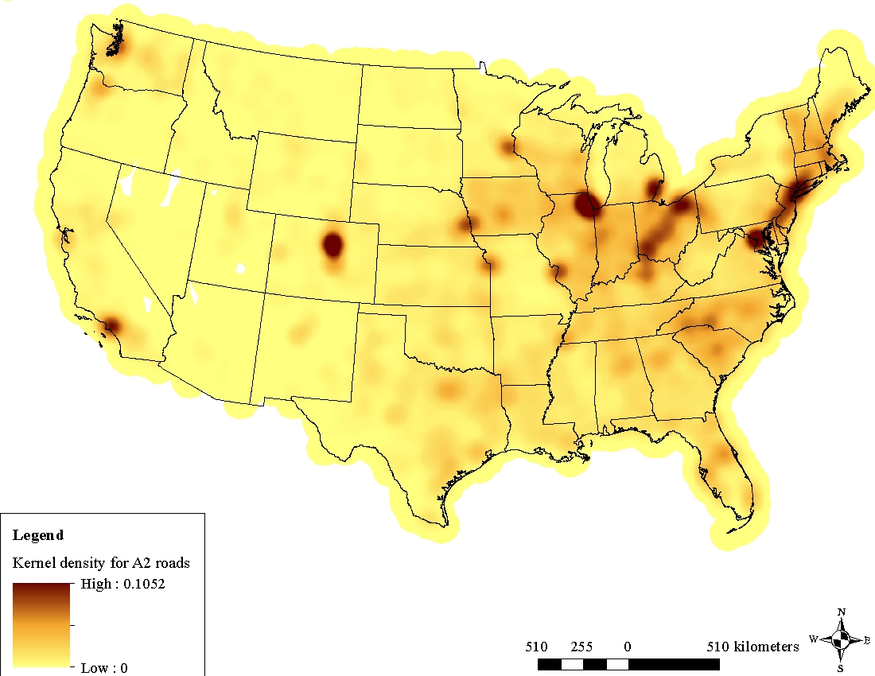
A3a)
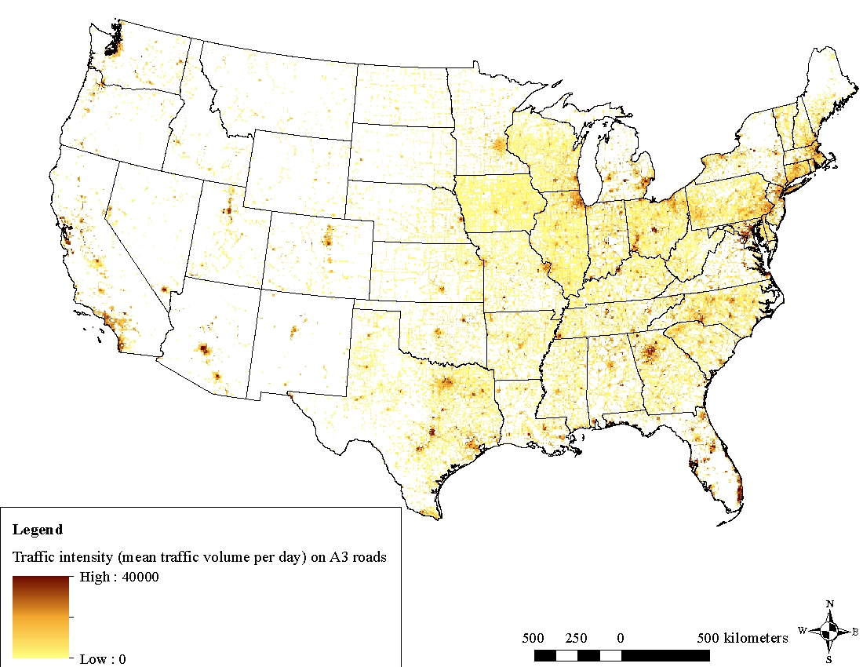
A3b)
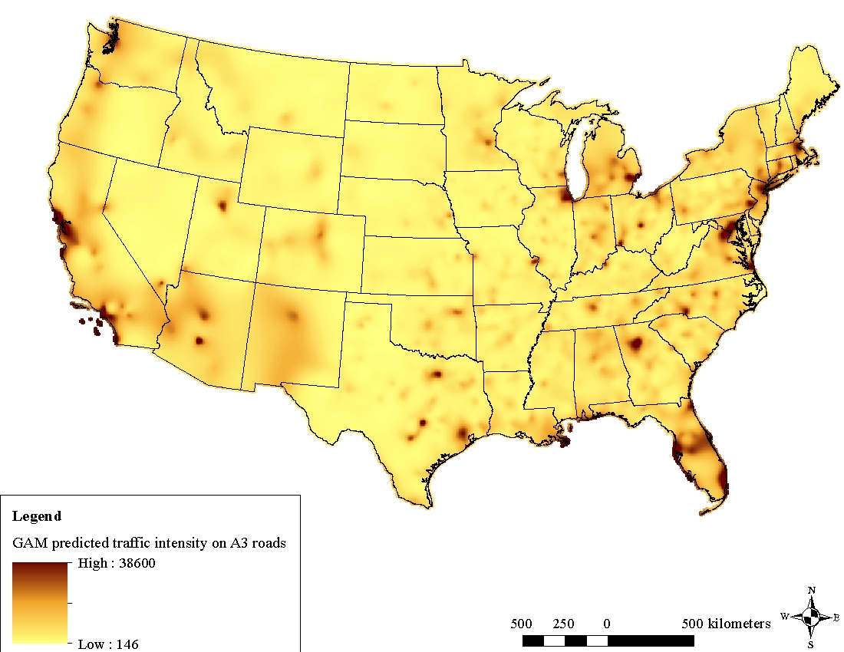
A3c)
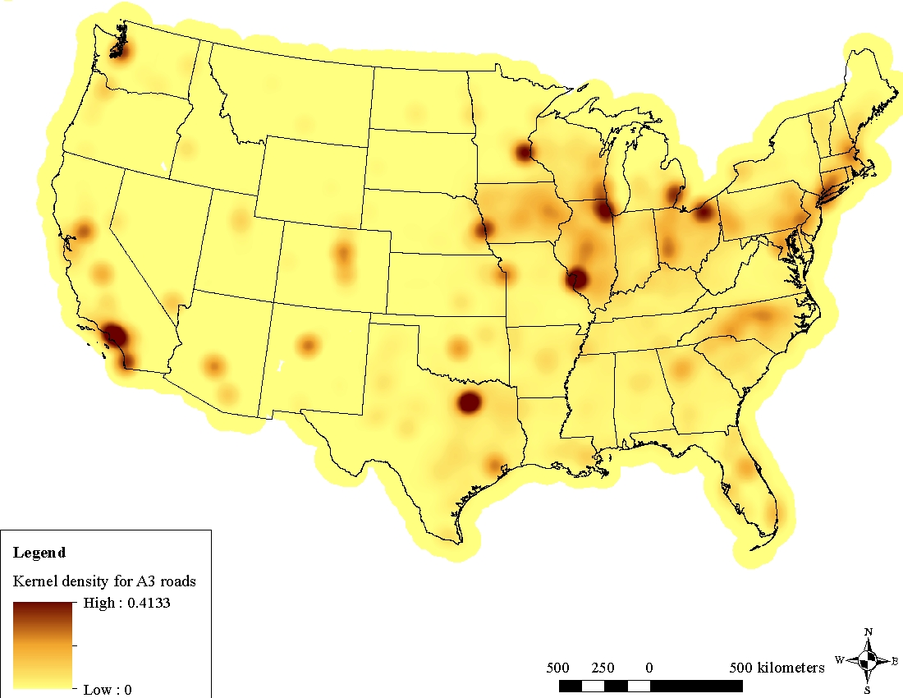
A4a)
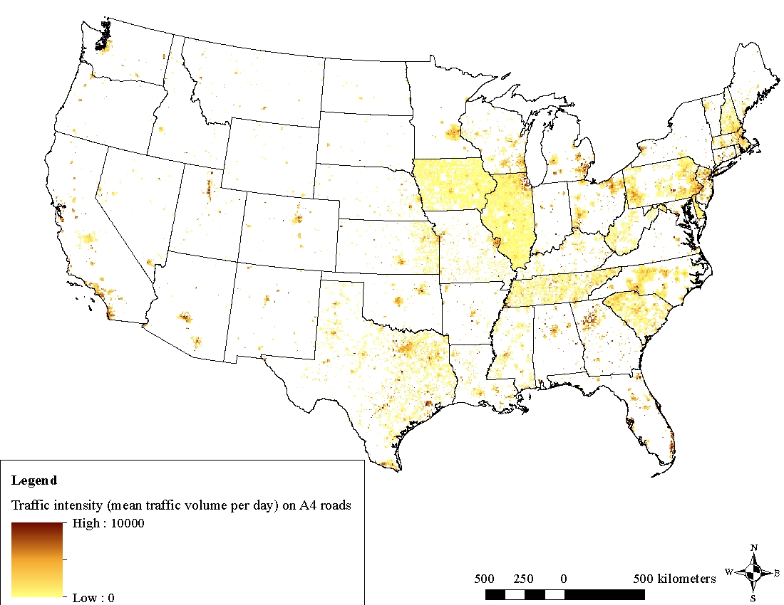
A4b)
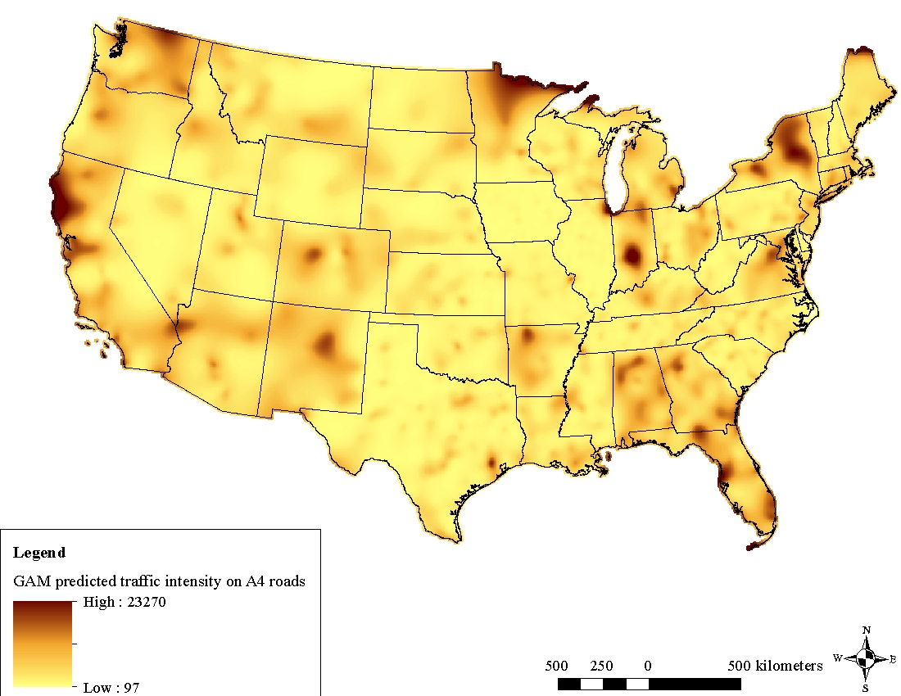
A4c)
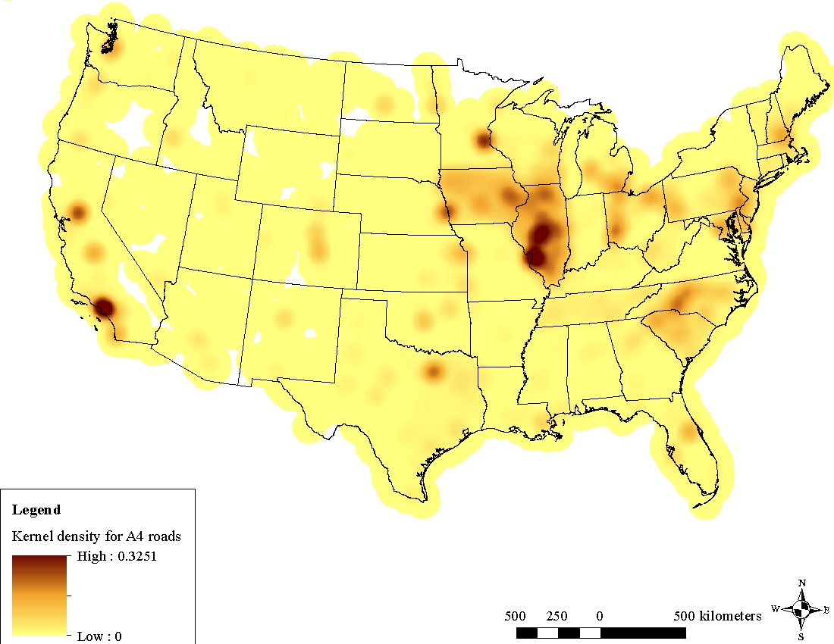

Figure S5. Plots of the smooth functions showing non-linearity in the effects of A1-A3) spatio-temporal covariates (other than ADMS-Roads output, which is shown in Figure 2), and B1-B3) GIS-based spatial covariates in the spatio-temporal model of 24-hr average PM_{2.5} EC from 1999-2011.
A1)
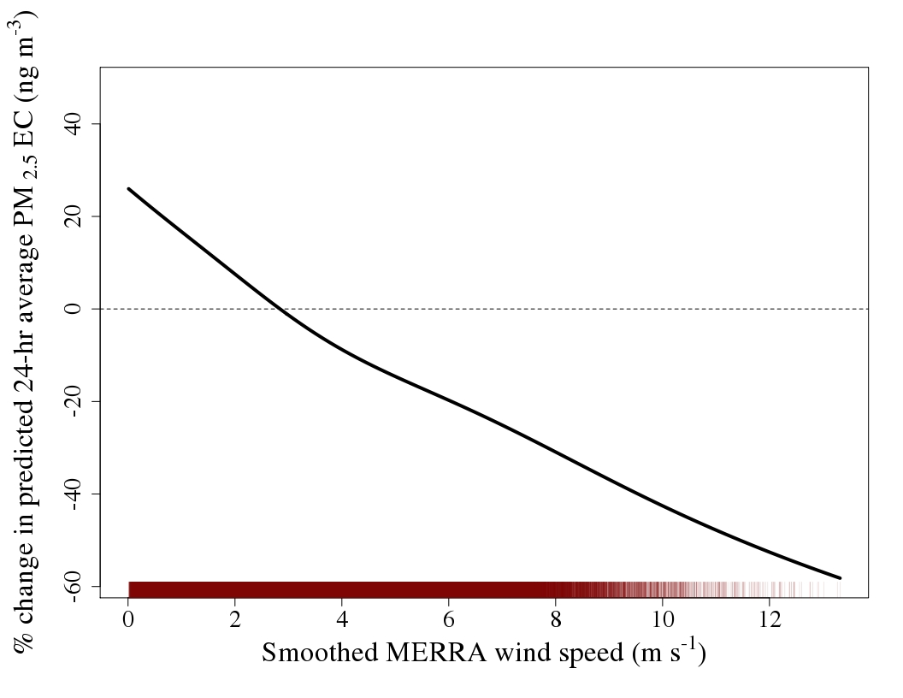
A2)
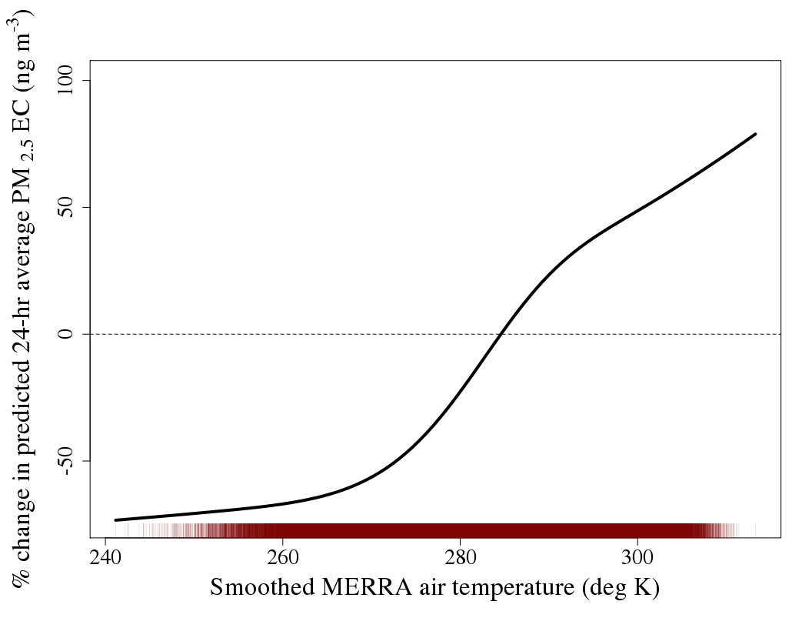

A3)
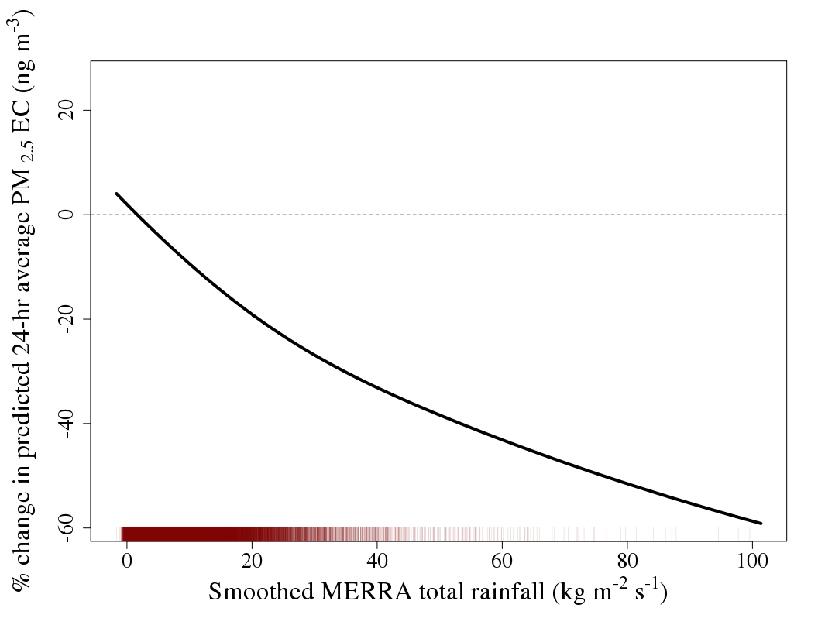
B1)
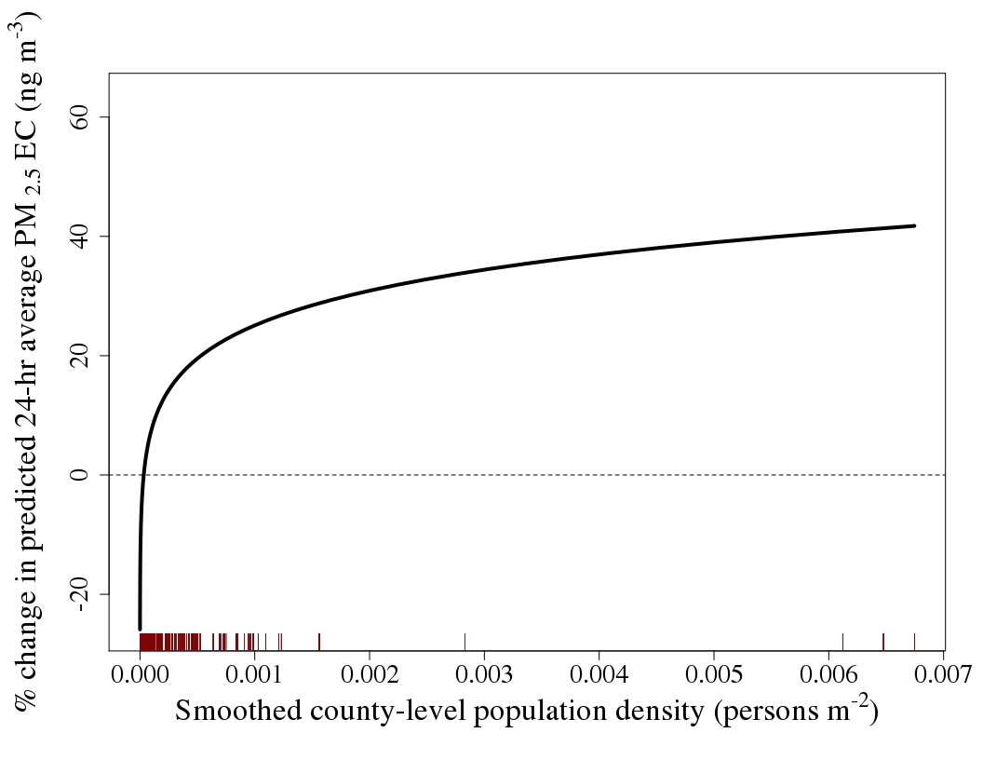
B2)
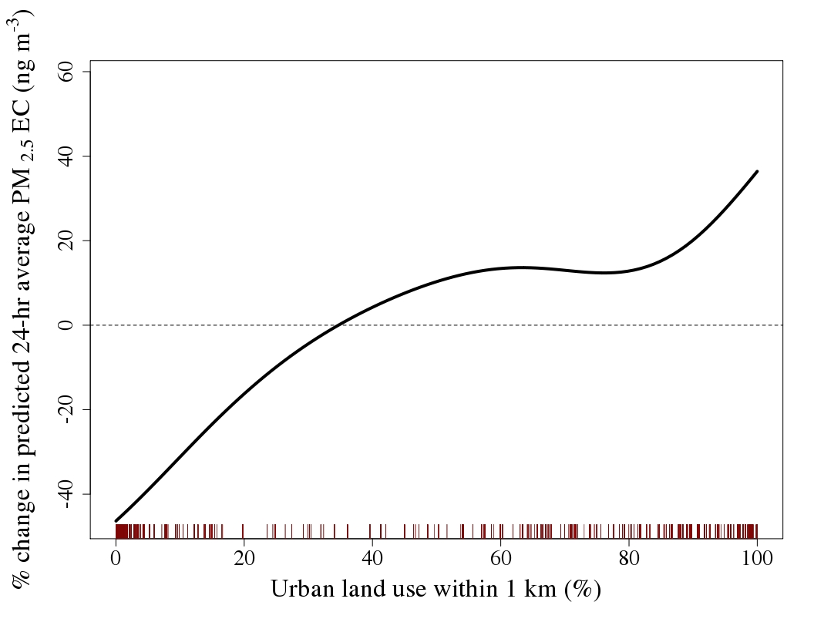
B3)
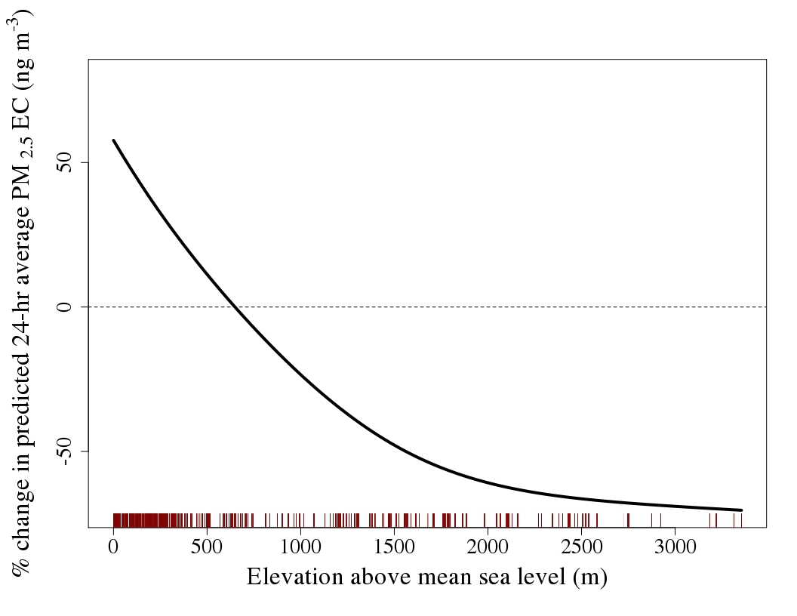
Figure S6. A) Traffic-related PM levels from ADMS-Roads output (summed across road classes A1-A3; units are ng m⁻³), in the same domain as Figure 1, for August 4, 2008. B) Same as A but showing 24-hr average levels for August 10, 2008. C) Same as A but showing annual-average levels for 2008. 0th to 90th percentiles are shown for A, B, and C. The prevailing wind direction from smoothed MERRA data is shown with black arrows in A and B.
A)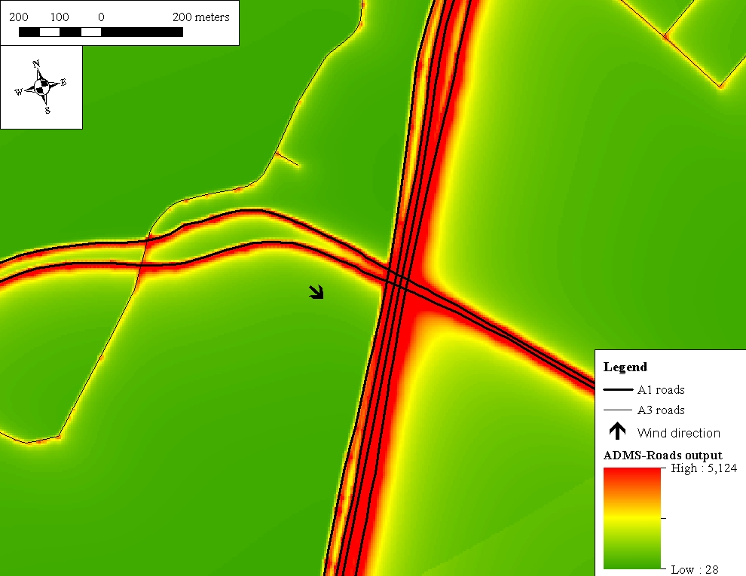

B)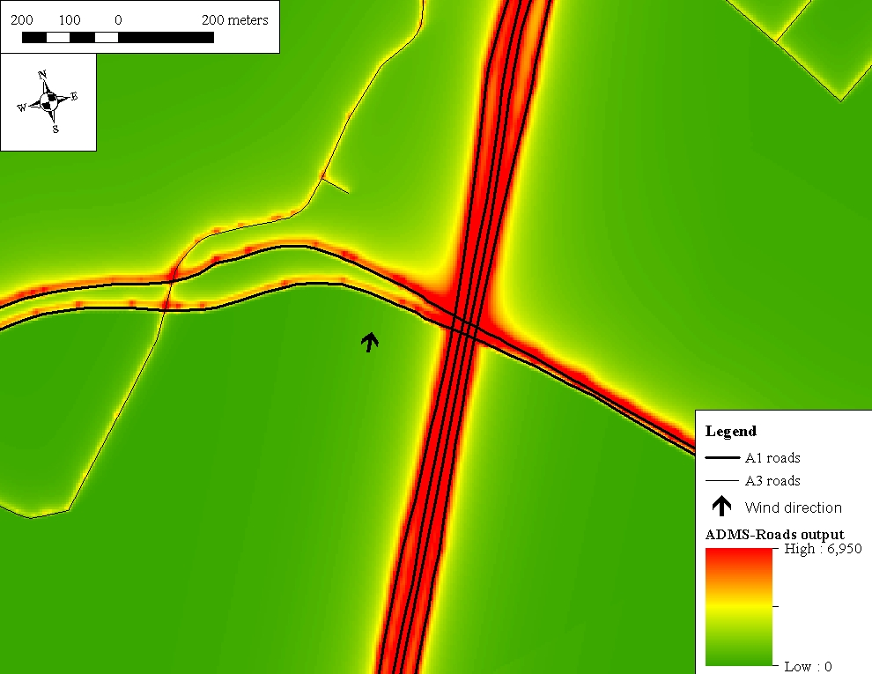

C)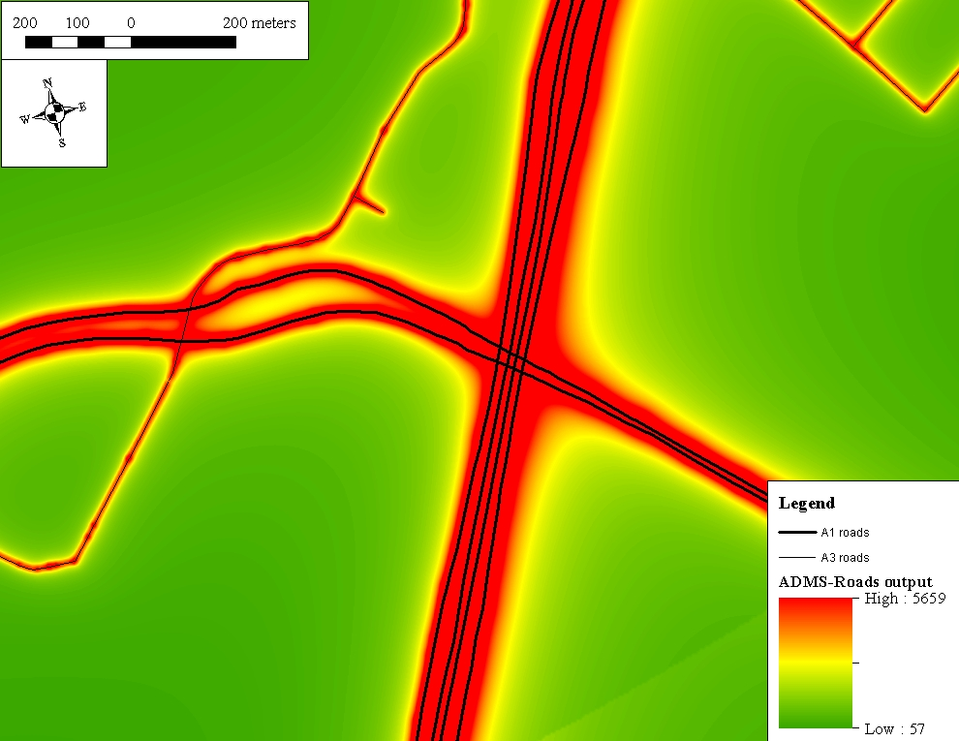

Figure S7. Mean traffic-related PM levels from ADMS-Roads output (summed across road classes A1-A3; units are ng m⁻³) in the conterminous US on a 6 km grid across all days from 1999-2011 (219,948 24-hr average cell values each day for 4,748 days). The “Histogram equalize” option in ArcGIS was used to display maximal spatial variation in the data.
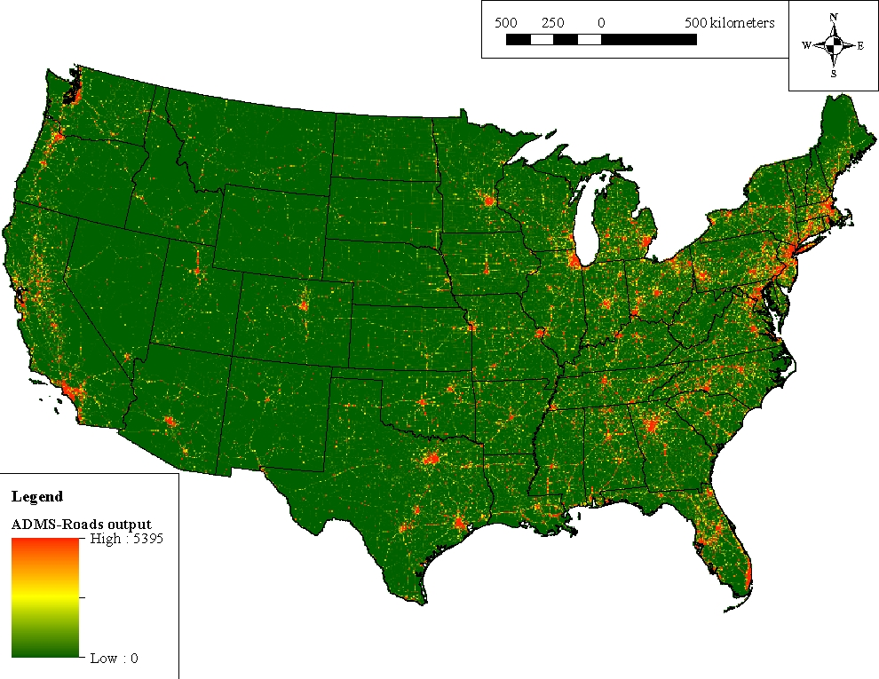

Figure S8. Mean standard errors in predicted 24-hr average PM_{2.5} EC levels (in ng m⁻³) on a 6 km grid in the conterminous US (219,948 cell values each day) averaged across 2008. 5th to 95th percentiles are shown.
