Supplementary Material to

Impact of the temporary closure of a major bridge on local air quality in two large German cities: an accountability study

Brach B, Pikmann J, Fachinger F, Kemmerer P, Büchler B, Singer S, König J, Blettner M, Drewnick F, Gianicolo E

Appendix 1. Methods

Comparison of pollution changes during the closure between the Theodor Heuss Bridge and the monitoring stations
As the pollution levels at the Theodor Heuss Bridge were found to be mainly influenced by regional developments, we carried out a comparison of the closure-dependent mean concentrations at the bridge with the surrounding monitoring stations. This evaluation should enable to assess whether the excess pollution determined during compared to outside the closure was lower at the bridge than at the monitoring stations. This could reveal an effect of closure that is potentially overlain by regional influences. Therefore, for each pollutant at each measurement point the mean values of all available monitoring stations were subtracted from the corresponding value of the Theodor Heuss Bridge. Means of these differences were calculated for the time periods before, during and after the closure (Figure s2).

Regression analysis
Multivariable linear regression models for each pollutant were set up, including wind speed and wind direction as independent variables besides the closure variable. From the 16 wind directions, west-southwest was chosen as the reference group, as this was the wind direction with the most data points. Several key assumptions of a linear regression were violated, such as linearity of the relationship, homoscedasticity, independence of residuals error terms, and normality of residuals. Thus, various transformations were tested, including log, root, quadratic and reciprocal transformations of the dependent pollutant variables and a polynomial transformation of the independent variables. Based on plots of residuals vs. fitted values, i.e. estimated responses, the log transformation (middle column of figure. s2) proved to be the most appropriate to treat the violated assumptions. The undesirable pattern of a funnel opening to the right is reduced and the scatterplot smoothing red line approaches a desired horizontal band around the zero-residual line, compared to the non-transformed models. Furthermore, the goodness of fit was improved by this transformation for most pollutants compared to the original regression models (e.g. improvement of adjusted R² for the black carbon model from 49% to 63%), but not for the particle number, NO₂ and ozone (Table s1). NO and ozone data contained some negative or 0-values due to noise of the measuring device, which could by its nature not be log-transformed. Thus, these values were excluded, and the log-transformation was applied to the remaining values.
In addition to the transformation of the dependent variable, a restricted cubic spline transformation was performed for the only interval-scaled independent variable wind speed. Restricted cubic splines can be used to model complex, nonlinear relationships between a continuous variable and an outcome and thus have the potential to enhance the present models. Splines are functions composed piecewise of polynomials. The range of values of the independent variable is divided into areas separated by nodes, giving the curves between the nodes a smooth and continuous progression. In addition, the individual curves merge smoothly into each other in the nodes (Croxford 2016). When setting up a spline function it is important to consider the location and even more the number of nodes. According to Stone (Stone 1986), five nodes are usually sufficient in practice. Their position is often determined by the quantiles of the variables, whereby Harrell (Harrell Jr 2001) proposes the following quantiles for five nodes, which were also used for the wind speed variable in the present regression model: 0.05, 0.275, 0.5, 0.725, 0.95.
The addition of the spline transformation to the log-transformed models led to a further increase in adjusted R² (Table s1) and, in sum, to further improvements in the assumptions of linearity, homoscedasticity and conditional expected value, as can be seen in the plots of residuals vs. fitted values (right column of figure s3). By adding the spline transformation, the residuals for most pollutants did not show any pattern anymore and are uniformly distributed around the zero-residual line. The scatterplot smoothing red line approaches a horizontal band even more than in the only log-transformed models. However, the models still deviate from a normal distribution, despite improvements, as can be seen in the Normal Q-Q plots (Figure s4). Furthermore, there is evidence for autocorrelation still after the transformations. While the p-Value of the Durbin-Watson test no longer point to autocorrelation for the transformed models, the d-statistic still indicates positive autocorrelation for all pollutants (Table s2). Since time series of values are involved, a violation of this assumption has been expected. Autocorrelation might point to unaccounted variables with a temporal trend or seasonal variations and leads to loss of information and is thus a limitation of our model (Fahrmeir et al. 2007).
The combined log-spline-transformations for NO and ozone, the two pollutants with missing data (see above), appeared less appropriate than for the other pollutants, which is particularly true for ozone. Ozone is in addition the only pollutant for which the goodness of fit dropped sharply instead of increasing. Furthermore, the amount of missing values is unequal during and outside the closure for both pollutants (29% vs. 23% for NO and 9% vs. 17% for ozone), which offers potential for biased results. Consequently, the model for ozone was not evaluated. The findings of the regression for NO must be interpreted with caution.

Appendix 2. Results
Comparability of the periods during and outside the closure (Table s5)
Solar radiation (−31%; percentages not reported in table), wind speed (−24%) and temperature (−12%) were on average lower during the closure compared to outside, whereas there was more rain (+37.5%). At the end of the closure as well as some days after the reopening there was heavy rainfall in Germany and also in Mainz and Wiesbaden leading to significant floods. There was less wind from the west during the closure, but more east and south wind. During the closure there were also more measurements on Sundays (15.5% vs. 11.6%), when car traffic is usually lower. The first four days of the winter school holidays in Rhineland-Palatinate fell in the period after the closure.
Influence of wind speed on the pollutant concentrations (Figure s5)
In an additional attempt to investigate the influence of meteorological conditions on measured pollutant concentrations, the polar graphs were extended to also include the variable wind speed. This approach did not produce major deviations from the patterns described in the main article. At low wind speeds (lower tertile), at which a stronger influence of local emissions is to be expected, the lower concentrations during the closure with wind from west to east-northeast is largely confirmed. Statements about the pollutant conditions during and outside the closure at high wind speeds (upper tertile) could not be made, as there were hardly any data points for these wind speeds from most of the mentioned wind directions.

Appendix 3. Tables and figures

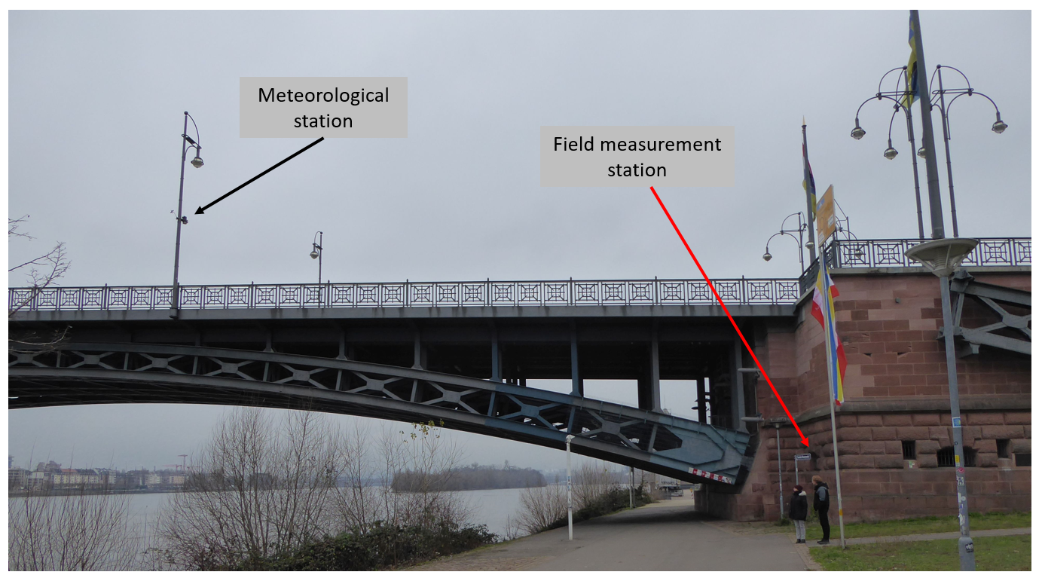

Figure s1: Photo of the measurement location in relation to the Theodor Heuss Bridge (i.e. the bridgehead at the easterly end of the bridge) and adjacent roads.

Table s1: Mean pollutant concentrations at the Theodor Heuss Bridge and across all monitoring stations as well as absolute and relative differences before, during, and after the closure. The differences are calculated with respect to the average of the monitoring station concentrations.

Pollutant | Average Concentration at Theodor Heuss Bridge |  |  | Average Concentration of all Monitoring Sites |  |  | Absolute Difference |  |  | Relative Difference
 | before | during | after | before | during | after | before | during | after | before | during | after
BC /  µg m⁻³ | 0.90 | 0.92 | 0.71 | 1.67 | 1.47 | 1.30 | -0.77 | -0.55 | -0.59 | -46% | -37% | -45%
NO /  µg m⁻³ | 10.6 | 14.6 | 11.5 | 25.9 | 27.1 | 21.8 | -15.3 | -12.5 | -10.3 | -59% | -46% | -47%
NO₂ /  µg m⁻³ | 31.4 | 32.7 | 33.4 | 33.3 | 30.3 | 28.3 | -1.9 | 2.4 | 5.1 | -6% | +8% | +18%
PM_{2.5} /  µg m⁻³ | 10.2 | 11.8 | 8.7 | 9.1 | 11.8 | 8.7 | 1.1 | 0.02 | 0.02 | +12% | +0.2% | +0.2%
PM₁₀ /  µg m⁻³ | 14.7 | 19.1 | 14.9 | 14.5 | 18.6 | 15.2 | 0.21 | 0.51 | -0.29 | +1.4% | +2.7% | -2.0%

The comparison between pollutant concentrations measured at the Theodor Heuss Bridge and at the air quality monitoring stations showed very similar levels for those pollutants which were more regionally distributed like NO₂, PM_{2.5}, and PM₁₀. For pollutants which were dominated by very local traffic sources like BC and NO, the concentrations measured at the bridge site were much smaller than those measured at the monitoring sites. This is due to the fact that some of the monitoring sites included in this comparison are traffic sites, located very close to major roads (see also Figure s8).
Concentrations measured at traffic sites are extraordinarily affected by the prevailing wind direction during an averaging interval. Therefore, the differences observed between the two sampling sites for pollutants affected by local traffic emissions (i.e. BC and NO) show a large variability between the different sampling intervals, which is mostly the result of different meteorological conditions during the respective intervals.
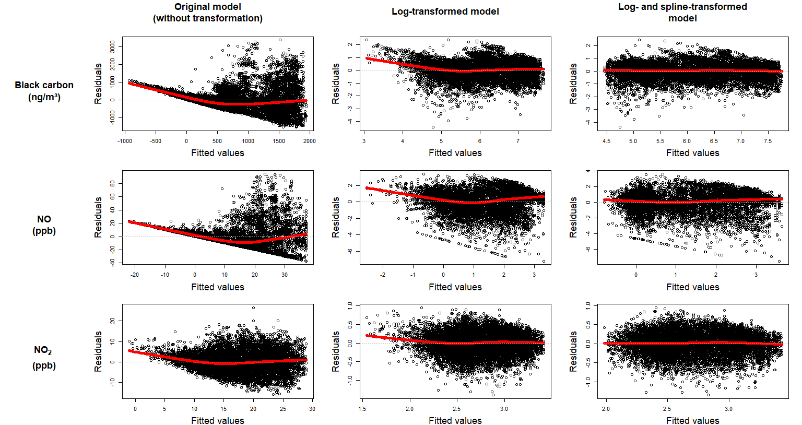
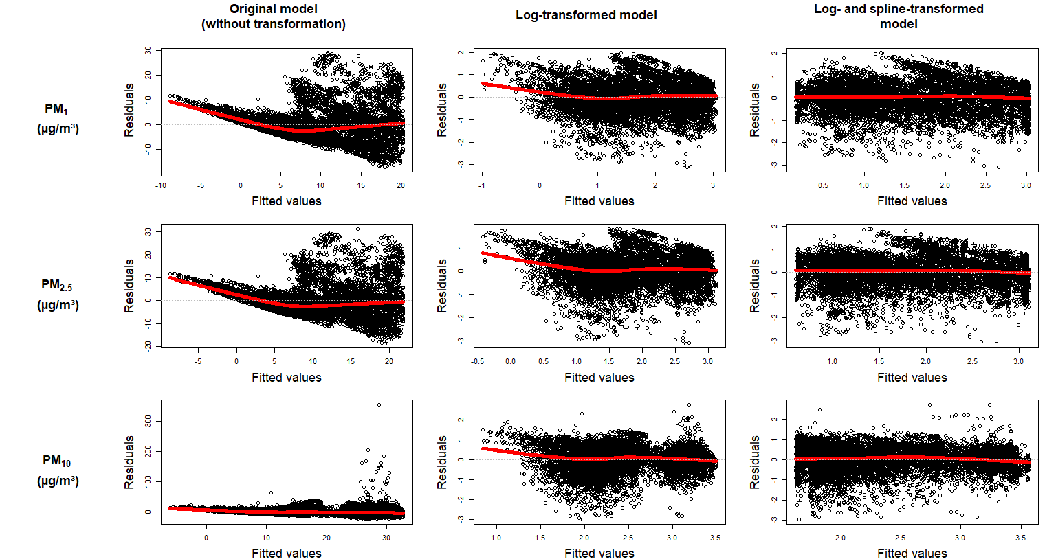
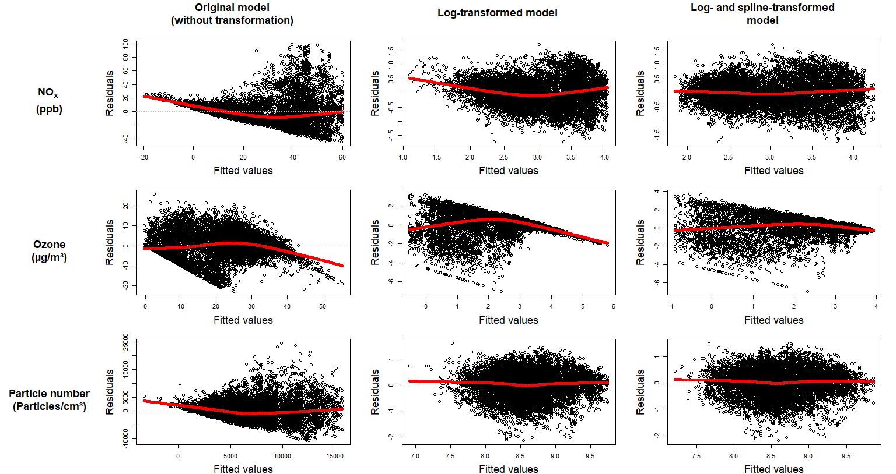

Figure s3: “Residuals vs. fitted” plots for several pollutants and different multiple regression models: The original untransformed models, the log-transformed models, and the final log- and spline-transformed models.
Table s2: Adjusted R² for several regression models.
Pollutant | Univariate regression of Pollutant concentrations on bridge closure status | Multiple regression without transformation | Multiple regression with log-transformation | Multiple regression with log- and spline-transformation
Black carbon | 0.01 | 0.49 | 0.63 | 0.67
NO | 0.00 | 0.30 | 0.34 | 0.39
NO₂ | 0.00 | 0.56 | 0.56 | 0.58
NO_{x} | 0.00 | 0.42 | 0.56 | 0.59
O₃ | 0.00 | 0.70 | 0.50 | 0.58
Particle number | 0.02 | 0.43 | 0.42 | 0.42
PM₁ | 0.01 | 0.47 | 0.58 | 0.62
PM_{2.5} | 0.01 | 0.47 | 0.56 | 0.60
PM₁₀ | 0.01 | 0.35 | 0.43 | 0.47

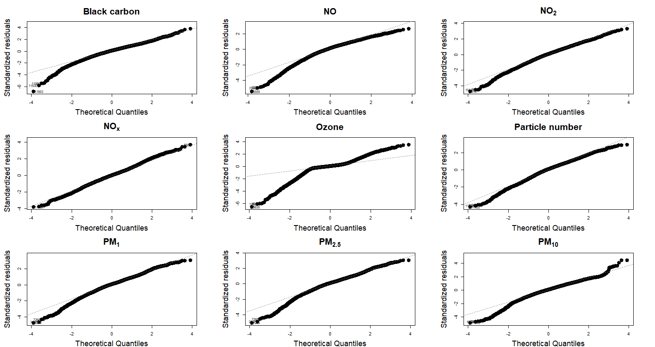

Figure s4: Normal Q-Q plots of all pollutants for the log- and spline-transformed multiple regression models.

Table s3: Durbin-Watson test for first-order autocorrelation of the log- and spline-transformed multiple regression models.¹
Pollutant | Original model |  | Log- and spline-  transformed model
Pollutant | d | p-value | d | p-value
Black carbon | 0.11 | <0.001 | 0.22 | 0.76
NO | 0.11 | <0.001 | 0.79 | 0.76
NO₂ | 0.31 | <0.001 | 0.44 | 0.76
NO_{x} | 0.13 | <0.001 | 0.35 | 0.76
Ozone | 0.26 | <0.001 | 0.28 | 0.76
Particle number | 0.18 | <0.001 | 0.18 | 0.76
PM₁ | 0.08 | <0.001 | 0.13 | 0.76
PM_{2.5} | 0.08 | <0.001 | 0.11 | 0.76
PM₁₀ | 0.27 | <0.001 | 0.12 | 0.76

¹ d of 2 indicates no autocorrelation, whereas d of 0 and 4 indicate perfect positive and perfect negative autocorrelation, respectively. For small p-values (<0.05), the null hypothesis of no autocorrelation is rejected.

Table s4: Comparison of meteorological and time-related factors at the Theodor Heuss Bridge during and outside its closure.
Variable | During closure | Out of closure
 | Arithmetic mean (95% CI)
Wind speed (m/s) | 2.24 (2.20 - 2.28) | 2.94 (2.88 - 3.01)
Temperature (°C) | 5.55 (5.45 - 5.64) | 6.32 (6.22 - 6.42)
Humidity (%) | 72.6 (72.3 - 72.8) | 66.7 (66.3 - 67.0)
Rain (mm) per day | 0.22 (0.02 - 0.43) | 0.16 (-0.04 - 0.36)
Solar radiation (W/m²) per hour | 280 (236 - 323) | 406 (339 - 473)
Wind direction | Frequency (%)
North | 9.7 | 9.9
East | 18.9 | 14.8
South | 42.4 | 37.3
West | 28.9 | 38.1
---------------------------------------------------------------------------------------
Weekdays | Frequency (%)
Monday – Friday | 72.2 | 73.1
Saturday | 12.4 | 15.4
Sunday | 15.5 | 11.6
School holidays | 0 | 18
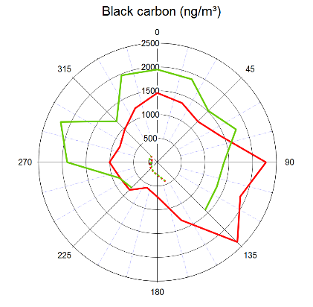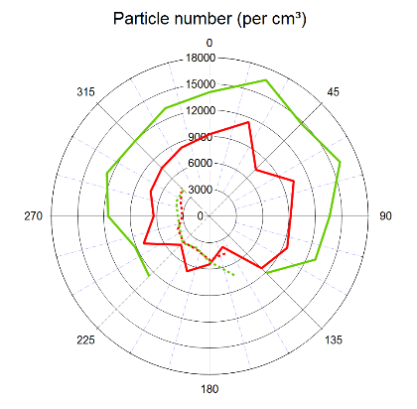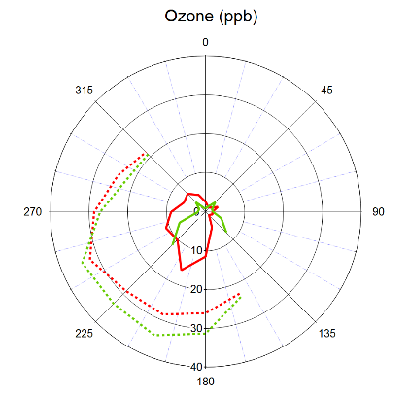
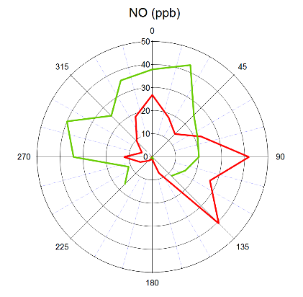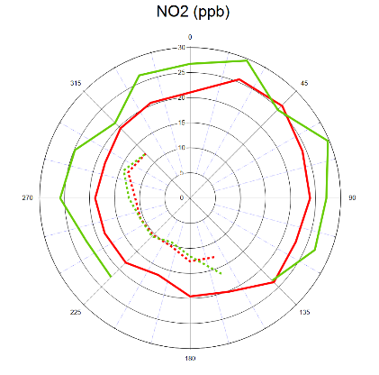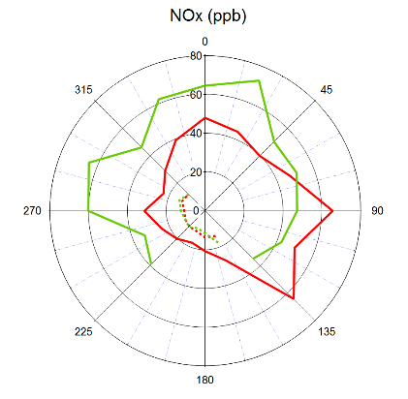
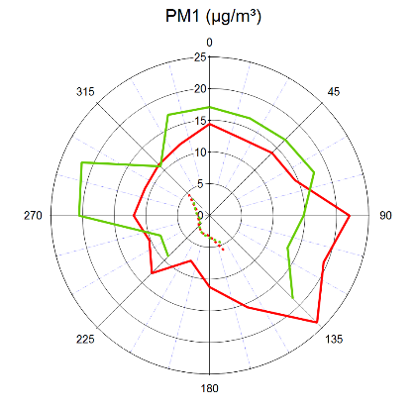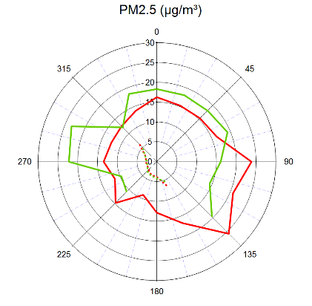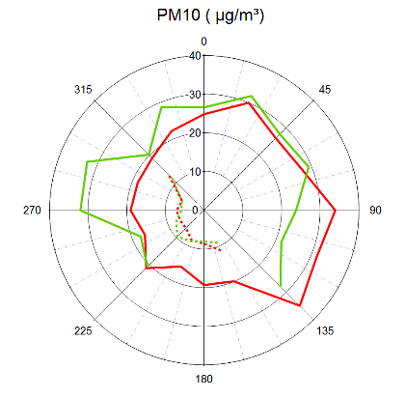
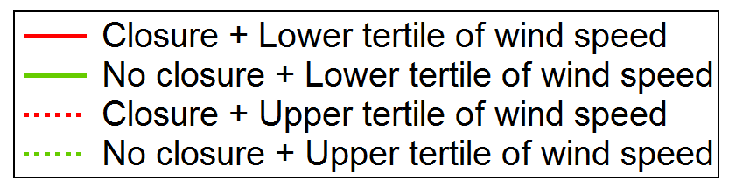

Figure s5: Mean pollutant concentrations at the Theodor Heuss Bridge depending on wind direction and wind speed during and outside the bridge closure.
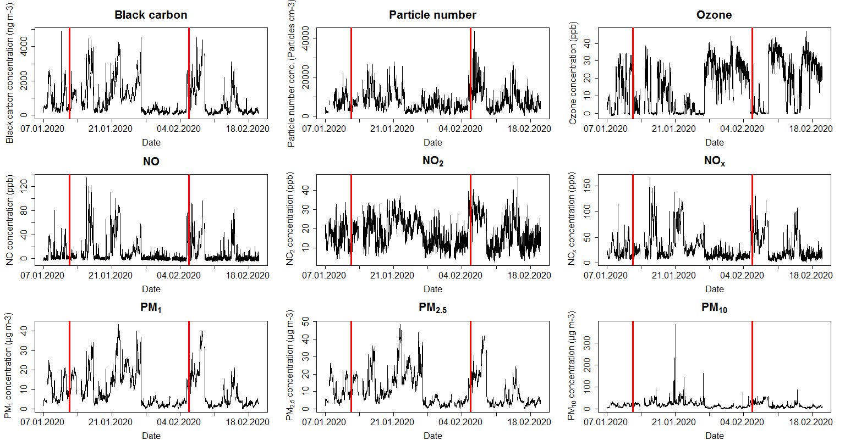

Figure s6: 1-hour Concentration time series (7th January 2020 - 20th February 2020) of all measured pollutants at the Theodor Heuss Bridge. The vertical red lines indicate the beginning and the end of the closure period.

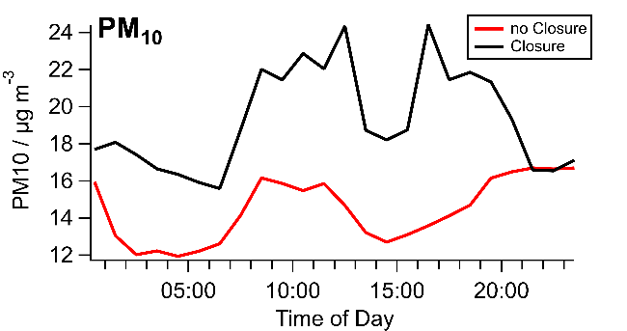
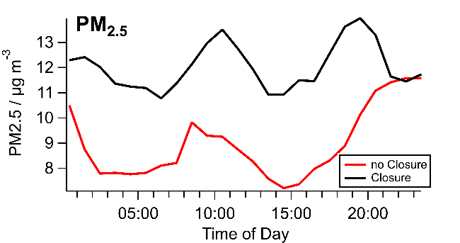
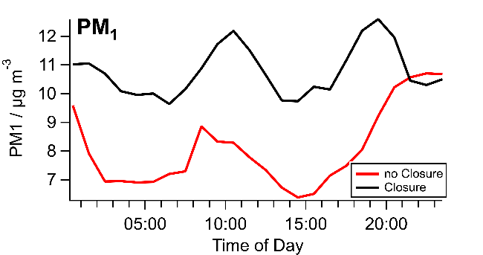
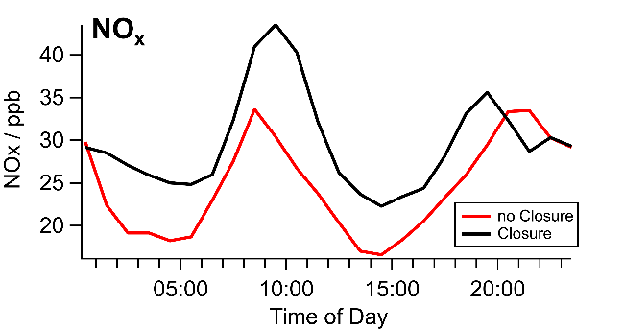
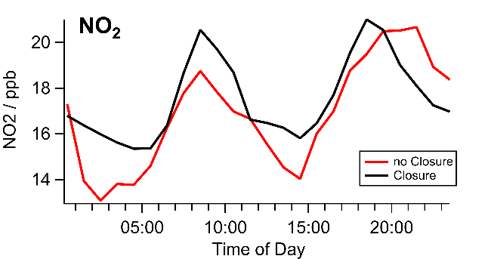
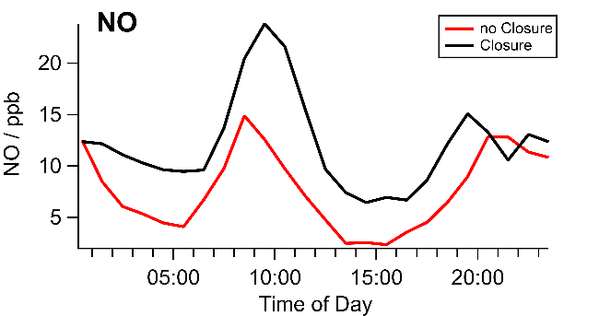
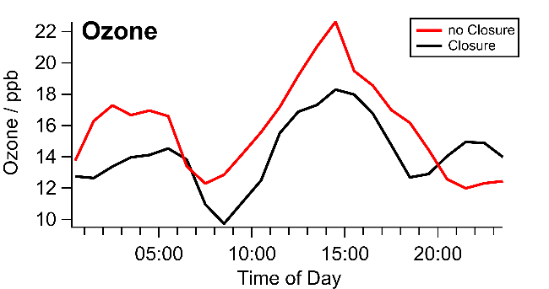
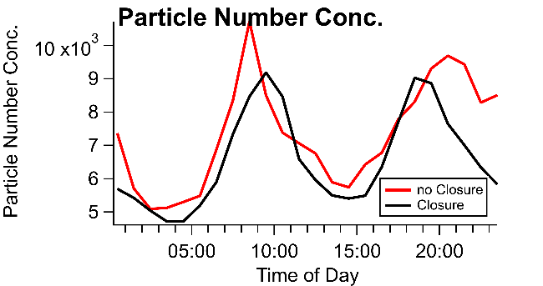
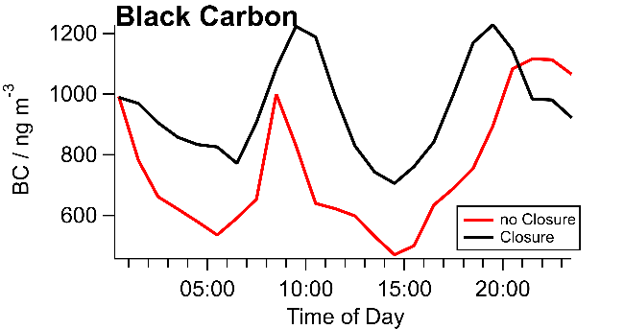

Figure s7: Hourly concentration profiles for individual pollutants, separated for measurements during (black) and outside (red) the bridge closure, respectively. The profiles for the measurements outside the closure were calculated as the mean of the average measured before and the one measured after the closure.
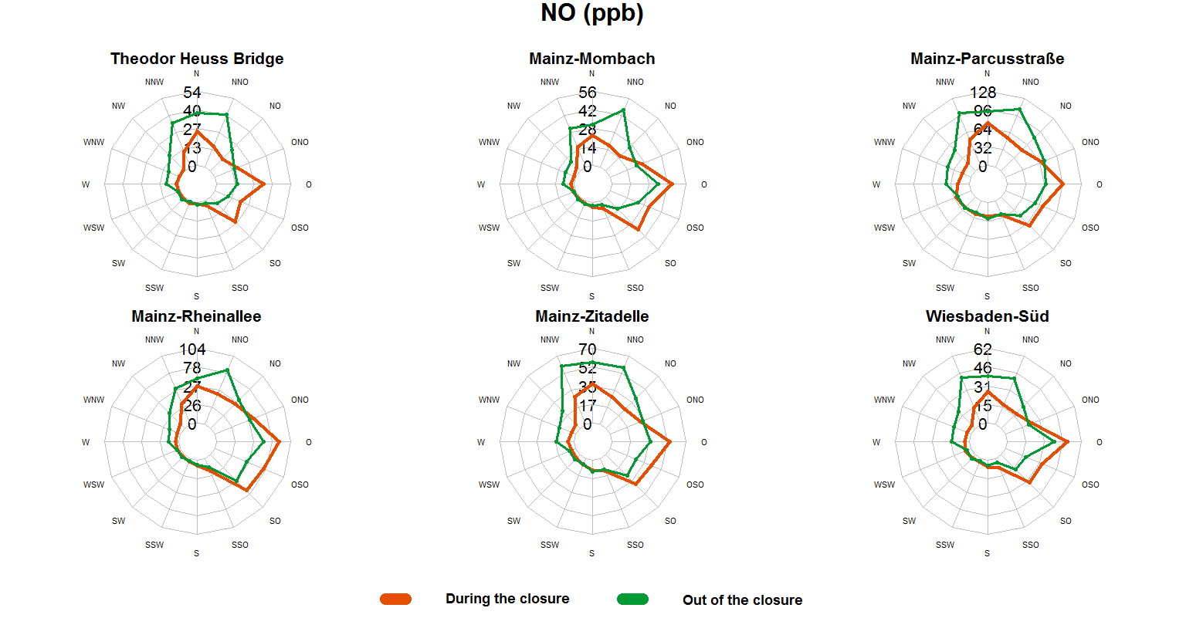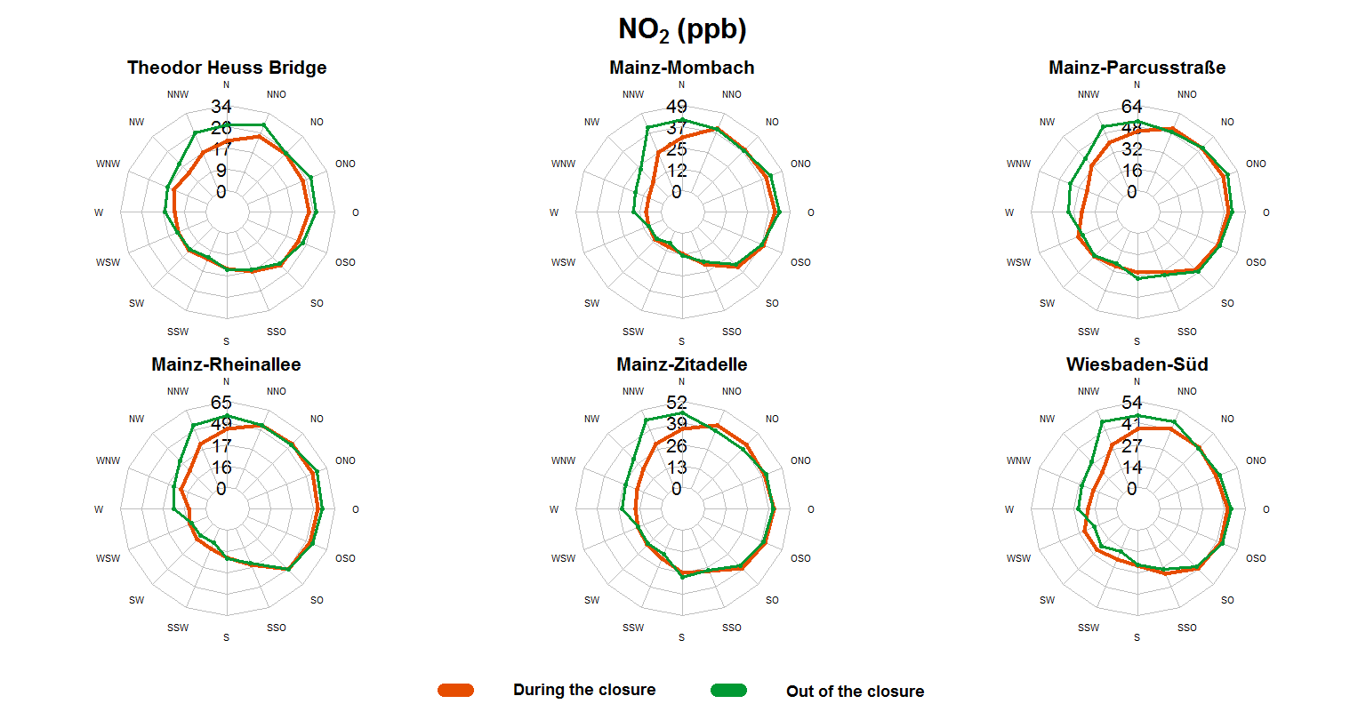

Figure s8: Mean concentration of pollutants not covered in figure 3 separated by wind direction at the Theodor Heuss Bridge and the monitoring stations during (red traces) and out of (green traces) the closure period.

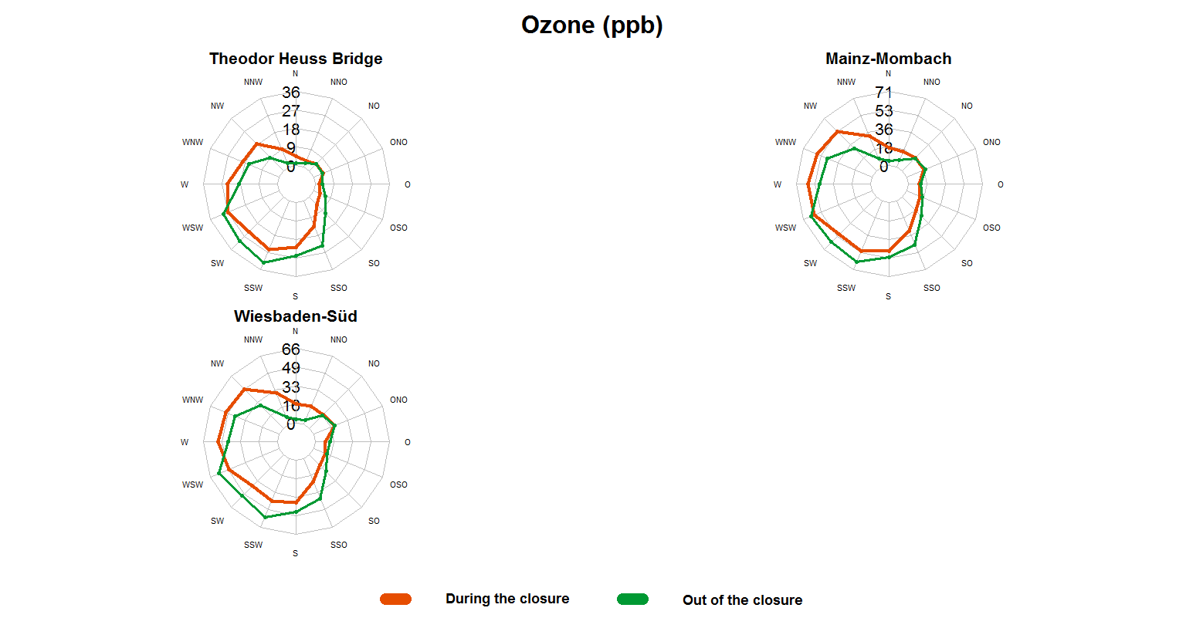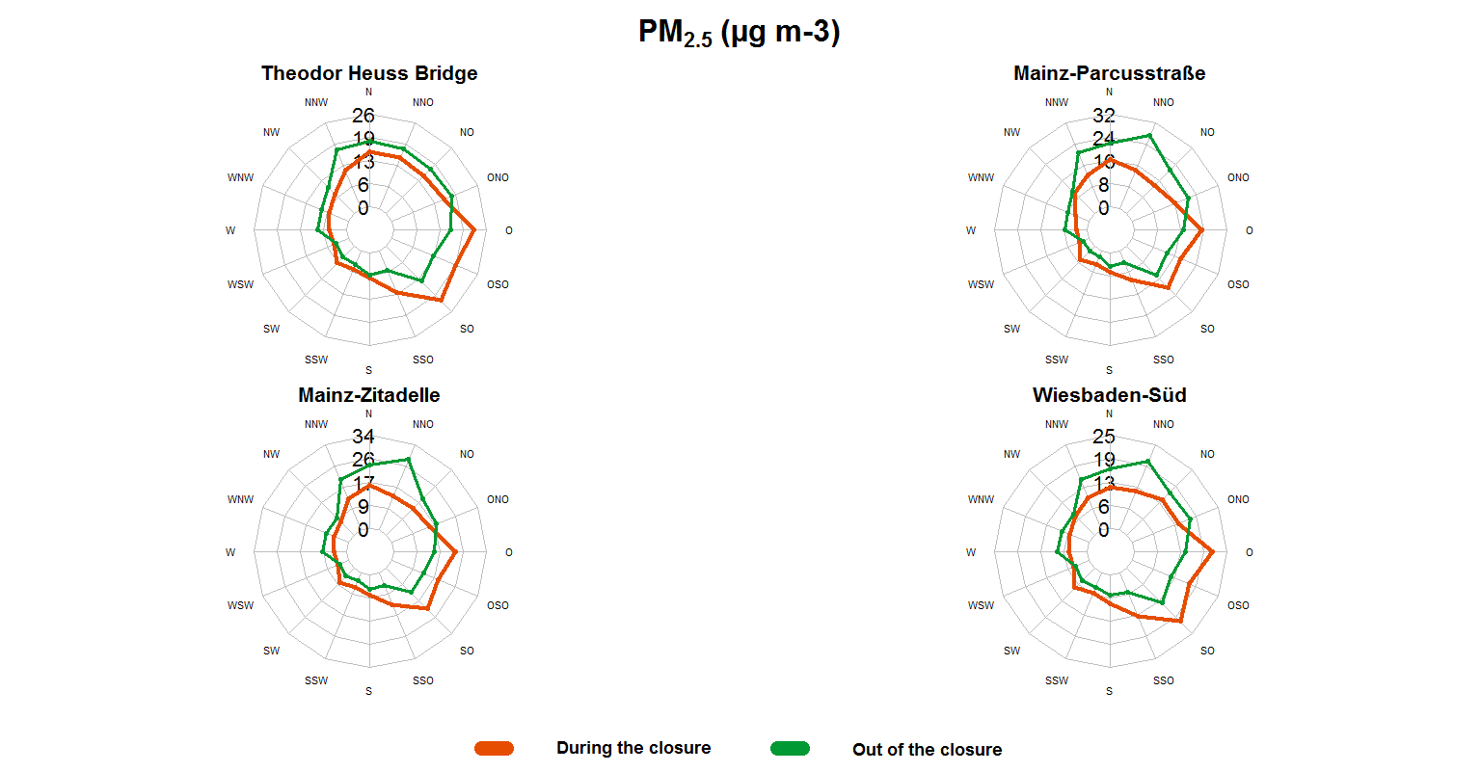
Continuation of figure s8

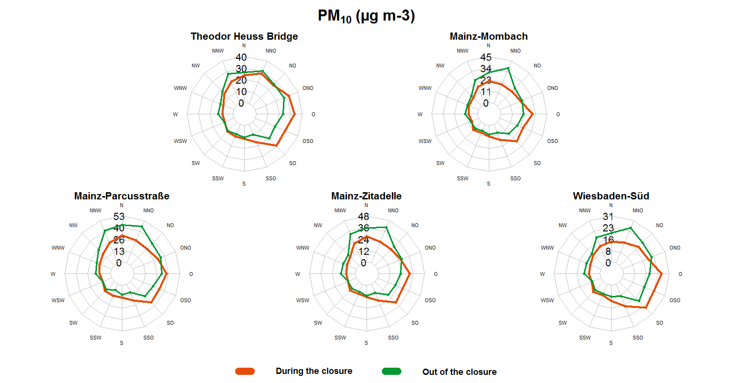

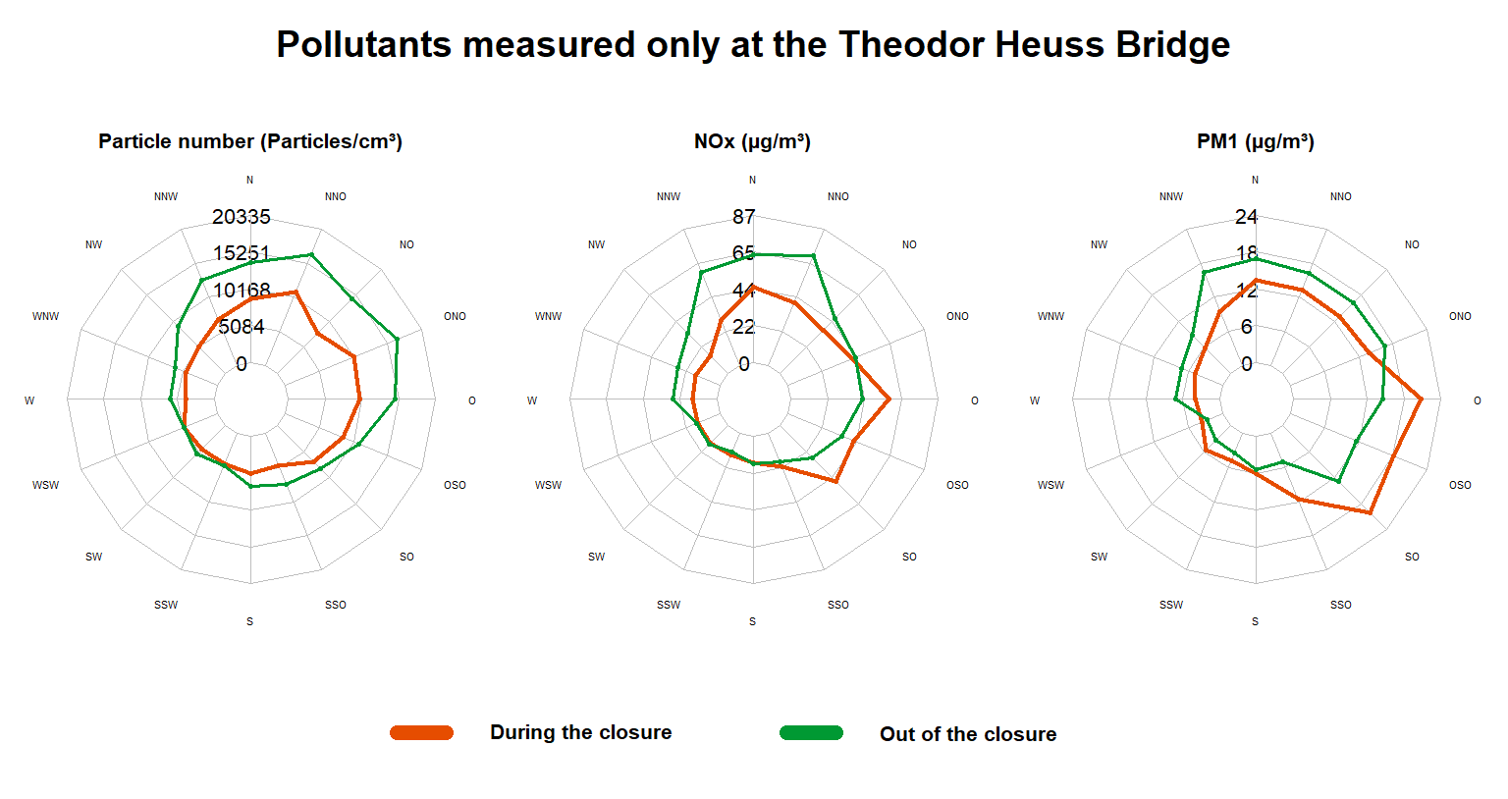
Continuation of figure s8

Table s5: Measurement instruments at the Theodor Heuss Bridge.
Instrument | Measured variables
Aerosol Dynamics CPC¹, Model MAGIC 200 | Particle number concentration
2B Technologies, NOx monitor, Model 405 | NO, NO₂ and NO_{x}
Thermo Instruments, Black carbon monitor, Model MAAP² | Black carbon concentration in PM₁
2B Technologies, Ozone monitor, Model 205 | Ozone
TSI SMPS³, Model 3898 | Particle number size distribution (for particles with a particle diameter of approx. 15 nm - 450 nm); used to calculate PM₁, PM_{2.5} and PM₁₀ in combination with OPC⁴
Grimm Aerosoltechnik OPC⁵, Model 1.109 | Particle number size distribution (for particles with a particle diameter of approx. 250 nm - >10 µm); used to calculate PM₁, PM_{2.5} and PM₁₀ in combination with SMPS⁴
Davis Vantage Pro II Weather station | Temperature, precipitation intensity, relative humidity, air pressure, total radiation and UV radiation, wind direction and wind speed

¹ Condensation Particle Counter
² Multi-Angle Absorption Photometer
³ Scanning Mobility Particle Sizer
⁴ PM₁, PM_{2.5}, PM₁₀ were calculated from the combined OPC and SMPS size distributions as follows: OPC size distributions were re-binned accounting for optical properties of the particles as described in (Drewnick et al. 2021), and merged with the SMPS size distributions for each time step individually by averaging the data from the two instruments in the overlapping size bins. The merged number size distributions were converted to mass size distributions assuming spherical particles with density of 1.5 g cm⁻³ in the size range <700 nm and particles with a shape factor (1.5;(Hinds 1999)) and density (2.7 g cm⁻³(Hinds 1999)) of mineral dust in the size range >3000 nm, and a loglinearly interpolated shape and density in between. PM₁, PM_{2.5}, and PM₁₀ were calculated from these mass size distributions by integrating from the smallest available size bin up to aerodynamic diameters of 1 µm, 2.5 µm, and 10 µm, respectively.
⁵ Optical Particle Counter
The selection of instruments for the field measurement station was made to cover typical pollutants, known to be emitted by traffic sources. These include instruments to measure particle number concentrations and particulate black carbon as well as nitrogen oxides, which are all three strongly enhanced in combustion engine emissions. Two instruments for a combined measurement of the particle number size distribution from 15 nm up to more than 10 µm particle diameter were used to calculate particle mass concentrations for different size fractions (i.e. PM1, PM2.5, PM10), which are a measure for both, local emissions and the overall aerosol burden. An ozone instrument provides information on ozone mixing ratios, which strongly reflect photochemical processes in the atmosphere together with the influence of fresh combustion engine emissions. A meteorological station, fixed on a pole on top of the THB, mainly provides information on wind direction and wind speed, allowing to assess the direction from which the actually probed air was advected from.

Table s6: Data sources and measurement instruments or methods for pollutants of air quality monitoring stations.

Monitoring station | Pollutant | Instrument or method | Data source
Mainz-Mombach | NO | Horiba Europa APNA360/APNA370 | ZIMEN¹ (Margit von Döhren, personal communication)
Mainz-Mombach | NO₂ | Horiba Europa APNA360/APNA370 | ZIMEN¹ (Margit von Döhren, personal communication)
Mainz-Mombach | O₃ | Horiba Europe APOA360/APOA370 | Umweltbundesamt (German Environment Agency) (umweltbundesamt.de/daten/luft/luftdaten/luftqualitaet)
Mainz-Mombach | PM₁₀ | Thermo Fisher SHARP5030 | ZIMEN¹ (Margit von Döhren, personal communication)
Mainz-Mombach | Black carbon | Thermo Electron MAAP5012 | ZIMEN¹ (Margit von Döhren, personal communication)
Mainz-Parcusstraße | NO | Horiba Europa APNA360/APNA370 | ZIMEN¹ (Margit von Döhren, personal communication)
Mainz-Parcusstraße | NO₂ | Horiba Europa APNA360/APNA370 | ZIMEN¹ (Margit von Döhren, personal communication)
Mainz-Parcusstraße | PM_{2.5} | Thermo Fisher SHARP5030 | ZIMEN¹ (Margit von Döhren, personal communication)
Mainz-Parcusstraße | PM₁₀ | Thermo Fisher SHARP5030 | ZIMEN¹ (Margit von Döhren, personal communication)
Mainz-Parcusstraße | Black carbon | Thermo Electron MAAP5012 | ZIMEN¹ (Margit von Döhren, personal communication)
Mainz-Rheinallee | NO | Horiba Europa APNA360/APNA370 | ZIMEN¹ (Margit von Döhren, personal communication)
Mainz-Rheinallee | NO₂ | Horiba Europa APNA360/APNA370 | ZIMEN¹ (Margit von Döhren, personal communication)
Mainz-Zitadelle | NO | Horiba Europa APNA360/APNA370 | ZIMEN¹ (Margit von Döhren, personal communication)
Mainz-Zitadelle | NO₂ | Horiba Europa APNA360/APNA370 | ZIMEN¹ (Margit von Döhren, personal communication)
Mainz-Zitadelle | PM_{2.5} | Thermo Fisher SHARP5030 | ZIMEN¹ (Margit von Döhren, personal communication)
Mainz-Zitadelle | PM₁₀ | Thermo Fisher SHARP5030 | ZIMEN¹ (Margit von Döhren, personal communication)
Wiesbaden-Süd | NO | Chemiluminescence / diffusive sampling | Umweltbundesamt (German Environment Agency)
Wiesbaden-Süd | NO₂ | Chemiluminescence / diffusive sampling | HLNUG² (hlnug.de/messwerte/datenportalhttps://www.hlnug.de/messwerte/luft/recherche-1)
Wiesbaden-Süd | O₃ | UV-photometry | Umweltbundesamt (German Environment Agency)
Wiesbaden-Süd | PM_{2.5} | Radiometry, nephelometry, optical procedures / gravimetry | HLNUG²
Wiesbaden-Süd | PM₁₀ | Radiometry, nephelometry, optical procedures / gravimetry | HLUNG²

¹ ZIMEN: Zentrales Imissionsmessnetz (Central emission monitoring network of the Environment Agency of the German federal state of Rhineland-Palatinate)
² HLNUG: Hessisches Landesamt für Naturschutz, Umwelt und Geologie (Environment Agency of the German federal state of Hesse). Information on the instruments were unfortunately not available to us.

Table s7: Median and mean concentrations of different pollutants at the monitoring stations during (12th Jan – 5th Feb 2020) and out of (7th – 12th Jan 2020 / 5th Feb – 20th Feb 2020) the bridge closure compared to concentrations at the Theodor Heuss Bridge (THB).
Measurement site | Median  [95% confidence interval] |  |  | Mean  [95% confidence interval]
Measurement site | Before closure | During closure | After closure | Before closure | During closure | After closure
Black carbon (μg m⁻³)
THB | 0.6  [0.5 ; 0.6] | 0.5  [0.4 ; 0.5] | 0.3  [0.3 ; 0.3] | 0.9  [0.9 ; 0.9] | 0.9  [0.9 ; 1.0] | 0.7  [0.7 ; 0.7]
MZ-Mombach¹ | 1.0  [0.9 ; 1.0] | 0.6  [0.5 ; 0.6] | 0.4  [0.4 ; 0.4] | 1.2  [1.2 ; 1.3] | 1.1  [1.1 ; 1.1] | 1.0  [1.0 ; 1.1]
MZ-Parcusstraße² | 2.0  [1.9 ; 2.0] | 1.4  [1.4 ; 1.4] | 1.3  [1.2 ; 1.3] | 2.1  [2.1 ; 2.2] | 1.8  [1.8 ; 1.9] | 1.8  [1.7 ; 1.8]
NO (μg m⁻³)
THB | 3.0  [2.7 ; 3.3] | 2.0  [1.8 ; 2.1] | 1.3  [1.2 ; 1.5] | 10.6  [9.7 ; 11.4] | 14.6  [13.9 ; 15.3] | 11.5  [10.8 ; 12.2]
MZ-Mombach¹ | 4.0  [3.0 ; 5.0] | 1.0  [1.0 ; 1.0] | 1.0  [1.0 ; 1.0] | 13.6  [12.4 ; 14.7] | 16.2  [15.4 ; 17] | 11.9  [11.3 ; 12.5]
MZ-Zitadelle¹ | 16.0  [15.0 ; 20.0] | 7.0  [7.0 ; 8.0] | 8.0  [7.0 ; 8.0] | 22.2  [21.1 ; 23.4] | 21.5  [20.8 ; 22.3] | 20.8  [20.0 ; 21.6]
Wiesbaden-Süd¹ | 7.4  [7.2 ; 10.8] | 2.5  [2.4 ; 2.6] | 2.3  [2.2 ; 2.4] | 14.3  [13.4 ; 15.1] | 17.0  [16.2 ; 17.8] | 14.7  [13.9 ; 15.4]
MZ-Parcusstraße² | 46.0  [44.0 ; 47.0] | 28.0  [27.0 ; 28.0] | 29.0  [28.0 ; 30.0] | 46.7  [45.1 ; 48.2] | 45.4  [44.1 ; 46.7] | 43.7  [42.4 ; 46.7]
MZ-Rheinallee² | 16.0  [13.0 ; 20.0] | 8.0  [7.0 ; 8.0] | 4.0  [4.0 ; 5.0] | 35.2  [32.9 ; 37.5] | 33.3  [32.2 ; 34.4] | 24.0  [23.0 ; 25.0]
NO₂ (μg m⁻³)
THB | 31.3  [30.7 ; 32.0] | 31.3  [30.7 ; 31.9] | 29.0  [28.3 ; 29.8] | 31.4  [30.9 ; 32.0] | 32.7  [32.4 ; 33.0] | 33.4  [32.9 ; 33.9]
MZ-Mombach¹ | 27.0  [27.0 ; 28.0] | 16.0  [15.0 ; 17.0] | 11.0  [11.0 ; 12.0] | 23.8  [23.1 ; 24.5] | 22.1  [21.7 ; 22.5] | 20.8  [20.3 ; 21.4]
MZ-Zitadelle¹ | 32.0  [31.0 ; 33.0] | 26.0  [26.0 ; 27.0] | 26.0  [25.0 ; 27.0] | 31.9  [31.2 ; 32.6] | 29.1  [28.8 ; 29.5] | 27.4  [26.9 ; 27.9]
Wiesbaden-Süd¹ | 35.0  [34.0 ; 36.0] | 29.0  [29.0 ; 30.0] | 23.0  [22.0 ; 24.0] | 33.6  [33.0 ; 34.2] | 30.6  [30.2 ; 31.0] | 27.5  [26.9 ; 28.0]
MZ-Parcusstraße² | 42.0  [42.0 ; 43.0] | 38.0  [37.0 ; 38.0] | 38.0  [38.0 ; 39.0] | 42.6  [41.9 ; 43.4] | 38.0  [37.6 ; 38.4] | 37.2  [36.7 ; 37.8]
MZ-Rheinallee² | 37.0  [37.0 ; 38.0] | 30.0  [29.0 ; 31.0] | 21.0  [20.0 ; 22.0] | 35.7  [34.9 ; 36.6] | 32.6  [32.1 ; 33.1] | 29.1  [28.4 ; 29.7]
NO_{x} (=NO + NO₂; μg m⁻³)
THB | 34.3  [33.4 ; 35.3] | 33.3  [32.4 ; 34] | 30.3  [29.5 ; 31.3] | 42.0  [40.6 ; 43.4] | 47.3  [46.3 ; 48.3] | 44.9  [43.7 ; 46.1]

Continuation of table s7
Measurement site | Median  [95% confidence interval] |  |  | Mean  [95% confidence interval]
Measurement site | Before closure | During closure | After closure | Before closure | During closure | After closure
Ozone (μg m⁻³)
THB | 8.1  [7.1 ; 8.8] | 14.6  [13.6 ; 15.7] | 24.2  [23.7 ; 24.9] | 21.8  [20.6 ; 23] | 29.0  [28.4 ; 29.6] | 40.4  [39.5 ; 41.3]
MZ-Mombach¹ | 16.0  [14.0 ; 19.0] | 44.0  [43.0 ; 45.0] | 56.0  [53.0 ; 56.0] | 25.7  [24.4 ; 27.0] | 36.1  [35.4 ; 36.7] | 43.2  [42.3 ; 44.1]
Wiesbaden-Süd¹ | 7.0  [5.0 ; 10.0] | 28.0  [27.0 ; 31.0] | 46.0  [44.0 ; 48.0] | 19.1  [18.0 ; 20.1] | 29.7  [29.1 ; 30.3] | 39.2  [38.3 ; 40.0]
Particle number concentration (particles cm⁻³)
THB | 6470  [6235 ; 6834] | 5224  [5142 ; 5341] | 6665  [6440 ; 6888] | 7132  [6899 ; 7366] | 6467  [6357 ;6577] | 8061  [7895 ; 8228]
PM₁ (μg m⁻³)
THB | 6.9  [6.2 ; 7.6] | 6.6  [6.4 ; 6.9] | 3.6  [3.5 ; 3.7] | 9.5  [9.2 ; 9.8] | 10.5  [10.3 ; 10.8] | 7.6  [7.3 ; 7.9]
PM_{2.5} (μg m⁻³)
THB | 8.0  [7.0 ; 8.6] | 8.3  [8.1 ; 8.6] | 4.6  [4.5 ; 4.7] | 10.2  [9.8 ; 10.5] | 11.8  [11.6 ; 12.1] | 8.7  [8.4 ; 9.0]
MZ-Zitadelle¹ | 9.0  [8.0 ; 10.0] | 7.0  [7.0 ; 8.0] | 5.0  [5.0 ; 5.0] | 10.0  [9.7 ; 10.3] | 11.9  [11.6 ; 12.2] | 9.9  [9.5 ; 10.2]
Wiesbaden-Süd¹ | 9.0  [8.8 ; 9.3] | 11.2  [10.9 ; 11.5] | 8.9  [8.6 ; 9.1] | 9.0  [8.8 ; 9.3] | 11.2  [10.9 ; 11.5] | 8.9  [8.6 ; 9.1]
MZ-Parcusstraße² | 8.0  [8.0 ; 8.0] | 6.0  [6.0 ; 6.0] | 3.0  [3.0 ; 3.0] | 8.5  [8.2 ; 8.9] | 11.2  [10.9 ; 11.5] | 9.2  [8.8 ; 9.5]
PM₁₀ (μg m⁻³)
THB | 15.0  [14.1 ; 15.7] | 16.3  [15.9 ; 16.7] | 10.6  [10.4 ; 11.0] | 14.7  [14.3 ; 15.1] | 19.1  [18.7 ; 19.5] | 14.9  [14.6 ; 15.3]
MZ-Mombach¹ | 13.0  [12.0 ; 13.0] | 12.0  [12.0 ; 13.0] | 10.0  [9.0 ; 10.0] | 25.7  [24.4 ; 27.0] | 36.1  [35.4 ; 36.7] | 43.2  [42.3 ; 44.1]
MZ-Zitadelle¹ | 14.0  [13.0 ; 14.0] | 14.0  [14.0 ; 14.0] | 11.0  [10.0 ; 11.0] | 15.2  [14.8 ; 15.6] | 19.1  [18.8 ; 19.5] | 17.0  [16.5 ; 17.4]
Wiesbaden-Süd¹ | 11.5  [11.2 ; 11.8] | 14.6  [14.3 ; 14.9] | 12.2  [11.9 ; 12.5] | 11.5  [11.2 ; 11.8] | 14.6  [14.3 ; 14.9] | 12.2  [11.9 ; 12.5]
MZ-Parcusstraße² | 19.0  [18.0 ; 19.0] | 19.0  [19.0 ; 20.0] | 14.0  [13.0 ; 14.0] | 18.4  [17.8 ; 18.9] | 23.2  [22.8 ; 23.7] | 20.1  [19.6 ; 20.6]
¹ urban background station
² urban traffic station

References
Croxford R (2016) Restricted cubic spline regression: a brief introduction. Toronto: Institute for Clinical Evaluative Sciences:1-5
Drewnick F, Pikmann J, Fachinger F, Moormann L, Sprang F, Borrmann S (2021) Aerosol filtration efficiency of household materials for homemade face masks: Influence of material properties, particle size, particle electrical charge, face velocity, and leaks. Aerosol Science and Technology 55(1):63-79
Fahrmeir L, Kneib T, Lang S, Marx B (2007) Regression. Springer
Harrell Jr F (2001) Regression modeling strategies with applications to linear models, logistic regression and survival analysis. New York: Spring-Verlag. Inc
Hinds WC (1999) Aerosol technology: properties, behavior, and measurement of airborne particles. John Wiley & Sons
Stone CJ (1986) [Generalized additive models]: comment. Statistical Science 1(3):312-314

