Supplementary Information

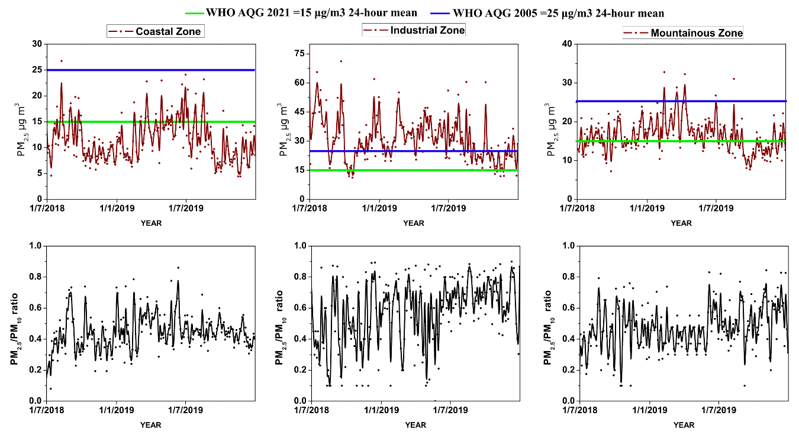
Figure S1. Daily PM_{2.5} concentrations in the northern Caribbean region of Colombia from July 2018 to December 2019

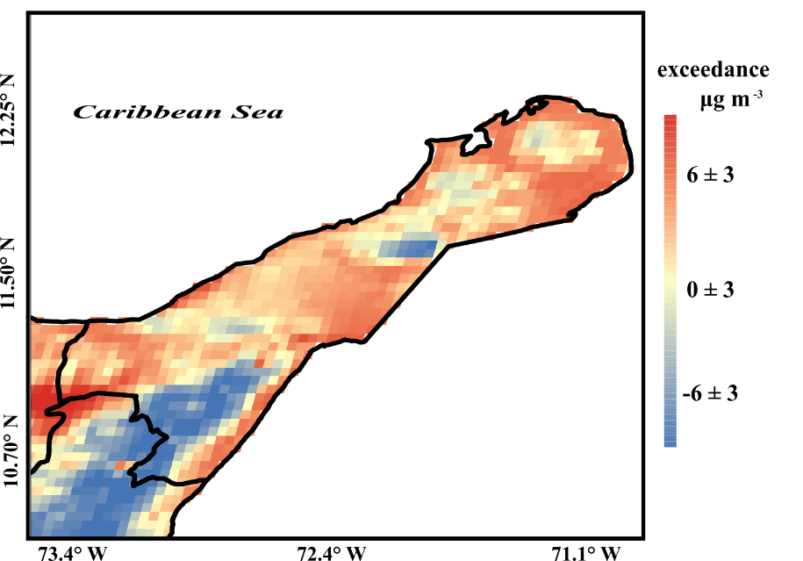
Figure S2. Representative zones (yellow areas) and zones with excess average PM₁₀ concentration according to surface monitoring station records during the period 2011–2019. Surface station records vs. dispersion modeling estimates integrating the population density of each zone. The spatial distribution of PM₁₀ was obtained through spatial interpolation performed using the deterministic inverse distance weighting (IDW) method for the surface stations located in the study domain.

Table S1. Configuration of the WRF model for simulations in the northern Caribbean region of Colombia
Dynamics | Non-hydrostatic
Observation period | January 2011 to December 2019
Resolution | Domain 1: 36 × 36 km, Domain 2: 12 × 12 km, Domain 3: 4 × 4 km
Area covered | 7.43 to 15.54°N, -76.92 to -68.63°E
Projection | Mercator
Horizontal grid system | Arakawa-C grid
Vertical resolution | 38 vertical levels
spin-up time | 15 days
Microphysics scheme | Thompson scheme
Longwave and shortwave radiation Scheme | RRTMG
PBL schemes | MYNN
Cumulus parameterization | New Tiedtke scheme

Table S2. Summary of the results of CALPUFF-CALMET-WRF evaluation for PM₁₀ concentrations for 2011–2019 in the northern Caribbean region of Colombia
Statistics | Unit | Range | Best value | Performance of the CALPUFF mode
 |  |  |  | Coastal Zone | Industrial Zone | Mountainous Zone
$$BIAS=\sum_{t=1}^{n}{\frac{∅_{P}-∅_{O}}{∅_{O}}}$$ | µg m⁻³ | -∞ to ∞ | 0 | -5.83 | -9.1 | 3.21
$$RMSE=\sqrt{\sum_{t=1}^{n}{\frac{{{(∅}_{P}-∅_{O})}^{2}}{n}}}$$ | µg m⁻³ | 0 to ∞ | 0 | 13.43 | 16.65 | 16.62
$$NRMSE=\frac{\sqrt{\sum_{t=1}^{n}{\frac{{{(∅}_{P}-∅_{O})}^{2}}{n}}}}{\overline{∅_{O}}}$$ | None | 0 to ∞ | 0 | 0.43 | 0.41 | 0.48
$$r=\frac{1}{(n-1)}\sum_{t=1}^{n}{\left(\frac{∅_{P}-\overline{∅_{P}}}{σ_{P}}\right)\left(\frac{∅_{O}-\overline{∅_{O}}}{σ_{O}}\right)}$$ | None | -1 to 1 | 1 | 0.63 | 0.51 | 0.68
$$MG=e^{(\overline{ln}{C_{0}-}\overline{\ln{C_{p}}})}$$ | None | 0 to ∞ | 1 | 1.23 | 1.29 | 0.92

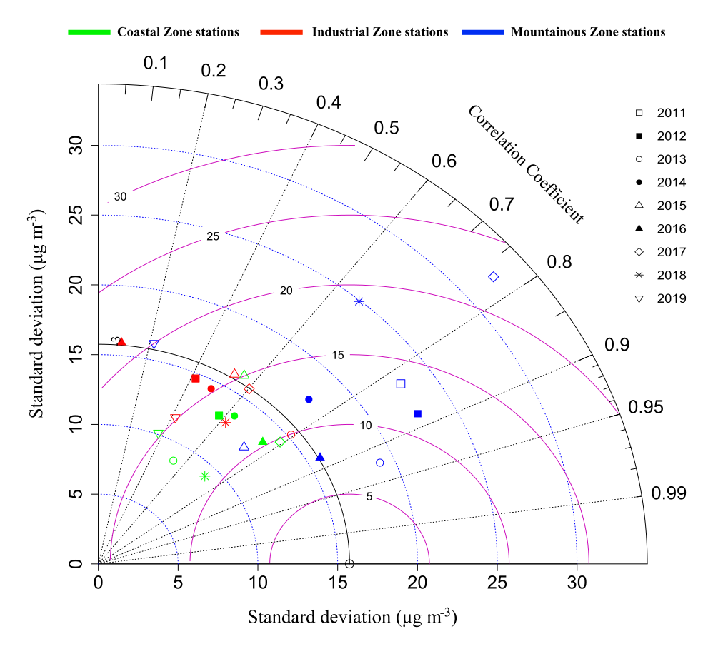
Figure S3. Taylor plot of annual PM₁₀ concentrations vs. PM₁₀ concentrations estimated using the CALPUFF-CALMET-WRF modeling system.

Table S3. Monthly PM₁₀ concentrations (µg m⁻³) in the Caribbean region of Colombia over the period 2011-2019.
 | Coastal Zone  (µg m⁻³) | Industrial Zone  (µg m⁻³) | Mountainous Zone  (µg m⁻³)
JAN | 22 ± 8 | 35 ± 8 | 32 ± 12
FEB | 27 ± 11 | 42 ± 11 | 39 ± 14
MAR | 26 ± 10 | 46 ± 13 | 44 ± 15
APR | 31 ± 15 | 50 ± 29 | 42 ± 18
MAY | 37 ± 17 | 40 ± 13 | 36 ± 13
JUN | 43 ± 26 | 42 ± 17 | 39 ± 18
JUL | 35 ± 15 | 42 ± 12 | 37 ± 15
AUG | 29 ± 10 | 37 ± 10 | 31 ± 11
SEP | 26 ± 13 | 32 ± 10 | 28 ± 12
OCT | 18 ± 10 | 28 ± 7 | 22 ± 7
NOV | 16 ± 6 | 27 ± 8 | 19 ± 7
DEC | 21 ± 7 | 30 ± 7 | 26 ± 11

Table S4. Estimated percentages of ALRI, COPD, IHD, LC, stroke, and post-neonatal infant mortality deaths attributable to PM₁₀ exposure in the Northern Caribbean region of Colombia (2011-2019).
Year | Mortality | Northern Caribbean region | Number of Attributable Cases per 100,000 Population at Risk
2011 | ALRI (children 0-4) | 8% | 24
2011 | COPD (adults 18+) | 12% | 19
2011 | IHD (adults 18+) | 24% | 38
2011 | LC (adults 18+) | 10% | 5
2011 | Stroke (adults 18+) | 17% | 17
2011 | Postneonatal infant mortality, allcause | 3% | 326
2012 | ALRI (children 0-4) | 9% | 11
2012 | COPD (adults 18+) | 14% | 9
2012 | IHD (adults 18+) | 26% | 35
2012 | LC (adults 18+) | 9% | 6
2012 | Stroke (adults 18+) | 19% | 21
2012 | Postneonatal infant mortality, allcause | 5% | 321
2013 | ALRI (children 0-4) | 14% | 37
2013 | COPD (adults 18+) | 17% | 8
2013 | IHD (adults 18+) | 26% | 36
2013 | LC (adults 18+) | 9% | 6
2013 | Stroke (adults 18+) | 18% | 22
2013 | Postneonatal infant mortality, allcause | 5% | 315
2014 | ALRI (children 0-4) | 9% | 22
2014 | COPD (adults 18+) | 17% | 17
2014 | IHD (adults 18+) | 28% | 33
2014 | LC (adults 18+) | 6% | 8
2014 | Stroke (adults 18+) | 19% | 22
2014 | Postneonatal infant mortality, allcause | 6% | 343
2015 | ALRI (children 0-4) | 14% | 22
2015 | COPD (adults 18+) | 19% | 16
2015 | IHD (adults 18+) | 28% | 49
2015 | LC (adults 18+) | 7% | 7
2015 | Stroke (adults 18+) | 20% | 28
2015 | Postneonatal infant mortality, allcause | 7% | 312
2016 | ALRI (children 0-4) | 14% | 35
2016 | COPD (adults 18+) | 18% | 17
2016 | IHD (adults 18+) | 29% | 58
2016 | LC (adults 18+) | 14% | 6
2016 | Stroke (adults 18+) | 20% | 25
2016 | Postneonatal infant mortality, allcause | 5% | 387
2017 | ALRI (children 0-4) | 12% | 33
2017 | COPD (adults 18+) | 16% | 19
2017 | IHD (adults 18+) | 27% | 57
2017 | LC (adults 18+) | 9% | 8
2017 | Stroke (adults 18+) | 19% | 33
2017 | Postneonatal infant mortality, allcause | 6% | 372
2018 | ALRI (children 0-4) | 13% | 56
2018 | COPD (adults 18+) | 17% | 20
2018 | IHD (adults 18+) | 27% | 61
2018 | LC (adults 18+) | 10% | 12
2018 | Stroke (adults 18+) | 19% | 37
2018 | Postneonatal infant mortality, allcause | 7% | 519
2019 | ALRI (children 0-4) | 12% | 58
2019 | COPD (adults 18+) | 16% | 26
2019 | IHD (adults 18+) | 26% | 72
2019 | LC (adults 18+) | 8% | 13
2019 | Stroke (adults 18+) | 18% | 40
2019 | Postneonatal infant mortality, allcause | 5% | 666

