SUPPLEMENTARY MATERIALS
Biological effects of particulate matter samples during the COVID-19 pandemic: a comparison with the pre-lockdown period in North-West Italy

Marta Gea^{1,#}, Manuela Macrì^{2,#}, Daniele Marangon³, Francesco Antonio Pitasi³, Marco Fontana³, Tiziana Schilirò^{1,}*, Sara Bonetta¹

¹Department of Public Health and Pediatrics, University of Torino, via Santena 5 bis, 10126 Torino, Italy
²Department of Life Sciences and Systems Biology, University of Torino, via Accademia Albertina 13, 10123 Torino, Italy
³Regional Agency for Environmental Protection of Piedmont (ARPA Piemonte), via Sabaudia 164, 10095 Grugliasco, Italy
#Marta Gea and Manuela Macrì equally contributed to this work

*Corresponding author:
Tiziana Schilirò
tiziana.schiliro@unito.it;
Department of Public Health and Pediatrics,
University of Torino,
Via Santena 5 bis, 10126 Torino, Italy.
Phone: +39 0116705820

Air Quality, Atmosphere & Health

Fig. S1 Cytotoxicity of 2019 PM extracts at 24 h and 72 h in the rural site: (a) January/February PM extracts, (b) March PM extracts; (c) April PM extracts; (d) May/June PM extracts; (e) Summer PM extracts; (f) Autumn PM extracts. Data are expressed as means ± standard deviations.
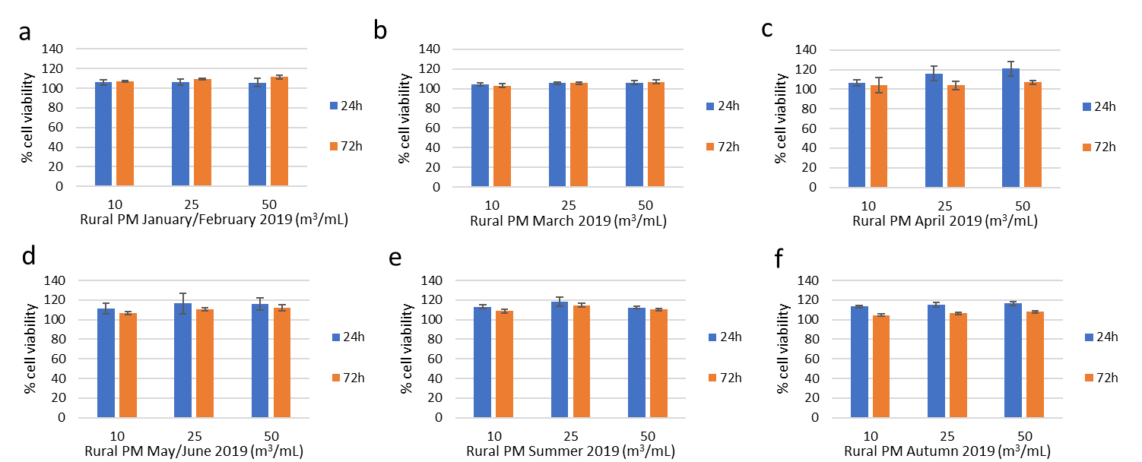

Fig. S2 Cytotoxicity of 2020 PM extracts at 24 h and 72 h in the rural site: (a) January/February PM extracts, (b) March PM extracts; (c) April PM extracts; (d) May/June PM extracts; (e) Summer PM extracts; (f) Autumn PM extracts. Data are expressed as means ± standard deviations.
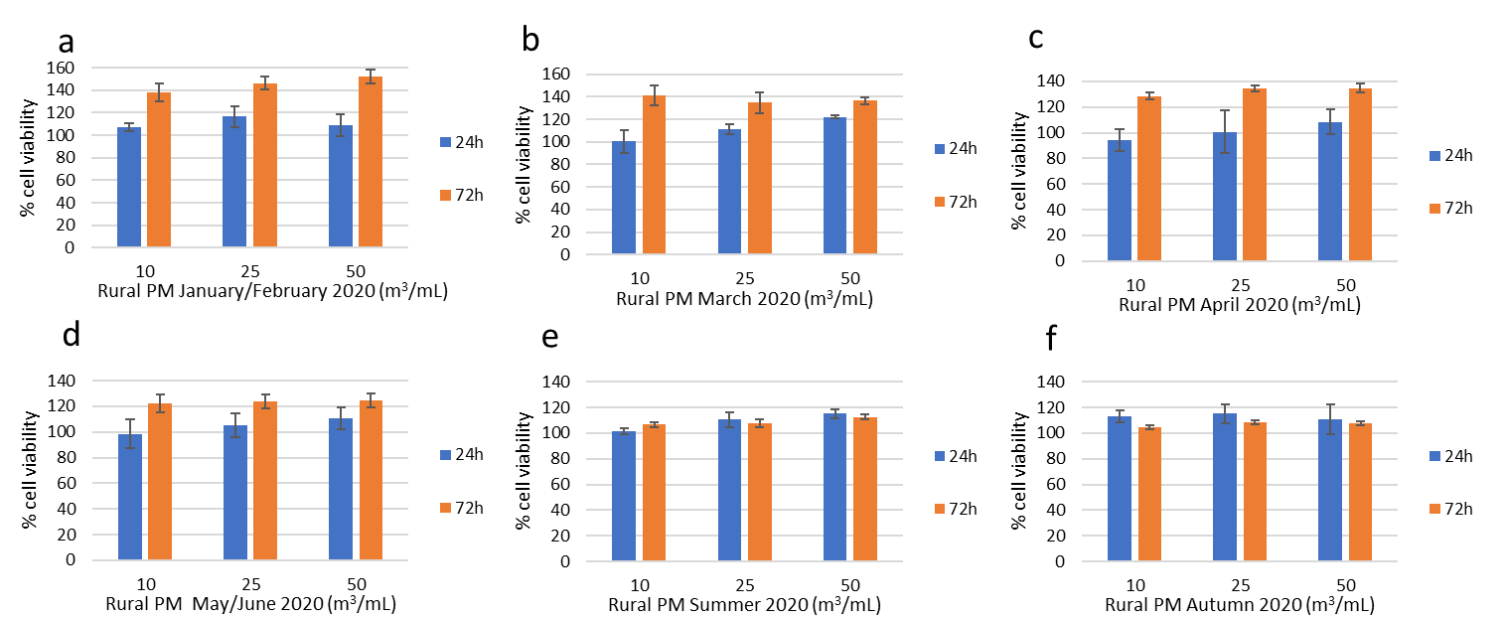

Fig. S3 Cytotoxicity of 2019 and 2020 PM extracts at 24 h and 72 h in the urban background, urban traffic and incinerator sites during April, May/June and Summer. (a) Urban PM April 2019, (b) Traffic PM April 2019; (c) Incinerator PM April 2019; (d) Urban PM May/June 2019; (e) Traffic PM May/June 2019; (f) Incinerator PM May/June 2019; (g) Urban PM Summer 2019; (h) Traffic PM Summer 2019; (i) Incinerator PM Summer 2019; (j) Urban PM April 2020, (k) Traffic PM April 2020; (l) Incinerator PM April 2020; (m) Urban PM May/June 2020; (n) Traffic PM May/June 2020; (o) Incinerator PM May/June 2020; (p) Urban PM Summer 2020; (q) Traffic PM Summer 2020; (r) Incinerator PM Summer 2020. Data are expressed as means ± standard deviations.
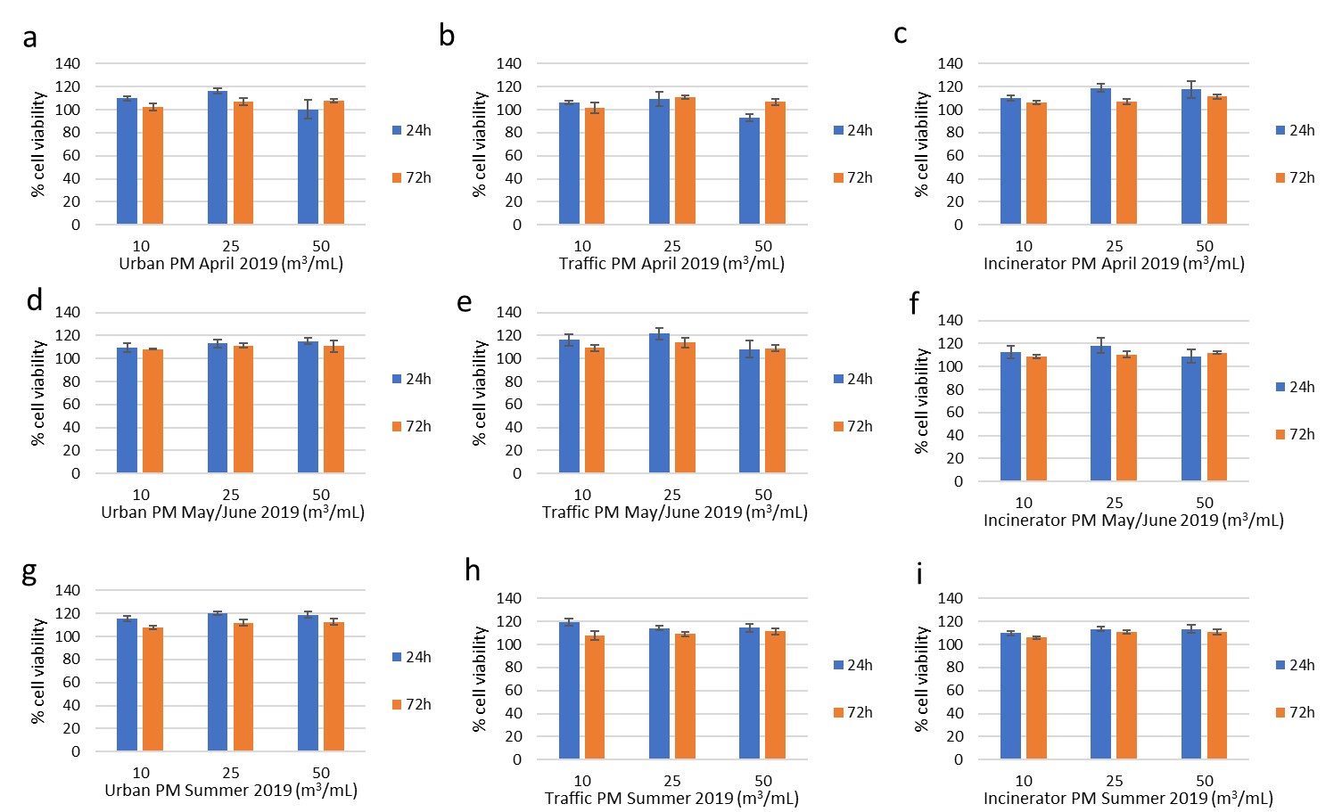
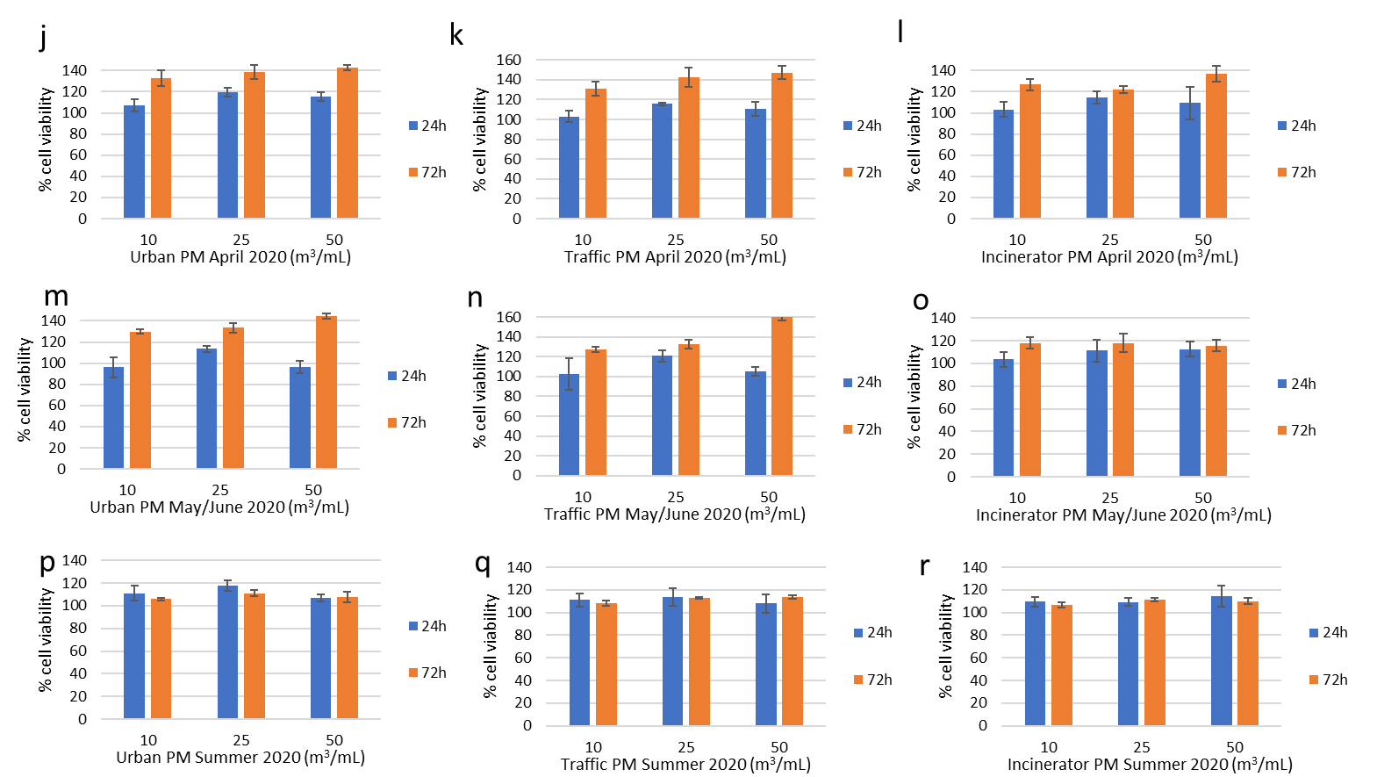
Fig. S4 Cytotoxicity of PM extracts at 72 h: (a) January/February PM extracts (no restrictions), (b) March PM extracts (first lockdown, hard restrictions); (c) Autumn PM extracts (second lockdown, intermediate restrictions). PM rural extracts (2019 and 2020, 24 h and 72 h) did not induce any cytotoxic effect (data not shown). Data are expressed as means ± standard deviations.*p≤ 0.05 Kruskal-Wallis test followed by Dunnett’s post hoc test vs negative control

Fig. S5 Genotoxicity of May/June PM extracts at 24 h exposure: (a) urban background PM, (b) urban traffic PM, (c) rural PM, (d) incinerator PM. Data are expressed as means ± standard deviations.*p≤0.05 one-way ANOVA test followed by Dunnett’s post hoc test vs. negative control
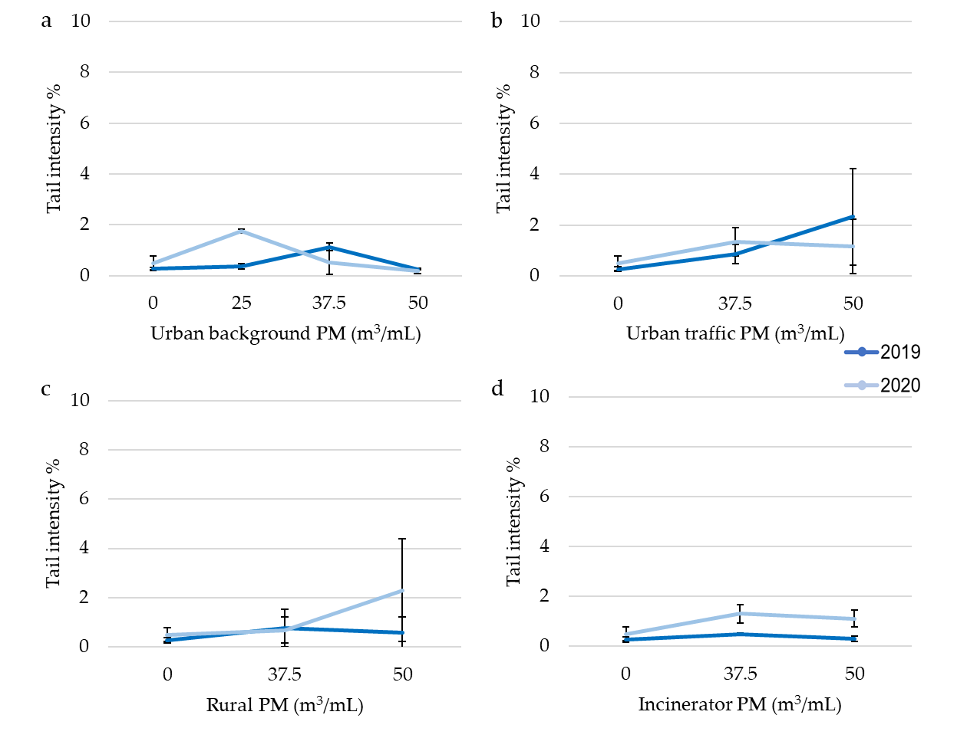

Fig. S6 Genotoxicity of Summer PM extracts at 24 h exposure: (a) urban background PM, (b) urban traffic PM, (c) rural PM, (d) incinerator PM. Data are expressed as means ± standard deviations.*p≤0.05 one-way ANOVA test followed by Dunnett’s post hoc test vs. negative control
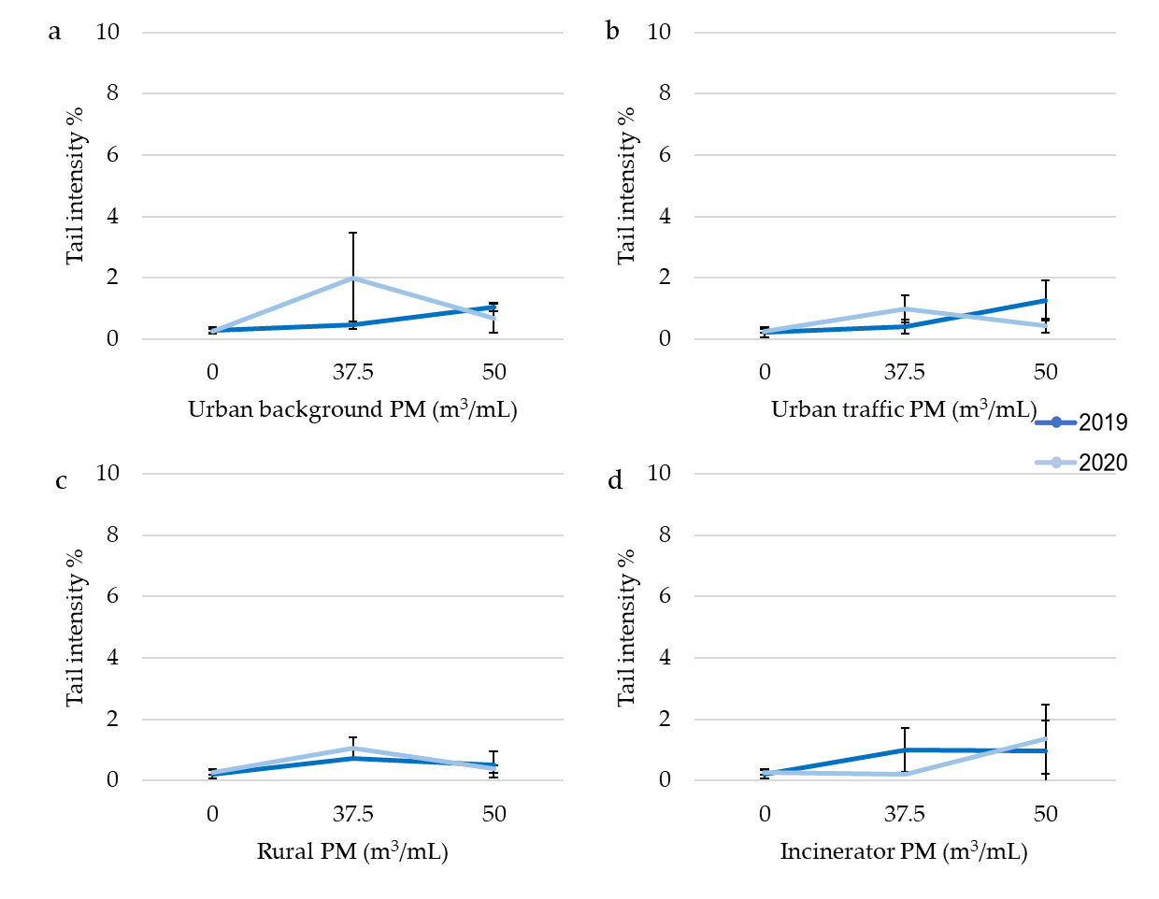

Fig. S7 Genotoxicity of January/February PM extracts at 24 h exposure: (a) urban background PM, (b) urban traffic PM, (c) rural PM, (d) incinerator PM. Data are expressed as means ± standard deviations.*p≤0.05 one-way ANOVA test followed by Dunnett’s post hoc test vs. negative control
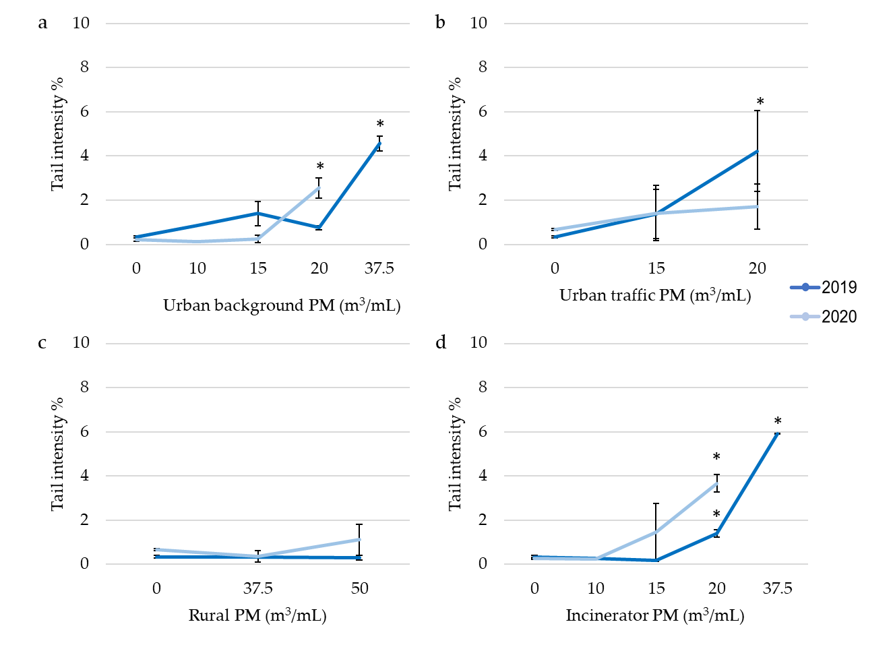

Fig. S8 Genotoxicity of March PM extracts at 24 h exposure: (a) urban background PM, (b) urban traffic PM, (c) rural PM, (d) incinerator PM. Data are expressed as means ± standard deviations.*p≤0.05 one-way ANOVA test followed by Dunnett’s post hoc test vs. negative control
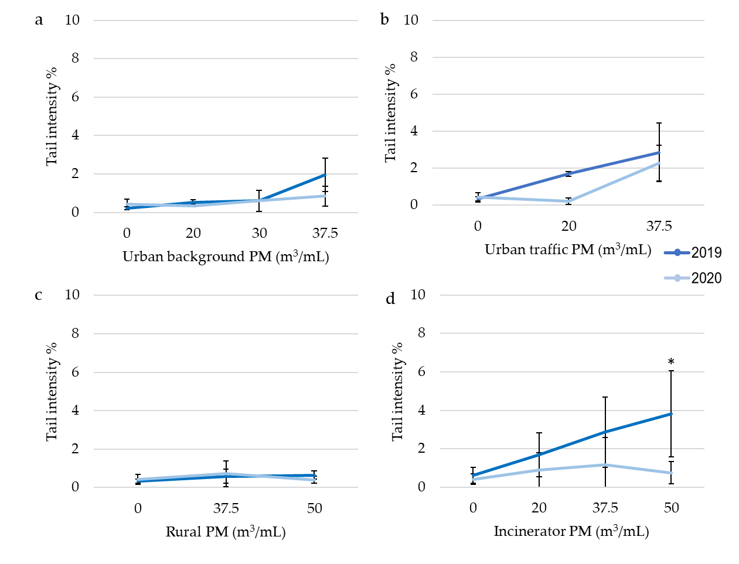

Fig. S9 Genotoxicity of April PM extracts at 24 h exposure: (a) urban background PM, (b) urban traffic PM, (c) rural PM, (d) incinerator PM. Data are expressed as means ± standard deviations.*p≤0.05 one-way ANOVA test followed by Dunnett’s post hoc test vs. negative control
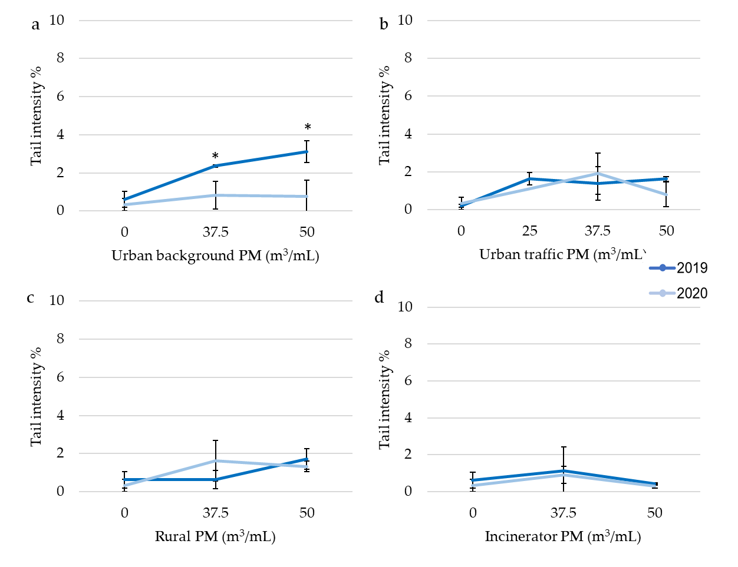

Table S1 Number of strains on which the extracts induced a significant mutagenic effect (MR ≥1). Strains: TA98, TA98 + S9, TA100, TA100 + S9

Period | Urban background site |  | Urban traffic site |  | Rural site |  | Incinerator site
Period | 2019 | 2020 | 2019 | 2020 | 2019 | 2020 | 2019 | 2020
January/  February | 4 | 4 | 4 | 4 | 2 | 1 | 4 | 4
March | 3 | 2 | 4 | 3 | 1 | 0 | 4 | 3
April | 2 | 0 | 1 | 2 | 0 | 0 | 0 | 2
May/June | 0 | 0 | 0 | 0 | 0 | 0 | 0 | 0
Summer (July-August, September) | 0 | 0 | 0 | 0 | 0 | 0 | 0 | 0
Autumn (October, November, December) | 3 | 4 | 4 | 4 | 1 | 2 | 4 | 4

