Supplementary Material

Journal: Air Quality, Atmosphere, and Health
Relation of wind direction and coal terminal activity patterns with air pollution burden in a community bordering a coal export terminal, Curtis Bay, Maryland, USA
Lauren N. Deanes ^{a†}, Bonita D. Salmerón^{a†}, Matthew A. Aubourg^{a*}, Laura E. Schmidtª, Kristoffer Spicerª, Caila Wagarª, Gregory G. Sawtell^{b,c}, Carlos C. Sanchez-Gonzalez^{c}, David Jones^{b}, Angela Shaneyfelt^{b}, David H. Hagan^{d}, David McClosky^{d}, Nicholas J. Spada^{e}, Russell R. Dickerson^{f}, Vivek Ravichandran^{g}, Sacoby M. Wilson^{g}, Anik Burman^{h}, Abhirup Datta^{h}, Christopher D. Heaney^{a,I,j*}

ªCommunity Science and Innovation for Environmental Justice (CSI EJ) Initiative, Department of Environmental Health and Engineering, Johns Hopkins Bloomberg School of Public Health, Baltimore, Maryland, 21205, United States; ldeanes1@jhu.edu (0000-0002-7224-7008), bsalmer2@jh.edu, maubour1@jh.edu (0000-0003-3691-0586), lschmi15@jh.edu, kspicer3@jhu.edu, cailawagar@gmail.com, cheaney1@jhu.edu (0000-0003-3211-8495)
^{b}Community of Curtis Bay Association, Baltimore, Maryland, 21226, United States; greg@sbclt.org, davidjon6@comcast.net, shaneyfeltangie@gmail.com
^{c}South Baltimore Community Land Trust, Baltimore, Maryland, 21225, United States; greg@sbclt.org, carlos@sbclt.org
^{d}QuantAQ, Inc., Somerville, Massachusetts, 02143, United States; david.hagan@quant-aq.com (0000-0001-5111-4671), david.mcclosky@quant-aq.com (0009-0005-8897-0793)
^{e}Air Quality Research Center, University of California, Davis, CA 95616, United States; njspada@ucdavis.edu (0000-0003-0922-6682)
^{f}Department of Atmospheric and Oceanic Science, University of Maryland, College Park, Maryland, 20742, United States; rrd@umd.edu (0000-0003-0206-3083)
^{g}Department of Global, Environmental, and Occupational Health, University of Maryland, College Park, School of Public Health, College Park, Maryland, 20742, United States; swilson2@umd.edu (0000-0002-0453-8954), vravicha@terpmail.umd.edu (0000-0001-8954-6162)
^{h}Department of Biostatistics, Johns Hopkins Bloomberg School of Public Health, Baltimore, Maryland, 21205, United States; aburman3@jhu.edu, abhidatta@jhu.edu (0000-0002-5046-0289)
^{i}Department of Epidemiology, Johns Hopkins Bloomberg School of Public Health, Baltimore, Maryland, 21205, United States; cheaney1@jhu.edu (0000-0003-3211-8495)
^{j}Department of International Health, Johns Hopkins Bloomberg School of Public Health, Baltimore, Maryland, 21205, United States; cheaney1@jhu.edu (0000-0003-3211-8495)

†Contributed equally.
*Correspondence: Matthew A. Aubourg and Christopher D. Heaney; Department of Environmental Health and Engineering, Johns Hopkins Bloomberg School of Public Health, Baltimore, Maryland, US; Email address: maubour1@jh.edu and cheaney1@jhu.edu

Supplemental Results Text
Deployment times for air monitoring locations across the network
Due to different deployment times for monitors at each location, there are slightly different time ranges associated with each pollutant when comparing between locations. The earliest deployment in the network included MODULAIR monitors at Locations 1, 5, 8, and 10 in July 2022, while the end of deployment for most sensors at all locations was July 17, 2023 (Table S1). However, for the analyses herein we restricted to time periods with non-missing trail camera data (Figure S1). This changes the start and end dates to September 16, 2022 and June 28, 2023, respectively (Figure S1).

Sensitivity testing of downwind angle definition
As shown in Figure S2, we examined one wider and one narrower downwind angle in addition to the primary downwind angle definition. We observed that wider downwind angles diluted the overall associations as expected (data not shown). Results for the narrower downwind definition were consistent with the overall findings (data not shown); however, because the narrower angle excluded the full extent of the coal terminal operations (e.g., geographic footprint and the range of operational activities), this supported our use of the primary downwind angle definition: ±30º of the central bearing adjusted based on the location of each air monitoring site and to reflect the unique spatial orientation aspects of the coal terminal and its operations – e.g., trajectory of rail lines within the coal terminal and docking location of coal export barges at the facility (Methods Section 2.3.1).

Variability of associations stratified by proximity to coal terminal
To assess potential spatial differences in our results, conditional fixed effects linear regression models were performed by stratifying locations into two groups by distance to coal terminal—< 0.5 km (Locations 1,2,3,4) and > 0.5 km (Locations 5,6,7,8,9,10). As shown in Tables S3 and S4, beta coefficients of the relationship between being downwind of the coal terminal versus not and PM and BC air pollutants were ~1.7-3.0 times higher in the more proximal (< 0.5 km away) versus more distal (> 0.5 km away) monitoring locations. As shown in Tables S5 and S6, beta coefficients of the relationship between visible bulldozer activity and PM air pollutants were between ~1.5-1.8 times higher in the locations < 0.5 km away versus > 0.5 km away. Notably, the beta coefficient for BC at proximal locations is positive and becomes negative for the distal locations. Further, betas of the relationship between visible bulldozer activity and PM air pollutants stratified by downwind were between ~1.2-1.9 times higher in the locations < 0.5 km away versus > 0.5 km away (Tables S5 and S6). The beta coefficient of the relationship between visible bulldozer activity and BC when downwind of the coal terminal was 30 times for the proximal < 0.5 km away locations versus the distal > 0.5 km away locations (Tables S5 and S6).

Variability in associations with longer time-weighted averages (5-, 15, and 60-minute time scales)
For analyses of stratified mean concentrations and fixed-effects of downwind alone on particulate matter (PM) and black carbon (BC) concentrations, the results remained consistent across the 5-, 15-, and 60-minute time scales (Tables S8, S10-S12). In fixed-effects analyses on the relationship between visible bulldozer activity and PM and BC concentrations with stratification by wind direction, there were some notable differences over time (Figures S4-S6, Tables S13-S15). Starting at the 5-minute level the significance of the interaction between wind direction and visible bulldozer activity for total suspended particles (TSP) and BC decreases (TSP: p < 0.05, BC: p < 0.3), however the p-value for the unstratified visible bulldozer activity model maintains significance for both TSP and BC until only TSP loses significance at 15-minutes (p < 0.40) and BC maintains a level of significance through the 60-minute time scale (p < 0.02).

Relation of downwind and coal terminal activity with gases
For measured gases (CO, NO, NO₂, and O₃) (Table S7), downwind only stratified analyses demonstrated that the concentrations of NO and NO₂ were higher when downwind of the terminal at all time scales, while the opposite was true for CO and O₃ (Tables S9, S16-19). In fixed-effects analyses on the relationship between visible bulldozer activity and gas concentrations and stratification of the relationship by wind direction, the 1-minute interaction p-values suggest that the effect of visible bulldozer activity on NO₂ and O₃ varies by downwind conditions (p-interaction < 0.001). For NO₂, mean concentrations are higher when downwind of the terminal, while the opposite is true for O₃. Carbon monoxide concentrations are also higher when downwind of the terminal, with the opposite result for NO, but the differences for these pollutants are not statistically significant (Table S20, Figure S7). This trend is consistent for the 5- and 15-minute analyses (Tables S21-22, Figures S8-9). Finally, at the 60-min time scale, for all four ground-level gas pollutants, p-interaction values are all > 0.1, suggesting that the association of visible bulldozer activity with air pollutant concentrations does not vary by downwind conditions at this time resolution (Table S23, Figure S10).

Fig. S1 Time period of data collection and data completeness by air pollutant and location restricted by availability of trail camera observations within a ten-node multi-pollutant air sensor network, Curtis Bay, Baltimore, Maryland, U.S., 2022-2023.
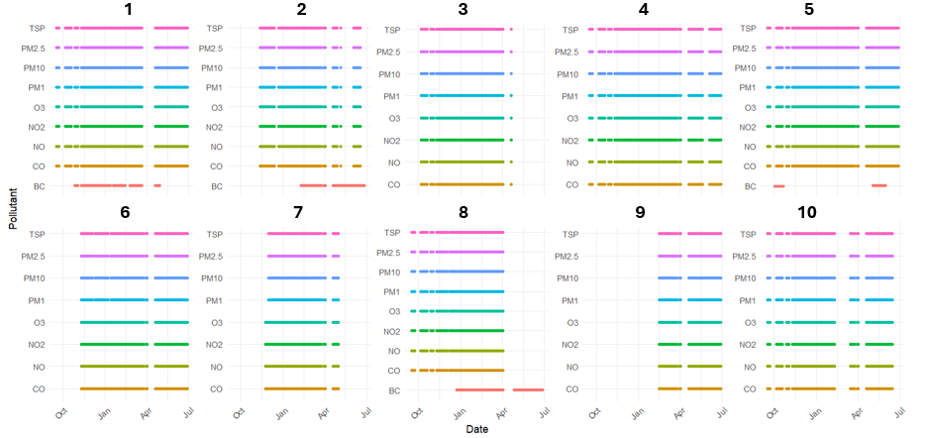

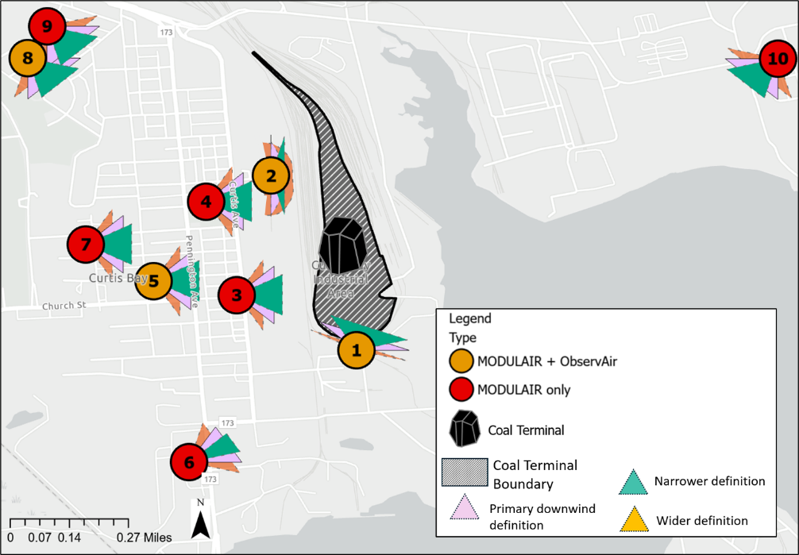
Fig. S2 Definitions of range of degrees used to define the primary definitions of downwind angle from the coal terminal variable, and visual representation of narrower and wider angle definitions, Curtis Bay, Maryland, U.S., 2022-2023.
Primary downwind angle definitions
 | Start angle | End angle
1 | < 90◦ | > 315◦
2 | > 0◦ | < 180◦
3 | > 45◦ | < 135◦
4 | > 45◦ | < 135◦
5 | > 45◦ | < 135◦
6 | > 30◦ | < 90◦
7 | > 45◦ | < 135◦
8 | > 90◦ | < 180◦
9 | > 90◦ | < 180◦
10 | > 180◦ | < 270◦
Fig. S3 Results of inter-operator reliability for trail camera-based coding of any visible bulldozer activity at 1-min time intervals from October 2022 (left/blue) and December 2022 (right/orange) subsets of the observation time period, Curtis Bay, Maryland, U.S., 2022-2023.
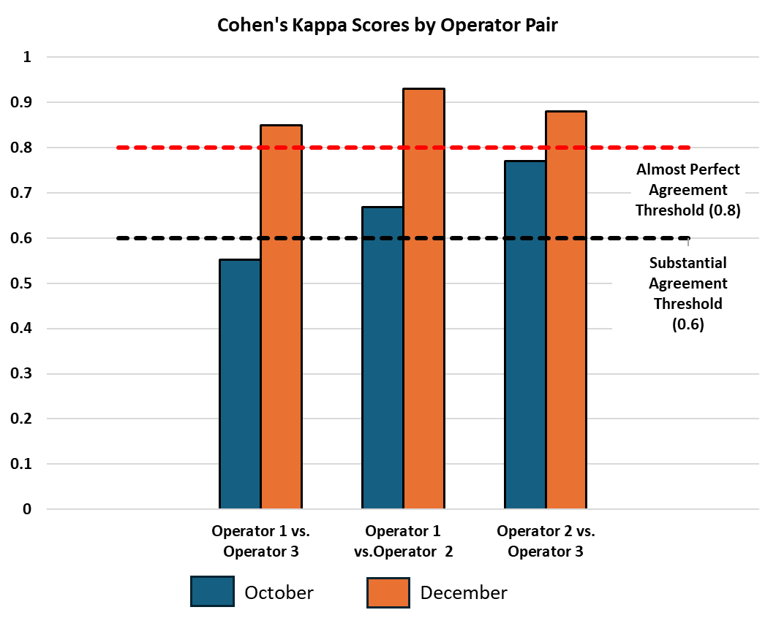

Fig. S4 Forest plot showing magnitude of beta coefficient and 95% confidence interval (CI) estimates of the relation between any visible bulldozer activity at the coal terminal and changes in PM₁, PM_{2.5}, PM₁₀, and total suspended particles (TSP) and black carbon (BC) stratified by time periods that were downwind of the coal terminal versus not at 5-minute average time intervals, Curtis Bay, Baltimore, Maryland, U.S., 2022-2023.
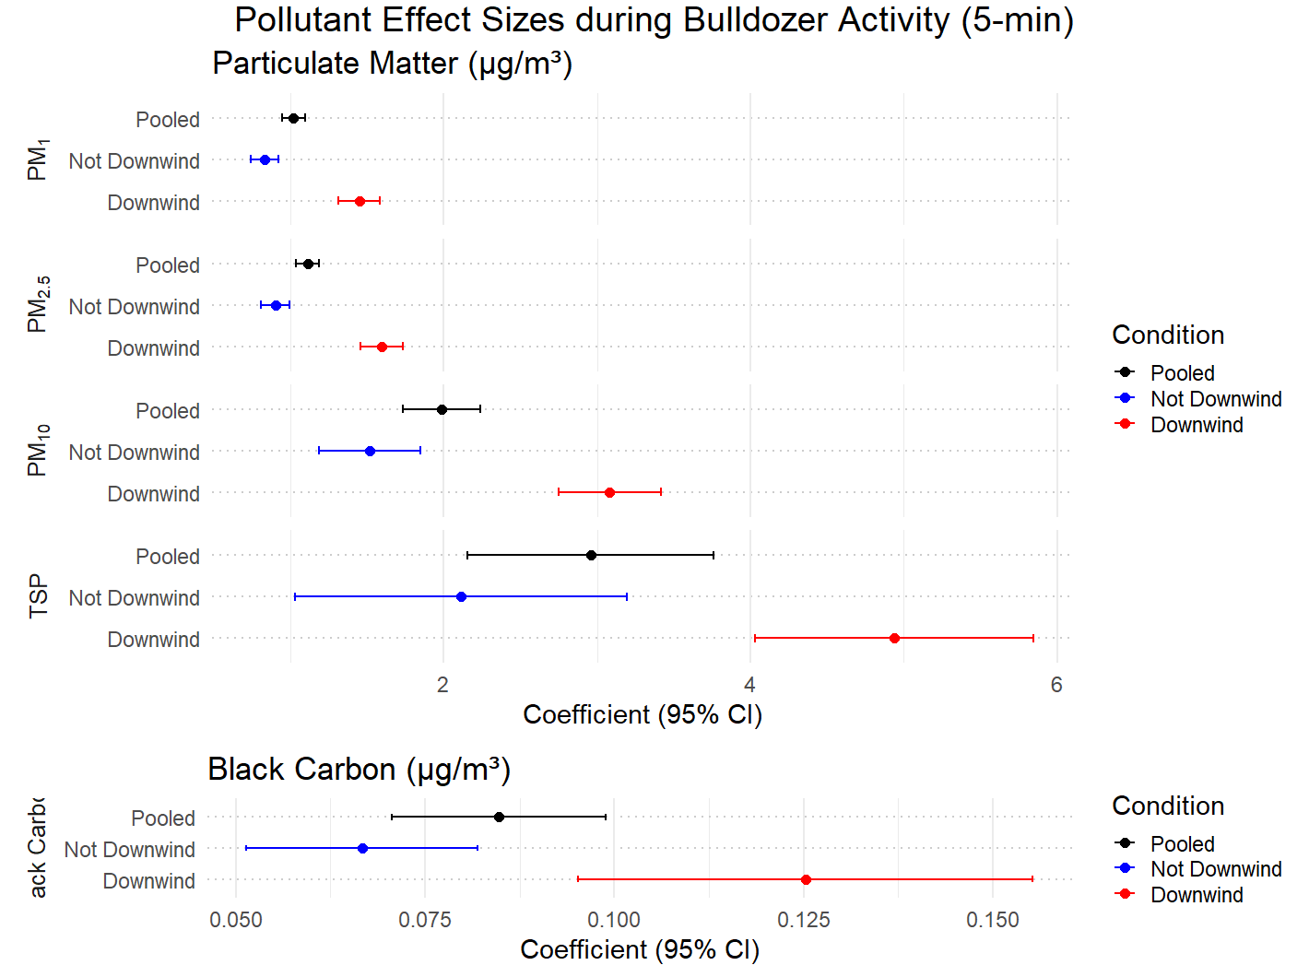
Black Carbon
Note. Binary any visible bulldozer activity versus none was defined as: Greater than the mean of the sum of single minutes within 5-min time periods that had any visible bulldozer activity=1; less than the mean of the sum of single minutes within 5-min time periods that had any visible bulldozer activity =0. All p-interaction values < 0.001 for PM₁, PM_{2.5}, PM₁₀, and BC. Coefficient = Beta coefficient of conditional fixed effects linear regression model for the relation between any visible bulldozer activity at the coal terminal and air pollutant levels.

Fig. S5 Forest plot showing magnitude of beta coefficient and 95% confidence interval (CI) estimates of the relation between any visible bulldozer activity at the coal terminal and changes in PM₁, PM_{2.5}, PM₁₀, and total suspended particles (TSP) and black carbon (BC) stratified by time periods that were downwind of the coal terminal versus not at 15-minute average time intervals, Curtis Bay, Baltimore, Maryland, U.S., 2022-2023.
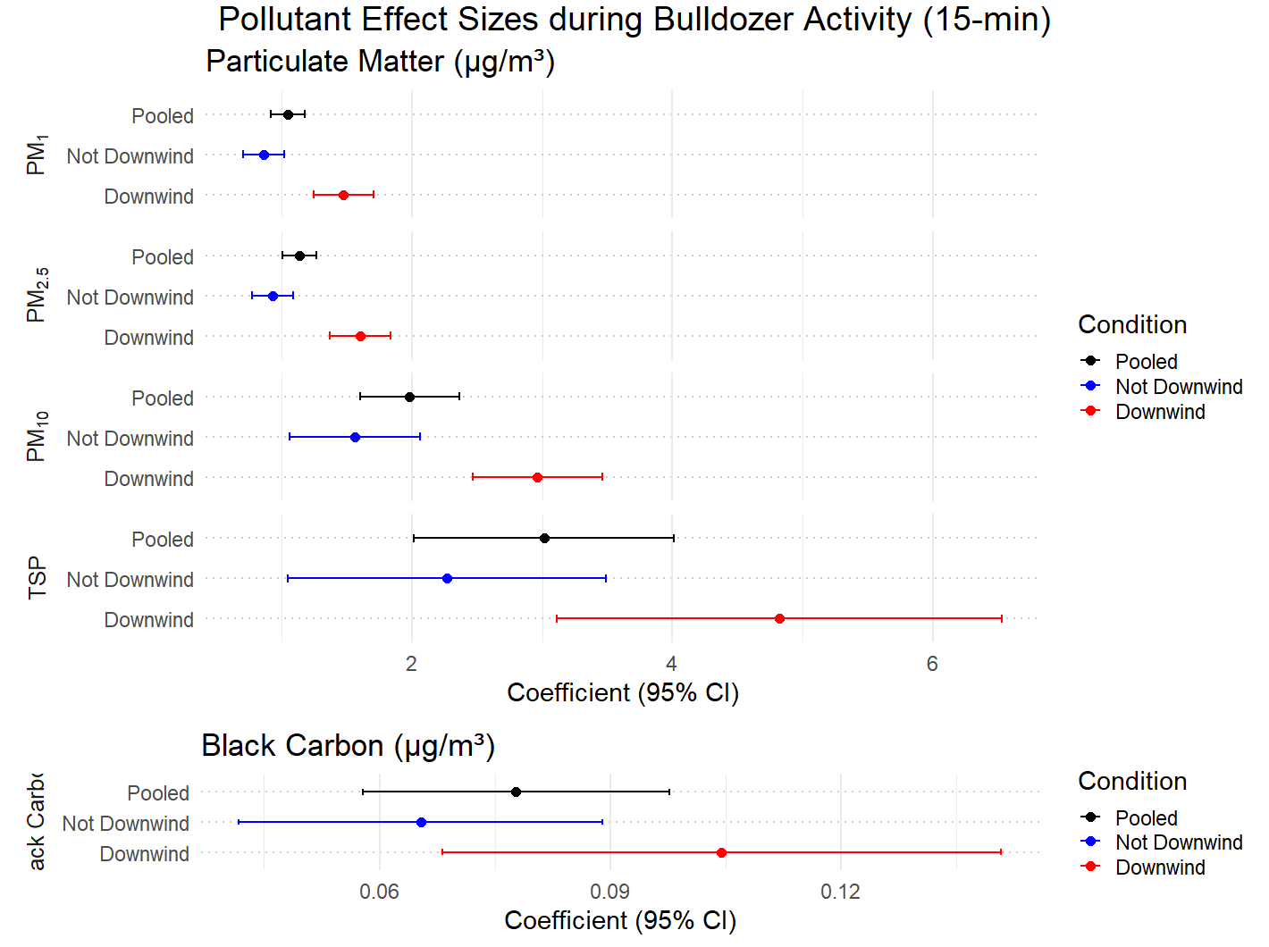
Black Carbon
Black Carbon
Note. Binary any visible bulldozer activity versus none was defined as: Greater than the mean of the sum of single minutes within 15-min time periods that had any visible bulldozer activity=1; less than or equal to the mean of the sum of single minutes within 15-min time periods that had any visible bulldozer activity =0. All p-interaction values < 0.001 for PM₁ and PM_{2.5}. Coefficient = Beta coefficient of conditional fixed effects linear regression model for the relation between any visible bulldozer activity at the coal terminal and air pollutant levels.

Fig. S6 Forest plot showing magnitude of beta coefficient and 95% confidence interval (CI) estimates of the relation between any visible bulldozer activity at the coal terminal and changes in PM₁, PM_{2.5}, PM₁₀, and total suspended particles (TSP) and black carbon (BC) stratified by time periods that were downwind of the coal terminal versus not at 60-minute average time intervals, Curtis Bay, Baltimore, Maryland, U.S., 2022-2023.
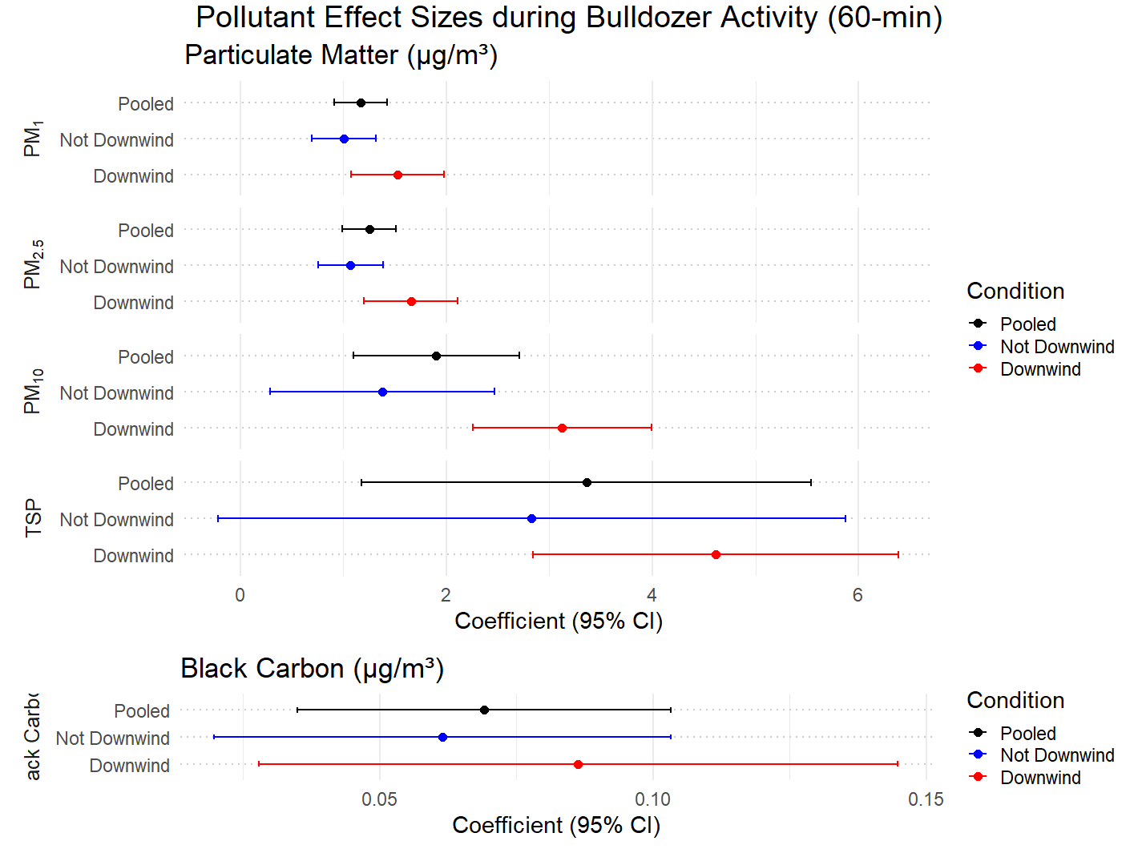
Black Carbon
Black Carbon
Black Carbon
Note. Binary any visible bulldozer activity versus none was defined as: Greater than the mean of the sum of single minutes within 60-min time periods that had any visible bulldozer activity=1; less than or equal to the mean of the sum of single minutes within 60-min time periods that had any visible bulldozer activity =0. All p-interaction values < 0.001 for PM₁ and PM_{2.5}. Coefficient = Beta coefficient of conditional fixed effects linear regression model for the relation between any visible bulldozer activity at the coal terminal and air pollutant levels.

Fig. S7 Forest plot showing magnitude of beta coefficient and 95% confidence interval (CI) estimates of the relation between any visible bulldozer activity at the coal terminal and changes in carbon monoxide (CO), nitric oxide (NO), nitrogen dioxide (NO₂), and ozone (O₃) gases stratified by time periods that were downwind of the coal terminal versus not at 1-minute average time intervals, Curtis Bay, Baltimore, Maryland, U.S., 2022-2023.
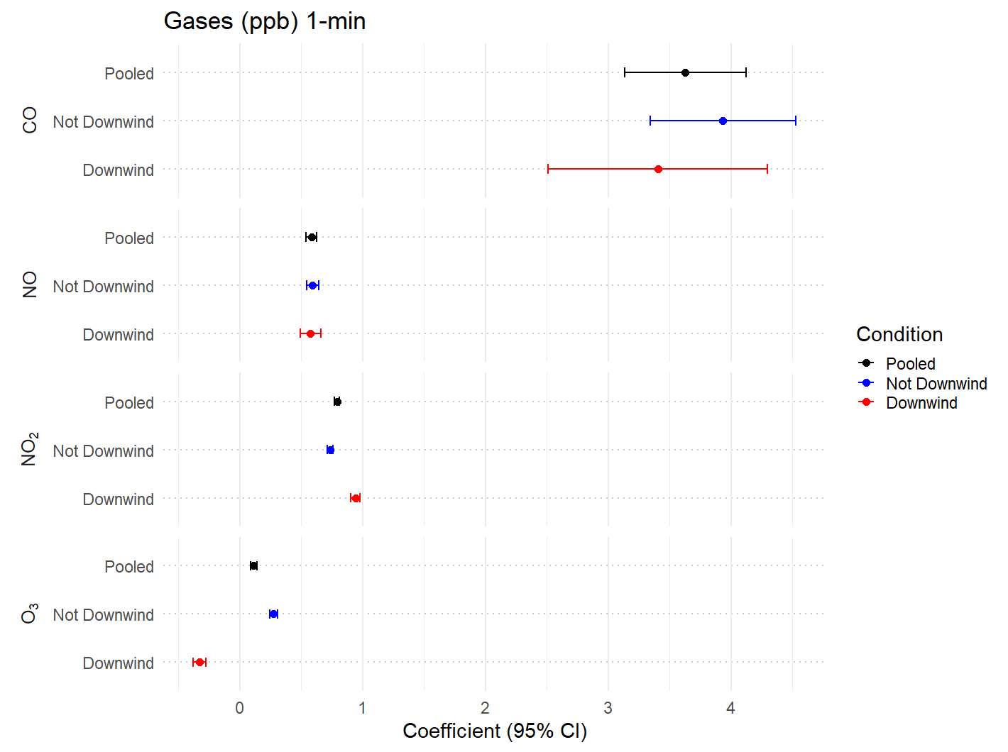
Note. All p-interaction values < 0.001 for NO₂ and O₃. Coefficient = Beta coefficient of conditional fixed effects linear regression model for the relation between any visible bulldozer activity at the coal terminal and gas air pollutant levels.

Fig. S8 Forest plot showing magnitude of beta coefficient and 95% confidence interval (CI) estimates of the relation between any visible bulldozer activity at the coal terminal and changes in carbon monoxide (CO), nitric oxide (NO), nitrogen dioxide (NO₂), and ozone (O₃) gases stratified by time periods that were downwind of the coal terminal versus not at 5-minute average time intervals, Curtis Bay, Baltimore, Maryland, U.S., 2022-2023.
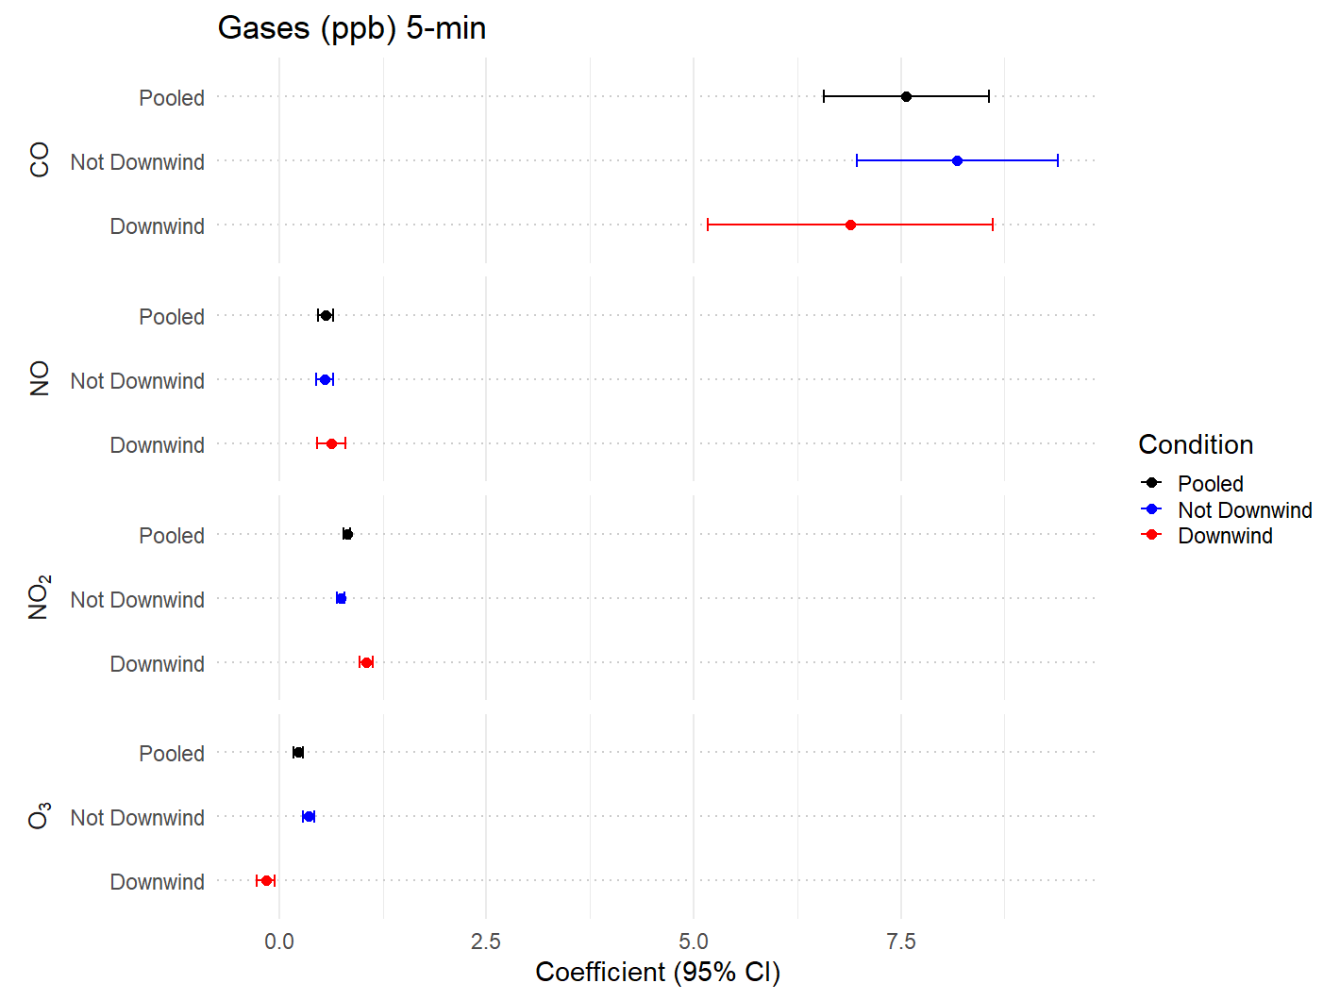
Note. Binary any visible bulldozer activity versus none was defined as: Greater than the mean of the sum of single minutes within 5-min time periods that had any visible bulldozer activity=1; less than or equal to the mean of the sum of single minutes within 5-min time periods that had any visible bulldozer activity =0. All p-interaction values < 0.001 for NO₂ and O₃. Coefficient = Beta coefficient of conditional fixed effects linear regression model for the relation between any visible bulldozer activity at the coal terminal and gas air pollutant levels.

Fig. S9 Forest plot showing magnitude of beta coefficient and 95% confidence interval (CI) estimates of the relation between any visible bulldozer activity at the coal terminal and changes in carbon monoxide (CO), nitric oxide (NO), nitrogen dioxide (NO₂), and ozone (O₃) gases stratified by time periods that were downwind of the coal terminal versus not at 15-minute average time intervals, Curtis Bay, Baltimore, Maryland, U.S., 2022-2023.
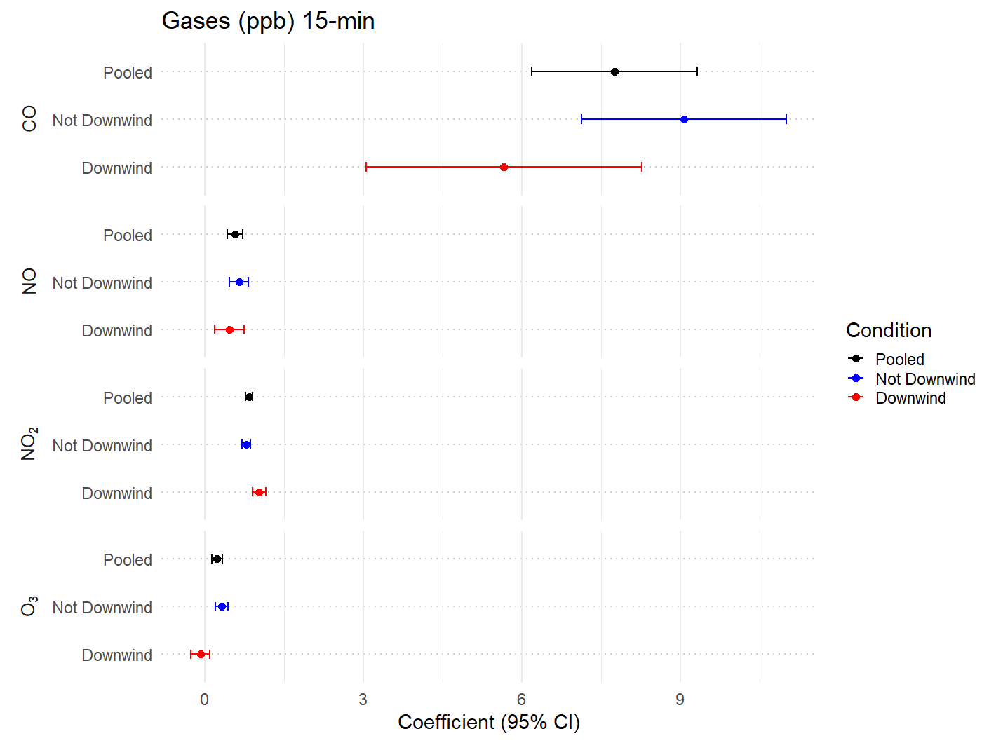
Note. Binary any visible bulldozer activity versus none was defined as: Greater than the mean of the sum of single minutes within 15-min time periods that had any visible bulldozer activity=1; less than or equal to the mean of the sum of single minutes within 15-min time periods that had any visible bulldozer activity =0. All p-interaction values < 0.001 for NO₂ and O₃. Coefficient = Beta coefficient of conditional fixed effects linear regression model for the relation between any visible bulldozer activity at the coal terminal and gas air pollutant levels.

Fig. S10 Forest plot showing magnitude of beta coefficient and 95% confidence interval (CI) estimates of the relation between any visible bulldozer activity at the coal terminal and changes in carbon monoxide (CO), nitric oxide (NO), nitrogen dioxide (NO₂), and ozone (O₃) gases stratified by time periods that were downwind of the coal terminal versus not at 60-minute average time intervals, Curtis Bay, Baltimore, Maryland, U.S., 2022-2023.
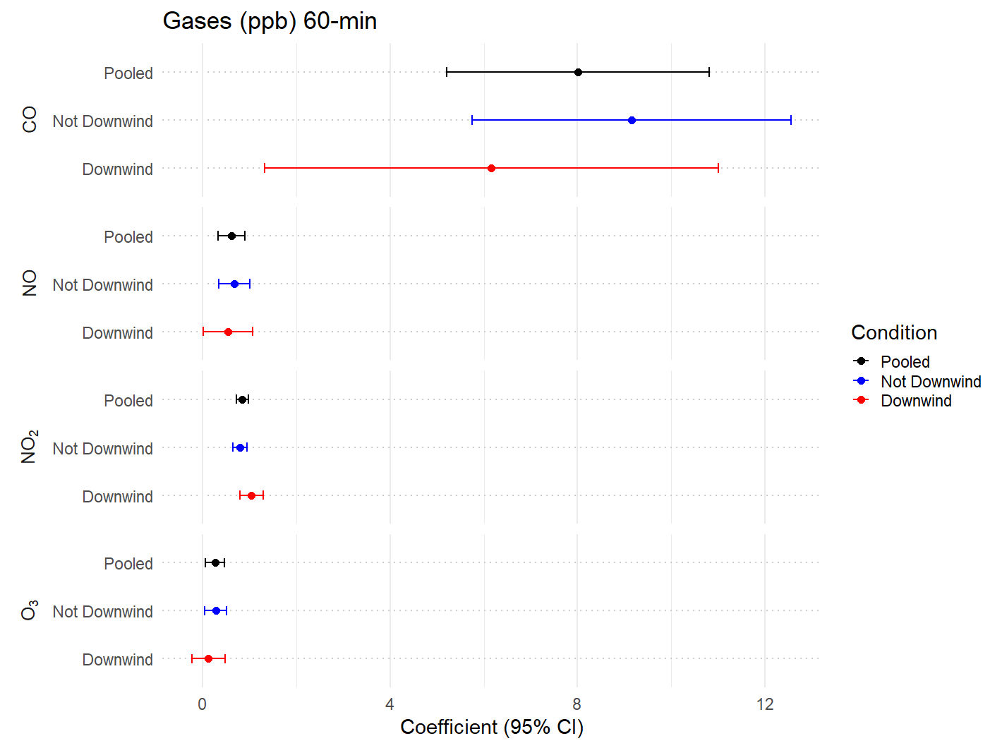
Note. Binary any visible bulldozer activity versus none was defined as: Greater than the mean of the sum of single minutes within 60-min time periods that had any visible bulldozer activity=1; less than or equal to the mean of the sum of single minutes within 60-min time periods that had any visible bulldozer activity =0. Coefficient = Beta coefficient of conditional fixed effects linear regression model for the relation between any visible bulldozer activity at the coal terminal and gas air pollutant levels.

Table S1. Full range of deployment dates by location within a ten-node multi-pollutant air sensor network unrestricted by trail camera availability, Curtis Bay, Baltimore, Maryland, U.S., 2022-2023.
Location | Deployment Start | Deployment End
1 | 07.14.2022 | 03.21.2023
 | 4.12.2023 | 07.17.2023
2 | 11.11.2022 | 06.19.2023
3 | 10.07.2022 | 04.20.2023
4 | 09.14.2022 | 07.17.2023
5 | 07.05.2022 | 07.17.2023
6 | 11.08.2022 | 07.17.2023
7 | 11.29.2022 | 04.30.2023
8 | 07.26.2022 | 06.26.2023
9 | 02.15.2023 | 07.17.203
10 | 07.10.2022 | 02.28.2023
 | 03.15.2023 | 06.14.2023

Table S2a. MODULAIR PM_{2.5} FRM collocation results (July-August 2023).
PM_{2.5} | Bias & Linearity |  |  | Data Quality
PM_{2.5} | R² | Slope | Intercept (b) | Number of paired values (hours)
Metric Target Range* | ≤0.70 | 1.0 ± 0.35 | -5 ≤ b ≤ 5 | --
MOD-00095 | 0.76 | 0.85 | 0.69 | 397
MOD-00096 | 0.75 | 0.89 | 0.66 | 397
MOD-00097 | 0.70 | 1.02 | -0.06 | 342
MOD-00098 | 0.70 | 0.80 | 0.84 | 397
MOD-00100 | 0.70 | 0.84 | 1.02 | 397
MOD-00102 | 0.71 | 0.89 | 0.57 | 397
MOD-00129 | 0.87 | 0.83 | 1.67 | 389
MOD-00131 | 0.87 | 0.89 | 1.75 | 389
MOD-00135 | 0.86 | 0.93 | 1.32 | 397
MOD-00136 | 0.86 | 0.91 | 1.41 | 397
MOD-00137 | 0.88 | 0.94 | 1.43 | 397

 | Precision (between collocated sensors)
 | CV (%) | SD (µg/m³)
Metric Target Range | ≤ 30.0 | ≤ 5.0
Deployment Value | 12.1 | 1.07

Note. PM = particulate matter; FRM = Federal Reference Method; CV% = coefficient of variation; SD = standard deviation.
Table S2b. MODULAIR PM₁₀ FRM collocation results (July-August 2023).
PM₁₀ | Bias & Linearity |  |  | Data Quality
PM₁₀ | R² | Slope | Intercept (b) | Number of paired values (hours)
Metric Target Range* | ≥0.70 | 1.0 ± 0.35 | -5 ≤ b ≤ 5 | --
MOD-00095 | 0.74 | 0.83 | 2.7 | 397
MOD-00096 | 0.72 | 0.62 | 2.5 | 397
MOD-00097 | 0.71 | 1.21 | -0.3 | 342
MOD-00098 | 0.71 | 0.91 | 5.0 | 397
MOD-00100 | 0.75 | 0.70 | 3.7 | 397
MOD-00102 | 0.78 | 0.75 | 2.4 | 397
MOD-00129 | 0.75 | 1.10 | 2.1 | 389
MOD-00131 | 0.75 | 1.06 | 2.3 | 389
MOD-00135 | 0.70 | 1.09 | 4.2 | 397
MOD-00136 | 0.74 | 1.00 | 3.7 | 397
MOD-00137 | 0.77 | 0.94 | 3.4 | 397

 | Precision (between collocated sensors)
 | CV (%) | SD (µg/m³)
Metric Target Range | ≤ 30.0 | ≤ 5.0
Deployment Value | 22.7 | 4.38

Note. PM = particulate matter; FRM = Federal Reference Method; CV% = coefficient of variation; SD = standard deviation.

Table S3. Relation between monitor being downwind of the coal terminal and pollutant concentration for Locations 1-4 (1-min time scale), Curtis Bay, Maryland, U.S., 2022-2023.
 | No. of records | Mean of pollutant (SD) | Downwind Beta Coefficientª | 95% CI | t-value | p-value
PM₁ (µg/m³)
Downwind of coal terminal yes=1; no=0) | 882,499 | 8.6 (7.1) | 0.82 | 0.79, 0.85 | 55.3 | <0.0001
PM_{2.5} (µg/m³)
Downwind of coal terminal (yes=1; no=0) | 880,673 | 9.4 (7.5) | 1.24 | 1.21, 1.27 | 80.3 | <0.0001
PM₁₀ (µg/m³)
Downwind of coal terminal (yes=1; no=0) | 880,673 | 23.3 (41.3) | 5.9 | 5.7, 6.1 | 65.4 | <0.0001
TSP (µg/m³)
Downwind of coal terminal (yes=1; no=0) | 880,673 | 34.3 (160.6) | 7.5 | 6.7, 8.2 | 20.5 | <0.0001
Black Carbon (µg/m³)
Downwind of coal terminal (yes=1; no=0) | 212,707 | 0.88 (1.5) | 0.12 | 0.11, 0.14 | 20.0 | <0.0001
ªThe beta coefficient is the increase in air pollutant (per µg/m³) when the monitor was downwind of the coal terminal versus not downwind. Coefficients are derived from conditional fixed effects linear regression models adjusted for temperature (ºCelsius), wind speed (mph), solar radiation (watts per square meter), NO (ppb), and time of day (AM/PM).
Note. PM = particulate matter; TSP = total suspended particles; SD = standard deviation; CI = confidence interval.

Table S4. Relation between monitor being downwind of the coal terminal and pollutant concentration for Locations 5-10 (1-min time scale), Curtis Bay, Maryland, U.S., 2022-2023.
 | No. of records | Mean of pollutant (SD) | Downwind Beta Coefficientª | 95% CI | t-value | p-value
PM₁ (µg/m³)
Downwind of coal terminal yes=1; no=0) | 1,156,416 | 8.1 (5.8) | 0.46 | 0.44, 0.49 | 36.6 | <0.0001
PM_{2.5} (µg/m³)
Downwind of coal terminal (yes=1; no=0) | 1,154,869 | 8.9 (6.2) | 0.58 | 0.56, 0.61 | 44.0 | <0.0001
PM₁₀ (µg/m³)
Downwind of coal terminal (yes=1; no=0) | 1,154,869 | 23.6 (67.8) | 2.0 | 1.7, 2.3 | 12.7 | <0.0001
TSP (µg/m³)
Downwind of coal terminal (yes=1; no=0) | 1,154,869 | 36.5 (249.1) | 3.1 | 1.9, 4.2 | 5.3 | <0.0001
Black Carbon (µg/m³)
Downwind of coal terminal (yes=1; no=0) | 149,156 | 0.60 (0.74) | 0.07 | 0.06, 0.74 | 17.8 | <0.0001
ªThe beta coefficient is the increase in air pollutant (per µg/m³) when the monitor was downwind of the coal terminal versus not downwind. Coefficients are derived from conditional fixed effects linear regression models adjusted for temperature (ºCelsius), wind speed (mph), solar radiation (watts per square meter), NO (ppb), and time of day (AM/PM).
Note. PM = particulate matter; TSP = total suspended particles; SD = standard deviation; CI = confidence interval.

Table S5. Relation between any visible bulldozer activity at the coal terminal and air pollutant levels, stratified by wind direction for Locations 1-4 (1-min time scale), Curtis Bay, Maryland, U.S., 2022-2023.
 | No. of | 1-min mean | Visible Bulldozer Beta
 | records | air pollutant (SD) | Coefficientª | 95% CI | t-value | p-interaction
Any visible coal terminal bulldozer activity (yes=1; no=0)
PM₁ (µg/m³)^{b} | 882,499 | 8.6 (7.1) | 0.51*** | 0.48, 0.53 | 35.9
Wind direction (downwind of coal terminal) | 292,815 | 9.3 (6.8) | 0.89*** | 0.85, 0.94 | 39.1 | <0.0001
Wind direction (not downwind of coal terminal) | 589,684 | 8.2 (7.2) | 0.30*** | 0.27, 0.34 | 17.1 | <0.0001
PM_{2.5} (µg/m³)^{b} | 880,673 | 9.4 (7.5) | 0.60*** | 0.58, 0.63 | 41.2
Wind direction (downwind of coal terminal) | 292,180 | 10.4 (7.3) | 1.05*** | 1.01, 1.10 | 43.8 | <0.0001
Wind direction (not downwind of coal terminal) | 588,493 | 8.9 (7.5) | 0.37*** | 0.33, 0.40 | 20.1 | <0.0001
PM₁₀ (µg/m³)^{b} | 880,673 | 23.3 (41.3) | 1.6*** | 1.5, 1.8 | 19.0
Wind direction (downwind of coal terminal) | 292,180 | 28.1 (44.7) | 2.6*** | 2.3, 3.0 | 16.7 | <0.0001
Wind direction (not downwind of coal terminal) | 588,493 | 21.0 (39.3) | 1.1*** | 0.91, 1.3 | 11.0 | <0.0001
TSP (µg/m³)^{b} | 878,673 | 34.3 (160.6) | 2.9*** | 2.2, 3.6 | 8.4
Wind direction (downwind of coal terminal) | 292,180 | 40.8 (166.5) | 5.1*** | 3.9, 6.3 | 8.2 | <0.0001
Wind direction (not downwind of coal terminal) | 588,493 | 31.1 (157.6) | 1.8*** | 1.0, 2.7 | 4.4 | <0.0001
Black carbon (µg/m³)^{c} | 212,707 | 0.88 (1.5) | 0.16*** | 0.15, 0.18 | 27.9
Wind direction (downwind of coal terminal) | 71,820 | 0.98 (1.5) | 0.21*** | 0.19, 0.23 | 19.5 | <0.0001
Wind direction (not downwind of coal terminal) | 140,887 | 0.83 (1.5) | 0.14*** | 0.13, 0.16 | 20.6 | <0.0001

ªThe beta coefficient is the increase in air pollutant (per µg/m³) when any bulldozer activity was versus was not observed. Coefficients are derived from conditional fixed effects linear regression models adjusted for temperature (ºCelsius), wind speed (mph), solar radiation (watts per square meter), NO (ppb), and time of day (AM/PM).
^{b}Models include data from air monitoring locations 1 through 4.
^{c}Models include data from air monitoring locations 1 and 2.
*p-value <0.05, **p-value <0.01, ***p-value <0.001
Note. PM = particulate matter; TSP = total suspended particles; SD = standard deviation; CI = confidence interval.
Table S6. Relation between any visible bulldozer activity at the coal terminal and air pollutant levels, stratified by wind direction for Locations 5-10 (1-min time scale), Curtis Bay, Maryland, U.S., 2022-2023.
 | No. of | 1-min mean | Visible Bulldozer Beta
 | records | air pollutant (SD) | Coefficientª | 95% CI | t-value | p-interaction
Any visible coal terminal bulldozer activity (yes=1; no=0)
PM₁ (µg/m³)^{b} | 1,156,416 | 8.1 (5.8) | 0.32*** | 0.30, 0.34 | 30.6
Wind direction (downwind of coal terminal) | 286,830 | 8.7 (6.5) | 0.61*** | 0.57, 0.66 | 26.2 | <0.0001
Wind direction (not downwind of coal terminal) | 869,586 | 7.9 (5.6) | 0.22*** | 0.20, 0.25 | 20.0 | <0.0001
PM_{2.5} (µg/m³)^{b} | 1,154,869 | 8.9 (6.2) | 0.40*** | 0.37, 0.41 | 36.2
Wind direction (downwind of coal terminal) | 286,350 | 9.6 (6.8) | 0.73*** | 0.68, 0.78 | 30.4 | <0.0001
Wind direction (not downwind of coal terminal) | 868,519 | 8.7 (6.0) | 0.28*** | 0.26, 0.31 | 23.7 | <0.0001
PM₁₀ (µg/m³)^{b} | 1,154,869 | 23.6 (67.8) | 1.1*** | 0.8, 1.3 | 8.5
Wind direction (downwind of coal terminal) | 286,350 | 22.8 (42.7) | 2.1*** | 1.7, 2.4 | 13.0 | <0.002
Wind direction (not downwind of coal terminal) | 868,519 | 23.9 (74.2) | 0.7*** | 0.4, 1.1 | 4.7 | <0.002
TSP (µg/m³)^{b} | 1,154,868 | 36.5 (249.1) | 1.6** | 0.7, 2.5 | 3.5
Wind direction (downwind of coal terminal) | 286,350 | 34.1 (160.0) | 2.7*** | 1.5, 3.9 | 4.4 | <0.6
Wind direction (not downwind of coal terminal) | 868,518 | 37.3 (272.1) | 1.3* | 0.1, 2.4 | 2.1 | <0.6
Black carbon (µg/m³)^{c} | 149,156 | 0.6 (0.74) | -0.01* | -0.02, -0.003 | -3.2
Wind direction (downwind of coal terminal) | 40,278 | 0.71 (0.74) | 0.01 | -0.004, 0.02 | 1.3 | <0.0001
Wind direction (not downwind of coal terminal) | 108,878 | 0.57 (0.74) | -0.02*** | -0.02, -0.01 | -4.7 | <0.0001
ªThe beta coefficient is the increase in air pollutant (per µg/m³) when any bulldozer activity was versus was not observed. Coefficients are derived from conditional fixed effects linear regression models adjusted for temperature (ºCelsius), wind speed (mph), solar radiation (watts per square meter), NO (ppb), and time of day (AM/PM).
^{b}Models include data from air monitoring locations 5 through 10.
^{c}Models include data from air monitoring locations 5 and 8.
*p-value <0.05, **p-value <0.01, ***p-value <0.001
Note. PM = particulate matter; TSP = total suspended particles; SD = standard deviation; CI = confidence interval.

Table S7. Descriptive statistics for nitric oxide (NO), nitrogen dioxide (NO₂), carbon monoxide (CO)and ozone (O₃) in parts per billion (ppb) using the MODULAIR at 1-minute time interval, Curtis Bay, Baltimore, Maryland, U.S., 2022-2023.
 |  | Location
Covariate |  | 1 | 2 | 3 | 4 | 5 | 6 | 7 | 8 | 9 | 10
NO (ppb) | n | 277,718 | 157,867 | 192,208 | 260,192 | 291,563 | 229,053 | 126,294 | 198,566 | 123,513 | 216,613
NO (ppb) | min | 0.02 | 0.01 | 0.39 | 0.02 | 0.02 | 0.00 | 0.11 | 0.00 | 0.12 | 0.03
NO (ppb) | mean (SD) | 9.4 (17.0) | 9.6 (16.9) | 14.5 (21.1) | 8.3 (15.2) | 5.7 (11.1) | 10.0 (15.5) | 9.2 (13.7) | 6.8 (12.5) | 7.0 (10.2) | 12.5 (22.9)
NO (ppb) | max | 462.1 | 186.4 | 316.0 | 319.1 | 195.0 | 226.9 | 145.4 | 188.3 | 152.5 | 379.2
NO₂ (ppb) | n | 276,345 | 162,984 | 192,890 | 270,809 | 291,797 | 232,240 | 124,020 | 200,260 | 124,933 | 218,366
NO₂ (ppb) | min | 0.00 | 0.00 | 0.00 | 0.00 | 1.11 | 0.00 | 0.00 | 0.03 | 0.00 | 0.00
NO₂ (ppb) | mean (SD) | 10.8  (7.4) | 10.4  (8.0) | 12.1 (8.6) | 10.8 (7.0) | 24.2 (8.9) | 11.3 (7.1) | 7.1 (5.8) | 14.3 (8.1) | 7.3 (4.7) | 13.6 (8.5)
NO₂ (ppb) | max | 99.3 | 52.3 | 90.3 | 55.4 | 83.5 | 82.9 | 207.2 | 124.3 | 45.0 | 64.6
CO (ppb) | n | 277,848 | 164,930 | 193,663 | 271,130 | 291,449 | 232,190 | 147,894 | 200,390 | 126,622 | 218,988
CO (ppb) | min | 2.5 | 18.6 | 63.3 | 0.18 | 0.06 | 0.05 | 50.7 | 68.0 | 0.50 | 1.8
CO (ppb) | mean (SD) | 293.3 (214.3) | 290.0 (153.1) | 300.7 (269.0) | 307.7 (297.8) | 244.8 (134.8) | 290.0 (140.7) | 263.6 (110.3) | 260.3 (134.9) | 257.5 (127.8) | 252.5 (117.7)
CO (ppb) | max | 11,313.5 | 2,795.9 | 11,347.9 | 11,447.4 | 11,089.2 | 10,282.3 | 5,991.5 | 10,496.6 | 5,805.1 | 2,843.9
O₃ (ppb) | n | 277,378 | 164,809 | 193,130 | 271,549 | 291,650 | 232,445 | 147,895 | 199,650 | 126,662 | 218,990
O₃ (ppb) | min | 0.00 | 0.05 | 0.00 | 0.04 | 0.02 | 0.07 | 0.67 | 0.00 | 3.5 | 0.54
O₃ (ppb) | mean (SD) | 35.1 (12.6) | 35.1 (14.0) | 34.0 (11.9) | 31.7 (12.8) | 30.8 (11.8) | 36.1 (15.1) | 33.7 (12.9) | 35.4 (13.2) | 42.3 (13.7) | 31.45 (14.0)
O₃ (ppb) | max | 74.2 | 119.8 | 80.3 | 83.7 | 74.4 | 151.7 | 135.7 | 103.6 | 127.1 | 94.5
Note: Sample size determined by available non-missing trail camera data. SD = standard deviation.
Table S8. Mean and standard deviation of PM₁, PM_{2.5}, PM₁₀, total suspended particles (TSP) and black carbon (BC) in µg/m³ at 1-, 5-, 15-, and 60-minute time weighted average intervals, stratified by corresponding the time period’s status as downwind of the coal terminal vs. not and any visible bulldozer activity vs. none, Curtis Bay, Maryland, U.S., 2022-2023.
 |  | 1-minute |  | 5-minuteª |  | 15-minuteª |  | 60-minuteª
 |  | Visible Bulldozer Activity
 |  | No | Yes | No | Yes | No | Yes | No | Yes
PM₁ (µg/m³) | Not downwind of coal terminal | 7.8  (5.9) | 8.0 (6.5) | 8.9 (11.5) | 9.5 (13.8) | 8.9  (11.5) | 9.5  (14.0) | 8.8 (10.6) | 9.6 (14.6)
 | Downwind of coal terminal | 8.7  (6.3) | 9.4 (7.1) | 9.8 (11.5) | 11.1 (14.2) | 9.8  (11.1) | 11.0  (14.1) | 9.7 (10.1) | 11.0 (14.6)
PM_{2.5} (µg/m³) | Not downwind of coal terminal | 8.5  (5.9) | 8.8 (6.4) | 9.7 (11.6) | 10.3 (13.8) | 9.6  (11.5) | 10.3  (14.0) | 9.6 (10.6) | 10.4 (14.6)
 | Downwind of coal terminal | 9.6  (6.3) | 10.5 (7.1) | 10.8 (11.5) | 12.1 (14.2) | 10.7  (11.1) | 12.1 (14.0) | 10.6 (10.1) | 12.0 (14.6)
PM₁₀ (µg/m³) | Not downwind of coal terminal | 21.9  (56.2) | 23.5 (73.8) | 23.2 (44.2) | 25.2 (51.5) | 213.1 (40.6) | 25.3 (43.6) | 23.4 (49.7) | 25.4 (24.0)
 | Downwind of Coal Terminal | 24.2  (45.1) | 27.1 (41.7) | 25.2 (30.7) | 28.5 (35.6) | 25.4  (28.0) | 28.4 (31.0) | 25.2 (23.0) | 28.3 (25.5)
TSP (µg/m³) | Not downwind of coal terminal | 33.4  (193.4) | 36.4 (278.6) | 35.1 (119.2) | 38.6 (183.8) | 35.0  (91.3) | 38.7 (110.2) | 35.6 (91.8) | 39.8 (149.1)
 | Downwind of coal terminal | 35.4  (156.4) | 40.2 (171.9) | 36.1 (76.6) | 41.5 (92.8) | 36.7  (63.0) | 41.7 (119.4) | 36.3 (48.9) | 41.2 (51.7)
Black Carbon (µg/m³) | Not downwind of coal terminal | 0.67  (0.95) | 0.76 (1.42) | 0.71 (0.83) | 0.80 (1.2) | 0.71  (0.78) | 0.80 (1.1) | 0.71 (0.72) | 0.80 (1.0)
 | Downwind of coal terminal | 0.81  (0.94) | 0.93 (1.60) | 0.85 (0.80) | 0.96 (1.52) | 0.86  (0.73) | 0.94 (1.06) | 0.85 (0.65) | 0.91 (0.85)
ªFor the 5-, 15-, and 60-minute time intervals binary variables were defined as follows. Downwind of the coal terminal versus not: the average wind direction (based on U and V vectors) at each respective time scale was within the range of the pre-specified downwind angle=1; the average wind direction (based on U and V vectors) at each respective time scale was not within the range of the pre-specified downwind angle=0. Any visible bulldozer activity versus none: greater than the mean of the sum of single minutes with any visible bulldozer activity=1; less than or equal to the mean of the sum of single minutes with any visible bulldozer activity=0.
Note. PM = particulate matter.

Table S9. Mean and standard deviation of carbon monoxide (CO), nitric oxide (NO), nitrogen dioxide (NO₂), and ozone (O₃) in parts per billion (ppb) at 1-, 5-, 15-, and 60-minute time weighted average intervals, stratified by corresponding the time period’s status as downwind of the coal terminal vs. not and any visible bulldozer activity vs. none, Curtis Bay, Maryland, U.S., 2022-2023.
 |  | 1-minute |  | 5-minuteª |  | 15-minuteª |  | 60-minuteª
 |  | Visible Bulldozer Activity
 |  | No | Yes | No | Yes | No | Yes | No | Yes
CO (ppb) | Not Downwind of Coal Terminal | 276.9 (183.3) | 284.4 (203.8) | 279.6 (169.3) | 290.2 (194.6) | 279.4 (150.0) | 2891.1 (142.1) | 278.8 (133.5) | 290.8 (171.1)
CO (ppb) | Downwind of Coal Terminal | 266.6 (170.0) | 273.5 (192.5) | 271.1 (154.4) | 279.8 (180.8) | 270.5 (187.6) | 277.2 (157.7) | 270.1 (134.5) | 276.8 (145.0)
NO (ppb) | Not Downwind of Coal Terminal | 8.4  (15.5) | 9.7  (16.8) | 8.2  (14.6) | 9.4  (16.0) | 8.2  (14.2) | 9.5  (15.7) | 8.1  (13.4) | 9.5  (15.0)
NO (ppb) | Downwind of Coal Terminal | 9.2  (16.8) | 10.7 (17.5) | 9.1  (16.4) | 10.5 (17.0) | 9.1  (16.2) | 10.3  (16.2) | 9.1  (15.4) | 10.3  (15.7)
NO₂ (ppb) | Not Downwind of Coal Terminal | 12.0  (8.6) | 12.8  (9.1) | 11.5  (8.1) | 12.3  (8.7) | 11.3  (8.0) | 12.2  (8.6) | 11.1  (7.7) | 12.0  (8.3)
NO₂ (ppb) | Downwind of Coal Terminal | 14.3  (9.5) | 15.3  (9.9) | 15.1  (9.7) | 16.1 (10.1) | 15.3  (9.7) | 16.3  (10.0) | 15.4  (9.5) | 16.4  (9.9)
O₃ (ppb) | Not Downwind of Coal Terminal | 34.7  (13.4) | 34.3 (14.0) | 35.3 (13.6) | 35.0 (14.3) | 35.4 (13.5) | 35.0  (14.3) | 35.5 (13.3) | 35.0  (14.2)
O₃ (ppb) | Downwind of Coal Terminal | 33.4  (12.9) | 32.3 (13.0) | 33.3 (13.2) | 32.4 (13.7) | 33.3 (13.1) | 32.5  (13.5) | 33.1 (12.8) | 32.7  (13.3)
ªFor the 5-, 15-, and 60-minute time intervals binary variables were defined as follows. Binary downwind of the coal terminal versus not defined as: the average wind direction (based on U and V vectors) at each respective time scale was within the range of the pre-specified downwind angle=1; the average wind direction (based on U and V vectors) at each respective time scale was not within the range of the pre-specified downwind angle=0. Binary any visible bulldozer activity versus none defined as: greater than the mean of the sum of single minutes with any visible bulldozer activity=1; less than or equal to the mean of the sum of single minutes with any visible bulldozer activity=0.

Table S10. Relation of changes in downwind of the coal terminal versus not and changes in PM₁, PM_{2.5}, PM₁₀, total suspended particles (TSP) and black carbon (BC) air pollutant concentrations at 5-min average time scale, Curtis Bay, Maryland, U.S., 2022-2023.
 | No. of records | 5-min mean (SD)  air pollutant | Downwind Beta Coefficientª | 95% CI | t-value | p-value
PM₁ (µg/m³)
Downwind of coal terminal (yes=1; no=0)^{b} | 428,504 | 9.6 (12.8) | 0.41 | 0.33, 0.50 | 9.3 | <0.0001
PM_{2.5} (µg/m³)
Downwind of coal terminal (yes=1; no=0) ^{b} | 427,936 | 10.5 (13.0) | 0.71 | 0.62, 0.80 | 15.8 | <0.0001
PM₁₀ (µg/m³)
Downwind of coal terminal (yes=1; no=0) ^{b} | 427,936 | 25.0 (43.3) | 4.0 | 3.7, 4.3 | 26.7 | <0.0001
TSP (µg/m³)
Downwind of coal terminal (yes=1; no=0) ^{b} | 427,936 | 37.3 (133.6) | 5.1 | 4.1, 6.0 | 10.7 | <0.0001
Black Carbon (µg/m³)
Downwind of coal terminal (yes=1; no=0) ^{b} | 74,782 | 0.79 (1.1) | 0.12 | 0.11, 0.14 | 15.5 | <0.0001
ªThe beta coefficient is the increase in 5-min mean air pollutant (per µg/m³ when the monitor was downwind of the coal terminal versus not downwind. Beta coefficients and 95% confidence intervals (CI) are derived from conditional fixed effects linear regression models adjusted for temperature (ºC), wind speed (mph), solar radiation (1-hour mean watts per square meter), NO (ppb), and time of day (AM/PM). ​
^{b}The binary variable of downwind of the coal terminal versus not was defined as follows: 5-min average wind direction (based on U and V vectors) was within the range of the pre-specified downwind angle=1; the 5-min average wind direction (based on U and V vectors) was not within the range of the pre-specified downwind angle=0.
Note. PM = particulate matter.

Table S11. Relation of changes in downwind of the coal terminal versus not and changes in PM₁, PM_{2.5}, PM₁₀, total suspended particles (TSP) and black carbon (BC) air pollutant concentrations at 15-min average time scale, Curtis Bay, Maryland, U.S., 2022-2023.
 | No. of records | 15-min mean (SD) air pollutant | Downwind Beta Coefficientª | 95% CI | t-value | p-value
PM₁ (µg/m³)
Downwind of coal terminal (yes=1; no=0)^{b} | 142,794 | 9.6 (12.7) | 0.34 | 0.18, 0.49 | 4.4 | <0.0001
PM_{2.5} (µg/m³)
Downwind of coal terminal (yes=1; no=0) ^{b} | 142,685 | 10.5 (12.9) | 0.65 | 0.50, 0.80 | 8.4 | <0.0001
PM₁₀ (µg/m³)
Downwind of coal terminal (yes=1; no=0) ^{b} | 142,685 | 25.0 (38.0) | 4.3 | 3.9, 4.7 | 19.1 | <0.0001
TSP (µg/m³)
Downwind of coal terminal (yes=1; no=0) ^{b} | 142,685 | 37.4 (96.7) | 6.0 | 4.9, 7.2 | 10.2 | <0.0001
Black Carbon (µg/m³)
Downwind of coal terminal (yes=1; no=0) ^{b} | 24,955 | 0.79 (1.0) | 0.12 | 0.09, 0.14 | 10.1 | <0.0001
ªThe beta coefficient is the increase in 15-min mean air pollutant (per µg/m³) when the monitor was downwind of the coal terminal versus not downwind. Beta coefficients and 95% confidence intervals (CI) are derived from conditional fixed effects linear regression models adjusted for temperature (ºC), wind speed (mph), solar radiation (1-hour mean watts per square meter), NO (ppb), and time of day (AM/PM). ​
^{b}The binary variable of downwind of the coal terminal versus not was defined as follows: 15-min average wind direction (based on U and V vectors) was within the range of the pre-specified downwind angle=1; the 15-min average wind direction (based on U and V vectors) was not within the range of the pre-specified downwind angle=0.
Note. PM = particulate matter.

Table S12. Relation of changes in downwind of the coal terminal versus not and changes in PM₁, PM_{2.5}, PM₁₀, total suspended particles (TSP) and black carbon (BC) air pollutant concentrations at 60-min average time scale, Curtis Bay, Maryland, U.S., 2022-2023.
 | No. of records | 60-min mean (SD) air pollutant | Downwind Beta Coefficientª | 95% CI | t-value | p-value
PM₁ (µg/m³)
Downwind of coal terminal (yes=1; no=0)^{b} | 35,374 | 9.6 (12.6) | 0.26 | -0.04, 0.56 | 1.7 | <0.1
PM_{2.5} (µg/m³)
Downwind of coal terminal (yes=1; no=0) ^{b} | 35,370 | 10.4 (12.8) | 0.58 | 0.28, 0.90 | 3.7 | <0.001
PM₁₀ (µg/m³)
Downwind of coal terminal (yes=1; no=0) ^{b} | 35,370 | 25.2 (39.9) | 4.4 | 3.4, 5.3 | 9.0 | <0.0001
TSP (µg/m³)
Downwind of coal terminal (yes=1; no=0) ^{b} | 35,370 | 38.0 (105.1) | 5.4 | 2.8, 8.0 | 4.1 | <0.0001
Black Carbon (µg/m³)
Downwind of coal terminal (yes=1; no=0) ^{b} | 6,198 | 0.79 (0.90) | 0.12 | 0.08, 0.16 | 6.1 | <0.0001
ªThe beta coefficient is the increase in 60-min mean air pollutant (per µg/m³) when the monitor was downwind of the coal terminal versus not downwind. Beta coefficients and 95% confidence intervals (CI) are derived from conditional fixed effects linear regression models adjusted for temperature (ºC), wind speed (mph), solar radiation (1-hour mean watts per square meter), NO (ppb), and time of day (AM/PM). ​
^{b}The binary variable of downwind of the coal terminal versus not was defined as follows: 60-min average wind direction (based on U and V vectors) was within the range of the pre-specified downwind angle=1; the 60-min average wind direction (based on U and V vectors) was not within the range of the pre-specified downwind angle=0.
Note. PM = particulate matter.

Table S13. Relation between changes in any visible observed bulldozer activity at the coal terminal versus none and changes in air pollution levels, stratified by wind direction (5-min time scale), Curtis Bay, Baltimore, Maryland, U.S., 2022-2023.
 | No. of | 5-min mean | Visible Bulldozer Activity Beta
 | records | air pollutant (SD) | Coefficientª | 95% CI | t-value | p-interaction
Any visible bulldozer activity at coal terminal above mean (yes=1; no=0)^{b}
PM₁ (µg/m³)^{c} | 428,504 | 9.6 (12.8) | 1.02*** | 0.94, 1.1 | 26.5
Wind direction (downwind of coal terminal) | 129,147 | 10.4 (12.8) | 1.45*** | 1.31, 1.59 | 20.6 | <0.0001
Wind direction (not downwind of coal terminal) | 299,357 | 9.33 (12.8) | 0.83*** | 0.74, 0.92 | 18.2 | <0.0001
PM_{2.5} (µg/m³)^{c} | 427,936 | 10.5 (13.0) | 1.11*** | 1.04, 1.2 | 28.6
Wind direction (downwind of coal terminal) | 128,950 | 11.4 (13.4) | 1.60*** | 1.45. 1.73 | 22.5 | <0.0001
Wind direction (not downwind of coal terminal) | 298,986 | 10.1 (13.0) | 0.90*** | 0.81, 1.0 | 19.4 | <0.0001
PM₁₀ (µg/m³)^{c} | 427,936 | 25.0 (43.3) | 1.98*** | 1.7, 2.2 | 15.3
Wind direction (downwind of coal terminal) | 128,950 | 26.7 (32.7) | 3.10*** | 2.7, 3.4 | 18.1 | <0.0001
Wind direction (not downwind of coal terminal) | 298,986 | 24.2 (47.1) | 1.5*** | 1.2, 1.8 | 8.9 | <0.0001
TSP (µg/m³)^{c} | 427,936 | 37.3 (133.6) | 2.96*** | 2.2, 3.8 | 7.2
Wind direction (downwind of coal terminal) | 128,950 | 38.5 (83.9) | 4.94*** | 3.5, 5.8 | 10.7 | <0.02
Wind direction (not downwind of coal terminal) | 298,986 | 36.8 (150.0) | 2.11* | 1.0, 3.2 | 3.8 | <0.02
Black carbon (µg/m³)^{d} | 74,782 | 0.79 (1.1) | 0.08*** | 0.07, 0.10 | 11,8
Wind direction (downwind of coal terminal) | 23,241 | 0.91 (1.3) | 0.13*** | 0.10, 0.16 | 8.2 | <0.001
Wind direction (not downwind of coal terminal) | 51,541 | 0.73 (1.1) | 0.07*** | 0.05, 0.08 | 8.6 | <0.001
ªThe beta coefficient is the increase in air pollutant (per ppb) when any bulldozer activity above the mean of the sum was versus was not observed. Coefficients are derived from conditional fixed effects linear regression models adjusted for temperature (ºCelsius), wind speed (mph), solar radiation (watts per square meter), NO (ppb), and time of day (AM/PM).
^{b}Models include data from air monitoring locations 1 through 10.
^{c}Models include data from air monitoring locations 1, 2, 5, and 8.
***p-value <0.001, **p-value <0.01, *p-value <0.05
Note. PM = particulate matter; TSP = total suspended particles; SD = standard deviation; CI = confidence interval.

Table S14. Relation between any observed bulldozer activity at the coal terminal and air pollution levels, stratified by wind direction (15-min time scale), Curtis Bay, Baltimore, Maryland, U.S., 2022-2023.
 | No. of | 15-min mean | Visible Bulldozer Activity Beta
 | records | air pollutant (SD) | coefficientª | 95% CI | t-value | p-interaction
Any visible coal terminal bulldozer activity above mean (yes=1; no=0)
PM₁ (µg/m³)^{b} | 142,794 | 9.6 (12.7) | 1.05*** | 0.92, 1.2 | 15.9
Wind direction (downwind of coal terminal) | 43,685 | 10.3 (12.5) | 1.47*** | 1.2, 1.7 | 12.5 | <0.0001
Wind direction (not downwind of coal terminal) | 99,109 | 9.32 (12.8) | 0.86*** | 0.70, 1.02 | 10.8 | <0.0001
PM_{2.5} (µg/m³)^{b} | 142,685 | 10.5 (12.9) | 1.14*** | 1.0, 1.3 | 17.0
Wind direction (downwind of coal terminal) | 43,642 | 11.3 (12.7) | 1.60*** | 1.4, 1.8 | 13.5 | <0.0001
Wind direction (not downwind of coal terminal) | 99,043 | 10.1 (13.0) | 0.93*** | 0.77, 1.1 | 11.6 | <0.0001
PM₁₀ (µg/m³)^{b} | 142,685 | 25.0 (38.0) | 1.98*** | 1.6, 2.4 | 10.2
Wind direction (downwind of coal terminal) | 43,642 | 26.7 (29.1) | 2.96*** | 2.5, 3.5 | 11.7 | <0.01
Wind direction (not downwind of coal terminal) | 99,043 | 24.3 (41.2) | 1.60*** | 1.1, 2.1 | 6.1 | <0.01
TSP (µg/m³)^{b} | 142,685 | 37.4 (96.7) | 3.01*** | 2.0, 4.0 | 5.9
Wind direction (downwind of coal terminal) | 43,642 | 38.9 (91.5) | 4.82*** | 3.1, 6.5 | 5.5 | <0.3
Wind direction (not downwind of coal terminal) | 99,043 | 36.8 (98.9) | 2.27* | 1.0, 3.5 | 3.6 | <0.3
Black carbon (µg/m³)^{c} | 24,955 | 0.79 (0.99) | 0.08*** | 0.06, 0.10 | 7.7
Wind direction (downwind of coal terminal) | 7,712 | 0.90 (0.95) | 0.10*** | 0.07, 0.14 | 5.6 | <0.1
Wind direction (not downwind of coal terminal) | 17,243 | 0.73 (1.01) | 0.07*** | 0.04, 0.09 | 5.4 | <0.1
ªThe beta coefficient is the increase in air pollutant (per ppb) when any bulldozer activity above the mean of the sum was versus was not observed. Coefficients are derived from conditional fixed effects linear regression models adjusted for temperature (ºCelsius), wind speed (mph), solar radiation (watts per square meter), NO (ppb), and time of day (AM/PM).
^{b}Models include data from air monitoring locations 1 through 10.
^{c}Models include data from air monitoring locations 1, 2, 5, and 8.
***p-value <0.001, **p-value <0.01, *p-value <0.05
Note. PM = particulate matter; TSP = total suspended particles; SD = standard deviation; CI = confidence interval.

Table S15. Relation between any observed bulldozer activity at the coal terminal and air pollution levels, stratified by wind direction (60-min time scale), Curtis Bay, Baltimore, Maryland, U.S., 2022-2023.
 | No. of | 60-min mean | Visible Bulldozer Activity Beta
 | records | air pollutant (SD) | coefficientª | 95% CI | t-value | p-interaction
Any visible coal terminal bulldozer activity above mean (yes=1; no=0)
PM₁ (µg/m³)^{b} | 35,374 | 9.6 (12.6) | 1.17*** | 0.91, 1.42 | 8.9
Wind direction (downwind of coal terminal) | 10,848 | 10.3 (12.3) | 1.52*** | 1.08, 1.98 | 6.6 | <0.05
Wind direction (not downwind of coal terminal) | 24,526 | 9.3 (12.7) | 1.01*** | 0.70, 1.32 | 6.4 | <0.05
PM_{2.5} (µg/m³)^{b} | 35,370 | 10.4 (12.8) | 1.25*** | 0.99, 1.5 | 9.5
Wind direction (downwind of coal terminal) | 10,847 | 11.3 (12.5) | 1.66*** | 1.2, 2.1 | 7.1 | <0.05
Wind direction (not downwind of coal terminal) | 24,523 | 10.1 (13.0) | 1.07*** | 0.76, 1.4 | 6.7 | <0.05
PM₁₀ (µg/m³)^{b} | 35,370 | 25.2 (39.9) | 1.90** | 1.1, 2.7 | 4.6
Wind direction (downwind of coal terminal) | 10,847 | 26.6 (26.1) | 3.12*** | 2.3, 4.0 | 7.0 | <0.5
Wind direction (not downwind of coal terminal) | 24,523 | 24.5 (44.7) | 1.38* | 0.29, 2.5 | 2.5 | <0.5
TSP (µg/m³)^{b} | 35,370 | 38.0 (105.1) | 3.36* | 1.2, 5.5 | 3.0
Wind direction (downwind of coal terminal) | 10,847 | 38.5 (50.4) | 4.61** | 2.8, 6.4 | 5.1 | <0.6
Wind direction (not downwind of coal terminal) | 24,523 | 37.7 (121.7) | 2.83 | -0.21, 5.9 | 1.8 | <0.6
Black carbon (µg/m³)^{c} | 6,198 | 0.78 (0.90) | 0.07*** | 0.03, 0.10 | 4.0
Wind direction (downwind of coal terminal) | 1,922 | 0.90 (0.80) | 0.09** | 0.03, 0.14 | 2.9 | <0.6
Wind direction (not downwind of coal terminal) | 4,276 | 0.73 (0.9) | 0.06** | 0.02, 0.10 | 2.9 | <0.6
ªThe beta coefficient is the increase in air pollutant (per ppb) when any bulldozer activity above the mean of the sum was versus was not observed. Coefficients are derived from conditional fixed effects linear regression models adjusted for temperature (ºCelsius), wind speed (mph), solar radiation (watts per square meter), NO (ppb), and time of day (AM/PM).
^{b}Models include data from air monitoring locations 1 through 10.
^{c}Models include data from air monitoring locations 1, 2, 5, and 8.
***p-value <0.001, **p-value <0.01, *p-value <0.05
Note. PM = particulate matter; TSP = total suspended particles; SD = standard deviation; CI = confidence interval.

Table S16. Relationship between monitor being downwind of the coal terminal and gas pollutant concentration (1-min time scale), Curtis Bay, Baltimore, Maryland, U.S., 2022-2023.
 | No. of records | Mean of pollutant (SD) | Downwind Beta Coefficientª | 95% CI | t-value | p-value
CO (ppb)
Downwind of coal terminal (yes=1; no=0) | 2,111,744 | 277.3 (189.6) | -12.5 | -13.0, -11.9 | -43.3 | <0.0001
NO (ppb)
Downwind of coal terminal (yes=1; no=0) | 2,062,211 | 9.21 (16.4) | 1.7 | 1.64, 1.74 | 67.7 | <0.0001
NO₂ (ppb)
Downwind of coal terminal (yes=1; no=0) | 2,082,178 | 13.0 (9.1) | 0.61 | 0.59, 0.63 | 55.9 | <0.0001
O₃ (ppb)
Downwind of coal terminal (yes=1; no=0) | 2,110,787 | 34.1 (13.5) | -0.98 | -1.0, -0.95 | -61.9 | <0.0001
ªThe beta coefficient is the increase in air pollutant (per ppb) when the monitor was downwind of the coal terminal versus not downwind. Coefficients are derived from conditional fixed effects linear regression models adjusted for temperature (ºCelsius), wind speed (mph), solar radiation (watts per square meter), and time of day (AM/PM).
^{b}The binary variable of downwind of the coal terminal versus not was defined as follows: 1-min average wind direction (based on U and V vectors) was within the range of the pre-specified downwind angle=1; the 1-min average wind direction (based on U and V vectors) was not within the range of the pre-specified downwind angle=0.
Note. CO = carbon dioxide, NO = nitric oxide, NO₂ = nitrogen dioxide, O₃ = ozone; SD = standard deviation; CI = confidence interval.
Table S17. Relationship between monitor being downwind of the coal terminal and gas pollutant concentration (5-min time scale), Curtis Bay, Baltimore, Maryland, U.S., 2022-2023.
 | No. of records | Mean of pollutant (SD) | Downwind Beta Coefficientª | 95% CI | t-value | p-value
CO (ppb)
Downwind of coal terminal (yes=1; no=0) ^{b} | 442,989 | 281.6 (177.8) | -10.6 | -11.8, -9.5 | -18.1 | <0.0001
NO (ppb)
Downwind of coal terminal (yes=1; no=0) ^{b} | 433,145 | 9.0 (15.7) | 2.2 | 2.1, 2.3 | 41.4 | <0.0001
NO₂ (ppb)
Downwind of coal terminal (yes=1; no=0) ^{b} | 438,509 | 13.0 (9.0) | 0.85 | 0.81, 0.90 | 36.3 | <0.0001
O₃ (ppb)
Downwind of coal terminal (yes=1; no=0) ^{b} | 442,971 | 34.5 (13.8) | -1.32 | -1.39, -1.25 | -37.8 | <0.0001
ªThe beta coefficient is the increase in air pollutant (per ppb) when the monitor was downwind of the coal terminal versus not downwind. Coefficients are derived from conditional fixed effects linear regression models adjusted for temperature (ºCelsius), wind speed (mph), solar radiation (watts per square meter), and time of day (AM/PM).
^{b}The binary variable of downwind of the coal terminal versus not was defined as follows: 5-min average wind direction (based on U and V vectors) was within the range of the pre-specified downwind angle=1; the 5-min average wind direction (based on U and V vectors) was not within the range of the pre-specified downwind angle=0.
Note. CO = carbon dioxide, NO = nitric oxide, NO₂ = nitrogen dioxide, O₃ = ozone; SD = standard deviation; CI = confidence interval.
Table S18. Relationship between monitor being downwind of the coal terminal and gas pollutant concentration (15-min time scale), Curtis Bay, Baltimore, Maryland, U.S., 2022-2023.
 | No. of records | Mean of pollutant (SD) | Downwind Beta Coefficientª | 95% CI | t-value | p-value
CO (ppb)
Downwind of coal terminal (yes=1; no=0) ^{b} | 147,611 | 281.3 (163.5) | -11.8 | -13.6, -9.9 | -12.6 | <0.0001
NO (ppb)
Downwind of coal terminal (yes=1; no=0) ^{b} | 144,331 | 9.0 (15.3) | 2.2 | 2.0, 2.4 | 24.8 | <0.0001
NO₂ (ppb)
Downwind of coal terminal (yes=1; no=0) ^{b} | 146,387 | 12.9 (9.0) | 0.84 | 0.76, 0.92 | 20.8 | <0.0001
O₃ (ppb)
Downwind of coal terminal (yes=1; no=0) ^{b} | 147,620 | 34.5 (13.8) | -1.3 | -1.4, -1.2 | -21.9 | <0.0001
ªThe beta coefficient is the increase in air pollutant (per ppb) when the monitor was downwind of the coal terminal versus not downwind. Coefficients are derived from conditional fixed effects linear regression models adjusted for temperature (ºCelsius), wind speed (mph), solar radiation (watts per square meter), and time of day (AM/PM).
^{b}The binary variable of downwind of the coal terminal versus not was defined as follows: 15-min average wind direction (based on U and V vectors) was within the range of the pre-specified downwind angle=1; the 15-min average wind direction (based on U and V vectors) was not within the range of the pre-specified downwind angle=0.
Note. CO = carbon dioxide, NO = nitric oxide, NO₂ = nitrogen dioxide, O₃ = ozone; SD = standard deviation; CI = confidence interval.
Table S19. Relationship between monitor being downwind of the coal terminal and gas pollutant concentration (60-min time scale), Curtis Bay, Baltimore, Maryland, U.S., 2022-2023.
 | No. of records | Mean of pollutant (SD) | Downwind Beta Coefficientª | 95% CI | t-value | p-value
CO (ppb)
Downwind of coal terminal (yes=1; no=0) ^{b} | 36,515 | 281.0 (148.3) | -11.1 | -14.5, -7.8 | -6.6 | <0.0001
NO (ppb)
Downwind of coal terminal (yes=1; no=0) ^{b} | 35,746 | 9.0 (14.6) | 2.3 | 2.0, 2.7 | 13.7 | <0.0001
NO₂ (ppb)
Downwind of coal terminal (yes=1; no=0) ^{b} | 36,304 | 12.9 (8.8) | 0.93 | 0.80, 1.1 | 11.9 | <0.0001
O₃ (ppb)
Downwind of coal terminal (yes=1; no=0) ^{b} | 36,517 | 34.6 (13.6) | -1.4 | -1.7, -1.1 | -12.0 | <0.0001
ªThe beta coefficient is the increase in air pollutant (per ppb) when the monitor was downwind of the coal terminal versus not downwind. Coefficients are derived from conditional fixed effects linear regression models adjusted for temperature (ºCelsius), wind speed (mph), solar radiation (watts per square meter), and time of day (AM/PM).
^{b}The binary variable of downwind of the coal terminal versus not was defined as follows: 60-min average wind direction (based on U and V vectors) was within the range of the pre-specified downwind angle=1; the 60-min average wind direction (based on U and V vectors) was not within the range of the pre-specified downwind angle=0.
Note. CO = carbon dioxide, NO = nitric oxide, NO₂ = nitrogen dioxide, O₃ = ozone; SD = standard deviation; CI = confidence interval.
Table S20. Relation between any observed bulldozer activity at the coal terminal and gas pollutant levels, stratified by wind direction (1-min time scale), Curtis Bay, Baltimore, Maryland, U.S., 2022-2023.
 | No. of | 1-min mean | Visible Bulldozer Activity Beta
 | records | air pollutant (SD) | coefficientª | 95% CI | t-value | p-interaction
Any visible coal terminal bulldozer activity (yes=1; no=0)
CO (ppb) | 2,111,744 | 277.3 (189.6) | 3.6*** | 3.1, 4.1 | 14.4
Wind direction (downwind of coal terminal) | 591,889 | 269.6 (180.0) | 3.4*** | 2.5, 4.3 | 7.5 | <0.2
Wind direction (not downwind of coal terminal) | 1,519,855 | 280.3 (193.2) | 4.0*** | 3.3, 4.5 | 13.1 | <0.2
NO (ppb) | 2,062,211 | 9.2 (16.4) | 0.58*** | 0.54, 0.63 | 26.7
Wind direction (downwind of coal terminal) | 582,088 | 9.8 (17.2) | 0.57*** | 0.49, 0.66 | 13.6 | <0.05
Wind direction (not downwind of coal terminal) | 1,480,123 | 9.0 (16.1) | 0.60*** | 0.54, 0.64 | 23.3 | <0.05
NO₂ (ppb) | 2,082,178 | 13.0 (9.1) | 0.79*** | 0.77, 0.81 | 82.2
Wind direction (downwind of coal terminal) | 589,774 | 14.7 (9.7) | 0.94*** | 0.91, 0.98 | 50.1 | <0.0001
Wind direction (not downwind of coal terminal) | 1,492,404 | 12.4 (8.8) | 0.74*** | 0.71, 0.76 | 67.0 | <0.0001
O₃ (ppb) | 2,110,787 | 34.1 (13.5) | 0.11*** | 0.09, 0.14 | 8.2
Wind direction (downwind of coal terminal) | 591,404 | 33.0 (13.0) | -0.33*** | -0.4, -0.38 | -12.6 | <0.0001
Wind direction (not downwind of coal terminal) | 1,519,347 | 34.5 (13.7) | 0.28*** | 0.24, 0.31 | 16.9 | <0.0001
ªThe beta coefficient is the increase in air pollutant (per ppb) when any visible bulldozer activity was versus was not observed. Coefficients are derived from conditional fixed effects linear regression models adjusted for temperature (ºCelsius), wind speed (mph), solar radiation (watts per square meter), and time of day (AM/PM). ^{b}Models include data from air monitoring locations 1 through 10.
*p-value <0.05, **p-value <0.01, *p-value <0.001
Note. CO = carbon dioxide, NO = nitric oxide, NO₂ = nitrogen dioxide, O₃ = ozone; SD = standard deviation; CI = confidence interval.

Table S21. Relation between any observed bulldozer activity at the coal terminal and gas pollutant levels, stratified by wind direction (5-min time scale), Curtis Bay, Baltimore, Maryland, U.S., 2022-2023.
 | No. of | 5-min mean | Visible Bulldozer Activity Beta
 | records | air pollutant (SD) | coefficientª | 95% CI | t-value | p-interaction
Any visible coal terminal bulldozer activity above mean (yes=1; no=0)
CO (ppb) | 442,989 | 281.6 (177.8) | 7.6*** | 6.6, 8.6 | 14.9
Wind direction (downwind of coal terminal) | 131,581 | 274.9 (166.3) | 7.0*** | 5.2, 8.6 | 7.9 | <0.05
Wind direction (not downwind of coal terminal) | 311,408 | 284.4 (181.1) | 8.2*** | 7.0, 9.4 | 13.3 | <0.05
NO (ppb) | 433,145 | 9.0 (15.7) | 0.56*** | 0.47, 0.65 | 12.3
Wind direction (downwind of coal terminal) | 129,600 | 9.7 (16.7) | 0.63*** | 0.46, 0.80 | 7.3 | <0.2
Wind direction (not downwind of coal terminal) | 303,545 | 8.7 (15.2) | 0.55*** | 0.44, 0.65 | 10.3 | <0.2
NO₂ (ppb) | 438,509 | 13.0 (9.0) | 0.82*** | 0.78, 0.86 | 40.2
Wind direction (downwind of coal terminal) | 131,403 | 15.5 (9.9) | 1.1*** | 0.97, 1.1 | 26.8 | <0.0001
Wind direction (not downwind of coal terminal) | 307,106 | 11.8 (8.4) | 0.74*** | 0.69, 0.79 | 31.5 | <0.0001
O₃ (ppb) | 442,971 | 34.5 (13.8) | 0.23*** | 0.17, 0.29 | 7.5
Wind direction (downwind of coal terminal) | 131,564 | 32.9 (13.4) | -0.16*** | -0.16, -0.27 | -3.0 | <0.0001
Wind direction (not downwind of coal terminal) | 311,407 | 35.2 (13.9) | 0.35*** | 0.28, 0.43 | 9.9 | <0.0001
ªThe beta coefficient is the increase in air pollutant (per ppb) when any visible bulldozer activity above the mean of the sum was versus was not observed. Coefficients are derived from conditional fixed effects linear regression models adjusted for temperature (ºCelsius), wind speed (mph), solar radiation (watts per square meter), and time of day (AM/PM).
^{b}Models include data from air monitoring locations 1 through 10.
*p-value <0.05, **p-value <0.01, *p-value <0.001
Note. CO = carbon dioxide, NO = nitric oxide, NO₂ = nitrogen dioxide, O₃ = ozone; SD = standard deviation; CI = confidence interval.

Table S22. Relation between any observed bulldozer activity at the coal terminal and gas pollutant levels, stratified by wind direction (15-min time scale), Curtis Bay, Baltimore, Maryland, U.S., 2022-2023.
 | No. of | 15-min mean | Visible Bulldozer Activity Beta
 | records | air pollutant (SD) | coefficientª | 95% CI | t-value | p-interaction
Any visible coal terminal bulldozer activity above mean (yes=1; no=0)
CO (ppb) | 147,611 | 281.3 (163.5) | 7.8*** | 6.2, 9.3 | 9.7
Wind direction (downwind of coal terminal) | 44,477 | 273.5 (149.1) | 5.7*** | 3.1, 8.3 | 4.3 | <0.01
Wind direction (not downwind of coal terminal) | 103,134 | 284.7 (169.2) | 9.1*** | 7.1, 11.0 | 9.2 | <0.01
NO (ppb) | 144,331 | 9.0 (15.3) | 0.57*** | 0.42, 0.72 | 7.5
Wind direction (downwind of coal terminal) | 43,816 | 9.6 (16.2) | 0.47*** | 0.20, 0.75 | 3.3 | <0.6
Wind direction (not downwind of coal terminal) | 100,515 | 8.8 (14.9) | 0.65*** | 0.47, 0.82 | 7.2 | <0.6
NO₂ (ppb) | 146,387 | 12.9 (9.0) | 0.84*** | 0.77, 0.91 | 24.3
Wind direction (downwind of coal terminal) | 44,439 | 15.7 (9.8) | 1.03*** | 0.90, 1.2 | 15.6 | <0.2
Wind direction (not downwind of coal terminal) | 101,948 | 11.7 (8.3) | 0.79*** | 0.71, 0.87 | 19.7 | <0.2
O₃ (ppb) | 147,620 | 34.5 (13.8) | 0.24** | 0.13, 0.34 | 4.5
Wind direction (downwind of coal terminal) | 44,475 | 33.0 (13.3) | -0.08 | -0.26, 0.10 | -0.9 | <0.1
Wind direction (not downwind of coal terminal) | 103,145 | 35.2 (13.9) | 0.33*** | 0.20, 0.45 | 5.3 | <0.1
ªThe beta coefficient is the increase in air pollutant (per ppb) when any visible bulldozer activity above the mean of the sum was versus was not observed. Coefficients are derived from conditional fixed effects linear regression models adjusted for temperature (ºCelsius), wind speed (mph), solar radiation (watts per square meter), and time of day (AM/PM).
^{b}Models include data from air monitoring locations 1 through 10.
*p-value <0.05, **p-value <0.01, *p-value <0.001
Note. CO = carbon dioxide, NO = nitric oxide, NO₂ = nitrogen dioxide, O₃ = ozone; SD = standard deviation; CI = confidence interval.

Table S23. Relation between any observed bulldozer activity at the coal terminal and gas pollutant levels, stratified by wind direction (60-min time scale), Curtis Bay, Baltimore, Maryland, U.S., 2022-2023.
 | No. of | 60-min mean | Visible Bulldozer Activity Beta
 | records | air pollutant (SD) | coefficientª | 95% CI | t-value | p-interaction
Any visible coal terminal bulldozer activity above mean (yes=1; no=0)
CO (ppb) | 36,515 | 281.0 (148.3) | 8.0* | 5.2, 10.8 | 5.6
Wind direction (downwind of coal terminal) | 11,027 | 273.1 (139.4) | 6.2* | 1.32, 11.0 | 2.5 | <0.2
Wind direction (not downwind of coal terminal) | 25,488 | 284.4 (151.8) | 9.1** | 5.7, 12.5 | 5.3 | <0.2
NO (ppb) | 35,746 | 9.0 (14.6) | 0.62** | 0.33, 0.90 | 4.2
Wind direction (downwind of coal terminal) | 10,876 | 9.6 (15.6) | 0.54* | 0.02, 1.1 | 2.0 | <0.9
Wind direction (not downwind of coal terminal) | 24,870 | 8.7 (14.2) | 0.68*** | 0.34, 1.0 | 4.0 | <0.9
NO₂ (ppb) | 36,304 | 12.9 (8.8) | 0.85*** | 0.72, 0.98 | 12.8
Wind direction (downwind of coal terminal) | 11,026 | 15.9 (9.7) | 1.0*** | 0.75, 1.3 | 8.2 | <0.5
Wind direction (not downwind of coal terminal) | 25,278 | 11.5 (8.0) | 0.80*** | 0.64, 0.94 | 10.4 | <0.5
O₃ (ppb) | 36,517 | 34.6 (13.6) | 0.27 | 0.07, 0.46 | 2.6
Wind direction (downwind of coal terminal) | 11,028 | 33.0 (13.0) | 0.13 | -0.22, 0.48 | 0.7 | <0.9
Wind direction (not downwind of coal terminal) | 25,489 | 35.3 (13.7) | 0.28 | 0.04, 0.52 | 2.3 | <0.9
ªThe beta coefficient is the increase in air pollutant (per ppb) when any bulldozer activity above the mean of the sum was versus was not observed. Coefficients are derived from conditional fixed effects linear regression models adjusted for temperature (ºCelsius), wind speed (mph), solar radiation (watts per square meter), and time of day (AM/PM).
^{b}Models include data from air monitoring locations 1 through 10.
*p-value <0.05, **p-value <0.01, ***p-value <0.001
Note. CO = carbon dioxide, NO = nitric oxide, NO₂ = nitrogen dioxide, O₃ = ozone; SD = standard deviation; CI = confidence interval.

