SUPPORT INFORMATION

Air Quality Index and Ozone Environmental Contingencies in the Megalopolis of the Metropolitan Zone of the Valley of Mexico

Mauro Cortez-Huerta ^{a,b,c,*}, Yrany Rubio Gomez ^{a,c}, Elizabeth Vega ^{c}, Miriam Vega-Hernández ^{b}, Ángel Silveti-Loeza ^{b}, Gladys Linares-Fleites ^{d}, Miguel Ángel Valera-Pérez ^{d,**}

ª Programa de Maestría y Doctorado en Ingeniería, Facultad de Ingeniería, Universidad Nacional Autónoma de México, Ciudad Universitaria, 04510, Mexico.
^{b} Colegio de Ingeniería Ambiental, Facultad de Ingeniería Química, Benemérita Universidad Autónoma de Puebla, Ciudad Universitaria, 72570, Mexico.
^{c} Departamento de Ciencias Ambientales, Instituto de Ciencias de la Atmósfera y Cambio Climático, Universidad Nacional Autónoma de México, Ciudad Universitaria, 04510, Mexico.
^{d} Departamento de Investigación en Ciencias Agrícolas, Instituto de Ciencias, Benemérita Universidad Autónoma de Puebla, Ciudad Universitaria, 72570, Mexico.

* Corresponding author: mauro.cortez@comunidad.unam.mx
** Corresponding author secondary: miguel.valera@correo.buap.mx

Table of Contents
Table S1. Automatic O₃ monitoring stations in the MZMVM from 2001 to 2022.
Table S2. Descriptive statistics of hourly O₃ concentrations for the MZMVM from 2001 to 2022.
Table S3. The proportionality constant K calculates the AQI for one-hour in the MZMVM.
Table S4. The proportionality constant K calculates the AQI for the eight-hour rolling average in the MZMVM.
Figure. S1. Distribution of hourly concentrations and maximum values of O₃ for the MZMVM from 2001-2022.
Figure. S2. Temporal variation of hourly O₃ concentrations by hour, week, and month in the MZMVM from 2001-2022.
Figure. S3. Changes in the maximum allowable O₃ levels for Phase 1 and 2 in the ZMVM from 2001 to 2022.

Table S1. Automatic O₃ monitoring stations in the MZMVM from 2001 to 2022. The black color indicates the recording of raw hourly data, while the red indicates the data's absence.
Stade | Monitoring Network | Station |  | Coordinates |  | Data register
Stade | Monitoring Network | Name | ID | LAT | LON | 2001-2022
CDMX | “Red Automática de Monitoreo Atmosférico de la Zona Metropolitana del Valle de México” (RAMA-ZMVM) | Ajusco | AJU | 19.15 | -99.16
CDMX |  | Ajusco Medio | AJM | 19.27 | -99.21
CDMX |  | Azcapotzalco | AZC | 19.49 | -99.18
CDMX |  | Benito Juárez | BJU | 19.37 | -99.16
CDMX |  | Camarones | CAM | 19.47 | -99.17
CDMX |  | Centro de Ciencias de la Atmósfera | CCA | 19.33 | -99.18
CDMX |  | Cerro de la Estrella | CES | 19.34 | -99.11
CDMX |  | Coyoacán | COY | 19.34 | -99.16
CDMX |  | Cuajimalpa | CUA | 19.37 | -99.29
CDMX |  | Gustavo A. Madero | GAM | 19.48 | -99.09
CDMX |  | Hangares | HAN | 19.42 | -99.09
CDMX |  | Hospital General de México | HGM | 19.41 | -99.15
CDMX |  | Iztacalco | IZT | 19.38 | -99.12
CDMX |  | Lagunilla | LAG | 19.44 | -99.14
CDMX |  | Merced | MER | 19.42 | -99.12
CDMX |  | Miguel Hidalgo | MGH | 19.40 | -99.20
CDMX |  | Milpa Alta | MPA | 19.17 | -98.99
CDMX |  | Pedregal | PED | 19.33 | -99.20
CDMX |  | Plateros | PLA | 19.37 | -99.19
CDMX |  | San Juan de Aragón | SJA | 19.47 | -99.09
CDMX |  | Santa Fe | SFE | 19.36 | -99.26
CDMX |  | Santa Úrsula | SUR | 19.31 | -99.15
CDMX |  | Santiago Acahualtepec | SAC | 19.35 | -99.01
CDMX |  | Tacuba | TAC | 19.46 | -99.19
CDMX |  | Taxqueña | TAX | 19.34 | -99.13
CDMX |  | Tláhuac | TAH | 19.25 | -99.01
CDMX |  | Tlalpan | TPN | 19.28 | -99.21
CDMX |  | UAM Iztapalapa | UIZ | 19.36 | -99.07
CDMX |  | UAM Xochimilco | UAX | 19.30 | -99.10
EDOMEX |  | Acolman | ACO | 19.64 | -98.91
EDOMEX |  | Atizapán | ATI | 19.58 | -99.25
EDOMEX |  | Chalco | CHO | 19.27 | -98.89
EDOMEX |  | Cuautitlán | CUT | 19.65 | -99.21
EDOMEX |  | FES Acatlán | FAC | 19.48 | -99.24
EDOMEX |  | FES Aragón | FAR | 19.47 | -99.05
EDOMEX |  | Investigaciones Nucleares | INN | 19.29 | -99.38
EDOMEX |  | La Presa | LPR | 19.54 | -99.12
EDOMEX |  | Los Laureles | LLA | 19.58 | -99.04
EDOMEX |  | Montecillo | MON | 19.46 | -98.90
EDOMEX |  | Nezahualcóyotl | NEZ | 19.39 | -99.03
EDOMEX |  | San Agustín | SAG | 19.53 | -99.03
EDOMEX |  | Tlalnepantla | TLA | 19.53 | -99.20
EDOMEX |  | Tultitlán | TLI | 19.60 | -99.19
EDOMEX |  | Villa de las Flores | VIF | 19.66 | -99.10
EDOMEX |  | Xalostoc | XAL | 19.53 | -99.08
EDOMEX | “Red Automática de Monitoreo Atmosférico de la Zona Metropolitana del Valle de Toluca” (RAMA-ZMVT) | Almoloya de Juárez | AJZ | 19.37 | -99.75
EDOMEX |  | Calimaya | CAA | 19.19 | -99.59
EDOMEX |  | Ceboruco | CBO | 19.26 | -99.65
EDOMEX |  | Metepec | MTC | 19.27 | -99.60
EDOMEX |  | Oxtotitlán | OXN | 19.28 | -99.68
EDOMEX |  | San Mateo Atenco | SMA | 19.28 | -99.54
EDOMEX |  | Toluca Centro | CET | 19.28 | -99.66
EDOMEX |  | Xonacatlán | XON | 19.40 | -99.53
HGO | “Sistema de Monitoreo Atmosférico del Estado de Hidalgo” (SIMAEH) | Atitalaquia | ATI | 20.06 | -99.22
HGO |  | Atotonilco | ATO | 20.01 | -99.22
HGO |  | Huichapan | HUI | 20.38 | -99.65
HGO |  | Jardín del Maestro | JDN | 20.12 | -98.74
HGO |  | Museo de Rehilete | REH | 20.08 | -98.78
HGO |  | Tepeji | TPJ | 19.91 | -99.34
HGO |  | Tepetitlán | TEP | 19.77 | -98.58
HGO |  | Tizayuca | TIZ | 19.84 | -98.98
HGO |  | Tula | TUL | 20.00 | -99.34
HGO |  | Tulancingo | TLN | 20.09 | -98.37
MOR | “Sistema de Monitoreo Atmosférico del Estado de Morelos” (SIMAEM) | Cuautla | CUA | 18.81 | -98.96
MOR |  | Cuernavaca | CUE | 18.92 | -99.23
MOR |  | Ocuituco | OCU | 18.88 | -98.78
MOR |  | Zacatepec | ZAC | 18.65 | -99.18
PUE | “Red Estatal de Monitoreo Atmosférico” (REMA) | Agua Santa | STA | 18.99 | -98.25
PUE | “Red Estatal de Monitoreo Atmosférico” (REMA) | Ninfas | NIN | 19.04 | -98.21
PUE | “Red Estatal de Monitoreo Atmosférico” (REMA) | Serdán | SER | 19.07 | -98.22
PUE | “Red Estatal de Monitoreo Atmosférico” (REMA) | Universidad Tecnológica de Puebla | UTP | 19.07 | -98.15
PUE | “Red Estatal de Monitoreo Atmosférico” (REMA) | Velódromo | VEL | 19.12 | -98.28
QRO | “Centro de Monitoreo de Calidad del Aire de Querétaro” (CeMCAQ) | Carrillo Puerto | CAP | 20.61 | -100.44
QRO |  | Corregidora | COR | 20.55 | -100.45
QRO |  | Epigmenio Gonzáles | EPG | 20.63 | -100.41
QRO |  | Félix Osores | FEO | 20.64 | -100.46
QRO |  | Josefa Vergara | JOV | 20.57 | -100.39
QRO |  | San Juan del Rio | SJR | 20.39 | -99.97
TLX | “Sistema de Monitoreo Atmosférico del Estado de Tlaxcala” (SIMAET) | Apizaco | APZ | 19.41 | -98.15
TLX |  | Tlaxcala | TLA | 19.32 | -98.24

Table S2. Descriptive statistics of hourly O₃ concentrations for the MZMVM from 2001 to 2022.
Statistics | CDMX | EDOMX | HGO | MOR | PUE | QRO | TLX
Mean | 31.1 | 28.12 | 26.25 | 29.54 | 22.7 | 25.26 | 32.35
Minimum | 1 | 1 | 1 | 1 | 1 | 1 | 1
Maximum | 284 | 247 | 199 | 198 | 220 | 199 | 199
Median | 21 | 22 | 23 | 25 | 17 | 23 | 29
Max daily mean | 75.21 | 58.93 | 65.92 | 70.7 | 81.47 | 48.34 | 171
Maximum 8-hour rolling mean | 202.5 | 151 | 106.83 | 91.33 | 120.67 | 91.87 | 76.25
95th percentile | 92 | 75 | 61 | 68 | 63 | 57 | 68
99th percentile | 125 | 98 | 79 | 85 | 84 | 71 | 89
Number of hours in which the maximum of 95 ppb is exceeded | 5,047 | 3,517 | 294 | 103 | 663 | 16 | 78
Number of hours in which the maximum of 70 ppb 8-hour rolling mean is exceeded | 4,434 | 3,380 | 487 | 296 | 790 | 19 | 110

Table S3. The proportionality constant K calculates the AQI for one-hour in the MZMVM.
Lower Index (I_{L}) | Upper Index (I_{U}) | Lower Concentration (C_{L}) | Upper Concentration (C_{U}) | K
0 | 50 | 0 | 50 | 1.0000
51 | 100 | 51 | 95 | 1.1136
101 | 150 | 96 | 135 | 1.2564
151 | 200 | 136 | 175 | 1.2564
201 | 300 | 176 | 604 | 0.2313

Table S4. The proportionality constant K calculates the AQI for the eight-hour moving average in the MZMVM.
Lower Index (I_{L}) | Upper Index (I_{U}) | Lower Concentration (C_{L}) | Upper Concentration (C_{U}) | K
0 | 50 | 0 | 51 | 0.9804
51 | 100 | 52 | 70 | 2.7222
101 | 150 | 71 | 92 | 2.3333
151 | 200 | 93 | 114 | 2.3333
201 | 300 | 114 | 604 | 0.2020

Fig.S1. Distribution of hourly concentrations and maximum values of O₃ for the MZMVM from 2001-2022.
a) CDMX, b) EDOMX, c) HGO, d) MOR, e) PUE, f) QRO, and g) TLX.
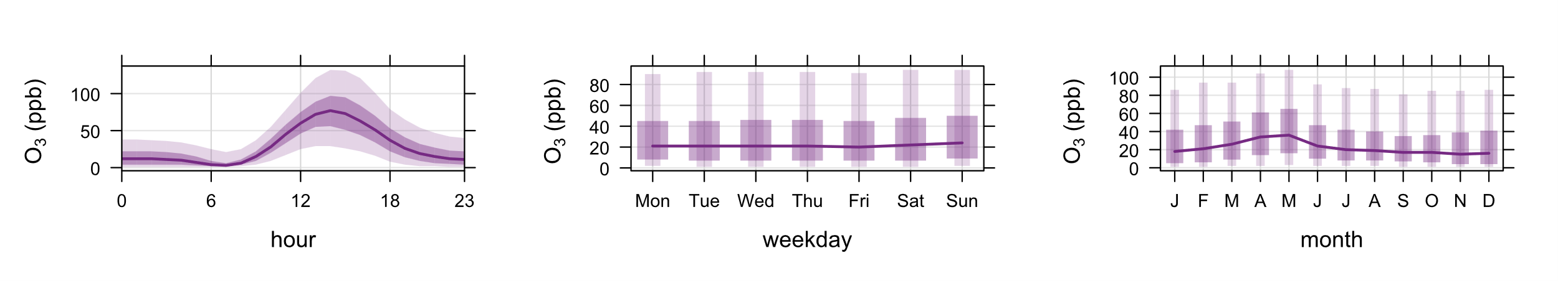
A
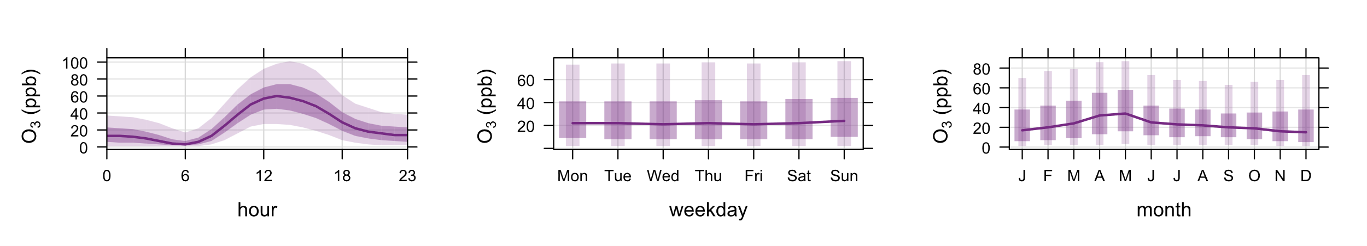
B
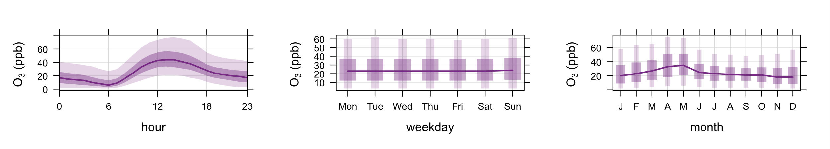
C
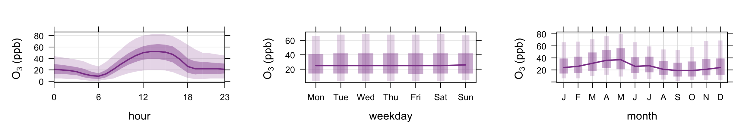
D
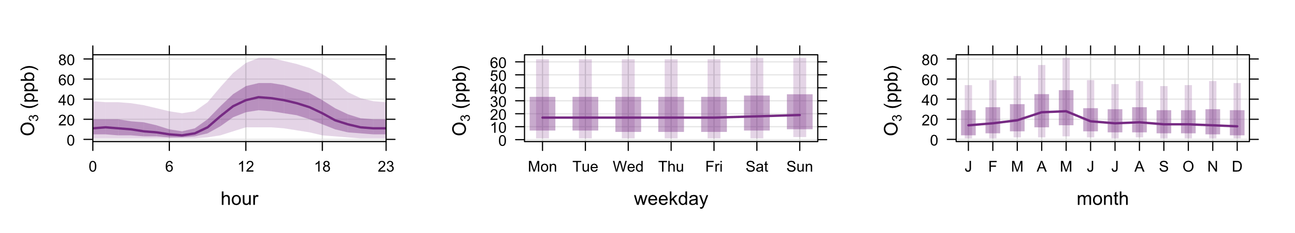
E
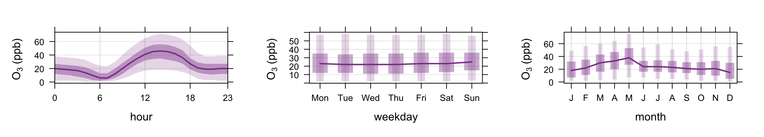
F
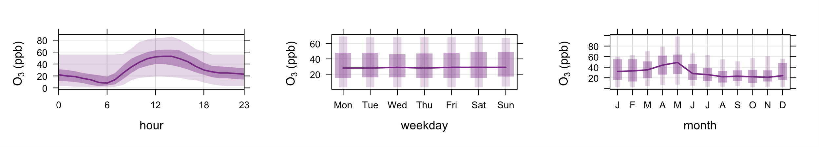
G
Figure. S2. Temporal variation of hourly O₃ concentrations by hour, week, and month in the MZMVM from 2001-2022. a) CDMX, b) EDOMX, c) HGO, d) MOR, e) PUE, f) QRO, and g) TLX.
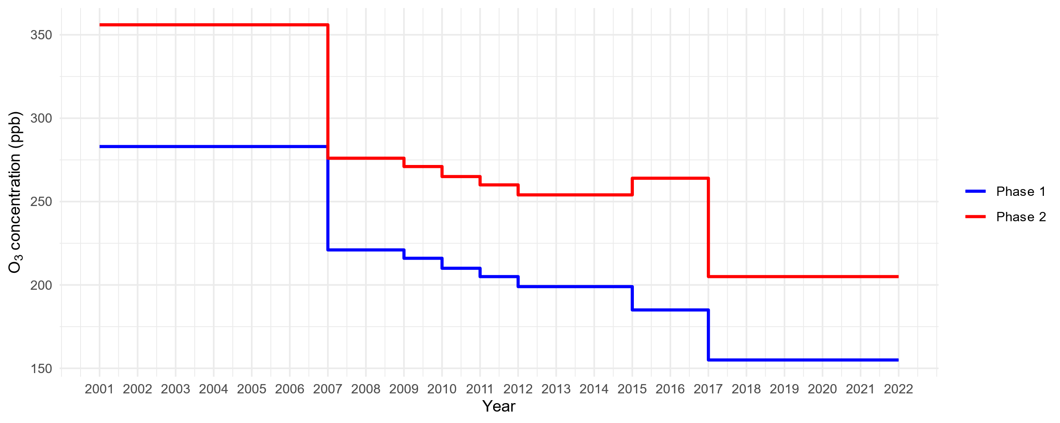
Figure S3. Changes in the maximum allowable O₃ levels for Phase 1 and 2 in the ZMVM from 2001 to 2022.

