Table S1. Relative change (%) in concentrations of PM_{2.5} and its chemical components.
Parameters | Relative Change (%) |  |  |  |  | Relative Change (%)
Parameters | 2021 vs 2019 |  |  |  |  | 2021 vs 2020
Parameters | Spring | Summer | Fall | Winter | Annual | Spring | Summer | Fall | Winter | Annual
PM_{2.5} | 51.3 | 30.2 | 32.3 | 24.8 | 39.8 | 71.2 | 14.7 | 22.2 | 37.5 | 39.9
SO₄²⁻ | -26 | 0.2 | -17.8 | -8.8 | -11.4 | 28.4 | 20.6 | 2.3 | -29.9 | 4.9
NO₃⁻ | 3.3 | 149 | 82.5 | 39.5 | 35.5 | 162.4 | -3 | 130.7 | 37.7 | 81.7
OC | -16.5 | - | -1.6 | 11.3 | 19.3 | 16 | - | 106.4 | 2.6 | 64.2
EC | 6.4 | - | -4.9 | 39.3 | 20.8 | 48.7 | - | 106.1 | 25.4 | 64.7
Si | 204.4 | 1.3 | -23.6 | -43.2 | 27.6 | 624.1 | 145.1 | 104.5 | 121.6 | 280
K | 22.4 | 0.4 | -25.4 | -20.3 | -10.5 | 79.3 | 43.8 | 7 | -15.4 | 20
Ca | 193.7 | 18.5 | -3.8 | 31.9 | 63.7 | 335.3 | 40.1 | 28 | 329.4 | 200
Mn | 76.6 | 17.6 | -21.1 | -19.5 | 31.5 | 126.8 | 45.8 | 6.7 | 15.2 | 0
Fe | 181 | 9.2 | -17.5 | -6.9 | 37.2 | 283.5 | 32.1 | 13.4 | 52.6 | 88.9
Ti | 330.1 | 26.7 | -18.1 | -6 | 70.5 | 422 | 35.1 | 49.6 | 7.6 | 122.7
Zn | 5.4 | 3.5 | -18.9 | -19.9 | 2.6 | 43.6 | 24.3 | 2.3 | 0.9 | 50
Pb | -10.1 | -20.3 | -45.5 | -15 | -33.8 | 21 | 1.9 | -17.1 | -18.2 | 0
V | -71.1 | -80.5 | -49.7 | -17.2 | -73.1 | 63.1 | -20.9 | 54.5 | 80.3 | 10.1
Cr | 45.1 | -3 | -6.7 | -23.1 | 2.8 | 133.3 | 26 | 72.3 | -11.9 | 45.7
Ni | -12.6 | -36.2 | 1.3 | 32.8 | -11.3 | 67.9 | -17.2 | 112.6 | -4.9 | 10.7
Cu | -25.9 | -50 | -54.2 | -43.8 | -48.1 | 1.1 | -15.6 | -10 | 36.5 | -9.4
As | 120.5 | 64.5 | -28.9 | 56.7 | 19.2 | 141.4 | 28.1 | -57.5 | 18.2 | 2.4
Se | 29.5 | 4.3 | -10.9 | -8.5 | 3.1 | 66.8 | 42.6 | 31.4 | -9.3 | 30.2
Br | -8 | 38.6 | -7.8 | -8.1 | -4.9 | 11.5 | 73.0 | 26.2 | 60.5 | 31.8

Table S2. Seasonal relative change (%) in concentrations of PM_{2.5} and thermodynamic parameters.
Parameters | Relative Change (%) |  |  |  |  | Relative Change (%)
Parameters | 2021 vs 2019 |  |  |  |  | 2021 vs 2020
Parameters | Spring | Summer | Fall | Winter | Annual | Spring | Summer | Fall | Winter | Annual
PM_{2.5} | 51.30 | 30.20 | 32.30 | 24.80 | 39.80 | 71.20 | 14.70 | 22.20 | 37.50 | 39.90
NH₃ | 38.72 | 44.60 | 12.96 | 4.69 | 30.97 | -4.48 | 47.48 | 15.61 | -4.99 | 11.40
SO₂ | -0.28 | 14.55 | 7.42 | -11.16 | 1.09 | 15.45 | 13.77 | 21.62 | -5.59 | 8.69
AWC | 76.30 | 57.90 | -3.20 | 28.40 | 47.30 | 59.80 | 18.40 | -22.40 | -10.90 | 19.30
RH | 16.20 | 5.70 | 5.20 | 17.80 | 11.70 | 3.10 | -0.20 | 1.90 | 0.40 | 2.40
T | -4.30 | 0.10 | 3.20 | -112.60 | 5.30 | 5.40 | 5.00 | 7.70 | -112.30 | 11.40
RF | 189.00 | 143.60 | 38.80 | 24.40 | 112.40 | -27.60 | -10.20 | 17.80 | -31.20 | -1.40
WS | -7.90 | 2.20 | 17.80 | 13.00 | 4.60 | -9.40 | -2.60 | 12.70 | 12.70 | 1.90
ACR | -12.70 | -42.30 | 18.50 | -12.90 | -16.50 | 28.90 | -15.00 | 5.20 | 2.60 | 3.60
SOR | -19.00 | 18.70 | -21.60 | -5.60 | -5.50 | -4.10 | 30.20 | -30.90 | -18.00 | -5.90
NOR | -11.50 | 10.40 | 10.10 | -26.80 | -9.50 | 12.90 | 0.20 | 9.60 | -13.90 | -1.50

Table S3. Summary of transportation pathways (main locations) of backward trajectories from Baengnyeongdo Island at 25 m and 50 m above ground during the winter season (2019-21).

Date | Daily Average PM_{2.5} | 2019 |  | Date | Daily Average PM_{2.5} | 2020 |  | Date | Daily Average PM_{2.5} | 2021
Date | Daily Average PM_{2.5} | Trajectory Analysis: Transport Pathways |  | Date | Daily Average PM_{2.5} | Trajectory Analysis: Transport Pathways |  | Date | Daily Average PM_{2.5} | Trajectory Analysis: Transport Pathways
Date | μg/m³ | 25 m Above Ground Level (AGL) | 50 m Above Ground Level (AGL) | Date | μg/m³ | 25 m Above Ground Level (AGL) | 50 m Above Ground Level (AGL) | Date | μg/m³ | 25 m Above Ground Level (AGL) | 50 m Above Ground Level (AGL)
Maximum considered PM_{2.5} levels
12/11/2019 | 44.25 | China (Inner Mongolia, Beijing, Dalian), Yellow Sea, Baengnyeongdo | China (Inner Mongolia, Beijing, Dalian), Yellow Sea, Baengnyeongdo | 2/9/2020 | 34.79 | North Korea (Nampo), China (Chifeng, Hailar), Mongolia (Choibalsan), Russia (Borzya), Baengnyeongdo | North Korea (Nampo), China (Chifeng, Hailar), Mongolia (Choibalsan), Russia (Borzya), Baengnyeongdo | 2/6/2021 | 65.46 | China (Dongying, Yantai, Rongcheng), Yellow Sea, Baengnyeongdo | China (Laizhou, Penglai, Yantai, Rongcheng), Yellow Sea, Baengnyeongdo
2/2/2019 | 38.63 | China (Liaoning, Dalian, Shandong), Yellow Sea, Baengnyeongdo | China (Chengde, Liaoning, Dalian, Shandong), Yellow Sea, Baengnyeongdo | 2/15/2020 | 33.00 | Yellow Sea, North Korea (Sinuiju, Nampo, Pyongyang), Baengnyeongdo | Yellow Sea, North Korea ( Sinuiju, Nampo, Pyongyang), Baengnyeongdo | 1/13/2021 | 45.21 | China (Jincheng, Suzhou, Lianyungang), Yellow Sea, Baengnyeongdo | Mongolia (Altai), China (Yulin, Xuchang, Suzhou, Lianyungang), Yellow Sea, Baengnyeongdo
1/18/2019 | 30.21 | Russia (Buryatia, Deshulan), Mongolia (Teregen Bayan Sumeü, Tsagaan-Ovoo), China (Jinzhou, Anshan), Yellow Sea, Baengnyeongdo | Russia (Buryatia, Deshulan), Mongolia (Teregen Bayan Sumeü, Tsagaan-Ovoo), China (Jinzhou, Anshan), Yellow Sea, Baengnyeongdo | 1/4/2020 | 31.88 | Yellow Sea, China (Dalian, Jinzhou, Anshan), Baengnyeongdo | Yellow Sea, China (Dalian, Jinzhou), Baengnyeongdo | 2/21/2021 | 44.88 | Yellow Sea, East China Sea, China (Lianyungang, Nanjing, Chuzhou, Liu'an, Huanggang), Baengnyeongdo | Yellow Sea, East China Sea, China (Lianyungang, Nanjing, Chuzhou, Liu'an, Huanggang), Baengnyeongdo
12/23/2019 | 27.50 | Mongolia (Öldzey Abagayn Jisa, Enger Hulasa), China (Liaoning, Yingkou, Anshan, Dandong), Yellow Sea, Baengnyeongdo | China (Langfang, Huludao, Dalian, Dandong), Yellow Sea, Baengnyeongdo | 1/31/2020 | 29.96 | Russia (Khabarovsk Krai), China (Jiamusi, Mudanjiang, Benxi, Dandong), Yellow Sea, Baengnyeongdo | Russia (Khabarovsk Krai), China (Jiamusi, Mudanjiang, Benxi, Dandong), Yellow Sea, Baengnyeongdo | 2/12/2021 | 29.79 | East China Sea, South Korea (Gunsan), Yellow Sea, Baengnyeongdo | East China Sea, South Korea (Seocheon), Yellow Sea, Baengnyeongdo
Minimum considered PM_{2.5} levels
2/14/2019 | 8.88 | Russia (Borzya, Chita), China (Inner Mongolia, Fushun, Dandong), North Korea (Tongrim), Yellow Sea, Baengnyeongdo | Russia (Chita, Borzya), Mongolia (Sain Chuulgan uul), China (Inner Mongolia, Fushun, Dandong), North Korea (Tongrim), Yellow Sea, Baengnyeongdo | 12/14/2020 | 8.79 | Russia (Bratsk, Ust-Kut, Chita), Mongolia, China (Fuxin, Dandong), Baengnyeongdo | Russia ( Bratsk, Ust-Kut, Chita), Mongolia, China ( Fuxin, Dandong), Baengnyeongdo | 1/1/2021 | 11.08 | Russia (Zeya), Mongolia, China (Manzhouli, Qinhuangdao), Yellow Sea, Baengnyeongdo | Russia(Zeya), eastern Mongolia, China (Manzhouli, Qinhuangdao), Yellow Sea, Baengnyeongdo
2/8/2019 | 7.79 | Russia (Zeya, Borzya), Mongolia (Choibalsan),China (Hailar, Tongliao), North Korea (Sinuiju), Baengnyeongdo | Russia (Zeya, Borzya), Mongolia (Choibalsan),China (Hailar, Tongliao), North Korea (Sinuiju), Baengnyeongdo | 1/25/2020 | 7.71 | Yellow Sea, China (Tongliao), Russia (Chita, Ust-Kut, Dikson), Baengnyeongdo | Yellow Sea, China (Tongliao), Russia (Chita, Ust-Kut, Dikson), Baengnyeongdo | 2/24/2021 | 10.74 | China (Jinzhou, Tongliao, Baotou, Ulaanbaatar), Baengnyeongdo | China (Jinzhou, Tongliao, Baotou, Ulaanbaatar), Baengnyeongdo
12/2/2019 | 7.21 | Russia (Irkutsk Oblast, Kyra), Mongolia (Gurban-Bayan- Somon, Choibalsan), China (Inner Mongolia, Liaoning, Dalian), Yellow Sea, Baengnyeongdo | Russia (Irkutsk Oblast, Kyra), Mongolia (Gurban-Bayan- Somon, Choibalsan), China (Inner Mongolia, Liaoning, Dalian), Yellow Sea, Baengnyeongdo | 2/18/2020 | 7.46 | Russia (Yakutsk, Neryungri, Tynda), China (Zhalantun, Qiqihar, Tongliao, Benxi, Dandong), Baengnyeongdo | Russia (Ust-Maya, Ayan, Skovorodino, Yakutsk, Neryungri, Tynda), China (Zhalantun, Qiqihar, Tongliao, Benxi, Dandong), Baengnyeongdo | 1/19/2021 | 8.26 | China (Jinzhou, Manzhouli, Tongliao, Baotou, Ulaanbaatar), North Korea (Nampo), Baengnyeongdo | China (Jinzhou, Manzhouli, Tongliao, Baotou, Ulaanbaatar), North Korea (Nampo), Baengnyeongdo
12/5/2019 | 5.75 | Russia (Irkutsk Oblast, Chita), Mongolia (Choibalsan), China (Shenyang, Anshan, Dandong), Yellow Sea, Baengnyeongdo | Russia (Irkutsk Oblast, Chita), Mongolia (Choibalsan), China (Shenyang, Anshan, Dandong), Yellow Sea, Baengnyeongdo | 2/6/2020 | 7.39 | Russia (Amursk, Tynda, Neryungri, Zeya), China (Qiqihar, Suihua, Fuxin), Yellow Sea, Baengnyeongdo | Russia (Amursk, Birobidzhan, Skovorodino, Zeya), China (Heihe, Qiqihar), Baengnyeongdo | 1/7/2021 | 6.54 | Russia (Zeya), Mongolia (Choibalsan), China (Manzhouli, Hailar, Chifeng, Tongliao), North Korea (Nampo), Baengnyeongdo | Russia (Zeya), Mongolia (Choibalsan), China (Manzhouli, Hailar, Chifeng, Tongliao), North Korea (Nampo), Baengnyeongdo

Table S4. Summary of transportation pathways (main locations) of backward trajectories from Baengnyeongdo Island at 25 m and 50 m above ground during the summer season (2019-21).
Date | Daily Average PM_{2.5} | 2019 |  | Date | Daily Average PM_{2.5} | 2020 |  | Date | Daily Average PM_{2.5} | 2021
Date | Daily Average PM_{2.5} | Trajectory Analysis: Transport Pathways |  | Date | Daily Average PM_{2.5} | Trajectory Analysis: Transport Pathways |  | Date | Daily Average PM_{2.5} | Trajectory Analysis: Transport Pathways
Date | μg/m³ | 25 m Above Ground Level (AGL) | 50 m Above Ground Level (AGL) | Date | μg/m³ | 25 m Above Ground Level (AGL) | 50 m Above Ground Level (AGL) | Date | μg/m³ | 25 m Above Ground Level (AGL) | 50 m Above Ground Level (AGL)
Maximum considered PM_{2.5} levels
8/7/2019 | 24.63 | North Korea (Hoeryong, Kyongsong, Chongjin, Sinpo, Wonsan), Yellow Sea, Baengnyeongdo | North Korea (Kaesong, Pyongyang, Sinuiju), China (Chaoyang,Tonghua), Yellow Sea, Baengnyeongdo | 6/20/2020 | 39.08 | China (Cangzhou, Qinhuangdao, Yingkou, Penglai, Rongcheng, Dongying), Yellow Sea, Baengnyeongdo | China (Huanghua, Qinhuangdao,Dalian, Yingkou, Penglai, Rongcheng, Dongying), Yellow Sea, Baengnyeongdo | 8/26/2021 | 29.73 | Yellow Sea, China (Shangqiu, Lianyungang), Baengnyeongdo | Yellow Sea, China (Shangqiu, Lianyungang), Baengnyeongdo
8/22/2019 | 22.54 | Russia (Vladivostok, Slavyanka) North Korea (Wonsan, Nampo), South Korea (Samcheok, Busan), Japan (Goto Islands), East China Sea, Yellow Sea, Baengnyeongdo | Yellow Sea, East China Sea, Japan (Kitakyushu), South Korea (Gangneung), Russia (Vladivostok), Baengnyeongdo | 7/2/2020 | 25.79 | China (Jinzhou, Zhuanghe, Penglai, Longkou, Yantai, Dongying, Binzhou), Yellow Sea, Baengnyeongdo | North Korea (Nampo), China (Jinzhou, Zhuanghe, Penglai, Longkou, Yantai, Dongying, Binzhou), Baengnyeongdo | 6/27/2021 | 28.43 | North Korea (Haeju), Yellow Sea , Baengnyeongdo | China (Baoding, Cangzhou, Huanghua), Bohai Sea, Yellow Sea, Baengnyeongdo
7/17/2019 | 18.33 | North Korea (Sinchon, Ryongyon, Haeju, Nampo, Chongjin, Kimchaek, Hyesan), China (Tonghua), Baengnyeongdo | North Korea (Ryongyon, Haeju, Nampo, Chongjin, Kimchaek, Hyesan, Sinuiju), Baengnyeongdo | 7/5/2020 | 23.50 | China (Dongying, east of Dongying, Rizhao, Lianyungang), Yellow Sea, South Korea (Mokpo, Yeosu), Baengnyeongdo | China (Dongying, Rizhao), South Korea (Mokpo, Yeosu), Baengnyeongdo | 6/6/2021 | 27.04 | China (Bozhou, Bengbu, Hefei, Yancheng), Yellow Sea, Baengnyeongdo | Yellow Sea, China (Zaozhuang, Huai'an, Changzhou), Baengnyeongdo
8/28/2019 | 18.04 | Yellow Sea, China (Dandong), South Korea (Seosan, Boryeong, Dangjin), Baengnyeongdo | Yellow Sea, China (Dandong), South Korea (Seosan), Baengnyeongdo | 6/26/2020 | 23.42 | North Korea (Sinpo, Hamju, Tanchon, Kimchaek, Chongjin), China (Dandong, Jinzhou, Dalian), Yellow Sea , Baengnyeongdo | South Korea (Daegu, Chuncheon), North Korea (Hamju, Kimchaek, Tumen River Delta), China (Jinzhou, Dalian), Yellow Sea, Baengnyeongdo | 7/9/2021 | 24.75 | Yellow Sea, Bohai Sea, Baengnyeongdo | Yellow Sea, Bohai Sea, Baengnyeongdo
Minimum considered PM_{2.5} levels
7/23/2019 | 7.17 | South China Sea, Taiwan (Green Island), East China Sea, China (Zhoushan), Yellow Sea, Baengnyeongdo | Yellow Sea, China (Zhoushan, Yaeyama Islands), Taiwan (Pingtung), South China Sea, Baengnyeongdo | 7/14/2020 | 6.74 | North Korea (Nampo, Chongjin, Kimchaek), Sea of Japan, Russia (Primorsky Krai), Baengnyeongdo | Russia (Khabarovsk, Primorsky Krai), North Korea (Tumen River Delta, Chongjin, Kimchaek, Nampo), Sea of Japan, Baengnyeongdo | 7/15/2021 | 9.13 | Yellow Sea, East China Sea, Philippine Sea, Baengnyeongdo | Yellow Sea, East China Sea, Philippine Sea, Baengnyeongdo
8/19/2019 | 6.13 | China (Hulunbuir, Chifeng, Jinzhou), Bohai Sea, Yellow Sea, Baengnyeongdo | China (Hulunbuir, Xilin Gol, Chifeng, Jinzhou), Yellow Sea, Baengnyeongdo | 8/4/2020 | 6.62 | Yellow Sea, East China Sea, Pacific Ocean, Japan (Okinawa), Baengnyeongdo | Yellow Sea, East China Sea, Pacific Ocean, Japan (Okinawa), Baengnyeongdo | 6/3/2021 | 8.86 | Yellow Sea, East China Sea, Pacific Ocean, Baengnyeongdo | Yellow Sea, East China Sea, Pacific Ocean, Baengnyeongdo
7/11/2019 | 5.79 | Japan (Hachinohe), Sea of Japan, North Korea (Chongjin, Kimchaek, Pyongyang), Baengnyeongdo | Japan (Hachinohe), Sea of Japan, North Korea (Chongjin, Hamhung, Pyongyang), Baengnyeongdo | 8/1/2020 | 6.60 | Yellow Sea, East China Sea, Pacific Ocean, Baengnyeongdo | Yellow Sea, East China Sea, Pacific Ocean, Baengnyeongdo | 8/20/2021 | 7.42 | Yellow Sea, Sea of Japan, South Korea (Pohang, Yeosu, Mokpo), Baengnyeongdo | Yellow Sea, Sea of Japan, South Korea (Pohang, Yeosu, Mokpo), Baengnyeongdo
8/31/2019 | 5.17 | Russia (Birobidzhan, Zeya), China (Qiqihar, Songyuan, Yingkou, Dandong), Yellow Sea, Baengnyeongdo | Russia (Khabarovsk, Skovorodino), China (Qiqihar, Songyuan, Tieling, Jinzhou), Yellow Sea, Baengnyeongdo | 8/10/2020 | 4.47 | East China Sea, Pacific Ocean, Baengnyeongdo | East China Sea, Pacific Ocean, Baengnyeongdo | 6/12/2021 | 6.29 | Yellow Sea, North Korea (Nampo), South Korea (Incheon, Mokpo), Baengnyeongdo | China (Suzhou, Nantong, Haimen, Zhoushan, Qingdao), Yellow Sea, Baengnyeongdo

Table S5. Summary of transportation pathways (main locations) of backward trajectories from Baengnyeongdo Island at 25 m and 50 m above ground during the fall season (2019-21).
Date | Daily Average PM_{2.5} | 2019 |  | Date | Daily Average PM_{2.5} | 2020 |  | Date | Daily Average PM_{2.5} | 2021
Date | Daily Average PM_{2.5} | Trajectory Analysis: Transport Pathways |  | Date | Daily Average PM_{2.5} | Trajectory Analysis: Transport Pathways |  | Date | Daily Average PM_{2.5} | Trajectory Analysis: Transport Pathways
Date | μg/m³ | 25 m Above Ground Level (AGL) | 50 m Above Ground Level (AGL) | Date | μg/m³ | 25 m Above Ground Level (AGL) | 50 m Above Ground Level (AGL) | Date | μg/m³ | 25 m Above Ground Level (AGL) | 50 m Above Ground Level (AGL)
Maximum considered PM_{2.5} levels
10/21/2019 | 44.88 | Yellow sea, Baengnyeongdo | Yellow sea, Baengnyeongdo | 10/18/2020 | 29.05 | Yellow Sea, China (Dalian), Baengnyeongdo | Yellow Sea, China (Dalian), Baengnyeongdo | 11/18/2021 | 76.33 | China (Dalian), Yellow Sea, Baengnyeongdo | China (Dalian), Yellow Sea, Baengnyeongdo
9/9/2019 | 30.54 | China (Jinzhou, Shenyang, Huludao, Penglai), Yellow sea, Baengnyeongdo | China (Jinzhou, Shenyang, Huludao, Penglai), Yellow Sea, Baengnyeongdo | 9/6/2020 | 27.50 | Yellow Sea, South Korea (Incheon, Gyeonggi , Andong, Gunsan, Boryeong), Baengnyeongdo | South Korea (Incheon, Cheonan, Daegu, Buan), Yellow Sea, China (Shandong), Baengnyeongdo | 11/3/2021 | 38.88 | Yellow Sea, China (Tongliao, Jinzhou, Yantai), Baengnyeongdo | Yellow Sea, China(Tongliao, Jinzhou, Yantai), Baengnyeongdo
9/30/2019 | 26.54 | Yellow Sea, Baengnyeongdo | Yellow Sea, Baengnyeongdo | 11/26/2020 | 20.50 | China (Dalian, Jinzhou, Yingkou, Shenyang, Chaoyang, League), Baengnyeongdo | China (Bayannur, Xilin Gol League, Chifeng, Tongliao, Tieling, Jinzhou), Baengnyeongdo | 11/6/2021 | 34.92 | North Korea (Hwangju, Sariwon, Changyon), Yellow Sea, Baengnyeongdo | North Korea (Haeju, Kumsan), Yellow Sea, China (Yantai, Qingdao, Weifang), Baengnyeongdo
11/23/2019 | 25.75 | North Korea (Hoeryong, Wonsan), Yellow Sea, Baengnyeongdo | North Korea (Hoeryong, Wonsan), Yellow Sea, Baengnyeongdo | 11/14/2020 | 19.25 | China (Qinhuangdao, Benxi, Chifeng, Hulunbuir), Baengnyeongdo | China (Qinhuangdao, Benxi, Chifeng, Hulunbuir), Baengnyeongdo | 10/25/2021 | 33.67 | North Korea (Cholsan County), Yellow Sea, China (Dalian, Jinzhou, Huludao), Baengnyeongdo | North Korea (Cholsan County), Yellow Sea, China (Dalian, Jinzhou, Huludao), Baengnyeongdo
Minimum considered PM_{2.5} levels
11/29/2019 | 5.54 | North Korea (Nampo), China (Shenyang, Hulunbuir), Baengnyeongdo | North Korea (Nampo), China (Hulunbuir), Mongolia (Sükhbaatar), Baengnyeongdo | 11/5/2020 | 10.75 | Yellow Sea, China (Qinhuangdao, Shandong, Weihai), Bohai Sea, Baengnyeongdo | Yellow Sea, China (Qinhuangdao, Shandong, Weihai), Bohai Sea, Baengnyeongdo | 11/27/2021 | 9.63 | China (Songyuan, Baicheng, Ergun, Shenyang), Russia (Skovorodino), North Korea (Sinŭiju), Baengnyeongdo | China (Hailar, Tongliao), Russia (Khabarovsk, Zeya, Blagoveshchensk), North Korea (Cholsan County), Baengnyeongdo
10/6/2019 | 5.17 | North Korea (Haeju , Nampo, Tanchon), Yellow sea, Baengnyeongdo | North Korea (Haeju, Nampo, Tanchon), Yellow sea, Baengnyeongdo | 9/18/2020 | 9.96 | China (Weihai, Yantai, Tangshan, Qinhuangdao, Dalian), Yellow Sea, Baengnyeongdo | China (Weihai, Yantai, Tangshan, Qinhuangdao, Dalian), Yellow Sea, Baengnyeongdo | 11/9/2021 | 8.35 | China (Yantai, Qinhuangdao, Chifeng, Xilin Gol), Mongolia (Choibalsan, Ulaanbaatar), Russia (Chita), Baengnyeongdo | China (Yantai, Qinhuangdao, Chifeng, Xilin Gol), Mongolia (Choibalsan, Ulaanbaatar), Russia (Chita), Baengnyeongdo
11/14/2019 | 2.29 | China (Fuxin, Xilin Gol League), Yellow sea, Baengnyeongdo | China (Fuxin, Xilin Gol League), Yellow sea, Baengnyeongdo | 10/6/2020 | 9.35 | China (Shenyang, Hulunbuir, Erguna), Yellow Sea, Baengnyeongdo | China (Shenyang, Hulunbuir, Erguna), Yellow Sea, Baengnyeongdo | 9/4/2021 | 7.75 | North Korea (Haeju, Kumgang County, Tanchon, Chongjin), Yellow Sea, Baengnyeongdo | North Korea (Haeju, Kumgang County, Tanchon, Chongjin), Yellow Sea, Baengnyeongdo
11/20/2019 | 1.83 | China (Dalian, Fuxin), Baengnyeongdo | China (Dalian, Fuxin), Baengnyeongdo | 11/29/2020 | 8.09 | China (Dalian, Chaoyang, Chifeng, Hulunbuir), Yellow Sea, Baengnyeongdo | China (Dalian, Chaoyang, Chifeng, Hulunbuir), Yellow Sea, Baengnyeongdo | 11/12/2021 | 7.43 | Russia (Olenyok, Lensk, Zabaykalsk), China (Hailar District, Jinzhou,Huludao), Baengnyeongdo | Russia (Olenyok, Lensk, Zabaykalsk), China (Hailar District, Jinzhou,Huludao), Baengnyeongdo

Table S6. Summary of sample counts for PM_{2.5} and its constituents.
Parameters | Number of Samples
Parameters | 2019 | 2020 | 2021
PM_{2.5} | 87 | 96 | 108
SO₄²⁻ | 89 | 87 | 87
NO₃⁻ | 89 | 85 | 84
OC | 94 | 90 | 42
EC | 82 | 92 | 42
Si | 92 | 78 | 101
K | 94 | 93 | 101
Ca | 94 | 94 | 101
Mn | 94 | 94 | 101
Fe | 94 | 94 | 101
Zn | 94 | 94 | 101
Pb | 94 | 90 | 101
Ti | 94 | 91 | 101
V | 115 | 99 | 94
Cr | 89 | 77 | 89
Ni | 93 | 84 | 97
Cu | 93 | 74 | 80
As | 85 | 84 | 67
Se | 90 | 78 | 100
Br | 93 | 90 | 99

Element | MDL_{3σ} (μgm⁻³)
Si | 4.0
K | 3.0
Ca | 6.0
Mn | 0.5
Fe | 3.0
Zn | 0.4
Pb | 0.3
Ti | 5.0
V | 0.3
Cr | 2.0
Ni | 0.3
Cu | 1.0
Br | 0.3
Table S7. Minimum Detection Limits (MDL_{3σ}) for the offline XRF analysis performed by ARPA Lombardia with Epsilon 4 spectrometer.

Table S8. Summary of blank check measurements of trace metals for QA/QC.
Element | Concentration (μgm⁻³)
Element | 2019 | 2020 | 2021
Si | 1.396 | 1.867 | 2.017
K | 2.385 | 3.731 | 3.805
Ca | 0.017 | 0.345 | 0.13
Mn | 0.018 | 0.247 | 0.208
Fe | 3.407 | 3.275 | 3.639
Zn | 0.771 | 0.562 | 0.801
Pb | 0.071 | 0.102 | 0.087
Ti | 0.328 | 0.865 | 1.013
V | 0.009 | 0.013 | 0.024
Cr | 0.607 | 0.487 | 0.577
Ni | 0.117 | 0.174 | 0.158
Cu | 3.916 | 6.96 | 7.032
Br | 1.578 | 0.412 | 0.316

Table S9. Summary of blank check measurements of OC/EC for QA/QC.
OC (μgm⁻³)
 | Sample 1 | Sample 2 | Sample 3 | Sample 4 | Sample 5 | Sample 6
2019 | 1 | 0.91 | 0.9 | 0.97 | 0.86 | 1.1
2020 | 0.93 | 0.93 | 0.86 | 0.92 | 0.94 | 0.99
2021 | 0.57 | 0.57 | 0.51 | 0.5 | 0.52 | 0.52
EC (μgm⁻³)
 | Sample 1 | Sample 2 | Sample 3 | Sample 4 | Sample 5 | Sample 6
2019 | 0.085 | 0.092 | 0.082 | 0.114 | 0.103 | 0.102
2020 | 0.165 | 0.118 | 0.081 | 0.070 | 0.152 | 0.127
2021 | 0.139 | 0.101 | 0.126 | 0.178 | 0.142 | 0.170

Table S10. A one-at-a-time sensitivity test for SOR and NOR at ±20% perturbance of particulate NO₃⁻ and SO₄²⁻, and gaseous SO₂ and NO₂.
Perturbation |  | Spring |  |  |  |  | Summer |  |  |  |  |  |  |  | Fall |  |  |  |  |  |  | Winter
Parameter | Value | 2019 | 2020 |  | 2021 |  | 2019 |  | 2020 |  | 2021 |  | 2019 |  |  | 2020 |  | 2021 |  | 2019 |  |  | 2020 |  | 2021
SOR
None | None | 0.45 ± 0.18 |  | 0.38 ± 0.11 |  | 0.36 ± 0.14 |  | 0.39 ± 0.13 |  | 0.36 ± 0.16 |  | 0.46 ± 0.28 |  | 0.35 ± 0.18 |  |  | 0.4 ± 0.16 |  | 0.27 ± 0.14 |  | 0.32 ± 0.16 |  |  | 0.35 ± 0.14 | 0.27 ± 0.16
SO₄⁺ | 20% | 0.49 ± 0.18 |  | 0.42 ± 0.11 |  | 0.39 ± 0.14 |  | 0.43 ± 0.14 |  | 0.39 ± 0.17 |  | 0.5 ± 0.27 |  | 0.39 ± 0.19 |  |  | 0.44 ± 0.16 |  | 0.3 ± 0.15 |  | 0.36 ± 0.17 |  |  | 0.39 ± 0.15 | 0.31 ± 0.16
SO₄⁺ | -20% | 0.4 ± 0.17 |  | 0.33 ± 0.1 |  | 0.31 ± 0.14 |  | 0.34 ± 0.13 |  | 0.32 ± 0.16 |  | 0.43 ± 0.29 |  | 0.31 ± 0.17 |  |  | 0.35 ± 0.15 |  | 0.23 ± 0.12 |  | 0.28 ± 0.15 |  |  | 0.31 ± 0.14 | 0.24 ± 0.15
SO₂ | 20% | 0.41 ± 0.17 |  | 0.34 ± 0.11 |  | 0.32 ± 0.14 |  | 0.35 ± 0.13 |  | 0.32 ± 0.16 |  | 0.43 ± 0.29 |  | 0.32 ± 0.17 |  |  | 0.36 ± 0.15 |  | 0.24 ± 0.13 |  | 0.29 ± 0.15 |  |  | 0.32 ± 0.14 | 0.24 ± 0.15
SO₂ | -20% | 0.49 ± 0.18 |  | 0.43 ± 0.12 |  | 0.4 ± 0.14 |  | 0.44 ± 0.14 |  | 0.4 ± 0.17 |  | 0.5 ± 0.27 |  | 0.4 ± 0.19 |  |  | 0.45 ± 0.16 |  | 0.31 ± 0.15 |  | 0.37 ± 0.17 |  |  | 0.4 ± 0.15 | 0.31 ± 0.16
NOR
None | None | 0.27 ± 0.17 |  | 0.21 ± 0.12 |  | 0.24 ± 0.13 |  | 0.14 ± 0.11 |  | 0.15 ± 0.13 |  | 0.15 ± 0.12 |  | 0.15 ± 0.13 |  |  | 0.15 ± 0.12 |  | 0.16 ± 0.14 |  | 0.28 ± 0.15 |  |  | 0.24 ± 0.12 | 0.21 ± 0.15
NO₃⁻ | 20% | 0.31 ± 0.18 |  | 0.24 ± 0.13 |  | 0.24 ± 0.13 |  | 0.16 ± 0.12 |  | 0.17 ± 0.14 |  | 0.15 ± 0.12 |  | 0.17 ± 0.15 |  |  | 0.15 ± 0.12 |  | 0.16 ± 0.14 |  | 0.32 ± 0.16 |  |  | 0.26 ± 0.13 | 0.21 ± 0.15
NO₃⁻ | -20% | 0.24 ± 0.15 |  | 0.18 ± 0.1 |  | 0.24 ± 0.13 |  | 0.11 ± 0.09 |  | 0.13 ± 0.11 |  | 0.15 ± 0.12 |  | 0.13 ± 0.12 |  |  | 0.15 ± 0.12 |  | 0.16 ± 0.14 |  | 0.24 ± 0.14 |  |  | 0.21 ± 0.11 | 0.21 ± 0.15
NO_{x} | 20% | 0.24 ± 0.16 |  | 0.19 ± 0.1 |  | 0.24 ± 0.13 |  | 0.12 ± 0.1 |  | 0.13 ± 0.12 |  | 0.15 ± 0.12 |  | 0.13 ± 0.12 |  |  | 0.15 ± 0.12 |  | 0.16 ± 0.14 |  | 0.25 ± 0.14 |  |  | 0.22 ± 0.11 | 0.21 ± 0.15
NO_{x} | -20% | 0.31 ± 0.18 |  | 0.25 ± 0.13 |  | 0.24 ± 0.13 |  | 0.16 ± 0.12 |  | 0.17 ± 0.15 |  | 0.15 ± 0.12 |  | 0.18 ± 0.15 |  |  | 0.15 ± 0.12 |  | 0.16 ± 0.14 |  | 0.32 ± 0.16 |  |  | 0.26 ± 0.13 | 0.21 ± 0.15

Table S11. A one-at-a-time sensitivity test for ACR with 2-5 ℃ in T, 5-15% in RH, and ±20% in ionic concentration inputs.
Perturbation |  | Spring |  |  | Summer |  |  | Fall |  |  | Winter
Variable | Value | 2019 | 2020 | 2021 | Parameter | Value | 2019 | 2020 | 2021 | Parameter | Value | 2019 | 2020
None | None | 18.24 ± 27.98 | 20.12 ± 26.31 | 32.16 ± 41.54 | 33.66 ± 29.45 | 44.89 ± 43.07 | 53.14 ± 46.47 | 18.59 ± 34.06 | 23.18 ± 33.12 | 17.99 ± 46.69 | 14.66 ± 23.87 | 20.94 ± 32.43 | 17.24 ± 30.06
T | 2 ℃ | 18.01 ± 27.94 | 19.98 ± 26.32 | 31.83 ± 41.54 | 33.03 ± 28.9 | 44.21 ± 42.75 | 52.44 ± 46.21 | 18.26 ± 33.72 | 22.83 ± 32.85 | 17.72 ± 46.64 | 14.57 ± 23.85 | 20.86 ± 32.42 | 17.16 ± 30.05
T | –2 ℃ | 18.44 ± 28 | 20.23 ± 26.29 | 32.41 ± 41.52 | 34.19 ± 29.89 | 45.48 ± 43.3 | 53.68 ± 46.59 | 18.86 ± 34.31 | 23.47 ± 33.31 | 18.23 ± 46.71 | 14.73 ± 23.87 | 21 ± 32.43 | 17.29 ± 30.06
T | 5 ℃ | 17.58 ± 27.81 | 19.66 ± 26.34 | 31.2 ± 41.49 | 31.99 ± 27.86 | 42.85 ± 42.04 | 51.04 ± 45.62 | 17.64 ± 32.96 | 22.14 ± 32.21 | 17.3 ± 46.51 | 14.36 ± 23.81 | 20.66 ± 32.39 | 16.98 ± 30.03
T | –5 ℃ | 18.67 ± 28.01 | 20.34 ± 26.27 | 32.67 ± 41.49 | 34.9 ± 30.43 | 46.13 ± 43.52 | 54.28 ± 46.69 | 19.16 ± 34.53 | 23.78 ± 33.48 | 18.55 ± 46.73 | 14.81 ± 23.88 | 21.05 ± 32.43 | 17.34 ± 30.06
RH | 5% | 28.9 ± 47.05 | 113.41 ± 252.75 | 199.8 ± 446.33 | 334.01 ± 428.11 | 423.66 ± 483.15 | 525.2 ± 513.32 | 114.95 ± 407.54 | 169.44 ± 324.36 | 98.36 ± 285.99 | 23.27 ± 55.16 | 98.61 ± 354.56 | 64.96 ± 274.61
RH | -5% | 13.65 ± 20.32 | 11.31 ± 10.89 | 18.87 ± 23.86 | 15.37 ± 10.52 | 16.56 ± 15.24 | 20.29 ± 15.81 | 10.83 ± 16.87 | 11.59 ± 15.4 | 10.44 ± 24.08 | 11.01 ± 15.92 | 13.52 ± 16.81 | 11.25 ± 15.64
RH | 15% | 287.93 ± 705.8 | 271.97 ± 491.16 | 772.38 ± 1718.1 | 513.88 ± 429.03 | 532.32 ± 520.15 | 647.61 ± 519.27 | 447.75 ± 884.01 | 438.58 ± 825.05 | 367.53 ± 1090.87 | 249.14 ± 871.07 | 299.22 ± 693.23 | 343.23 ± 796.94
RH | -15% | 8.75 ± 12.66 | 6.45 ± 5.32 | 34.88 ± 197.52 | 8.04 ± 4.53 | 7.43 ± 6.36 | 9.13 ± 6.43 | 6.07 ± 8.39 | 6.09 ± 7.6 | 5.7 ± 11.4 | 7.04 ± 9.49 | 8.09 ± 9.17 | 6.6 ± 7.98
SO₄²⁻ | 20% | 19.8 ± 29.67 | 22.27 ± 29.16 | 34.22 ± 43.95 | 37.88 ± 32.48 | 50.87 ± 47.87 | 59.97 ± 51.41 | 20.62 ± 37.25 | 25.87 ± 36.43 | 19.4 ± 48.46 | 15.61 ± 25.14 | 22.63 ± 34.79 | 18.31 ± 31.73
SO₄²⁻ | -20% | 16.61 ± 26.24 | 17.98 ± 23.52 | 30.01 ± 39.07 | 28.86 ± 26.12 | 38.91 ± 38.26 | 46.23 ± 41.64 | 16.46 ± 30.71 | 20.45 ± 29.84 | 16.54 ± 44.94 | 13.56 ± 22.45 | 19.22 ± 30.08 | 16.14 ± 28.4
NH₄⁺ | -20% | 18.45 ± 28.05 | 20.2 ± 26.3 | 32.39 ± 41.55 | 34.32 ± 30.14 | 45.5 ± 43.3 | 53.58 ± 46.63 | 18.85 ± 34.4 | 23.43 ± 33.32 | 18.2 ± 46.72 | 14.79 ± 23.9 | 21.1 ± 32.51 | 17.3 ± 30.06
NH₄⁺ | 20% | 17.23 ± 25.96 | 19.98 ± 26.31 | 30.88 ± 39.59 | 32.25 ± 28.24 | 43.81 ± 42.43 | 52.3 ± 46.01 | 17.84 ± 32.64 | 22.69 ± 32.61 | 17.63 ± 46.52 | 14.02 ± 23.44 | 20.59 ± 32.23 | 17.04 ± 30.04
NO₃⁻ | 20% | 19.79 ± 31.21 | 21.76 ± 28.69 | 35.7 ± 46.44 | 34.91 ± 31.27 | 47.59 ± 46.72 | 56.26 ± 50.58 | 19.92 ± 37.14 | 24.92 ± 36.21 | 19.93 ± 53.84 | 15.96 ± 26.82 | 22.97 ± 36.1 | 19.23 ± 34
NO₃⁻ | -20% | 16.6 ± 24.6 | 18.48 ± 23.98 | 28.42 ± 36.25 | 32.39 ± 27.69 | 42.18 ± 39.48 | 50.02 ± 42.48 | 17.23 ± 30.96 | 21.44 ± 30.1 | 16.03 ± 39.53 | 13.19 ± 20.81 | 18.9 ± 28.77 | 15.21 ± 26.11

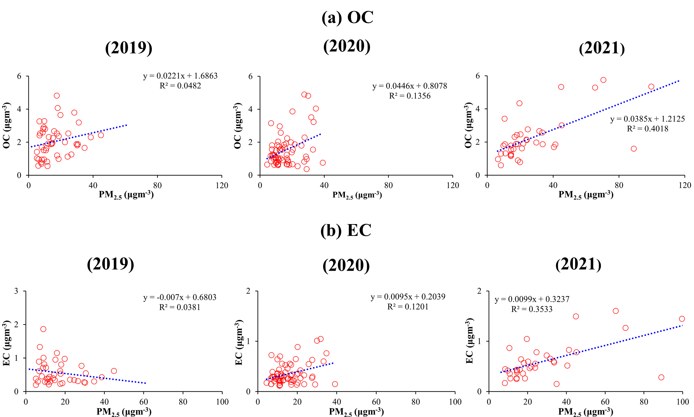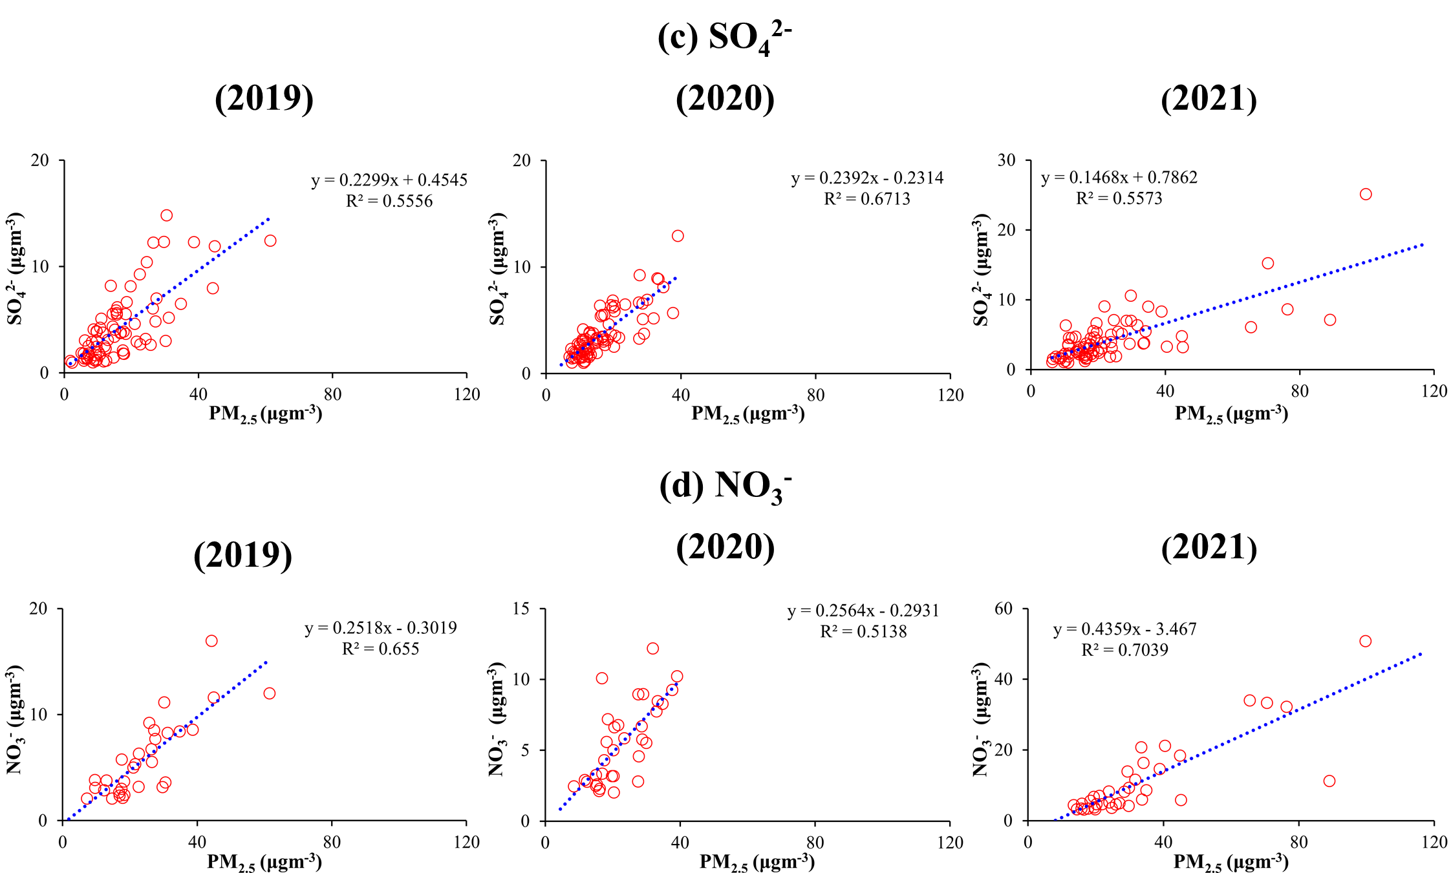

Figure S1. Correlation between PM_{2.5} and (a) EC (b) OC (c) SO₄²⁻ (d) NO₃⁻.

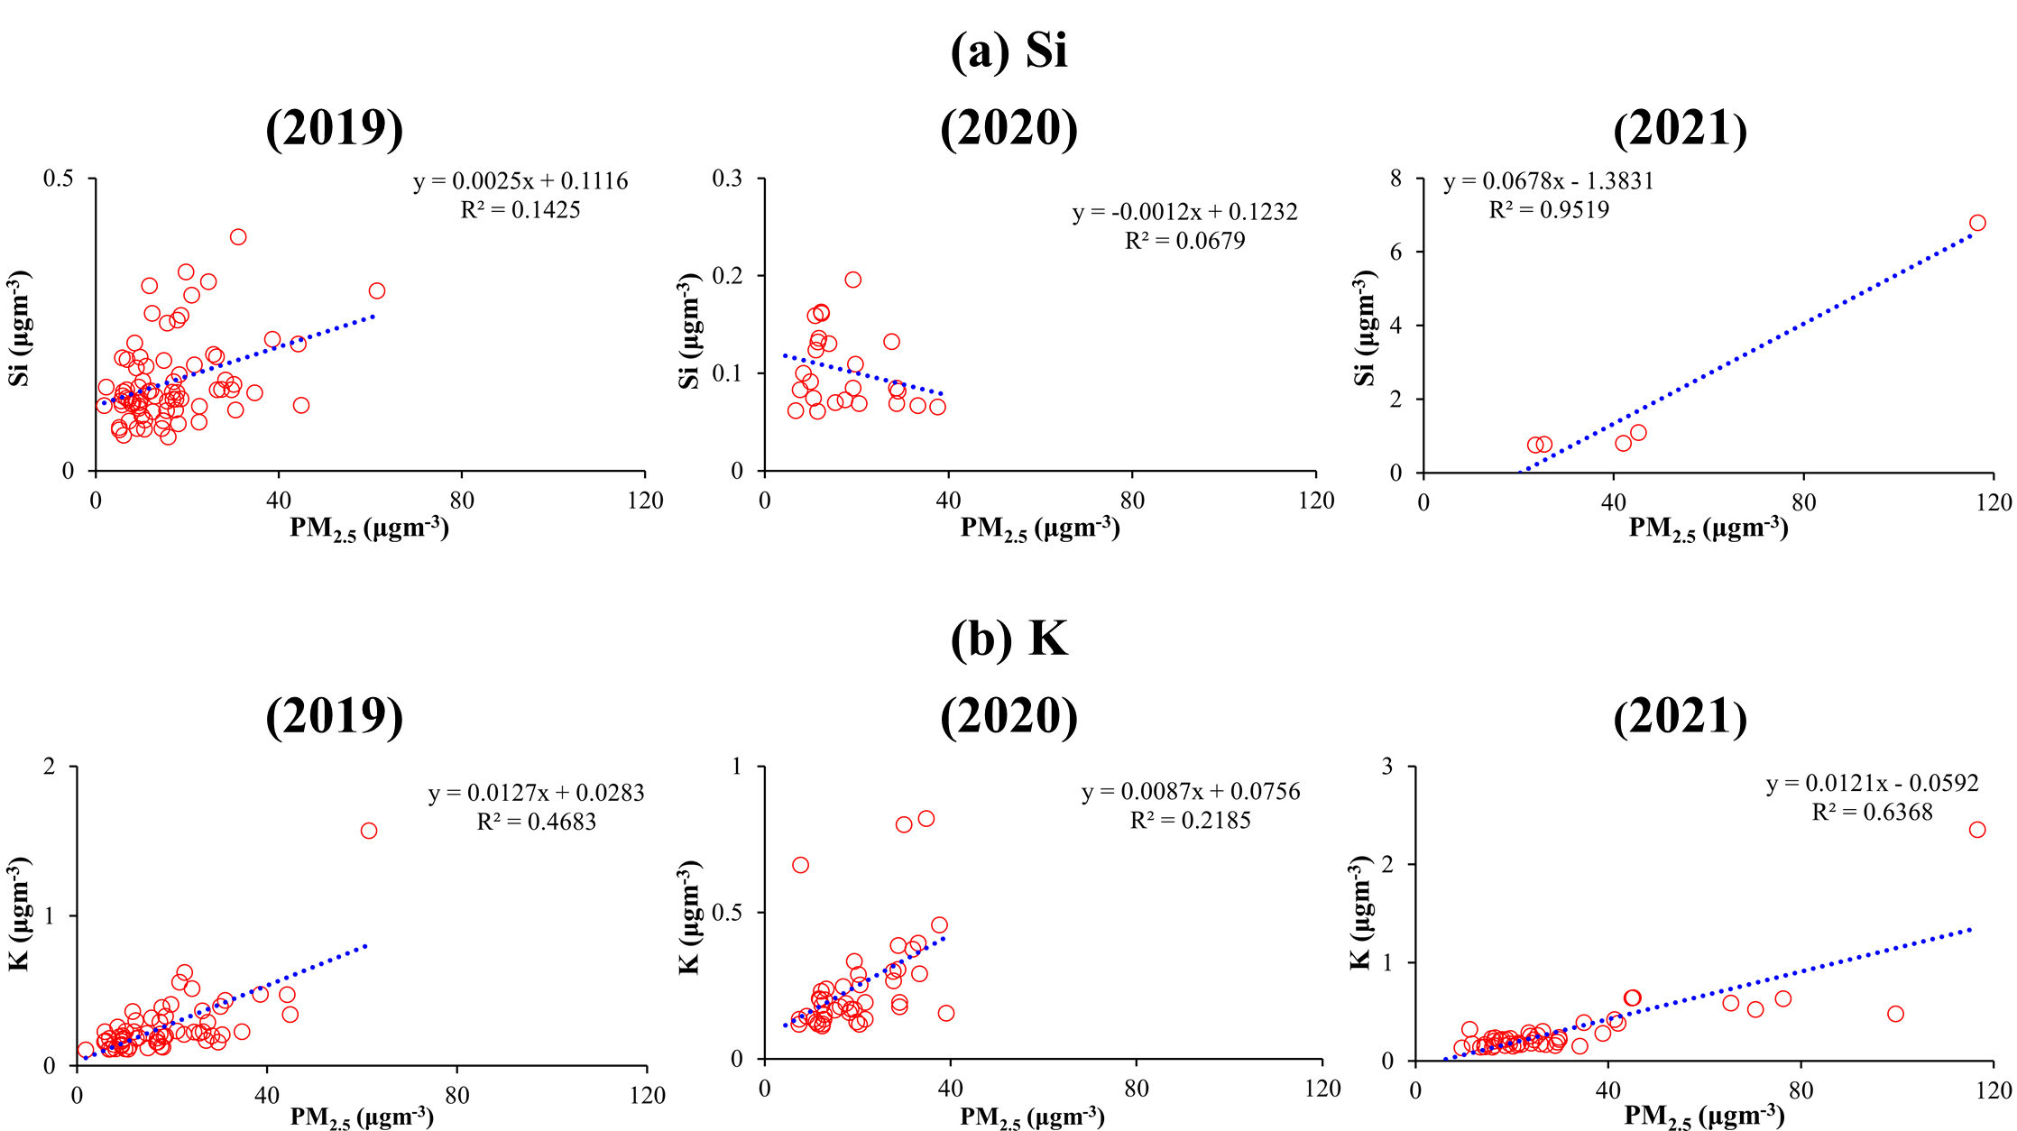
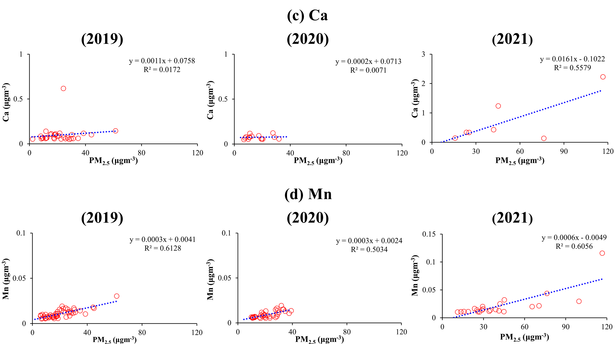
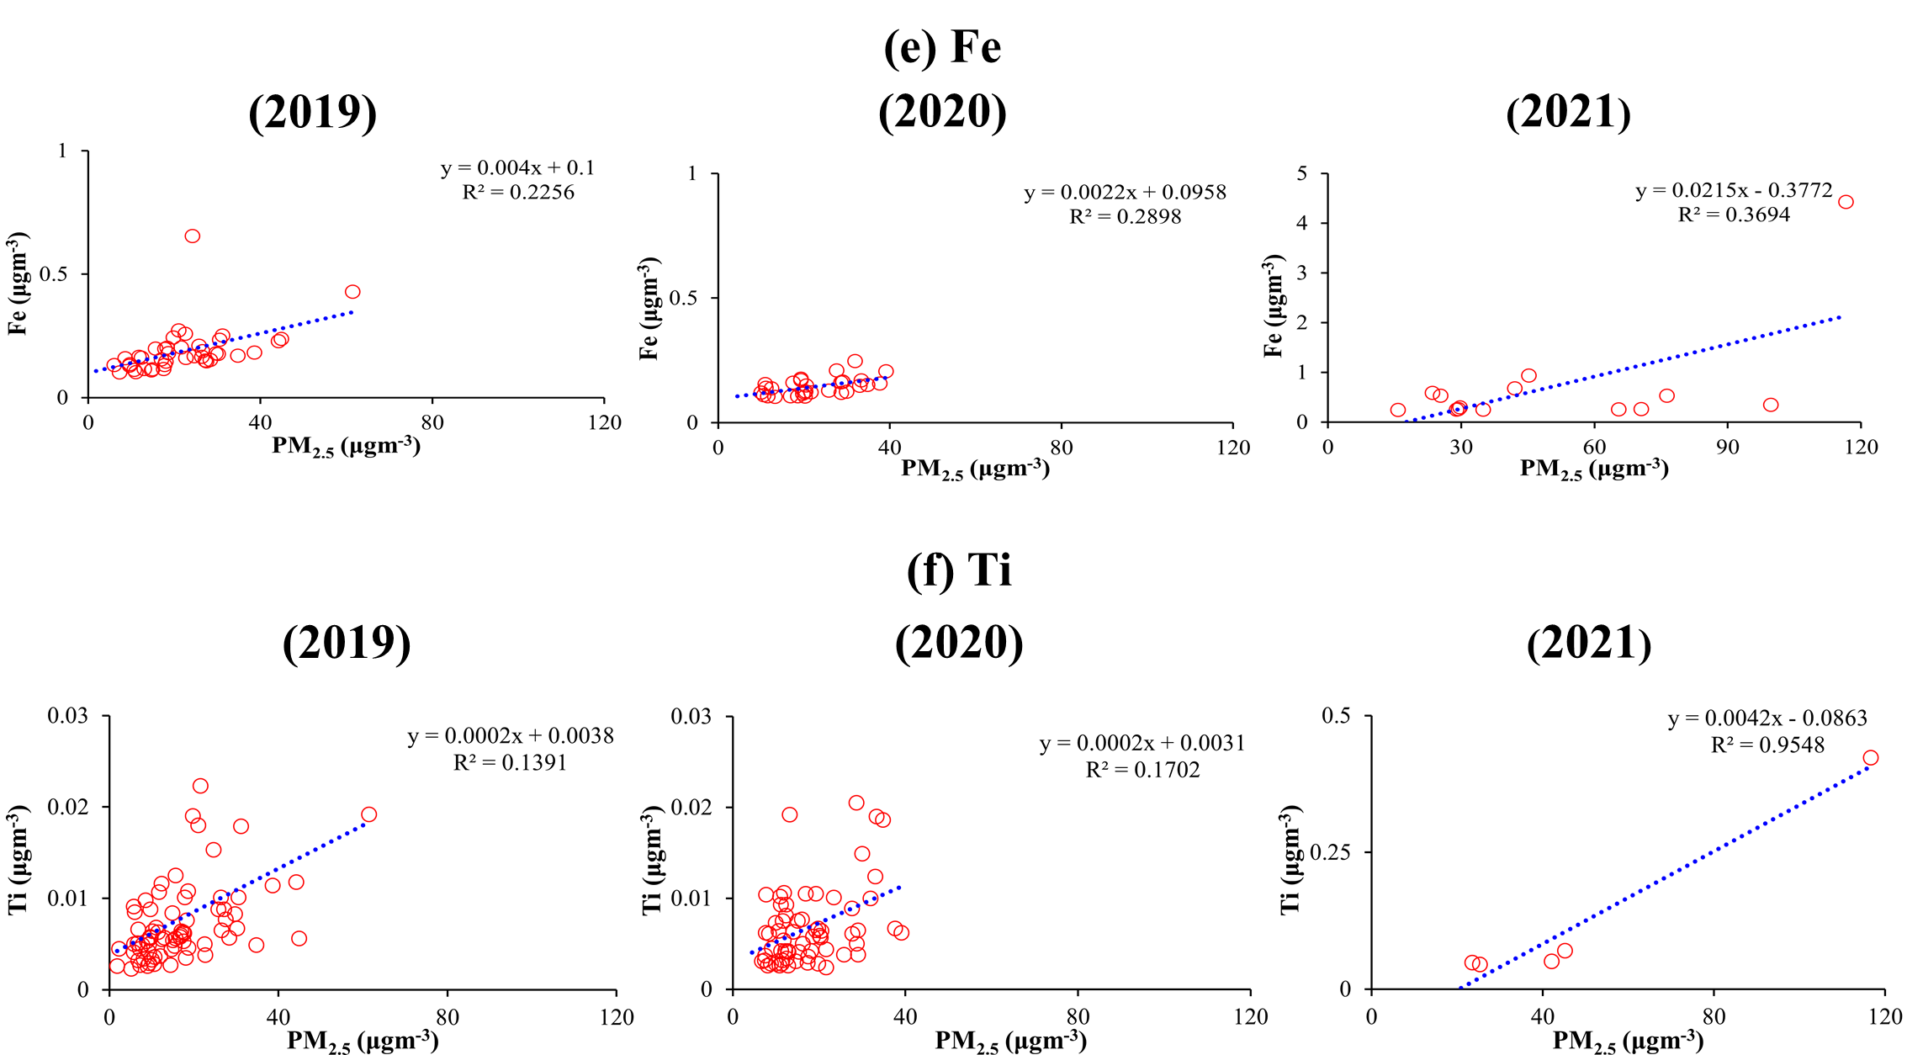
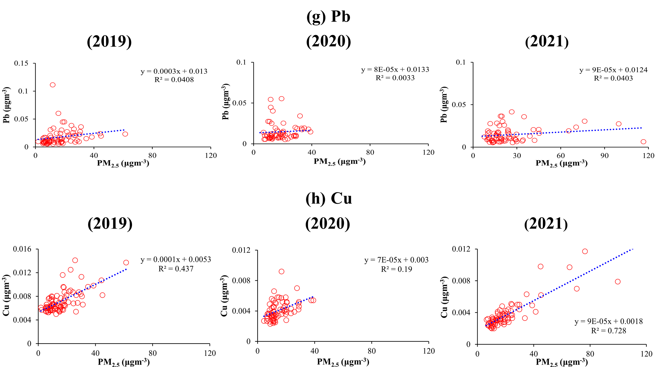
Figure S2. Correlation between PM_{2.5} and metallic species: (a) Si (b) K (c) Ca (d) Mn (e) Fe (f) Ti (g) Pb (h) Cu.

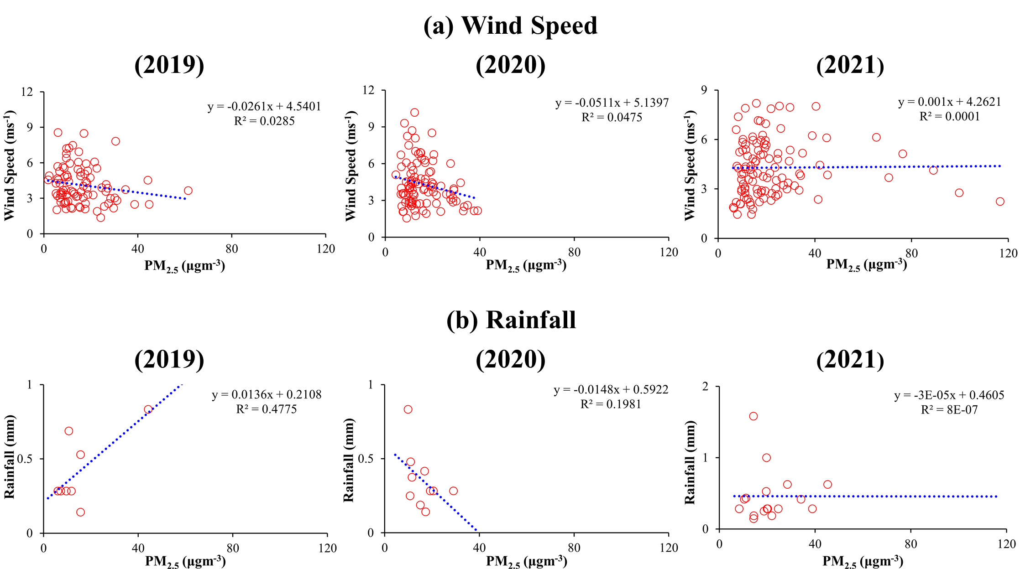
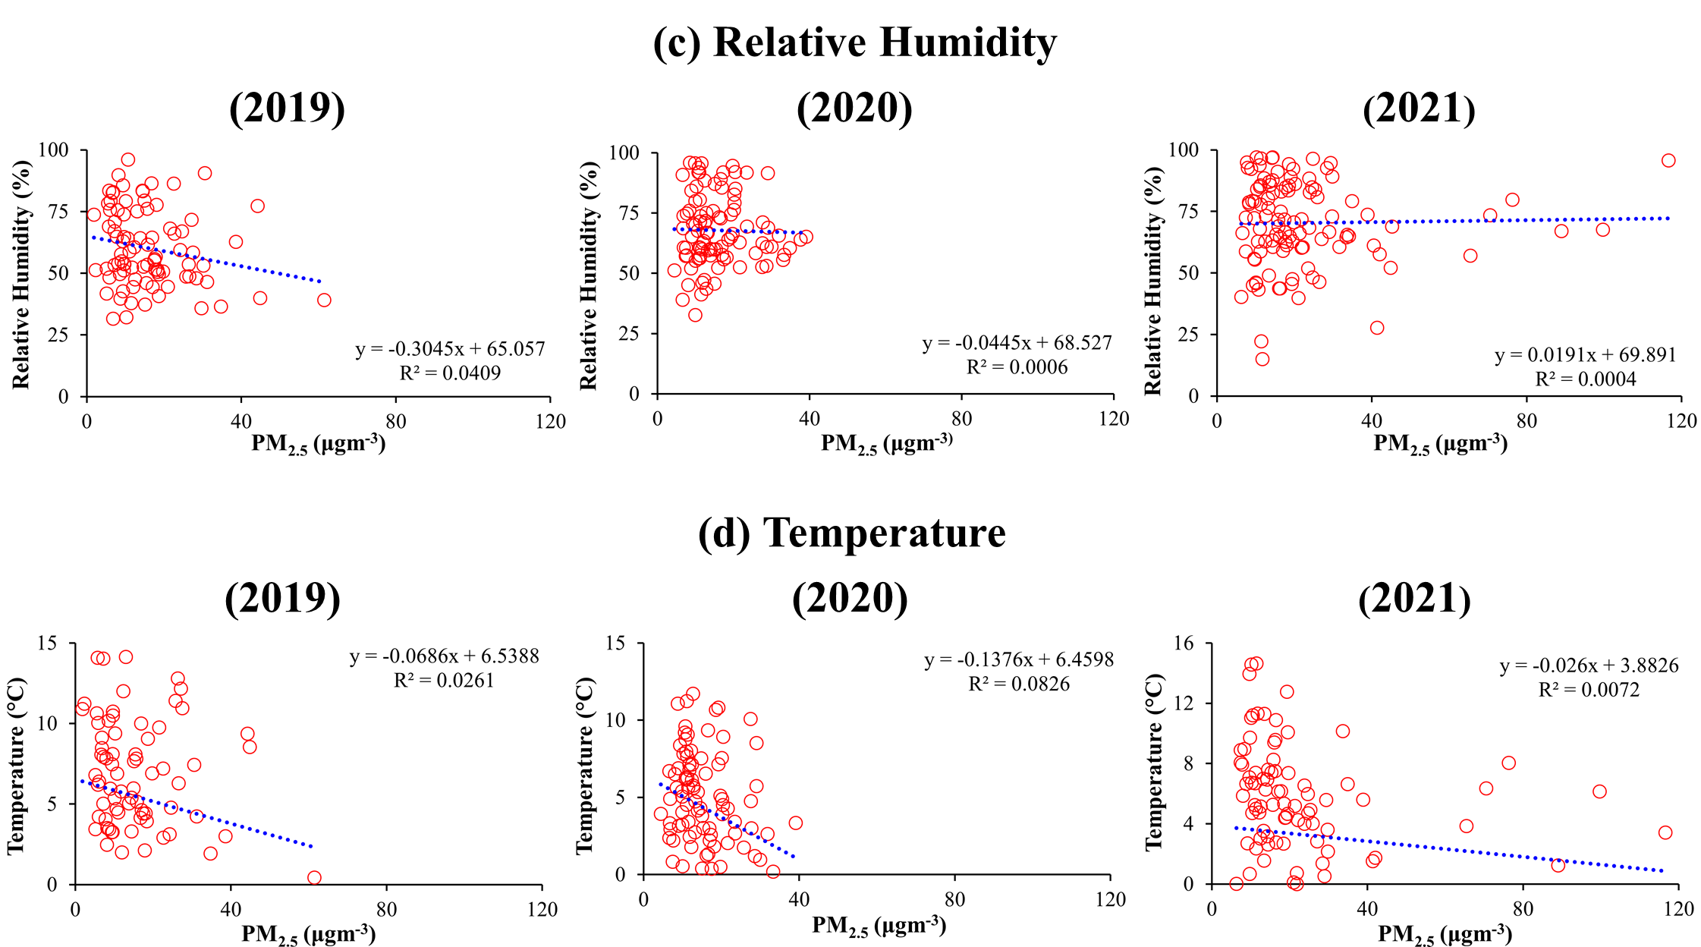
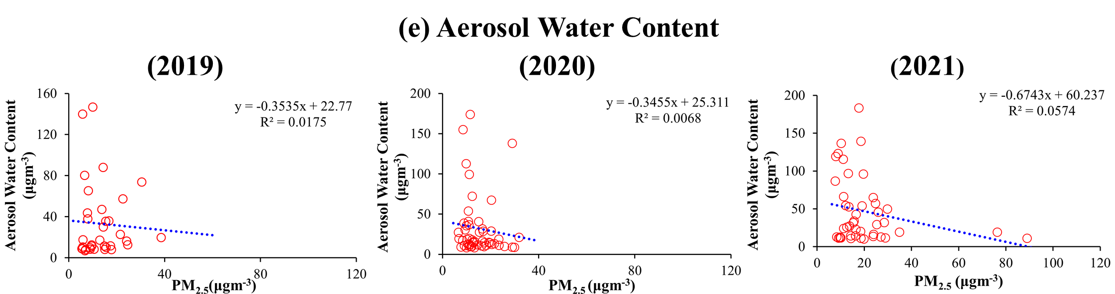
Figure S3. Correlation between PM_{2.5} and meteorological parameters: (a) Wind speed (b) Rainfall (c) Relative humidity (d) Temperature (e) Aerosol Water Content

