SUPPLEMENTARY INFORMATION
Figures
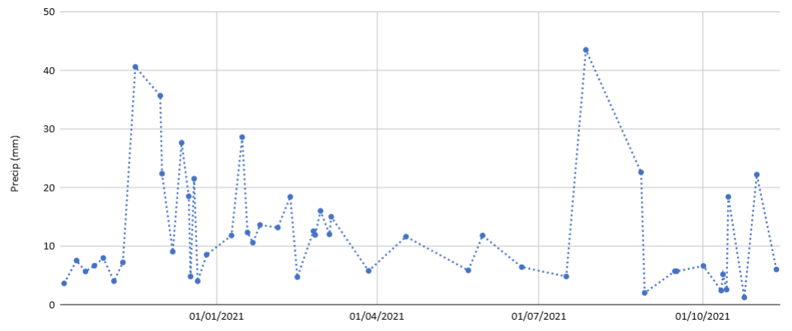
Figure S1. Total accumulated precipitation (mm) for the collected samples.

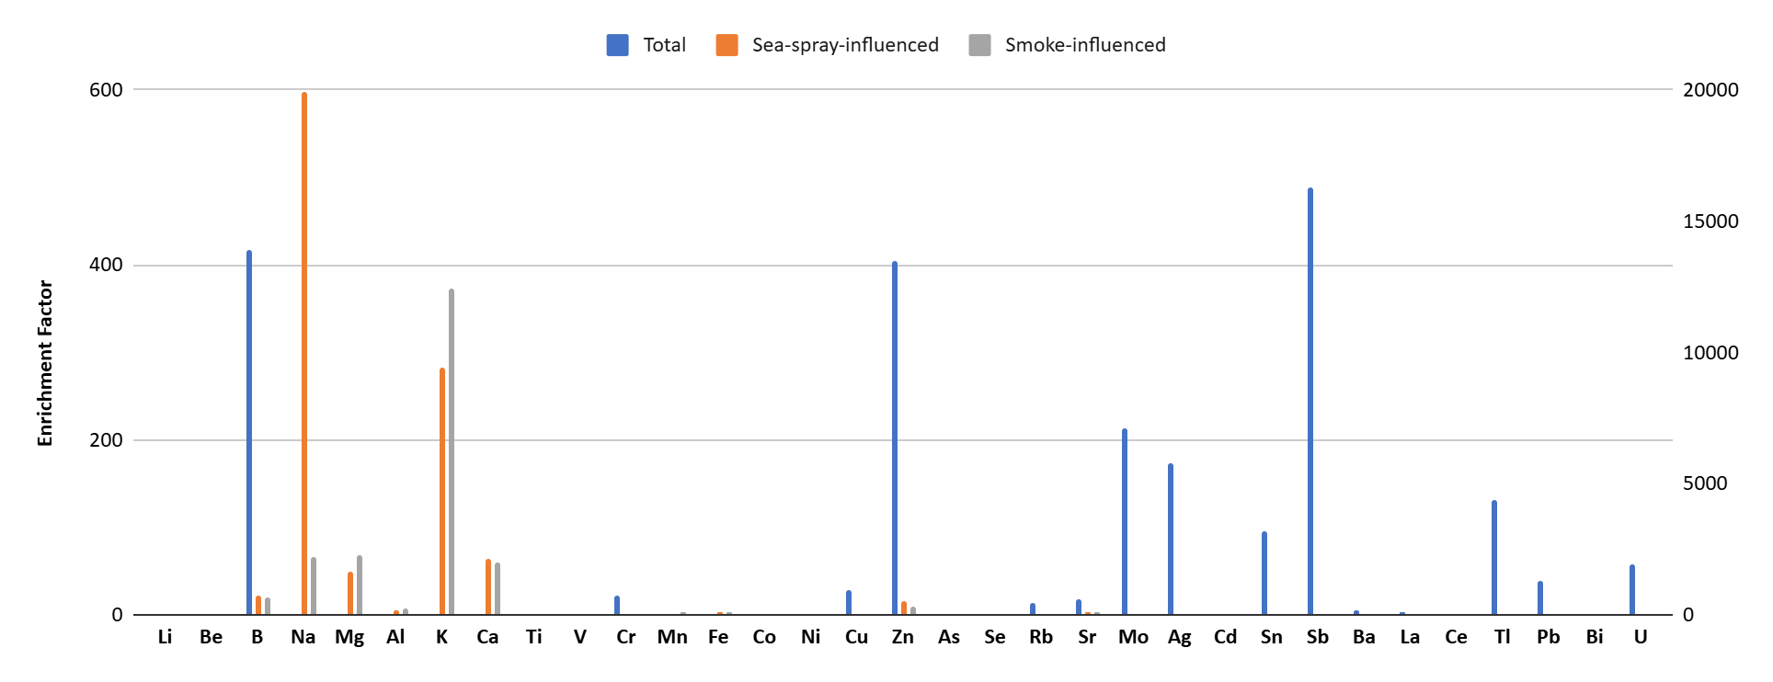
Figure S2. Enrichment factors for rainwater samples.
(a)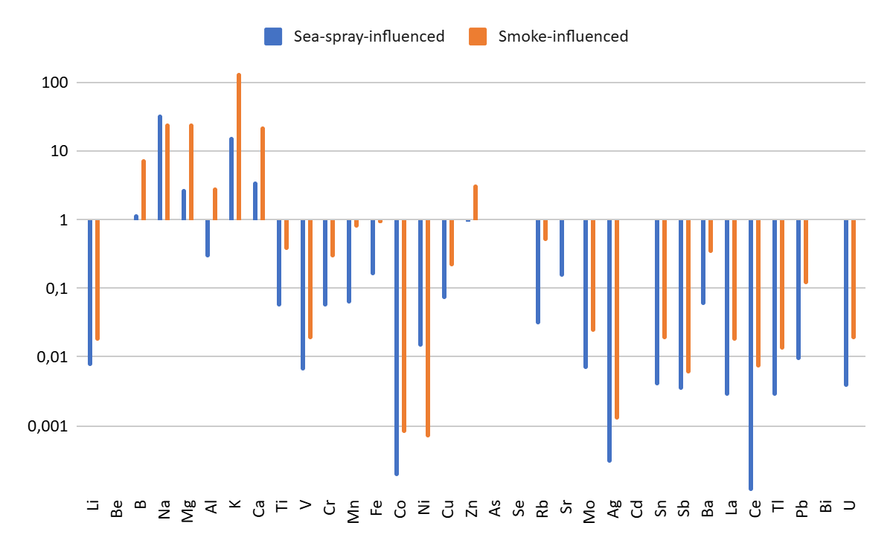
(b)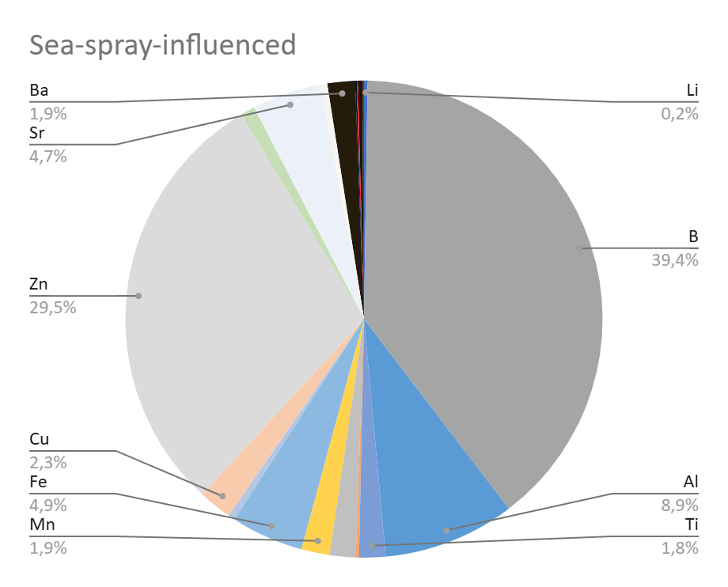(c)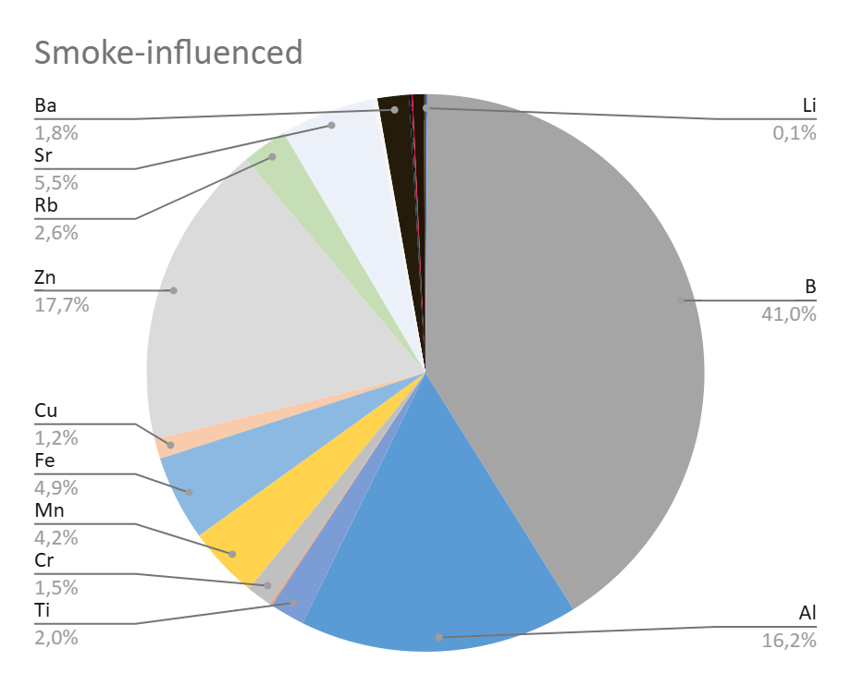
Figure S3. Concentrations of elements during sea-spray and biomass burning smoke-influenced samples (a) and proportions for each case (b and c).

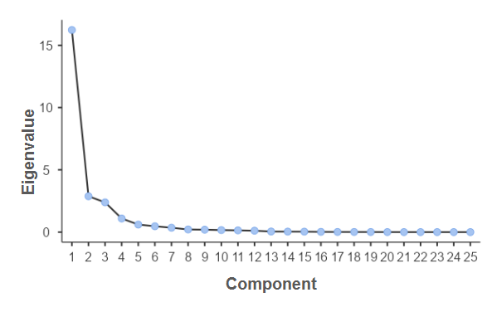
Figure S4. PCA eigenvalues and number of components.
(a)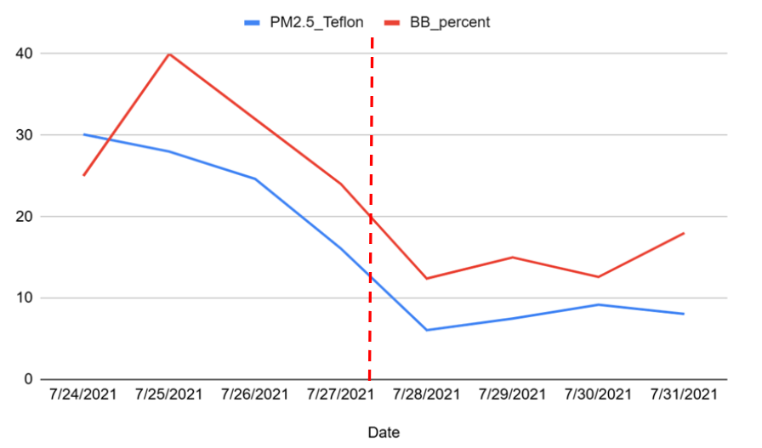
(b)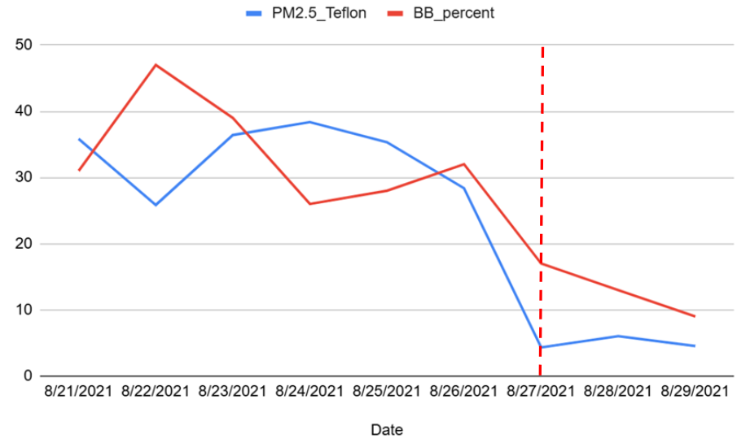
Figure S5. PM_{2.5} concentrations and biomass-burning-related black carbon (measured with AE33) in weeks during biomass-burning-impacted samples in July (a) and August (b).
(a)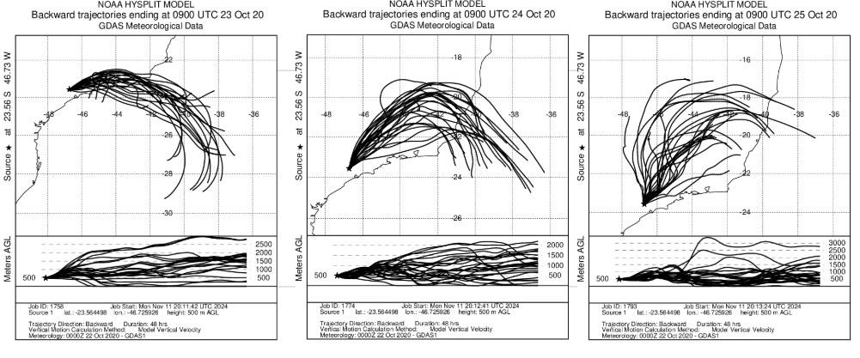
(b)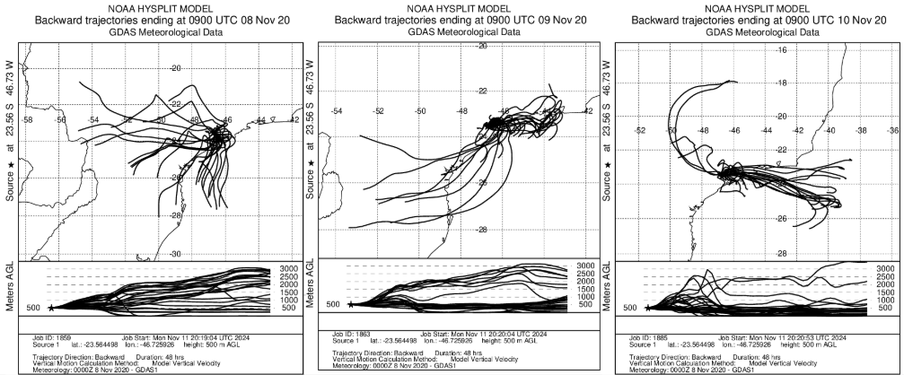
(c)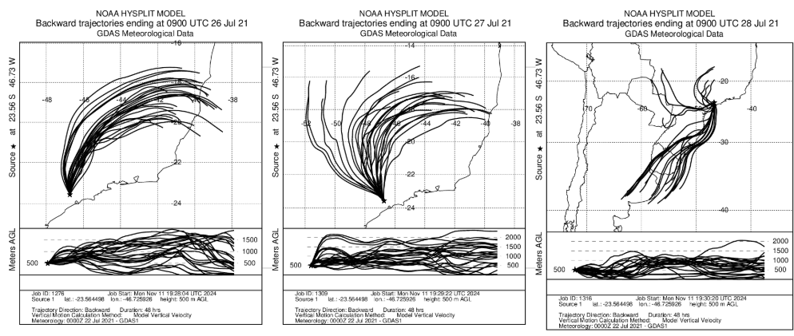
(d)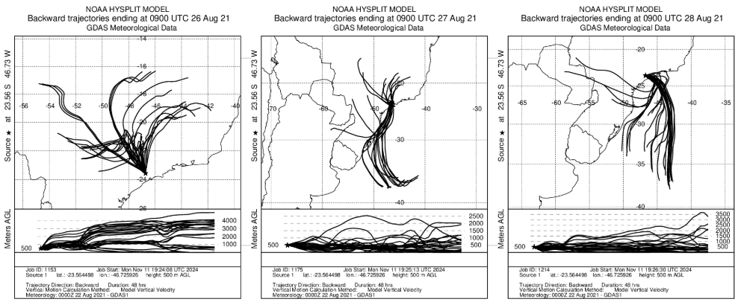
Figure S6. Backward trajectories before, during and after rain events for October and November 2020 (a and b), and July and August, 2021 (c and d).
(a)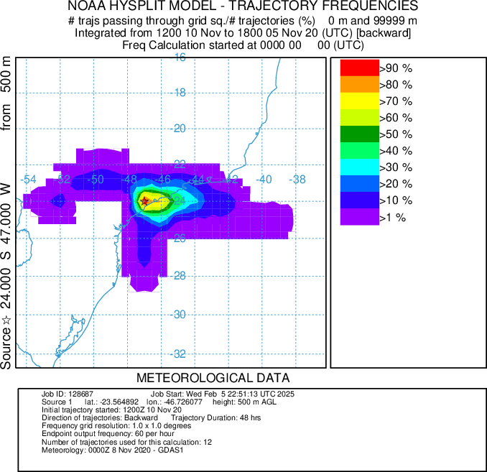(b)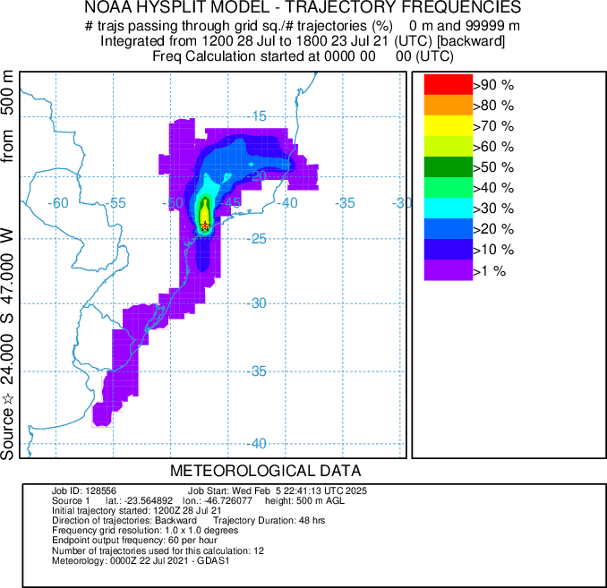
Figure S7. Air mass trajectories for the events in November 2020 (a) and July and 2021 (b).
(a)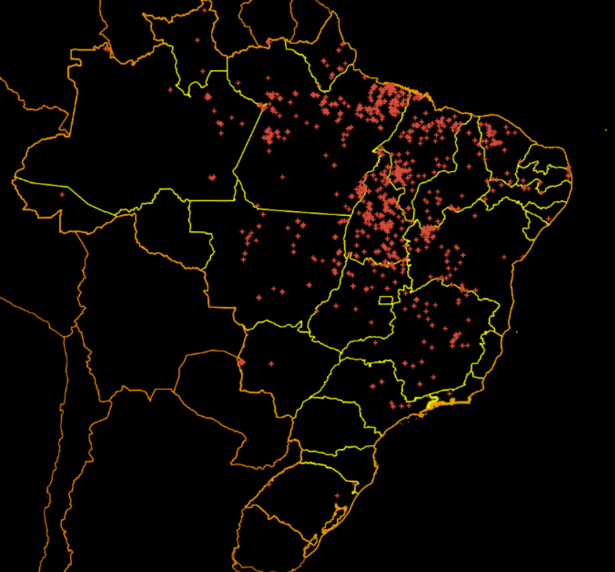(b)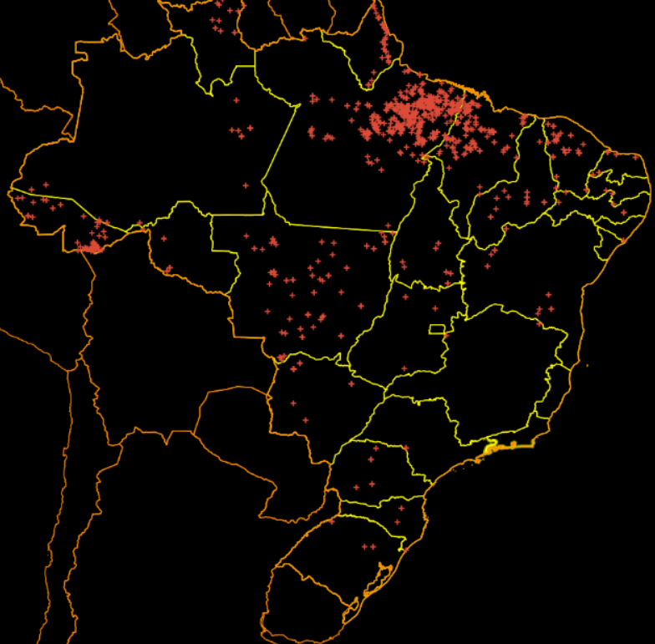(c)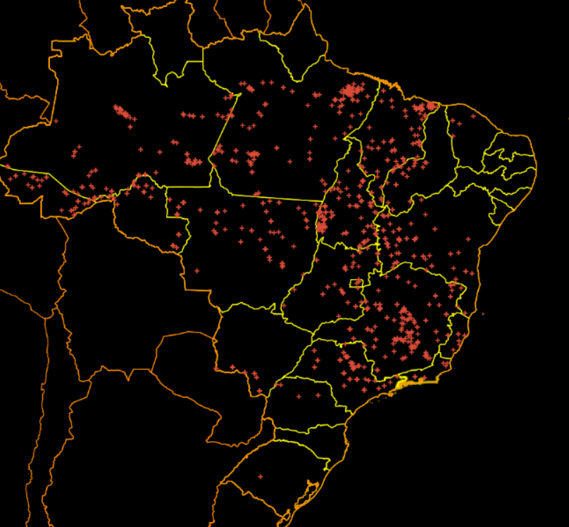(d)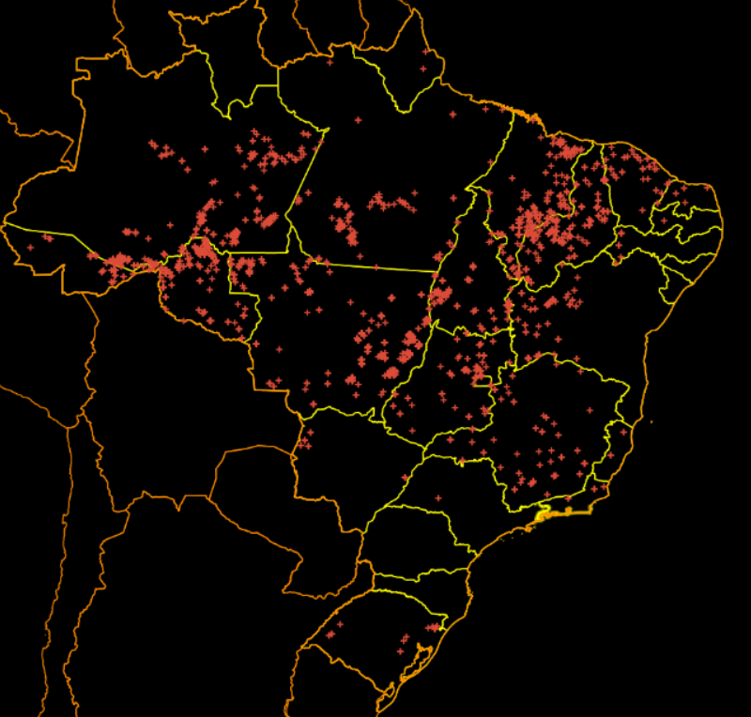
Figure S8. Fire map for Brazil in the periods of October, November 2020 (a and b); and July and August 2021 (c and d).
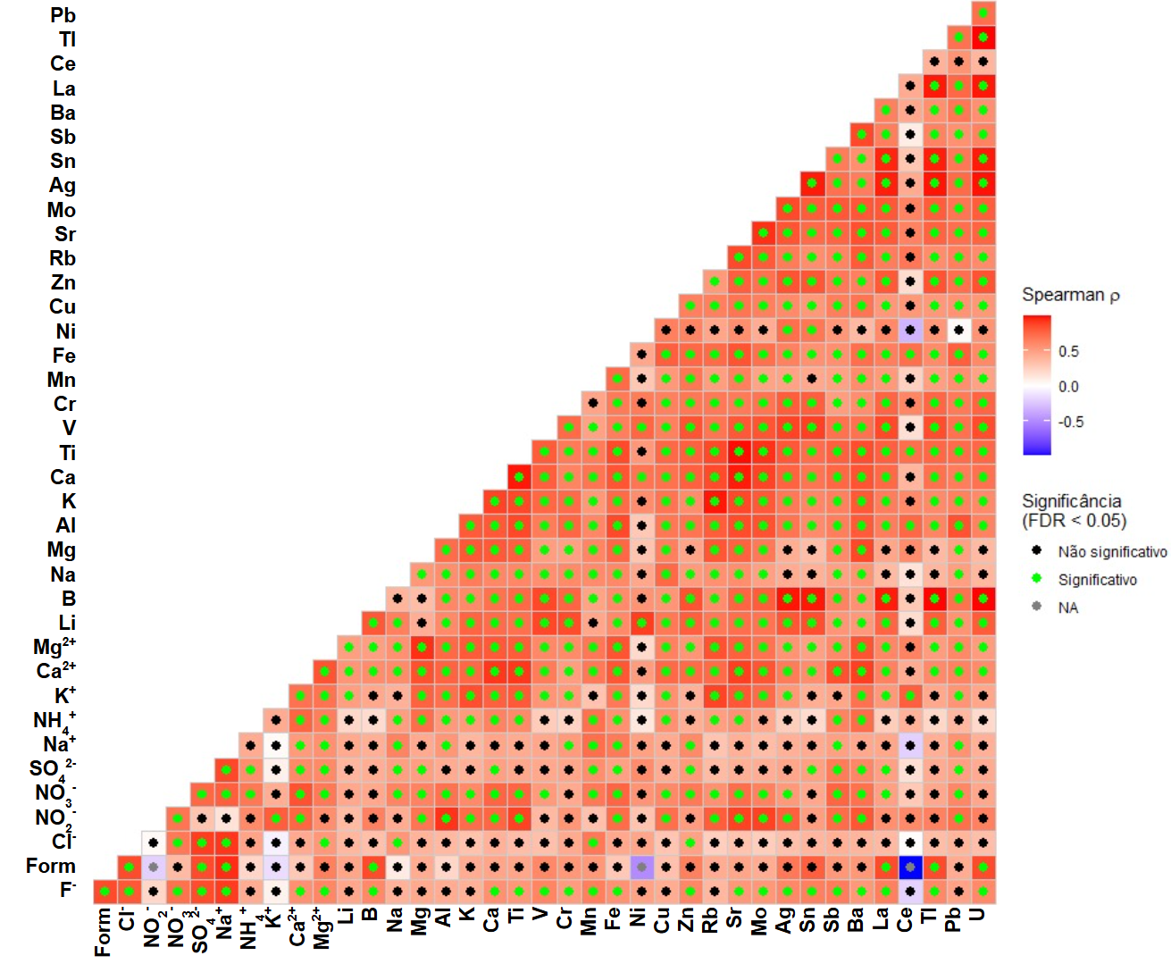
Figure S9. Correlation matrix with FDR correction (False Discovery Rate).
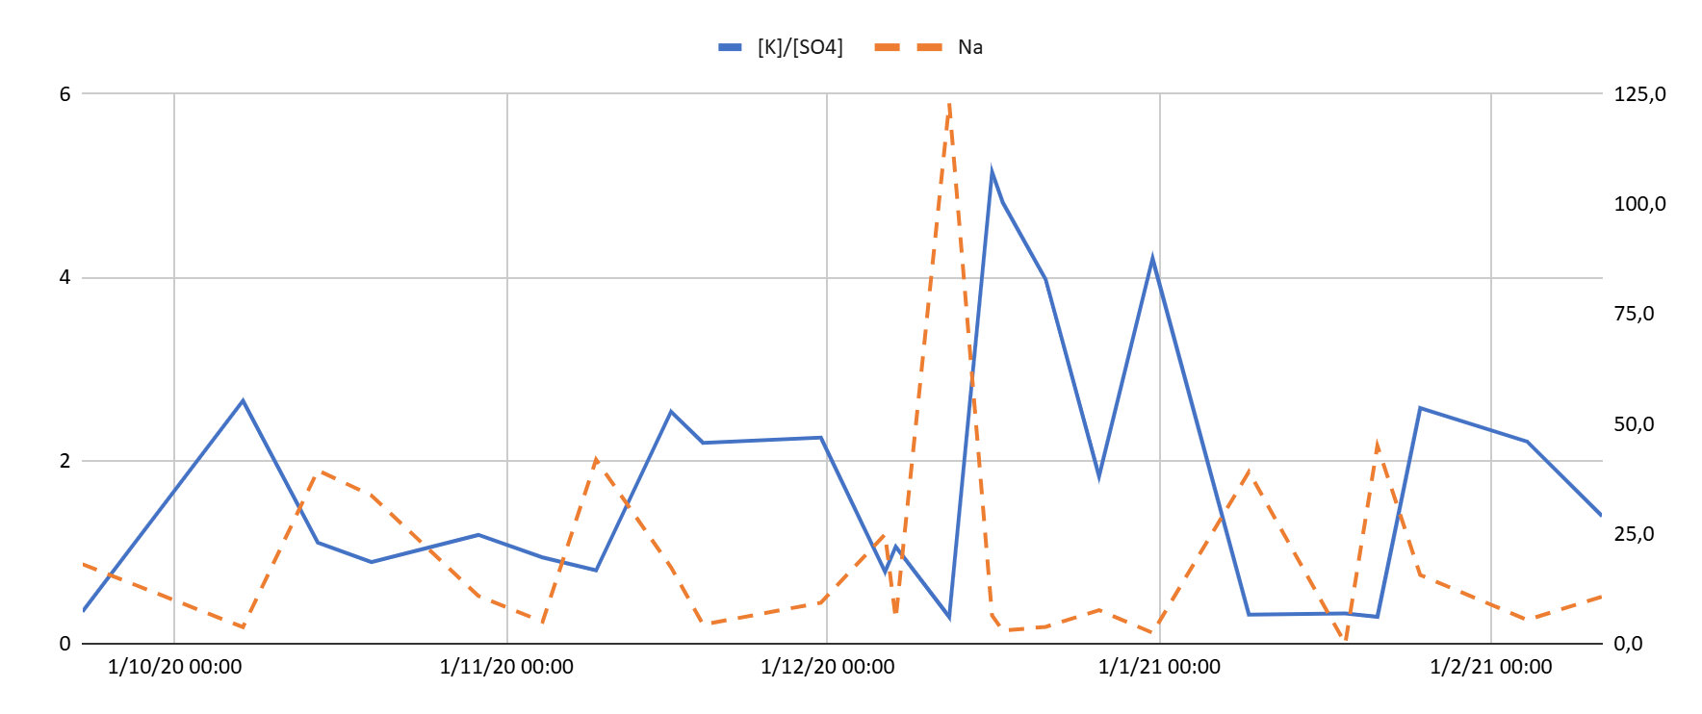
Figure S10. Concentrations of sodium and [K]/[SO₄²⁻] ratios.
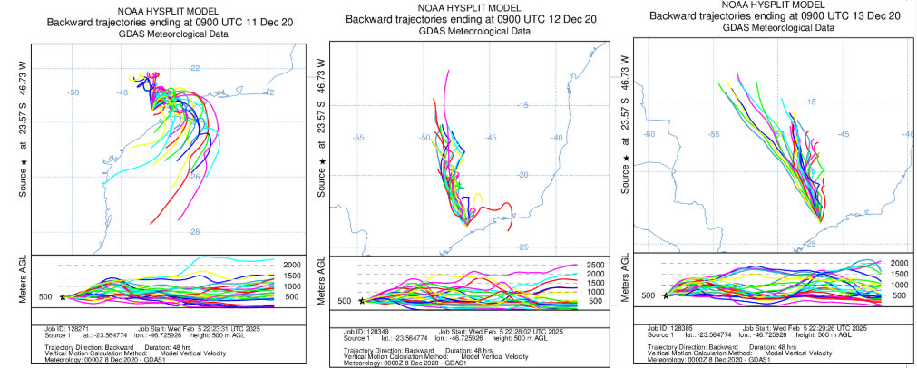
Figure S11. Back trajectories before and after the rain event on 13th December 2020.

