SUPPLEMENTARY INFORMATION
Tables
Table S1. Uncertainty (Unc) and limit of detection (LOD) for elements determined with the ICP.

 | Unc (%) | LOD (µg L⁻¹)
Li | 12.45 | 0.0356
B | 16.01 | 0.0356
Na | 11.16 | 0.1414
Mg | 293.67 | 0.2386
Al | 36.44 | 0.3020
K | 65.73 | 1.4161
Ca | 38.38 | 0.6310
Ti | 9.66 | 0.0129
V | 1.12 | 0.0022
Cr | 0.48 | 0.0068
Mn | 0.38 | 0.0062
Fe | 8.88 | 0.0523
Co | 0.35 | 0.0014
Ni | 0.72 | 0.0164
Cu | 0.24 | 0.0080
Zn | 160.37 | 0.2821
As | 0.19 | 0.0031
Se | 5.22 | 0.1351
Rb | 2.35 | 0.0032
Sr | 1.26 | 0.0166
Mo | 0.30 | 0.0043
Ag | 0.32 | 0.0003
Cd | 0.72 | 0.0095
Sn | 0.61 | 0.0044
Sb | 4.68 | 0.0011
Ba | 0.51 | 0.0188
La | 0.05 | 0.0005
Ce | 0.31 | 0.0008
Tl | 0.01 | 0.0001
Pb | 0.05 | 0.0004
Bi | 0.07 | 0.0003
U | 0.01 | 0.0001

Table S2. Minimum, maximum, average and standard deviation of species wet deposition.

(mg m⁻²) | Min | Max | Avg | SD
Li | 0.001 | 0.024 | 0.007 | 0.005
B | 0.28 | 10.03 | 2.62 | 2.10
Na | 0.5 | 38.0 | 11.9 | 8.2
Mg | 0.3 | 34.1 | 4.1 | 5.1
Al | 0.09 | 4.18 | 0.64 | 0.68
K | 2.31 | 147.20 | 20.52 | 25.97
Ca | 0.22 | 23.03 | 4.99 | 4.40
Ti | 0.01 | 0.39 | 0.08 | 0.07
V | 0.0004 | 0.0262 | 0.0067 | 0.0056
Cr | 0.01 | 0.46 | 0.10 | 0.10
Mn | 0.002 | 1.073 | 0.091 | 0.161
Fe | 0.05 | 1.88 | 0.31 | 0.38
Co | 0.0002 | 0.0171 | 0.0026 | 0.0059
Ni | 0.0001 | 0.0225 | 0.0042 | 0.0059
Cu | 0.01 | 0.24 | 0.06 | 0.04
Zn | 0.09 | 4.51 | 1.12 | 0.95
Rb | 0.01 | 0.52 | 0.06 | 0.09
Sr | 0.01 | 1.19 | 0.22 | 0.20
Mo | 0.001 | 0.034 | 0.010 | 0.007
Ag | 0.00005 | 0.00159 | 0.00050 | 0.00037
Sn | 0.001 | 0.044 | 0.010 | 0.010
Sb | 0.0003 | 0.0134 | 0.0034 | 0.0026
Ba | 0.01 | 0.35 | 0.09 | 0.07
La | 0.001 | 0.022 | 0.005 | 0.004
Ce | 0.0001 | 0.0103 | 0.0017 | 0.0024
Tl | 0.0005 | 0.0168 | 0.0048 | 0.0038
Pb | 0.003 | 0.140 | 0.028 | 0.029
U | 0.001 | 0.023 | 0.007 | 0.005

Table S3. Average, minimum and maximum wet depositions in wet and dry seasons (mg m⁻²).

Season | Wet | Dry | Wet | Dry | Wet | Dry
(mg m⁻²) | Avg |  | Min |  | Max
Li | 0.007 | 0.007 | 0.001 | 0.001 | 0.024 | 0.023
B | 2.6 | 2.7 | 0.3 | 0.4 | 7.8 | 10.0
Na | 11.6 | 12.9 | 0.5 | 1.2 | 38.0 | 29.0
Mg | 3.1 | 7.7 | 0.3 | 1.9 | 6.8 | 34.1
Al | 0.57 | 0.90 | 0.09 | 0.18 | 2.16 | 4.18
K | 14.83 | 42.70 | 2.31 | 9.41 | 34.01 | 147.20
Ca | 4.38 | 7.37 | 0.22 | 1.00 | 11.38 | 23.03
Ti | 0.07 | 0.12 | 0.01 | 0.02 | 0.19 | 0.39
V | 0.0068 | 0.0063 | 0.0004 | 0.0004 | 0.0238 | 0.0262
Cr | 0.10 | 0.09 | 0.01 | 0.01 | 0.46 | 0.35
Mn | 0.059 | 0.216 | 0.002 | 0.030 | 0.194 | 1.073
Fe | 0.32 | 0.30 | 0.05 | 0.05 | 1.88 | 1.05
Ni | 0.0041 | 0.0042 | 0.0001 | 0.0006 | 0.0225 | 0.0152
Cu | 0.05 | 0.08 | 0.01 | 0.01 | 0.18 | 0.24
Zn | 1.07 | 1.31 | 0.09 | 0.18 | 4.51 | 4.00
Rb | 0.04 | 0.14 | 0.01 | 0.02 | 0.11 | 0.52
Sr | 0.20 | 0.33 | 0.01 | 0.10 | 0.47 | 1.19
Mo | 0.010 | 0.010 | 0.001 | 0.001 | 0.034 | 0.030
Ag | 0.00050 | 0.00047 | 0.00005 | 0.00010 | 0.00154 | 0.00159
Sn | 0.010 | 0.007 | 0.001 | 0.001 | 0.044 | 0.023
Sb | 0.0036 | 0.0027 | 0.0003 | 0.0004 | 0.0134 | 0.0069
Ba | 0.08 | 0.12 | 0.01 | 0.02 | 0.20 | 0.35
La | 0.005 | 0.006 | 0.001 | 0.001 | 0.018 | 0.022
Tl | 0.0048 | 0.0047 | 0.0005 | 0.0008 | 0.0160 | 0.0168
Pb | 0.026 | 0.036 | 0.003 | 0.004 | 0.089 | 0.140

Table S4. Mann-Whitney tests for independent samples, in the case of higher average concentration of species in the dry and wet seasons.

 |  | Dry > Wet |  | Wet > Dry
 |  | Stat | p | Stat | p
Li | U de Mann-Whitney | 163 | 0.79 | 163 | 0.21
B | U de Mann-Whitney | 180 | 0.65 | 180 | 0.36
Na | U de Mann-Whitney | 171 | 0.28 | 171 | 0.73
Mg | U de Mann-Whitney | 133 | 0.06 | 133 | 0.94
Al | U de Mann-Whitney | 185 | 0.41 | 185 | 0.60
K | U de Mann-Whitney | 117 | 0.03 | 117 | 0.98
Ca | U de Mann-Whitney | 179 | 0.35 | 179 | 0.66
Ti | U de Mann-Whitney | 182 | 0.38 | 182 | 0.63
V | U de Mann-Whitney | 149 | 0.88 | 149 | 0.13
Cr | U de Mann-Whitney | 154 | 0.85 | 154 | 0.16
Mn | U de Mann-Whitney | 103 | 0.01 | 103 | 0.99
Fe | U de Mann-Whitney | 185 | 0.60 | 185 | 0.41
Cu | U de Mann-Whitney | 158 | 0.18 | 158 | 0.83
Zn | U de Mann-Whitney | 175 | 0.32 | 175 | 0.69
Rb | U de Mann-Whitney | 126 | 0.05 | 126 | 0.96
Sr | U de Mann-Whitney | 177 | 0.33 | 177 | 0.67
Mo | U de Mann-Whitney | 183 | 0.62 | 183 | 0.39
Ag | U de Mann-Whitney | 165 | 0.78 | 165 | 0.23
Sn | U de Mann-Whitney | 158 | 0.83 | 158 | 0.18
Sb | U de Mann-Whitney | 148 | 0.88 | 148 | 0.12
Ba | U de Mann-Whitney | 174 | 0.31 | 174 | 0.70
La | U de Mann-Whitney | 173 | 0.71 | 173 | 0.30
Tl | U de Mann-Whitney | 167 | 0.76 | 167 | 0.24
Pb | U de Mann-Whitney | 194 | 0.52 | 194 | 0.50
U | U de Mann-Whitney | 165 | 0.78 | 165 | 0.23
 |  | Hₐ μ 0 > μ 1 |  | Hₐ μ 0 < μ 1

Table S5. Percentage of deposition for each case study period.

 | Sea spray(%) | Biomass burning(%)
Li | 4.6 | 10.6
B | 1.9 | 11.7
Na | 11.4 | 8.4
Mg | 2.8 | 25.5
Al | 1.8 | 18.9
K | 3.1 | 27.4
Ca | 3.0 | 18.3
Ti | 2.8 | 18.5
V | 3.9 | 11.2
Cr | 2.2 | 11.4
Mn | 2.7 | 34.2
Fe | 2.0 | 11.7
Co | 1.8 | 7.8
Ni | 25.8 | 1.2
Cu | 4.8 | 14.5
Zn | 3.4 | 11.8
Rb | 2.0 | 32.5
Sr | 2.7 | 18.1
Mo | 2.9 | 10.2
Ag | 2.4 | 10.2
Sn | 1.7 | 7.7
Sb | 4.0 | 6.8
Ba | 2.6 | 15.1
La | 2.1 | 13.2
Ce | 0.5 | 30.7
Tl | 2.3 | 10.9
Pb | 1.3 | 17.1
U | 2.3 | 11.0

Table S6. Correlation matrix among all analysed species.
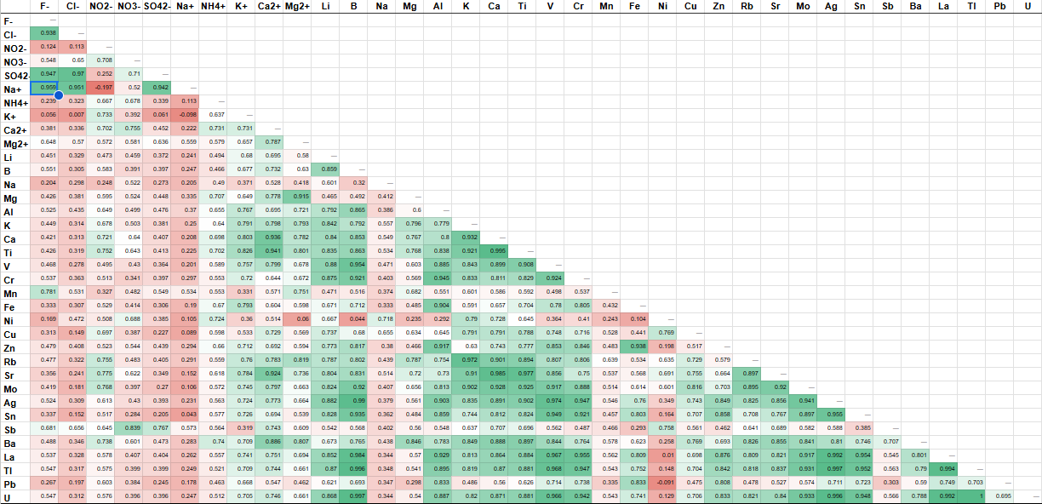
Table S7. Diagnostic ratios among chemical species.

 | Cu/Sb | Cu/Zn | Fe/Cu | Sn/Sb | La/Ce | V/Ni | Cl⁻/Na⁺ | SO₄²⁻/NO₃⁻
MIN | 5.7 | 0.01 | 1.2 | 0.5 | 0.7 | 0.2 | 0.4 | 0.2
MAX | 55.2 | 0.22 | 30.5 | 13.7 | 58.0 | 16.1 | 3.2 | 1.1
MED | 20.8 | 0.06 | 4.3 | 2.6 | 3.5 | 1.8 | 1.2 | 0.5
Sea-spray event | 21 | 0.08 | 2.2 | 1.1 | 24.3 | 0.4 | 0.9 | 0.6
Biomass smoke event | 37.6 | 0.07 | 4.3 | 3.2 | 2.4 | 26.9
Literature
LDV (Pereira et al., 2023a) | 14 | 6.2 | 4 | 1 | 0.7 | 0.6
HDV (Pereira et al., 2023a) | 11 | 0.9 | 9 | 2.2 | 1.4 | 1.6
Oil/Oil refin. |  |  |  |  | 4.3 | 1 - 3
Sea spray |  |  |  |  |  |  | 1.8
PM_{2.5} (2014)  (Pereira et al., 2017) |  |  |  |  |  |  |  | 2.2
PM_{2.5} (2019)  (Pereira et al., 2025) |  |  |  |  |  |  |  | 1.4

