Supplementary figures

Supplementary Figure S1:
Supplementary Figure S1A: Outlier exclusion – RCT studies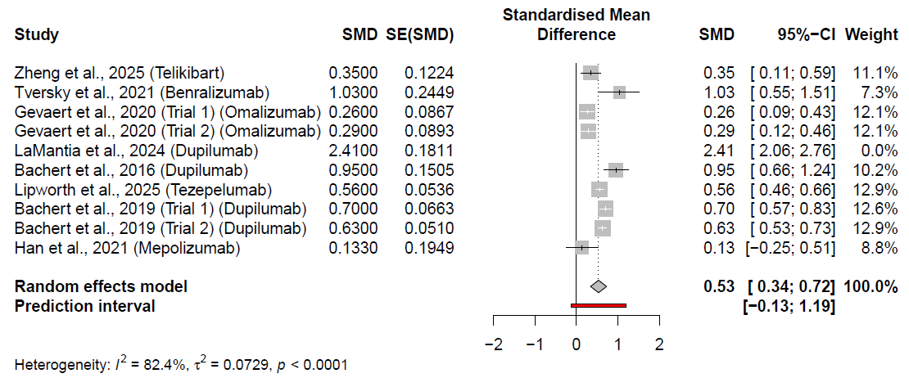
Pooled estimates of standardized mean differences (SMD) and 95% confidence intervals in RCT studies after removal of the influential outlier RCT (LaMantia et al, 2024). SMD, standardized mean differences; SE, standard error; 95%-CI, 95% confidence interval
Figure S1B: Outlier exclusion – Cohort studies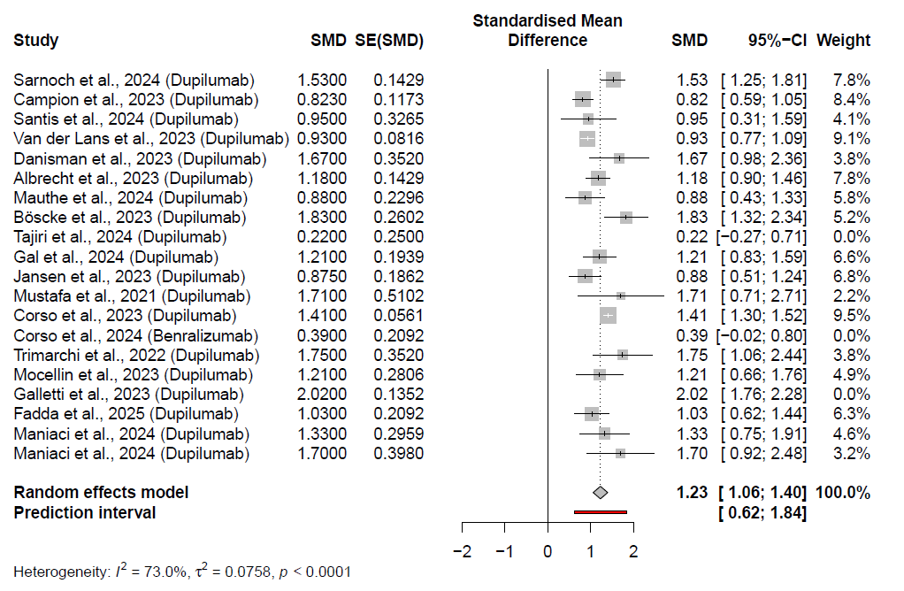
Pooled estimates of standardized mean differences and 95% confidence intervals in cohort studies after removal of outliers (Tajiri et al 2024, DeCorso et al 2024 and Galetti et al 2023). SMD, standardized mean differences; SE, standard error; 95%-CI, 95% confidence interval

Supplementary Figure S2:
S2A: Influence diagnostics: RCTs
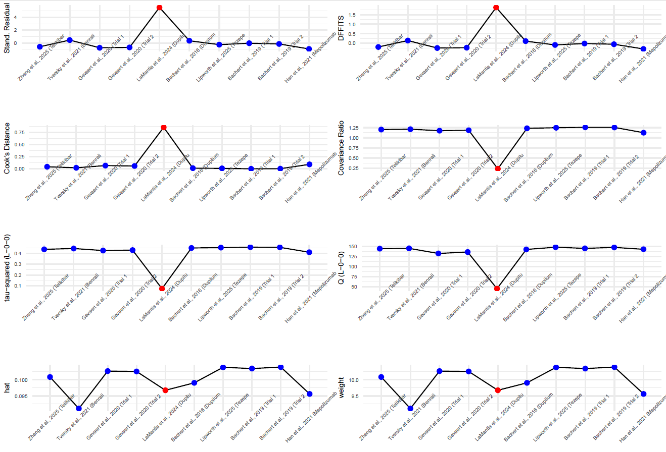
The figure shows eight diagnostic measures to evaluate individual study influence and leverage in the meta-analytic model. Each panel displays a separate diagnostic statistic: standardized residuals show how far each study deviates from the model prediction. Difference in fits (DFFITS) and Cook’s distance identify studies exerting high influence on fitted results. The covariance ratio assesses each study’s impact on the precision of pooled estimates. Tau-squared (L–0) and Q (L–0) denote between-study variance and heterogeneity when each study is omitted (leave-one-out analysis). Hat values measure leverage indicating how much a study influences its own fitted effect, and study weights indicate relative contribution to the pooled effect. Red markers highlight observations exceeding conventional influence thresholds. Blue markers represent individual studies.

S2B: Baujat plot RCTs
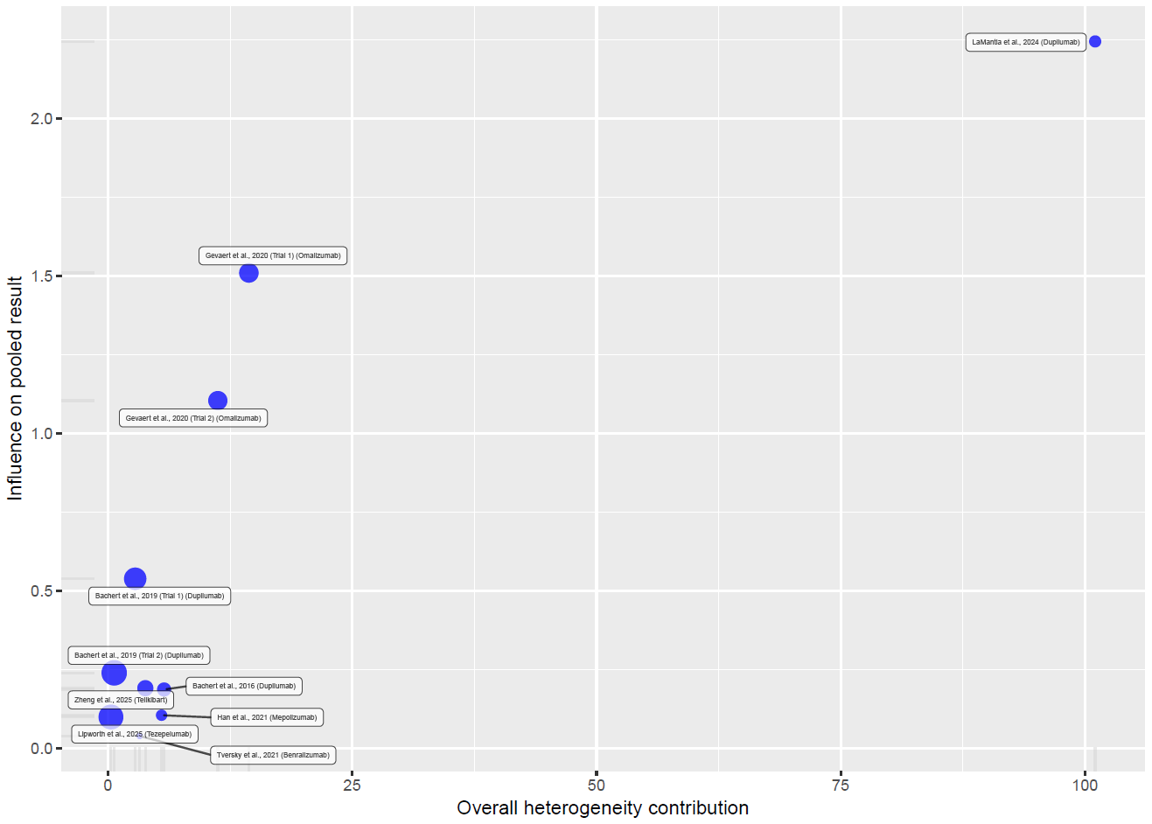
Baujat plot of RCTs, illustrating each randomized controlled trial’s contribution to overall heterogeneity (x-axis) and to the pooled effect size (y-axis). Studies in the upper-right quadrant exert the greatest influence on both and may indicate outliers or sources of heterogeneity.

S2C: Influence diagnostics – Cohort studies
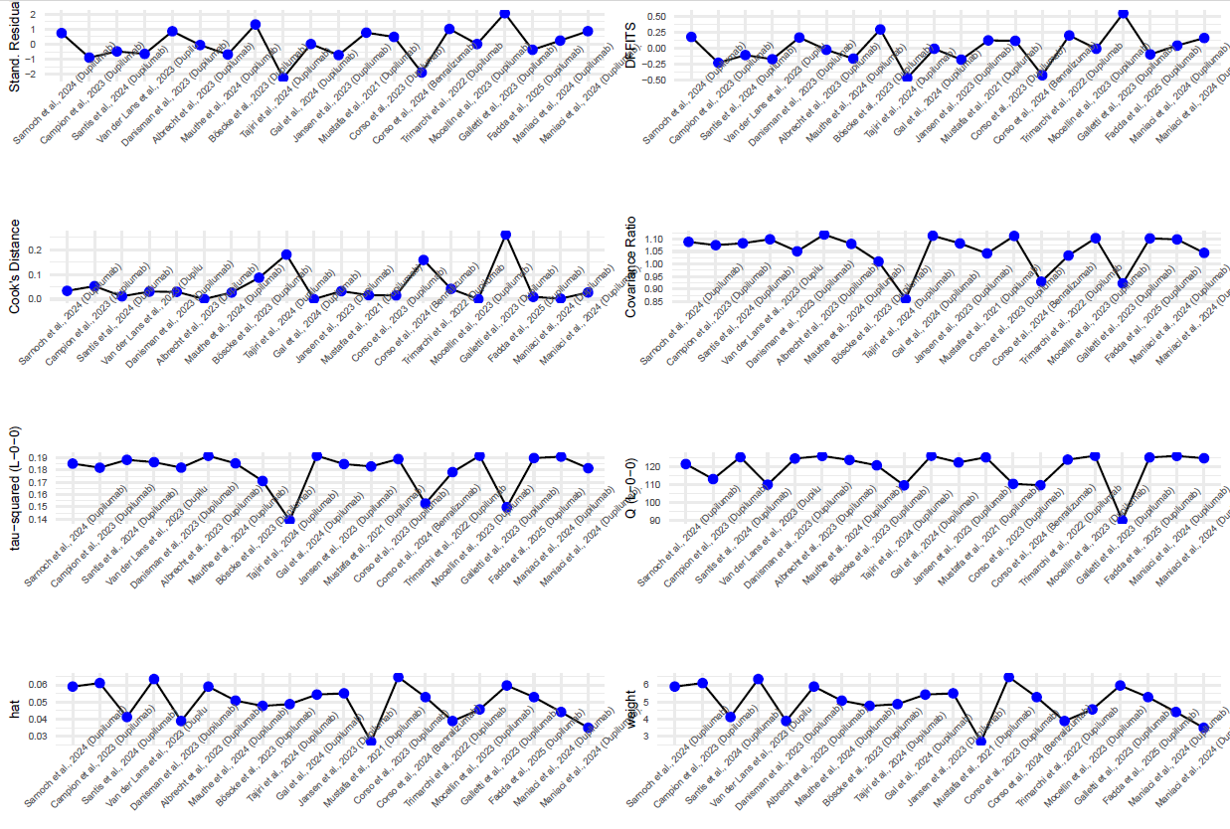
As in Figure S2A.

S2D: Baujat plot cohort studies
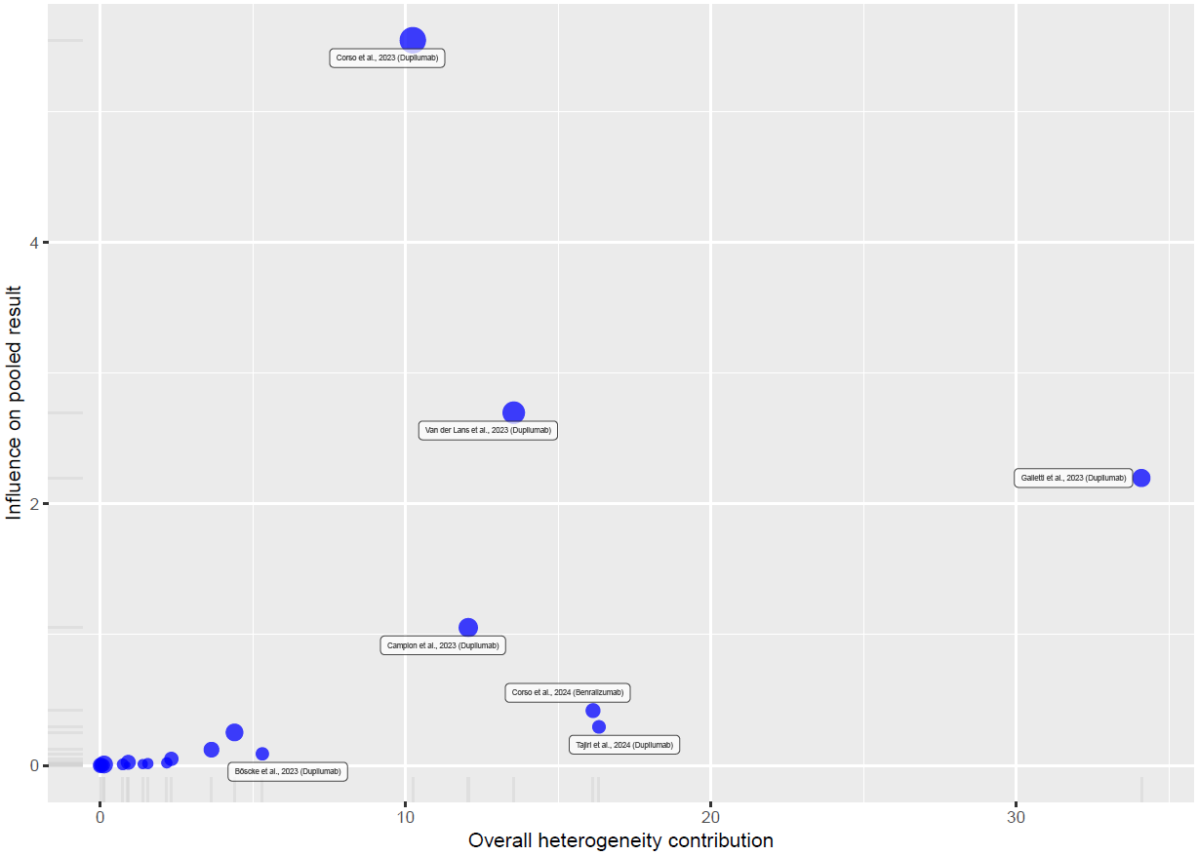
As in Figure S2B

Supplementary Figure S3
Supplementary Figure S3. Leave-one-out sensitivity analyses of RCT studies (S3A) and cohort studies (S3B).
S3A: Leave-one-out sensitivity analysis for RCTs
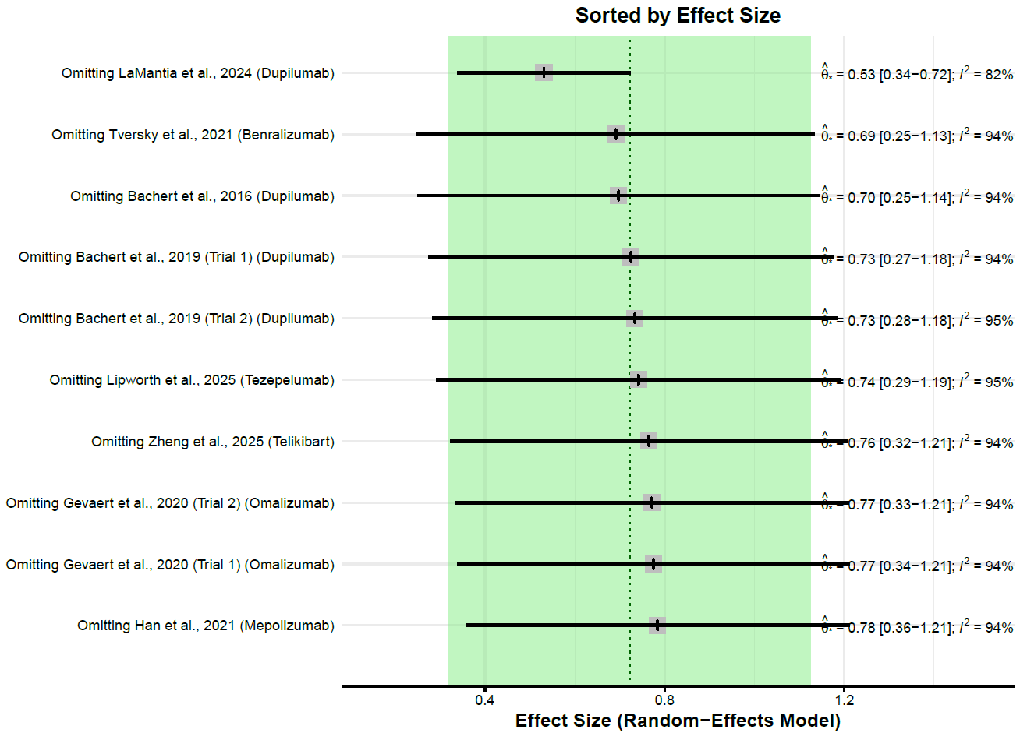
The random-effects meta-analysis is re-estimated repeatedly, each time omitting one trial, to evaluate individual study influence on the pooled effect and heterogeneity. The plot displays the re-estimated effect with its confidence interval for each omission, alongside the dashed line and shaded band representing the full dataset estimate and its confidence range. Minimal variation across iterations suggests that no single trial unduly influenced the overall result.
S3B Leave-one-out sensitivity analysis for cohorts. 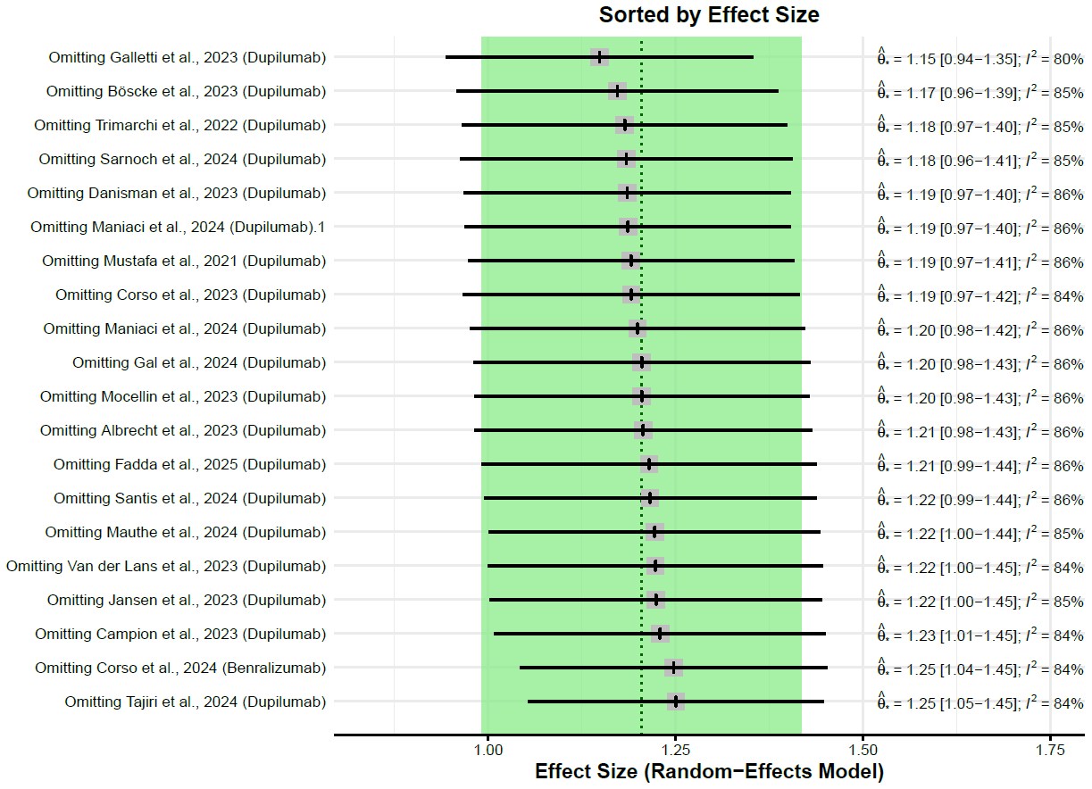
As in Figure S3A

Supplementary Figure S4
Supplementary Figure S4: Effects of follow-up duration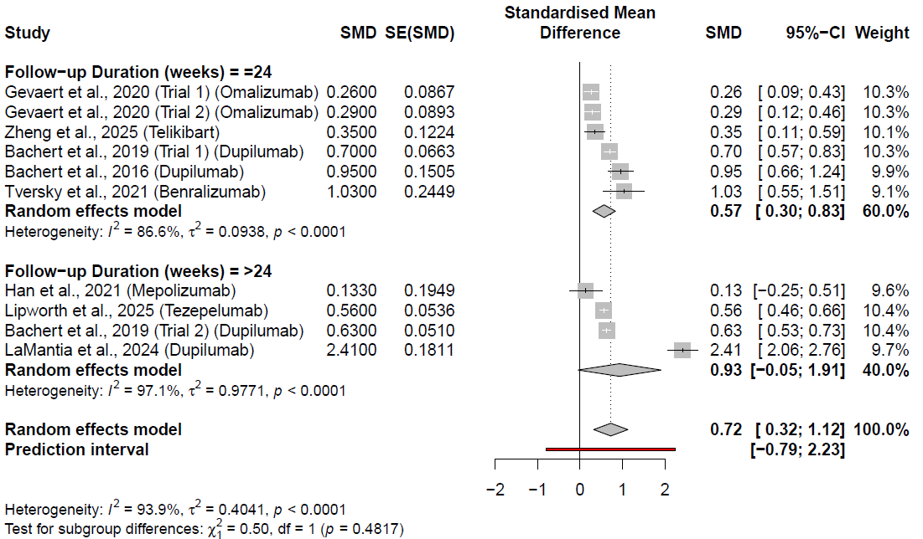
Subgroup-analysis of follow-up duration. Comparison of short- (≤24 weeks) and long-term (>24 weeks) follow-up.

Supplementary Figure S5 A+B: Publication bias
Supplementary Figure 5: Publication bias
S5A. Funnel plot for publication bias evaluation in RCTs
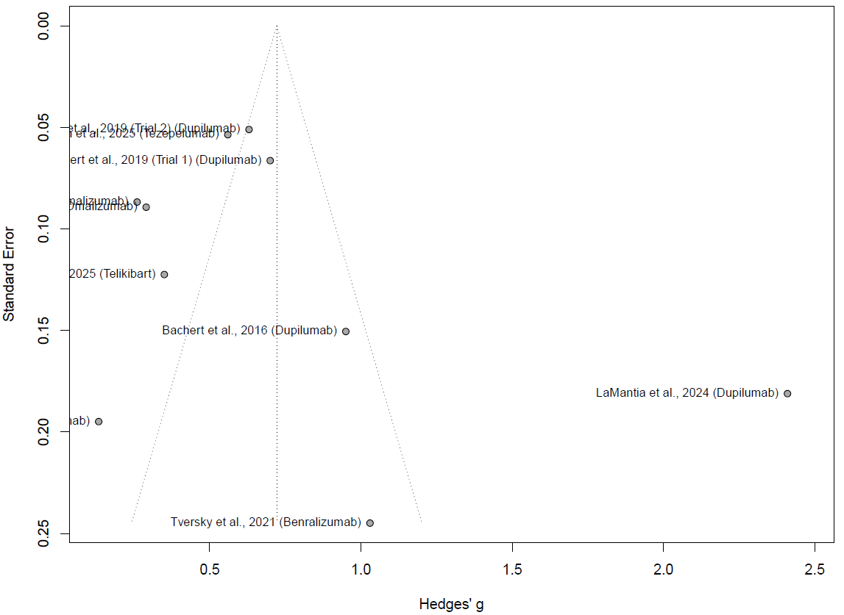
Funnel plot for visual assessment of publication bias; Each circle represents an individual study plotted by its standardized effect size (Hedges’ g) on the x-axis and standard error on the y-axis. The dotted lines mark the expected 95% confidence region under a symmetric distribution.

S5B. Funnel plot for publication bias evaluation in cohort studies
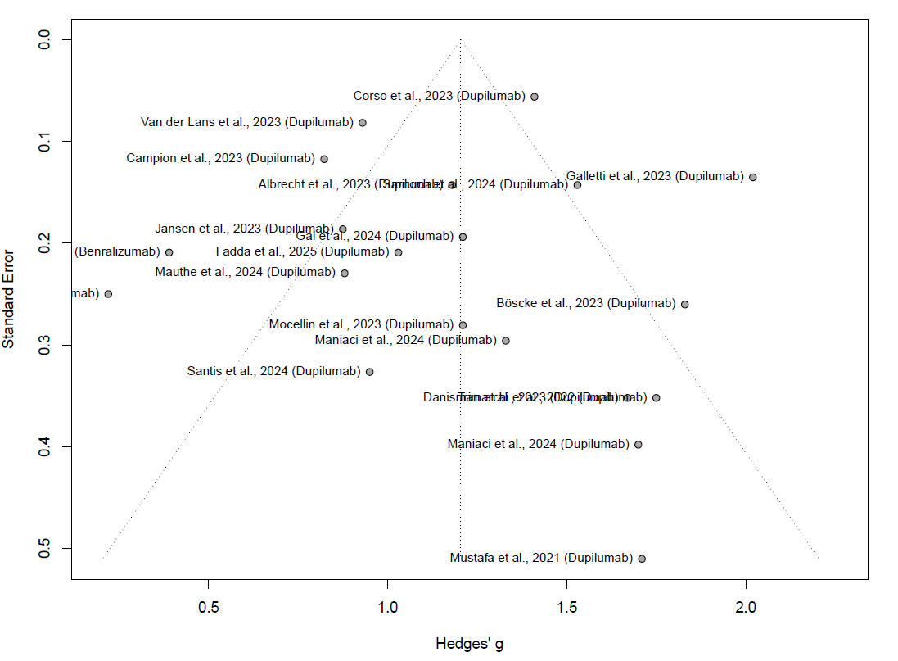
As in Figure S5A

Supplementary Table S1: Search strategy
#1 Population | #2 Intervention | #3 Outcome | #4 Study type
nasal polyp*[TiAb] OR  rhinosinus*[TiAb]  polypos*[TiAb] OR  rhinit*[TiAb] OR  sinusitis[MeSH Terms] OR  rhinitis[MeSH Terms] OR  nasal polyps[MeSH Terms] | mepolizumab[TiAb] OR  omalizumab[TiAb] OR  reslizumab[TiAb] OR  benralizumab[TiAb] OR  depemokimab[TiAb] OR  dupilumab[TiAb] OR  tezepelumab[TiAb] OR  "antibodies, monoclonal"[MeSH Terms] | smell[MeSH Terms] OR  olfaction[TiAb] OR  anosmia[TiAb] OR  hyposmia[TiAb] OR  Loss of smell [TiAb] OR  Smell loss [TiAb] OR  UPSIT[TiAb] OR  TDI[TiAb] OR  SSIT[TiAb] OR  sniffin sticks[TiAb] OR  "olfaction disorders"[MeSH Terms] | clinicaltrial[Filter] OR  meta-analysis[Filter] OR  randomizedcontrolledtrial[Filter] OR  Clinical study[Filter] OR  Observational study[Filter] OR  Multicenter study[Filter] OR  Pragmatic clinical trial[Filter] OR  comparative study[Filter]
#5 #1 AND #2 AND #3 AND #4

Supplementary Table S2: Baseline demographics and patient characteristics
Group | Sample Size | Mean age, years  (SD) | % Female | % with asthma | % with prior Surgery | Mean blood eosinophils/µL (SD) | Mean NPS (SD) | Mean  SNOT-22 (SD)
RCT
Han et al., 2021 [25]
(SYNAPSE)
Placebo | 201 | 48.9 (12.5) | 38 | 74 | 100 | 400 (0.91) | 5.6 (1.4) | 64.4 (19.0)
Mepolizumab | 206 | 48.6 (13.6) | 33 | 68 | 100 | 390 (0.88) | 5.4 (1.2) | 63.7 (17.6)
Gevaert et al., 2020 [24] (POLYP-1)
Placebo | 66 | 52.2 (11.6) | 38 | 49 | 61 | 359 (305) | 6.3 (0.9) | 60.5 (15.3)
Omalizumab | 72 | 50.0 (14.5) | 35 | 58 | 54 | 334 (265) | 6.2 (1.0) | 59.8 (19.7)
Gevaert et al., 2020 [24](POLYP-2)
Placebo | 65 | 51.0 (12.0) | 32 | 60 | 62 | 357 (196) | 6.1 (0.9) | 59.8 (18.2)
Omalizumab | 62 | 49.0 (11.9) | 37 | 61 | 63 | 311 (177) | 6.4 (0.9) | 59.2 (20.5)
Zheng et al., 2025[26]
Placebo | 34 | 44.2 (12.7) | 50 | 59 | 62 | 500 (400) | 5.7 (0.8) | 53.7 (24.5)
Telikibart | 36 | 46.6 (12.4) | 33 | 31 | 61 | 400 (300) | 6.1 (0.9) | 47.3 (26.0)
Tversky et al., 2021[27]
Placebo | 12 | 50.8 (13.1) | 42 | 100 | 100 | 846 (592) | 6.2 (0.97) | 64.8 (18.3)
Benralizumab | 12 | 49.8 (12.1) | 42 | 83 | 100 | 698 (412) | 5.7 (0.87) | 57.6 (16.8)
Lipworth et al., 2025[28]
Placebo | 205 | 49.4 (13.7) | 32 | 62 | 72 | 359 (248) | 6.1 (1.3) | 69.2 (18.4)
Tezepelumab | 203 | 50.1 (13.6) | 38 | 60 | 71 | 357 (229) | 6.1 (1.2) | 68.2 (18.4)
Bachert et al., 2019[23] (SINUS-24)
Placebo | 133 | 50 (41–60)* | 47 | 59 | 74 | 440 (310) | 5.9 (1.3) | 50.9 (20.2)
Dupilumab | 143 | 52 (39–61)* | 38 | 57 | 69 | 440 (350) | 5.6 (1.2) | 48.0 (20.2)
Bachert et al., 2019[23] (SINUS-52)
Placebo | 153 | 53 (44–61)* | 38 | 59 | 58 | 450 (360) | 6 (1.2) | 53.5 (21.9)
Dupilumab(q2w) | 153 | 51 (42–61)* | 35 | 57 | 59 | 450 (390) | 6 (1.2) | 50.2 (19.7)
Dupilumab(q2w-q4w) | 145 | 53 (42–63)* | 40 | 63 | 59 | 400 (300) | 6.3 (1.2) | 51.9 (21.1)
Bachert et al., 2016[29]
Placebo | 30 | 49.3 (9.1) | 47 | 63 | 63 | 450 (670) | 5.7 (0.9) | 40.6 (19.9)
Dupilumab | 30 | 47.4 (9.8) | 40 | 53 | 53 | 410 (240) | 5.9 (1.0) | 41.4 (18.2)
LaMantia et al., 2024[30]
Placebo | 60 | 53.9 (11.6) | 35 | 62 | NR | 690 (378) | 5.4 (0.9) | 57.8 (19.5)
Dupilumab | 60 | 50.8 (14.1) | 37 | 55 | NR | 761 (600) | 5.7 (1.2) | 59.7 (21.1)
Cohort
Sarnoch et al., 2024[31] | 104 | 50.1(13.6) | 51 | 83 | NR | 380 (260) | 4.72 (1.6) | 60.4 (19.34)
Campion et al., 2023[32] | 97 | 46.3 (14.2) | 37 | 65 | 93 | NR | 4 (2-6)* | 40 (28-62)*
De Santis et al., 2024[33] | 14 | 47.5 (17.2) | 43 | 79 | 100 | 433 (25) | NR | 60.3 (3.5)
Van der Lans et al., 2022[34] | 228 | 51 (18-90)* | 37.3 | 81 | 100 | 570 (390) | 5.3 (1.9) | 53.6 (19.6)
Danisman et al., 2023[35] | 20 | 56 (12) | 30 | 90 | 70 | 649 (405) | 4.50 (1.9) | 55 (NA)#
Albrecht et al., 2023[36] | 81 | 49.7 (14.2) | 48 | 75 | 100 | 473 (401) | 5.31(1.9) | 55 (16.9)
Mauthe et al., 2024[37] | 26 | 51.6 (11.8) | 23 | NR | NR | NR | 5 (2.0) | 48.4 (16.6)
Böscke et al., 2023[38] | 41 | 52 (27-79)* | 44 | 68 | 100 | 440 (280-580)* | 5 (4-6)* | 48 (37-68)*
Tajiri et al., 2024[39] | 16 | 57 (37-77)* | 56 | 100 | 69 | 583 (363-1159)* | 6 (2-8)* | 36 (13-70)*
Gal et al., 2024[40] | 47 | 52.9 (13.5) | 24 | NR | 100 | NR | 6.15 (1.7) | 52.4 (24.3)
Jansen et al., 2023[41] | 40 | 52 (16.3) | 55 | 88 | 100 | NR | 4.30 (1.5) | 60.5 (22.2)
Mustafa et al., 2021[42] | 10 | 43 (35-59)* | 50 | 100 | 100 | 500 (325-650)* | NR | 46 (34-65)*
DeCorso et al., 2023[43] | 648 | 54 (45-63)* | 38 | 57 | 91 | 500 (300-682)* | 6 (5-6)* | 58 (49-70)*
DeCorso et al., 2024[44] | 25 | 57.5 (8.9) | 48 | NR | 72 | 650 (222) | 5.1 (1.8) | 57 (15.30)
Trimarchi et al., 2022[45] | 21 | 47 (29-84)* | 24 | 71 | 100 | 540 (0-1100)* | 5 (5-6)* | 65 (48-74)*
Mocellin et al., 2023[46] | 23 | 55.8 (14.8) | 61 | 83 | 74 | 680 (510) | 6.1 (1.3) | 62.7 (18.6)
Galletti et al., 2023[47] | 170 | 54 (45-63)* | 36 | 45 | 77 | 600 (300-700)* | 6 (5-7)* | 66 (53-78)*
Fadda et al., 2025[48] | 32 | 57.9 (19.9) | 32 | 78 | 88 | 552 (330) | 5.3 (1.5) | 55.9 (15.1)
Maniaci et al., 2025[49] | 22 | 52.1 (8.6) | 23 | 41 | 0 | 522 (74.6) | 5.8 (1) | 55.2 (16.7)
Maniaci et al., 2025[50] | 16 | 57 (50-59)* | 38 | 38 | 100 | 520 (490-583)* | 5.5 (5-6)* | 48 (39-70)*

Data are means (SDs) unless otherwise specified. NPS, nasal polyp score (0–8) higher indicating more disease; SNOT-22, 22-item Sino-Nasal Outcome Test (0-110), higher scores indicating worse disease; NR, Not reported; NA, not applicable; q2w, 300mg/2 weeks; q2w-q4w, 300mg/2 weeks for 24 weeks, then every 4 weeks for 28 weeks. *, median (IQR); NR, Not reported; #, SNOT-20 was reported in the study and converted to SNOT-22 value by multiplying the value by 1.1

