Supplemental Figure: Complementary Mechanisms of SGLT2i and GLP-1RA Across the Cardiometabolic Continuum in Type 2 Diabetes
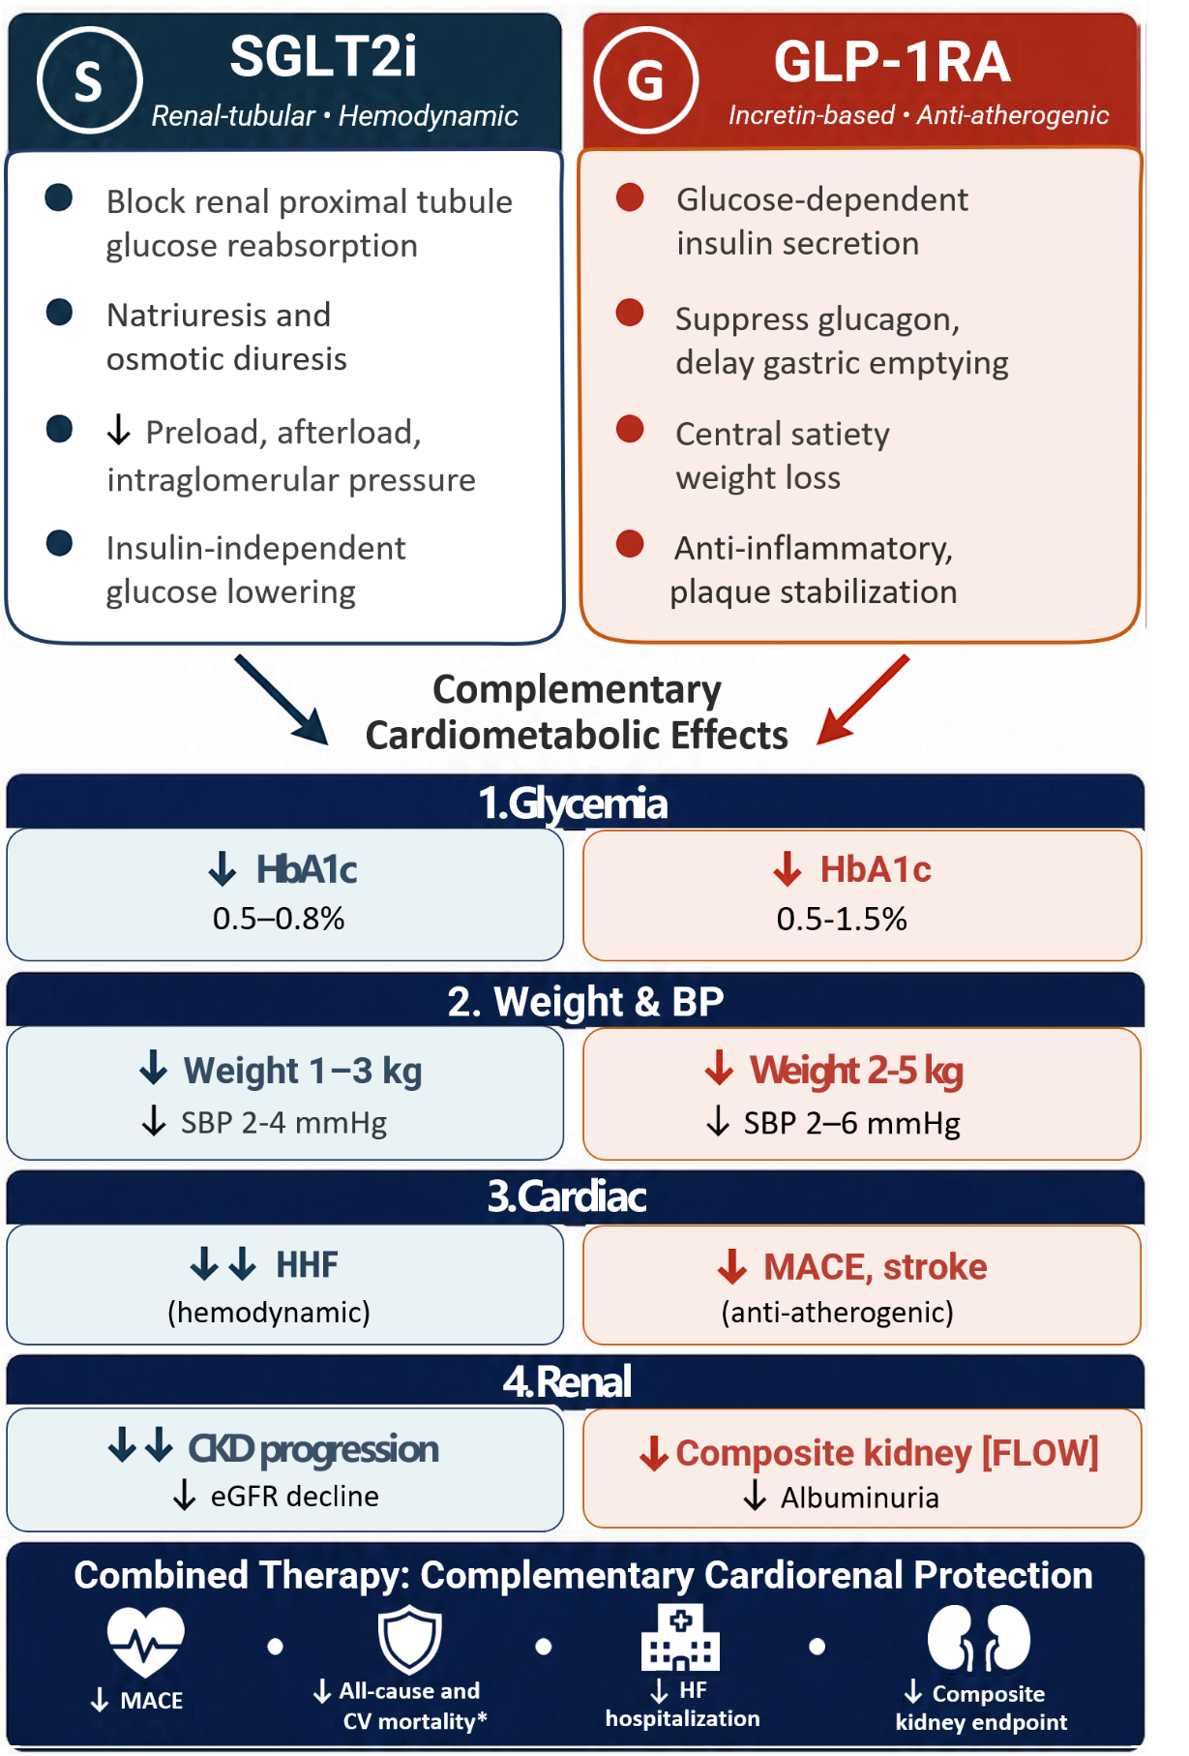
ASCVD, atherosclerotic cardiovascular disease
BMI, body mass index
BP, blood pressure
CKD, chronic kidney disease
CV, cardiovascular
eGFR, estimated glomerular filtration rate
GLP-1RA, glucagon-like peptide-1 receptor agonist
HbA1c, hemoglobin A1c
HF, heart failure
HHF, hospitalizations for heart failure
kg, kilograms
MACE, major adverse cardiovascular events
SGLT2i, sodium-glucose cotransporter 2 inhibitors
* Based on observational evidence

