Fig. S1 Preferred Reporting Items for Systematic Reviews and Meta-Analyses (PRISMA) flow diagram.

Identification of studies via databases and registers

Records identified from:
MEDLINE (n=1,721)
Cochrane Library (n = 2,253)
Clinical Trials (n=125)
Registers (n = 0)

Records removed before screening:
Duplicate records removed
(n = 462)
Records marked as ineligible by automation tools (n = 0)
Records removed for other reasons (n = 0)

Identification

Records excluded
(n = 3,597)
Records screened
(n = 3,637)

Reports not retrieved
(n =0)
Reports sought for retrieval
(n = 40)
Screening

Reports excluded:
Study type (n = 21)
Type 1 diabetes (n = 2)
No publicly available results (n = 3)

Reports assessed for eligibility
(n =40)

Studies included in review
(n = 14)
Included

Fig. S2 Odds ratio of achieving an HbA1c <7.0% between once-weekly and daily basal insulin analogs.
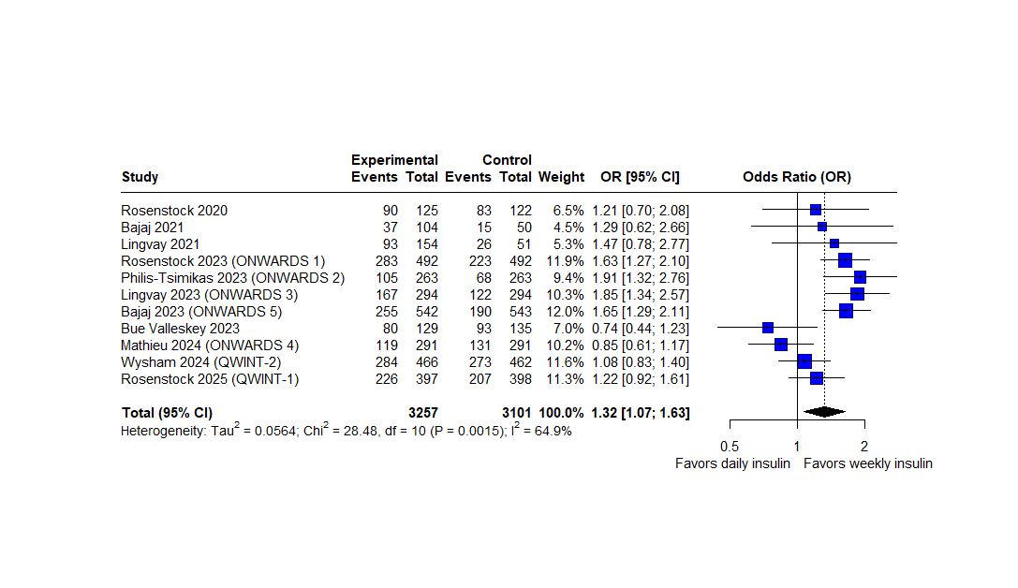

Fig. S3 Difference in mean change in HbA1c (%) between once-weekly and daily basal insulin analogs, based on insulin naivety status.
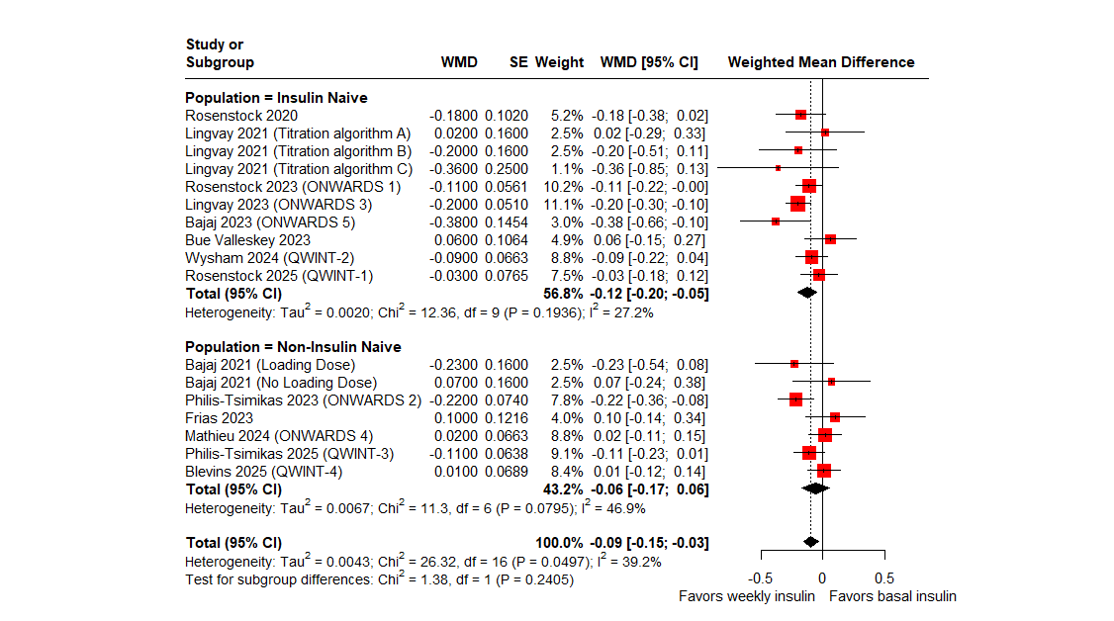

Fig. S4 Difference in mean change in HbA1c (%) between once-weekly and daily basal insulin analogs, based on intervention (type of once-weekly basal insulin analog) used.
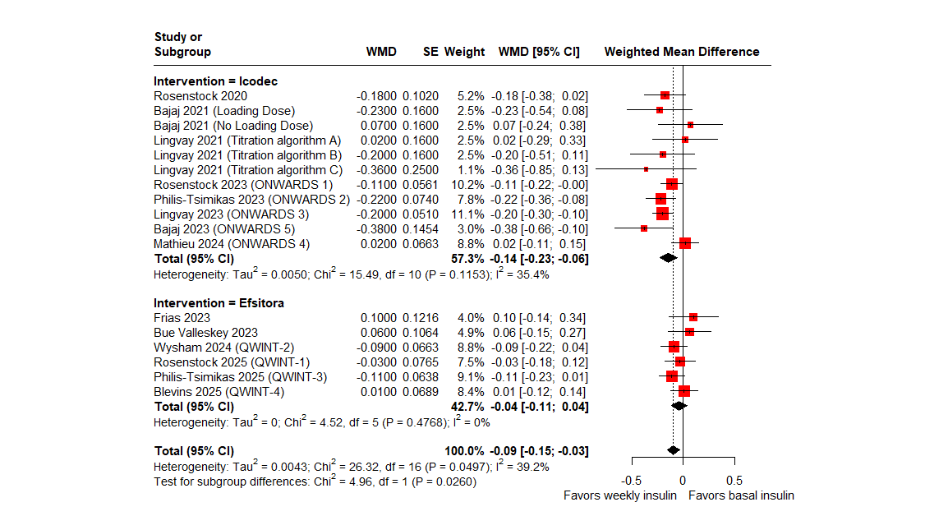

Fig. S5 Difference in mean change in HbA1c (%) between once-weekly and daily basal insulin analogs, based on comparator (type of daily basal insulin analog) usedª.
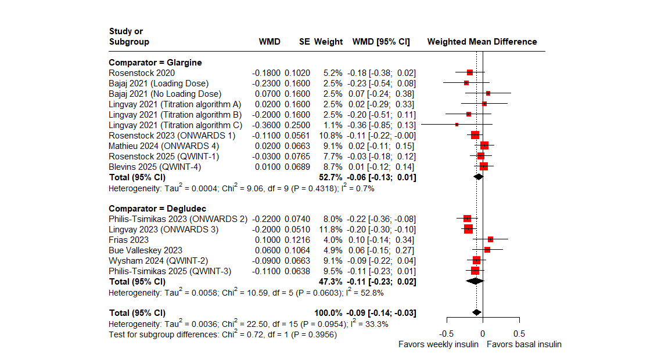
ªONWARDS 5 was excluded from this analysis; comparator arm included both types of basal insulin and treatment allocation could not be determined.

Fig. S6 Post hoc sensitivity analysis for the mean change in HbA1c (%) between once-weekly and daily basal insulin analogs, excluding two trials with trial-specific dosing/titration algorithms.
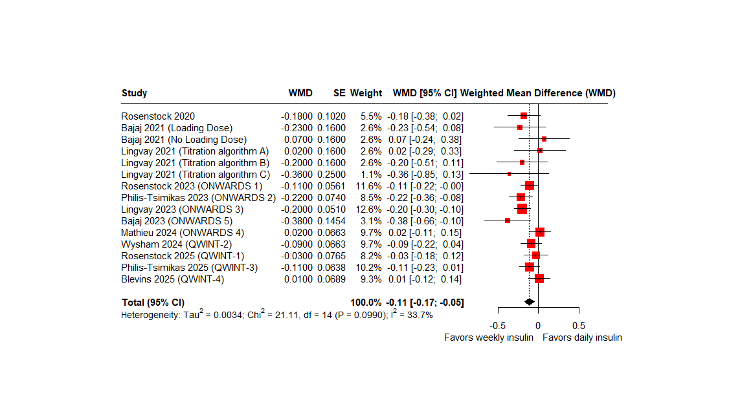
ªStudies Bue Valleskey 2023 and Frias 2023 were excluded.

Fig. S7 Difference in mean change in TIR between once-weekly and daily basal insulin analogs (main analysis).
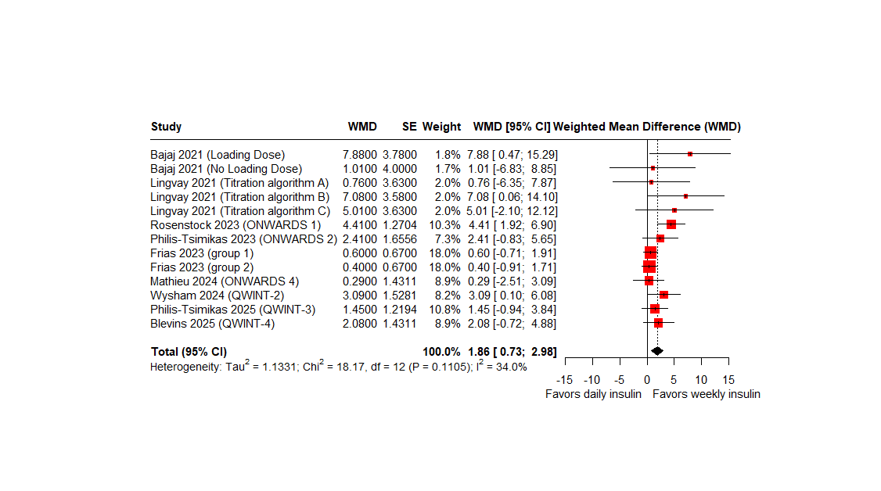

Fig. S8 Post hoc sensitivity analysis for the difference in mean change in TIR between once-weekly and daily basal insulin analogs, including a trial with different definition of TIRª.
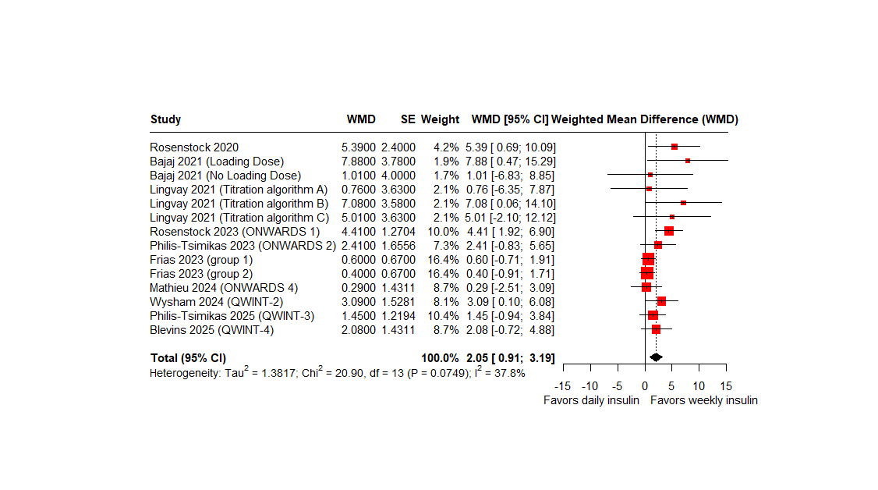
ªTIR was defined generally as 70-180 mg/dL, except for Rosenstock 2020 (70-140 mg/dL) and Frias 2023 (71-180 mg/dL)

Fig. S9 Difference in mean change in FPG (mg/dL) between once-weekly and daily basal insulin analogs (main analysis).
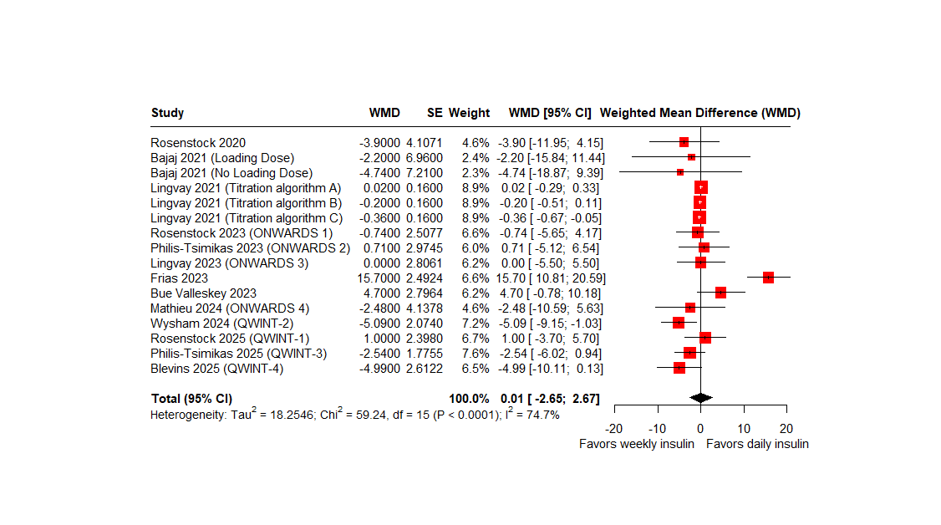

Fig. S10 Post hoc sensitivity analysis for the mean change in FPG (mg/dL) between once-weekly and daily basal insulin analogs, excluding two trials with trial-specific dosing/titration algorithmsª.
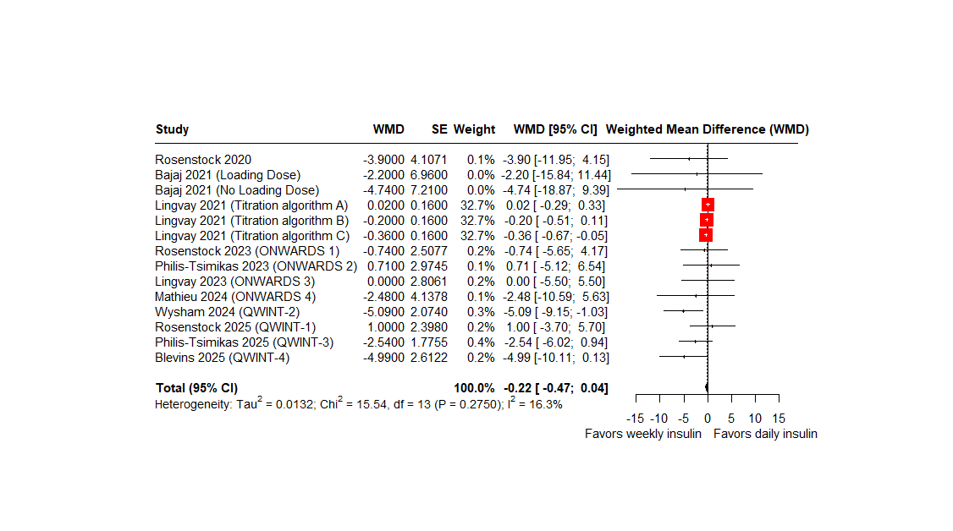
ªStudies Bue Valleskey 2023 and Frias 2023 were excluded.

Fig. S11 Difference in mean change in weight (kg) between once-weekly and daily basal insulin analogs.
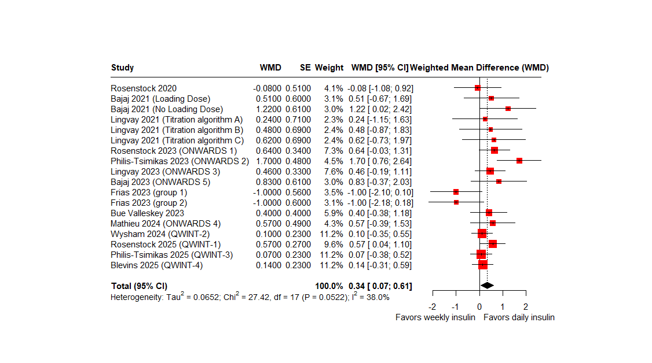

Fig. S12 Odds ratio of developing level 2 or 3 hypoglycemia between once-weekly and daily basal insulin analogs.
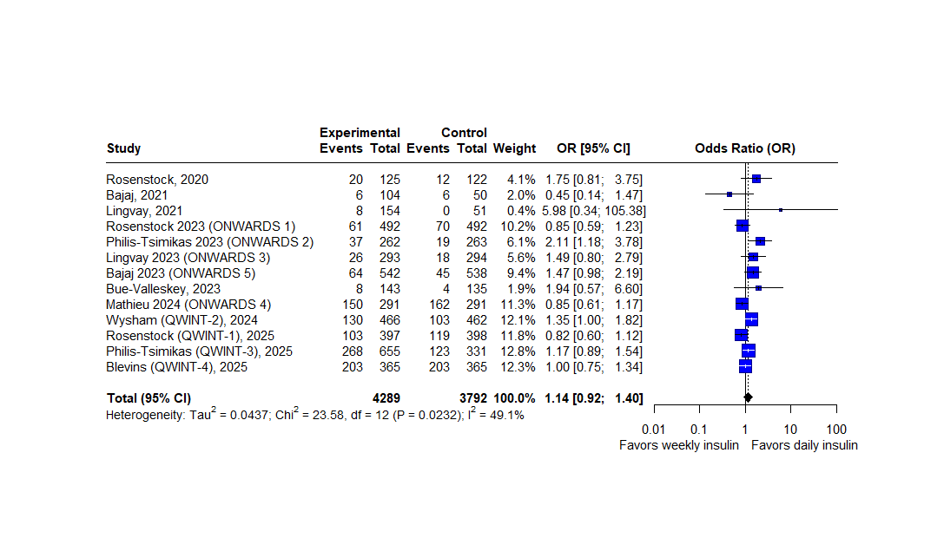

Fig. S13 Funnel plot assessing small study effects (publication bias).
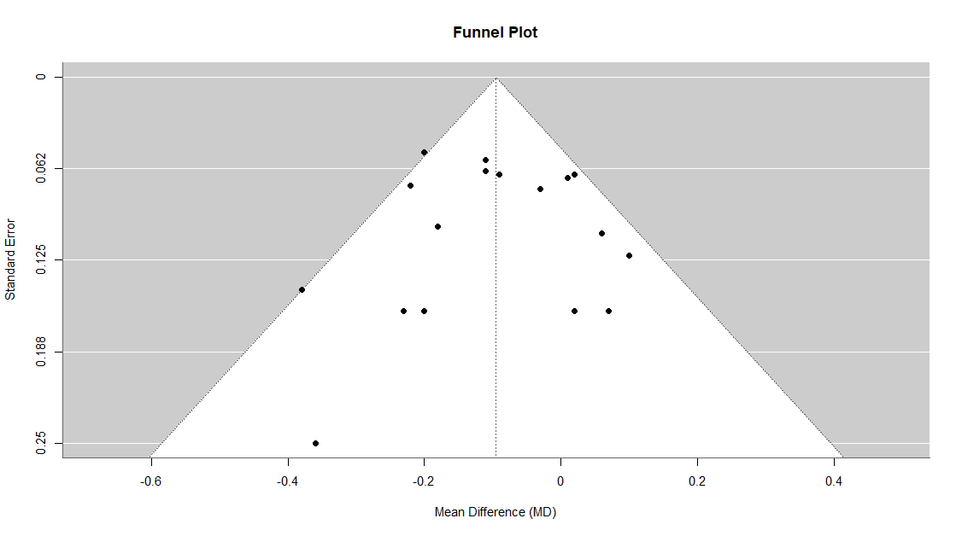

Table S1

MEDLINE/PubMed Search Strategy, as of 05 Jun 2025
(icodec) OR (BIF) OR (insulin BIF) OR (insulin Fc) OR (basal insulin Fc) OR (LY3209590) OR (insulin efsitora) OR (insulin efsitora alfa) OR (efsitora alfa) OR (efsitora) OR (weekly insulin) OR (once-weekly insulin) OR (once weekly insulin) OR (long acting insulin) OR (long-acting insulin)
AND
(type 2 diabetes mellitus) OR (type II diabetes mellitus) OR (T2DM) OR (TIIDM) OR (T2 DM) OR (TII DM)
AND
((clinical trial) OR (RCT) OR (randomized controlled trial))
Results: 1,721

Table S2

Cochrane Library Search Strategy, as of 05 Jun 2025
ID | Search | Number
#1 | MeSH descriptor: [Randomized Controlled Trial] explode all trees | 37
#2 | (randomized controlled trial) OR (randomized control trial) OR (randomized trial) OR (RCT) | 1124455
#3 | MeSH descriptor: [Insulin, Long-Acting] explode all trees | 2440
#4 | (weekly-insulin) OR (weekly insulin) OR (weekly basal insulin) OR (icodec) OR (insulin Fc) OR (BIF) OR (efsitora) OR (efsitora alfa) OR (LY3209590) | 3801
#5 | MeSH descriptor: [Diabetes Mellitus, Type 2] explode all trees | 26718
#6 | (T2DM) OR (TIIDM) OR (T2 DM) OR (TII DM) OR (type 2 diabetes) OR (type II diabetes) | 96804
#7 | #1 OR #2 | 1124455
#8 | #3 OR #4 | 6079
#9 | #5 OR #6 | 96805
#10 | #7 AND #8 AND #9 | 2,253

Table S3

Clinical Trials database Library Search Strategy, as of 05 June 2025
ICODEC OR (insulin 287) OR BIF OR efsitora OR LY3209590 OR (insulin Fc) OR (NNC0148-0287 C)
Results: 125

Table S4

RoB 2 assessment of the included studies
Study | Year | Randomization process | Assignment to intervention | Missing outcome data | Outcome Measurement | Result reporting | Overall Risk of Bias
Rosenstock | 2020 | Low | Low | Low | Low | Low | Low
Bajaj | 2021 | Low | Low | Low | Low | Low | Low
Lingvay | 2021 | Low | Low | Low | Low | Low | Low
Rosenstock | 2023 | Low | Low | Low | Low | Low | Low
Philis-Tsimikas | 2023 | Low | Low | Low | Low | Low | Low
Lingvay | 2023 | Low | Low | Low | Low | Low | Low
Mathieu | 2023 | Low | Low | Low | Low | Low | Low
Bajaj | 2023 | Low | Low | Low | Low | Low | Low
Frias | 2023 | Low | Low | Low | Low | Low | Low
Bue-Valleskey | 2023 | Low | High | Low | Low | Low | High
Wysham, QWINT-2 | 2023 | Low | Low | Low | Low | Low | Low
Rosenstock, QWINT-1 | 2025 | Low | Low | Low | Low | Low | Low
Philis-Tsimikas, QWINT-3 | 2025 | Low | Low | Some concerns | Low | Low | Some concerns
Blevins, QWINT-4 | 2025 | Low | Low | Low risk | Low | Low | Low
Overall risk of bias |  |  |  |  |  |  | Low

