Appendix A:
Search strategy and MeSH

- Postural balance.ab,kw,ti.
- Poatural Sway.ab,kw,ti.
- Equilbrium.ab,kw,ti.
- Mobility ab,kw,ti.
- Physical function ab,kw,ti.
- 1 OR 2 OR 3 OR 4 OR 5
- Cognition.ab,kw,ti.
- Cognitive domains ab,kw,ti.
- Executive function.ab,kw,ti.
- Processing speed.ab,kw,ti.
- Memory.ab,kw,ti.
- Attention.ab,kw,ti.
- Language.ab,kw,ti.
- Mental.ab,kw,ti.
- 7 OR 8 OR 9 OR 10 OR 11 OR 12 OR 13 OR 14
- Association.ab,kw,ti.
- Correlation.ab,kw,ti.
- Relationship.ab,kw,ti.
- 16 OR 17 OR 18
- (1 OR 2 OR 3 OR 4 OR 5) AND (7 OR 8 OR 9 OR 10 OR 11 OR 12 OR 13 OR 14) AND (16 OR 17 OR 18).

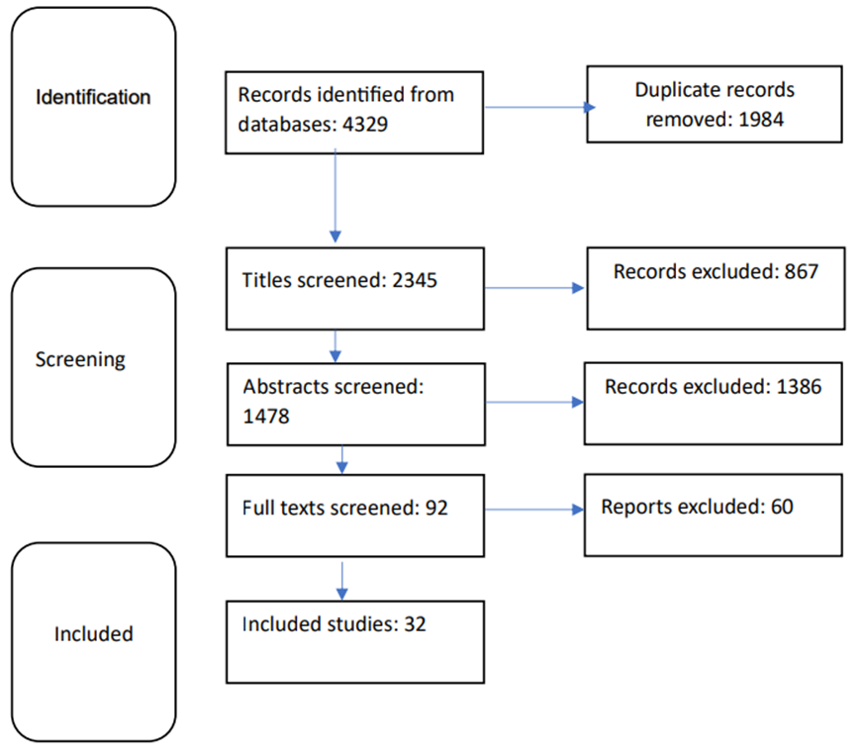
Figure 1. Flowchart for the process of literature search

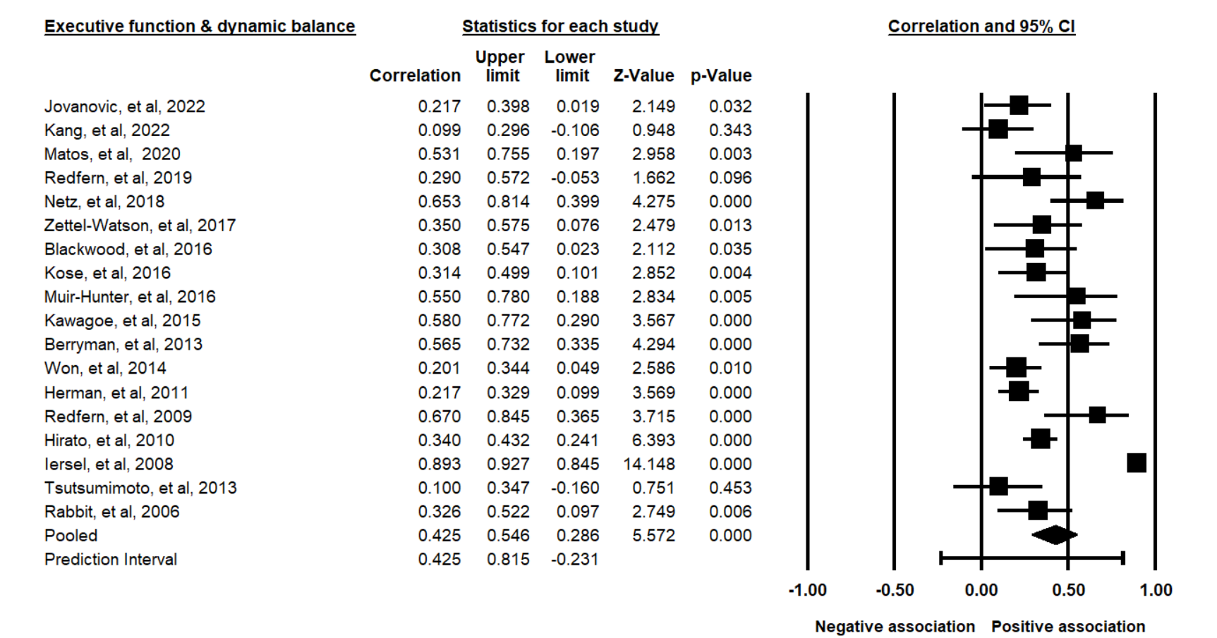
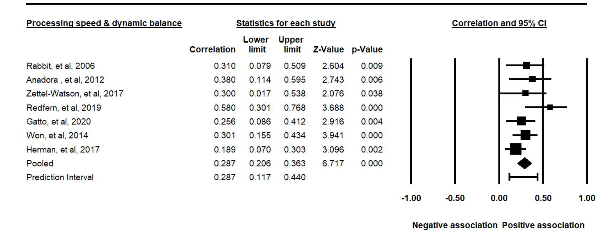
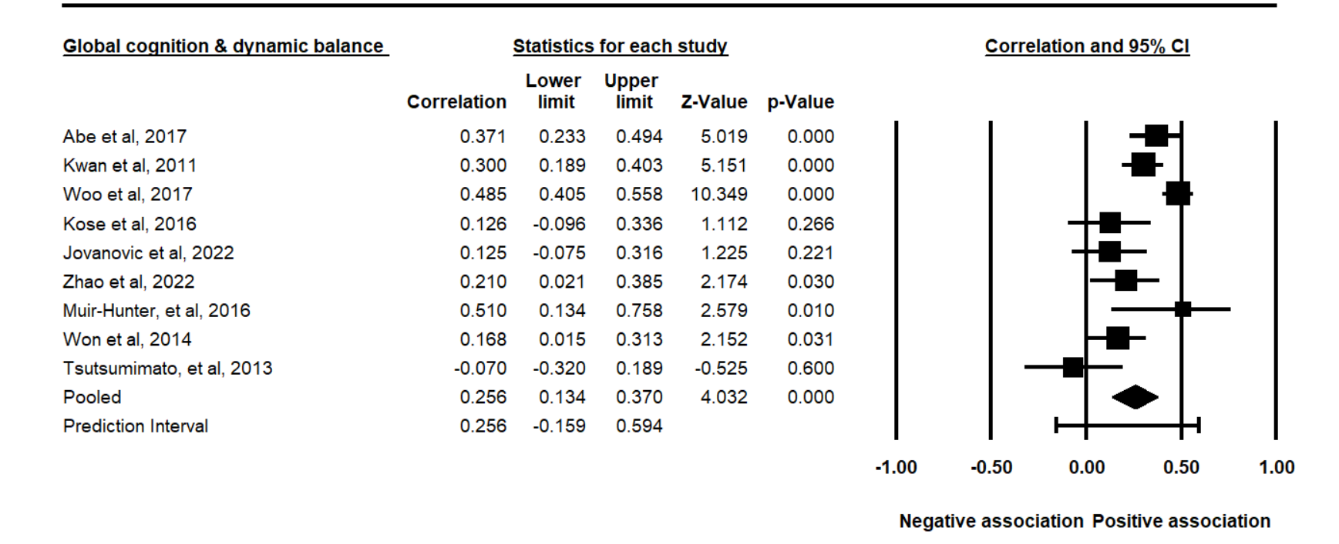
Figure 2. Statistical summary and forest plot of effect sizes for the association of executive function, processing speed, global cognition, and memory with dynamic balance

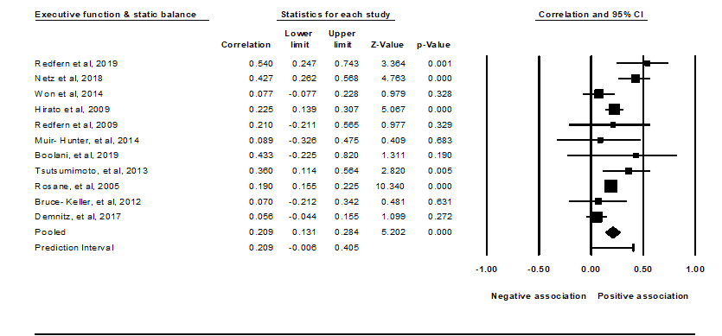

Figure 3. Statistical summary and forest plot of effect sizes for the association of executive function, processing speed, and global cognition with static balance

Table 1: Characteristics of the relationship between measures of processing speed, memory and dynamic/static balance.
First Author |  | Number of participants | Mean Age |  |  | % Female |  | Balance  Task | Processing speed | Association
Processing speed and dynamic balance
Gatto, et al, (42)  2020 |  | 127 | 74.9 + 7.9 |  |  | 57.5% |  | TUG | Coding subtest of WAISNSIV, Stroop, and TMT | S  0.432
Herman, et al, (28)  2011 |  | 265 | 76.4 |  |  | 58% |  | TUG | Digit Span Test | S  r: 0.189
Redfern, et al, (32)  2019 |  | 34 | 76.0±  4 |  |  | 61.7% |  | Postural sway | MAPIT battery, Choice Reaction Time | S  r: 0.58
Zettel-Watson, et al, (36) 2017 |  | 48 | 69.5±  8.1 |  |  | 64% |  | FABS | Digit Symbol Substitution | S  r: 0.29
Won, et al,(30)  2014 |  | 164 | 66 ± 4.6 |  |  | 66.5% |  | FRT | Digit Symbol Test | S  r: 0.301
Rabbit, et al, ⁽³⁵⁾  2006 |  | 69 | 73.2± 8.1 |  |  | 57.97% |  | TBT | Digit Coding | S  r: 0.31
Sprague, et al, (43)  2019 |  | 2783 | 73.6±  5.7 |  |  | 73.60% |  | Turn 360 | Useful Field of View | S  0.060
Processing speed and static balance
Redfern, et al, (32)  2019 |  | 34 | 76.0±  4 |  |  | 61.7% |  | Postural sway | MAPIT battery, Choice Reaction Time | S  r: 0.36
Won, et al, (30)  2014 |  | 164 | 66 ± 4.6 |  |  | 66.5% |  | Postural Sway | Digit Span Test | NS  r: 0.052
Demnitz, et al, (39)  2017 |  | 387 | 69.0 ± 5.1 |  |  | 19% |  | SLS | Digit span | S  r: 0.151
Bruce- Keller, et al,(40)  2012 |  | 50 | 74.2±  7.8 |  |  | 42% |  | Balance SPPB | Digit Symbol Test | S  r: 0.29
First Author | Number of participants |  | Mean Age |  | % Female |  |  | Balance  Task | Memory | Association
Episodic Memory and dynamic balance
Kang et al, (20)  2022 | 94 |  | 77.6±  5.3 |  | 100% |  |  | TUG | Seoul Neuropsychological Screening Battery | NS  r: 0.304
Jovanovic, et al,(21) 2022 | 98 |  | 68.5 |  | 83.6% |  |  | TUG | Delayed recal the 5-word list | NS  r: 0.076
Sprague, et al, (43)  2019 | 2783 |  | 73.6±  5.7 |  | 73.60% |  |  | Turn 360 | Hopkins Verbal Learning Test | S  r: 0.1
Kose, et al, (24)  2016 | 80 |  | 75.7± 5.8 |  | 45% |  |  | TUG | Wechsler Memory, logical memory I | NS  r: 0.073
Won, et al, (30)  2014 | 164 |  | 66 ± 4.6 |  | 66.5% |  |  | FRT | Rey Auditory Verbal Learning Test | NS  r: 0.142
Rabbit, et al, (35)  2006 | 69 |  | 73.2± 8.1 |  | 57.97% |  |  | TBT | Memory for Object and Location | S  r: 0.26
Episodic Memory and static balance
Demnitz, et al, (39)  2017 | 387 |  | 69.0 ± 5.1 | 19% |  |  | SLS |  | Hopkins Verbal Learning Test | S  r: 0.063
Won, et al, (30)  2014 | 164 |  | 66 ± 4.6 | 66.5% |  |  | Postural sway |  | Rey Auditory Verbal Learning Test | NS  r: 0.151
Table 1: No: Number of participants, M: male, F: Female, Number: reference of the study; TUG: Timed Up and Go Test; FRT: Functional Reach Test; TBT: Tinetti Balance Test; BBT: Berg Balance Test; FABS: Fullerton Advanced Balance Score; SPBB: Balance Score on the Short Physical Performance Battery. SLS: Single leg stance time, mCTCIB: Modified Clinical Test of Sensory Interaction on Balance. NS: Non-significant, S: Significant. r: correlation. Bolds are studies which had MMSE score>24 as inclusion criteria.

