Appendix A:
Search strategy and MeSH

1. Postural balance.ab,kw,ti.
2. Postural way.ab,kw,ti.
3. Equilbrium.ab,kw,ti.
4. posturography
4. 1 OR 2 OR 3
5. Cognition.ab,kw,ti.
6. Executive function.ab,kw,ti.
7. Attention.ab,kw,ti.
8. Working memory.ab,kw,ti.
9. Mental flexibility.ab,kw,ti.
10. Set shifting.ab,kw,ti.
11. Inhibition.ab,kw,ti.
12. 5 OR 6 OR 7 OR 8 OR 9 OR 10 OR 11
13. Association.ab,kw,ti.
14. Correlation.ab,kw,ti.
15. Relationship.ab,kw,ti.
16. 13 OR 14 OR 15
17. (1 OR 2 OR 3) AND (5 OR 6 OR 7 OR 8 OR 9 OR 10 OR 11) AND (13 OR 14 OR 15).

Appendix B:
Newcastle-Ottawa Scale adapted for cross-sectional studies.
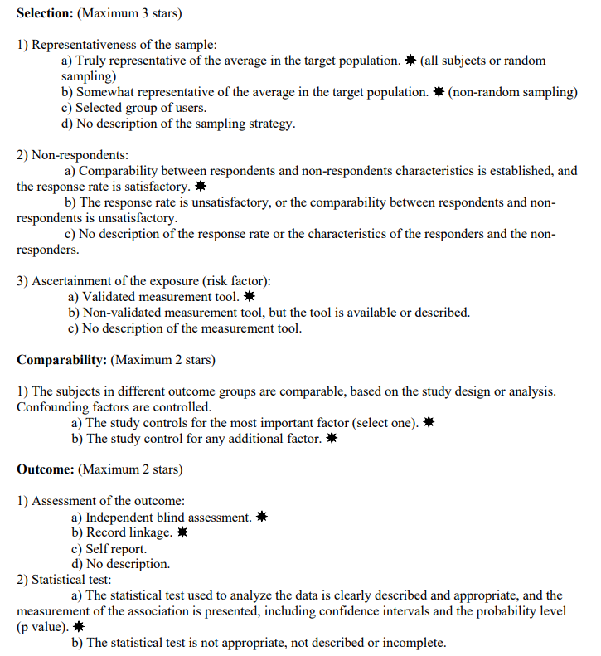

AXIS TOOL:
