Supplementary information for Food and Bioprocess Technology:
Effect of Whole Cluster Fermentation on Phenolics in Cold-Hardy Hybrid Wines
Alexander D. Gapinski¹, Andrew C. Horton² and Aude A. Watrelot¹*

¹Department of Food Science and Human Nutrition, Iowa State University, 536 Farm House Lane, Ames, IA 50011-1054, USA.
²Department of Horticultural Science, University of Minnesota, UMN Horticulture Research Center, 600 Arboretum Blvd. Excelsior MN, 55331, USA.

*Corresponding author: Department of Food Science and Human Nutrition, Iowa State University, Food Sciences Building, 536 Farm House Lane, Ames, IA 50011, USA, watrelot@iastate.edu, +1-515-294-0343, ORCID: 0000-0003-2411-6529

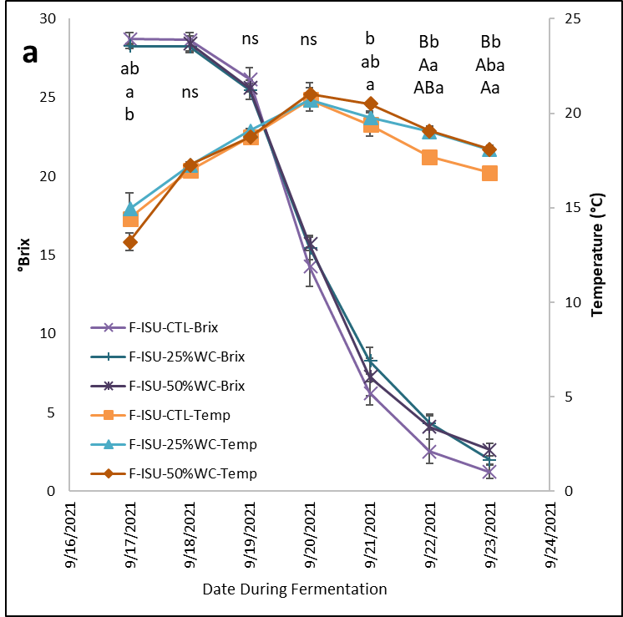
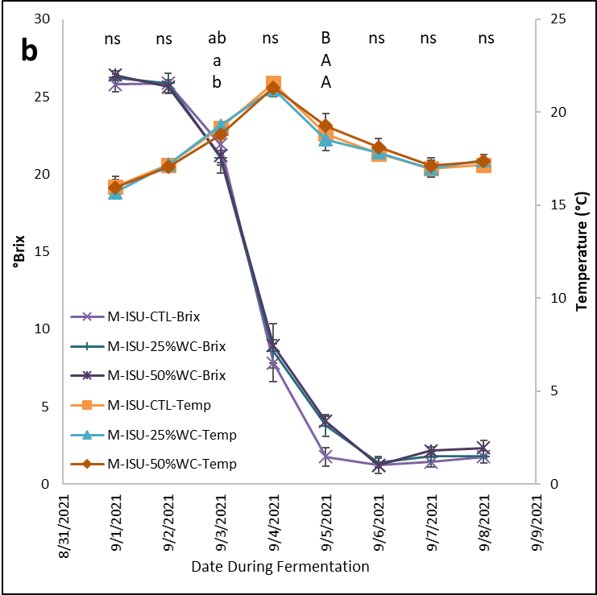
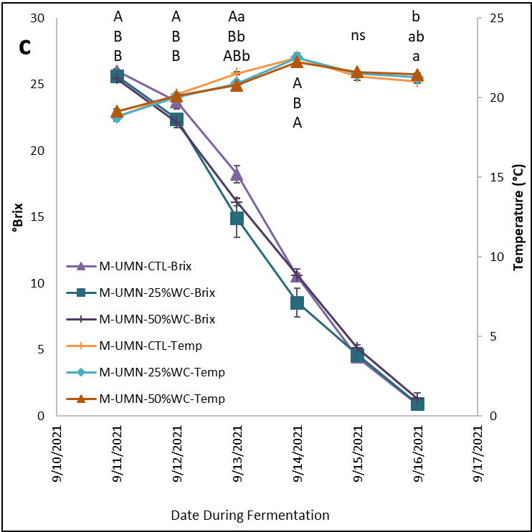

Fig. S1 Temperature and °Brix throughout fermentation for F-ISU (a), M-ISU (b), and M-UMN (c); uppercase letters designate statistical significance (p < 0.05) detected by Tukey’s HSD test for °Brix between conditions for each date; lowercase letters designate statistical significance (p < 0.05) detected by Tukey’s HSD test for temperature between conditions for each date; “ns” indicates no significant differences

Table S1. Basic chemical properties of each set of conditions at each time point.
Condition/Time Point | Glycerol (g/L)
F-ISU-CTL
Crushing | ndª
Bottling | 10.84 ± 0.10^{b} A^{c} a^{d}
4 months aging | 11.05 ± 0.28 A a
F-ISU-25%
Bottling | 10.15 ± 0.19 A a
4 months aging | 10.28 ± 0.12 A b
F-ISU-50%
Bottling | 10.61 ± 0.47 A a
4 months aging | 10.39 ± 0.21 A b
M-ISU-CTL
Crushing | nd
Bottling | 9.11 ± 0.65 A a
4 months aging | 9.66 ± 0.10 A a
M-ISU-25%
Bottling | 9.37 ± 0.26 A a
4 months aging | 9.12 ± 0.11 A b
M-ISU-50%
Bottling | 8.90 ± 0.28 B a
4 months aging | 9.28 ± 0.05 A ab
M-UMN-CTL
Crushing | nd
Bottling | 9.12 ± 0.41 A a
4 months aging | 8.93 ± 0.06 A a
M-UMN-25%
Bottling | 8.72 ± 0.10 A a
4 months aging | 8.70 ± 0.29 A a
M-UMN-50%
Bottling | 9.11 ± 0.89 A a
4 months aging | 8.59 ± 0.14 A a
ªnd, not detected, below limit of detection. ^{b}Values are averages of analytical triplicates ± one standard deviation. ^{c}Uppercase letters designate statistical significance (p < 0.05) detected by Tukey’s HSD test between time points for each condition. ^{d}Lowercase letters designate statistical significance (p < 0.05) detected by Tukey’s HSD test between conditions at each time point.

Table S2. Sensory attributes for the M-ISU and M-UMN wines presented during the 2022 Minnesota Grape Grower Association annual conference.
 | Round 1 |  |  | Round 2
 | M-ISU-CTL | M-ISU-25% | M-ISU-50% | M-UMN-CTL | M-UMN-25% | M-UMN-50%
Color intensity | 4.03 ± 1.52ª | 4.63 ± 1.52 | 5.03 ± 1.45 | 6.57 ± 1.63 | 6.87 ± 1.55 | 6.97 ± 1.73
Hue | 5.17 ± 1.62 | 4.77 ± 1.52 | 5.17 ± 1.66 | 3.30 ± 1.44 | 3.53 ± 1.48 | 3.43 ± 1.76
Red Fruit | 4.80 ± 1.99 | 4.13 ± 1.83 | 4.33 ± 1.69 | 5.97 ± 2.30 | 6.63 ± 2.19 | 5.47 ± 2.33
Dark Fruit | 4.50 ± 1.93 | 4.43 ± 2.08 | 4.80 ± 2.01 | 5.13 ± 2.10 | 5.33 ± 2.38 | 5.10 ± 2.26
Vegetal | 4.59 ± 2.03 | 5.14 ± 2.37 | 5.38 ± 1.95 | 3.10 ± 2.02 | 2.86 ± 1.64 | 3.10 ± 1.74
Dried Fruit/Jam | 4.07 ± 1.81 | 3.90 ± 1.82 | 4.10 ± 2.14 | 4.45 ± 2.03 | 5.52 ± 2.61 | 4.66 ± 1.82
Acidity | 4.50 ± 1.96 | 4.97 ± 1.59 | 4.90 ± 1.69 | 5.80 ± 1.58 | 6.13 ± 2.16 | 5.70 ± 1.91
Bitterness | 3.67 ± 1.94 | 4.50 ± 1.96 | 4.07 ± 1.76 | 4.27 ± 2.20 | 4.07 ± 2.43 | 4.23 ± 1.85
Sweetness | 2.60 ± 1.48 | 2.27 ± 1.26 | 2.13 ± 1.28 | 2.30 ± 1.34 | 2.37 ± 1.40 | 2.23 ± 1.30
Saltiness | 2.60 ± 2.39 | 2.67 ± 2.19 | 2.50 ± 1.70 | 2.27 ± 1.39 | 2.43 ± 1.65 | 2.23 ± 1.50
Body | 3.87 ± 1.43 | 4.23 ± 1.68 | 4.38 ± 1.56 | 4.63 ± 1.73 | 4.62 ± 2.16 | 4.53 ± 1.20
Texture | 5.07 ± 1.46 | 4.77 ± 1.55 | 5.00 ± 1.39 | 5.17 ± 1.93 | 5.03 ± 1.83 | 5.07 ± 1.51
Fruit Intensity | 5.41 ± 1.90 | 6.00 ± 1.95 | 5.17 ± 1.47 | 4.12 ± 1.93 | 3.76 ± 1.66 | 4.31 ± 1.65
Length | 5.07 ± 2.05 | 5.32 ± 2.20 | 5.25 ± 2.22 | 4.75 ± 1.78 | 4.50 ± 1.73 | 5.07 ± 1.65
ªValues are averages of all participant responses (n = 26-30) ± standard deviation from Rounds 1 and 2 only.

