Supplementary Information
Multi-length scale approach to investigate cleaning of food-derived deposits adhered to hard surfaces: mixtures of starch, whey protein, and lard

Section 1. Response surface equations.

Table SI.1. Response surface equations that describe shear stress in a milli-manipulation device. Shear stress (σ) of food complex deposits under ambient conditions (air, 20°C). The equations took into account the type of surface, concentration in solids (Design 1 and 2), and the composition of starch, whey, and lard expressed as a fraction by weight.
Stainless steel | Design 1 | $σ \left(J/{m^{2}}\right)=22.5194·Starch+41.8894·Whey+158.678·Lard-13.8202·Starch·Whey+162.225·Starch·Lard+99.0801·Whey·Lard-2311.21·Starch·Whey·Lard$
Stainless steel | Design 2 | $$σ \left(J/{m^{2}}\right)=109.265·Starch+60.9832·Whey+161.479·Lard-136.359·Starch·Whey+45.7701·Starch·Lard+159.75·Whey·Lard$$
Aluminium | Design 1 | $$σ \left(J/{m^{2}}\right)=16.9225·Starch+38.8248·Whey+128.545·Lard+5.35858·Starch·Whey+340.753·Starch·Lard+248.883·Whey·Lard+3205.2·Starch·Whey·Lard$$
Aluminium | Design 2 | $$σ \left(J/{m^{2}}\right)=84.1172·Starch+36.8824·Whey+93.7001·Lard-74.3828·Starch·Whey+60.3915*Starch·Lard+162.195·Whey·Lard$$
PTFE | Design 1 | $$σ \left(J/{m^{2}}\right)= 7.85722·Starch + 54.7482·Whey + 168.692·Lard - 4.89409·Starch·Whey + 395.469·Starch·Lard + 26.1801·Whey·Lard - 3054.16·Starch·Whey·Lard$$
PTFE | Design 2 | $$σ \left(J/{m^{2}}\right)= 94.5901·Starch + 54.9981·Whey + 162.06·Lard + 15.4638·Starch·Whey + 87.1729·Starch·Lard + 171.554·Whey·Lard$$

Table SI.2. Response surface equations that describe detergency in a lab-simulated Clean-In-Place (CIP) system. Detergency values (De, %) of food complex deposits under different chemical treatments (50°C, 30 minutes). The equations took into account the type of surface, concentration in solids (Design 1 and 2), and the composition of starch, whey, and lard expressed as a fraction by weight.

Method1  (water) | Design 1 | $$De=30.9858·Starch+50.8698·Whey+41.1759·Lard-65.6831·Starch·Whey+58.9292·Starch·Lard+33.4899·Whey·Lard$$
Method1  (water) | Design 2 | $De=7.95648·Starch+20.2742·Whey+44.4674·Lard-31.0884·Starch·Whey+113.858·Starch·Lard+35.7734·Whey·Lard$
Method2  (NaOH solution, 4 g/L) | Design 1 | $De=38.07·Starch+37.89·Whey+49.71·Lard+196.2·Starch·Whey+146.7·Starch·Lard-990.9·Whey·Lard$
Method2  (NaOH solution, 4 g/L) | Design 2 | $$De=13.1663·Starch+12.5699·Whey+48.1944·Lard-31.3375·Starch·Whey+108.872·Starch·Lard+79.6788·Whey·Lard$$

Section 2. Force profiles required for removing model deposits adhered to various surfaces in a milli-manipulation device.
Table SI.3. Examples of force profiles needed to detach various model deposits (Design1) adhered to stainless steel, using a milli-manipulation system. Additionally, photographs of the model deposits were taken at the beginning, middle, and end of the assay.
Model deposit | Photography |  | Profiles
A | - | - | 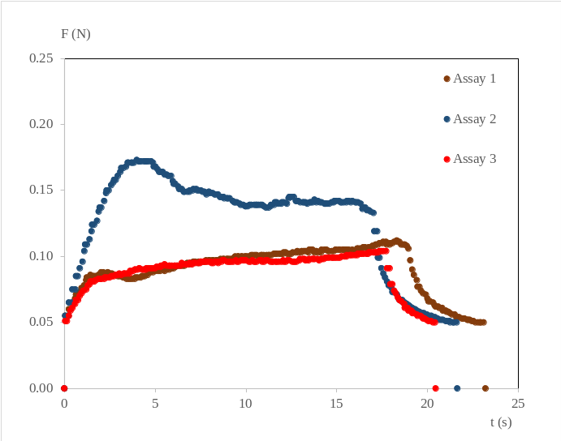
B | Initial | 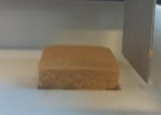 | 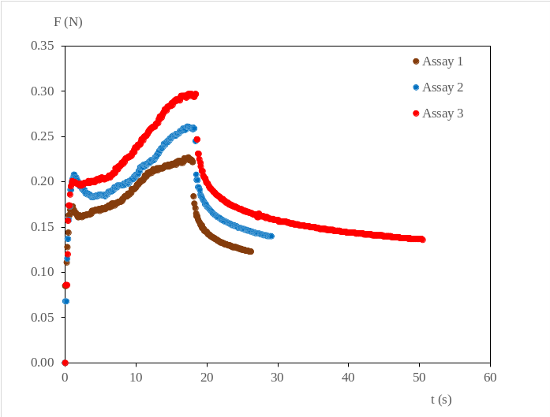
B | Middle | 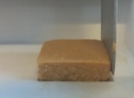
B | End | 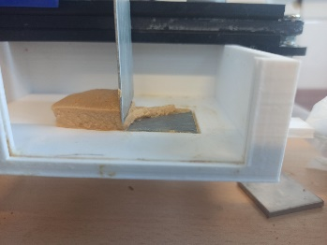
C | Initial | 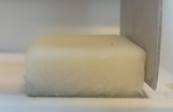 | 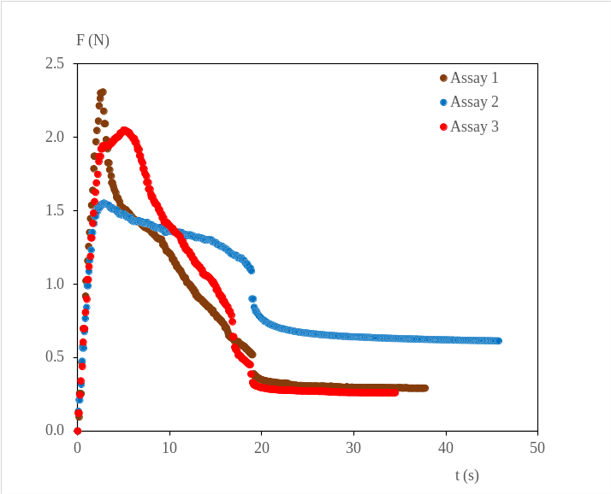
C | Middle | 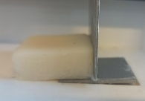
C | End | 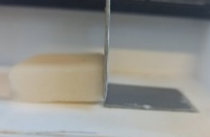
D | - |  | 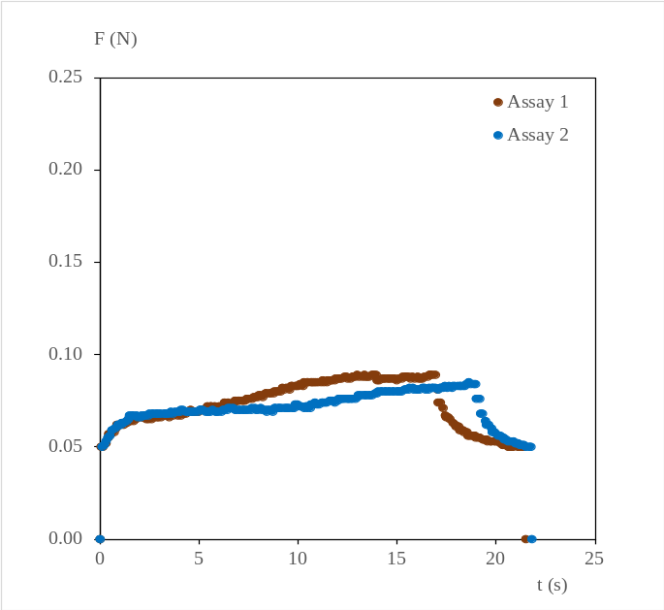

Table SI.4. Examples of force profiles needed to detach various model deposits (Design1) adhered to aluminum, using a milli-manipulation system. Additionally, photographs of the model deposits were taken at the beginning, middle, and end of the assay
Model deposit | Photography |  | Profile
A | - |  | 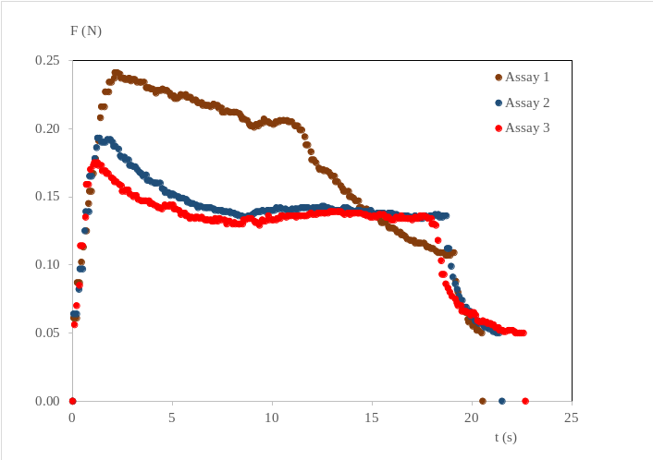
B | Initial | 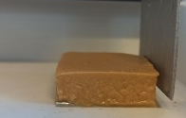 | 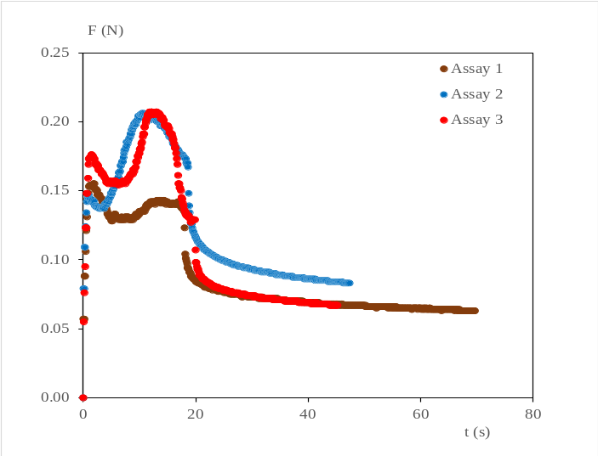
B | Middle | 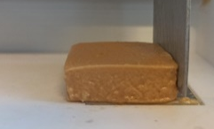
B | End | 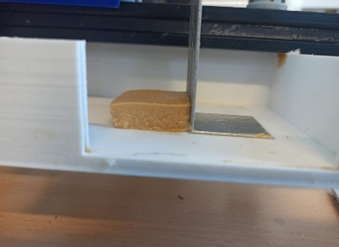
C | Initial | 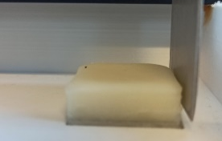 | 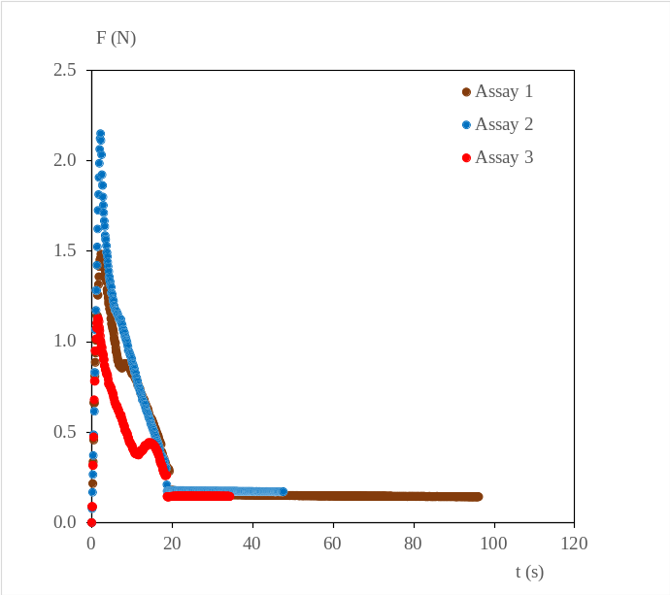
C | Middle | 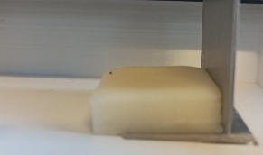
C | End | 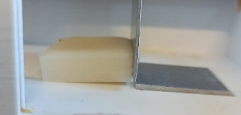
D | - |  | 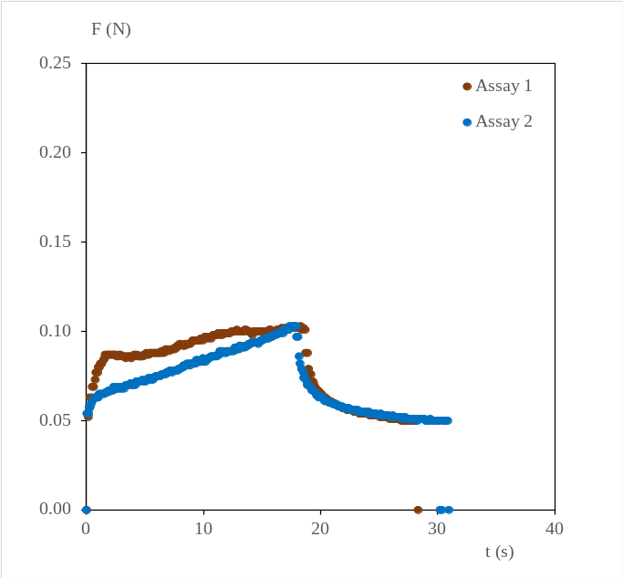
Table SI.5. Examples of force profiles needed to detach various model deposits (Design1) adhered to PTFE, using a milli-manipulation system. Additionally, photographs of the model deposits were taken at the beginning, middle, and end of the assay
Model deposit | Photography |  | Profile
A | - |  | 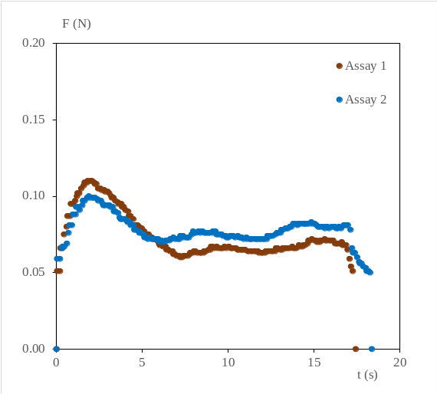
B | Initial | 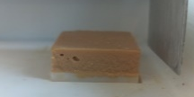 | 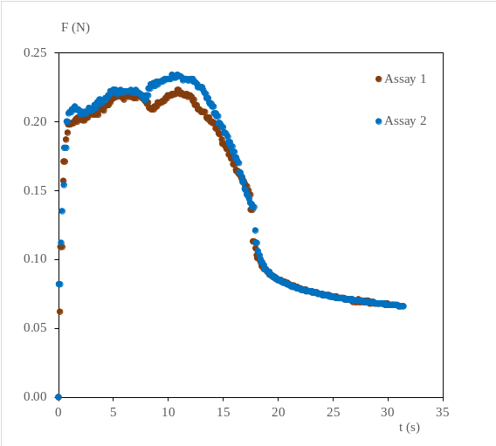
B | Middle | 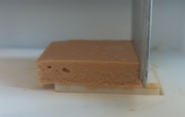
B | End | 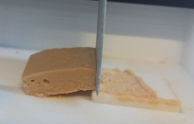
C | Initial | 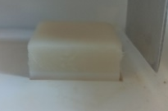 | 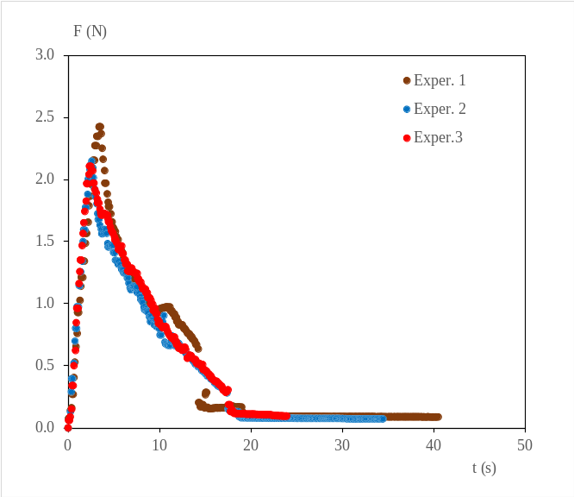
C | Middle | 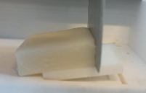
C | End | 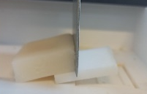
D | - |  | 