Supplementary materials
Foaming properties and foam structure of milk determined by its protein content and protein to fat ratio
Thao M. Ho^{1,2,3}, Xiaoying Xiong^{2,3}, Bhesh R. Bhandari^{2,3} and Nidhi Bansal^{2,3}*
¹Department of Food and Nutrition, University of Helsinki, P.O. Box 66, 00014, Finland.
²School of Agriculture and Food Sustainability, The University of Queensland, Brisbane, QLD 4072, Australia.
³ARC Dairy Innovation Hub, School of Agriculture and Food Sustainability, The University of Queensland, Brisbane, QLD 4072, Australia.
* Corresponding author.
Email: n.bansal@uq.edu.au; Phone: +61 7 33651673, Fax:+61 7 33651177.

Table S1: Main components (%) of skim milk powder (SMP), whole milk powder (WMP), commercial whole milk (WM), milk protein concentrate (MPC) and buttermilk powder(BMP) according to manufacturers.
Components, % (w/w) | SMP | WMP | WM | MPC | BMP
Protein | 32.5 | 25.0 | 3.3 | 81.5 | 31.0
Fat | 0.8 | 26.8 | 3.4 | 1.3 | 7.8
Lactose | 55.0 | 39.1 | 4.8 | 5.0 | 50

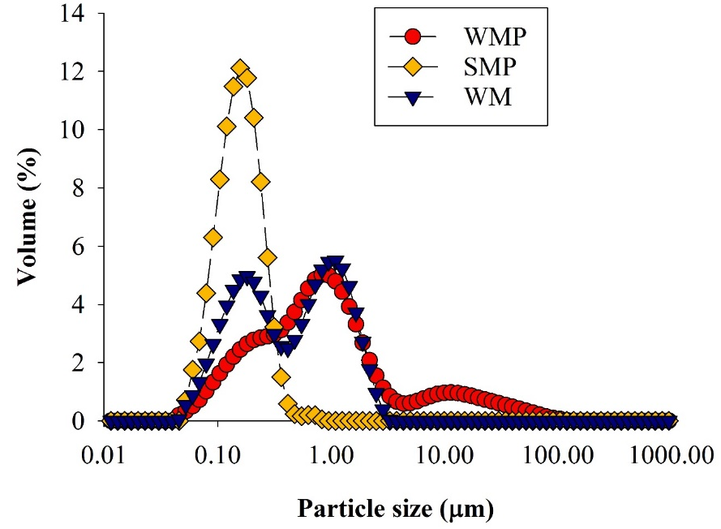

Figure S1: Particle size distribution of milk dispersions prepared from skim milk powder (SMP), whole milk powder (WMP) and commercial whole milk (WM).
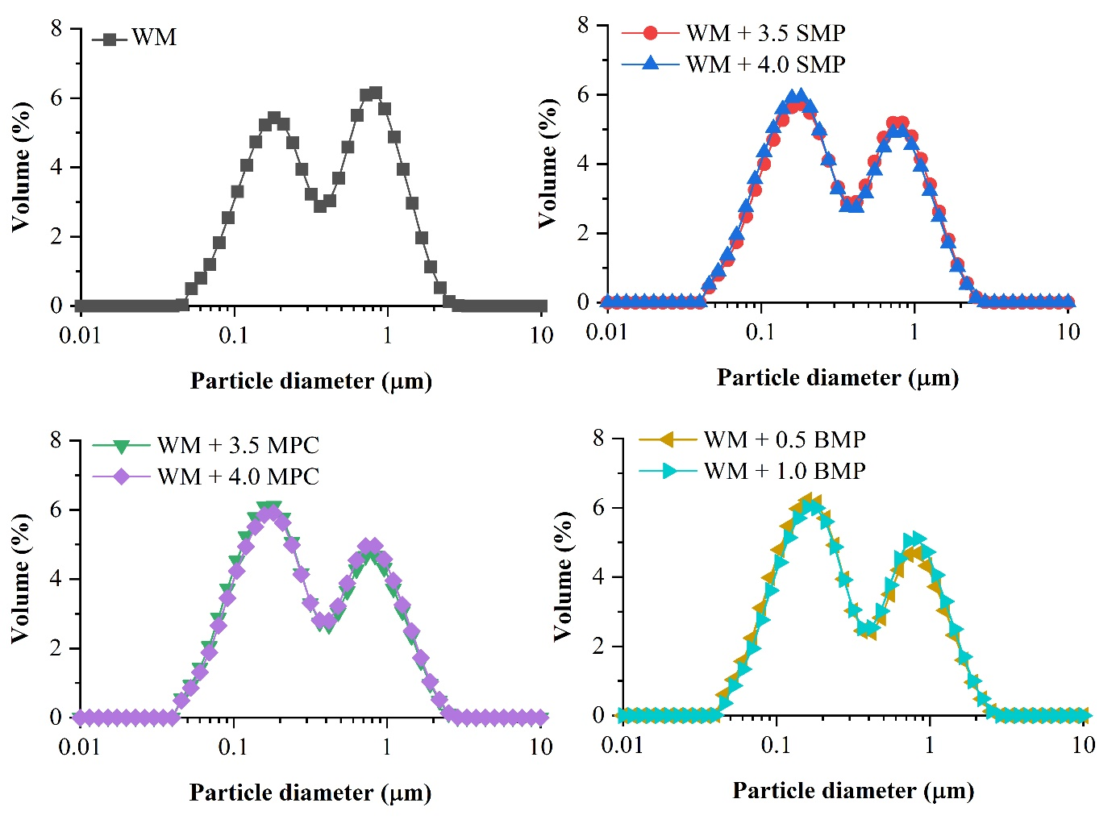

Figure S2: Particle size distribution of whole milk (WM), and that of WM containing added skim milk powder (SMP) and milk protein concentrate (MPC) at final protein content of 3.5 and 4%, and butter milk powder (BMP) at 0.5 and 1%.

