Supplementary Information

Infrared thermal image processing technique for evaluating superheated steam as a dry sanitation method

Hyeon Woo Park¹ and V. M. Balasubramaniam^{1, 2,*}
¹Department of Food Science and Technology, The Ohio State University, Columbus, OH 43210, USA
²Department of Food Agricultural and Biological Engineering, The Ohio State University, Columbus, OH 43210, USA

*Corresponding author:
V.M. Balasubramaniam
The Ohio State University, 2015 Fyffe Road, Columbus, OH, 43210, USA
Email: balasubramaniam.1@osu.edu

1. Effect of nozzle type on surface temperature
The three different nozzle types (the circular nozzle, the spray ball nozzle, and the flat fan nozzle) were used in preliminary experiments to identify the most suitable nozzle type for the pilot-scale superheated steam sanitation (Fig. S1). The surface temperature was compared during the superheated steam treatment using these three different nozzle types (see section 2.2.2). These preliminary experiments demonstrated that, regardless of surface-to-nozzle distance, the circular nozzle yielded the highest surface temperature among the three nozzle types tested (Fig. S2). Consequently, for this study, a circular nozzle with a diameter of 7.5 mm was selected for the pilot-scale superheated steam sanitation process.

2. Influence of superheated steam conditions on the sanitation efficacy
Additional preliminary experiments assessed the sanitation efficacy of two superheated steam generators, namely Unit A (SaniZap-600-4-240, Bayzi, Cincinnati, OH, USA) with lower temperature and higher velocity, and Unit B (SaniZap-1, Bayzi, Cincinnati, OH, USA) with higher temperature and lower velocity (see Section 2.3.3.2). The specific superheated steam conditions of these units are summarized in Table S1. Regardless of the sweeping conditions implemented in this study, Unit A demonstrated superior sanitation efficacy compared to Unit B (Fig. S3). Therefore, this study employed Unit A to investigate superheated steam sanitation under realistic conditions.

 | Unit A | Unit B
Superheated steam ratio (%) | 4.9% | 5.3%
Jet temperature (°C) | 340°C | 550°C
Jet velocity (m/s) | 131.5 | 56.5
Nozzle diameter (mm) | 7.5 | 10.0
Table S1. Comparison of superheated steam conditions for two different pilot-scale superheated steam generators.

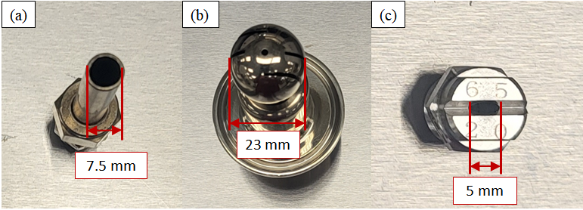
Fig. S1. Different nozzle types used for superheated steam sanitation: (a) circular nozzle, (b) spray ball nozzle, and (c) flat fan nozzle.

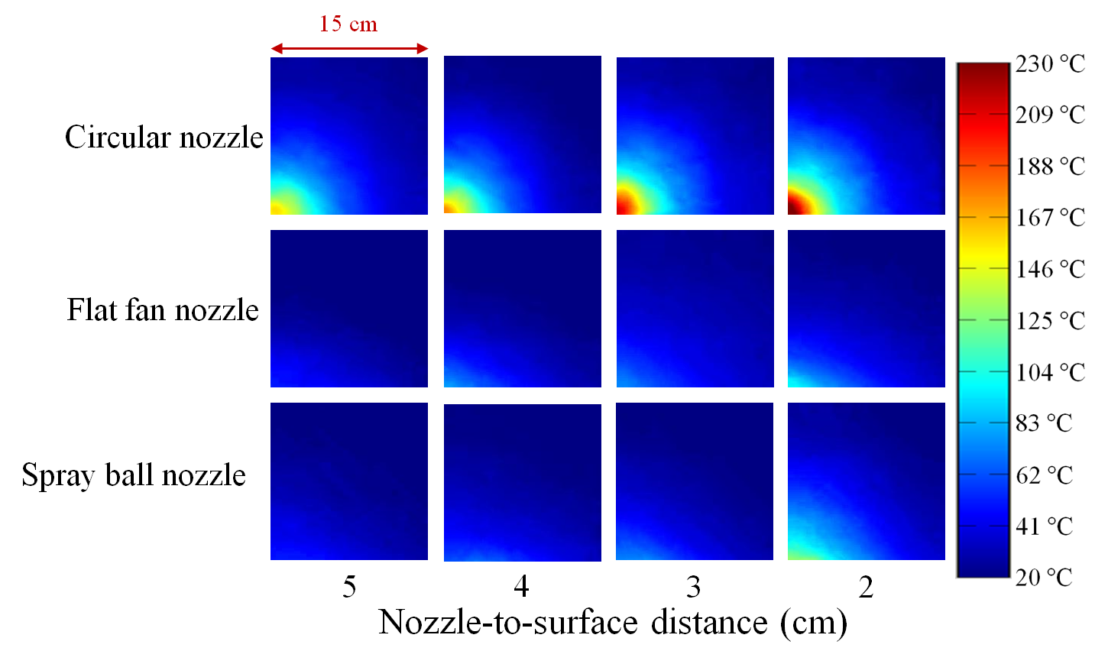
Fig. S2. Thermal image analysis of surface temperature distribution on a stainless steel (30 cm × 30 cm) during superheated steam sanitation with different nozzle types. The images are quarter-sections (15 cm × 15 cm) of the stainless steel surface, with the impingement located at the bottom left corner.

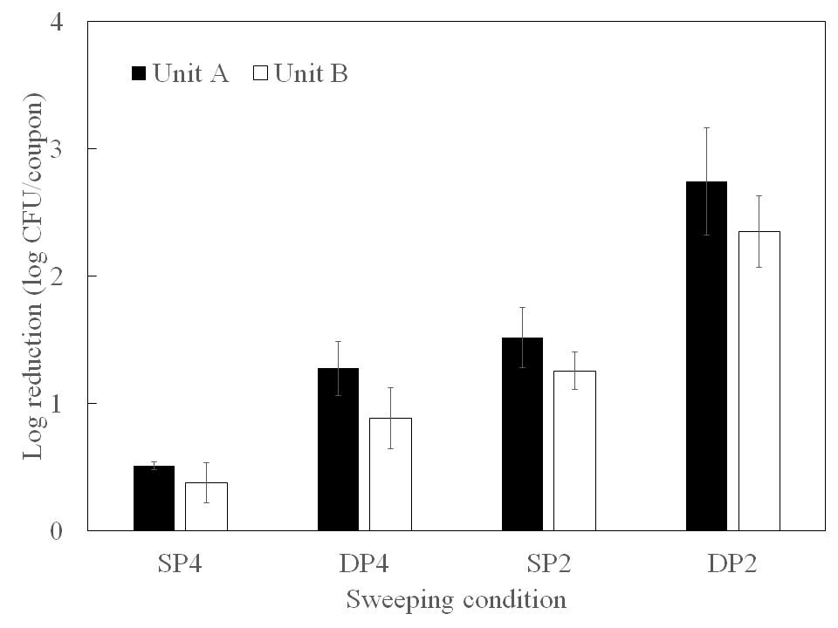
Fig. S3. Inactivation of Enterococcus faecium after superheated steam sanitation under different sweeping conditions: single pass at 4 cm/s (SP4), double pass at 4 cm/s (DP4), single pass at 2 cm/s (SP2), and double pass at 2 cm/s (DP2). The superheated steam conditions for these units are summarized in Table S1.

