Supplementary Material

Optimization of Protein Extraction using Response Surface Methodology

Protein Solubility

ST 1: Model Summary
S | R-Qd | R-Qd(cor) | R-Qd(prog)
1.37875 | 89.40% | 87.53% | 85.07%

ST 2: Target Size Optimization
Solution | pH | Time | Conc. | Prot.  solubility  Adjustment | Composite Desirability
1 | 6.37475 | 60 | 0.5 | 43.1325 | 1

ST3: Experimental results of Target Size Optimization
pH | Tim in min. | Conc. in wt% | Protein solubility in %
pH | Tim in min. | Conc. in wt% | Experimental | Target Size Optimization
6.4 | 60 | 0.5 | 39.07 ± 0.9 | 43.13

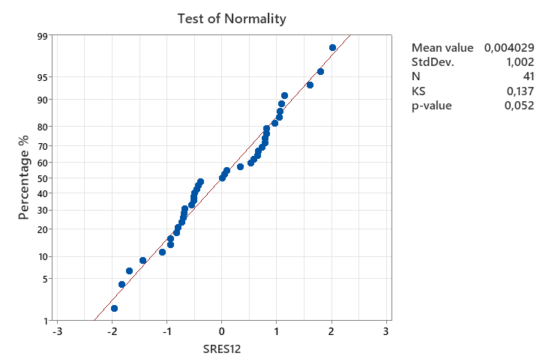
SFig. 1: Test of Normality - Data Protein Solubility

Protein Precipitation

ST 4: Model summary
S | R-Qd | R-Qd(cor) |  | R-Qd(prog)
2.00636 | 88.59% | 86.31% | 79.12%

ST 5: Target Size Optimization
Solution | pH |  | Time | Protein in  Supernatant  in % | Composite  Desirability
1 | 3.41010 |  | 20 | 15.1899 | 1

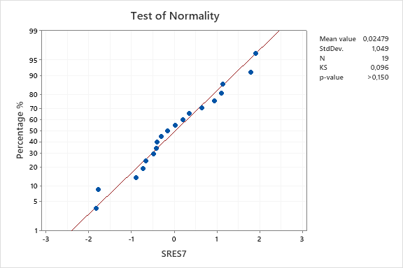

SFig. 2: Test of Normality - Data Protein Precipitation

Calibration Lines for Antioxidant Capacity (FRAP, DPPH) and Phenolic Content (Folin-Ciocalteu)

To Chapter:

Antioxidant Capacity and Phenolic Content

SFig. 3 - FRAP calibration curve
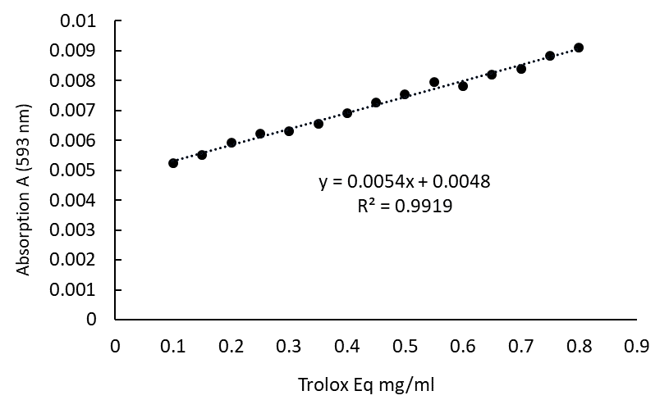

SFig. 4 - DPPH calibration curve
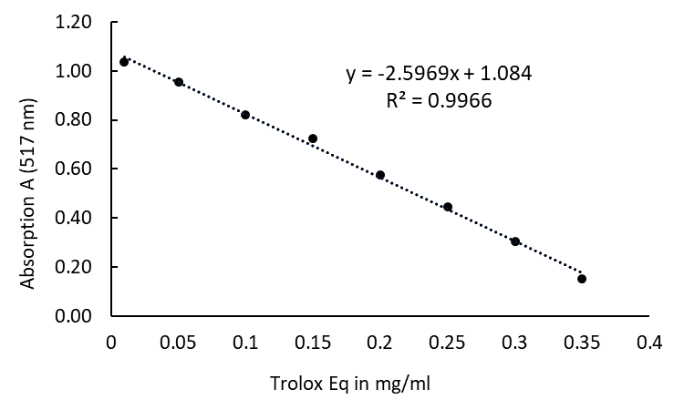

SFig. 5 - Folin-Ciocalteu calibration curve

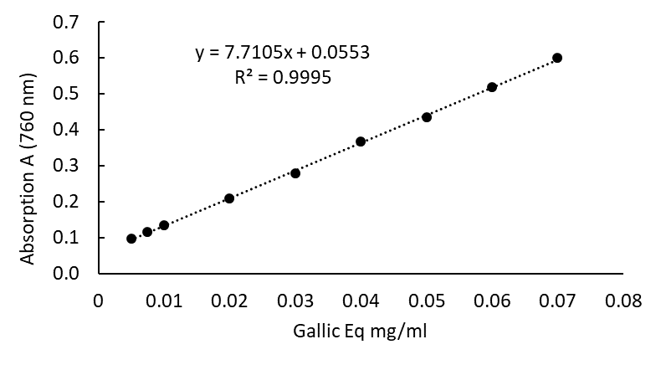

List of abbreviations

LG | Lemna gibba
LG flour | Lemna gibba flour
LG-C | Lemna gibba conventional extraction
LG-US-C | Lemna gibba ultrasound-assisted with conventional extraction
LG-UF | Lemna gibba ultrafiltration
LG-US-UF | Lemna gibba ultrasound-assisted extraction and ultrafiltration
RSM | Response surface methodology
CCD | Central composite design
UAE | Ultrasound-assisted extraction
US | Ultrasound
UF | Ultrafiltration
BCA (Protein) Assay | Bicinchoninic acid assay
BSA | Bovine-serum albumin
IEP | Isoelectric point
EAA | Essential amino acids
AAS | Amino acid score
SOP | Standard operation procedure
RT | Room temperature

