Table S1. Formulation table for experimental pancakes. The amount of each single ingredient is expressed in grams on a total weight of 100 grams of batter. The method for the egg substitution is reported in the Materials and methods section.
Samples | Wheat flour | Tap water | Corn oil | EP/PPCI | Sugar | Salt | Baking powder
EPp | 35.2 | 46.9 | 5.2 | 3.9 | 6.5 | 1.0 | 1.2
BBCp | 35.4 | 47.2 | 5.2 | 3.3 | 6.6 | 1.0 | 1.2
CCp | 35.4 | 47.2 | 5.2 | 3.3 | 6.6 | 1.0 | 1.2
PCp | 35.5 | 47.4 | 5.3 | 3.0 | 6.6 | 1.1 | 1.2
SCp | 35.6 | 47.5 | 5.3 | 2.7 | 6.6 | 1.1 | 1.2
MBCp | 35.4 | 47.2 | 5.2 | 3.3 | 6.6 | 1.0 | 1.2
CIp | 35.9 | 47.8 | 5.3 | 2.1 | 6.6 | 1.1 | 1.2
PIp | 35.8 | 47.7 | 5.3 | 2.3 | 6.6 | 1.1 | 1.2
BBIp | 35.9 | 47.8 | 5.3 | 2.1 | 6.6 | 1.1 | 1.2
EPp: Control pancake with EP; CCp: Chickpeas Concentrate pancake; CCp: Chickpeas Concentrate pancake; BBCp: Broad Bean Concentrate pancake; MBCp: Mung Bean Concentrate pancake; LCp: Lentil Concentrate pancake; PCp: Yellow Peas Concentrate pancake; SCp: Soy Concentrate pancake; CIp: Chickpeas Isolate pancake; BBIp: Broad Bean Isolate pancake; PIp: Yellow Peas Isolate pancake.

Table S2. Correlation matrix of PPCI and EP characteristics (normalized for protein content) vs pancake properties. The correlation coefficients range from negative (red, -1) to positive (green, +1), and the more are close to zero the lighter the color of the cell. The bold numbers are statistically different from zero for p < 0.05.
 | WHC | WSI_{g} | OHC | MGC | WAI | WSI | SP | EC | FC | FS | D | H | V | K | n | M% | BL | HAR | COH | CHE | L* | a* | b*
WHC | 1.00 | -0.74 | -0.20 | 0.40 | -0.54 | -0.51 | -0.64 | -0.46 | 0.27 | -0.71 | -0.94 | 0.65 | 0.47 | 0.73 | -0.24 | 0.73 | -0.66 | -0.62 | -0.23 | -0.59 | 0.52 | -0.56 | -0.55
WSI_{g} | -0.74 | 1.00 | 0.69 | 0.17 | 0.82 | 0.84 | 0.94 | 0.79 | 0.17 | 0.82 | 0.66 | -0.36 | -0.17 | -0.43 | -0.18 | -0.25 | 0.32 | 0.41 | -0.16 | 0.36 | -0.36 | 0.49 | 0.15
OHC | -0.20 | 0.69 | 1.00 | 0.69 | 0.61 | 0.59 | 0.59 | 0.47 | 0.69 | 0.71 | 0.13 | 0.36 | 0.54 | 0.28 | -0.68 | 0.26 | -0.39 | 0.05 | -0.76 | 0.02 | -0.15 | 0.35 | -0.16
MGC | 0.40 | 0.17 | 0.69 | 1.00 | 0.04 | 0.38 | 0.10 | 0.04 | 0.47 | 0.08 | -0.34 | 0.50 | 0.55 | 0.62 | -0.73 | 0.67 | -0.66 | -0.09 | -0.65 | -0.08 | 0.13 | 0.03 | -0.41
WAI | -0.54 | 0.82 | 0.61 | 0.04 | 1.00 | 0.55 | 0.90 | 0.69 | 0.24 | 0.77 | 0.42 | -0.18 | -0.06 | -0.44 | 0.02 | -0.19 | 0.32 | 0.15 | -0.17 | 0.11 | -0.30 | 0.42 | 0.16
WSI | -0.51 | 0.84 | 0.59 | 0.38 | 0.55 | 1.00 | 0.83 | 0.71 | 0.05 | 0.55 | 0.52 | -0.36 | -0.22 | -0.35 | -0.15 | -0.15 | 0.26 | 0.53 | -0.14 | 0.52 | -0.29 | 0.42 | 0.18
SP | -0.64 | 0.94 | 0.59 | 0.10 | 0.90 | 0.83 | 1.00 | 0.82 | 0.12 | 0.74 | 0.57 | -0.40 | -0.26 | -0.54 | 0.03 | -0.27 | 0.43 | 0.39 | -0.06 | 0.36 | -0.33 | 0.46 | 0.20
EC | -0.46 | 0.79 | 0.47 | 0.04 | 0.69 | 0.71 | 0.82 | 1.00 | 0.26 | 0.44 | 0.27 | -0.27 | -0.21 | -0.37 | -0.11 | -0.21 | 0.32 | 0.15 | -0.13 | 0.08 | -0.32 | 0.37 | 0.05
FC | 0.27 | 0.170 | 0.69 | 0.47 | 0.24 | 0.05 | 0.12 | 0.26 | 1.00 | 0.35 | -0.37 | 0.71 | 0.78 | 0.67 | -0.69 | 0.46 | -0.68 | -0.37 | -0.79 | -0.41 | 0.15 | -0.05 | -0.47
FS | -0.71 | 0.82 | 0.71 | 0.08 | 0.77 | 0.55 | 0.74 | 0.44 | 0.35 | 1.00 | 0.67 | -0.10 | 0.12 | -0.27 | -0.14 | -0.27 | 0.12 | 0.35 | -0.33 | 0.32 | -0.32 | 0.46 | 0.21
D | -0.94 | 0.66 | 0.13 | -0.34 | 0.42 | 0.52 | 0.57 | 0.27 | -0.37 | 0.67 | 1.00 | -0.72 | -0.53 | -0.70 | 0.25 | -0.64 | 0.65 | 0.72 | 0.36 | 0.72 | -0.34 | 0.41 | 0.47
H | 0.65 | -0.36 | 0.36 | 0.50 | -0.18 | -0.36 | -0.40 | -0.27 | 0.71 | -0.10 | -0.72 | 1.00 | 0.97 | 0.83 | -0.53 | 0.62 | -0.90 | -0.69 | -0.83 | -0.68 | 0.34 | -0.30 | -0.36
V | 0.47 | -0.17 | 0.54 | 0.55 | -0.06 | -0.22 | -0.26 | -0.21 | 0.78 | 0.12 | -0.53 | 0.97 | 1.00 | 0.80 | -0.63 | 0.56 | -0.90 | -0.58 | -0.91 | -0.57 | 0.28 | -0.19 | -0.32
K | 0.73 | -0.43 | 0.28 | 0.62 | -0.44 | -0.35 | -0.54 | -0.37 | 0.67 | -0.27 | -0.70 | 0.83 | 0.80 | 1.00 | -0.75 | 0.77 | -0.93 | -0.51 | -0.62 | -0.51 | 0.44 | -0.39 | -0.66
n | -0.24 | -0.18 | -0.68 | -0.73 | 0.02 | -0.15 | 0.03 | -0.11 | -0.69 | -0.14 | 0.25 | -0.53 | -0.63 | -0.75 | 1.00 | -0.59 | 0.68 | 0.20 | 0.65 | 0.23 | -0.23 | 0.07 | 0.56
M% | 0.73 | -0.25 | 0.26 | 0.67 | -0.19 | -0.15 | -0.27 | -0.21 | 0.46 | -0.27 | -0.64 | 0.62 | 0.56 | 0.77 | -0.59 | 1.00 | -0.78 | -0.66 | -0.40 | -0.64 | 0.70 | -0.64 | -0.87
BL | -0.66 | 0.32 | -0.39 | -0.66 | 0.32 | 0.26 | 0.43 | 0.32 | -0.68 | 0.12 | 0.65 | -0.90 | -0.90 | -0.93 | 0.68 | -0.78 | 1.00 | 0.61 | 0.78 | 0.60 | -0.39 | 0.35 | 0.58
HAR | -0.62 | 0.41 | 0.05 | -0.09 | 0.15 | 0.53 | 0.39 | 0.15 | -0.37 | 0.35 | 0.72 | -0.69 | -0.58 | -0.51 | 0.20 | -0.66 | 0.61 | 1.00 | 0.37 | 0.99 | -0.56 | 0.64 | 0.56
COH | -0.23 | -0.16 | -0.76 | -0.65 | -0.17 | -0.14 | -0.06 | -0.13 | -0.79 | -0.33 | 0.36 | -0.83 | -0.91 | -0.62 | 0.65 | -0.40 | 0.78 | 0.37 | 1.00 | 0.38 | 0.03 | -0.13 | 0.16
CHE | -0.59 | 0.36 | 0.02 | -0.08 | 0.11 | 0.52 | 0.36 | 0.08 | -0.41 | 0.32 | 0.72 | -0.68 | -0.57 | -0.51 | 0.23 | -0.64 | 0.60 | 0.99 | 0.38 | 1.00 | -0.50 | 0.58 | 0.58
L* | 0.52 | -0.36 | -0.15 | 0.13 | -0.30 | -0.29 | -0.33 | -0.32 | 0.15 | -0.32 | -0.34 | 0.34 | 0.28 | 0.44 | -0.23 | 0.70 | -0.39 | -0.56 | 0.03 | -0.50 | 1.00 | -0.96 | -0.67
a* | -0.56 | 0.492 | 0.35 | 0.03 | 0.42 | 0.42 | 0.46 | 0.37 | -0.05 | 0.46 | 0.41 | -0.30 | -0.19 | -0.39 | 0.07 | -0.64 | 0.35 | 0.64 | -0.13 | 0.58 | -0.96 | 1.00 | 0.65
b* | -0.55 | 0.149 | -0.16 | -0.41 | 0.16 | 0.18 | 0.20 | 0.05 | -0.47 | 0.21 | 0.47 | -0.36 | -0.32 | -0.66 | 0.56 | -0.87 | 0.58 | 0.56 | 0.16 | 0.58 | -0.67 | 0.65 | 1.00
WHC: Water Holding Capacity; WSI_{g}: Water Solubility Index of gels; OHC: Oil Holding Capacity; MGC: Minimum Gelling; Concentration; WAI: Water Absorption Index; WSI: Water Solubility Index; SP: Swelling Power; EC: Emulsion Capacity; FC: Foam Capacity; FS: Foam Stability; M%: Moisture content; BL: Baking Loss; HAR: Hardness; COH: Cohesiveness; CHE: Chewiness.

Table S3. Correlation matrix of powder characteristics and their nutritional contents. The correlation coefficients range from negative (red, -1) to positive (green, +1), and the more are close to zero the lighter the color of the cell. The bold numbers are statistically different from zero for p < 0.05.
Variables | FC | FS | MGC | EC | WAI | WSIG | SP | WHC | OHC | WSI | PROT | FAT | CARB | FIBRE
FC | - | - | - | - | - | - | - | - | - | - | 0,12 | 0,46 | -0,42 | -0,27
FS | - | - | - | - | - | - | - | - | - | - | -0,27 | -0,10 | 0,22 | 0,36
MGC | - | - | - | - | - | - | - | - | - | - | 0,81 | 0,13 | -0,74 | -0,50
EC | - | - | - | - | - | - | - | - | - | - | -0,19 | -0,18 | 0,56 | -0,02
WAI | - | - | - | - | - | - | - | - | - | - | 0,11 | -0,55 | 0,12 | 0,53
WSIG | - | - | - | - | - | - | - | - | - | - | -0,64 | 0,13 | 0,73 | -0,17
SP | - | - | - | - | - | - | - | - | - | - | -0,44 | -0,43 | 0,79 | 0,34
WHC | - | - | - | - | - | - | - | - | - | - | 0,81 | -0,06 | -0,63 | -0,36
OHC | - | - | - | - | - | - | - | - | - | - | 0,42 | 0,49 | -0,78 | -0,35
WSI | - | - | - | - | - | - | - | - | - | - | -0,84 | 0,09 | 0,70 | 0,24
PROT | 0,12 | -0,27 | 0,81 | -0,19 | 0,11 | -0,64 | -0,44 | 0,81 | 0,42 | -0,84 | - | - | - | -
FAT | 0,46 | -0,10 | 0,13 | -0,18 | -0,55 | 0,13 | -0,43 | -0,06 | 0,49 | 0,09 | - | - | - | -
CARB | -0,42 | 0,22 | -0,74 | 0,56 | 0,12 | 0,73 | 0,79 | -0,63 | -0,78 | 0,70 | - | - | - | -
FIBRE | -0,27 | 0,36 | -0,50 | -0,02 | 0,53 | -0,17 | 0,34 | -0,36 | -0,35 | 0,24 | - | - | - | -
WHC: Water Holding Capacity; WSI_{G}: Water Solubility Index of gels; OHC: Oil Holding Capacity; MGC: Minimum Gelling; Concentration; WAI: Water Absorption Index; WSI: Water Solubility Index; SP: Swelling Power; EC: Emulsion Capacity; FC: Foam Capacity; FS: Foam Stability; PROT: Proteins; CARB: Carbohydrates

Table S4. Loading score of powders characteristics. Bold numbers represent score with high significance (> 0.8 or < -0.8).
 | F1 | F2
WHC | 0,859 | 0,455
WSI_{G} | -0,898 | -0,189
OHC | 0,720 | -0,285
MGC | 0,921 | 0,249
WAI | -0,375 | 0,244
WSI | -0,661 | 0,172
SP | -0,846 | 0,375
EC | -0,478 | 0,506
FC | 0,456 | -0,372
FS | -0,416 | -0,785
Protein | 0,530 | -0,724
Fat | 0,416 | 0,847
Carbohydrate | -0,724 | 0,032
Fibre | -0,771 | -0,238
WHC: Water Holding Capacity; WSI_{G}: Water Solubility Index of gels; OHC: Oil Holding Capacity; MGC: Minimum Gelling; Concentration; WAI: Water Absorption Index; WSI: Water Solubility Index; SP: Swelling Power; EC: Emulsion Capacity; FC: Foam Capacity; FS: Foam Stability

Table S5. Loading score of powders characteristics. Bold numbers represent score with high significance (> 0.8 or < -0.8).
 | F1 | F2
Diameter | -0,745 | 0,064
Height | 0,891 | 0,339
Volume | 0,817 | 0,435
K | 0,887 | 0,196
n | -0,667 | -0,355
Moisture | 0,847 | -0,211
Baking Loss | -0,885 | -0,283
Hardness | -0,778 | 0,265
Cohesiveness | -0,652 | -0,669
Chewiness | -0,775 | 0,236
L* | 0,568 | -0,690
a* | -0,540 | 0,773
b* | -0,680 | 0,487
K: Consistency index, n: Flow index

 | EPp | SCp | CCp | BBCp | LCp | PCp | MBCp | Cip | Pip | BBIp
Front | 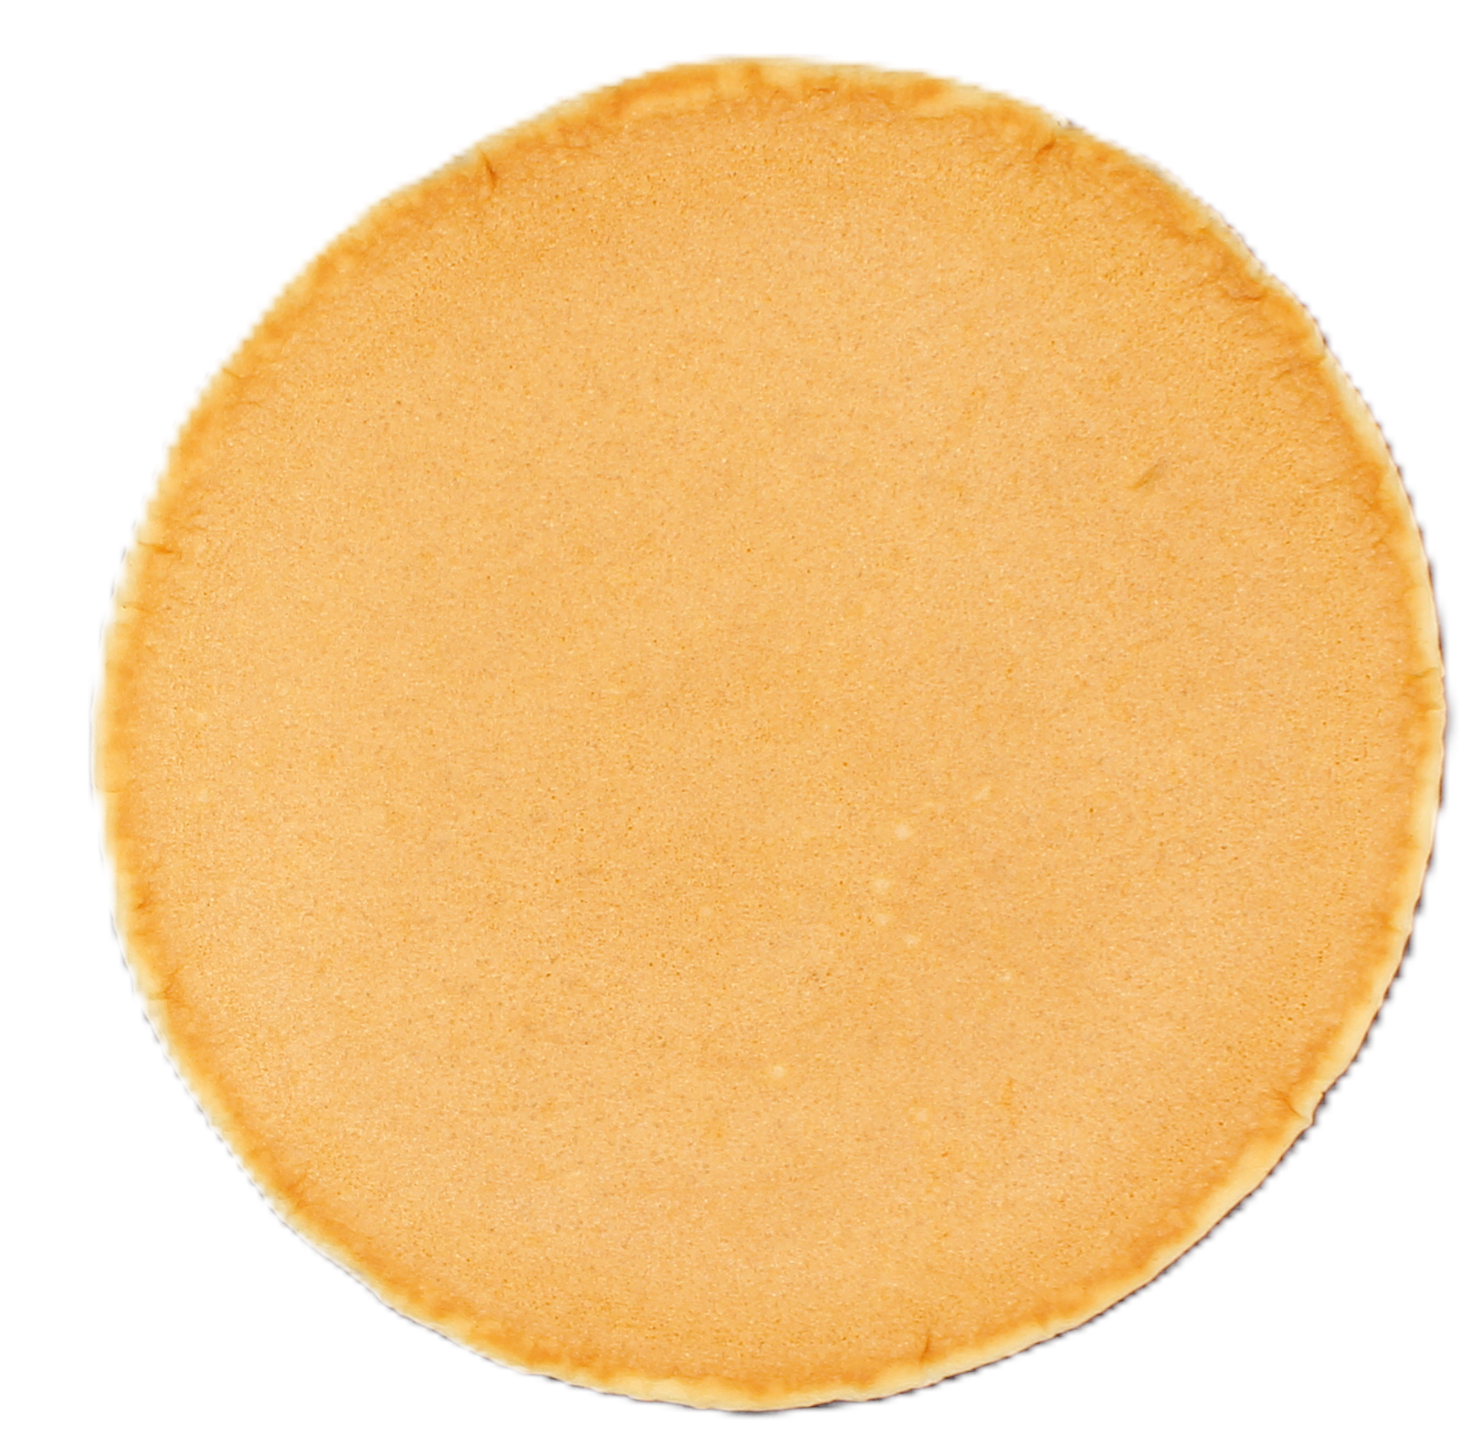 | 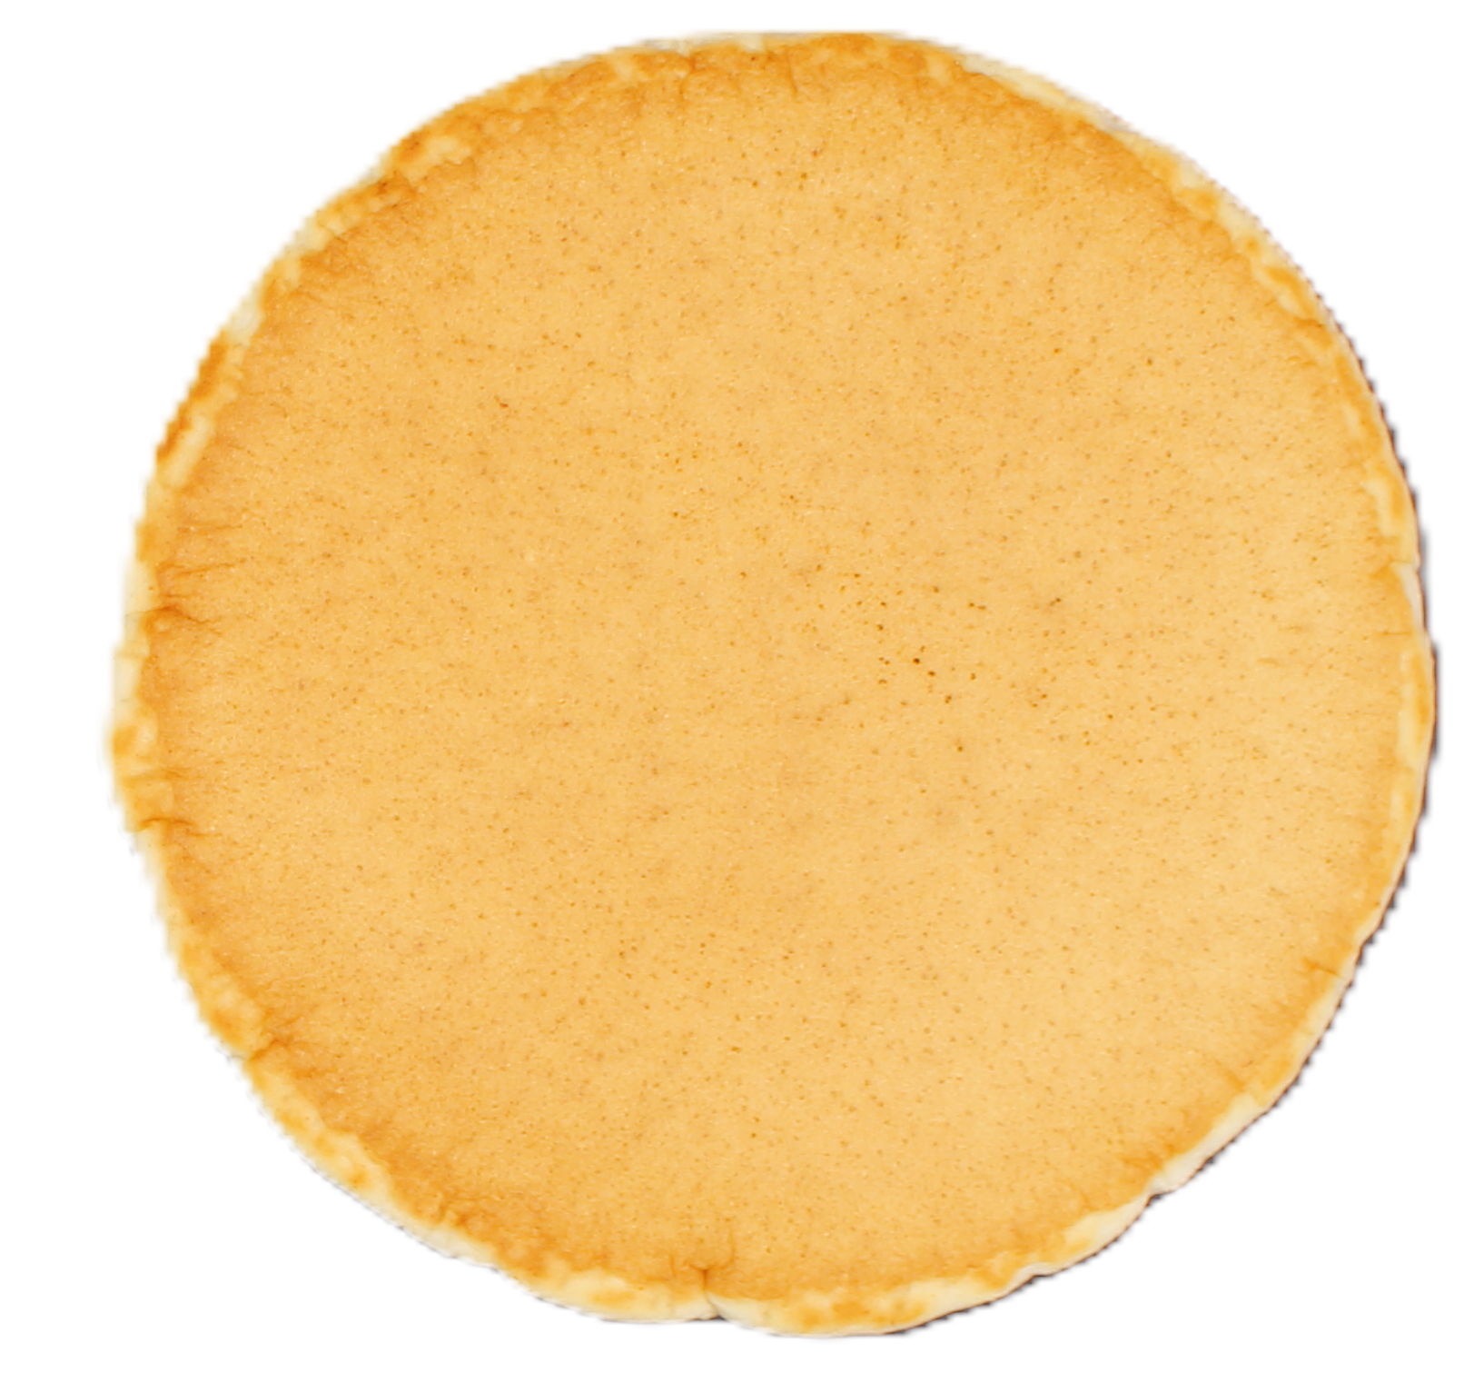 | 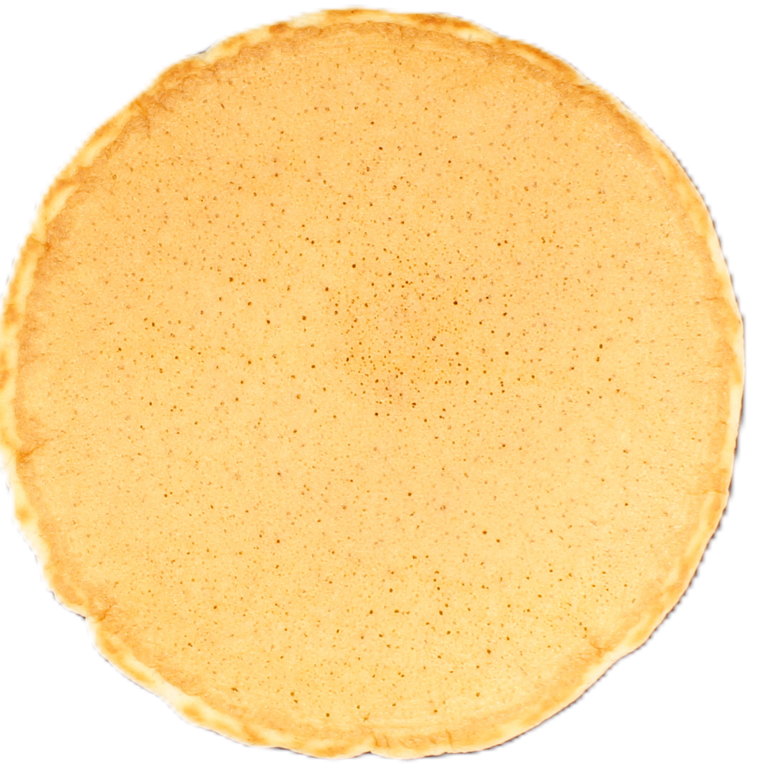 | 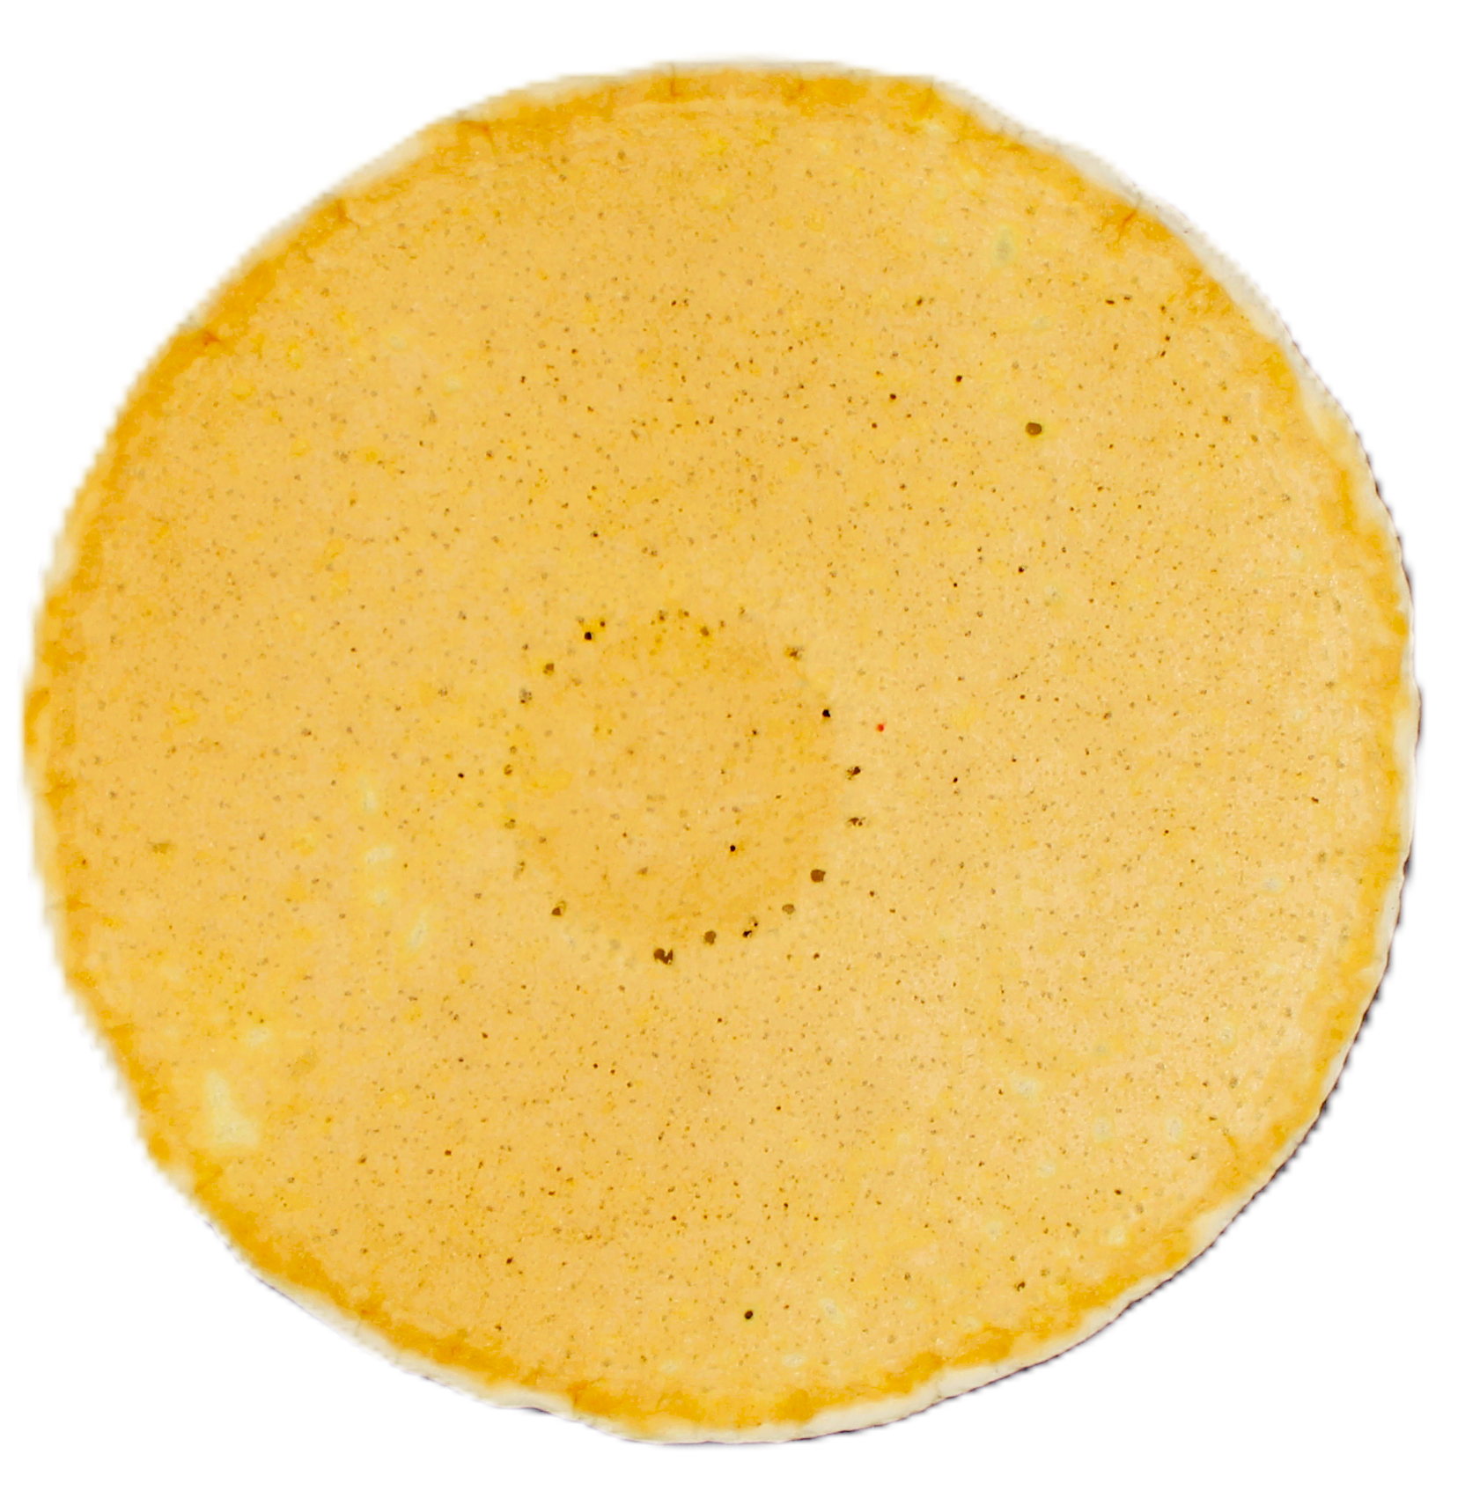 | 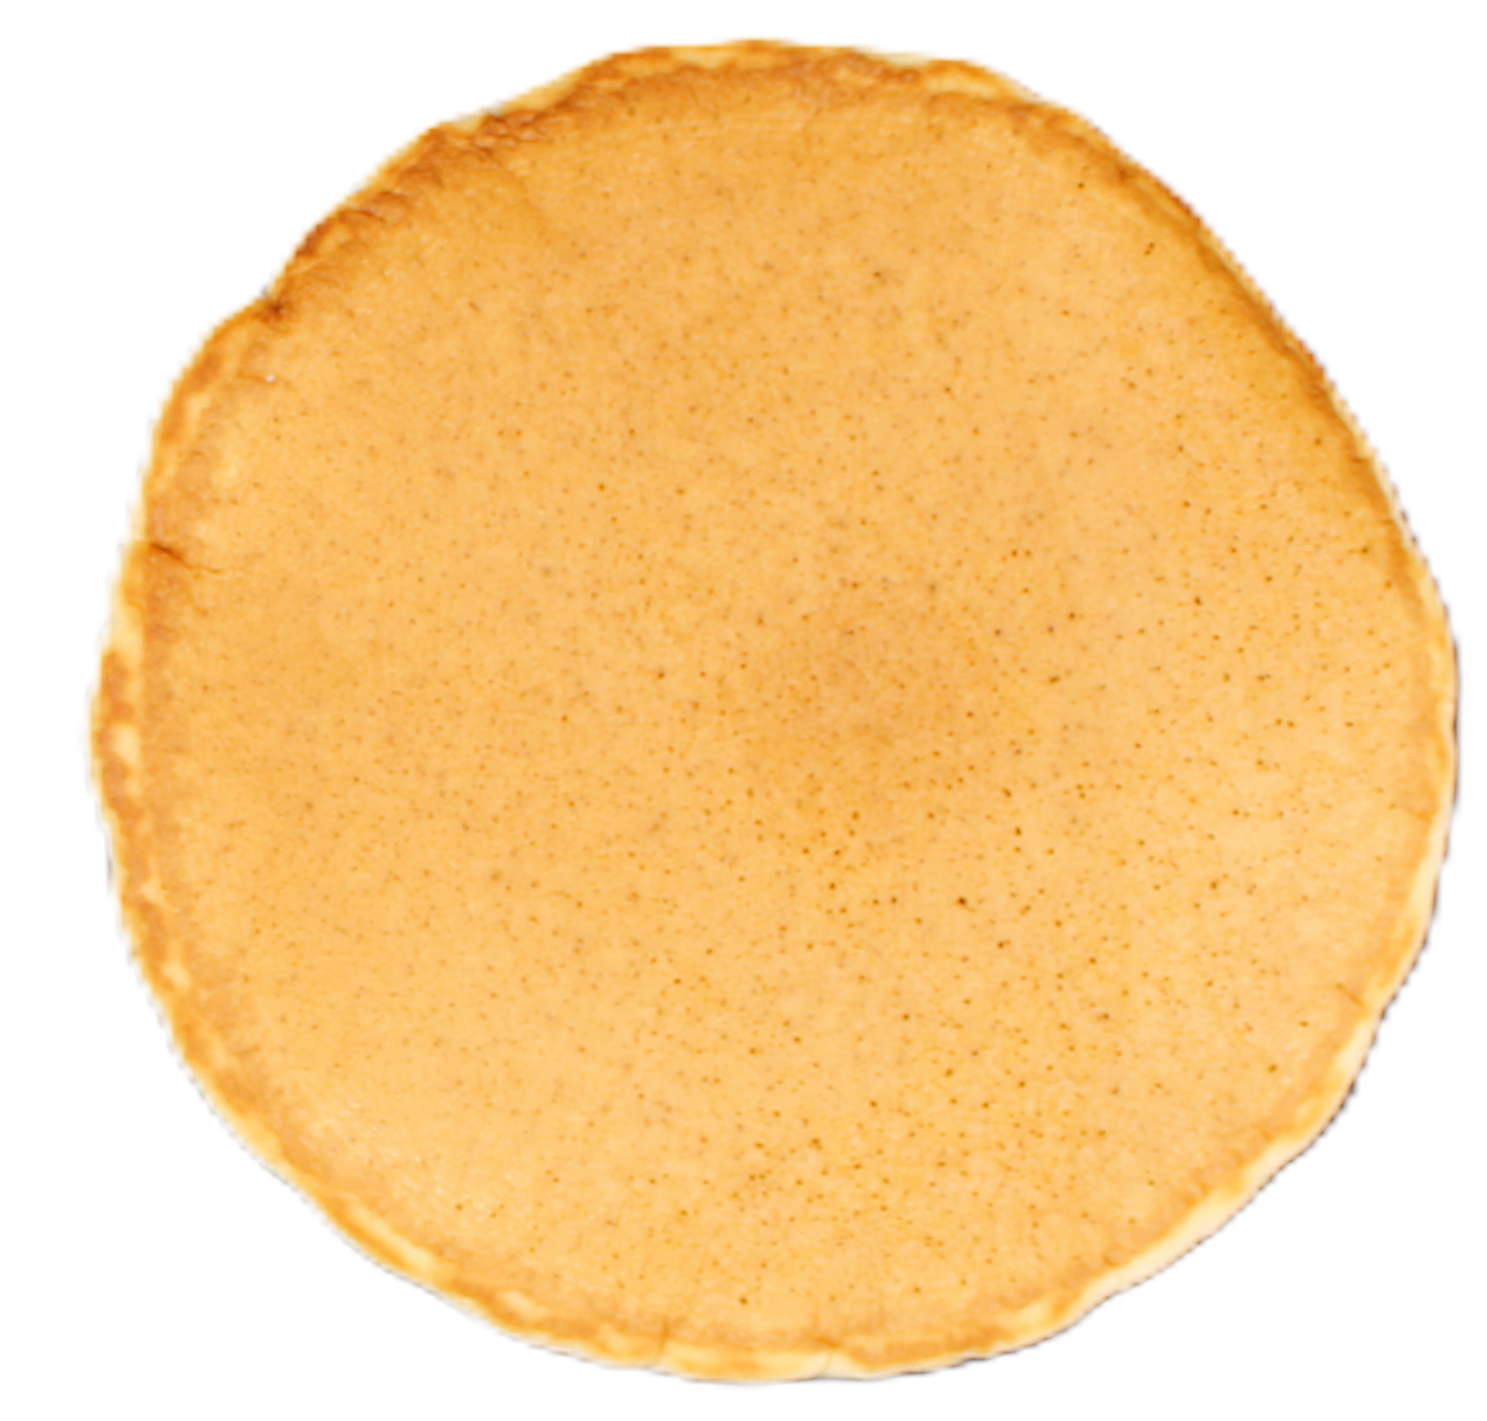 | 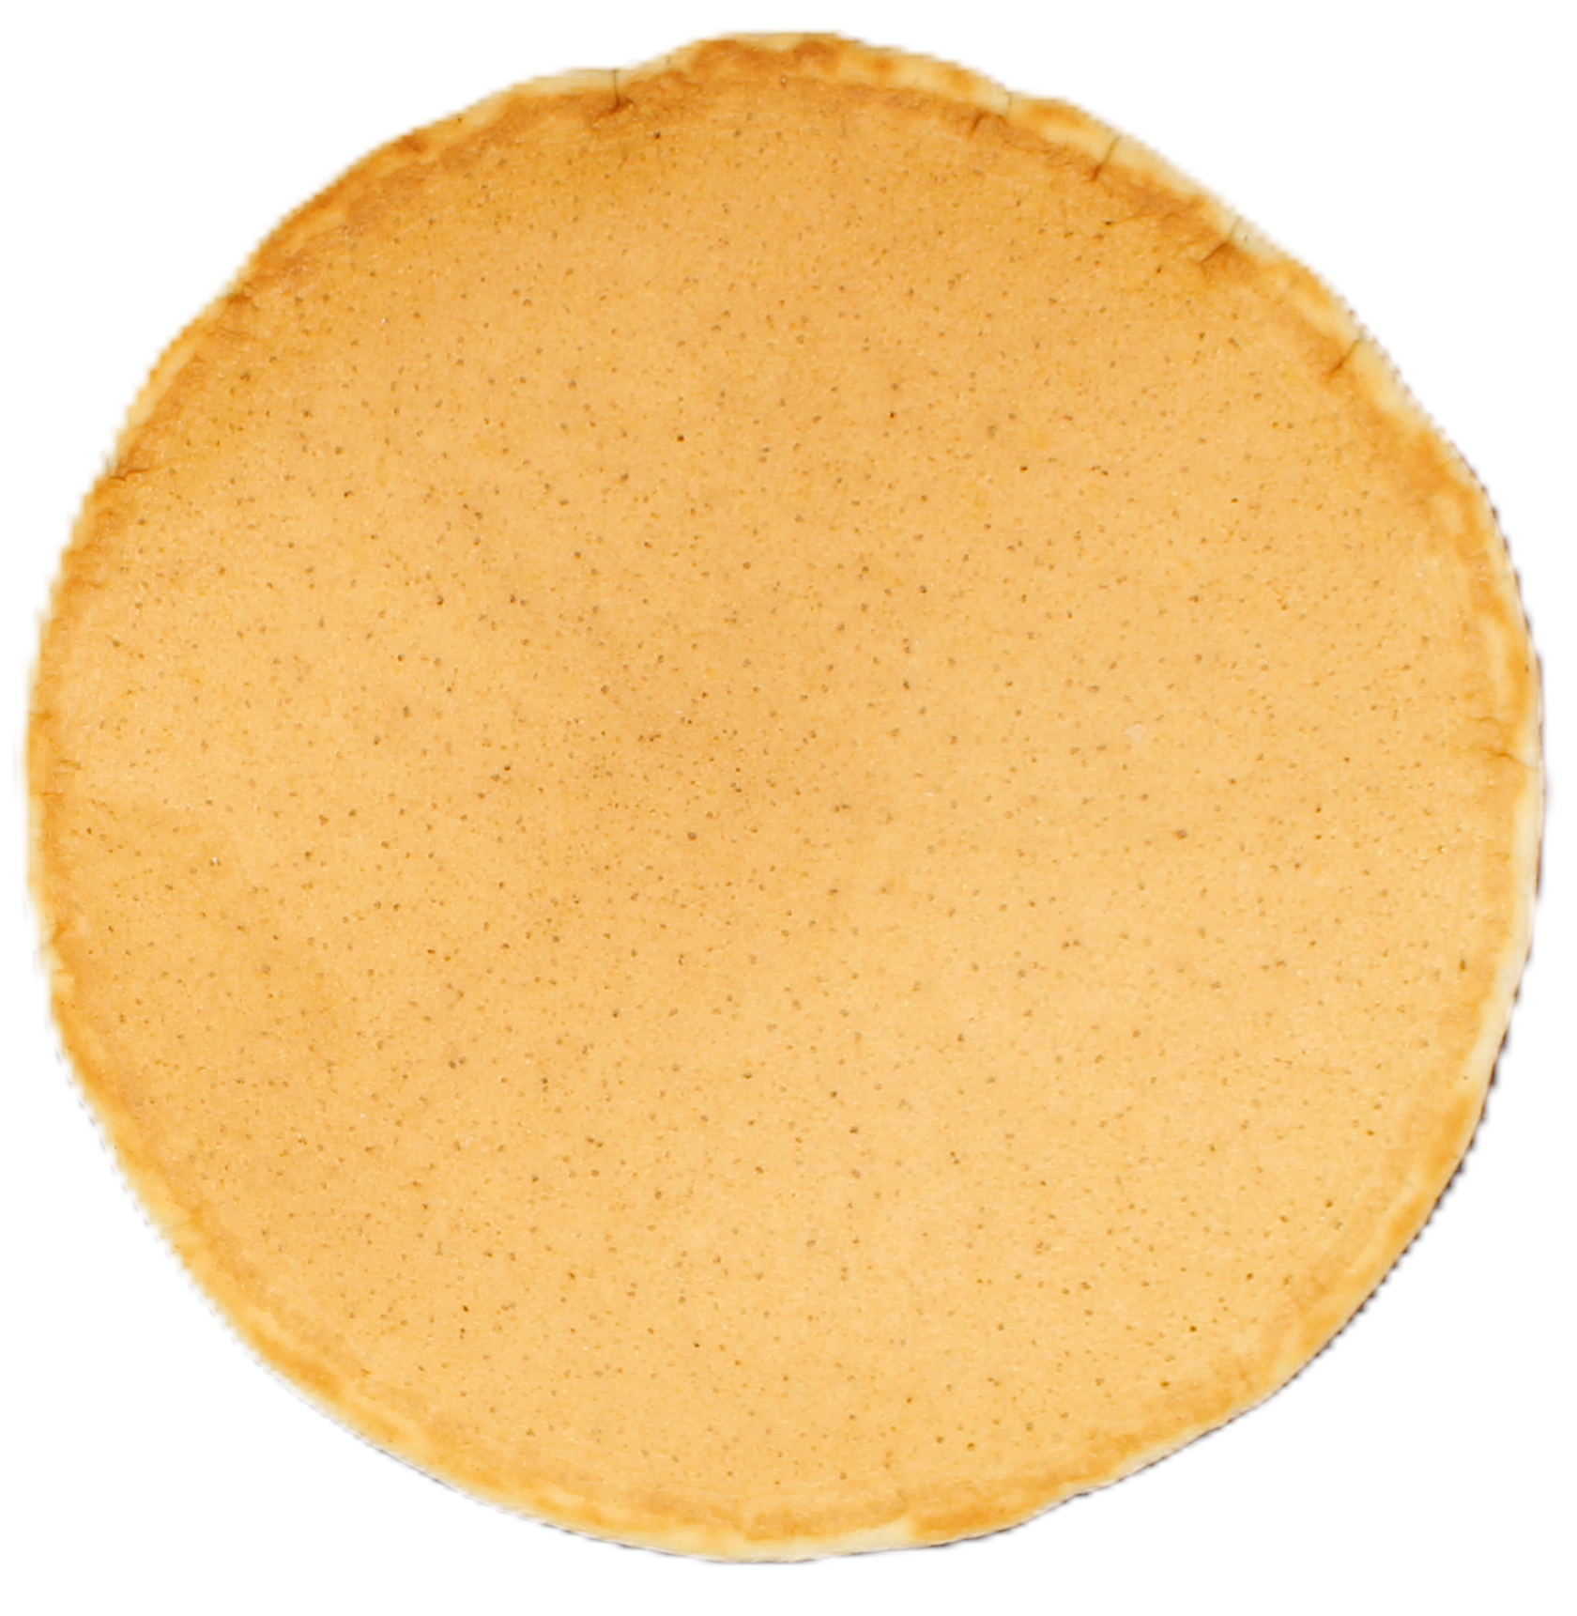 | 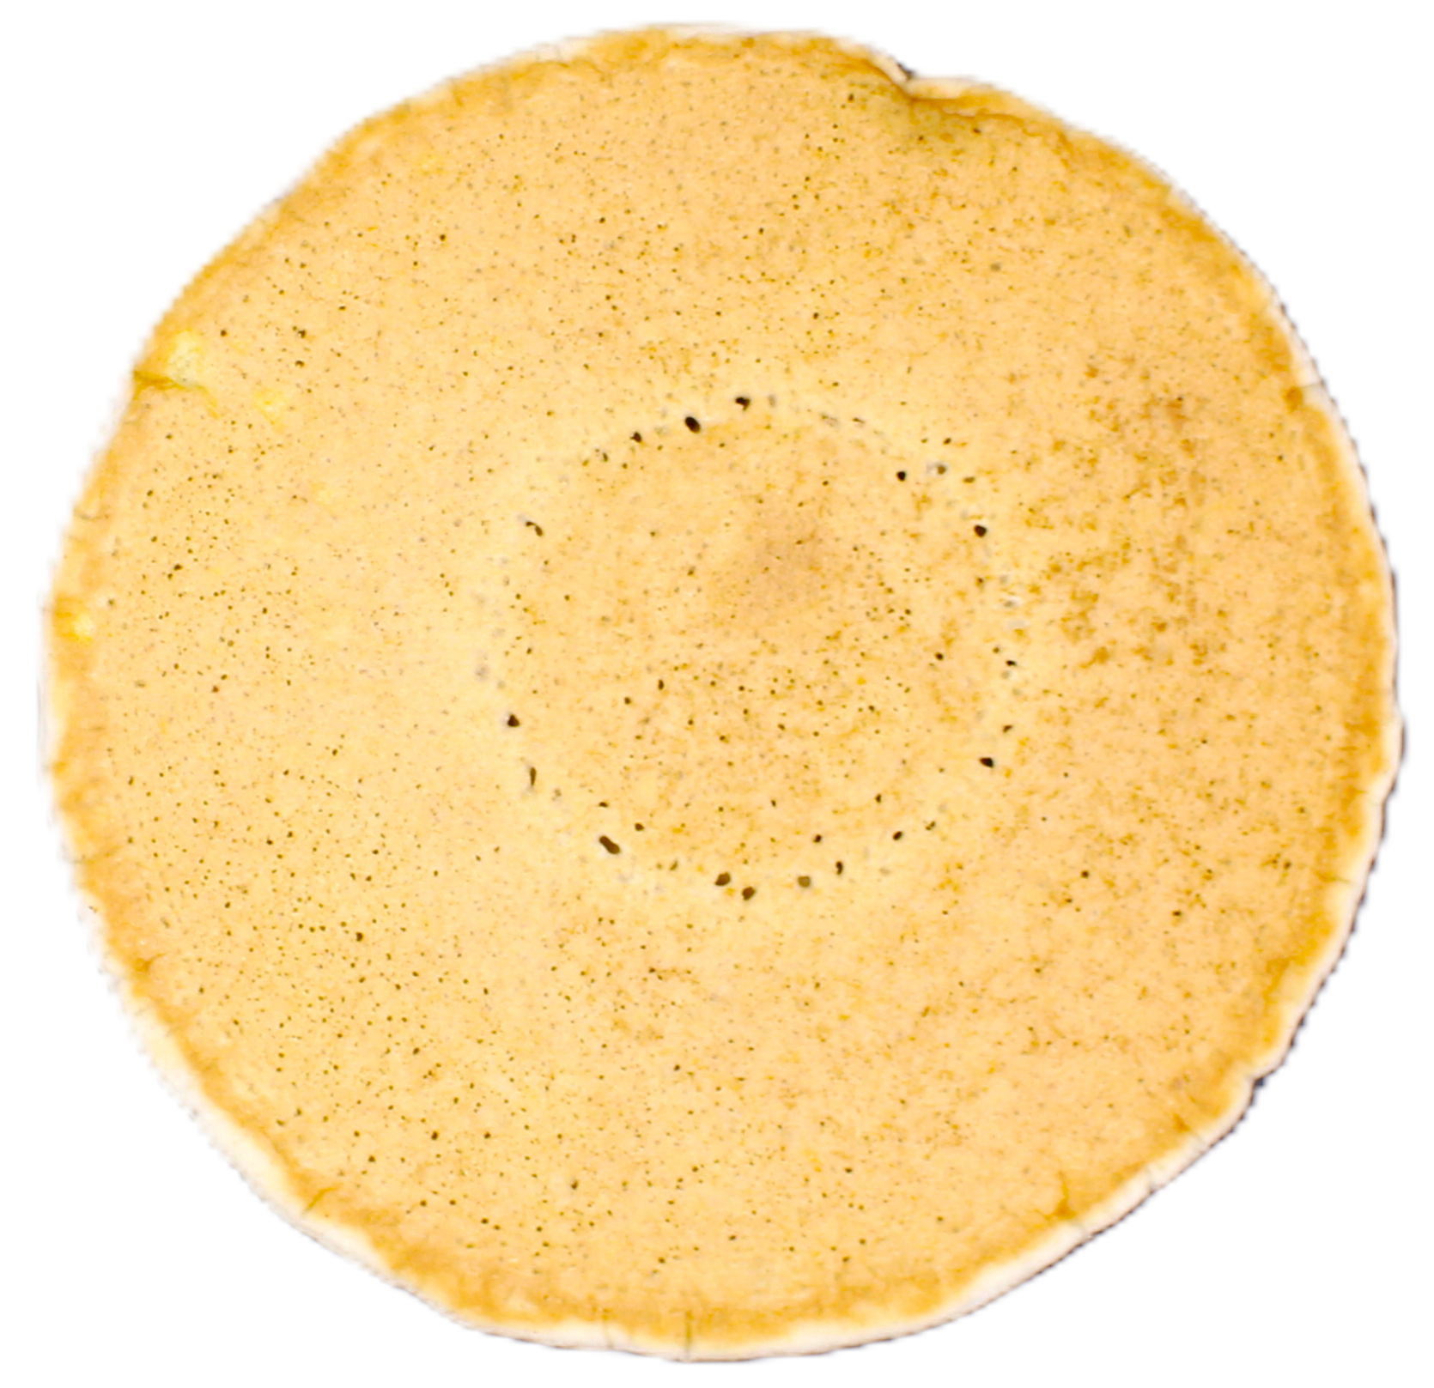 | 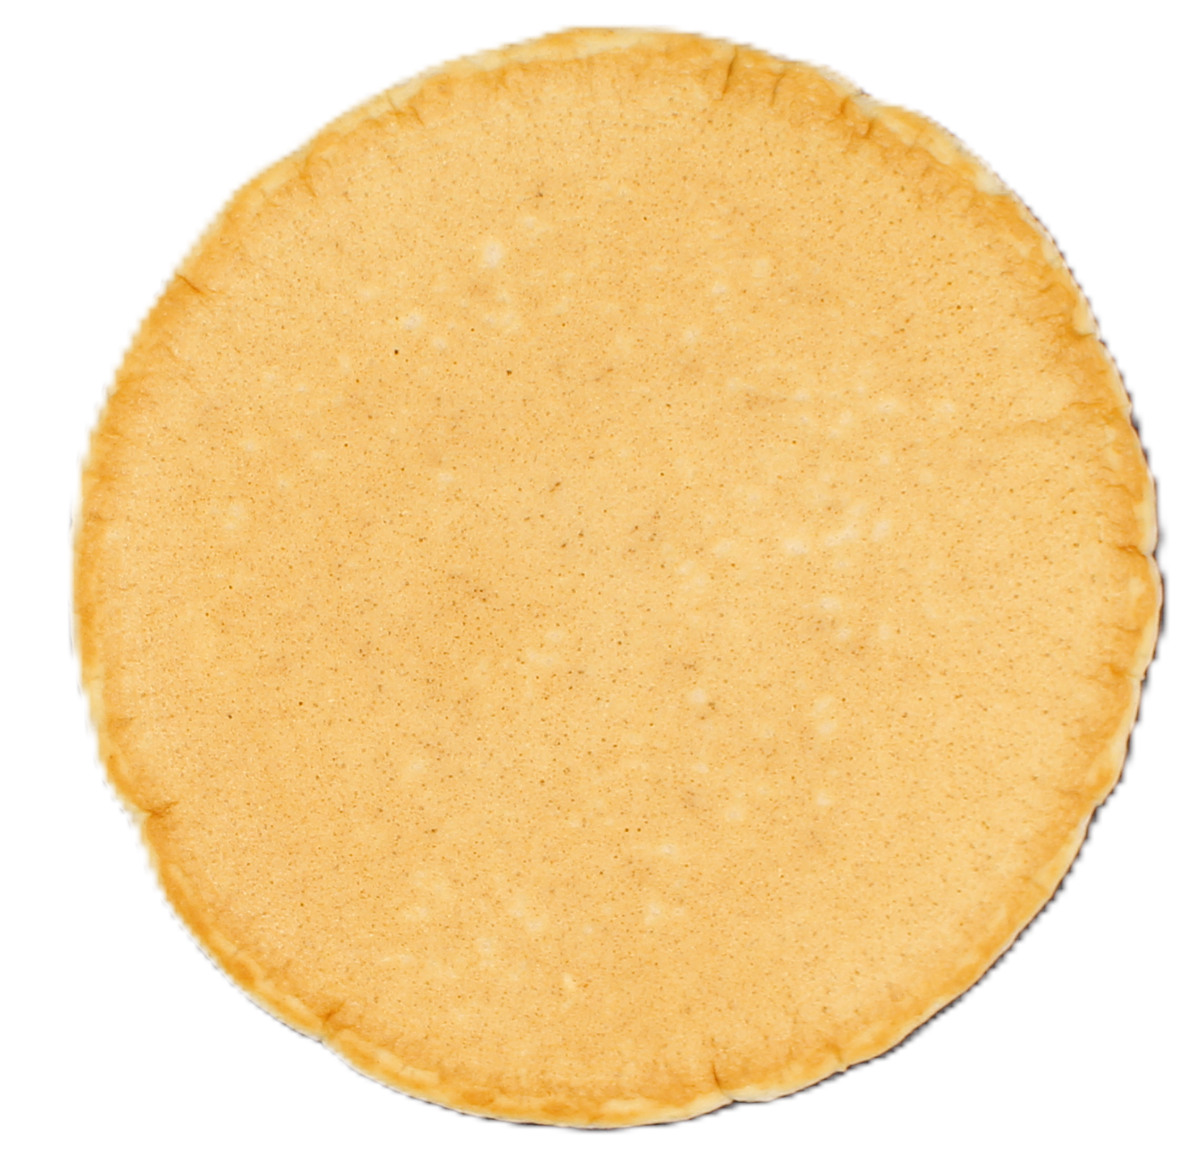 | 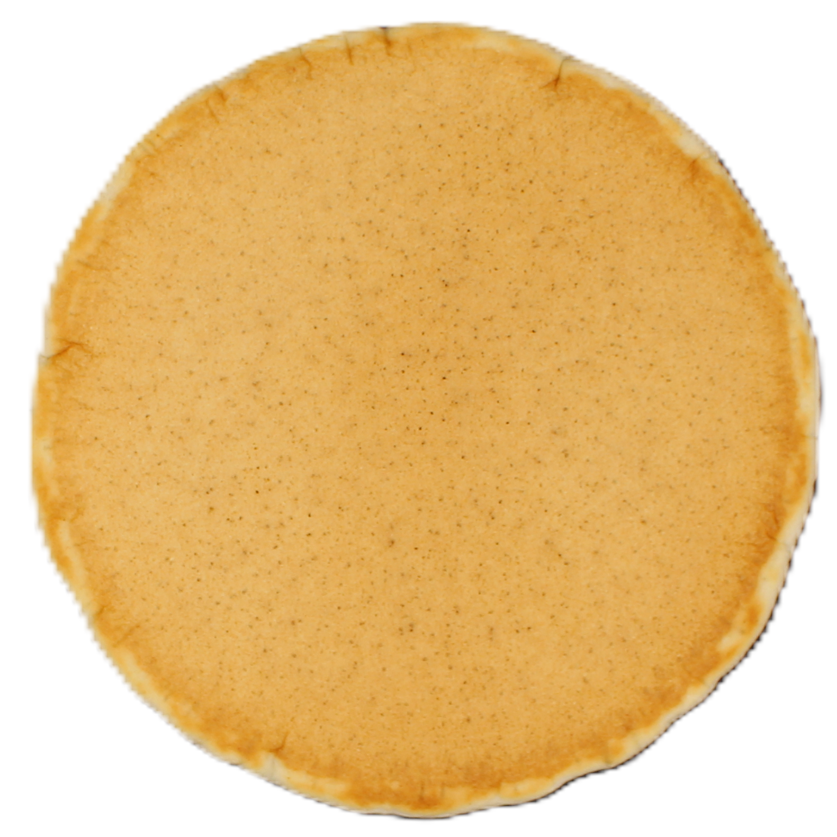 | 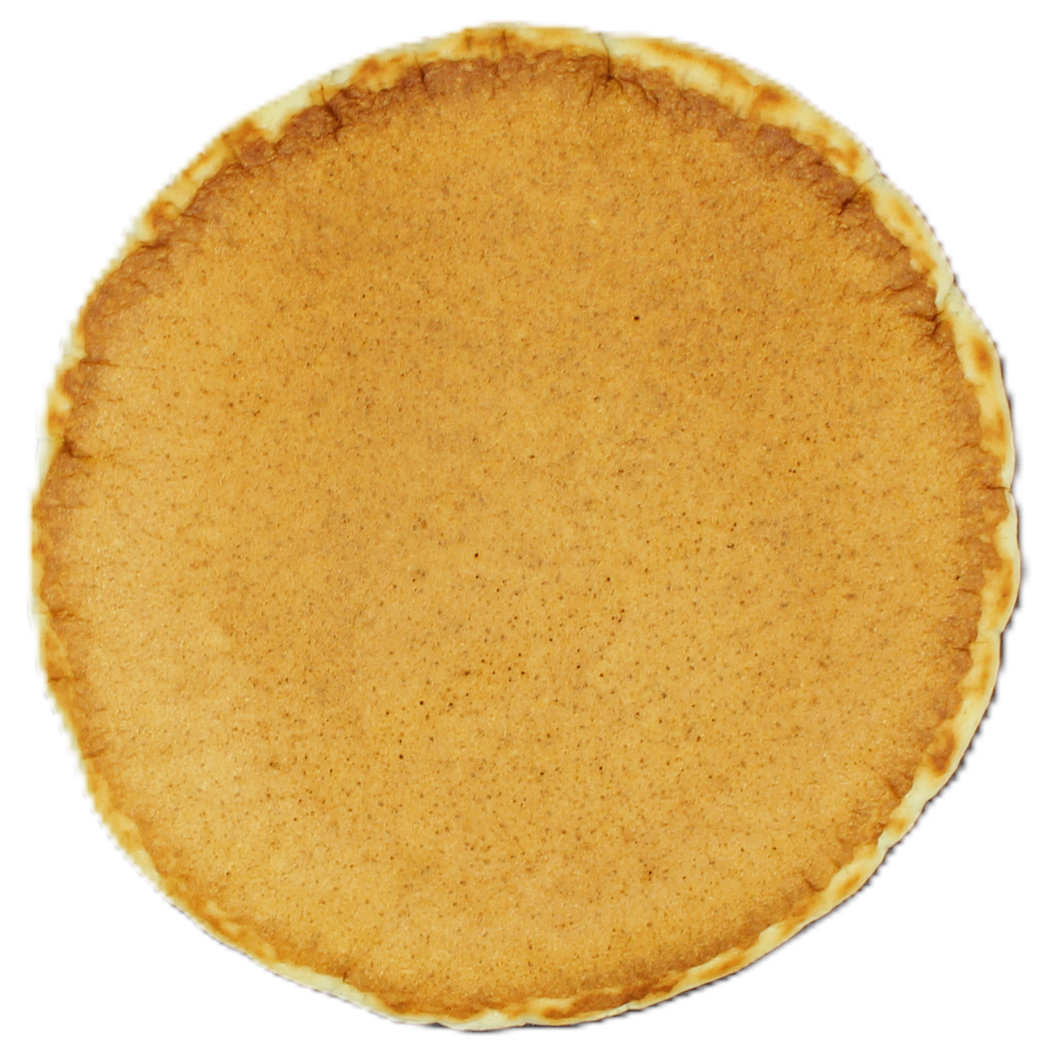
Back | 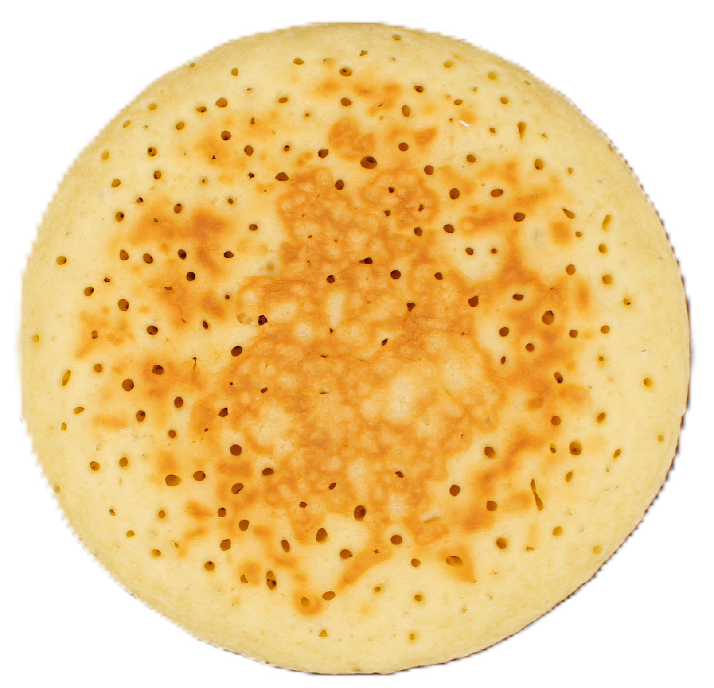 | 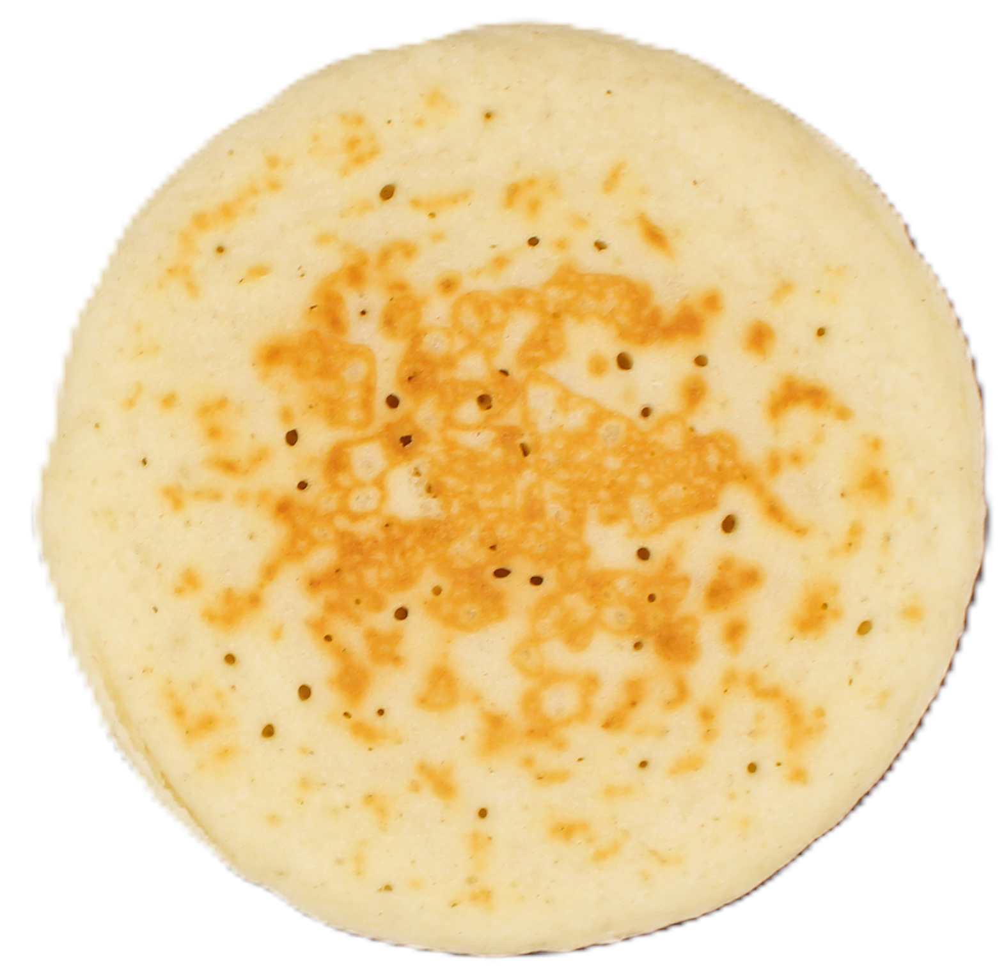 | 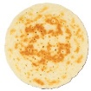 | 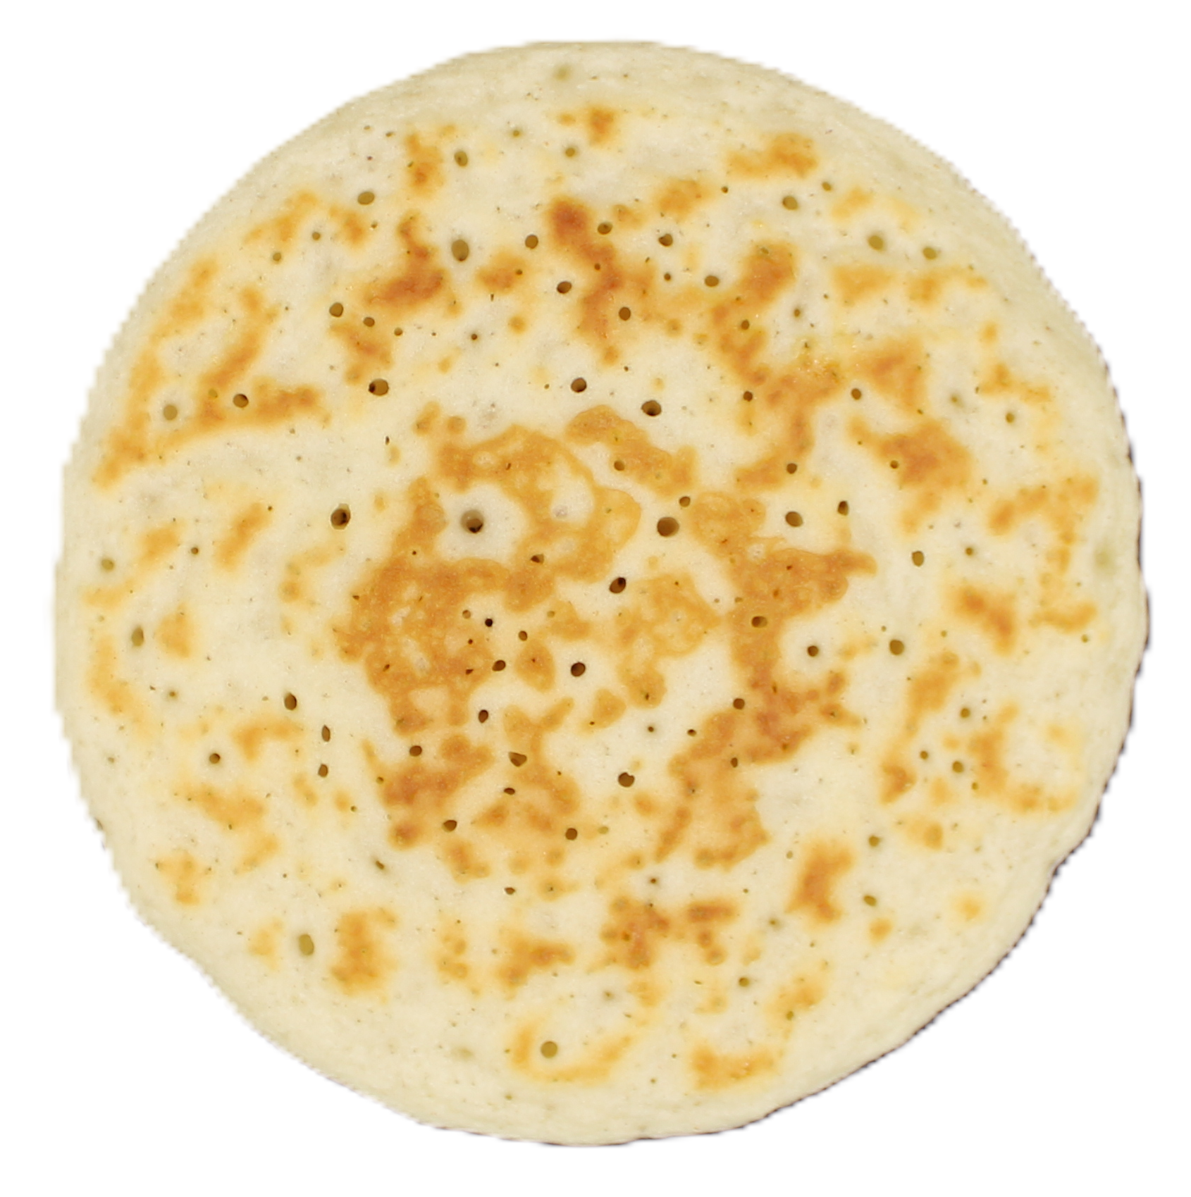 | 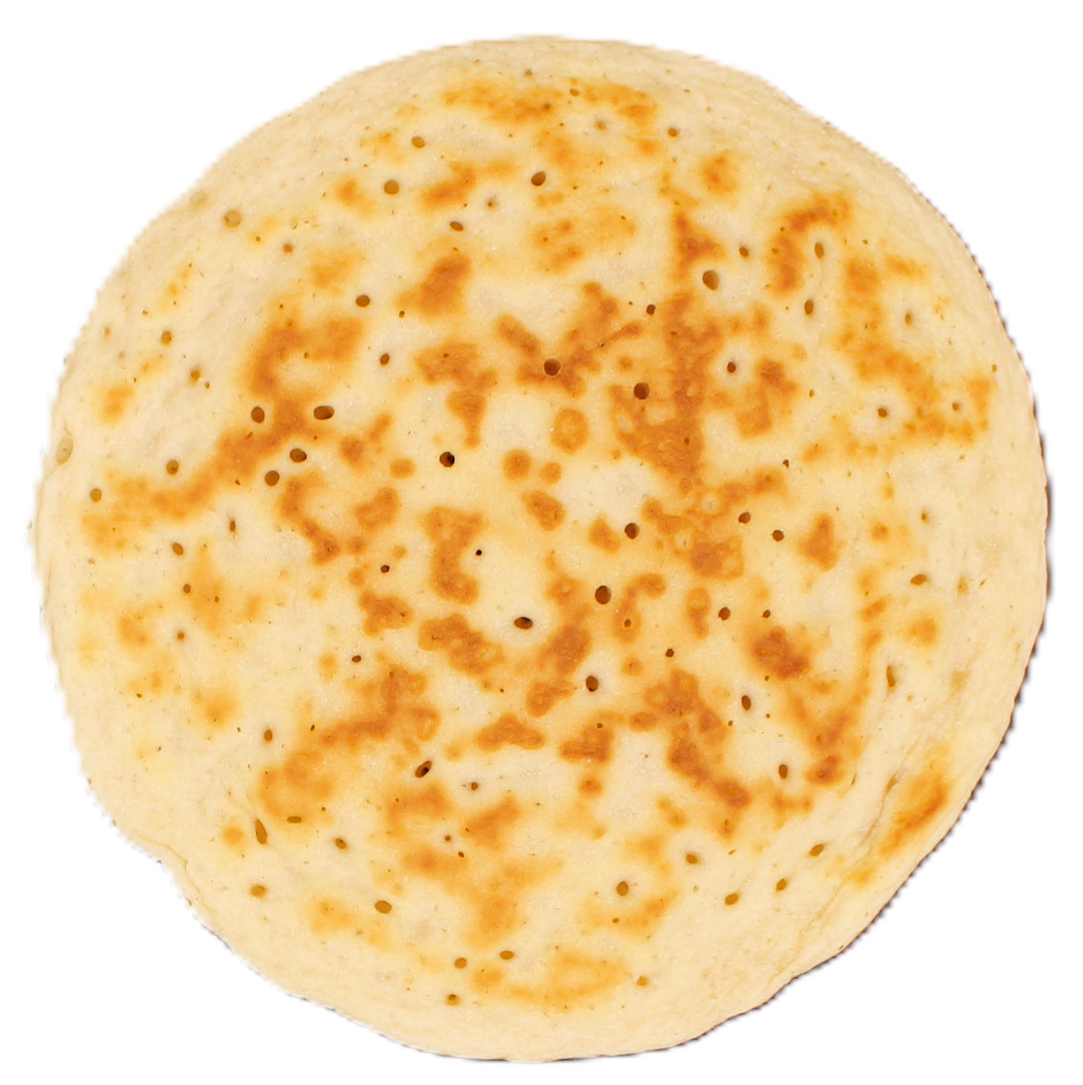 | 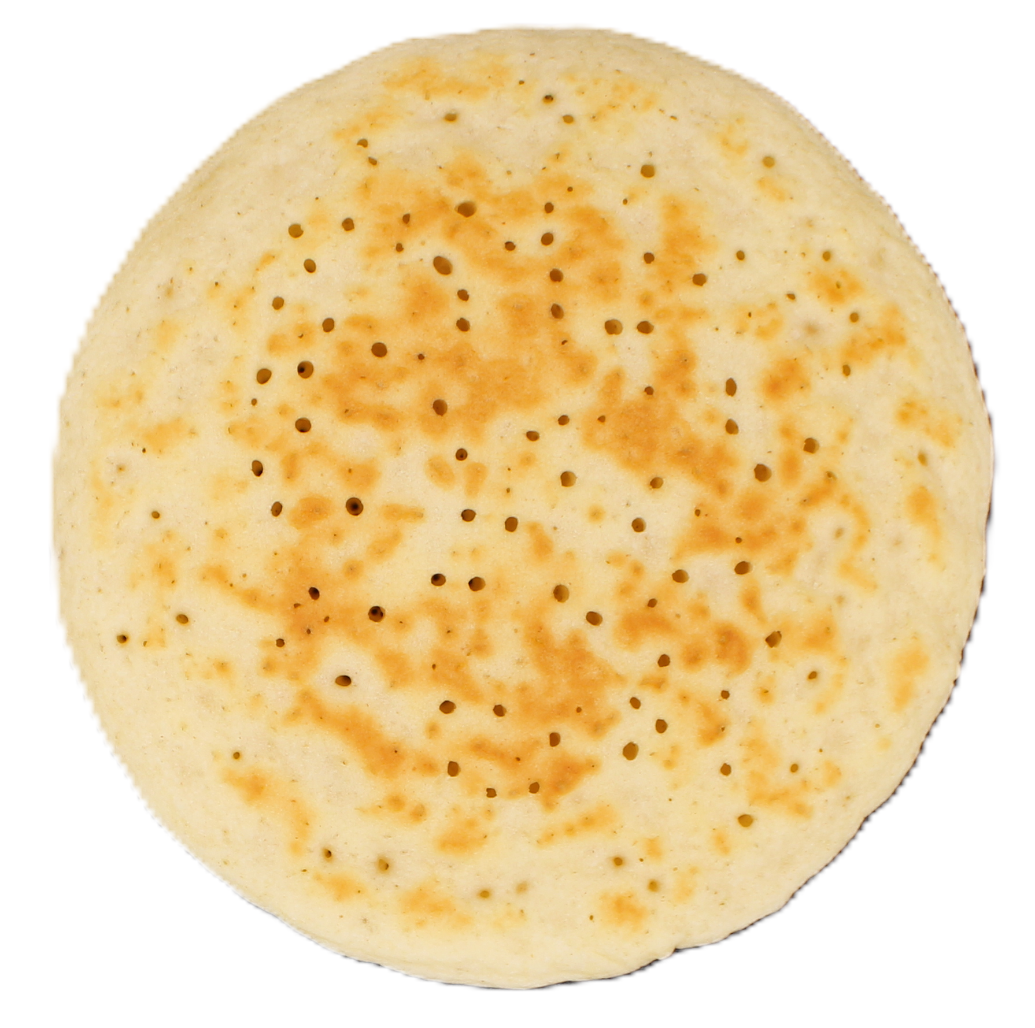 | 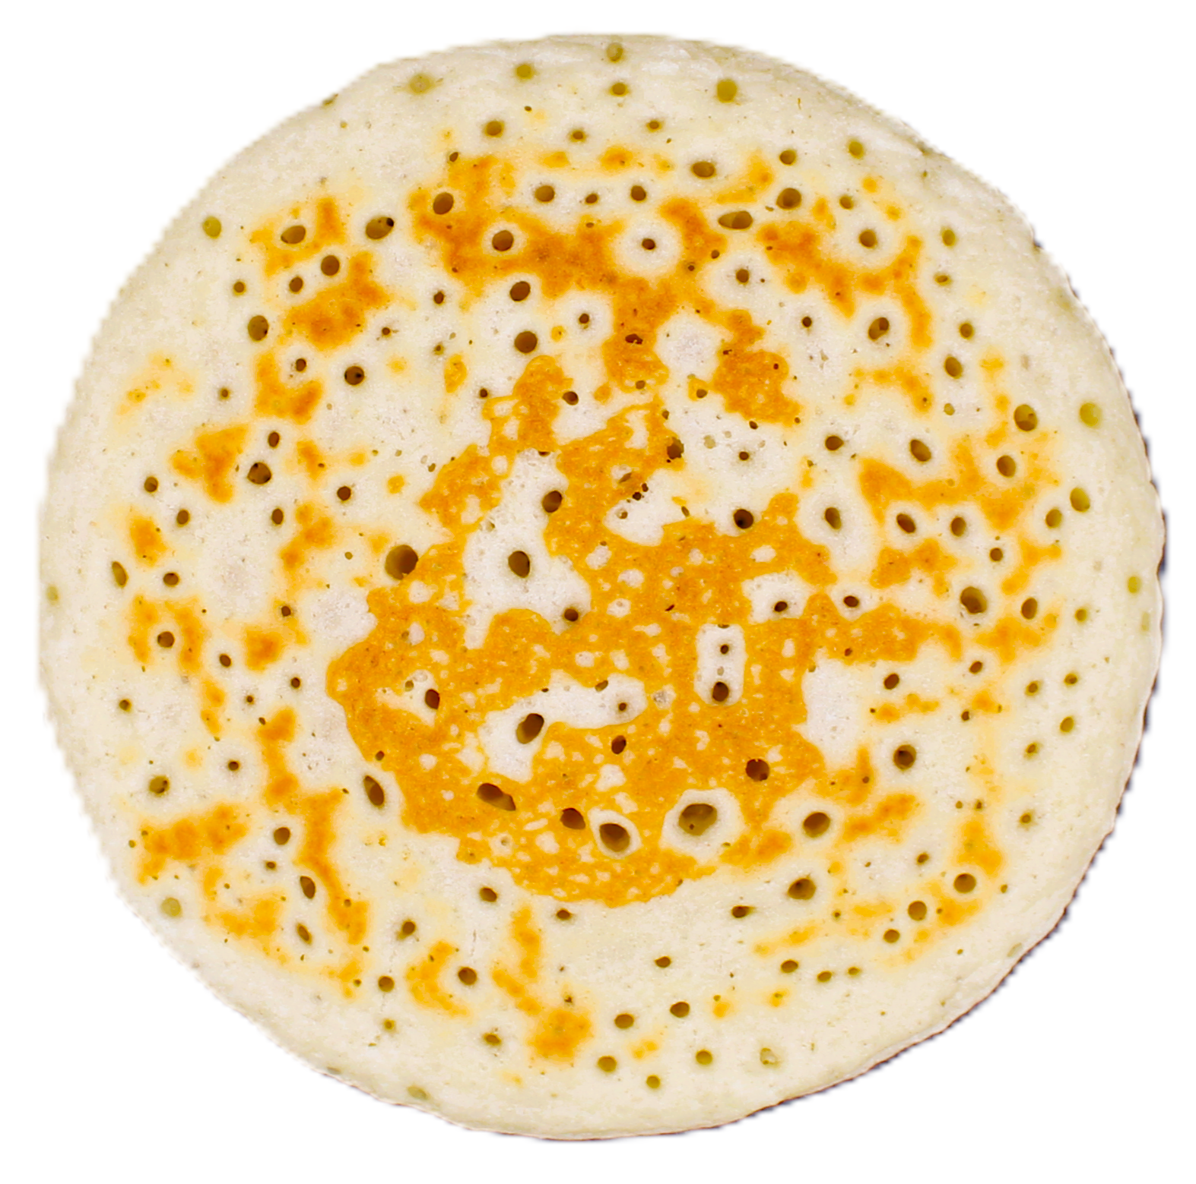 | 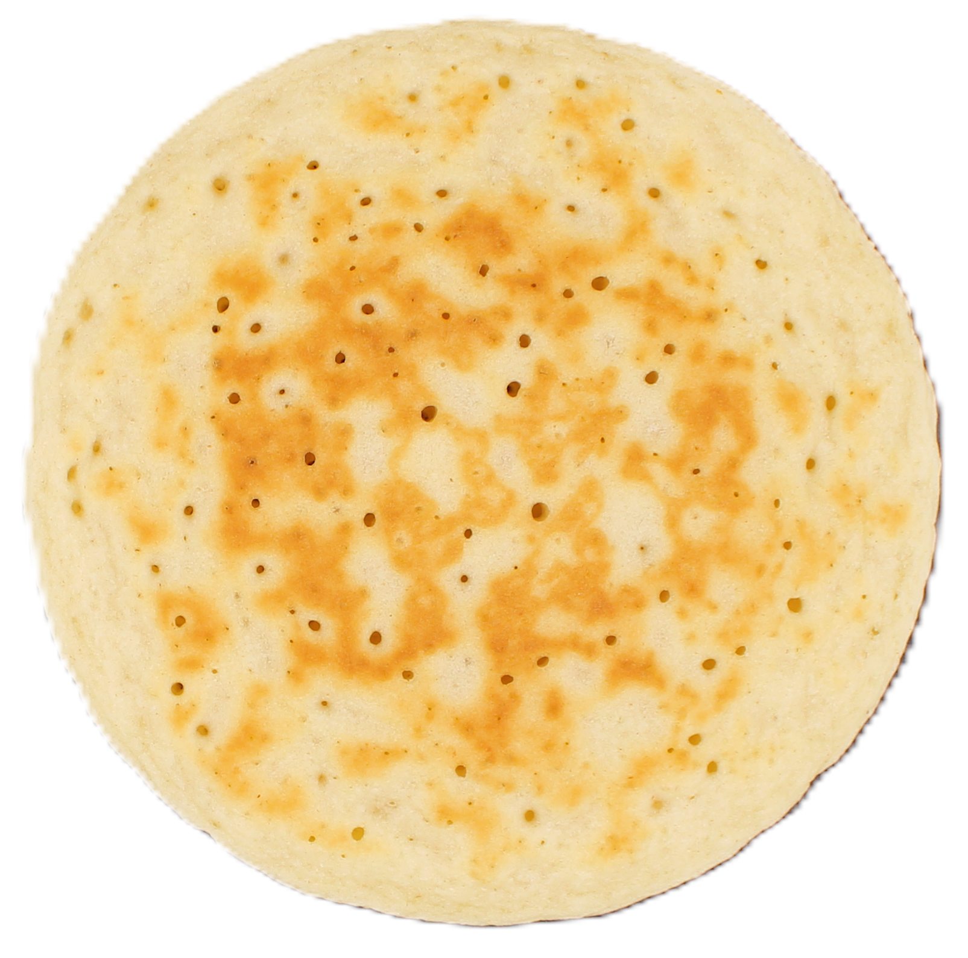 | 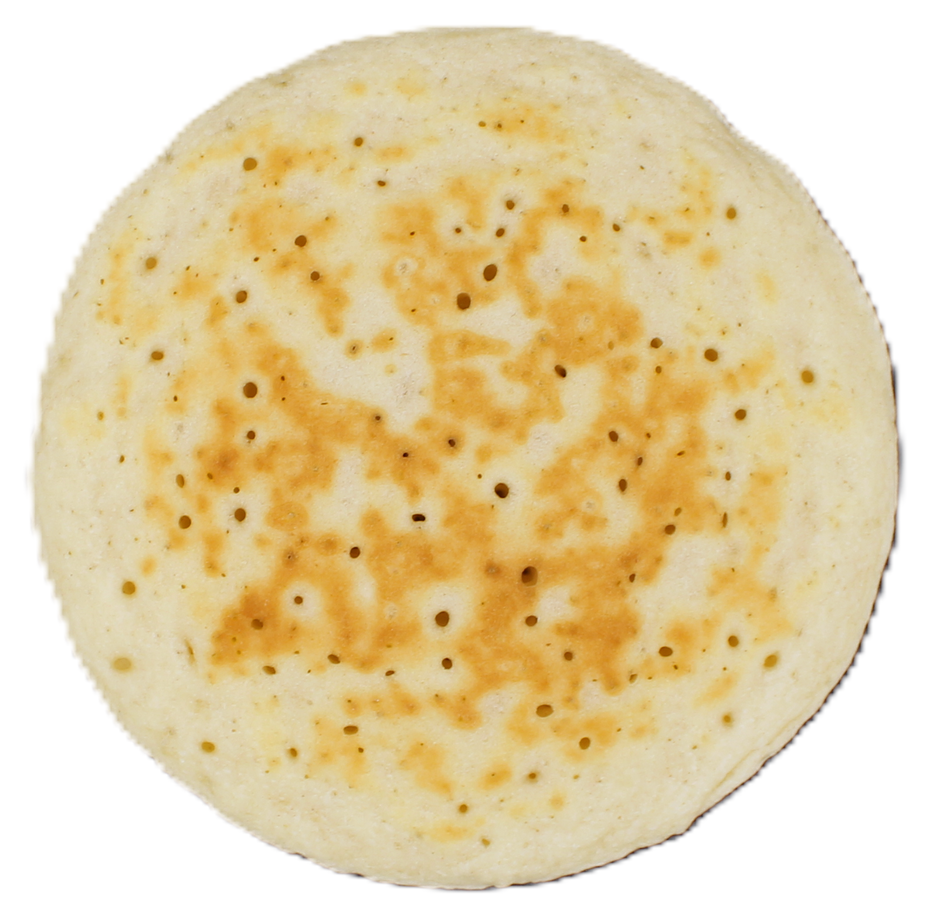 | 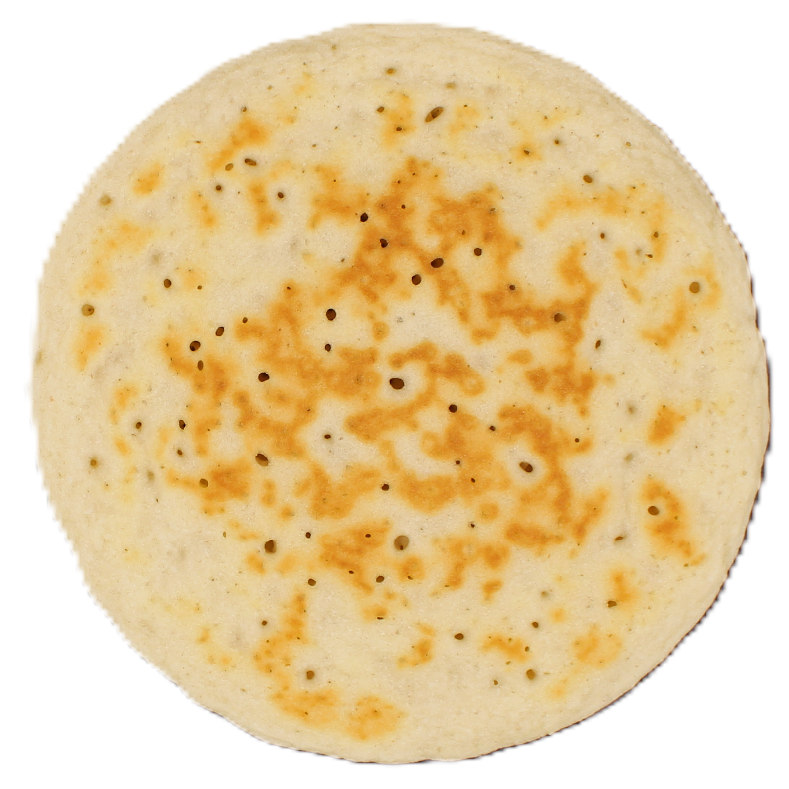
Figure S1. Front and back pictures of experimental pancakes.
EPp: Control pancake with EP; CCp: Chickpeas Concentrate pancake; CCp: Chickpeas Concentrate pancake; BBCp: Broad Bean Concentrate pancake; MBCp: Mung Bean Concentrate pancake; LCp: Lentil Concentrate pancake; PCp: Yellow Peas Concentrate pancake; SCp: Soy Concentrate pancake; CIp: Chickpeas Isolate pancake; BBIp: Broad Bean Isolate pancake; PIp: Yellow Peas Isolate pancake.

