SUPPLEMENTARY MATERIAL
Improving the long-term stability of Dunaliella salina supercritical fluid extracts with a new cryo-stirring liposomal nano-encapsulation
Victor M. Amador-Luna, Miguel Herrero, Pablo Mendoza-Orbaneja, Elena Ibáñez, Lidia Montero*.

Laboratory of Foodomics, Institute of Food Science Research, CIAL, CSIC Nicolas Cabrera 9, 28049 Madrid, Spain

* Corresponding author (L. Montero)
e-mail: lidia.montero@csic.es
Tel: +34 910 017 954
Content
S1. Disruption of the encapsulated product
S2. Encapsulation efficiency of the total terpene content
S3. Encapsulation efficiency of the total carotenoid content
S4. GC-MS analysis
S5. LC-DAD-MS analysis
S6. Bioactivity assays of the extract and the encapsulation samples S4
Figure S1. LC-DAD chromatogram of the carotenoids present in the samples
Figure S2. GC composition of the starting extract and final products
Figure S3. Effect of the different encapsulation steps on the volatile fraction
References
S1. Disruption of the encapsulated product
To calculate the encapsulation efficiency, the starting D. salina UHP-SFE extract was used as control (100% efficiency). Considering that the final encapsulated product was formed by an encapsulated/encapsulant ratio 1:10 (w/w), to maintain the real proportion of compounds between the starting and the encapsulated samples, the weighted quantity of the final encapsulated product was 10 times higher than the starting D. salina extract for the efficiency measurements
Then, the encapsulated product was destabilized to extract the encapsulated fraction. To this end, 2 mL ethanol were mixed with the encapsulated product and this mixture was homogenized using a glass Potter-Elvehjem type manual homogenizer with a Teflon stem to break the encapsulation (Figure 2I). After this, it was centrifuged at 5500 G for 5 minutes at 4 °C to precipitate the encapsulant phosphatidylcholine, which is insoluble in ethanol. The supernatant (encapsulated extract) was taken and used in the following tests.
S2. Encapsulation efficiency of the total terpenoid content
The encapsulation efficiency of the total terpenes was obtained using the following formula (Equation SM1).
$EE\text{TTC} \left(\%\right)=1-\frac{A_{i}-A_{f}}{A_{i}}·100\%$ (Equation SM1)
Where, Ai is the TTC value in the starting UHP-SFE extract, and Af is the TTC value in the encapsulated extract.
The values of the TTC evaluation are expressed as mg-eq limonene g⁻¹ extract because a monoterpene is used as standard (limonene). However, the main terpenes present in the D. salina extracts were carotenoids, which are tetraterpenes. Since the TCC protocol consists of a hydrolysis of all the terpenes till monoterpenes, tetraterpenes contain four isoprene units, which means that the value for each tetraterpenes is four times the monoterpene. For this reason, the results of TCC in most cases are higher than 1000 mg mg-eq limonene g⁻¹.
S3. Encapsulation efficiency of the total carotenoid content
The TCC encapsulation efficiency was calculated by Equation SM2.
$EE\text{TCC} \left(\%\right)=1-\frac{TC extract-TC encapsultation }{TC extract}·100\%$ (Equation SM2)

S4. GC-MS analysis
GC-MS analyses were performed using a QP2010 Plus system (Shimadzu Corporation, Kyoto, Japan) with a GC column Zebrom ZB-5Plus (30 m × 250 μm i.D × 0.25 μm) (Phenomenex, Torrance, CA). Helium was used as carrier gas with a linear velocity of 32.5 cm s⁻¹. The injection was performed at 250 ºC with a sample time of 1.5 min with an injection volume was 1 µL in split mode. The column temperature gradient started at 45 ºC for 1 min; then, it increased at a rate of 10 ºC min⁻¹ to 290 ºC followed by an increase up to 325 ºC at 5 ºC min⁻¹ and this temperature was held for 10 min. The MS detector operated using an electronic impact source at a temperature of 250 ºC and an interface temperature of 335 ºC was employed. The MS detector was operated in full-scan acquisition mode using a scan speed of 1428 amu s⁻¹ at an m/z range of 50-600 Da (5 spectra per second). The compounds were tentatively identified by systematic mass spectra deconvolution and search in the MS database, using the Shimadzu Mass Hunter Analysis tool (Mass Spectral Libraries and Database), and the Human Metabolome DataBase (HMDB) GC spectra search Mass Spectrum (HMDB version 5.0). The samples were prepared in ethanol. The encapsulated fraction samples were prepared 10 times more concentrated than the starting extract to maintain the real compound proportions after the encapsulation. The comparison between samples was performed in terms of relative abundance (peak area). The samples were analyzed in triplicates, determining the encapsulation efficiency of each identified compound using the following formula (equation 2).
$EE\text{ind,comp} \left(\%\right)=1-\frac{A_{i}-A_{f}}{A_{i}}·100\%$ (equation 2)
Where, EE_{ind,comp} is the encapsulation efficiency of each individual compound present, A_{i} is the area in the starting UHP-SFE extract and A_{f} is the compound area in the encapsulated fraction.

S5. HPLC-DAD-MS/MS analysis
The analysis of the individual carotenoids was performed using a LC-MS chromatographic separation. To do that, an Agilent 1100 series liquid chromatograph (Santa Clara, CA, USA) equipped with a diode-array detector (DAD) was employed. The chromatographic separation was carried out by using a YMC-C30 reversed phase column (250 mm × 4.6 mm i.d., 5 µm particle size; YMC Europe, Schermbeck, Germany) and a pre-column YMC-C30 (10 mm × 4 mm i.d., 5 µm particle size). A solution of methanol/MTBE/water (90:7:3, v/v/v) was used as mobile phase A and methanol/MTBE (10:90, v/v) was chosen as mobile phase B. The flow rate was 0.8 mL min⁻¹ and the injection volume was 10 µL. The gradient elution was based on previous studies (Bueno et al., 2020) being: 0% B (0-10 min); 0 to 30% B (10-20 min); 30 to 50% B (20-35 min); 50 to 80% B (35-45 min); 80 to 100% B (45-50 min); 100% B (50-60 min); 100 to 0% B (60-62 min); and a post-run column equilibration of 13 min at 0% B. The samples were dissolved in ethanol at an appropriate concentration (10.0 mg mL⁻¹) and filtered through a 0.45 μm PTFE hydrophobic filter. Absorption spectra were recorded from 240 to 770 nm using the DAD whereas the quantification of carotenoids was carried out at 450 nm. The instrument was controlled by LC ChemStation 3D Software Rev. 04.03 (Agilent Technologies, Santa Clara, CA, USA). The LC separation was coupled to an ion trap MS (Agilent ion trap 6320) using an atmospheric pressure chemical ionization (APCI) as ion source. The MS analyses were carried out under positive ionization mode, and the set parameters were: drying temperature, 350 °C; vaporizer temperature, 400 °C; drying gas flow rate, 5 L min⁻¹; nebulizer gas pressure, 60 psi; capillary voltage, -3.5 kV; corona current, 4000 nA. Data were acquired within a m/z range of 150-1300 Da in automatic MS/MS acquisition mode. The identification of carotenoids was performed using the UV-vis and the MS spectra of each peak.
For the β-carotene calibration curve, the stock solution was dissolved in ethanol (2 mg mL⁻¹). Six different concentrations were prepared in ethanol and injected in triplicate. Since β-carotene isomers standards were not available, the quantification of the different isomers was performed using the pure all-trans-β-carotene commercial standard, assuming that the response factor could be similar. This method was used for the analysis of carotenoids of both, the starting extract and the encapsulated product (10 times higher concentrated in comparison to the starting extract) in triplicate, determining the encapsulation efficiency of each carotenoid using the following formula (equation 5).
$EE\text{i,carot} \left(\%\right)=1-\frac{A_{i}-A_{f}}{A_{i}}·100\%$ (equation 5)
Where, $EE\text{i,carot}$is the encapsulation efficiency of each individual carotenoid, A_{i} is the carotenoid area in the starting UHP-SFE extract, and A_{f} is the carotenoid area in the encapsulated fraction
S6. Bioactivity assays of the extract and the encapsulated fraction
The encapsulated fraction obtained after the disruption of the encapsulated product (described in S1) was analyzed to evaluate all the in vitro assays. The sample concentration of the encapsulated extract used for the colorimetric assays was established based on the encapsulation efficiency to maintain a concentration equivalent to that of the starting extract.
S6.1 Antioxidant activity
The antioxidant bioactivity was evaluated against DPPH and ABTS radicals in addition to the ROS/RNS scavenging. The measurement of the total equivalent antioxidant capacity (TEAC) against the radical DPPH was carried out following the protocols described by Brand-Williams et al. (1995) with slight modifications for the adaptation of the measurements in 96-well plates doing the quantification before (starting extract) and after (encapsulated extract) the encapsulation. To do that a reaction between 990 µL 0.1 mM DPPH and 10 µL of the sample was carried out and the absorbance at 516 nm (previously calibrated the blank of DPPH with an absorbance of 0.6 UA at time = 0 min) was measured after 30 min. The TEAC-ABTS radical assay was carried out according Re et al. (1999) with modifications (Plaza & Rodríguez-Meizoso, 2013). Briefly, a reaction between ABTS and potassium persulfate was carried out in dark at room temperature during 16 h. After this incubation, 10 μL of extract were dissolved at different concentrations in a serial manner in ethanol and mixed with 990 μL of ABTS (7 mM) in 50 mM phosphate buffer (pH=7.4). After 45 min of incubation in dark at room temperature, the absorbance at 734 nm was measured. For both DPPH and ABTS inhibitions, the final result was presented as equivalents of Trolox after interpolation in respective radical inhibition curves with this compound.
The oxygen radical absorbance capacity (ORAC) method was carried out to know the ROS scavenging capacity according to Ou et al. (2001). To obtain this value, 100 μL of extract at different concentrations in ethanol:H₂O (1:9, v/v), 100 μL of AAPH (590 mM) in 30 mM phosphate-buffered saline (PBS) at pH=7.5, 25 μL of 10 μM fluorescein in PBS buffer and 100 μL of PBS buffer were mixed in the microwell-plate. Fluorescence was measured following the indications by Sánchez-Martínez et al. (2022). The RNS scavenging capacity was measured following the nitric oxide (NO) radical scavenging assay. To obtain this, 100 μL of extract at different concentrations in ethanol:water (1:3, v/v) and 50 μL of 5 mM SNP in 30 mM PBS (pH=7.5) were mixed in each well. This plate was incubated for 120 min under light at room temperature. Then, 100 μL of Griess reagent was added to each well and the absorbance was measured at 734 nm in order to know the nitrite ion concentration. Finally, the NO scavenging capacity was obtained following the protocol by Sánchez-Martínez et al. (2022). In both assays, ascorbic acid was used as standard and the result obtained in each sample was given as equivalents of ascorbic acid. All the assays were performed in triplicate.
S6.2 Anti-inflammatory activity
Lipoxidase (LOX) inhibition capacity was studied through a fluorescence assay based on enzymatic kinetics following the protocol described by Sánchez-Martínez et al. (2022) with modifications derived from the extract nature, using 100 μL of extract at different concentrations in ethanol, 75 μL of 1 μM fluorescein in buffer (150 mM Tris:HCl pH 9), 60 μL of LOX 208 U μL⁻¹ in buffer and linoleic acid (LA) in a concentration that corresponded to the K_{m} value in ethanol. Quercetin was used as reference inhibitor following the same protocol than the samples, and the result obtained in each sample was given as equivalents of quercetin. All the assays were performed in triplicate.
S6.3 Anticholinergic activity
To evaluate the anticholinergic activity of the starting extract and encapsulated extract, the anti-cholinergic activity was measured by the inhibition of AChE and BuChE enzymes with a fluorescent assay based on Ellman’s method and Sánchez-Martínez et al. (2022) with modifications derived from the extract nature. To do both inhibition assays, stocks of both enzymes were prepared in 150 mM Tris-HCl buffer at pH 8.00. 100 µL of the same buffer, 25 µL of AChE (or BuChE) enzyme (at a concentration of the K_{m} value in ultrapure water), and 100 µL of sample at seven different concentrations in ethanol were mixed in each well of the microplate. After 10 min of incubation, an autodispenser coupled to the microplate-reader introduced 25 µL of ABD-F (125 µM) in buffer and 50 µL of ACth (or BCth) in a concentration that correspond to the K_{m} value in ethanol were added and agitated to finally obtain the media speed of a kinetic measure at λ_{ex}=389 and λ_{em}=513 nm during 15 min at the minimum interval possible at 37 ºC. Galantamine was used as reference inhibitor following this protocol and the result obtained in each sample was given as equivalents of galantamine. All the assays were performed in triplicate.

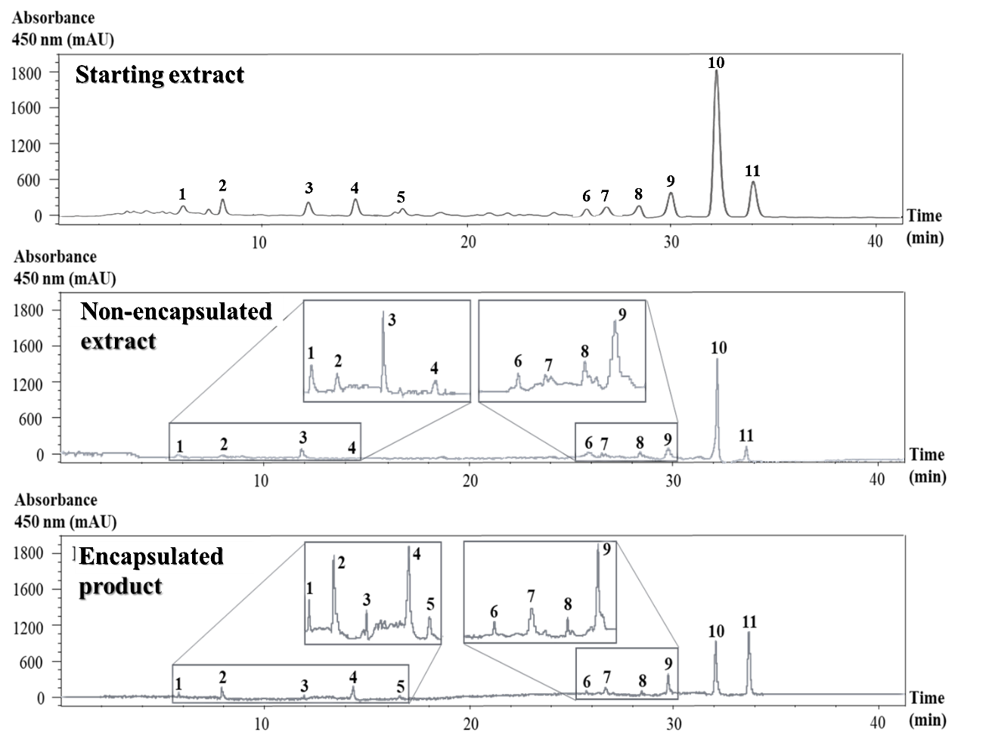
Figure S1. LC chromatogram of the carotenoids present in the starting D. salina UHP-SFE extract non-encapsulated fraction, and the encapsulated product after cryo-stirring microencapsulation process. For peak identification, see Table 1.

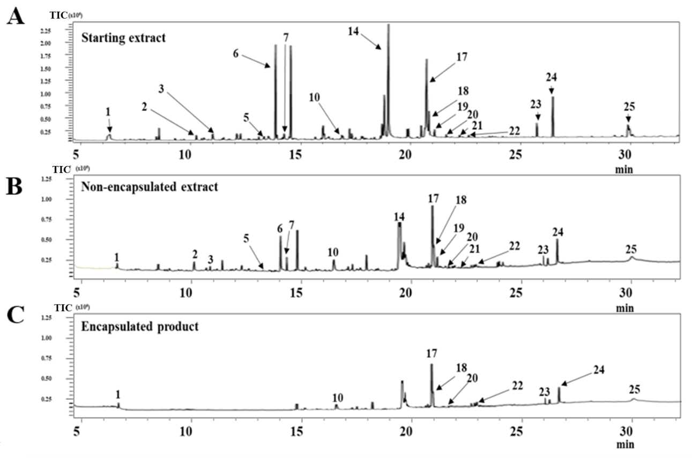
Figure S2. GC chromatograms of A) starting D. salina UHP-SFE extract, B) non-encapsulated fraction, and C) encapsulated product after cryo-stirring microencapsulation process with terpenoid identified peaks marked. For peak identification see Table 2.

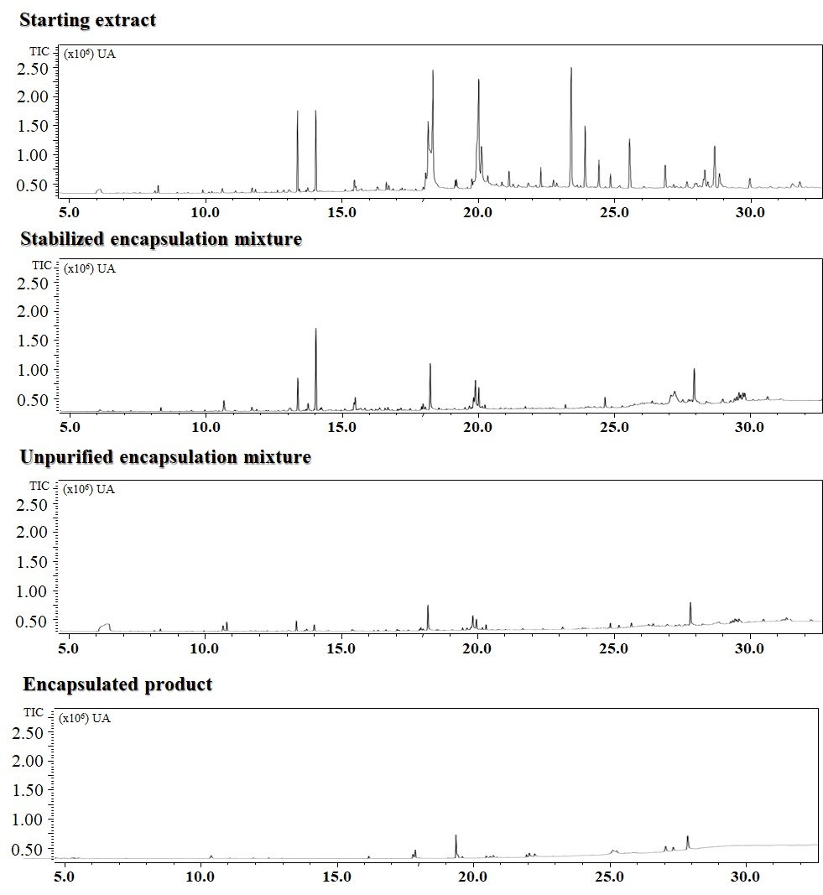
Figure S3. GC chromatograms of the starting D. salina extract and the different fractions obtained in each encapsulation step (for comparison of the peak areas see Table 3).

References.
Brand-Williams, W., Cuvelier, M.E., Bersetm C. Use of a Free Radical Method to Evaluate Antioxidant Activity. LWR-Food Science and Technology. Vol. 28 (1) (1995): pp. 25-30. https://doi.org/10.1016/S0023-6438(95)80008-5
Bueno, M., Vitali, C., Sánchez-Martínez, J.D., Mendiola, J.A., Cifuentes, A., Ibáñez, E., Herrero, M. Compressed CO₂ Technologues for the Recovery of Carotenoid-Enriched Extracts from Dunaliella salina with Potential neuroprotective activity. ACS Sustainable Chemical Engineering. Vol. 8 (2020): pp. 11413-11423. https://dx.doi.org/10.1021/acssuschemeng.0c03991?ref=pdf
Ou, B., Hampsch-Woodill, M., Prior, R.L. Development and validation of an improved oxygen radical absorbance capacity assay using fluorescein as the fluorescent probe. Journal of Agricultural Food Chemistry. Vol 49 (10) (2001): pp. 4619-4626. https://www.doi.org/ 10.1021/jf010586o
Plaza, M., Rodríguez-Meizoso, I. Advanced extraction processes to obtain bioactives from marine foods. Hernández-Ledesma, B., Herrero M. (Eds.), Bioactive Compounds fro Marine Foods: Plant and Animal Sources. John Wiley & Sons Ltd, Chichester, UK. (2013). Pp. 343-371.
Re, R., Pellegrini, N., Proteggente, A., Pannala, A., Yang, M., Rice-Evans, C. Antioxidant activity applying an improved ABTS radical cation decolorization assay. Free Radical Biology and Medicine. Vol. 26 (1999): pp. 9-10, https://www.doi.org/10.1016/S0891-5849(98)00315-3
Sánchez-Martínez, J.D., Alvarez-Rivera, G., Gallego, R., Fagundes, M.B., Valdés, A., Mendiola, J.A., Ibañez, E., Cifuentes, A. Neuroprotective potential of terpenoids-rich extracts from orange juice by-products obtained by pressurized liquid extraction. Food Chemistry: X. Vol. 13 (2022): 100242. https://www.doi.org/ 10.1016/j.fochx.2022.100242

