Supplementary Materials
Fig. S1. Opuntia ficus-indica var. Blanca fruits harvested from Buenavista del Norte (Tenerife, Canary Islands, Spain).
Table S1. Physicochemical characteristics of Opuntia ficus-indica var. Blanca Buenavista fruits. Data are expressed as means ± standard deviation.
Table S2. Composition of the digestive phases and enzymes used for the in vitro gastro-intestinal digestion assay by INFOGEST method.
Table S3. High Performance Liquid Chromatography retention times, UV/Vis spectra and MS spectral data of the main phenolic compounds identified in Opuntia ficus-indica var. Blanca peel extracts (OBB).
Table S4. Quantification of the main individual phenolic compounds present in Opuntia ficus-indica var. Blanca peel extract (OBB) and on Liposomes A and B with encapsulated OBB extract. Data are expressed as means ± standard deviation. Superscript letters indicate statistically significant differences between samples among each individual compound (p < 0.05).
Fig. S2. HPLC chromatograms of Opuntia ficus-indica var. Blanca peel extract (OBB) detected at 280 nm (phenolic acids) and 370 nm (flavonoids). Peak numbers are according to Table S3.
Table S5. Polydispersity index of Liposomes A and B with Opuntia ficus-indica var. Blanca peel extract (OBB) encapsulated and their respective controls without OBB extract (Control A and Control B) during conservation at 7ºC for 20 days. Values are expressed as mean ± standard deviation. Statistical analysis was performed using Tukey as a post hoc test. Superscript capital letters indicate statistically significant differences (p<0.05) between the different conservation days among each liposomal system, while superscript small letters indicate statistically significant differences between the different liposomal systems among each conservation time.
Table S6. Zeta potential (mV) values of liposomes A and B with Opuntia ficus-indica var. Blanca peel (OBB) encapsulated extract and Control, liposomes without encapsulated OBB extract. Values are expressed as mean ± standard deviation. Superscript capital letters indicate statistically significant differences (p<0.05) between the different conservation days among each liposomal system, while superscript small letters indicate statistically significant differences between the different liposomal systems among each conservation time.
Fig. S4. Confocal microscopy images of Liposome A with Opuntia ficus-indica var. Blanca peel extract (OBB) encapsulated and without extract (Control A) during in vitro gastro-intestinal digestion.
Table S7. Digestive stability (µg of compound/g dry weight) of the main phenolic compounds from Opuntia ficus-indica var. Blanca (OBB) peel extracts encapsulated on Liposome A during the different phases of in vitro digestion. Data are expressed as means ± standard deviation. Superscript letters indicate statistically significant differences (p < 0.05) among the different phases of each individual compound, separated by non-encapsulated OBB extract and Liposome A. 4-HAD: 4-Hydroxybenzoic acid derivative, QG1: quercetin glycoside I, QG2: quercetin glycoside II, IG1: isorhamnetin glucosyl-rhamnosyl-rhamnoside, IG2: isorhamnetin glucosyl-rhamnosyl-pentoside, IG7: Isorhamnetin hexoxyl-rhamnoside, KG1: kaempherol glucosyl-rhamnoside, IG5: isorhamnetin glucosyl-rhamnsoside.

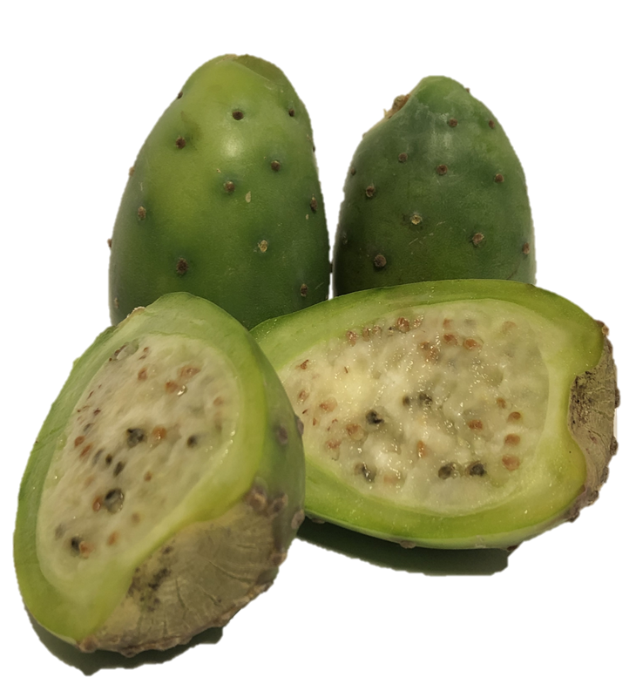
Fig. S1. Opuntia ficus-indica var. Blanca fruits harvested from Buenavista del Norte (Tenerife, Canary Islands, Spain).

Table S1. Physicochemical characteristics of Opuntia ficus-indica var. Blanca Buenavista fruits. Data are expressed as means ± standard deviation.
Opuntia ficus-indica var. Blanca Buenavista
Peel colour | Green
Pulp colour | White
Apical caliber (cm) | 5.9 ± 0.7
Equatorial caliber (cm) | 4.1 ± 1.2
Weight (g) | 92 ± 3.1
pH | 6.6 ± 0.1
Titratable acidity (%) | 0.01 ± 0.0
Soluble solids (Brixº) | 15.7 ± 0.1
Peel colour (CIELAB)
L* | 66.1 ± 4.3
a* | -21.8 ± 3.5
b* | 19.7 ± 2.9
Pulp colour (CIELAB)
L* | 67.9 ± 2.2
a* | -4.3 ± 0.7
b* | 11 ± 1.8

Table S2. Composition of the digestive phases and enzymes used for the in vitro gastro-intestinal digestion assay by INFOGEST method.
Simulated digestive phases at 1:1 (w/w)
Reagents | Stock | Simulated oral phase | Simulated gastric phase | Simulated intestinal phase
Reagents | Stock | % (v/v)
KCl | 0.5 M | 2 | 5.6 | 2.16
KH₂PO₄ | 0.5 M | 4 | 0.18 | 0.32
NaHCO₃ | 1 M | 0.8 | 2.6 | 17
NaCl | 2 M | 0.2 | 2 | 3.2
MgCl₂(H₂O)₆ | 0.15 M | 0.2 | 0.4 | 0.44
HCl | 1 M | 0.8 | 0.6 | 0.2
NaOH | 1 M | 0.2 | - | 0.32
MilliQ water | - | 91.8 | 88.62 | 76.36
pH |  | 6.8 | 1.3 | 8.2
Addition of enzyme % (v/v)
Amylase | 75 U/ml | 5 | - | -
Pepsine | 2500 U/ml | - | 4-8* | -
Lipase | 25 U/ml | - | 4 | -
Pancreatin | 100 U/ml | - | - | 12
Bile salt | 10 Mm | - | - | 6

Table S3. High Performance Liquid Chromatography retention times, UV/Vis spectra and MS spectral data of the main phenolic compounds identified in Opuntia ficus-indica var. Blanca peel extracts (OBB).
Peak nº | Retention time (min) | Compound | UV λ_{max} (nm) | [M+H] ⁺ | MS/MS (m/z) | Compound content  (ug/g BB extract)
1 | 3.337 | Piscidic acid isomer I | 228, 275 | 322.21 | 147.04, 119.05, 107.05, 91.05 | 4793 ± 356
2 | 10.464 | Piscidic acid | 232, 275 | 257.07 | 191.07, 147.04, 119.05, 107.05 | 76947 ± 357
3 | 33.214 | 4-Hydroxybenzoic acid derivative (4-HAD) | 274 | 205.05 | 161.06, 131.05, 115.05, 105.07 | 298 ± 17
4 | 37.285 | Quercetin glycoside I (QG1) | 266, 351 | 426.24 | 303.05, 191.07, 120.08 | 124 ± 3.5
5 | 38.363 | Quercetin glycoside II (QG2) | 269, 350 | 653.28 | 303.05, 177.05 | 1132 ± 21
6 | 40.819 | Isorhamnetin glucosyl-rhamnosyl-rhamnoside (IG1) | 254, 354 | 771.23 | 625.18, 317.07, 85.03 | 203 ± 1.2
7 | 42.368 | Isorhamnetin glucosyl-rhamnosyl-pentoside (IG2) | 253, 354 | 757.22 | 317.07, 167.07, 86.10 | 125 ± 4.3
8 | 42.913 | Isorhamnetin hexosyl-rhamnoside (IG7) | 255, 355 | 625.53 | 479.12, 317.07 | 1058 ± 73
9 | 43.478 | Kaempherol glucosyl-rhamnoside (KG1) | 262, 351 | 595.17 | 287.06 | 202 ± 6.4
10 | 44.158 | Isorhamnetin glucosyl-rhamnoside (IG5) | 253, 354 | 625.18 | 317.07, 85.03 | 86 ± 9.0

Table S4. Quantification of the main individual phenolic compounds present in Opuntia ficus-indica var. Blanca peel extract (OBB) and on Liposomes A and B with encapsulated OBB extract. Data are expressed as means ± standard deviation. Statistical analysis was performed using Tukey as a post hoc test. Superscript letters indicate statistically significant differences between samples among each individual compound (p < 0.05).
Compound | Compound content (μg compound/g dry weight)
Compound | OBB extract | Liposome A | Liposome B
Piscidic acid isomer I | 4,793 ± 356ª | 4,106 ± 282^{ab} | 3,274 ± 612^{b}
Piscidic acid | 76,947 ± 387ª | 67,469 ± 576^{b} | 63,120 ± 628^{c}
4-Hydroxybenzoic acid derivative | 298 ± 17ª | 263 ± 14^{ab} | 215 ± 36^{b}
Quercetin glycoside I (QG1) | 124 ± 4ª | 122 ± 3ª | 112 ± 4^{b}
Quercetin glycoside II (QG2) | 1,132 ± 21ª | 929 ± 56ª | 625 ± 139^{b}
Isorhamnetin glucosyl-rhamnosyl-rhamnoside (IG1) | 203 ± 1ª | 194 ± 3^{b} | 175 ± 3^{c}
Isorhamnetin glucosyl-rhamnosyl-pentoside (IG2) | 125 ± 4ª | 113 ± 3ª | 94 ± 6^{b}
Isorhamnetin hexosyl-rhamnoside (IG7) | 1,058 ± 73ª | 950 ± 75ª | 915 ± 63ª
Kaempherol glucosyl-rhamnoside (KG1) | 202 ± 6ª | 168 ± 21^{ab} | 141 ± 18^{b}
Isorhamnetin glucosyl-rhamnoside (IG5) | 86 ± 9ª | 76 ± 11ª | 64 ± 7ª

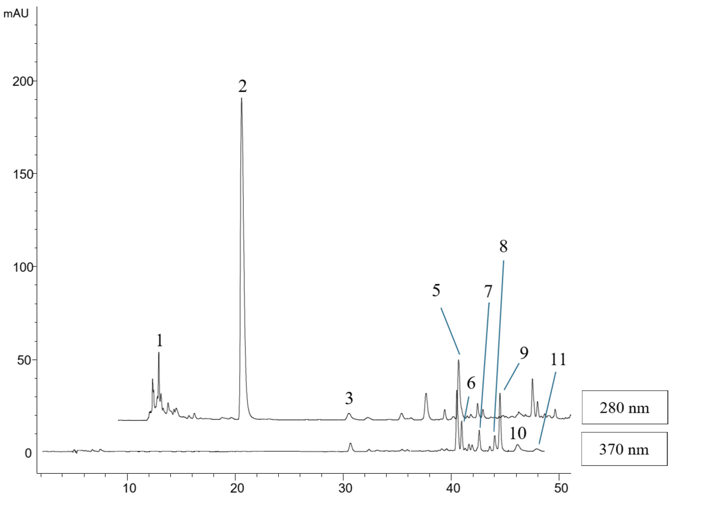
Fig. S2. HPLC chromatograms of Opuntia ficus-indica var. Blanca peel extract detected at 280 nm (phenolic acids) and 370 nm (flavonoids). Peak numbers are according to Table S2.

Table S5. Polydispersity index of Liposomes A and B with Opuntia ficus-indica var. Blanca peel extract (OBB) encapsulated and their respective controls without OBB extract (Control A and Control B) during conservation at 7ºC for 20 days. Values are expressed as mean ± standard deviation. Statistical analysis was performed using Tukey as a post hoc test. Superscript letters indicate statistically significant differences (p<0.05) between the different conservation days among each liposomal system.
Conservation | Polydispersity index
Conservation | Control A | Control B | Liposome A | Liposome B
Day 0 | 0.2 ± 0.01ª | 0.29 ± 0.04^{ab} | 0.25 ± 0.01ª | 0.38 ± 0.02ª
Day 1 | 0.2 ± 0.07ª | 0.26 ± 0.01^{b} | 0.25 ± 0.02ª | 0.39 ± 0.05ª
Day 3 | 0.21 ± 0.02ª | 0.24 ± 0.03^{b} | 0.27 ± 0.03ª | 0.39 ± 0.07ª
Day 6 | 0.22 ± 0.04ª | 0.34 ± 0.04^{ab} | 0.26 ± 0.05ª | 0.47 ± 0.03ª
Day 10 | 0.24 ± 0.1ª | 0.41 ± 0.02ª | 0.31 ± 0.04ª | 0.45 ± 0.1ª
Day 15 | 0.25 ± 0.02ª | 0.39 ± 0.03^{ab} | 0.34 ± 0.01ª | 0.47 ± 0.07ª
Day 20 | 0.22 ± 0.02ª | 0.41 ± 0.03ª | 0.35 ± 0.05ª | 0.52 ± 0.02ª

Table S6. Zeta potential (mV) values of liposomes A and B with Opuntia ficus-indica var. Blanca peel (OBB) encapsulated extract and Control, liposomes without encapsulated OBB extract. Values are expressed as mean ± standard deviation. Statistical analysis was performed using Tukey as a post hoc test. Superscript capital letters indicate statistically significant differences (p<0.05) between the different conservation days among each liposomal system.
Conservation | Zeta Potential (mV)
Conservation | Control A | Control B | Liposome A | Liposome B
Day 0 | -21.1 ± 2.8^{b} | -18.2 ± 1.4^{ab} | -22.5 ± 1.3ª | -20.8 ± 0.9ª
Day 1 | -21.9 ± 1.2^{ab} | -16.5 ± 0.8^{b} | -23.3 ± 5.6ª | -21.8 ± 0.5aª
Day 3 | -20.5 ± 1.3^{ab} | -16.9 ± 0.3^{ab} | -22.8 ± 2.9ª | -17.6 ± 0.5^{ab}
Day 6 | -24.3 ± 2.7ª | -19.7 ± 0.3ª | -24.1 ± 1.5ª | -15.2 ± 4.7^{c}
Day 10 | -20.4 ± 0.9^{ab} | -18.9 ± 1.3^{ab} | -24.2 ± 1.5ª | -20.6 ± 0.4^{ab}
ºDay 15 | -23.3 ± 1.7^{ab} | -18.4 ± 0.6^{ab} | -23.8 ± 3ª | -19.4 ± 0.5ª
Day 20 | -22.4 ± 0.7ª | -18.9 ± 2.3^{ab} | -20.8 ± 3.4ª | -16.7 ± 2.1^{b}

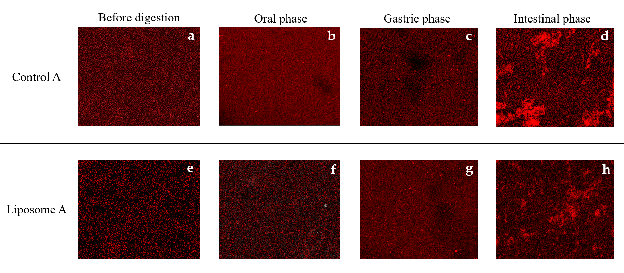
Fig. S4. Confocal microscopy images of Liposome A with Opuntia ficus-indica var. Blanca peel extract (OBB) encapsulated and without extract (Control A) during in vitro gastro-intestinal digestion.

Table S7. Digestive stability (µg of compound/g dry weight) of the main phenolic compounds from Opuntia ficus-indica var. Blanca (OBB) peel extracts encapsulated on Liposome A during the different phases of in vitro digestion. Data are expressed as means ± standard deviation. Statistical analysis was performed using Tukey as a post hoc test. Superscript letters indicate statistically significant differences (p < 0.05) among the different phases of each individual compound, separated by non-encapsulated OBB extract and Liposome A. 4-HAD: 4-Hydroxybenzoic acid derivative, QG1: quercetin glycoside I, QG2: quercetin glycoside II, IG1: isorhamnetin glucosyl-rhamnosyl-rhamnoside, IG2: isorhamnetin glucosyl-rhamnosyl-pentoside, IG7: Isorhamnetin hexoxyl-rhamnoside, KG1: kaempherol glucosyl-rhamnoside, IG5: isorhamnetin glucosyl-rhamnsoside.
Digestive Stability (μg compound/g d.w.)
Compound | Non-Encapsulated OBB Extract |  |  |  | Liposome A
Compound | Non-Digested Extract | Oral  Phase | Gastric  Phase | Intestinal Phase | Non-Digested Liposome | Oral  Phase | Gastric  Phase | Intestinal Phase
Piscidic acid isomer I | 4793 ± 356ª | 4220 ± 798ª | 3531 ± 700ª | 1794 ± 650^{b} | 4106 ± 282ª | 3762 ± 437ª | 3357 ± 265^{ab} | 2894 ± 279^{b}
Piscidic acid | 76,947 ± 357ª | 76,093 ± 468ª | 52,931 ± 6031^{b} | 36,075 ± 2141^{c} | 67,469 ± 576^{b} | 72,003 ± 1106ª | 65,462 ± 2084^{b} | 59,674 ± 2468^{c}
4-HAD | 298 ± 17ª | 295 ± 22ª | 219 ± 36^{b} | 152 ± 8^{c} | 263 ± 14ª | 247 ± 11^{ab} | 193 ± 53^{ab} | 172 ± 16^{b}
QG1 | 124 ± 4ª | 115 ± 9ª | 111 ± 6ª | 82 ± 11^{b} | 122 ± 3ª | 115 ± 15ª | 109 ± 18^{ab} | 78 ± 6^{b}
QG2 | 1132 ± 21ª | 1187 ± 40ª | 878 ± 75^{b} | 426 ± 41^{c} | 929 ± 56^{ab} | 1037 ± 57ª | 840 ± 33^{bc} | 730 ± 53^{c}
IG1 | 203 ± 1ª | 177 ± 2ª | 133 ± 17^{b} | 61 ± 15^{c} | 194 ± 3ª | 174 ± 17^{ab} | 169 ± 16^{ab} | 150 ± 7^{b}
IG2 | 125 ± 4ª | 115 ± 15ª | 84 ± 10^{b} | 53 ± 8ª | 113 ± 3ª | 109 ± 11ª | 95 ± 9^{ab} | 86 ± 9^{b}
IG7 | 1058 ± 73ª | 1105 ± 29ª | 872 ± 70^{b} | 474 ± 19^{c} | 950 ± 75ª | 873 ± 43ª | 763 ± 45^{bc} | 704 ± 43^{c}
KG1 | 202 ± 6ª | 169 ± 30ª | 157 ± 15^{b} | 86 ± 5^{c} | 168 ± 21ª | 153 ± 10ª | 129 ± 6ª | 129 ± 19ª
IG5 | 86 ± 9ª | 76 ± 12ª | 38 ± 2^{b} | 34 ± 8^{b} | 76 ± 11ª | 73 ± 14ª | 53 ± 3^{ab} | 43 ± 1^{b}

