Table S1: Antibiotics sensitivity of Pseudomonas aeruginosa (PAO1)
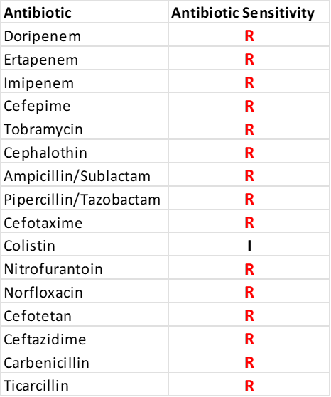

R: Resistant
S : Sensitive
I : Intermediate

