Supplementary data

Enhancing the water resistance of carboxymethyl cellulose films with cellulose nanofibers from spent coffee grounds and grapeseed oil
Lilah Saidi ª, Muhammad Bin Zia ª, Amy Gullins ª, Yong Wang ª, Peter Richard Wich ^{a b}, Cordelia Selomulya ª

ªSchool of Chemical Engineering, University of New South Wales, Sydney, NSW 2052, Australia
^{b}Australian Centre for NanoMedicine, University of New South Wales, Sydney, NSW 2052, Australia

Food and Bioprocess Technology

Corresponding author: cordelia.selomulya@unsw.edu.au (C.S.)

1. Materials and Methods

1.1. Measurement of film thickness
The film thickness was determined from the average of six measurements for each film with a hand-held digital micrometer (EVERTE digital micrometer, Bonthe Corp, China) with an accuracy of ±0.001 mm. The mean average film thickness was used for assessing water vapor permeability and mechanical properties.

1.2. Measurement of viscosity of the film-forming solutions
The viscosity of film-forming solutions was measured to determine the flow rheology of the solutions prior to casting. A Controlled Strain Rheometer (ARES-G2, TA Instrument, USA) and software supplied by TA-Trios were used. All measurements were performed at 25 ± 0.1 °C and in triplicate. The flow tests were carried out using a cone-plate geometry (diameter = 40 mm, cone angle = 2 degrees) with a truncation gap of 0.046 mm. Viscosity as a function of the shear rate was determined in the range of 0.1-100 s⁻¹. Samples were individually loaded on the measuring geometry. The correlation between viscosity (Pa·s) and shear rate (s⁻¹) was fitted using the power-law model, evaluating the apparent viscosity (Pa·s) at the tested shear rate range (0.1-100 s⁻¹):
$Apparent viscosity (Pa·s)=k*shear rate({s^{-1})}^{n-1}$ (1)
Where k is the consistency index (Pa·s^{n}) and n is the dimensionless flow behavioral index.

1.3. Measurement of chemical bonds characteristics
Fourier Transform Infrared (FTIR) Spectroscopy analysis was performed using a Fourier-transform infrared spectrometer (Alpha ATR-FTIR, BRUKER, Germany), at room temperature (25 ± 2 °C). The film samples were immersed in liquid nitrogen and placed in a freeze dryer overnight (Buchi Lyovapor L-200, Flawil, Switzerland). The films were scanned at 4 cm⁻¹ resolution, 400–4000 cm⁻¹ wavenumber frequency, and 32 scans were performed per sample, using air as a blank (Sutharsan, Boyer, and Zhao 2022).

1.4. Measurement of creaming index
The emulsion stability of oil-containing film-forming solution was tested by evaluating the creaming index following a method by Liu et al. with minor changes (Liu et al. 2025). Briefly, the oil-containing film-forming solutions were placed in glass bottles at room temperature. Samples of CMC, without CNFs, with oil concentrations of 0.025, 0.05, and 0.1% w/w were measured as the control; CMC-0.025, CMC-0.05, and CMC-0.1, respectively. The creaming index was measured using a digital caliper on days 0, 2, 4, and 6, and calculated according to the following equation:
$Creaming index=(\frac{H_{0}}{H}) ×100\%$ (S1)
Where H₀ and H represent the precipitation layer height and the overall height, respectively.

2. Supporting Figures
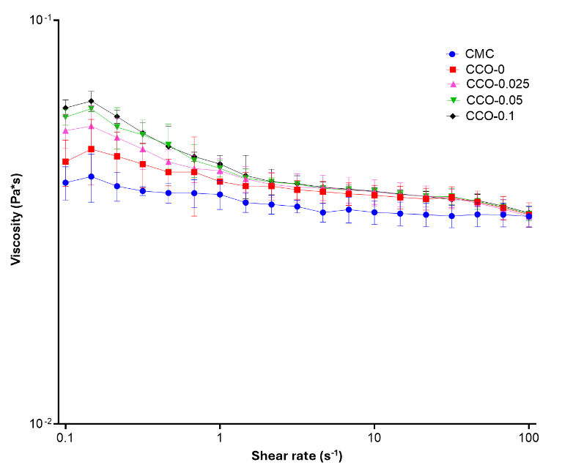
Fig. S1 Viscosity curve versus shear rate at 25 °C for all examined samples; Carboxymethyl cellulose (CMC), CMC with cellulose nanofibers (CNFs) (CCO-0), and CMC/CNFs with 0.025, 0.05, and 0.1 oil concentration wt% (CCO-0.025, CCO-0.05, and CCO-0.1, respectively)
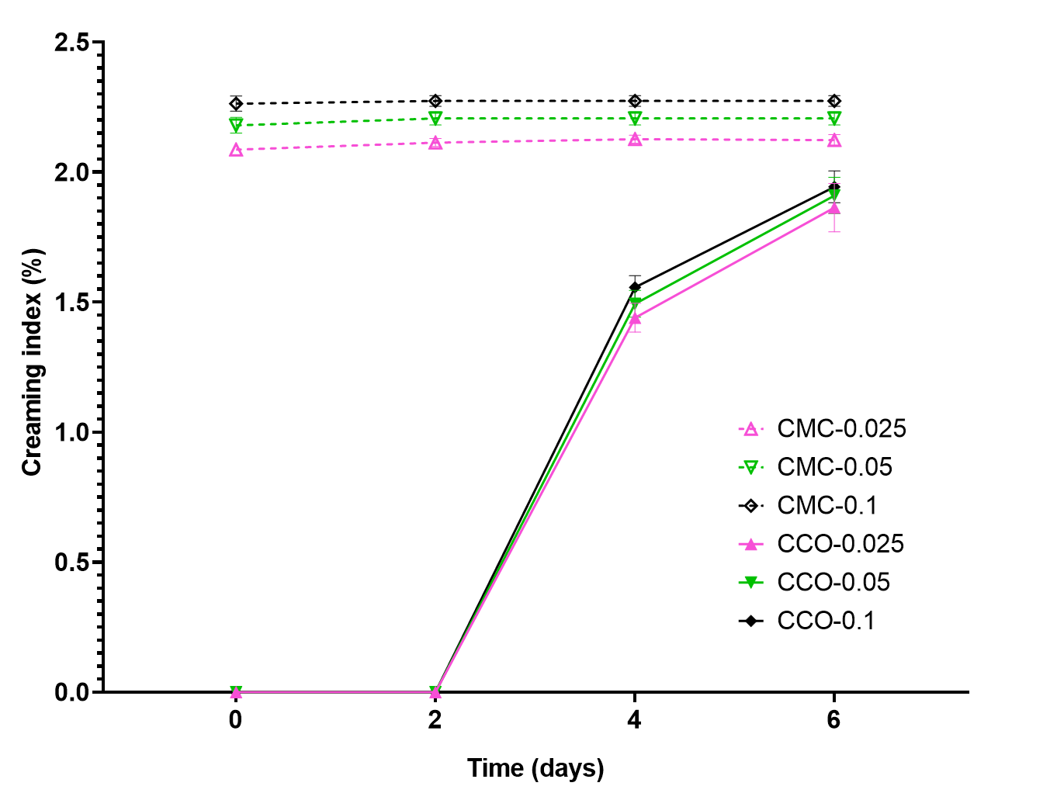
Fig. S2 The effect of CNFs on the creaming index (%) in oil-containing samples with and without CNFs samples; Carboxymethyl cellulose (CMC) with 0.025, 0.05, and 0.1 wt% oil (CMC-0.025, CMC-0.05, and CMC-0.1, respectively) and CMC with CNFs and 0.025, 0.05, and 0.1 wt% oil (CCO-0.025, CCO-0.05, and CCO-0.1, respectively)
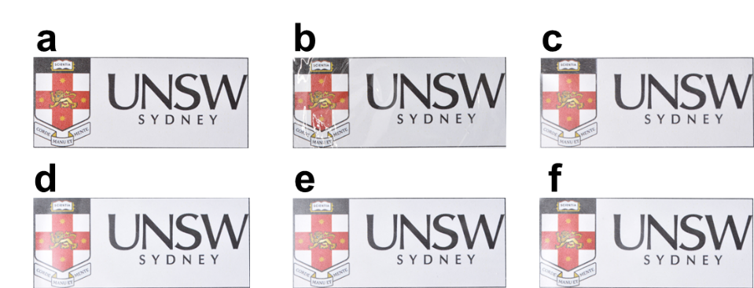
Fig. S3 Optical images of the films prepared: (a) No film (b) CMC, (c) CCO-0, (d) CCO-0.025, (e) CCO-0.05, (f) CCO-0.1
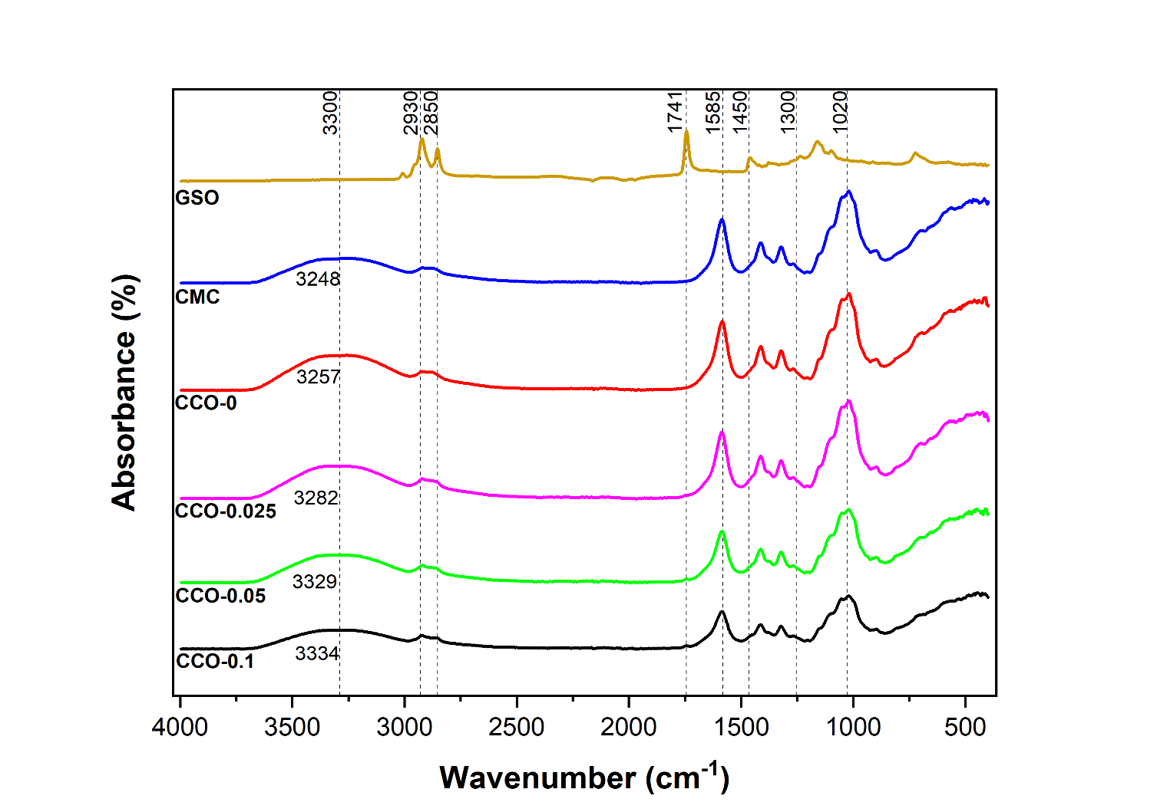
Fig. S4 Fourier transform infrared spectra of grapeseed oil (GSO), carboxymethyl cellulose (CMC), CMC with cellulose nanofibers (CNFs) (CCO-0), and CMC/CNFs with 0.025, 0.05, and 0.1 oil concentration wt% (CCO-0.025, CCO-0.05, and CCO-0.1, respectively)
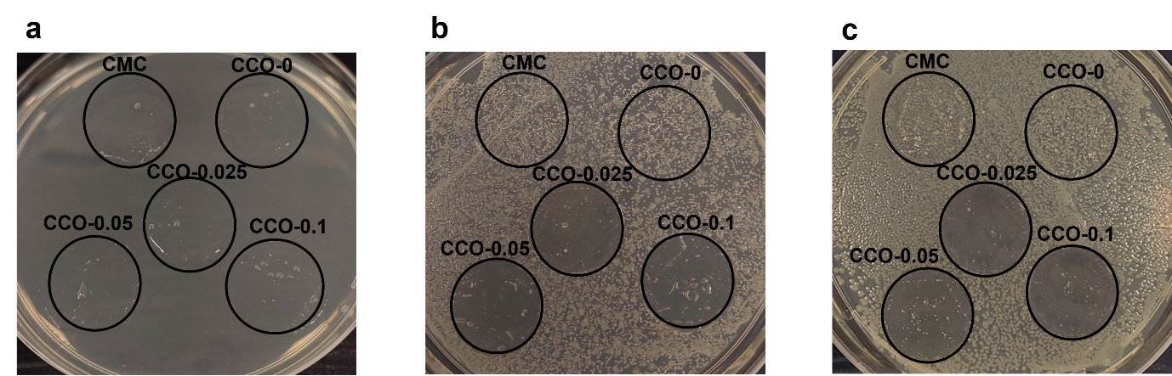
Fig. S5 The bacterial inhibition zone effects of the tested film discs on (a) blank non-inoculated plate (b) S. aureus and (c) E. coli; Carboxymethyl cellulose (CMC), CMC with cellulose nanofibers (CNFs) (CCO-0), and CMC/CNFs with 0.025, 0.05, and 0.1 oil concentration wt% (CCO-0.025, CCO-0.05, and CCO-0.1, respectively)

3. Supporting Table
Table S1: Consistency index (k) and flow behavior index (n) from the Power-Law model (Eq. (1)) of film-forming solutions.
Film-forming solution | k (Pa·s^{n}) | n | R²
CMC | 0.036±0.003^{b} | 0.969±0.006ª | 0.993
CCO-0 | 0.042±0.003^{ab} | 0.961±0.019ª | 0.988
CCO-0.025 | 0.046±0.002ª | 0.956±0.029ª | 0.973
CCO-0.05 | 0.047±0.003ª | 0.926±0.025ª | 0.967
CCO-0.1 | 0.048±0.003ª | 0.918±0.012ª | 0.964

* Mean ± standard deviation values in the same column denoted with common superscript lowercase letters do not differ from each other (P > 0.05).
Table S2: The volume distribution based on D₁₀, D₅₀, and D₉₀ values.
Film-forming solution | D₁₀ | D₅₀ | D₉₀
CCO-0.025 | 0.12±0.025ª | 6.29±0.32ª | 14.58±0.51ª
CCO-0.05 | 0.08±0.01^{b} | 3.67±0.36^{b} | 13.17±0.28^{b}
CCO-0.1 | 0.07±0.01^{b} | 2.02±0.11^{c} | 11.47±0.43^{c}

* Mean ± standard deviation values in the same column denoted with common superscript lowercase letters do not differ from each other (P > 0.05).

References
Sutharsan, J., Boyer, C. A. & Zhao, J. (2022). Physicochemical properties of chitosan edible films incorporated with different classes of flavonoids. Carbohydrate Polymer Technologies and Applications, 4, 100232.
Liu, S., Wang, Z., Yang, W., Huang, T., Geng, J.T., Wei, H., Gao, Y. & Jia, R. (2025). Carboxymethyl chitosan-assisted formation of stable soy protein isolate emulsions and their impact on the properties of squid (Dosidicus gigas) surimi gel. Food Hydrocolloids, 158, 110528.

