Supplementary material for:
Sustainable Leaf Protein Concentrate from Cauliflower Leaves via Ultrasonication-Assisted Extraction and Sieve Filtration

Kinjal A. Furia, Peter J. Torley, Mahsa Majzoobi, Asgar Farahnaky

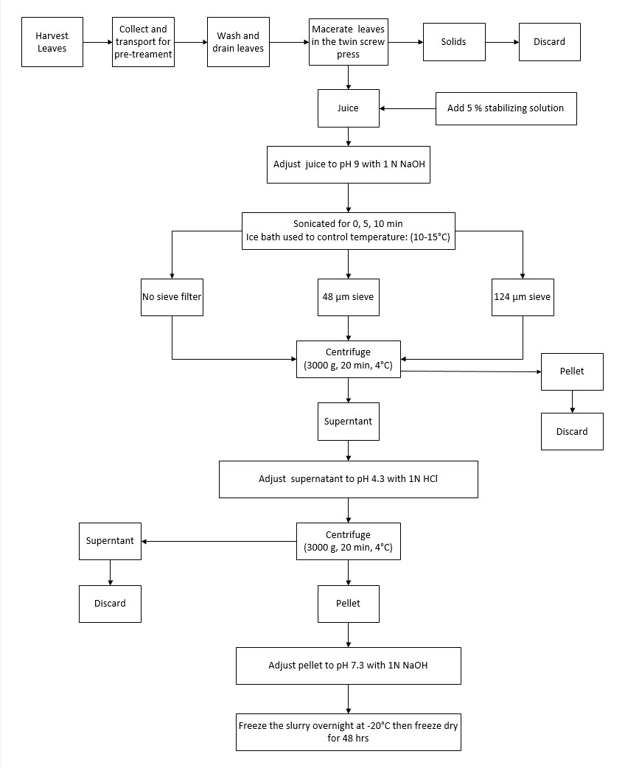

Fig. S1. Process flow diagram of ultrasound-assisted extraction of cauliflower leaf protein concentrates.
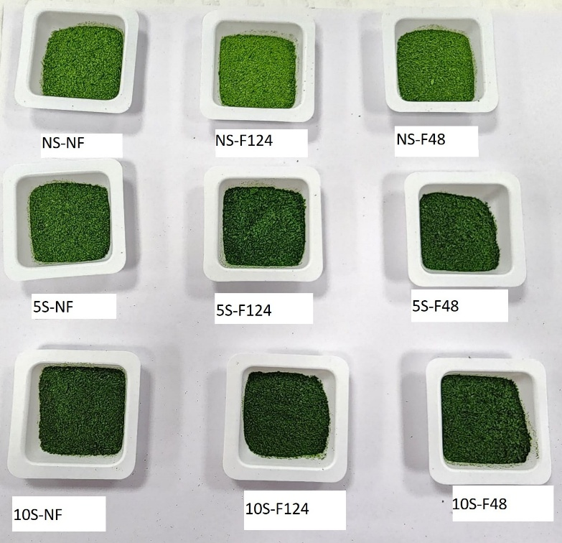
Fig. S2. The appearance of cauliflower leaf protein concentrates prepared with different combinations of sonication time (0 min, NS; 5 min, 5S; and 10 min, 10S) and sieve treatment (non-sieve filtered, NF; 124 µm sieve, F124; 48 µm sieve, F48).

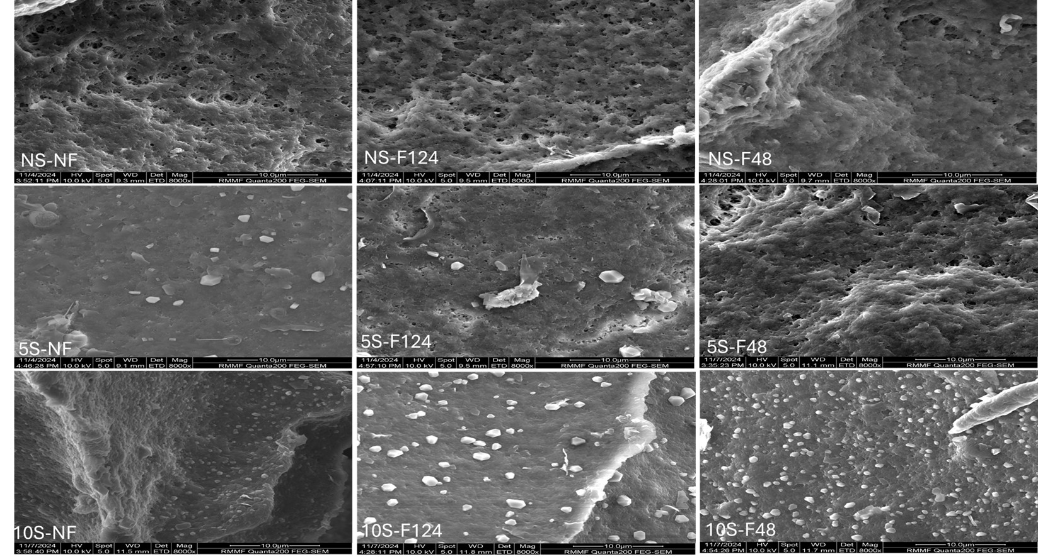
Fig. S3. SEM images of cauliflower leaf protein concentrates (LPC) at 8000x magnification.
Table S1: Protein solubility (%) of cauliflower leaf protein concentrates treated with different combinations of sonication time (0 min, NS; 5 min, 5S; and 10 min, 10S) and sieve treatment (non-sieve filtered, NF; 124 µm sieve, F124; 48 µm sieve, F48).
Samples | pH 4 (%) | pH 7 (%) | pH 9 (%)
Sieve filtration * Sonication time
NS-NF | 10.45 ± 0.12 ^{b c} | 12.40 ± 1.04 ª | 19.32 ± 0.79 ª ^{b c}
NS-F124 | 8.06 ± 0.46 ª | 12.29 ± 1.92 ª | 16.88 ± 0.84ª
NS-F48 | 8.33 ± 0.52ª ^{b} | 13.40 ± 0.53 ª ^{b} | 17.26 ± 0.74 ^{b c}
5S-NF | 10.79 ± 0.97 ^{c d} | 18.01 ± 0.53 ^{c d} | 23.12 ± 1.35 ^{c d}
5S-F124 | 10.33 ± 0.13ª ^{b c} | 15.91 ± 0.52 ^{b c} | 19.02 ± 0.95 ª ^{b c}
5S-F48 | 11.28 ± 0.32 ^{c d} | 15.34 ± 0.66 ª ^{b c} | 21.32 ± 0.98 ^{b c d}
10S-NF | 16.03 ± 0.77 ^{f} | 23.31 ± 1.34e | 32.00 ± 2.03 ^{e}
10S-F124 | 13.09 ± 1.42 ^{d e} | 17.57 ± 0.81^{c d} | 22.84 ± 1.89 ^{c d}
10S-F48 | 14.84 ± 1.32 ^{e f} | 19.18 ± 1.74 ^{d} | 23.70 ± 2.33 ^{d}
Sieve filtration
NF | 12.42 ± 2.77 ^{b} | 17.91± 4.80 ^{b} | 24.82 ± 5.78 ^{b}
F124 | 10.49 ± 2.31 ª | 15.25 ± 2.57 ª | 19.58 ± 2.85 ª
F48 | 11.48 ± 2.91 ^{b} | 15.97 ± 2.72 ª | 20.76 ± 3.11 ª
Sonication time
NS | 8.94 ± 1.19 ª | 12.69 ± 1.24 ª | 17.82 ± 1.33 ª
5S | 10.80 ± 0.65 ^{b} | 16.42 ± 1.31 ^{b} | 21.16 ± 2.02 ^{b}
10S | 14.65 ± 1.65 ^{c} | 20.02 ± 2.82 ^{c} | 26.18 ± 4.74 ^{c}
ANOVA
Sieve filtration | <0.001 | <0.001 | <0.001
Sonication time | <0.001 | <0.001 | <0.001
Sieve filtration * Sonication time | 0.046 | 0.002 | 0.003
^{a,b, c, d, e, f} Within a column, values that do not share a common superscript letter are significantly different (P<0.05). Values reported are mean ± standard deviation; the values are an average of n= 3.

Table S2: Thermal properties (onset, endset and peak temperature; and enthalpy) of dried cauliflower leaf protein concentrates treated with different combinations of sonication time (0 min, NS; 5 min, 5S; and 10 min, 10S) and sieve treatment (non-sieve filtered, NF; 124 µm sieve, F124; 48 µm sieve, F48).
Samples | Temperature (°C) |  |  | Enthalpy (J/g)  (∆H)
Samples | Onset | Endset | Peak | Enthalpy (J/g)  (∆H)
Sieve filtration * Sonication time
NS-NF (control) | 55.04 ± 1.59 ª | 69.21 ± 1.38 ª | 61.92 ± 0.52 ª | 0.10 ± 0.02 ª
NS-F124 | 54.46 ± 0.50 ª | 68.40 ± 0.64 ª | 61.63 ± 0.36 ª | 0.23 ± 0.02 ^{b c}
NS-F48 | 55.80 ± 0.07 ª | 68.84 ± 0.14 ª | 62.55 ± 0.32 ª | 0.23 ± 0.02 ^{b c}
5S-NF | 55.96 ± 0.15 ª | 68.58 ± 0.42 ª | 62.05 ± 0.18 ª | 0.17 ± 0.01 ^{a b}
5S-F124 | 55.58 ± 0.23 ª | 69.35 ± 0.99 ª | 62.15 ± 0.26 ª | 0.28 ± 0.06 ^{b c}
5S-F48 | 55.61 ± 0.29 ª | 69.18 ± 0.78 ª | 62.46 ± 0.30 ª | 0.25 ± 0.35 ^{b c}
10S-NF | 56.52 ± 0.90 ª | 67.64 ± 0.18 ª | 61.90 ± 0.45 ª | 0.10 ± 0.02 ª
10S-F124 | 56.03 ± 0.30 ª | 69.39 ± 0.64 ª | 62.10 ± 0.53 ª | 0.30 ± 0.05 ^{c}
10S-F48 | 56.42 ± 0.36 ª | 69.51± 0.21 ª | 62.56 ± 0.39 ª | 0.26 ± 0.05^{b c}
Sieve filteration
NF | 55.84 ± 0.90 ª | 68.48 ± 1.02 ª | 61.96 ± 0.34 ª | 0.12 ± 0.04 ª
F124 | 55.36 ± 0.62 ª | 69.09 ± 0.73 ª | 61.76 ± 0.43 ª | 0.27 ± 0.05 ^{b}
F48 | 55.94 ± 0.47 ª | 69.18 ± 0.49 ª | 62.52 ± 0.28 ^{b} | 0.25 ± 0.03 ^{b}
Sonication time
NS | 55.10 ± 1.01 ª | 68.82 ± 0.84 ª | 62.03 ± 0.53 ª | 0.19 ± 0.67 ª
5S | 55.71 ± 0.27 ^{a b} | 69.05 ± 0.75 ª | 62.22 ± 0.28 ª | 0.23 ± 0.05 ª
10S | 56.32 ± 0.55 ^{b} | 68.84 ± 0.97 ª | 62.18 ± 0.49 ª | 0.22 ± 0.10 ª
ANOVA
Sieve filtration | 0.168 | 0.779 | 0.008 | <0.001
Sonication time | 0.004 | 0.116 | 0.548 | 0.055
Sieve filtration * sonication time | 0.484 | 0.048 | 0.648 | 0.197
^{a,b,c} within a column, values that do not share a common superscript letter are significantly different (P<0.05). Values reported are mean ± standard deviation; the values are an average of n=3

