Fig. S1: Representative flow cytometry dot plot of PI vs SYTO-9 of LP, and LPPs obtained using different TS treatments. Four quadrants can be observed, including LR (PI‒ and SYTO-9+), UR (PI+ and SYTO-9+), UL (PI+ and SYTO-9‒), and LL (PI‒ and SYTO-9‒), indicating viable cells, inactivated cells, compromised cells, and cell debris, respectively.

LP (probiotic)
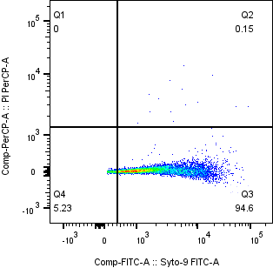

TS treatment #1)
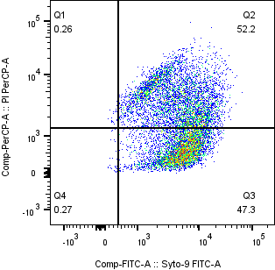

TS treatment #2)
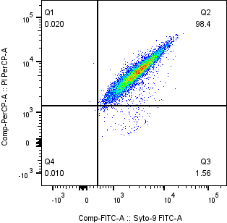

TS treatment #3)
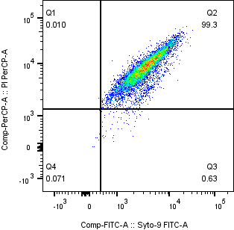

TS treatment #4)
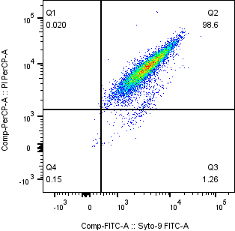

TS treatment #5)
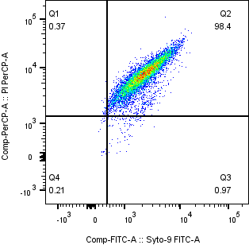

TS treatment #6)
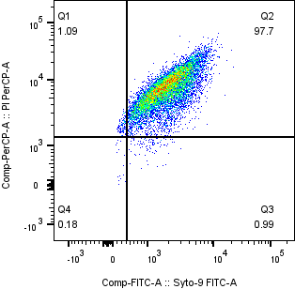

TS treatment #7)
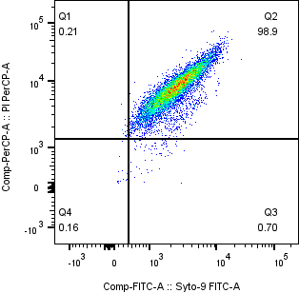

TS treatment #8)
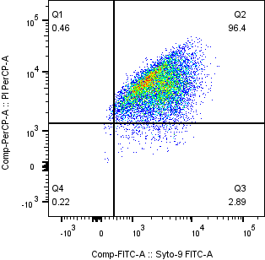

TS treatment #9)
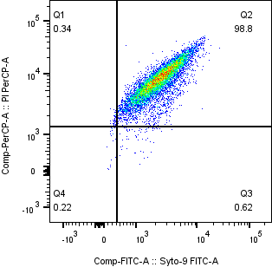

TS treatment #10)
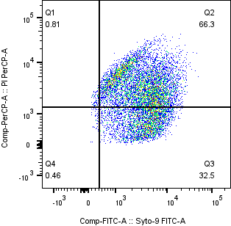

TS treatment #11)
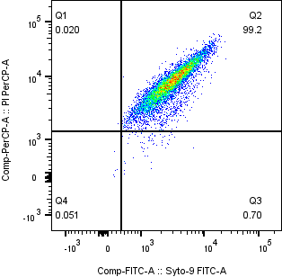

TS treatment #12)
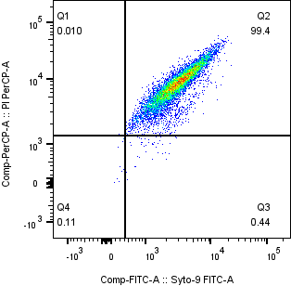
TS treatment #13)

TS treatment #14)
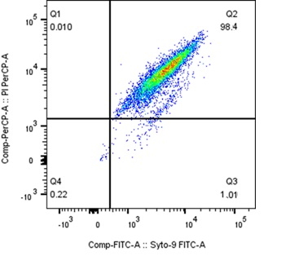

TS treatment #15)
