SUPPLEMENTARY MATERIAL
Figure 1S - Variation of ozone concentration (mean ± standard error) during filling of the incorporation tank (a) and ozone decomposition in the water in the immersion tank (b) for input concentrations equal to 15.77; 25.18 and 37.20 mg L⁻¹.
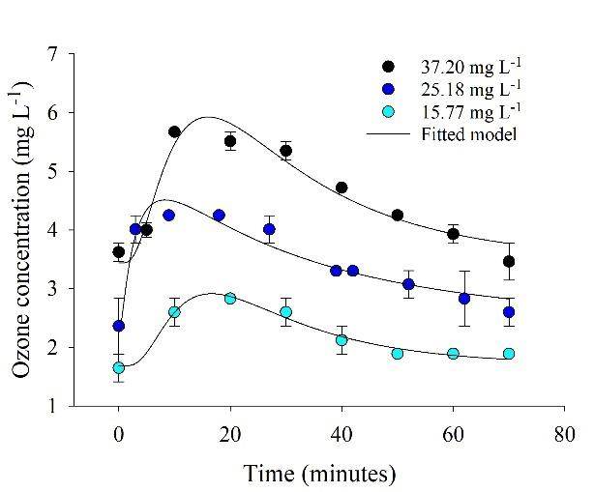 | 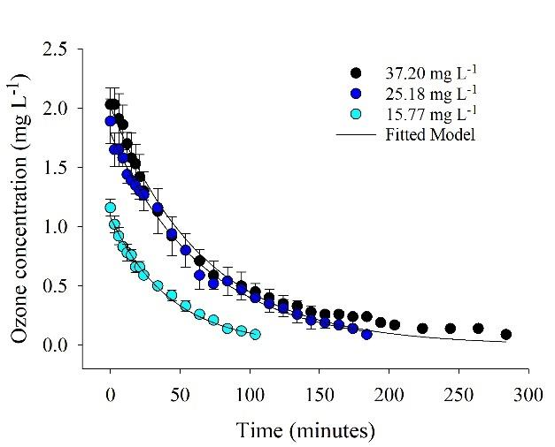
(a) | (b)
Figure 2S - Adjusted first-order reaction kinetic models for the decay of ozone concentration in the immersion tank for inlet concentrations equal to 15.77; 25.18 and 37.20 mg L⁻¹.
