Hybrid cryogels based on pectin and cassava and arrowroot starches: process optimization and physicochemical, morphological, rheological and thermal properties

Igor Henrique de Lima Costa^{a*}, Gabriela de Oliveiraª, Bruna da Fonseca Antunesª; Elder Pacheco da Cruzª, Elessandra da Rosa Zavarezeª and Alvaro Renato Guerra Diasª

ª Laboratory of Biopolymers and Nanotechnology in Food (BioNano), Graduate Program in Food Science and Technology, Department of Agroindustrial Science and Technology, Federal University of Pelotas, 96010-900, Pelotas, RS, Brazil

*Corresponding author: igorhenr.98@gmail.com (I.H.L. Costa); Tel: 55+ 83 999376746
Supplementary Table 1. Complete planning of type 2⁴ for screening variables in the processing of cryogels based on pectin and cassava starch.
Number of experiments | Decoded levels |  |  |  | Coded levels |  |  |  | WAC (%)
Number of experiments | CS (%) | P (%) | HS (rpm) | t (min) | CS | P | HS | t | WAC (%)
1 | 4 | 2 | 11000 | 2 | -1 | -1 | -1 | -1 | 0.00
2 | 6 | 2 | 11000 | 2 | +1 | -1 | -1 | -1 | 0.00
3 | 4 | 4 | 11000 | 2 | -1 | +1 | -1 | -1 | 772.89
4 | 6 | 4 | 11000 | 2 | +1 | +1 | -1 | -1 | 1039.64
5 | 4 | 2 | 20000 | 2 | -1 | -1 | +1 | -1 | 0.00
6 | 6 | 2 | 20000 | 2 | +1 | -1 | +1 | -1 | 0.00
7 | 4 | 4 | 20000 | 2 | -1 | +1 | +1 | -1 | 0.00
8 | 6 | 4 | 20000 | 2 | +1 | +1 | +1 | -1 | 0.00
9 | 4 | 2 | 11000 | 5 | -1 | -1 | -1 | +1 | 0.00
10 | 6 | 2 | 11000 | 5 | +1 | -1 | -1 | +1 | 905.93
11 | 4 | 4 | 11000 | 5 | -1 | +1 | -1 | +1 | 830.50
12 | 6 | 4 | 11000 | 5 | +1 | +1 | -1 | +1 | 924.87
13 | 4 | 2 | 20000 | 5 | -1 | -1 | +1 | +1 | 687.09
14 | 6 | 2 | 20000 | 5 | +1 | -1 | +1 | +1 | 0.00
15 | 4 | 4 | 20000 | 5 | -1 | +1 | +1 | +1 | 0.00
16 | 6 | 4 | 20000 | 5 | +1 | +1 | +1 | +1 | 0.00
CS - cassava starch. P - pectin. HS - homogenization speed of the polymer solution. t - homogenization time of the polymer solution. WAC - water absorption capacity.
Supplementary Table 2. Analysis of variance of the quadratic regression model to optimize the water absorption capacity of cryogels based on pectin and cassava starch.
Factor | SS | DF | MS | F value | p value
Model | 200900000 | 5 | 40180.71 | 13.14 | 0.0019
HS (linear) | 9021508 | 1 | 90215.08 | 29.51 | 0.0010
P (linear) | 70486.35 | 1 | 70486.35 | 23.06 | 0.0020
HS² (quadratic) | 783.02 | 1 | 783.02 | 0.26 | 0.6283
P² (quadratic) | 5923.34 | 1 | 5923.34 | 1.94 | 0.2065
HS*P (interaction) | 32826.80 | 1 | 32826.80 | 10.74 | 0.0135
Residual | 21398.72 | 7 | 3056.96 | - | -
Lack of fit | 20980.63 | 3 | 6993.54 | 66.91 | 0.0007
Pure error | 418.09 | 4 | 104.52 | - | -
Total | 222300000 | 12 | - | - | -
SS - sum of squares. MS - mean square. DF - degrees of freedom. HS - homogenization speed of the polymer solution. P - pectin.
Supplementary Table 3. Thermal properties of cryogels based on pectin and starches from cassava and arrowroot.
Sample | First event |  |  |  |  | Second event
Sample | T₀₁ (°C) | T_{p1} (°C) | T_{c1} (°C) | ΔT₁ (°C) | ΔH₁ (J g⁻¹) | T₀₂ (°C) | T_{p2} (°C) | T_{c2} (°C) | ΔT₂ (°C) | ΔH₂ (J g⁻¹)
CSPC | 65.45 | 105.98 | 154.50 | 89.09 | -243.18 | 220.10 | 239.79 | 250.23 | 30.13 | 24.60
ASPC | 33.49 | 81.45 | 128.03 | 94.54 | -220.94 | 222.84 | 240.34 | 251.38 | 28.54 | 18.07
CSC | 81.20 | 123.28 | 180.23 | 99.03 | -195.03 | 205.46 | 234.96 | 254.62 | 49.16 | -10.47
ASC | 52.23 | 91.86 | 137.07 | 84.84 | -202.23 | 211.80 | 222.17 | 245.76 | 33.96 | -16.66
PC | 100.08 | 128.32 | 207.93 | 107.85 | -222.44 | 226.07 | 241.48 | 255.80 | 29.73 | 73.62
CSPC - cassava starch and pectin cryogel. ASPC - arrowroot starch and pectin cryogel. CSC - cassava starch cryogel. ASC - arrowroot starch cryogel. PC - pectin cryogel. T₀ - initial temperature. T_{p} - peak temperature. T_{c} - completion temperature. ΔH - enthalpy change.

Supplementary Figure 1. Bibliometric indicator of the number of publications in the time frame from 2000 to 2025 for pectin cryogels and starch cryogels.

The search for experimental papers on the topic was conducted on December 26, 2024, on the Clarivate Analytics ISI Web of Science (WoS) website (via the CAPES Periodicals Portal) using a combination of keywords, Boolean operators, and special characters. The combination of the logical operators "pectin" and cryogel* located 32 experimental papers related to pectin cryogels, and "starch" and cryogel* located 96 experimental papers related to starch cryogels.
Supplementary Figure 2. Total variance explained by the Principal Components for the set of continuous (a) and discrete (b) variables used in the characterization of pectin and starch-based cryogels.
(a)
(b)

Supplementary Figure 3. Screening of significant variables in the production of cryogels based on pectin and cassava starch, based on the percentage of significant effects (a) and the normal probability of the effects (b).
(a)
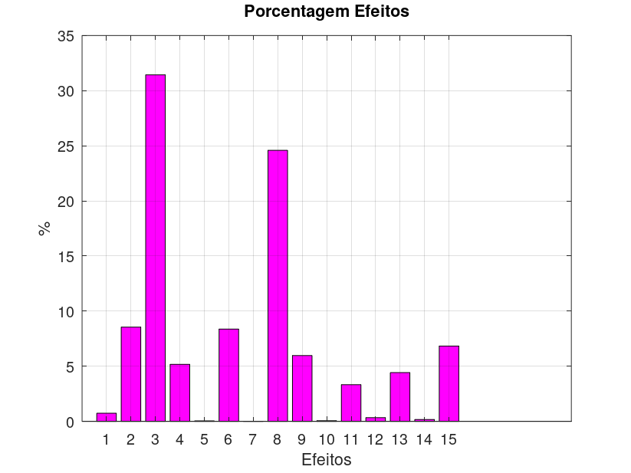
(b)
Effects
%
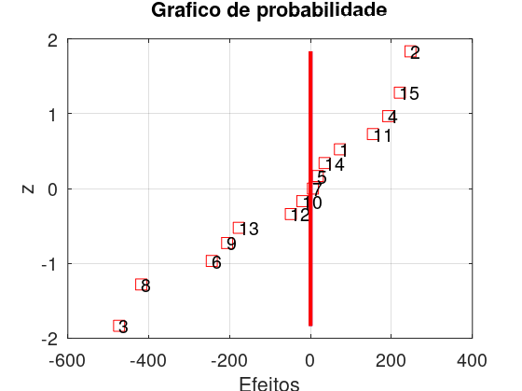
Effects
Expected Normal Value

Effect 1: starch cassava concentration. Effect 2: pectin concentration. Effect 3: homogenization speed of the polymer solution. Effect 4: homogenization time of the polymer solution. Effect 5: interaction between variables of effects 1 and 2. Effect 6: interaction between variables of effects 1 and 3. Effect 7: interaction between variables of effects 1 and 4. Effect 8: interaction between variables of effects 2 and 3. Effect 9: interaction between variables of effects 2 and 4. Effect 10: interaction between variables of effects 3 and 4. Effect 11: interaction between variables of effects 1, 2, and 3. Effect 12: interaction between variables of effects 1, 2, and 4. Effect 13: interaction between variables of effects 1, 3, and 4. Effect 14: interaction between variables of effects 2, 3, and 4. Effect 15: interaction between variables of effects 1, 2, 3, and 4.
Supplementary Figure 4. Evaluation of the quadratic regression model for optimizing the water absorption capacity of cryogels based on pectin and cassava starch by R² (a), normal probability (b), studentized residuals (c), and T of outliers (d).
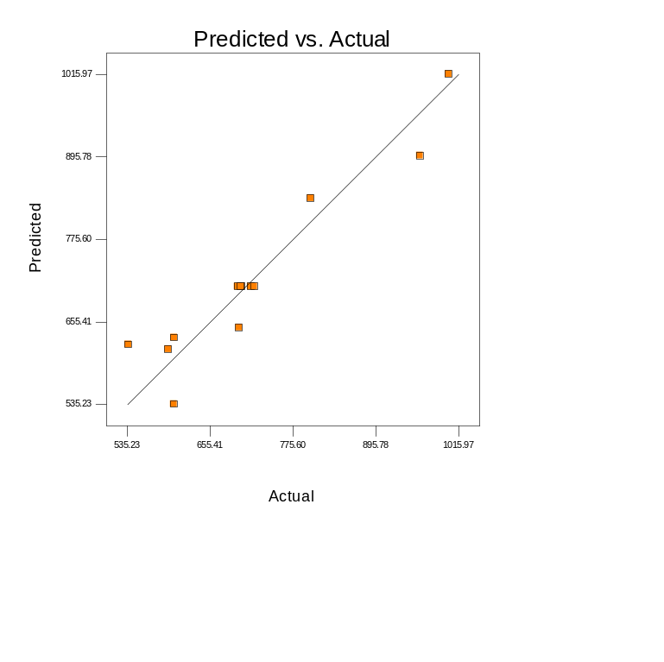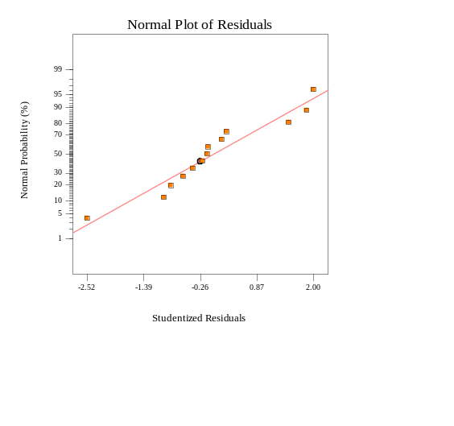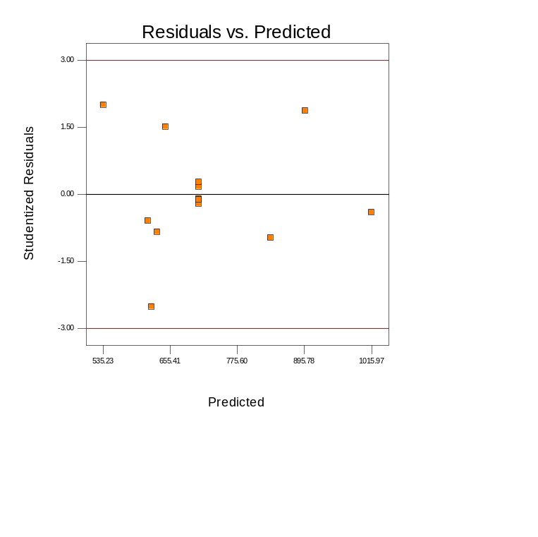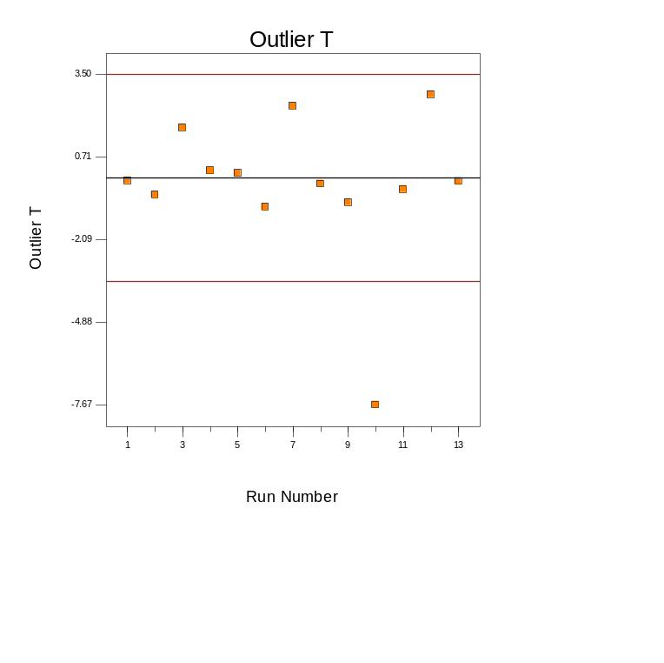
(b)
(a)
(d)
(c)

Supplementary Figure 5. Response surface (a) and contour lines (b) for the Rotational Central Composite Design to optimize the water absorption capacity of pectin and cassava starch cryogels.
(a)
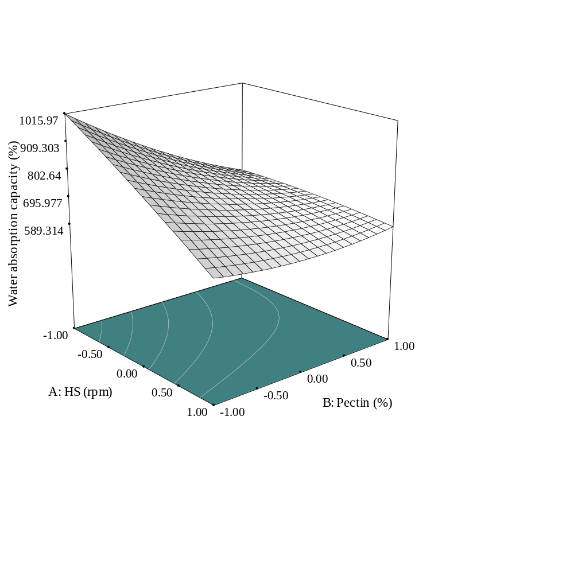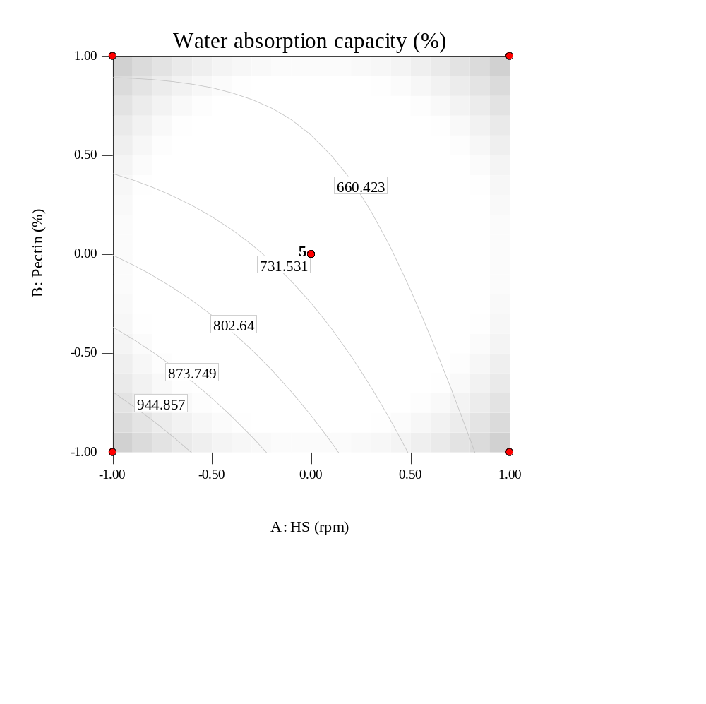
(b)
HS - homogenization speed of the polymer solution.
Supplementary Figure 6. Normal probability of the residuals of the Herschel-Bulkley rheological model for the polymer solutions of pectin and cassava starch (a), pectin and arrowroot starch (b), cassava starch (c), arrowroot starch (d) and pectin (e).
(a)
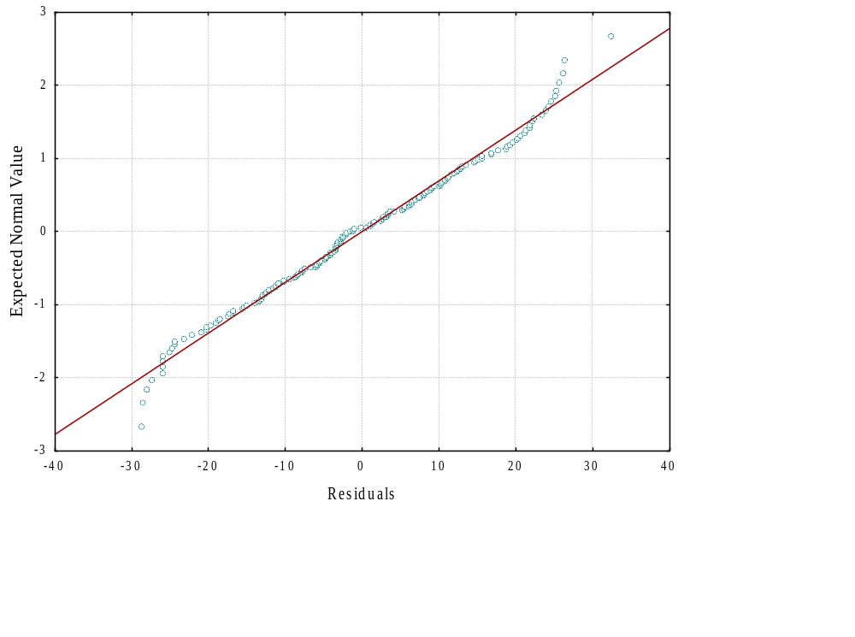
(b)
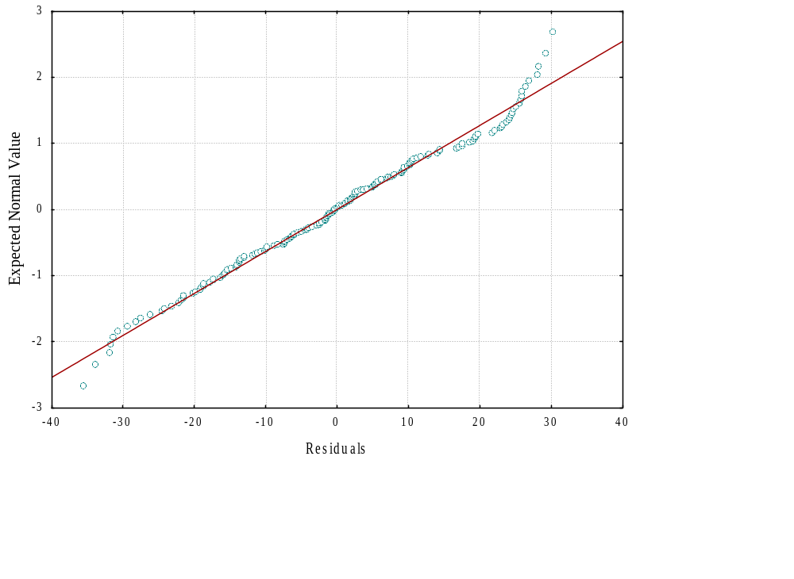
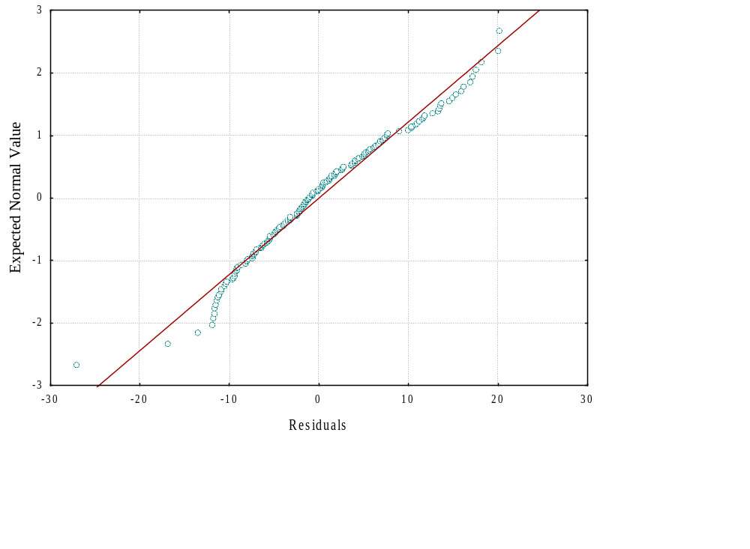
(d)
(c)
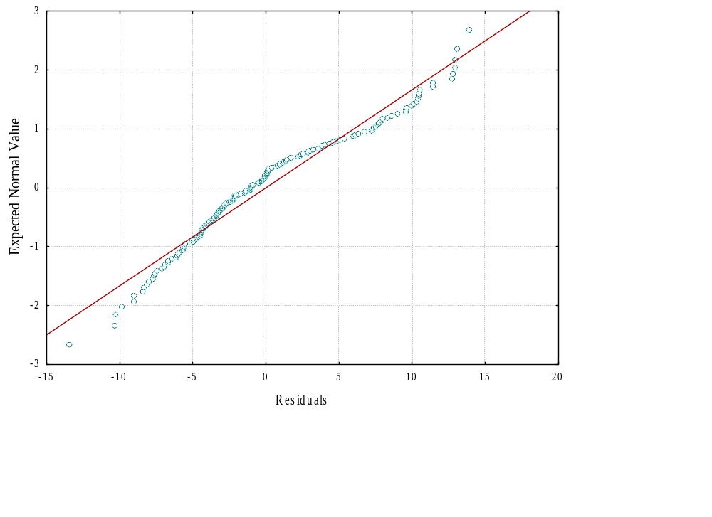
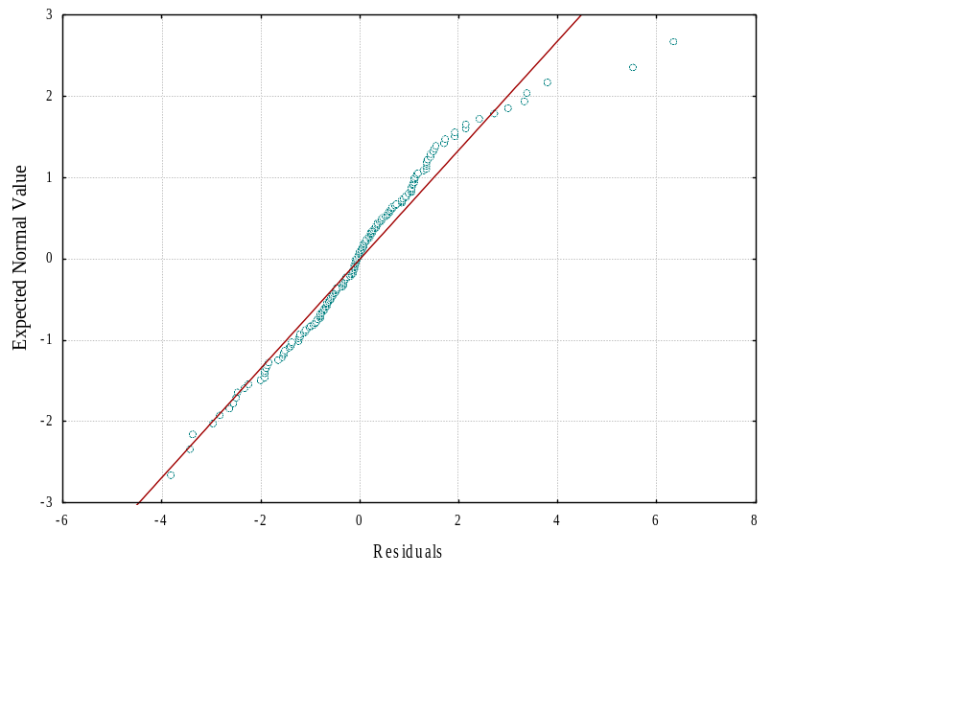
(e)
Supplementary Figure 7. Shear rate curves as a function of apparent viscosity (η) for polymer solutions based on pectin and starch.

