Supplementary Figure S1. Schematic representation of the dielectric barrier discharge cold atmospheric plasma (DBD-CAP) system and experimental configuration used for PAP treatment, including the main electrical, geometric, atmospheric, and thermal operating conditions.
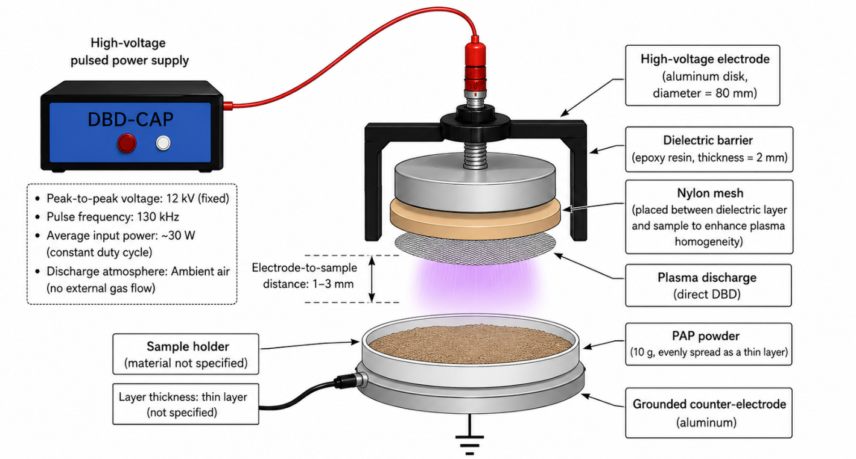
Figure S2. Six-component Gaussian fitting of the Amide I region (1600–1700 cm⁻¹) of untreated and CAP-treated PAP at 0, 2, 4, 6, 8, and 10 min. Experimental spectra are shown together with the overall Gaussian fit and the individual Gaussian components centered at 1684, 1668, 1655, 1645, 1638, and 1621 cm⁻¹. The integrated areas of the fitted components were used to estimate the relative contribution of β-sheet, α-helix, random coil/disordered structures, and β-turns.
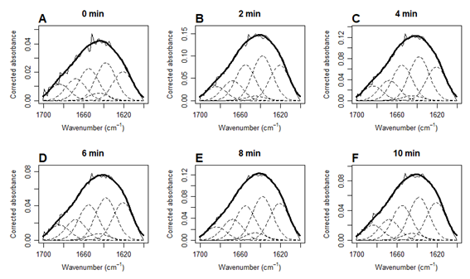
Table S1. Goodness-of-fit parameters for the six-component Gaussian fitting of the Amide I region.
Treatment | R² | RMSE | Residual SE
Control (0 min) | 0.9791 | 0.001901 | 0.001987
2 min | 0.9934 | 0.003874 | 0.004049
4 min | 0.9931 | 0.003281 | 0.003429
6 min | 0.9930 | 0.002047 | 0.002140
8 min | 0.9961 | 0.002470 | 0.002581
10 min | 0.9923 | 0.002509 | 0.002622
R², coefficient of determination, indicates the proportion of variance explained by the fitted model; RMSE, root mean square error, represents the average magnitude of the fitting errors; Residual SE, residual standard error, reflects the dispersion of the residuals around the fitted model. Higher R² and lower RMSE and Residual SE values indicate better goodness of fit.

