Supplementary Material
Optimizing the annealing process of sol-gel hybrid coating technology for corrosion protection of Al
Dimitris Tsamos ¹*, Panagiotis Artemiou ¹, Dimitris Fasnakis ², Dionisis Loizos², Stefanos Gerardis ² and Stergios Maropoulos ²*
- Laboratory for Biomaterials and Computational Mechanics, Department of Mechanical Engineering, University of Western Macedonia, 50100 Kozani, Greece;
- Centre for Testing of Materials and Constructions, Department of Mechanical Engineering, University of Western Macedonia, 50100 Kozani, Greece;
* Correspondence: DT d.tsamos@uowm.gr ; SM smaropoulos@uowm.gr

- XRF data for the aluminum substrate:
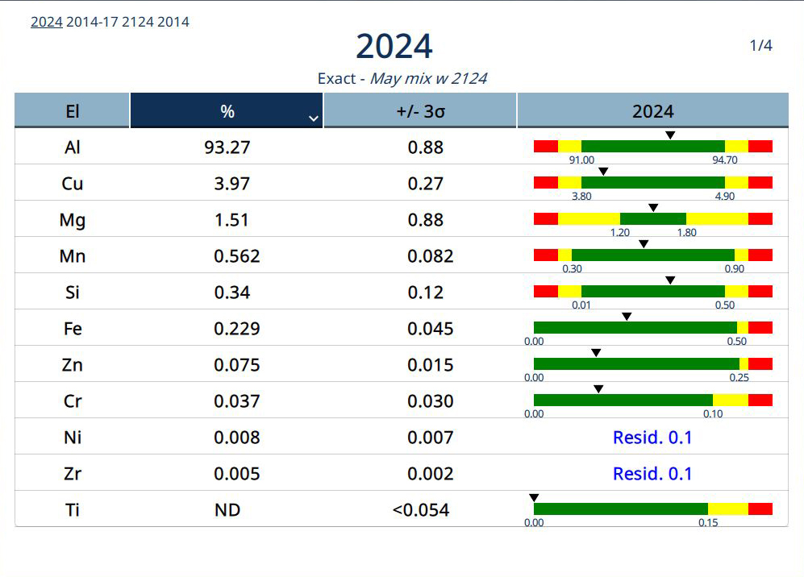
Spectrum 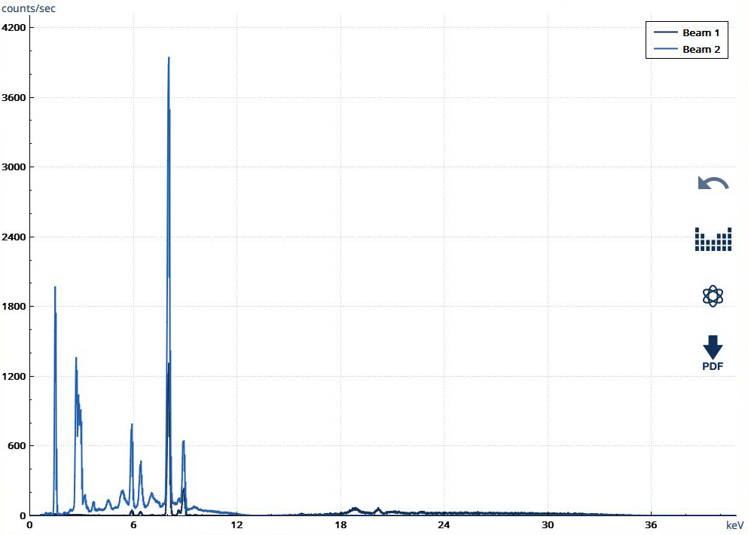

2. The images below present SEM images of the specimens after the 5-day immersion tests.
a) | b)
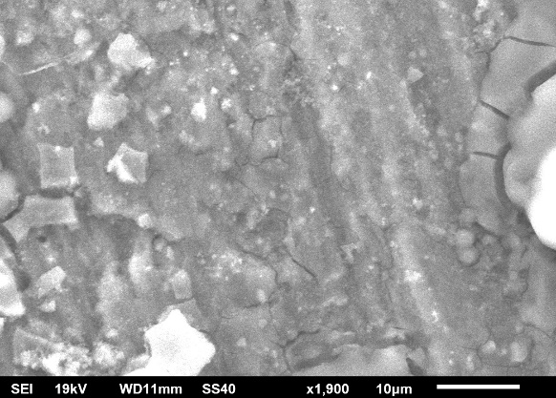

Figure 1 SEM shows micrographs of uncoated a) and coated b) aluminum specimens after the 5-day immersion tests. Notably, the uncoated sample exhibits more significant changes in surface morphology.

