Behavior of Sodium Dodecyl Sulfate in Acidic Environment
Supporting Information

1. Titration of SDS mit 1M HCl 1
a. 1st derivation of the SDS titration curve 1
b. 2nd derivation of the SDS titration curve 2
2. NMR Study 2
a. SDS Reference c_{DCl}= 0 mol L⁻¹ 2
b. SDS at pH 1.00, pD 1.40, c_{DCl}= 0.04 mol L⁻¹ 3
c. SDS at pH 0.00, pD 0.40, c_{DCl} = 0.40 mol·L⁻¹ 4
d. SDS at pH –0.50, pD –0.10, c_{DCl} = 1.26 mol·L⁻¹ 4
e. SDS at pH –1.00, pD –0.60, c_{DCl} = 4.00 mol·L⁻¹ 5
f. SDS at pH –1.40, pD –1.00, c_{DCl} = 10.09 mol·L⁻¹ 5
g. Only DMSO, pH –1.40, pD –1.00, c_{DCl} = 10.09 mol·L⁻¹ 6
3. Turbidity experiments 7

Titration of SDS mit 1M HCl

1st derivation of the SDS titration curve

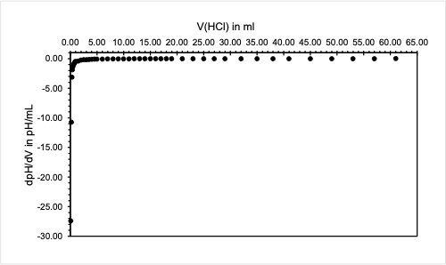
Figure S1: 1st derivation of the SDS titration curve.

2nd derivation of the SDS titration curve
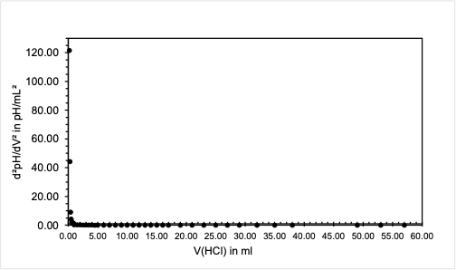
Figure S2: 2nd derivation of the SDS titration curve.

NMR Study

SDS Reference c_{DCl}= 0 mol L⁻¹

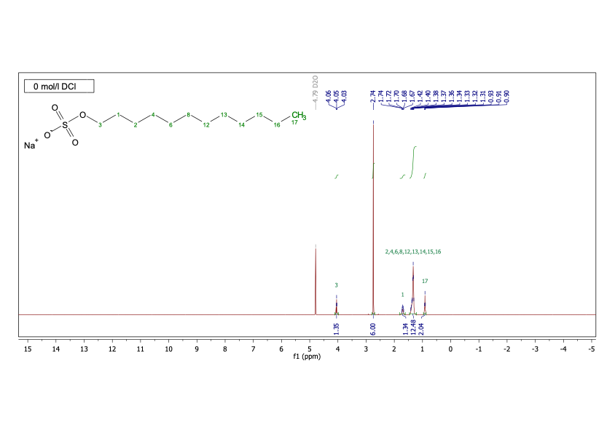
Figure S3: ¹H NMR (400 MHz, D₂O) δ = 4.06, 4.05, 4.03, 2.74, 1.74, 1.72, 1.70, 1.68, 1.67, 1.42, 1.40, 1.38, 1.37, 1.36, 1.34, 1.33, 1.32, 1.31, 0.93, 0.91, 0.90.

SDS at pH 1.00, pD 1.40, c_{DCl}= 0.04 mol L⁻¹
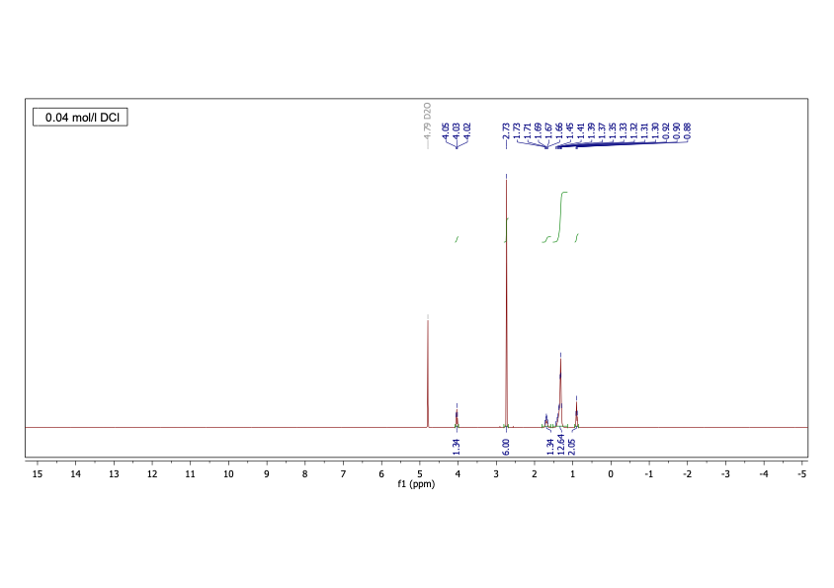
Figure S4: ¹H NMR (400 MHz, D₂O) δ = 4.05, 4.03, 4.02, 2.73, 1.73, 1.71, 1.69, 1.67, 1.66, 1.45, 1.41, 1.39, 1.37, 1.35, 1.33, 1.32, 1.31, 1.30, 0.92, 0.90, 0.88.

SDS at pH 0.00, pD 0.40, c_{DCl} = 0.40 mol·L⁻¹
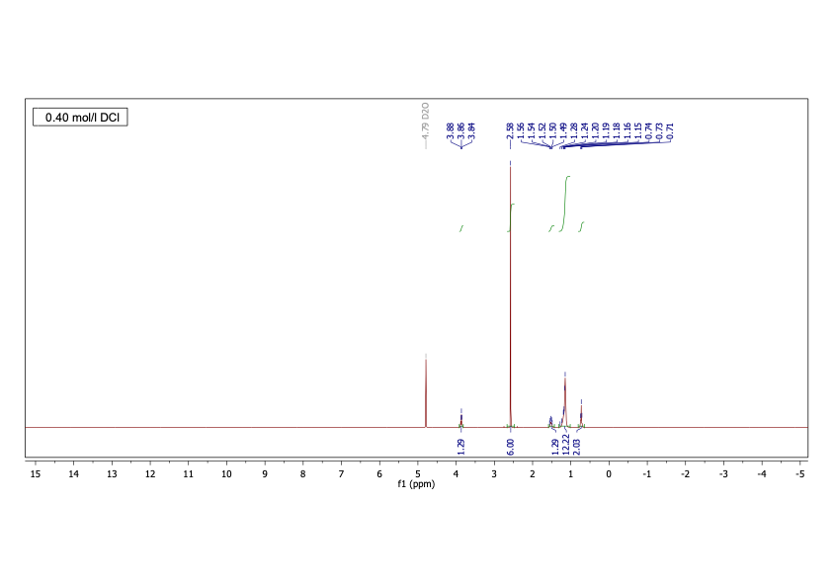
Figure S5: ¹H NMR (400 MHz, D₂O) δ = 3.88, 3.86, 3.84, 2.58, 1.56, 1.54, 1.52, 1.50, 1.49, 1.28, 1.24, 1.20, 1.19, 1.18, 1.16, 1.15, 0.74, 0.73, 0.71.

SDS at pH –0.50, pD –0.10, c_{DCl} = 1.26 mol·L⁻¹
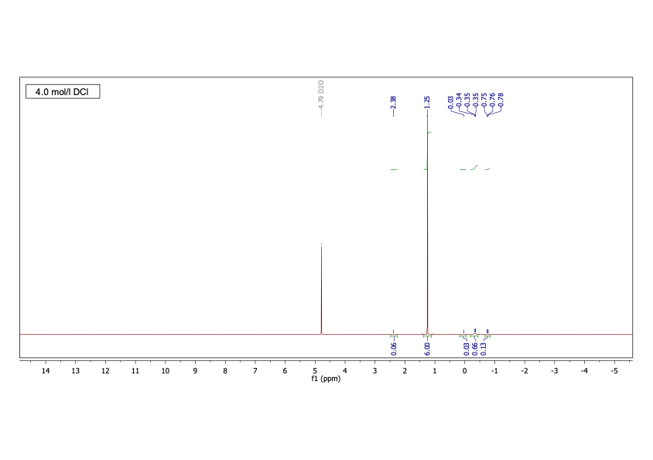
Figure S6: ¹H NMR (400 MHz, D₂O) δ = 3.48, 2.22, 1.13, 0.76, 0.36, 0.34, 0.32.

SDS at pH –1.00, pD –0.60, c_{DCl} = 4.00 mol·L⁻¹
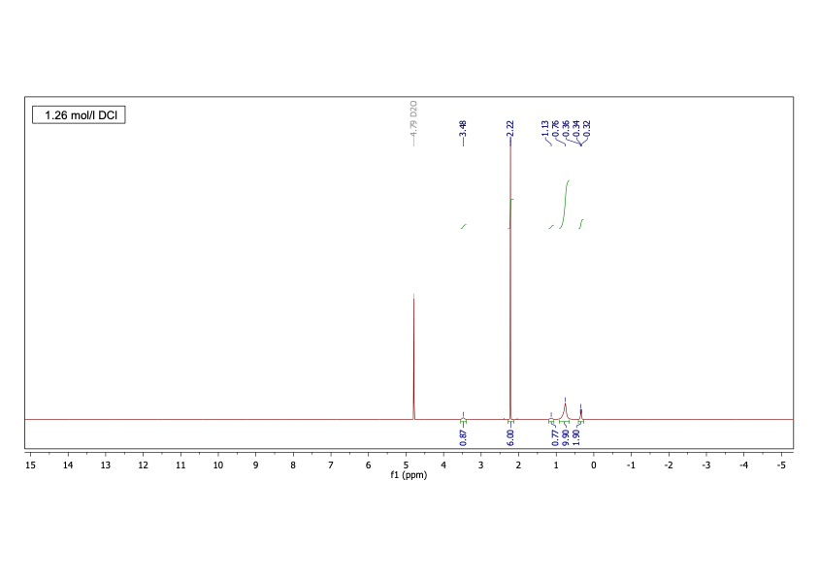
Figure S7: ¹H NMR (400 MHz, D₂O) δ = 2.38, 1.25, 0.03, -0.34, -0.35, -0.35, -0.75, -0.76, -0.78.

SDS at pH –1.40, pD –1.00, c_{DCl} = 10.09 mol·L⁻¹
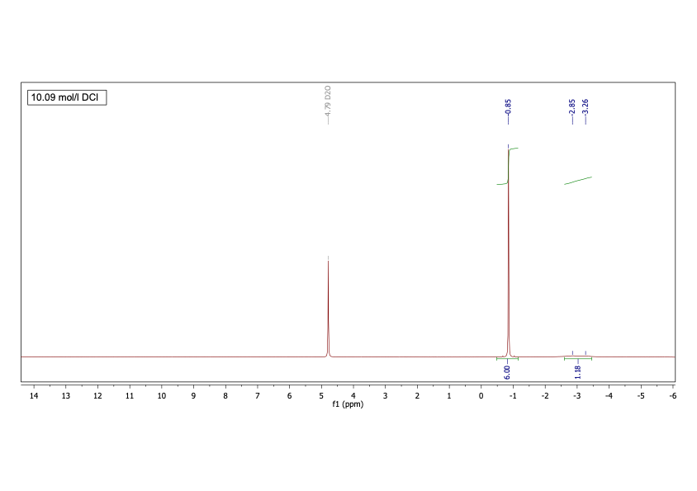
Figure S8: ¹H NMR (400 MHz, D₂O) δ = -0.85, -2.85, -3.26.

Only DMSO, pH –1.40, pD –1.00, c_{DCl} = 10.09 mol·L⁻¹
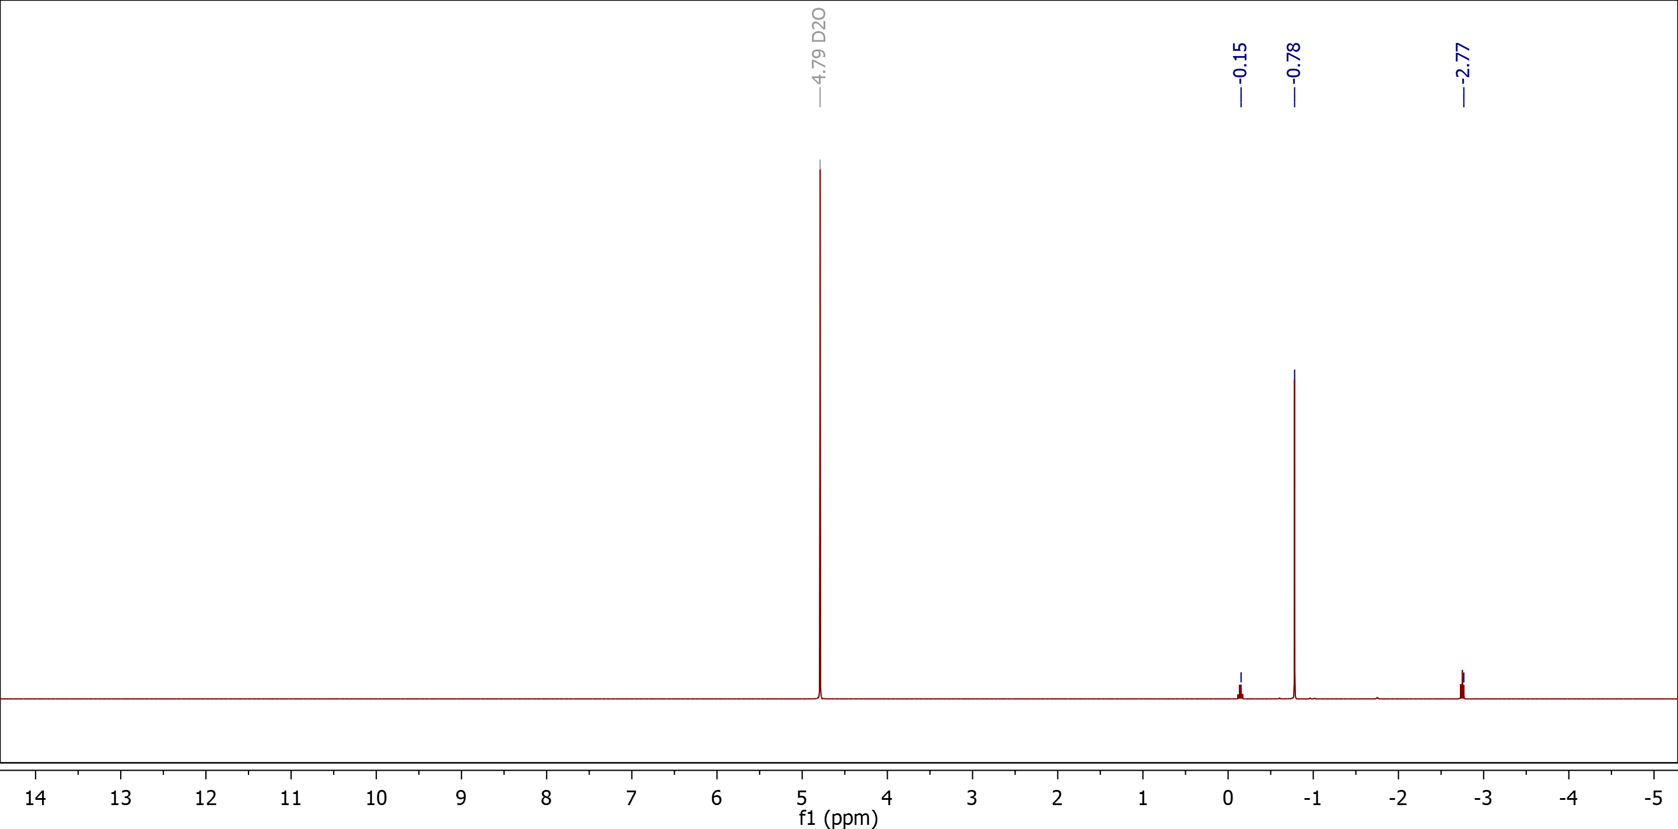
Figure S9: 1H NMR (400 MHz, D₂O) δ ¹H NMR (400 MHz, D₂O) δ = -0.15, -0.78, -2.77.

Turbidity experiments

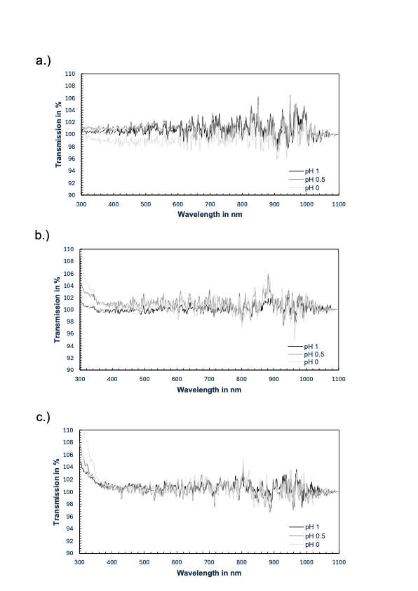
Figure S10: UV-VIS Transmission spectra of a.) 0.025 M, b.) 0.25 M, c.) 0.5 M SDS at pH 1, 0.5, and 0.

