Supporting Information for:
Comb-like copolymers with star conformation as dispersants of pigments in waterborne paint formulations

Sara Beldarrain^{1*}, Richard Aceituno¹, Amaia Iturrospe², Arantxa Arbe², Aitor Barquero¹, Edurne González^{1*}, and Jose Ramon Leiza¹.
¹POLYMAT, Kimika Aplikatua Saila, Kimika Fakultatea, University of the Basque Country, UPV/EHU, Joxe Mari Korta Zentroa, Tolosa Hiribidea 72, 20018 Donostia/San Sebastián, Spain.
²Centro de Física de Materiales (CFM-MPC), CSIC-UPV/EHU, Paseo Manuel Lardizabal 5, 20018 Donostia/San Sebastián, Spain.

Corresponding authors:
Sara Beldarrain. sara.beldarrain@ehu.eus
Edurne González. edurne.gonzalezg@ehu.eus

SI.1. Synthesis of the latexes used as binders in the waterborne coating formulations
SI.1.1. Materials
Technical grade monomers methyl methacrylate (MMA, Quimidroga), n-butyl acrylate (BA, Quimidroga) and acrylic acid (AA, Sigma-Aldrich), were used without any purification for the synthesis of the latexes. Potassium peroxodisulfate (KPS, Sigma-Aldrich) was used as thermal water-soluble initiator and tert-butyl hydroperoxide (70 wt%, TBHP, Sigma-Aldrich) and ascorbic acid (AsAc, Fluka) as water-soluble redox pair initiator. Alkyldiphenyloxide disulfonate (Dowfax 2A1, Dow Chemical) and Sipomer PAM200 (Rhodia), were used as surfactant in different reactions. Deionized water was used in all reactions.
SI.1.2. Procedure
The latexes were synthesized by seeded semibatch emulsion polymerization using a reactor equipped with a mechanical turbine stirrer, a reflux condenser, a nitrogen bubbling tube, a feeding inlet, and a sampling device. The first step was the synthesis of the seed for each latex. The seeds were synthesized semibatchwise at 70 °C. The reactor was initially charged with the necessary amount of deionized water and surfactant, and once the reaction temperature was reached, the initiator was added to the reactor as a shoot, and the feeding of the monomers was started. After feeding the monomers, the reactions were left one hour more at the reaction temperature batchwise to reduce the amount of residual monomer. Find the formulation used for the synthesis of the seed together with the reaction time and feeding time for each system in Tables SI.1-2.
Table SI.1. Formulation used for the synthesis of seed polymer particles with carboxylic acid functionalization (S_carb).
Material | Initial Charge (g) | Shot | Feed stream 1 (g) | Feed stream 2 (g)
Deionized water | 590.5 | 30 | - | 50
Calfax DB-45 | 6.0* | - | - | -
MMA/BA/AA  (49.5/49.5/1 wt %) | - | - | 300 | -
TBHP | - | 2.14 | - | -
AsAc | - | - | - | 1.5
Total reaction time: 4 hours. *45 wt% active solution
Feeding time: 3 hours.

Table SI.2. Formulation used for the synthesis of polymer particles with carboxylic acid functionalization (L_carb).
Material | Main polymerization |  |  |  | Post-polymerization
Material | Initial Charge (g) | Shot | Feed stream 1 (g) | Feed stream 2 (g) | Shot | Feed stream
S_carb | 555.3 | - | - | 30 | - | -
Deionized water | - | 30 | 40.1 | - | 5 | 15
Calfax DB-45 | - | - | 1.7* | - | - | -
MMA/BA/AA  (49.5/49.5/1 wt %) | - | - | 344.5 | - | - | -
TBHP | - | 4.9 | - | - | 5 | -
AsAc | - | - | - | 3.44 | - | 1.7
Total reaction time: 5 hours *45 wt% active solution
Feeding time: 4 hours.
Post-polymerization time: 1 hour.

The second step was the synthesis of the higher solids content functional latexes. In this case, the reactor was initially charged with the seed and water. When the temperature reached the reaction temperature, the initiator was added as a shot and the feeding of a monomer pre-emulsion containing water, surfactant and the monomers was started. Note that in the case of L_phos the pH of the pre-emulsion was neutralized to pH 7 by addition of ammonia solution to avoid hydrolysis of phosphate groups. Tables SI.3-4 show the formulation used for each latex together with the reaction times, feeding times and the post-polymerization times.
Table SI.3. Formulation used in the synthesis of seed polymer particles with phosphate functionalization (S_phos).
Material | Initial Charge (g) | Feed stream (g)
DI water | 436.9 | -
Dowfax 2A1 | 0.63* | -
MMA/BA  (50/50 wt %) | - | 62.6
KPS | 0.313 | -
NaHCO₃ | 1.035 | -
Total reaction time: 5 hours *45 wt% active solution
Feeding time: 4 hours.

Table SI.4. Formulation used in the synthesis of polymer particles with phosphate functionalization (L_phos).
Material | Initial Charge (g) | Feed stream (g)
S_phos | 107 | -
DI water | - | 149.8
Sipomer PAM200 | - | 5
MMA/BA  (50/50 wt %) | - | 238
KPS | 0.313 | -
Total reaction time: 5 hours
Feeding time: 4 hours.

SI.2. Characterization of comb-like copolymers
SI.2.1. Conversion and copolymer composition
The instantaneous conversions of MMA and PEGMA, as well as the overall instantaneous conversion of the synthesized copolymers, were calculated from the ¹H-NMR spectra (assignations in Figure SI.1) using Equations 1 and 2, and are presented in Figure SI.2. It can be observed that, in all cases, the instantaneous conversions of both monomers are very close in agreement with very similar reactivity ratios of the comonomers (Figure SI.2a-b). The cumulative copolymer composition with respect to the MAA monomer is shown in Figure SI.2c, indicating a homogeneous composition.

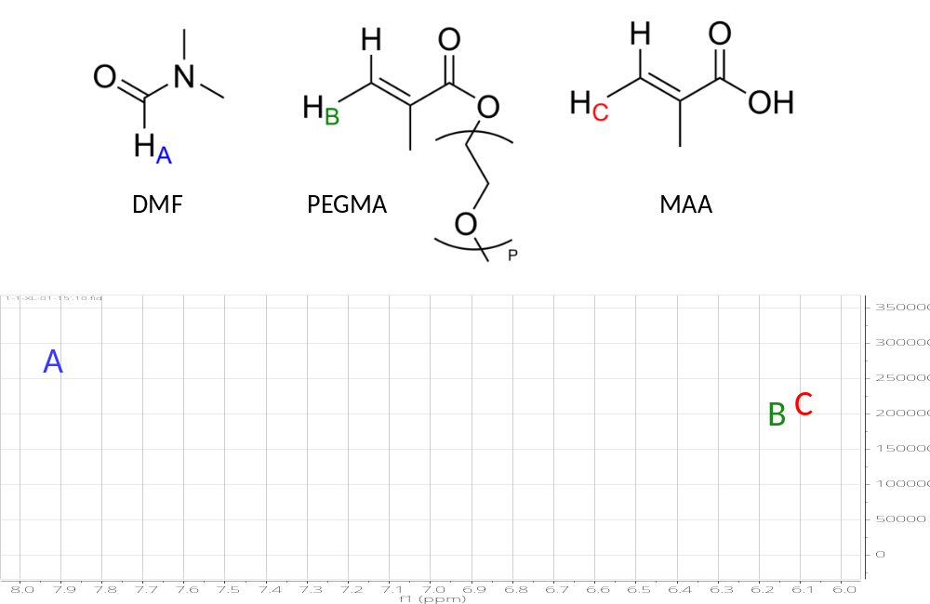
Figure SI.1. ¹H-NMR spectrum of a sample taken during the synthesis of the 1/1-XL copolymer.

$$x_{i}^{inst}=1-\frac{A_{i}∙n_{DMF}/A_{DMF}}{F_{i}∙t/{Mw}_{i}}∙\frac{m_{R}}{m_{NMR}}$$ |  |  |  | (Eq. 1)
$$Y_{MAA}=\frac{F_{MAA}∙t∙x_{MAA}^{inst}}{F_{MAA}∙t∙x_{MAA}^{inst}+F_{MPEG}∙t∙x_{MPEG}^{inst}}$$ |  |  |  | (Eq. 2)
i | MAA or PEGMA monomer
x^{inst} | Instantaneous conversion
A | Integrated area
n_{DMF} | DMF inside the NMR tube (mol)
F | Feeding rate (g/min)
t | Time (min)
MW | Molecular weight (g/mol)
m_{R} | Total mass inside of the reactor during the reaction (g)
m_{NMR} | Total mass inside of the NMR tube (g)
Y_{MAA} | Copolymer cumulative composition

1/1-L  0.67/1-L  1/1-XL  0.67/1-XL | 1/1-L  0.67/1-L  1/1-XL  0.67/1-XL
(a) | (b)
(c)

Figure SI.2. Instantaneous conversion for (a) MAA and (b) PEGMA. (c) Conversion evolution of the cumulative copolymer composition referred to MAA comonomer. The dotted lines correspond to the composition of the feed (in blue copolymers with 1/1 and in red copolymers with 0.67/1 MAA/PEGMA mol ratio).

SI.2.2. Molar mass distribution.
The molar mass distribution was measured using Size Exclusion Chromatography with Multiple Angle Light Scattering and Refractive Index detectors (SEC/MALS/RI). The equipment was composed by a LC20 pump (Shimadizu) coupled to a miniDAWN Treos multiangle (3 angles) light scattering laser photometer equipped with an He-Ne laser (λ=658 nm) and an Optilab T-Rex differential refractometer (λ=658 nm) (all from Wyatt Technology Corp., USA). The separation was carried out using three columns in series (Ultrahydrogel 120, 250 and 2000 with pore sizes of 120, 250 and 2000 Å, respectively, Waters, Barcelona, Spain). The analyses were carried out at 35 °C and a NaNO₃ 0.1 M, pH=12 (using NaOH as base) aqueous solution was used as eluent at a flow rate of 0.6 mL/min. The copolymers were filtered and injected (100 µL) into the equipment. The SEC/MALS/RI data was analyzed by using the ASTRA software version 6.1 (Wyatt technology, USA).

SI.2.3. Small-angle X-ray scattering (SAXS)
SAXS experiments were conducted using a Rigaku 3-pinhole PSAXS-L instrument operating at 45 kV and 0.88 mA. The MicroMax-002+ X-ray generator system comprises a microfocus sealed tube source module and an integrated Cu K_{α} X-ray generator unit. The flight path and sample chamber of this equipment are maintained under vacuum. Scattered X-rays were detected using a Dectris hybrid photon counting detector (Dectris EIGER2 R 1M), which offers micrometric spatial resolution (75 µm x 75 µm), a wide dynamic range, and a large pixel array (1M pixels). Azimuthally averaged scattered intensities were obtained as a function of scattering vector (Q), where $Q=4πλ^{1}sin⁡(θ)$, with 2 $θ$: scattering angle Reciprocal space calibration was performed using silver behenate as the standard. Solutions were placed in boron-rich capillaries with an outer diameter of 2 mm and a wall thickness of approximately 0.01 mm. Samples of 20 mg/mL were placed in transmission geometry, with sample-to-detector distances of 2 m, covering a Q-range between 0.008 and 0.20 Å⁻¹. A 3x3 Detector Scan Profile (DSP) was employed, with measuring times of 6000 s for each scan. The solvent, Milli-Q water, was measured under the same conditions and appropriately subtracted from the solution measurements. Azimuthally averaged scattered intensities obtained by SAXS (Figure SI.3) were described using the software Sasfit [1] by applying two possible models for chain conformations. These were either a generalized random coil or star polymer (Dozier model).
In the generalized Gaussian coil model, the intensity is given by [2]
$I\left(Q\right)=I_{o}\left[\frac{1}{νU^{\frac{1}{2ν}}}γ\left(\frac{1}{2ν},U\right)-\frac{1}{νU^{\frac{1}{ν}}}γ\left(\frac{1}{ν},U\right)\right]$
with $U=(2ν+1)(2ν+2)\frac{Q^{2}R_{g}^{2}}{6}$ and the lower incomplete Gamma function $γ\left(a,x\right)=\int_{0}^{x}{dt t^{a-1}exp⁡(-t)}$.
The Dozier model describes the form factor of a star polymer with f arms [3]:
$$I\left(Q\right)=I_{o}exp\left(-\frac{Q^{2}R_{g}^{2}}{3}\right)+\frac{4πα}{Qξ}Γ(μ)\frac{sin⁡[μ arctan⁡(Qξ)]}{{(1+Q^{2}ξ^{2})}^{μ/2}}$$
where $μ=\frac{1}{ν}-1$ and $ξ=2R_{g}/\sqrt{f}$. In both models, ν is the scaling exponent, R_{g} the radius of gyration and I_{o} is used to fit the global intensity. The Dozier expression also includes a scale parameter for fractal term ($α$).
From the fits of both conformation models the values of the radii of gyration R_{g} were obtained.

SAXS results
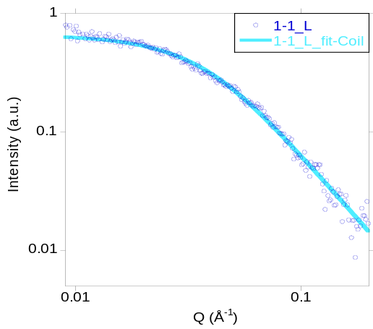 | 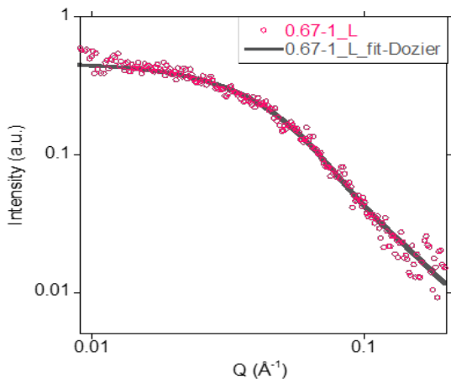
(a) 1/1-L (random coil) | (b) 0.67/1-L (Dozier)
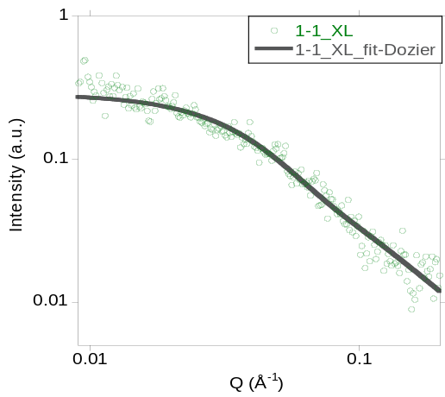 | 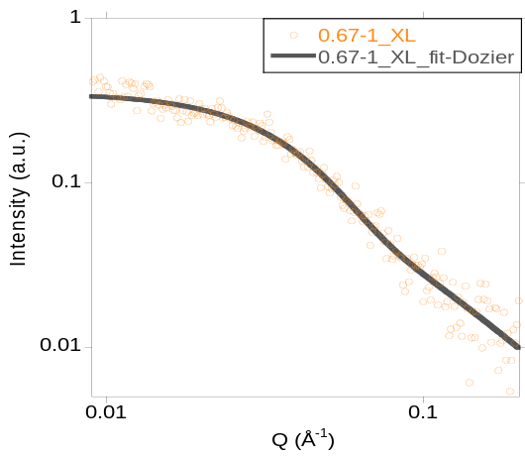
(c) 1/1-XL (Dozier) | (d) 0.67/1-XL (Dozier)

Figure SI.3. SAXS results on the synthesized comb-like copolymers. Lines are fits of a generalized gaussian function corresponding to a random coil (a) or a Dozier model for a star polymer (b-d).

SI.3. Characterization of the polyethylene glycol methyl ether methacrylate macromonomers
The Matrix assisted laser desorption ionization time of flight (MALDI-ToF) technique was employed to confirm that the number of ethylene oxide units in each PEGMA (P) matched the value provided by the suppliers. Figure SI.4 shows the results for the two PEGMAs. Number and weigh average molar masses and dispersity are given in Table SI.5.
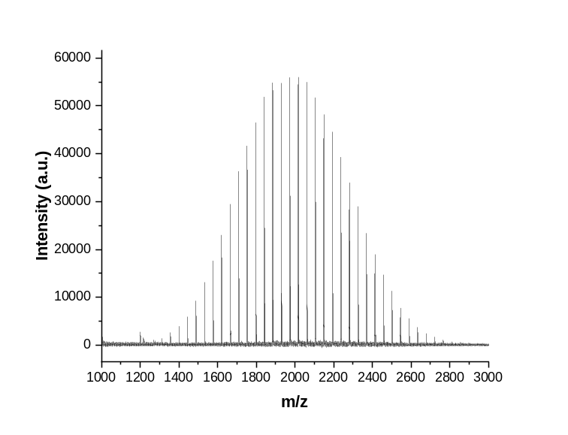
(a) PEGMA-L
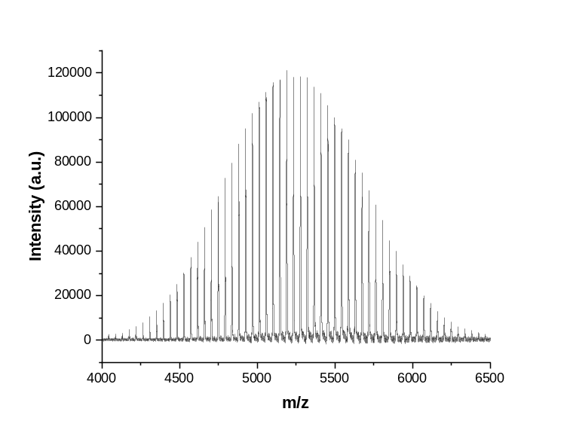
(b) PEGMA-XL

Figure SI.4. MALDI-ToF spectra for (a) PEGMA-L and (b) PEGMA-XL.
Table SI.5. Number and weigh average molar masses and dispersity of the PEGMA monomers obtained by MALDI-ToF.

 | PEGMA-L | PEGMA-XL
M_{n} (g/mol) | 1996 | 5209
M_{w} (g/mol) | 2027 | 5272
Ð | 1.02 | 1.01
EO units | 42.5 | 115.5

SI.4. Water uptake of latexes
The water absorption of both latexes was analyzed to assess differences caused by the latex itself or by additives used in the formulation. Figure SI.5 shows the evolution of water uptake in the dry latex films.

Figure SI.5. Water uptake (%) of L_carb and L_phos latexes.
REFERENCES
[1] I. Bressler, J. Kohlbrecher and A. F. Thünemann. Sasfit: a tool for small-angle scattering data analysis using a library of analytical expressions. Journal of Applied Crystallography 48, 1587 (2015)
[2] B. Hammouda. Small-angle scattering from branched polymers. Macromololecular Theory and Simulations 21, 372 (2012).
[3] W. D. Dozier, J. S. Huang, and L. J. Fetters. Colloidal nature of star polymer dilute and semidilute solutions. Macromolecules 24, 2810 (1991).

