Supporting information

Aqueous dispersion of birch bark suberin stabilized by carboxymethylated galactoglucomannan for barrier coating applications
Tapani Nick^{1,*}. Liqiu Hu¹. Nizam Puthiyaveettil Azeez¹. Minette Kvikant¹. Chunlin Xu¹. Martti Toivakka¹.
¹Laboratory of Natural Materials Technology. Åbo Akademi University. Finland
*Corresponding author. Email: tapani.nick@abo.fi
- Materials

CM-GGM characterization
¹³C NMR
Figure S1: ¹³C NMR results confirming the carboxymethylation of the two CM-GGM dispersants.

ATR-FTIR
Carboxymethylation decreased the hydroxyl stretching band (3380 cm⁻¹) and the symmetric C-H-vibration (2890 cm⁻¹). The COO⁻ peak at 1590 cm⁻¹ is more pronounced in the carboxymethylated galactoglucomannans. The presence of acetyl groups in the unmodified GGM is shown by the C=O stretching peak in 1730 cm⁻¹ and the C-H and the C-O bending vibrations at 1380 cm⁻¹ and 1250 cm⁻¹, see Figure S2.
Figure S2: ATR-FTIR spectra of GGM, CM-GGM-L, and CM-GGM-H
HPSEC
The molar masses of the GGM and CM-GGMs were analyzed using the HPSEC, with water as solvent. The CM-GGMs have similar molar mass distributions, with the CM-GGM-H having a higher content of low molar mass fractions, possibly because of more degradation during the synthesis in alkaline conditions. The higher molar mass fraction of the unmodified GGM was possibly not fully dissolved in the water and may have been filtered out before the analysis, see Figure 3.

Figure S3: Molar mass distributions of GGM, CM-GGM-L, and CM-GGM-H
  - Composition of suberin hydrolysates
Gas chromatography mass spectrometry (GC-MS)
Table S1: Composition of suberin hydrolysates
Compound | S1 |  |  | S2
 |  |  | (mg/g) |  |  | (mg/g)
acid 14:0 |  | 0.22 |  |  | 0.22
ferulic acid |  | 2.22 |  |  | 4.64
acid 16:0 |  | 1.12 |  |  | 1.19
alcohol 18:0 |  | 0.02 |  |  | 0.07
acid 18:2 |  | 1.30 |  |  | 1.24
acid 18:1 |  | 0.78 |  |  | 1.04
acid 18:0 |  | 0.42 |  |  | 0.48
16-hydroxy-16:0 acid |  | 2.97 |  |  | 2.28
acid 20:0 |  | 0.00 |  |  | 0.44
1,16-dioic-16:0 acid |  | 4.93 |  |  | 3.82
18-hydroxy-18:1 acid |  | 89.04 |  |  | 60.63
dihydroxy-16:0 acid |  | 23.65 |  |  | 22.87
monopalmitin |  | 2.01 |  |  | 1.88
1,18-dioic-18:1 acid |  | 28.73 |  |  | 21.72
1,18-dioic-18:0 acid |  | 8.32 |  |  | 6.63
(9),18-dihydroxy-18:1 acid ? |  | 6.53 |  |  | 5.23
dihydroxy-18:1 acid |  | 3.39 |  |  | 2.43
unidentified suberinic acids |  | 22.61 |  |  | 22.15
9,10-epoxy-18-hydroxy-18:0 acid |  | 163.27 |  |  | 103.89
(9)-oxo-18-hydroxy-18:0 acid |  | 4.52 |  |  | 4.19
monostearin |  | 8.25 |  |  | 17.05
9,10,18-trihydroxy-18:0 acid |  | 137.98 |  |  | 136.76
1,20-dioic-20:0 acid |  | 8.24 |  |  | 7.97
9,10-dihydroxy-1,18-dioic-18:0 acid |  | 2.01 |  |  | 2.94
22-hydroxy-22:0 acid |  | 10.72 |  |  | 75.08
1,22-dioic-22:0 acid |  | 18.62 |  |  | 26.01
Unidentified triterpenyl alcohols |  | 17.20 |  |  | 19.39
24-hydroxy-24:0 acid |  | 0.00 |  |  | 1.00
beta-sitosterol |  | 1.21 |  |  | 1.10
lupeol |  | 6.70 |  |  | 8.84
betulinol |  | 66.26 |  |  | 117.12
betulinic acid |  | 8.04 |  |  | 7.81
unidentified compound |  | 1.41 |  |  | 1.42
SUM |  | 652.70 |  |  | 689.54

- Dispersion characterization
  - TEM-imaging
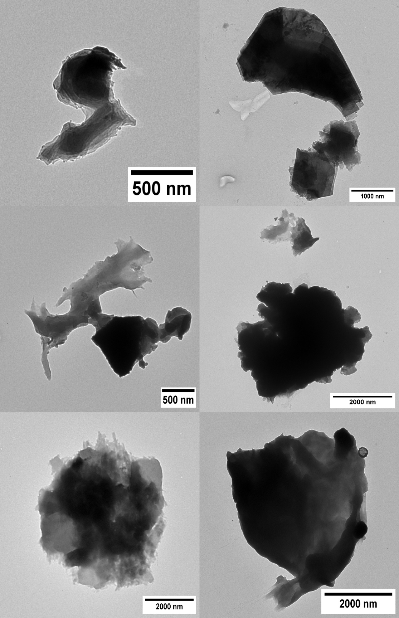
S1-PANa
S1-CMC
S1-GGM
S1-CM-GGM-L
S1-CM-GGM-H
S1-CM-GGM-H
Figure S4: TEM-images of particles in S1-suberin dispersions
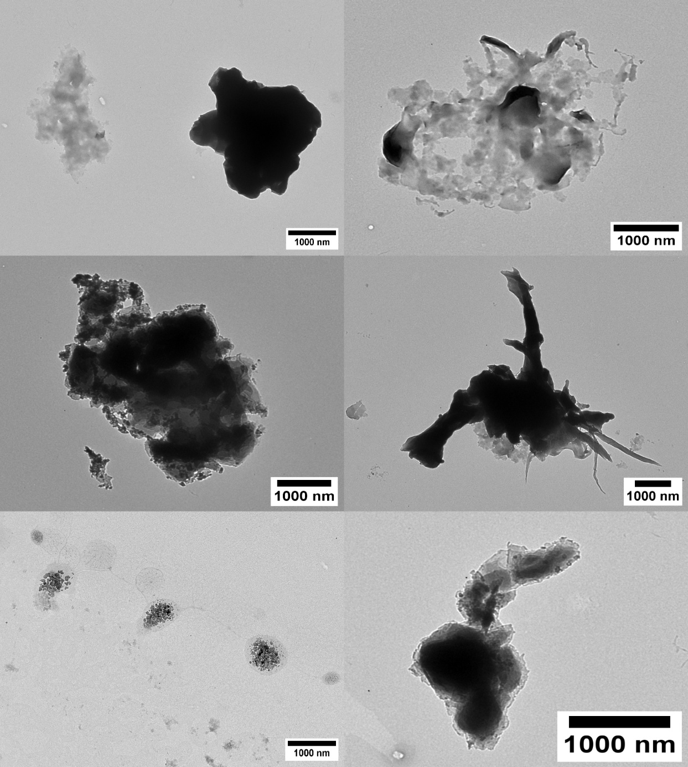
Figure S5: TEM-images of particles in S2-suberin dispersions.
S2-CM-GGM-H
S2-CM-GGM-H
S2-CM-GGM-H
S2-CM-GGM-H
S2-CMC
S2-CMC

  - Rheology
The results from the amplitude sweeps and frequency sweeps are shown in Figures 5 and 6, respectively.
Amplitude sweeps
Figure S6: Amplitude sweeps of suberin dispersions.

Figure S7: Yield stress determination from the first elastic stress peak value using amplitude sweep data.

Three-interval thixotropy test
Figure S8: Structure recovery rate during small oscillation in the third interval after shearing.
Frequency sweeps

Figure S9: Frequency sweep results of suberin dispersions, showing complex viscosity as a function of frequency (A), loss and storage moduli as function of frequency (B-D), phase shift angle as a function of frequency (E), and loss factor as a function of frequency (F).

- Coating characterization
  - Grease barrier
Table S2 contains the scanned images at time of failure during the grease barrier analysis.
Table S2: Images of basepaper and suberin-coated samples at time of failure during grease barrier test.
Sample | 1st failure | 2nd failure | 3rd failure
Base paperboard | 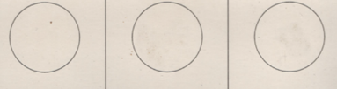  1 h | 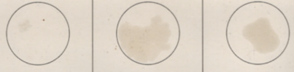  2h
POD ref. | 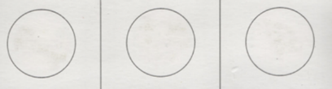  5 h
SB ref. | 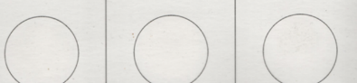  75 h | 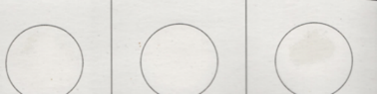  105 h | 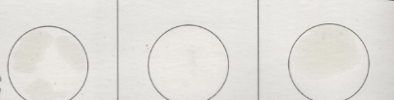  250 h
S1-PANa | 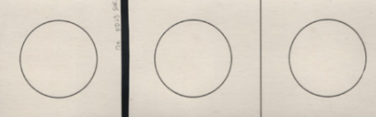  180 h | 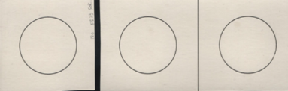  240 h | 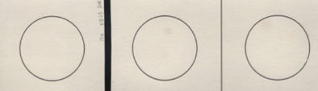  380 h, 2/3
S1-CMC |  |  | 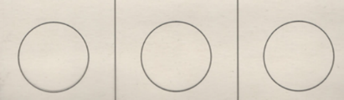  380 h, 0/3
S1-GGM | 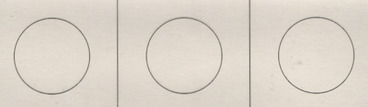  1 h | 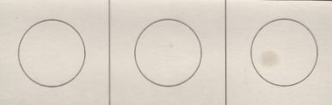  8 h | 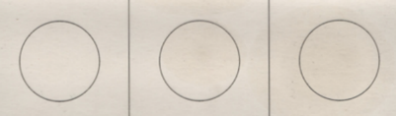  380 h, 2/3
S1-CM-GGM-L | 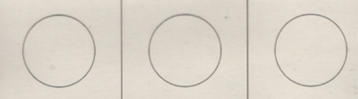  10 h |  | 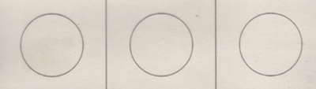  380 h, 1/3
S1-CM-GGM-H |  |  | 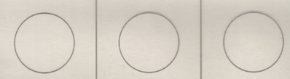  380 h, 0/3
S2-CMC |  |  | 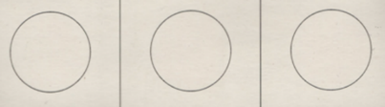  380 h, 0/3
S2-CM-GGM-H | 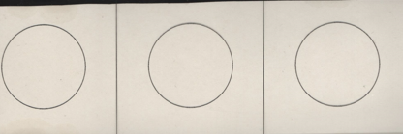  65 h, appearance of grease entering from the outer edge of the sample, no penetration through center | 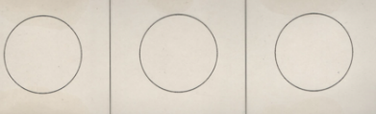  150 h, more grease appearing at the edges, but no penetration through the center | 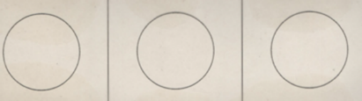  380 h, grease spreading from the sides of the sample, but no penetration through the center

