SUPPLEMENTARY INFORMATION

Capacitive sensor to monitor enzyme activity by following degradation of macromolecules in real-time
Gizem Ertürk Bergdahl^{1.2*}, Martin Hedström^{1.2} and Bo Mattiasson^{1.2}
¹ CapSenze Biosystems AB, Lund, Sweden
²Department of Biotechnology, Lund University, Sweden

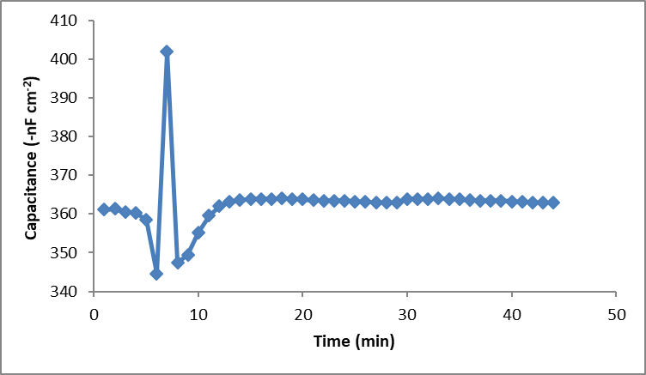
Start of injection

Figure SI-1. Injection of FabRICATOR enzyme directly onto the tyramine modified surface (before IgG immobilization)
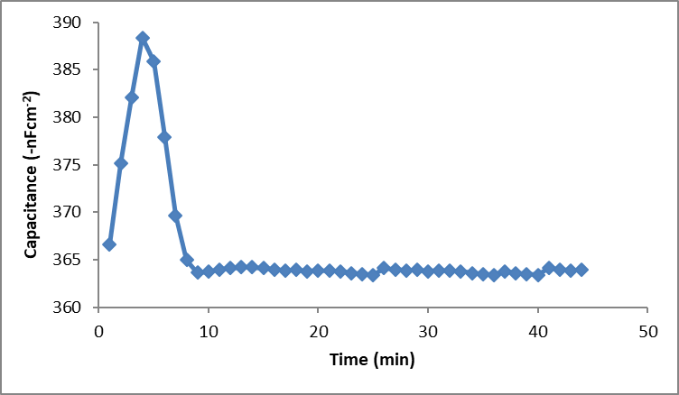
Start of injection

Figure SI-2. Injection of FabRICATOR enzyme directly onto the 3-APBA modified surface (before IgG injection)
As shown in Figure SI-1 and SI-2, the sensor did not give any significant response to the Fabricator enzyme when there was not any substrate (IgG) on the surface.

Figure SI-3. Actual sensorgram that shows the capacitance change after enzyme (0.1 µg/mL) injection. (running buffer: 10 mM phosphate, pH: 7.4; regeneration buffer: 25 mM glycine-HCl, pH: 2.5). [Capacitance value (C) recorded before FabRICATOR® injection: 363.3 nF, Capacitance value recorded after FabRICATOR® injection: 367.6 nF, Change in capacitance (∆C): 4.3 nF]

Figure SI-4. Actual sensorgram that shows the capacitance change after enzyme (0.2 µg/mL) injection. (running buffer: 10 mM phosphate, pH: 7.4; regeneration buffer: 25 mM glycine-HCl, pH: 2.5). [Capacitance value (C) recorded before FabRICATOR® injection: 363.3 nF, Capacitance value recorded after FabRICATOR® injection: 369.6 nF, Change in capacitance (∆C): 6.3 nF]

Figure SI-5. Actual sensorgram that shows the capacitance change after enzyme (0.3 µg/mL) injection. (running buffer: 10 mM phosphate, pH: 7.4; regeneration buffer: 25 mM glycine-HCl, pH: 2.5). [Capacitance value (C) recorded before FabRICATOR® injection: 365.3 nF, Capacitance value recorded after FabRICATOR® injection: 374.3 nF, Change in capacitance (∆C): 9.0 nF]

Figure SI-6. Actual sensorgram that shows the capacitance change after enzyme (0.4 µg/mL) injection. (running buffer: 10 mM phosphate, pH: 7.4; regeneration buffer: 25 mM glycine-HCl, pH: 2.5). [Capacitance value (C) recorded before FabRICATOR® injection: 363.3 nF, Capacitance value recorded after FabRICATOR® injection: 372.6 nF, Change in capacitance (∆C): 9.3 nF]

