Supplementary Material
Table 1 factors and levels of carbon and nitrogen sources
Factors  levels | Sucrose  (g/L) | NH₄SO₄  (g/L)
1 | 5 | 1
2 | 10 | 3
3 | 15 | 5
Table 2 Experimental arrangement and statistics of results
Group | Sucrose  (g/L) | NH₄SO₄  (g/L) | E₂₄  (%) | Surface tension  (mN/m)
1 | 5 | 3 | 50.67±1.16 | 59.57±0.88
2 | 15 | 1 | 56.67±0.58 | 61.90±1.89
3 | 10 | 3 | 60.67±1.15 | 54.72±0.68
4 | 10 | 5 | 56.67±0.58 | 56.93±0.81
5 | 5 | 5 | 52.00±2.00 | 60.10±0.46
6 | 10 | 1 | 62.33±2.52 | 63.00±1.32
7 | 5 | 1 | 48.00±2.65 | 63.82±0.66
8 | 15 | 3 | 68.00±1.00 | 55.37±0.91
9 | 15 | 5 | 65.33±0.58 | 53.68±0.59
K₁/3(E₂₄) | 50.22 | 55.67 | / | /
K₂/3(E₂₄) | 59.89 | 59.78 | / | /
K₃/3(E₂₄) | 63.33 | 58.00 | / | /
R(E₂₄) | 13.11 | 4.11 | / | /
Table 3 Anaylsis of variance
Group | quadratic sum | Freedom degree | F value | significance
Sucrose | 277.21 | 2 | 7.92 | 0.04
NH₄SO₄ | 25.51 | 2 | 0.73 | 0.54
A

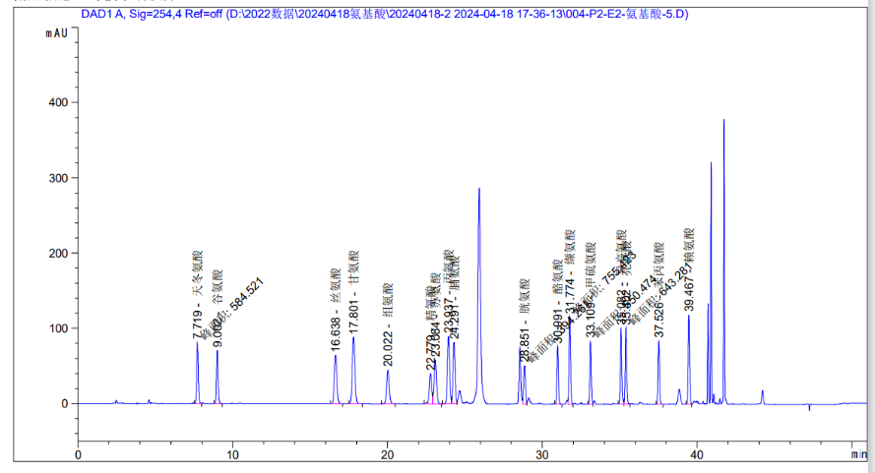
B
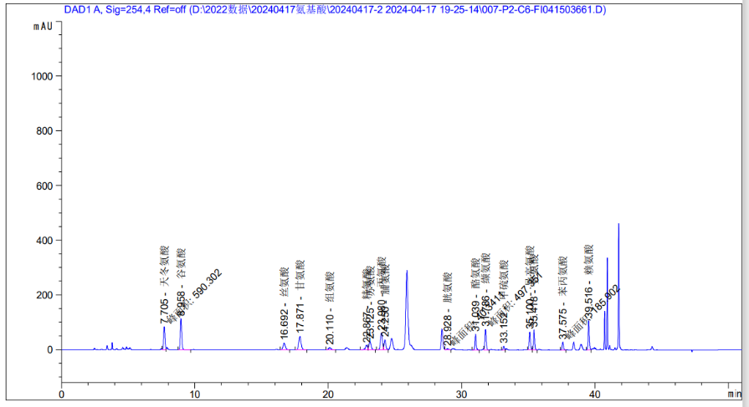
Fig. 1 Amino acid composition test of biosurfactant by HPLC. (A) standard sample. (B) Amino acid composition in surfactants

