Supplementary Information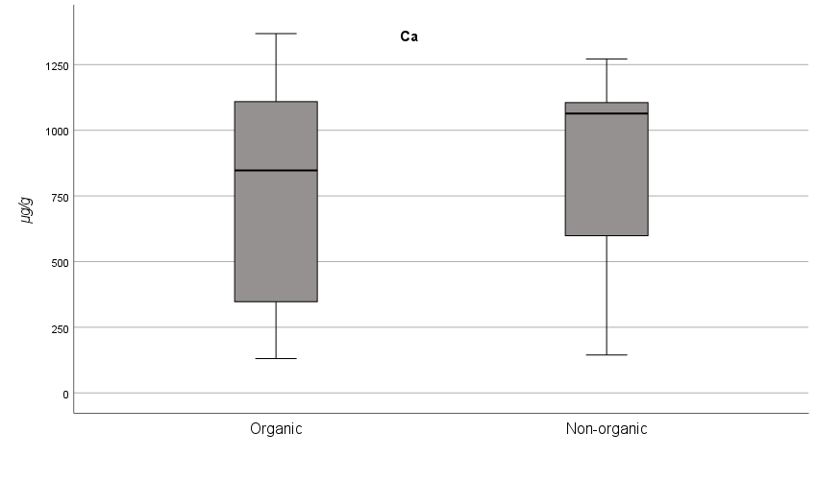
a)

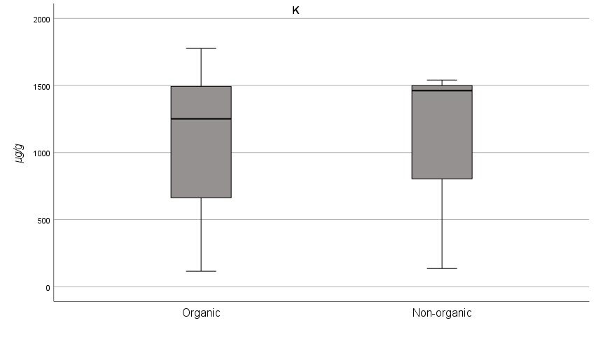
b)

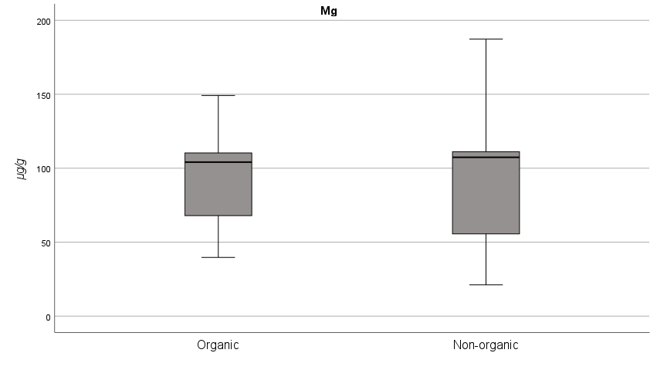
c)
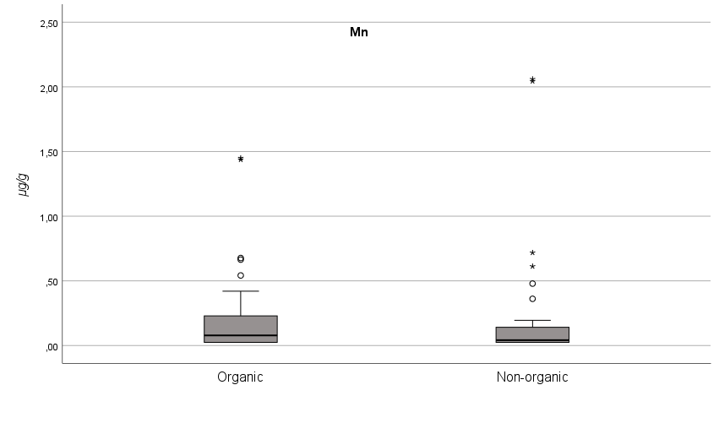
e)
d)
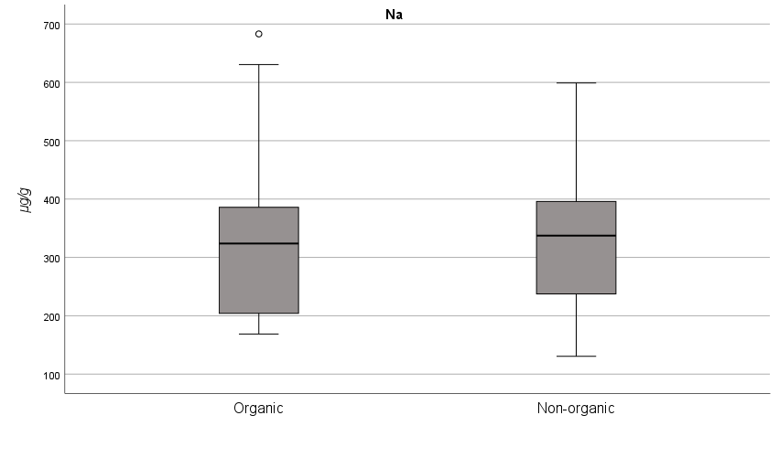
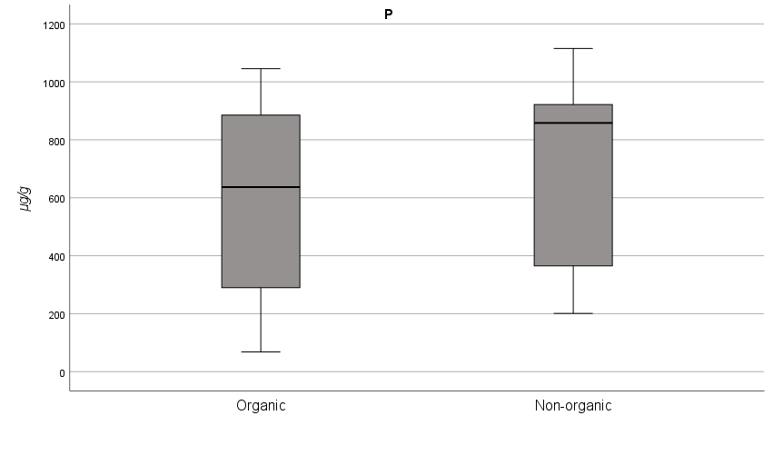
f)
Figure S1. Box plots Ca (a), K (b), Mg (c), Mn (d), Na (e), P (f) concentrations in milk and plant-based drinks according to the production system (organic or non-organic).

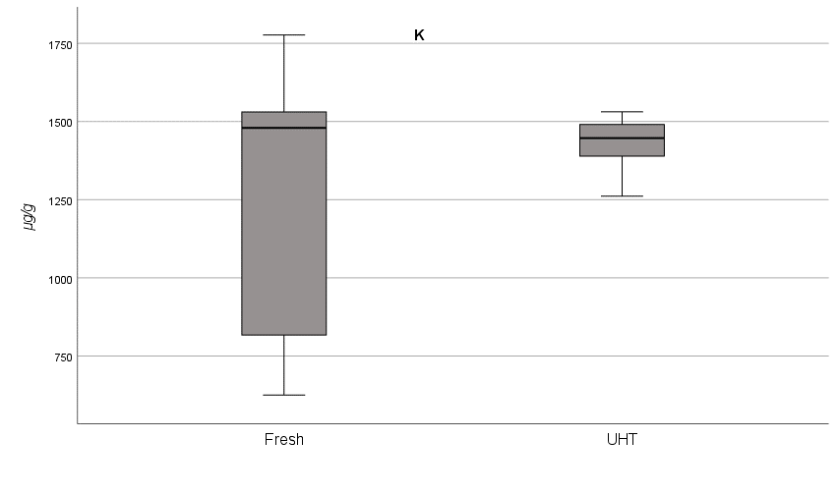
a)
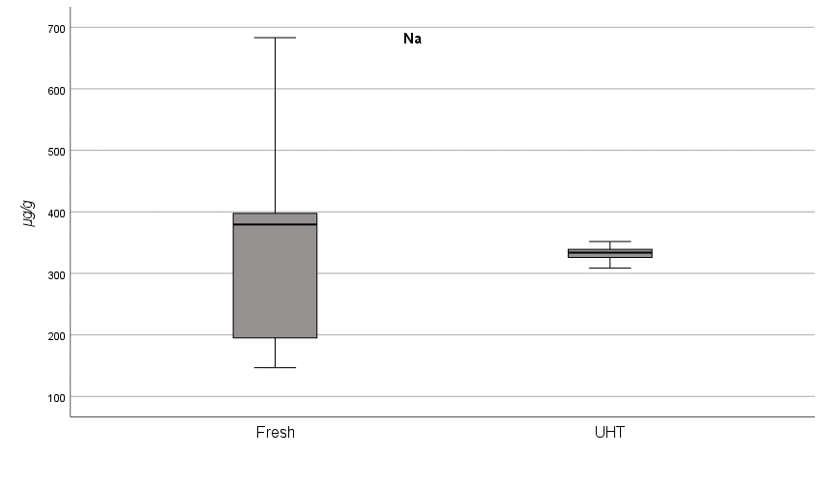
b)
Figure S2. Box plots K (a) and Na (b) concentrations in milk sample according to sterilization method (fresh or UHT).

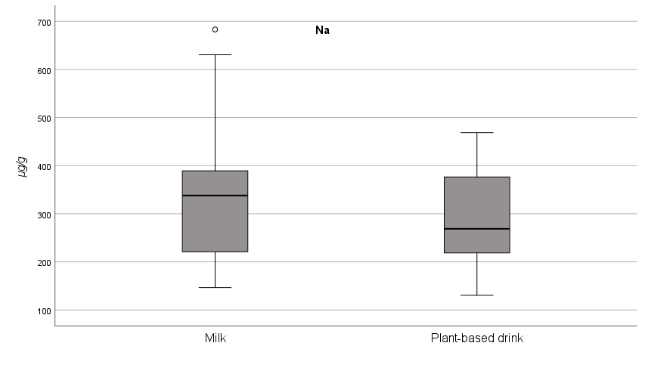
Figure S3. Box plot of Na concentrations in milks and plant-based drinks.

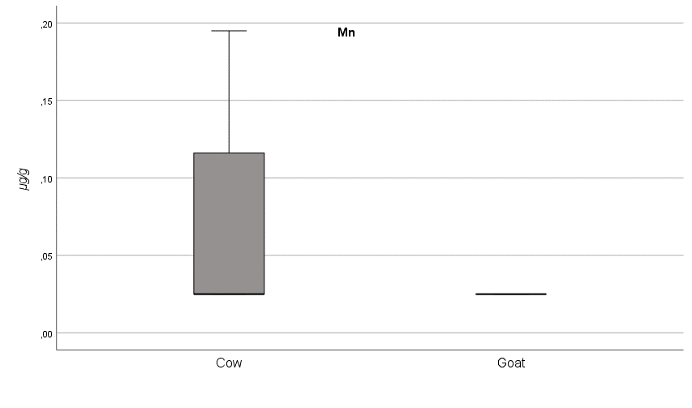
Figure S4. Box plot of Mn concentrations in cow and goat milks.

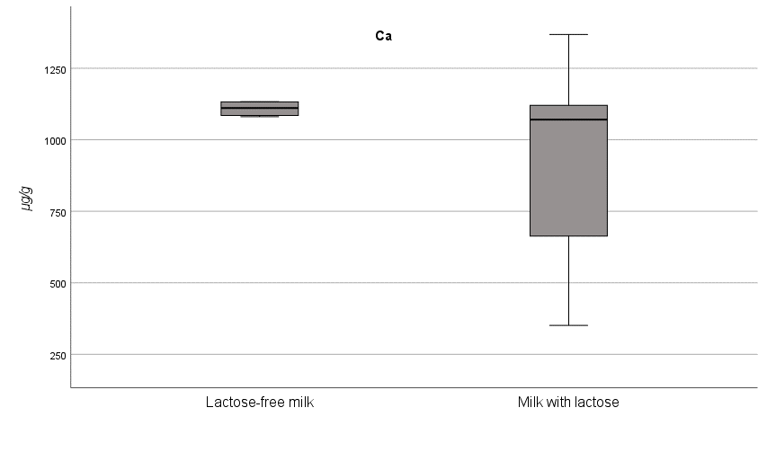
b)
a)
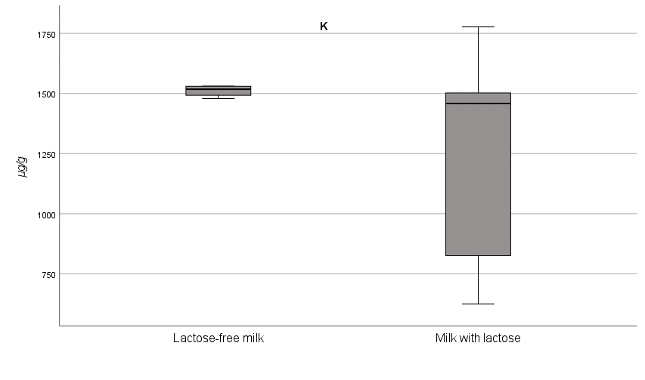
c)
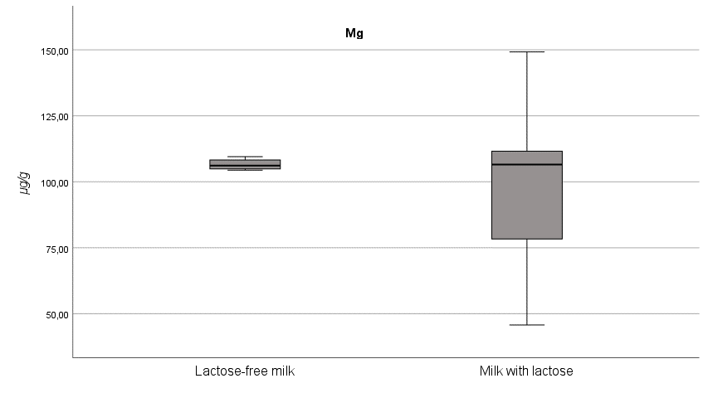
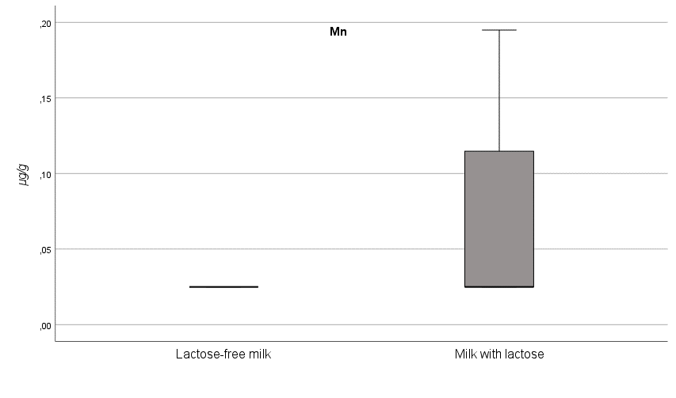
e)
d)
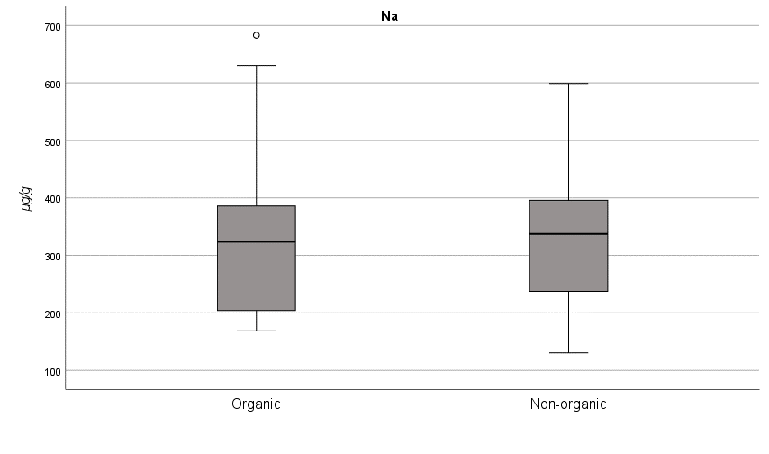
Lactose-free milk
Milk with lactose
f)
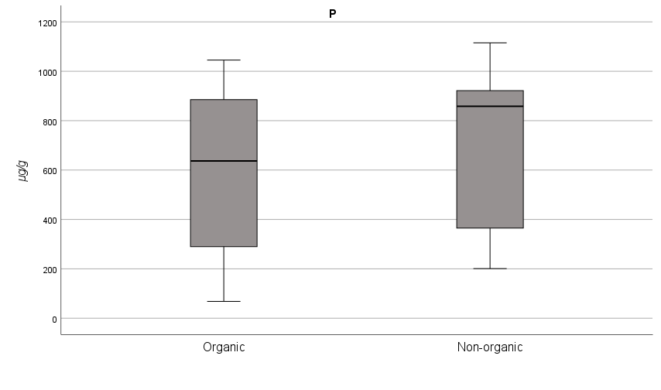
Milk with lactose
Lactose-free milk
Lactose-free

Figure S5. Box plots Ca (a), K (b), Mg (c), Mn (d), Na (e), P (f) concentrations in lactose and lactose-free milks.

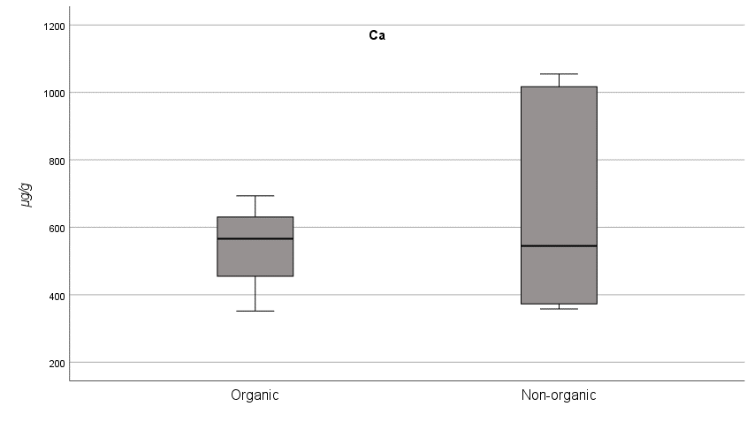
b)
a)
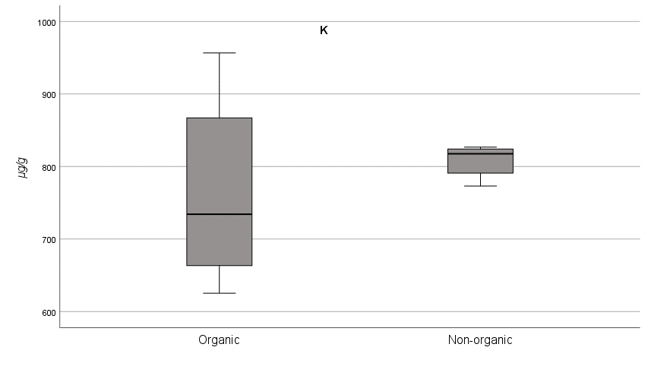
c)
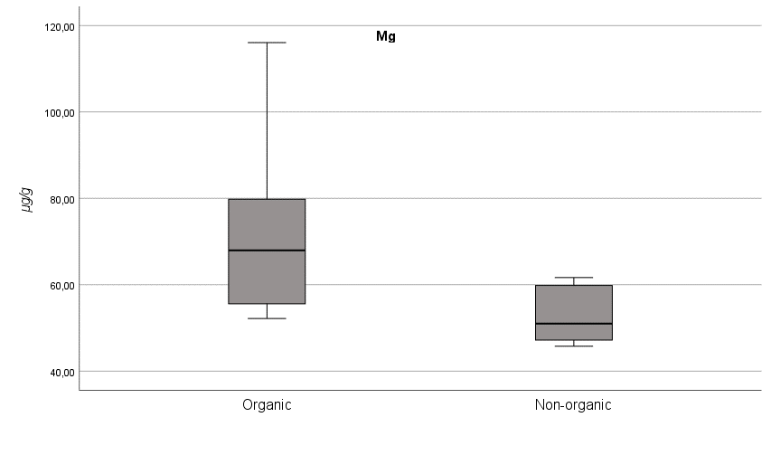
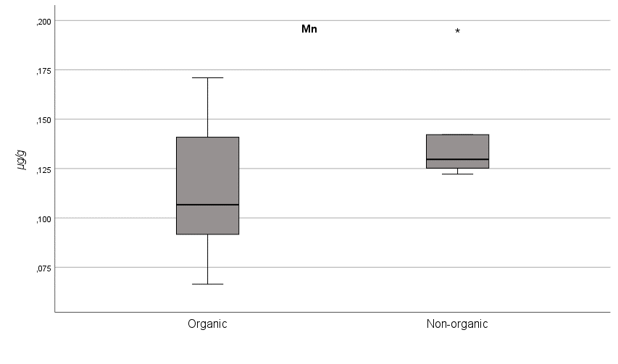
e)
d)
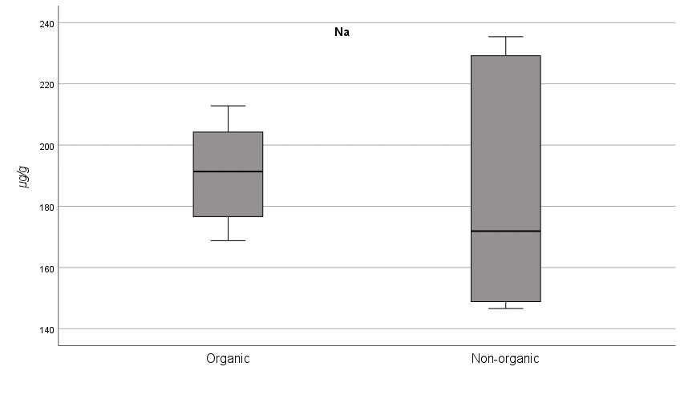
f)
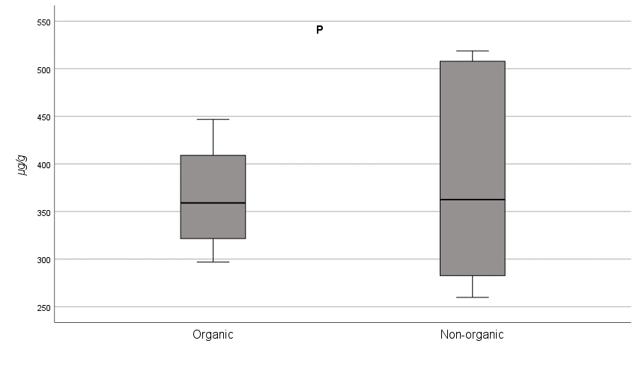
Figure S6. Box plots Ca (a), K (b), Mg (c), Mn (d), Na (e), P (f) concentrations in formula milks according to the production system (organic or non-organic).

