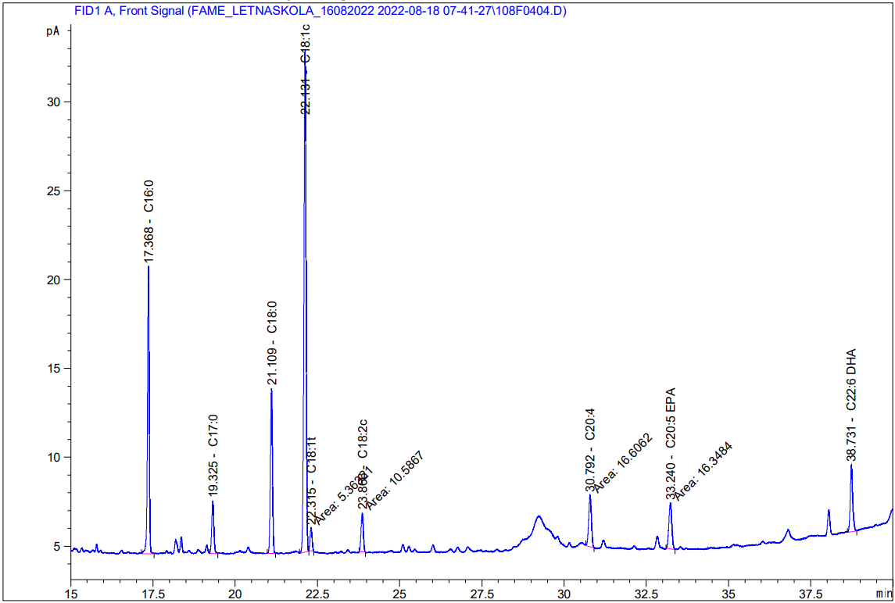
Figure S1. GC chromatogram of fish sample analysis

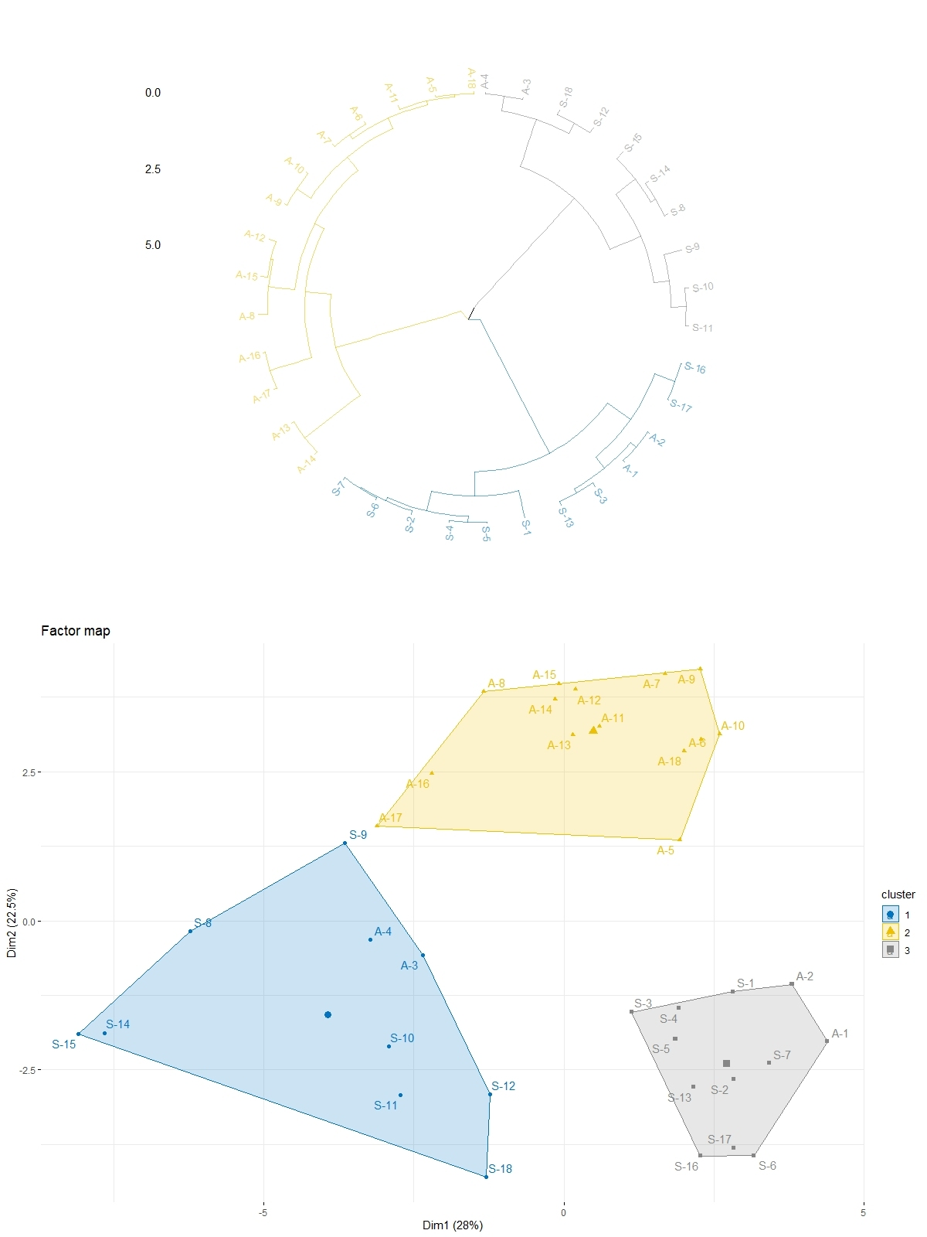
Figure S2 Cluster dendrogram and Factor map.

Figure S3 Results of estimated daily intake (EDI) (µg/kg/person); columns represent mean ± SD; the level of significance was set at *p < 0.05; ** p < 0.01; *** p < 0.001.

