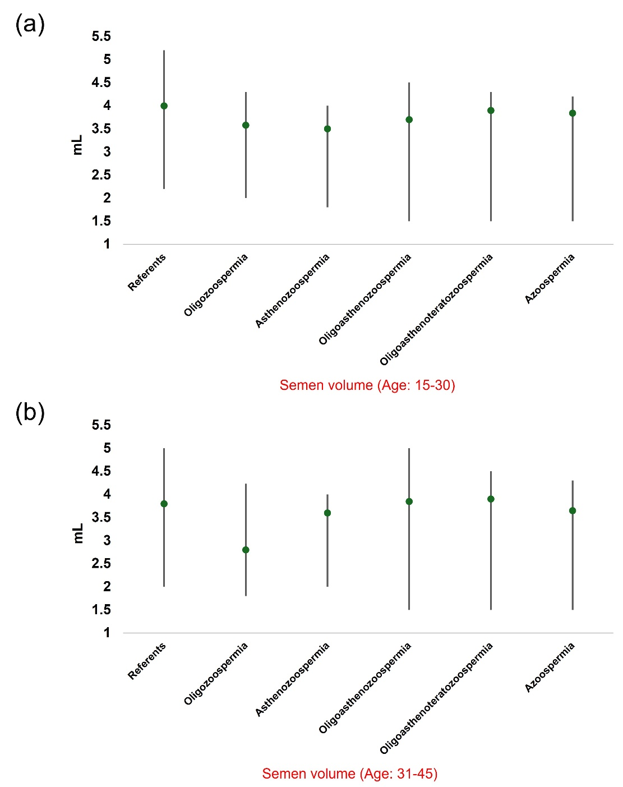
Supplementary Figure S1. Comparison of semen volume across various sperm disorders and the normal range for two different age groups: (a) 15-30 years and (b) 31-45 years.

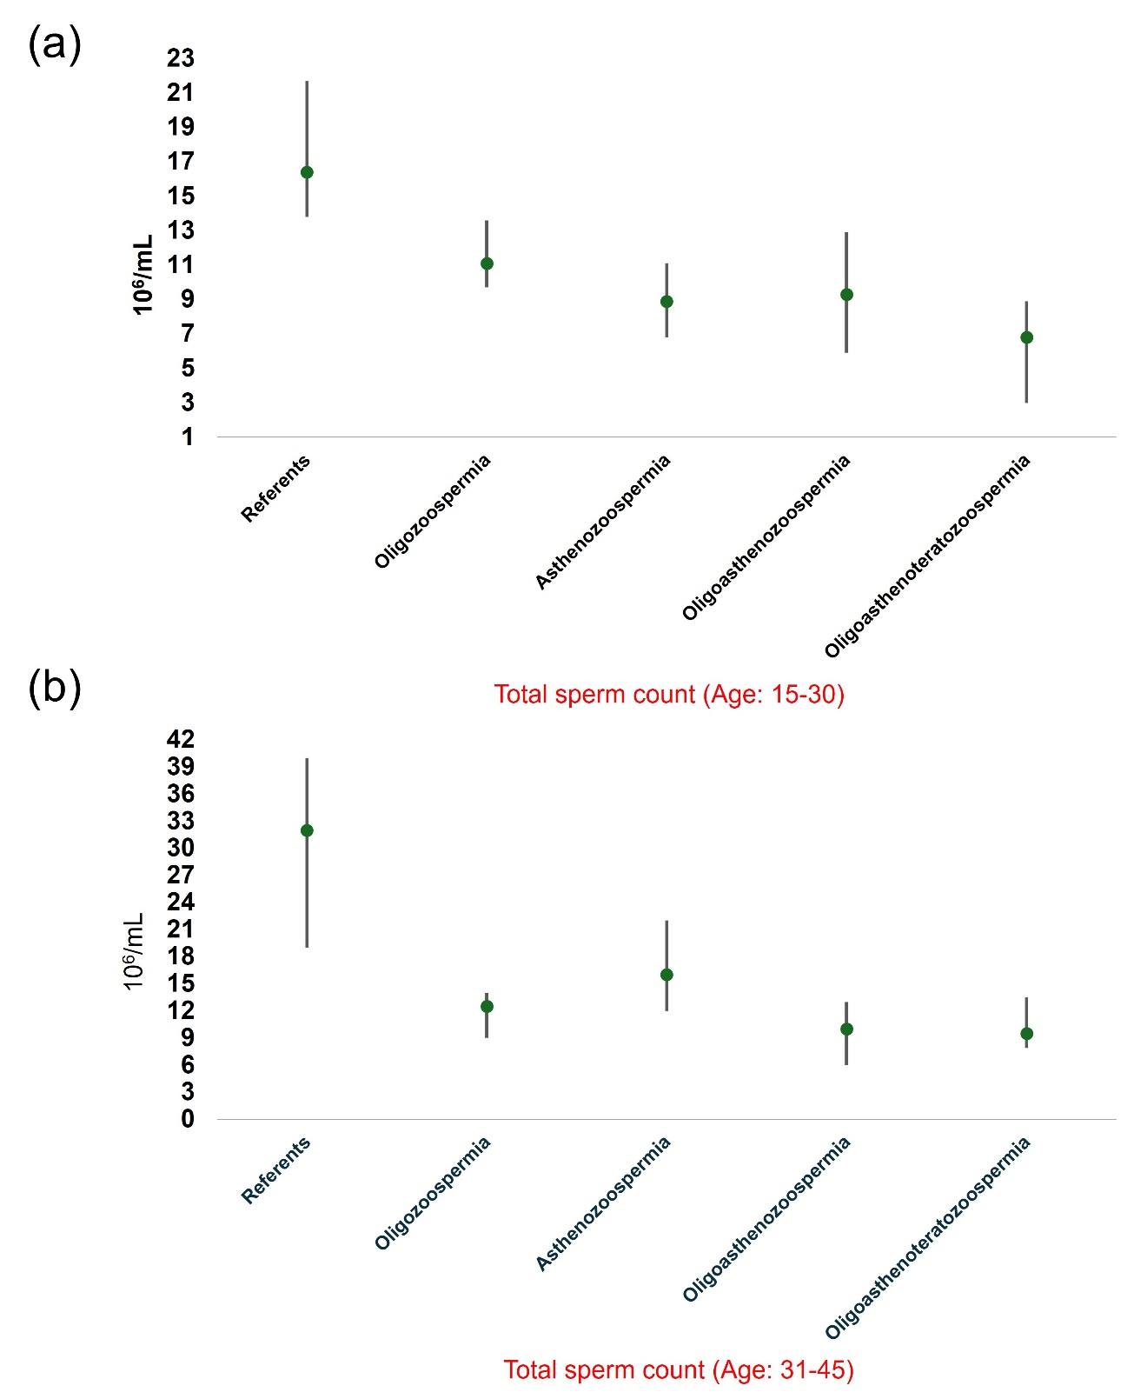
Supplementary Figure S2. Comparison of semen volume across various sperm disorders and the control range for two different age groups: (a) 15-30 years and (b) 31-45 years.

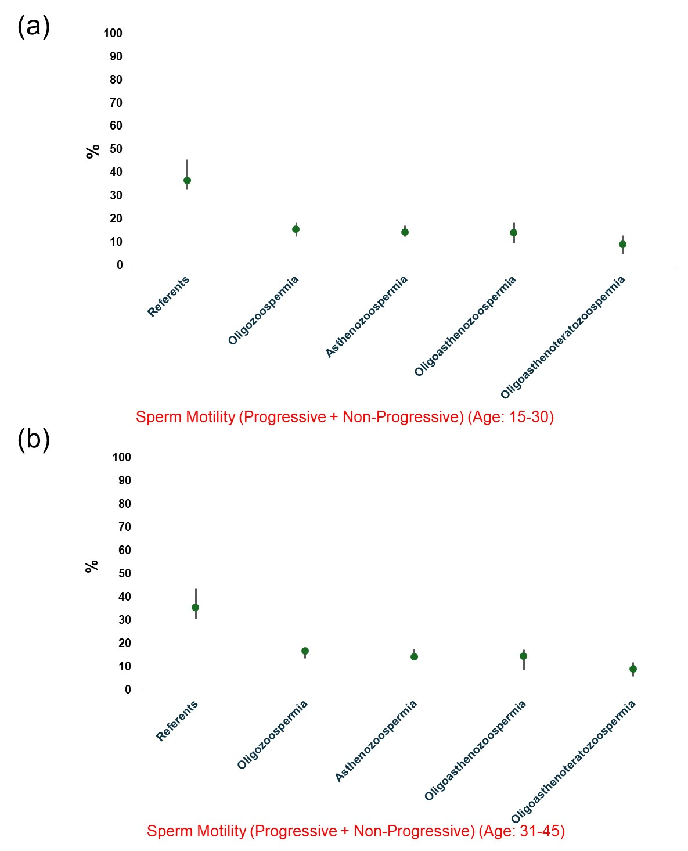
Supplementary Figure S3. The motility of spermatozoa (progressive + non-progressive motility) across various sperm disorders. The data is stratified into two distinct age groups: (a) 15-30 years and (b) 31-45 years. Motility is presented as percentage values. The median value in each category is represented by a green dot.
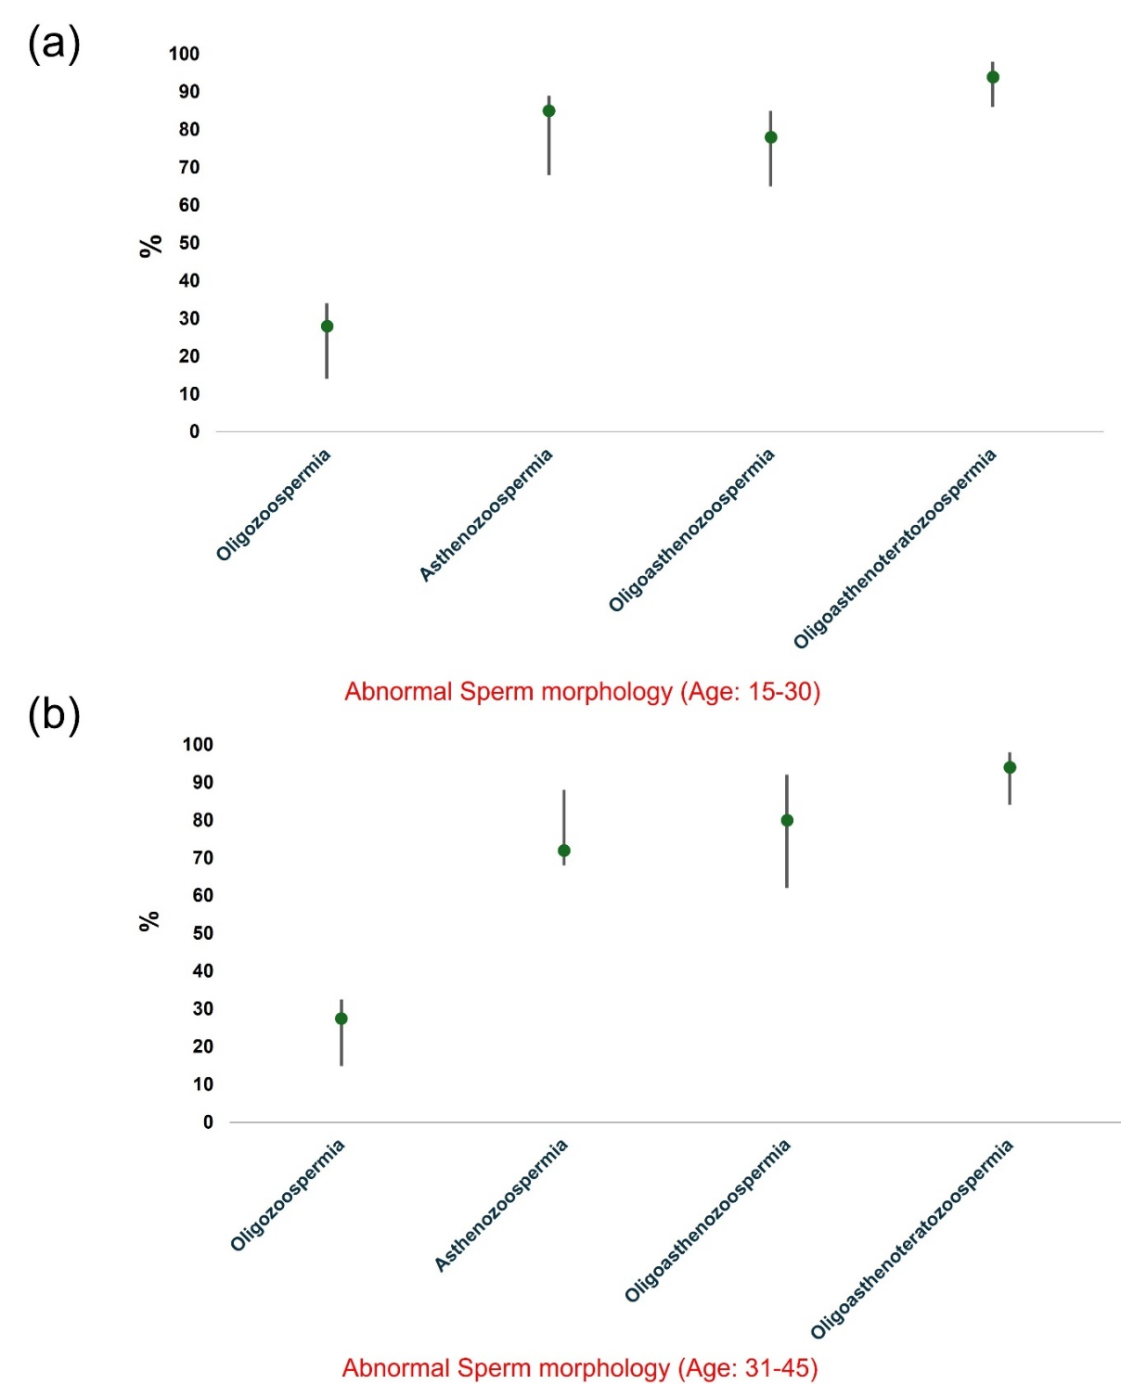

Supplementary Figure S4. Abnormal sperm morphology in various sperm disorders for two different age groups: (a) 15-30 years and (b) 31-45 years, presented as percentage values. The green dot indicates the median value.

