Supplementary file 3
Figure S1. Pooled correlation between HDL-C and serum selenium level in males.
Figure S2. Pooled correlation between HDL-C and serum selenium level in females.
Figure S3. Pooled correlation between LDL-C and serum selenium level in females.
Figure S4. Pooled correlation between TG and serum selenium level in males.
Figure S5. Pooled correlation between TG and serum selenium level in females.
Figure S6. Pooled correlation between TC and serum selenium level in males.
Figure S7. Pooled correlation between TC and serum selenium level in females.
Figure S8. Leave-one-out sensitivity analysis correlation between HDL-C and serum selenium level among adults.
Figure S9. Leave-one-out sensitivity analysis correlation between LDL-C and serum selenium level among adults.
Figure S10. Leave-one-out sensitivity analysis correlation between TG and serum selenium level among adults.
Figure S11. Leave-one-out sensitivity analysis correlation between TC and serum selenium level among adults.
Figure S12. Funnel plot for publication bias of correlation between TC and serum selenium level among adults.
Figure S13. Funnel plot for publication bias of correlation between LDL-C and serum selenium level among adults.
Figure S14. Funnel plot for publication bias of correlation between TG and serum selenium level among adults.
Figure S15. Funnel plot for publication bias of correlation between HDL-C and serum selenium level among adults.

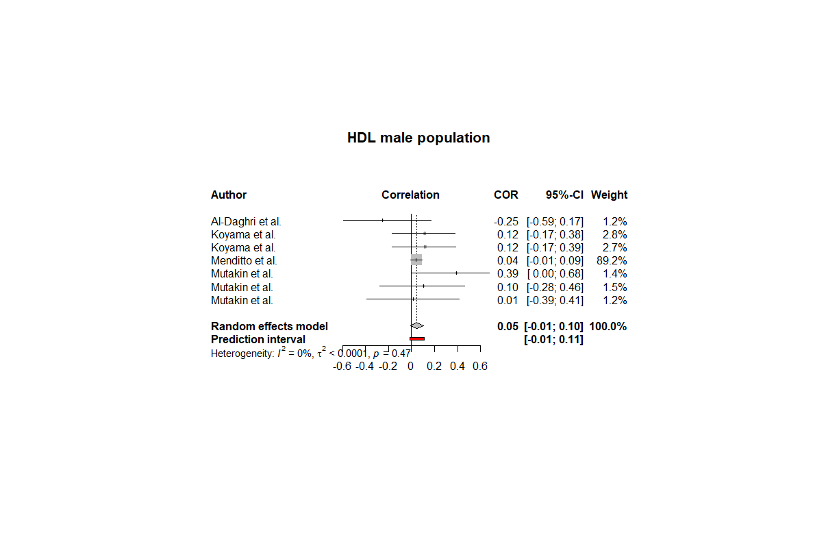
Figure S1. Pooled correlation between HDL-C and serum selenium level in males.

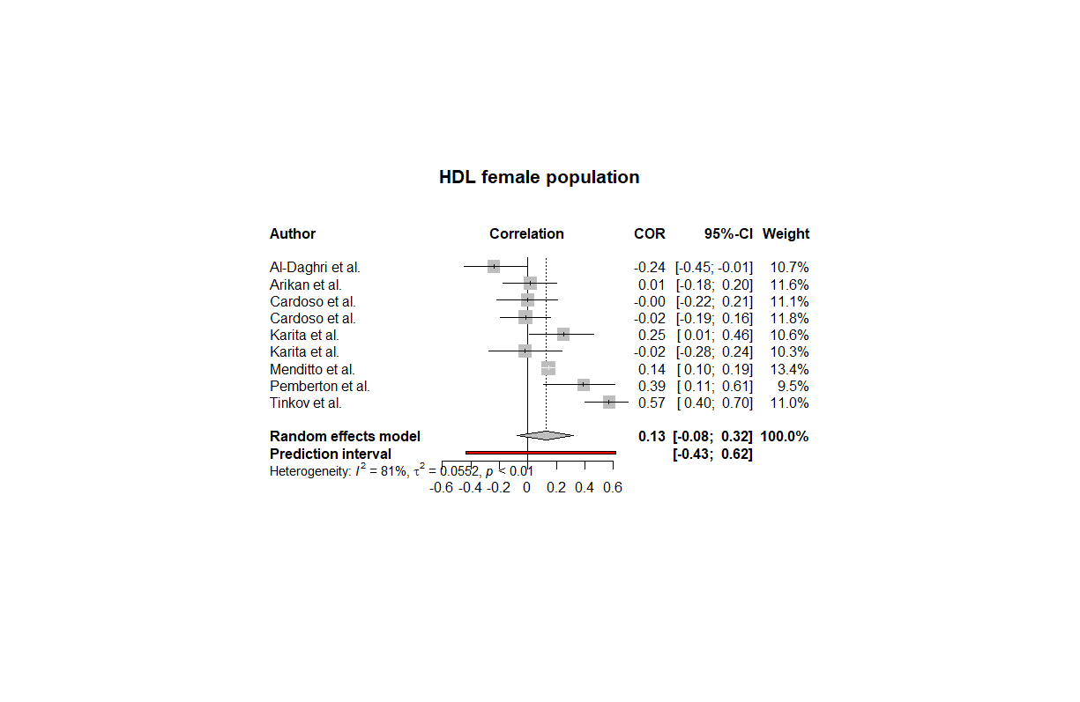
Figure S2. Pooled correlation between HDL-C and serum selenium level in females.

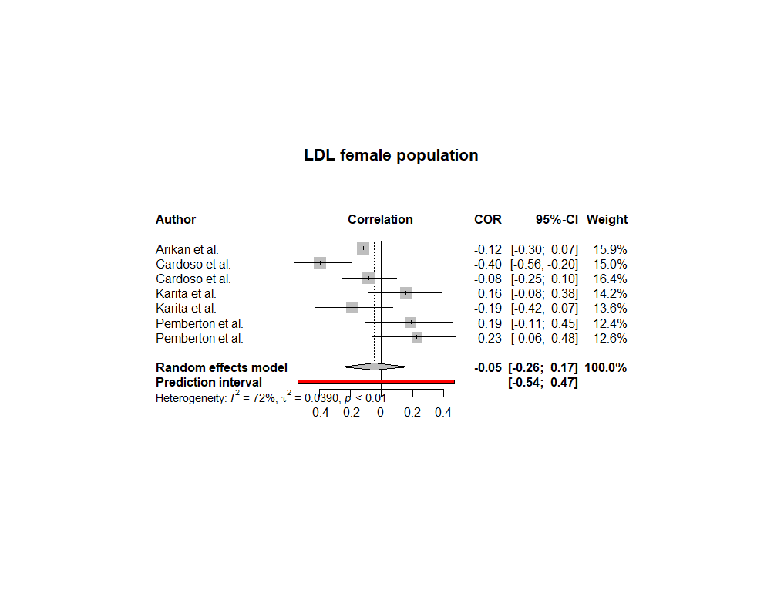
Figure S3. Pooled correlation between LDL-C and serum selenium level in females.

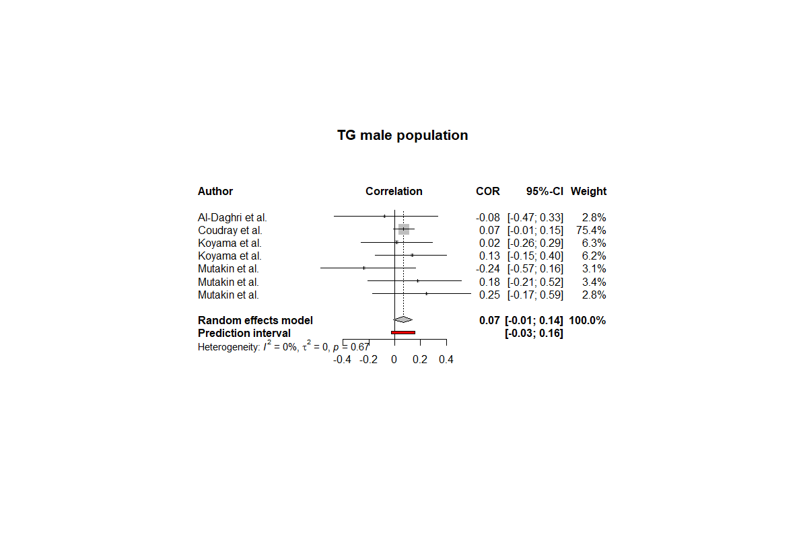
Figure S4. Pooled correlation between TG and serum selenium level in males.

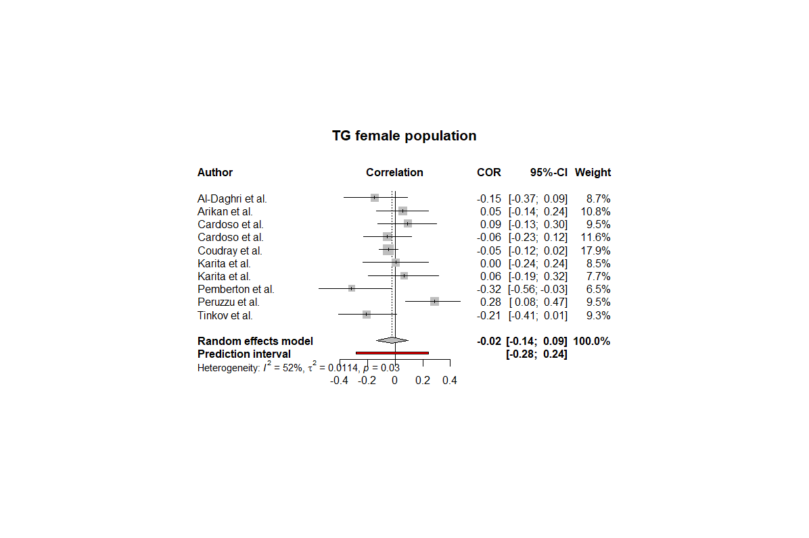
Figure S5. Pooled correlation between TG and serum selenium level in females.

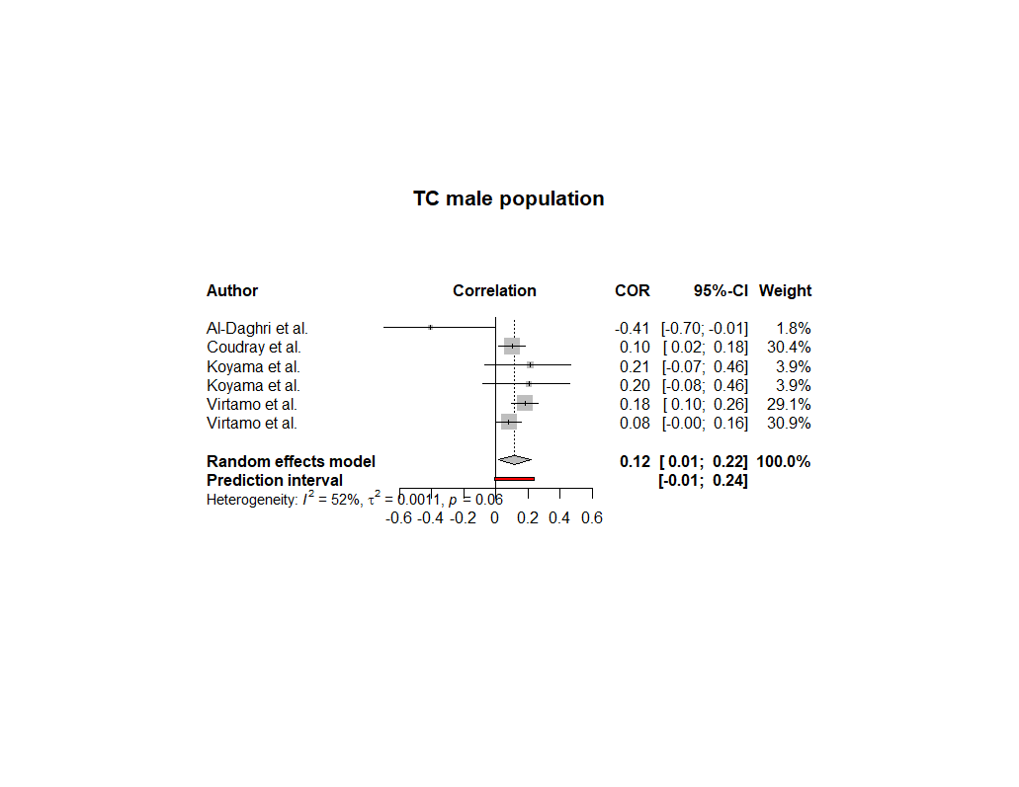
Figure S6. Pooled correlation between TC and serum selenium level in males.

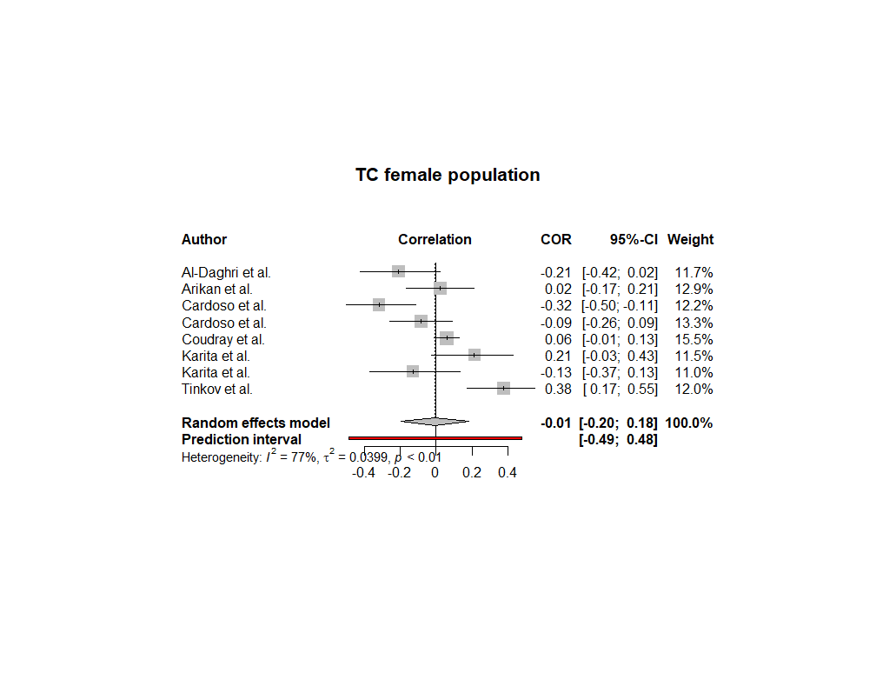
Figure S7. Pooled correlation between TC and serum selenium level in females.

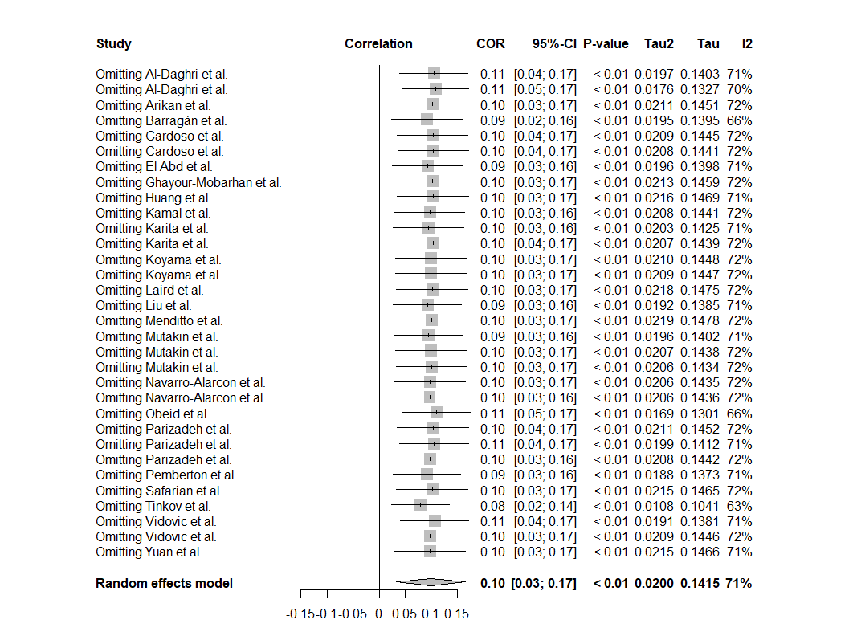
Figure S8. Leave-one-out sensitivity analysis correlation between HDL-C and serum selenium level among adults.

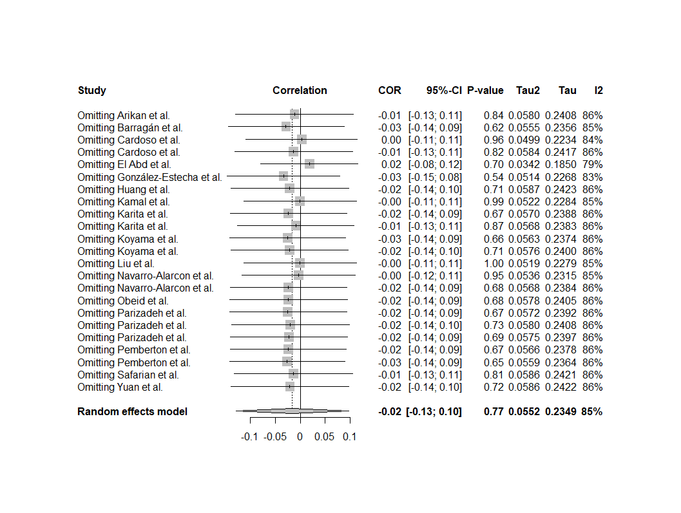
Figure S9. Leave-one-out sensitivity analysis correlation between LDL-C and serum selenium level among adults.

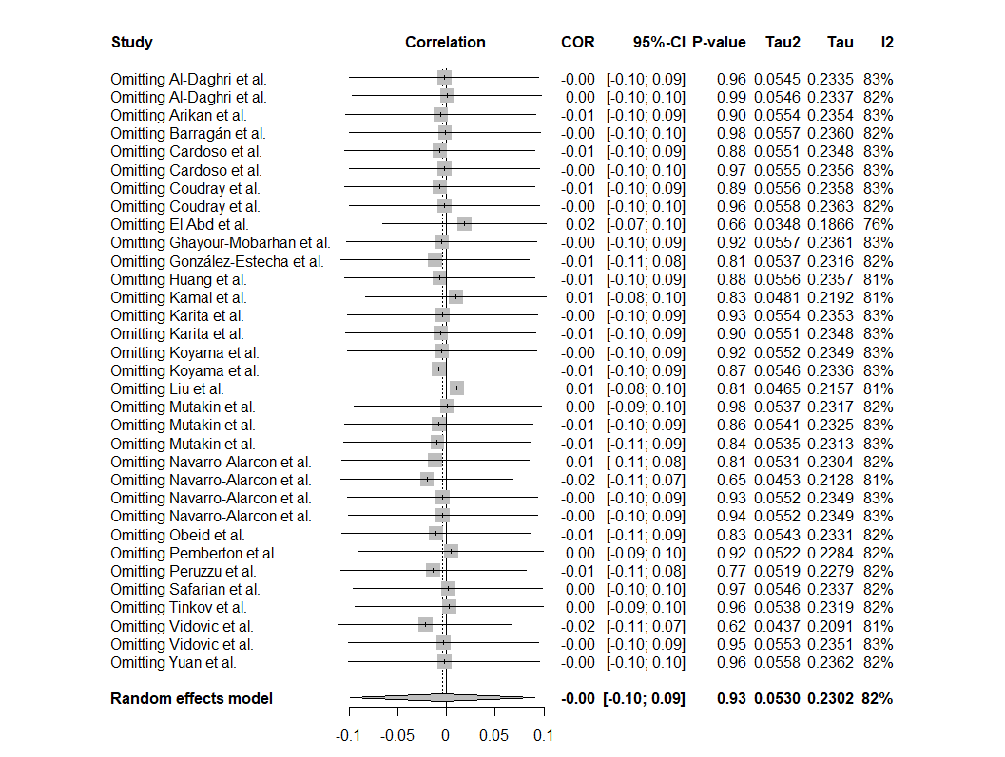
Figure S10. Leave-one-out sensitivity analysis correlation between TG and serum selenium level among adults.

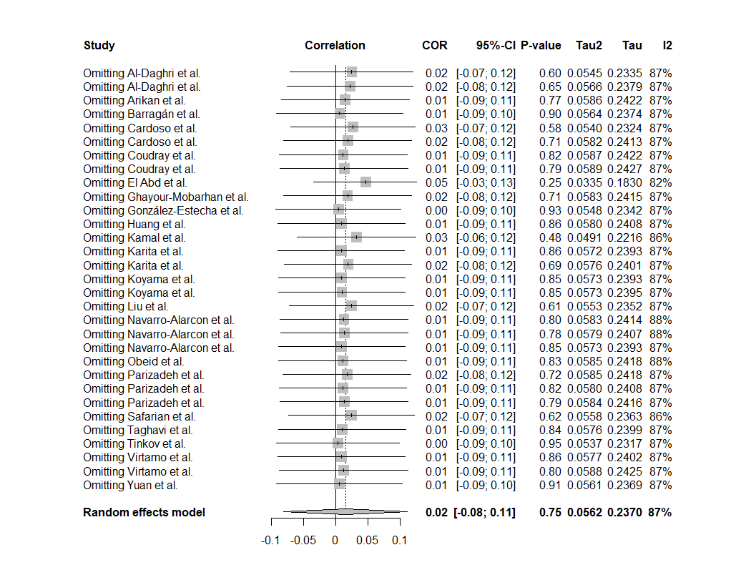
Figure S11. Leave-one-out sensitivity analysis correlation between TC and serum selenium level among adults.

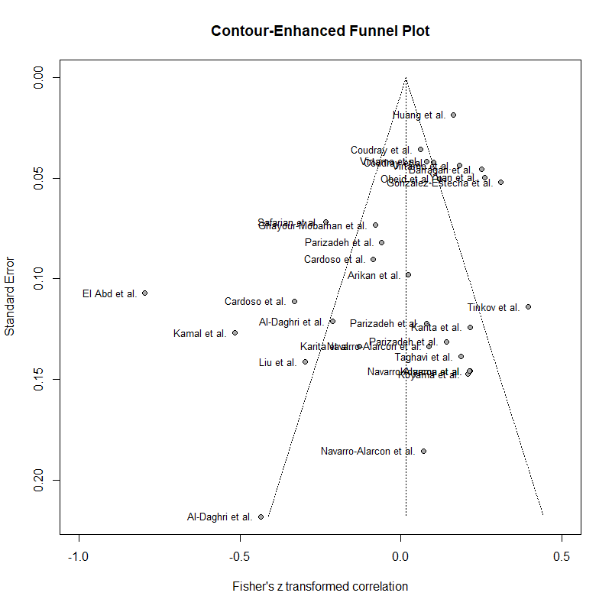
Figure S12. Funnel plot for publication bias of correlation between TC and serum selenium level among adults.

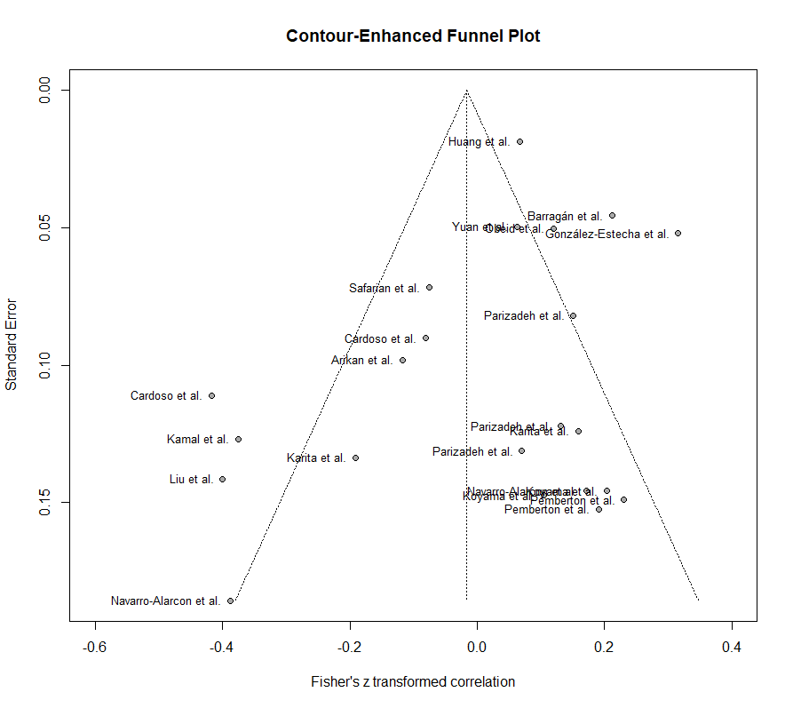
Figure S13. Funnel plot for publication bias of correlation between LDL-C and serum selenium level among adults.

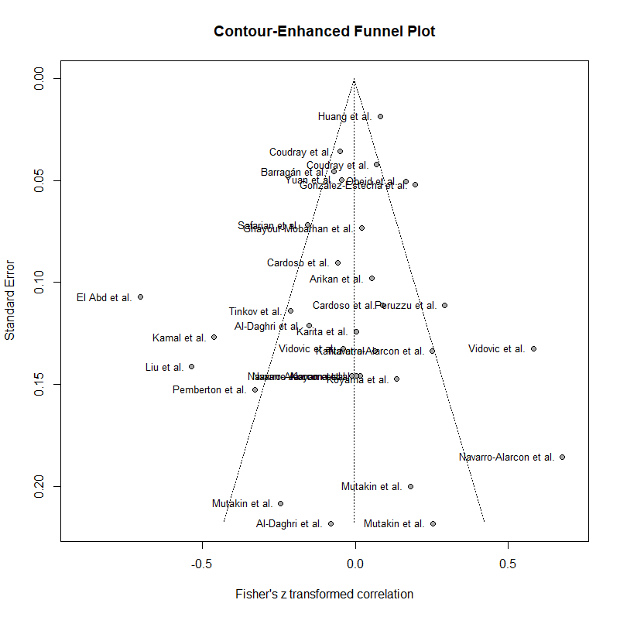
Figure S14. Funnel plot for publication bias of correlation between TG and serum selenium level among adults.

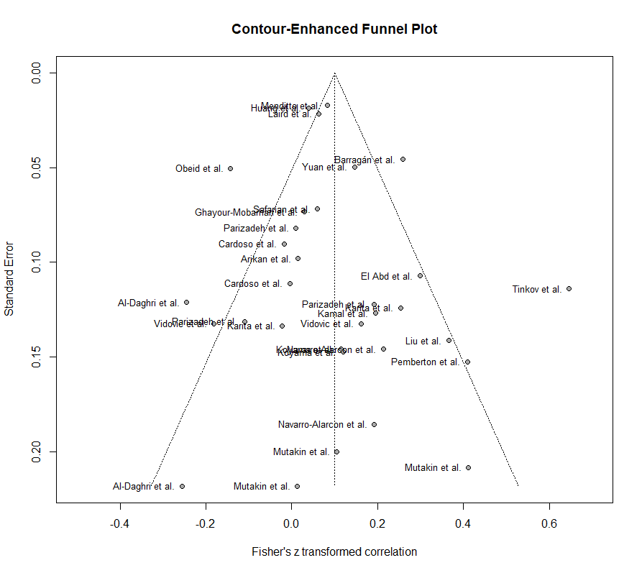
Figure S15. Funnel plot for publication bias of correlation between HDL-C and serum selenium level among adults.

