Table 1: Summary of unadjusted and adjusted p-values and odds ratios for the association of essential trace element levels between POI patients (n = 40) and controls (n = 41) in urine
Trace elements in urine | Unadjusted p value | Adjusted p value on age and BMI
Mn_U/SG: POI < HC; LOD > 80 % | p = 0.369¹ | p = 0.799²
Cu_U/SG: POI < HC | p < 0.001¹ | p < 0.001²
Zn_U/SG: POI < HC | p < 0.001¹ | p = 0.005²
Se_U/SG: POI < HC | p < 0.001¹ | p < 0.001²
Mo_U/SG: POI < HC | p < 0.001¹ | p = 0.009²
As_U/SG: POI < HC | p = 0.064¹ | p = 0.570²
Cd_U/SG: POI < HC | p < 0.001¹ | p < 0.001²
Hg_U/SG: POI < HC | p < 0.001¹ | p < 0.001²
Pb_U/SG: POI < HC | p < 0.001¹ | p = 0.515²

Legend: POI – premature ovarian insufficiency, HC – healthy control, LOD – level of detection, Mn_U/SG – urinary manganese normalised on specific gravity, Cu_U/SG – urinary copper normalised on specific gravity, Zn_U/SG – urinary zinc normalised on specific gravity, Se_U/SG – urinary selenium normalised on specific gravity, Mo_U/SG – urinary molybdenum normalised on specific gravity, Mo_U/SG – urinary molybdenum normalised on specific gravity, As_U/SG – urinary arsenic normalised on specific gravity, Cd_U/SG – urinary cadmium normalised on specific gravity, Hg_U/SG – urinary mercury normalised on specific gravity, Pb_U/SG – urinary lead normalised on specific gravity, 1 – Mann Whitney test, 2 – Logistic regression model, BMI – body mass index

Table 2: Summary of unadjusted and adjusted p-values and odds ratios for the association of essential trace element levels between POI patients (n = 40) and controls (n = 41) in whole blood
Trace elements in whole blood | Unadjusted p value | Adjusted p value on age, BMI, Ht*
Mn_WB*: POI > HC | p = 0.275² | p = 0.011³
Cu_WB: POI > HC | p < 0.017² | p = 0.608³
Zn_WB*: POI > HC | p < 0.001¹ | p = 0.975³
Se_WB: POI < HC | p = 0.817² | p = 0.647³
Mo_WB: POI < HC | p = 0.020² | p = 0.952³
As_WB: POI > HC | p = 0.702² | p = 0.514³
Cd_WB*: POI > HC | p = 0.835² | p = 0.645³
Hg_WB*: POI < HC | p = 0.184² | p = 0.093³
Pb_WB*: POI > HC | p = 0.040² | p = 0.078³

Legend: POI – premature ovarian insufficiency, HC – healthy control, Mn_WB – whole blood manganese, Cu_WB – whole blood copper, Zn_WB – whole blood zinc, Se_WB – whole blood selenium, Mo_WB - whole blood molybdenum, As_WB – whole blood arsenic, Cd_WB – whole blood cadmium, Hg_WB – whole blood mercury, Pb_WB – whole blood lead, 1 – Student T test for independent samples, 2 – Mann Whitney test, 3 – Logistic regression model, BMI – body mass index, Ht – hematocrit

Table 3: Summary of unadjusted and adjusted p-values and odds ratios for the association of trace element levels between POI patients (n = 40) and controls (n = 41) in serum
Trace elements in serum | Unadjusted p value | Adjusted p value on age and BMI
Mn_S: POI > HC | p = 0.009¹ | p = 0.128²
Cu_S: POI > HC | p < 0.001¹ | p = 0.004²
Zn_S: POI > HC | p = 0.658¹ | p = 0.674²
Se_S: POI < HC | p = 0.174¹ | p = 0.358²
Mo_S: POI < HC | p = 0.438¹ | p = 0.342²
As_S: POI < HC | p = 0.195¹ | p = 0.310²
Cd_S: POI < HC | p = 0.001¹ | p = 0.027²
Hg_S: POI < HC | p < 0.001¹ | p = 0.007²
Pb_S: POI < HC | p < 0.001¹ | p = 0.001²

Legend: POI – premature ovarian insufficiency, HC – healthy control, Mn_S - serum manganese, Cu_S - serum copper, Zn_S - serum zinc, Se_S - serum selenium, Mo_S - serum molybdenum, As_S - serum arsenic, Cd_S - serum cadmium, Hg_S - serum mercury, Pb_S – serum lead, 1 – Mann Whitney test, 2 – Logistic regression model, BMI – body mass index, Ht – hematocrit
Logistic regression models for urine TEs

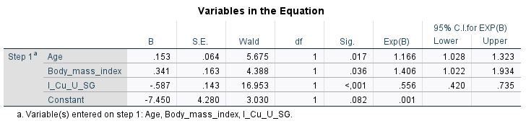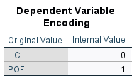
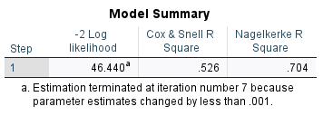
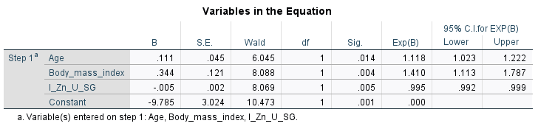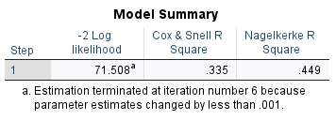
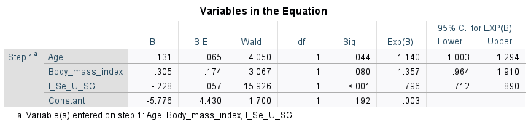
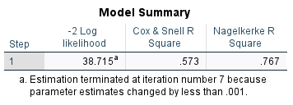
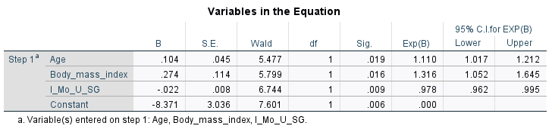
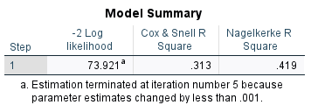

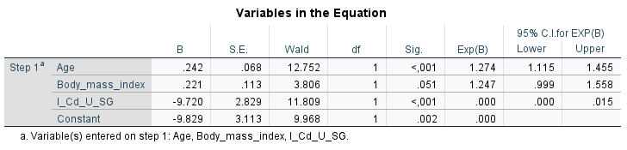
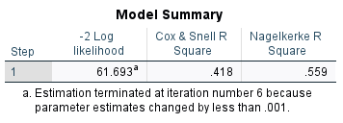
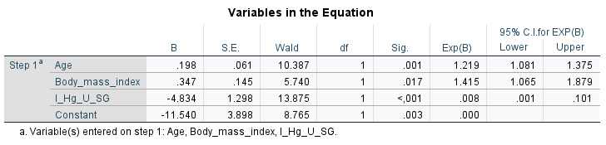
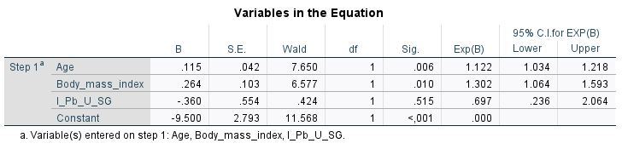
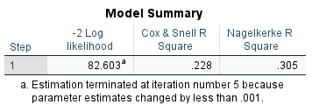
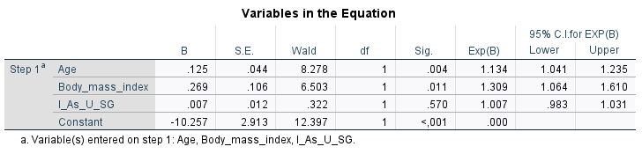
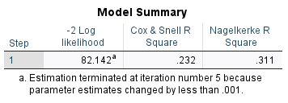
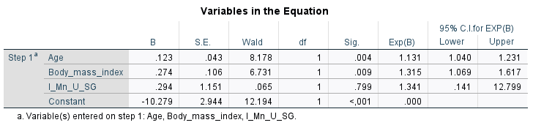
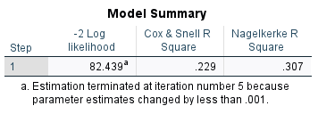

Logistic regression models for whole blood TEs
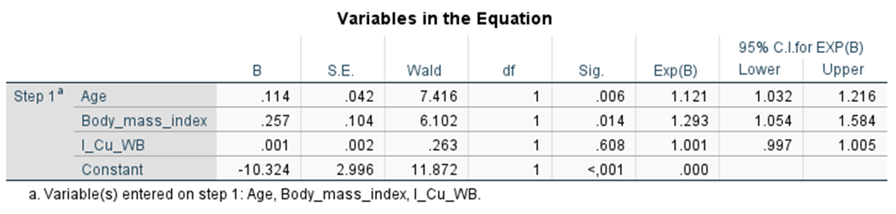
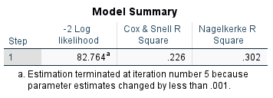
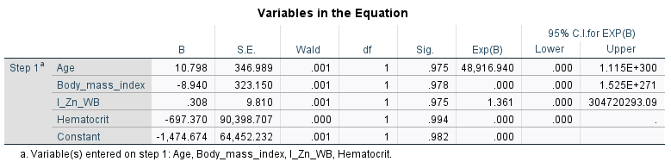
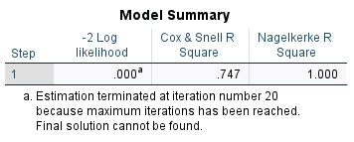

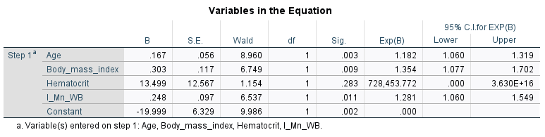
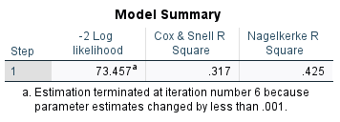

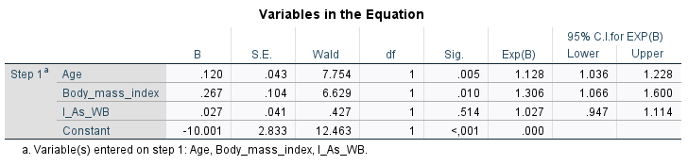
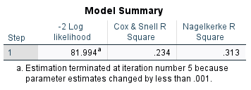
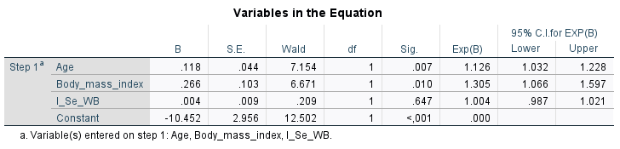
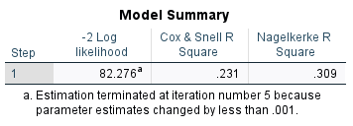

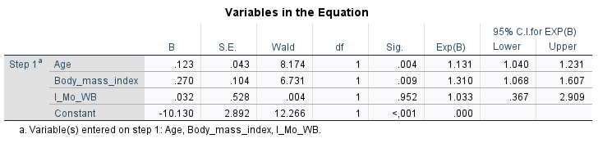
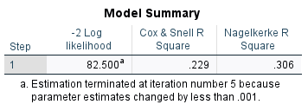
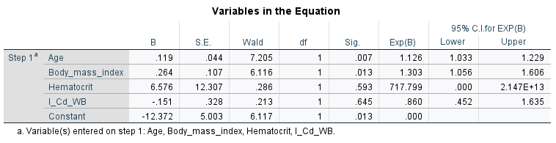
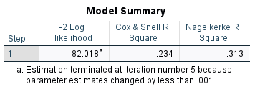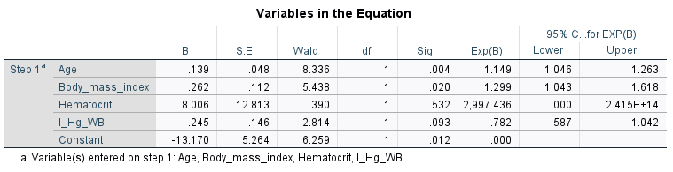
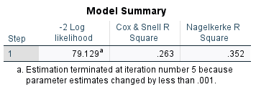

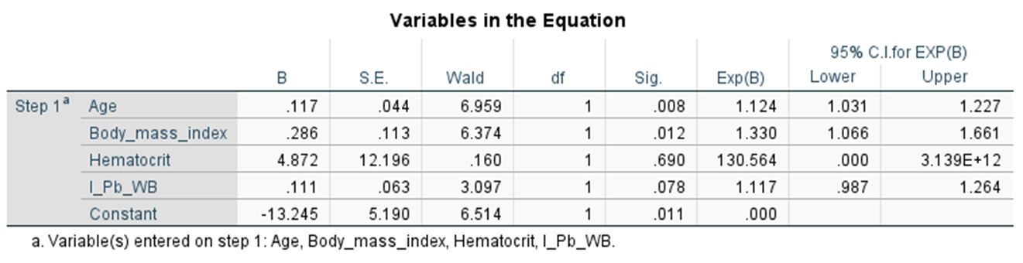
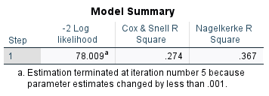
Logistic regression models for serum TEs
