Supplementary Figures
Supplementary Fig. 1 title: Participant inclusion flowchart
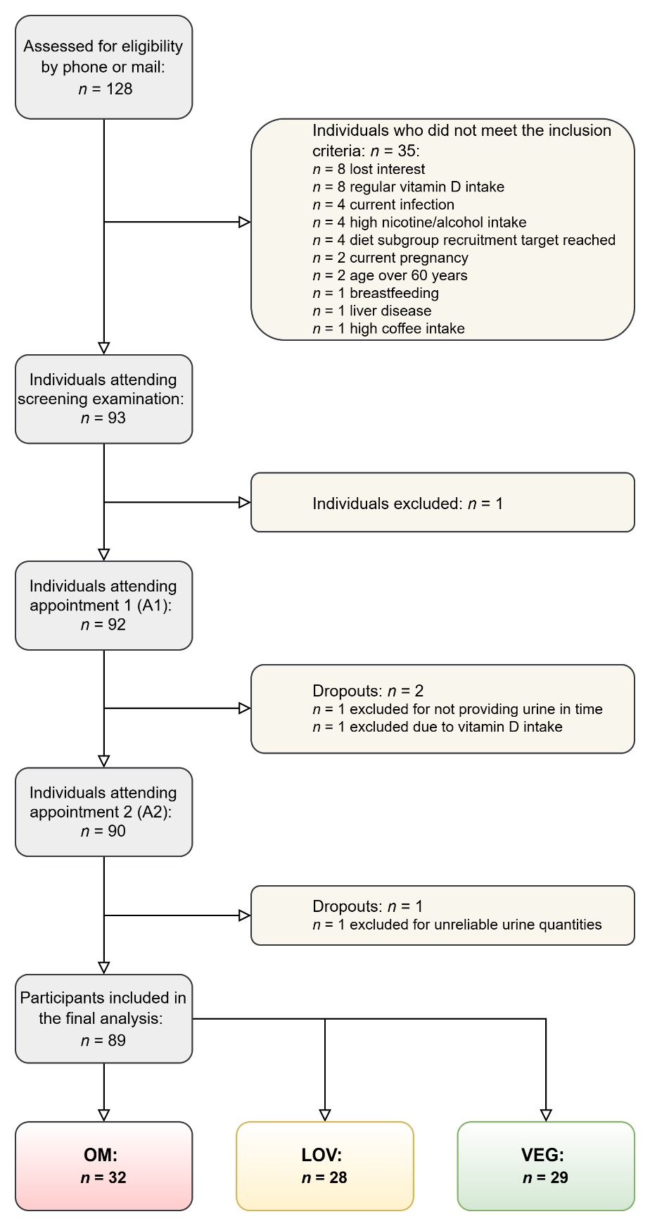
Supplementary Table 1 legend: OMN = Omnivores. LOV = Lacto-ovo-vegetarians. VN = Vegans.

