Table 1. General information of the donors and patients.
Group | ID | Gender | Age  (year) | Weight (kg) | High (m) | Hypertension | Smoking | Alcohol | Blood Pressure (mmHg)
donor | 2030337 | Female | 28 | 80 | 1.8 | No | No | No | 110/70
donor | 2032515 | Male | 40 | 45 | 1.72 | No | No | No | 116/64
donor | 1007036 | Male | 52 | 68.5 | 1.6 | No | No | No | 110/62
AAD | 2029974 | Female | 60 | 49 | 1.58 | Yes | No | No | 123/69
AAD | 2021615 | Female | 63 | 63 | 1.55 | Yes | No | No | 110/70
AAD | 2039998 | Male | 63 | 75 | 1.78 | Yes | No | No | 125/85
AAD | 2041275 | Male | 46 | 85 | 1.75 | Yes | No | No | 118/70

Table 2. IC50 value of Ciprofloxacin on VSMC.

log(inhibitor) vs. normalized response -- Variable slope
Best-fit values
LogIC50 | 110.3
HillSlope | -0.01074
IC50 | 2.127E+110
95% CI (profile likelihood)
LogIC50 | 106.5 to 114.2
HillSlope | -0.01197 to -0.009628
IC50 | 2.908e+106 to 1.602e+114
Goodness of Fit
Degrees of Freedom | 25
R squared | 0.9709
Sum of Squares | 535
Sy.x | 4.626
Number of points
# of X values | 30
# Y values analyzed | 27

Figure S1 CCK8 assay of different concentration of Ciprofloxacin.
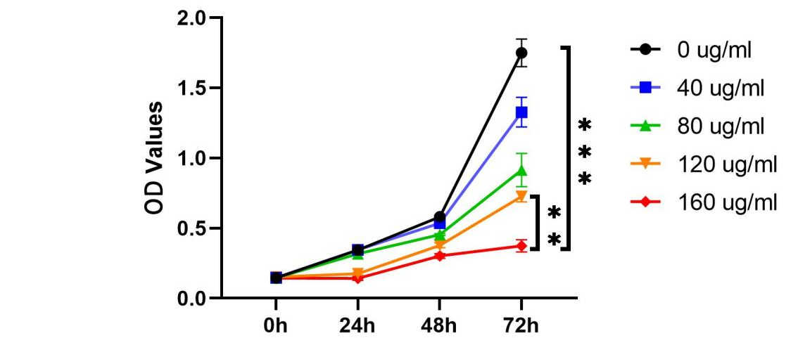

Figure S2 IC50 curve of Ciprofloxacin on VSMC.

