MGST3 Promotes Endometriosis Progression by Suppressing Ferroptosis
Yubing Hu^{1,2,#},Lei Zhang^{1,3,#},Litong Zhu¹,Na Chen¹,Guiyuan Yu¹,Yujin Feng¹,Ping Jin^{1,2,*}
1Department of Gynecology, Shenzhen Maternity and Child Healthcare Hospital, Women and Children's Medical Center, Southern Medical University, Shenzhen 518047, Guangdong, China
2Shenzhen School of Clinical Medicine, Southern Medical University, Shenzhen 518000, Guangdong, China
3State Key Laboratory of Ultrasound in Medicine and Engineering, College of Biomedical Engineering, Chongqing Medical University, Chongqing, China
#Yubing Hu and Lei Zhang are co-first author.
* Ping Jin is corresponding author.
Email:pingjin68@smu.edu.cn(Ping Jin)

Abstract
Background: Endometriosis (EMs) is characterized by dysregulated persistence and enhanced invasiveness of ectopic endometrial cells. Current treatment strategies remain limited by high recurrence rates and considerable adverse effects. Although iron overload is a recognized feature of EMs, ectopic lesions paradoxically demonstrate resistance to ferroptosis, an iron-dependent cell death mechanism. The mechanistic involvement of microsomal glutathione S-transferase 3 (MGST3) in this process remains to be clarified.
Methods and Results: This study examined MGST3 expression and its functional role in EMs using in vitro assays and an in vivo murine model. MGST3 expression was markedly increased in ectopic endometrial cells compared with controls. Functional analyses indicated that MGST3 enhances the invasive phenotype of immortalized human ectopic endometrial stromal cells while concurrently inhibiting apoptosis. Furthermore, treatment with GSTO-IN-2 in the mouse model attenuated ectopic lesion growth and significantly altered ferroptosis-associated markers. However, due to the lack of specificity of GSTO-IN-2 for MGST3, these in vivo findings cannot be directly attributed to an MGST3-specific effect.
Conclusion: Collectively, these results indicate that MGST3 may play a role in the regulation of ferroptosis in EMs, with its overexpression contributing to ferroptosis-associated survival phenotypes in endometrial stromal cells. MGST3 may therefore serve as a potential biomarker and requires further investigation as a therapeutic target in EMs.
Key words: MGST3, endometriosis, ferroptosis, targeted therapy

Introduction
Endometriosis (EMs) is defined by the ectopic implantation and growth of functional endometrial-like tissue, comprising both glandular and stromal components, at sites outside the uterine cavity and myometrium. Clinically, it is classified into three distinct phenotypes: ovarian, peritoneal, and deep infiltrating EMs. As a common gynecological disorder, it affects approximately 6%–10% of women of reproductive age worldwide^{[1]}.This condition is a major contributor to chronic pelvic pain and infertility. Its multifactorial etiology involves diverse biological processes, including retrograde menstruation, hormonal dysregulation, and coelomic metaplasia, together with dysregulated immune-inflammatory signaling and epigenetic reprogramming^{[2]}. However, the underlying pathogenesis of EMs remains poorly defined^{[3]}. The current clinical management strategies of EMs primarily involves pharmacological therapy and surgical intervention. However, both standalone medical treatment and postoperative therapy largely rely on nontargeted hormonal approaches, which are frequently associated with a range of adverse effects^{[4]}. Therefore, elucidation of the key molecular mechanisms driving its pathogenesis and the development of precise targeted therapeutic strategies have become major research priorities in this field.
EMs is recognized as an inflammatory disorder characterized by a markedly altered immune microenvironment^{[5]}.Redox imbalance and consequent lipid peroxidation are considered central mediators governing the progression of endometriotic lesions^{[6]}. A fundamental pathogenic mechanism involves depletion of the antioxidant defense system resulting from excessive generation of reactive oxygen species (ROS) within the peritoneal cavity. This disequilibrium between pro-oxidant and antioxidant systems ultimately leads to localized or systemic oxidative stress^{[6]}. This disrupted microenvironment directly enhances the survival capacity of ectopic endometrial cells and establishes a self-reinforcing cycle with chronic inflammation, in which both processes potentiate each other and collectively drive disease progression.
The glutathione S-transferase (GST) family represents a critical phase II detoxification enzyme system in cells. Multiple GST isoforms are localized to, or function within, mitochondria and serve as essential regulators of mitochondrial redox homeostasis. These enzymes mediate detoxification by catalyzing the conjugation of glutathione (GSH) to toxic metabolites, including lipid peroxides and electrophilic compounds, thereby protecting mitochondrial membranes, proteins, and mitochondrial DNA from oxidative damage. Their expression is regulated by transcription factors such as SKN-1, and activation of this pathway enhances mitochondrial antioxidant capacity while maintaining metabolic stability. Accordingly, GSTs function as a key link between intracellular antioxidant defense and mitochondrial health^{[22][23]}. Microsomal glutathione S-transferase (MGST3) is primarily localized to the endoplasmic reticulum and mitochondria-associated membranes. It catalyzes the conjugation of GSH to electrophilic substrates, thereby protecting cells and modulating inflammatory signaling through detoxification of ROS and attenuation of oxidative stress^{[7][8][9][10][11]}. However, the role of MGST3 in EMs remains to be elucidated.
In EMs, cyclic bleeding and the accumulation of retained blood lead to erythrocyte rupture, resulting in the release of hemoglobin, heme, and iron derivatives, and consequently a marked increase in iron concentration within cysts^{[13]}. Iron-driven Fenton reactions and autoxidation promote ROS generation, inducing extensive lipid peroxidation and triggering ferroptosis. This iron-dependent form of regulated cell death is characterized by the excessive accumulation of intracellular Fe²⁺, which drives lethal membrane lipid peroxidation and distinguishes it from other forms of programmed cell death. Therefore, iron is causally linked to ferroptosis, acting not only as an initiating factor but also as a driver that sustains and amplifies this process by enhancing oxidative stress and depleting antioxidant defenses. Although ferroptosis is typically induced under conditions of intracellular iron overload, compromised antioxidant capacity, and elevated oxidative stress, endometriotic lesions exhibit an iron-rich microenvironment in which cells paradoxically display increased resistance to ferroptosis, thereby facilitating their survival, progression, and establishment^{[14]}. While ferroptosis resistance appears to be a defining feature of EMs, the mechanisms underlying this refractory phenotype remain incompletely understood.
This study highlights the important contribution of MGST3-associated ferroptosis resistance to the progression of endometriotic lesions. Our findings demonstrate that MGST3 enhances the survival of endometriotic cells by attenuating ferroptosis sensitivity in immortalized human endometrial stromal cells (ihESCs). Upregulation of MGST3 in EMs inhibits ferroptosis in ihESCs and promotes disease progression. The therapeutic potential of targeting MGST3 was further supported in a murine model of EMs, in which pharmacological inhibition of the GST family combined with erastin effectively suppressed lesion growth. Collectively, these results suggest that MGST3 serves as a potential molecular target for the treatment of EMs.

Methods
Clinical samples
This study protocol was approved by the Ethics Committee of Shenzhen Maternity and Child Care Hospital, Women’s and Children’s Medical Center of Southern Medical University (ethics number: SFYLS [2024] 060). Written informed consent was obtained from all participants before enrollment. The study cohort included female patients with EMs diagnosed by laparoscopic surgery and confirmed by postoperative histopathology at Shenzhen Maternal and Child Health Hospital, Women’s and Children’s Medical Center of Southern Medical University from January 2024 to June 2025. Participants were aged 25–50 years and had regular menstrual cycles. The exclusion criteria included receipt of hormone therapy within the preceding 3 months, presence of pelvic cysts, or coexisting endocrine or metabolic disorders. Due to ethical and practical constraints, eutopic endometrial tissues from completely healthy women are difficult to obtain. Therefore, control samples were obtained from patients undergoing diagnosis and treatment for benign gynecological conditions (such as uterine prolapse, endometrial hyperplasia, endometrial polyps, or benign cervical lesions). The control group was required to have no clinical symptoms or signs indicative of EMs or adenomyosis. Detailed clinicopathological data for all enrolled patients, including age, menstrual phase, disease type, pathological stage, pairing status, and assay allocation, are provided in Supplementary Table 1. This study was conducted in accordance with the principles of the Declaration of Helsinki (2013 revision) and was approved by the institutional review board.
Cell culture
ihESCs were purchased from IMMOcell and cultured in Dulbecco’s modified eagle medium/F-12 (Absin, China) supplemented with 10% fetal bovine serum and 1% penicillin/streptomycin (Thermo Fisher, USA). Cells were maintained in a humidified incubator at 37°C with 5% CO₂. Cell purity (>90%) was confirmed by Vimentin immunofluorescence staining. The cells were verified to be pathogen-free (negative for human immunodeficiency virus type 1, hepatitis B virus, and hepatitis C virus, and microbial contamination). Cell line authentication was performed using short tandem repeat profiling, with additional bioinformatics verification using ExPASy.
The hESC line was obtained from Shanghai Zhongqiao Xinzhou Biotechnology Co., Ltd. Cell purity (>90%) was confirmed by Vimentin immunofluorescence staining. Cells were pathogen-free (negative for human immunodeficiency virus type 1, hepatitis B virus, and hepatitis C virus, and microbial contamination) and were cultured in ZMY046 medium (Zhongqiao Xinzhou) under standard conditions (37°C, 5% CO₂). Cell line authentication was performed using short tandem repeat profiling, with additional bioinformatics verification using ExPASy.
Immunohistochemistry
Tissues fixed in 4% paraformaldehyde were embedded in paraffin and sectioned at 4-μm thickness for staining. The sections were incubated at 60°C for 60 min, followed by deparaffinization in xylene and rehydration through a graded ethanol series. Endogenous peroxidase activity was blocked using 3% H₂O₂ for 15 min. Antigen retrieval was performed by microwave heating in sodium citrate buffer (pH = 6.0). Primary antibodies (Supplementary Table 2) were applied and incubated overnight at 4°C. The sections were then incubated with HRP-conjugated goat antirabbit IgG at room temperature for 60 min, followed by visualization using 3,3′-diaminobenzidine (E-IR-R101, Elabscience) for 5 min. After hematoxylin and eosin counterstaining, the sections were dehydrated and mounted.
RNA extraction, quantification, and complementary DNA (cDNA) synthesis
Total RNA was extracted using the NucleoSpin RNA Plus system (MACHEREY-NAGEL). RNA concentration and purity were assessed using an ND-1000 spectrophotometer. cDNA synthesis and reverse transcription quantitative real-time polymerase chain reaction (RT-qPCR) were performed using the Evo M-MLV reverse transcription kit (Erico), which includes a genomic DNA removal step to prevent interference with quantitative analysis. The synthesized cDNA is suitable for both dye-based and probe-based RT-qPCR applications.
RT-qPCR
cDNA synthesis was performed using 1000 ng of total RNA with a commercial kit, following the manufacturer’s instructions. mRNA expressions were quantified using the SYBR Green Pro Taq HS gene expression system (Accurate Biology, Hunan, China). The primers were obtained from Ruibo Biology. Glyceraldehyde 3-phosphate dehydrogenase mRNA was used as the internal reference. Relative gene expression was calculated using the comparative threshold cycle method, as previously described. Primer sequences are listed in Supplementary Table 3.
Western blot
Cells were lysed in radioimmunoprecipitation assay buffer supplemented with protease inhibitors (Beyotime) following three washes with Tris-buffered saline with 0.1% Tween® 20 detergent. Lysates were subjected to ultrasonic disruption and centrifuged at 12,000 × g for 15 min at 4°C. Protein concentrations were determined using the Bradford assay (Thermo Scientific). Equal amounts of protein were separated by 10% sodium dodecyl sulfate–polyacrylamide gel electrophoresis and transferred onto PVDF membranes (Merck). Membranes were blocked with 5% skimmed milk in Tris-buffered saline with 0.1% Tween® 20 detergent for 60 min and incubated overnight at 4°C with primary antibodies (Supplementary Table 2). After washing, membranes were incubated with HRP-conjugated antirabbit IgG secondary antibody for 1 h at room temperature. Protein bands were visualized using an enhanced chemiluminescence kit (STP262, Seyotin), and band intensities were quantified using ImageJ software.
Cell viability assessment
For cell viability analysis, logarithmic-phase cells were seeded into 96-well plates at a density of 5 × 10³ cells per well. After overnight attachment, the cells were incubated with medium containing 10 μL of Cell Counting Kit-8 (CCK-8) reagent (Beyotime) for 90 min at 37°C. Absorbance was measured at 450 nm using a Promega GloMAX microplate reader.
Transwell assay
Cell migration was assessed using 24-well Transwell inserts (Corning; 8 μm pore size, 6.5 mm diameter). Briefly, 2 × 10⁵ ihESCs transfected with small interfering RNA (siRNA) or plasmids were suspended in serum-free medium and seeded into the upper chamber. The lower chamber was filled with Dulbecco’s modified eagle medium/F-12 medium containing 10% fetal bovine serum to establish a chemotactic gradient. After incubation for 72 h at 37°C, nonmigrated cells on the upper surface were removed using a cotton swab. Migrated cells on the lower surface were fixed with paraformaldehyde for 30 min, stained with crystal violet, and imaged using a Leica DMIL LED Fluo microscope.
Wound healing test
The cells (2.5 × 10⁶ cells/well; three replicates per group) were seeded into 6-well plates and cultured to confluence. Linear scratches were created using a pipette tip, and the monolayer was washed with serum-free medium to remove detached cells. Migration was observed under a Leica DMIL LED Fluo microscope (Germany), and representative images were captured at 0, 12, and 24 h. Cells were maintained in serum-free medium throughout the experiment to minimize the influence of proliferation and ensure assay reliability.
Flow cytometry
Apoptosis was evaluated using Annexin V–fluorescein isothiocyanate/PI staining (Absin) according to the manufacturer’s instructions. Briefly, cells were washed with cold PBS, incubated with Annexin V–fluorescein isothiocyanate for 15 min and propidium iodide for 10 min at room temperature in the dark, and then analyzed by flow cytometry. The percentage of apoptotic cells was calculated based on the distribution of stained populations.
Cell transfection (plasmid and siRNA)
ihESCs were cultured to approximately 80% confluence before transfection. Plasmid transfection was performed using the Lipofectamine 3000 system (Thermo Fisher Scientific) according to the manufacturer’s protocol. The constructs included pcDNA3.1 empty vector and pcDNA3.1-MGST3 plasmid (You Bio Bioscience). RNA and protein were extracted from cells at 24 or 48 h post-transfection.
For siRNA transfection, ihESCs at 80% confluence were transfected with MGST3-targeting siRNA (100 nM) using riboFECT CP (RiboBio). Cells were maintained in antibiotic-free complete medium during transfection without medium replacement. After 24 or 48 h, the cells were collected for RNA and protein extraction. The siRNA sequences are provided in Supplementary Table 4.
Intracellular iron levels
Intracellular ferrous ion (Fe²⁺) levels were assessed using FerroOrange (Servicebio). ihESCs were incubated with 1 μM FerroOrange in serum-free medium for 30 min at 37°C with 5% CO₂. Fluorescence signals were measured at excitation 543 nm and emission 580 nm using a Promega GloMAX detection system.
ROS Level Detection
We used a ROS detection kit (Servicebio, China) to detect intracellular ROS levels in ihESCs. Cells were incubated with 2′,7′-dichlorodihydrofluorescein diacetate (10 μM) in serum-free medium for 30 min at 37°C with 5% CO₂. Fluorescence intensity was measured at 525 nm using a Promega GloMAX microplate reader.
Malondialdehyde assay (MDA)
Lipid peroxidation was evaluated by measuring MDA levels using a commercial kit (Beyotime). Cells were lysed on ice for 30 min (lysis buffer for WB/IP), and protein extracts were reacted with thiobarbituric acid working solution. Absorbance was measured at 532 nm using a GloMAX microplate reader.
GSH assay
Intracellular GSH levels were determined using a commercial assay kit (Servicebio, China). ihESCs were subjected to ten freeze–thaw cycles to ensure complete lysis. The lysates were then incubated with GSH detection reagent, and absorbance was measured at 412 nm using a GloMAX microplate reader (Promega, USA).
Lipid peroxidation assay
Lipid peroxidation was assessed using the C11-BODIPY 581/591 fluorescent probe (MCE, HY-D1301). Briefly, ihESCs in the control and si-MGST3 groups were incubated with C11-BODIPY 581/591 working solution at 37°C for 30 min in the dark. After incubation, the cells were washed three times with PBS to remove excess dye. Fluorescence signals were observed and captured using a fluorescence microscope. Oxidized C11-BODIPY fluorescence was detected in the green channel, whereas nonoxidized fluorescence was detected in the red channel. Lipid peroxidation levels were evaluated by comparing fluorescence intensity changes between groups.
Transmission electron microscopy（TEM）
Cell pellets were collected by centrifugation and immediately fixed in electron microscopy fixative at 4°C for 2–4 h. Samples were embedded in 1% buffered agarose (0.1 M PB, pH 7.4) and subsequently fixed with 1% osmium tetroxide in 0.1 M PB at room temperature in the dark. Samples were then dehydrated at room temperature. For embedding, samples were incubated in a 1:1 mixture of acetone and 812 embedding medium (SPI, USA) at 37°C for 2–4 h, followed by infiltration in a 1:2 mixture at 37°C overnight, and finally in pure 812 embedding medium at 37°C for 5–8 h. Polymerization was performed at 60°C. Resin blocks were sectioned into 60–80 nm ultrathin sections and stained before observation under a transmission electron microscope (HITACHI, Japan).
Mouse model of EMs
A total of 35 female C57BL/6 mice (6–8 weeks old) maintained under specific pathogen-free conditions were randomly assigned into seven experimental groups (n = 5 per group). These groups included erastin and ferrostatin-1 treatment groups, vehicle controls (DMSO and corn oil), and three dose groups of GSTO-IN-2 (low, medium, and high). The EMs model was established as follows. In brief, after anesthesia of estradiol-stimulated mice (0.2 mL/mouse), the abdominal cavity was opened with scissors and forceps at approximately 0.5 cm above the urethral orifice, and adipose tissue was separated to expose the uterine horn and Y-shaped uterus. One side of the uterus and its blood vessels was ligated, and the tubular uterus was excised and immersed in normal saline. The uterus was then longitudinally incised, spread flat, and the endometrial tissue was isolated. The endometrium was sutured to the abdominal wall of the mice, the abdominal cavity was wiped and disinfected with iodophor, and the incision was sutured to close the abdomen. Endometriotic lesions developed after 3 weeks. Mice were then treated intraperitoneally with erastin or ferrostatin-1 (20 mg/kg; MCE) or low dose of GSTO-IN-2 ( 10 mg / kg ) or medium dose of GSTO-IN-2 ( 15 mg / kg ) or high dose of GSTO-IN-2 ( 20 mg / kg ) for 2 weeks, following approval by the Ethics Committee of Shenzhen Maternal and Child Health Hospital (Ethical No.: SZMCHH 21-2509-23). DMSO and corn oil served as vehicle controls. At the endpoint, animals were sacrificed, and lesion volumes were calculated using the formula V = 1/2 × A × a2 (A: long radius; a: short radius).
EndometDB - Turku EM Database
MGST3 expression was further validated using EndometDB, which includes mRNA data from 115 patients and 53 controls. This platform provides transcriptomic profiles of over 24,000 genes along with detailed clinical information. MGST3 expressions across different EMs phenotypes (ovarian, peritoneal, and deep infiltrating) were compared with those in healthy endometrial samples. Data were visualized using database-generated box plots. Detailed study design information is available in the original publications^{[34]}.
Statistical analysis
All quantitative data are presented as mean ± SD from at least three independent experiments. Statistical analyses were performed using GraphPad Prism (version 10). Comparisons between groups were conducted using unpaired t-tests or one-way or two-way analysis of variance, as appropriate. All quantitative data were derived from at least three independent biological replicates. Technical replicates in each experiment were averaged before statistical analysis. A p-value of <0.05 was considered statistically significant (*p < 0.05, **p < 0.01, ***p < 0.001), while p ≥ 0.05 was considered not significant (ns).

Results

MGST3 expression is upregulated in EMs
MGST3 expression was significantly upregulated in EMs. Using EndometDB (including gene expression data from 115 patients and 53 controls), we analyzed MGST3 expression across deep infiltrating EMs (bladder, intestine, rectum), peritoneal lesions, ovarian EM (OMA), and eutopic endometrium. Compared with control endometrium, MGST3 expression was markedly elevated in all types of endometriotic lesions (Fig. 1A). Validation using clinical samples demonstrated consistency between immunohistochemical findings and bioinformatics analysis. MGST3 protein expression was strongly positive in both epithelial and stromal components of OMA tissues (Figs. 1B and C). In addition, Western blot analysis of clinical samples confirmed a significant increase in MGST3 protein levels in OMA tissues (Fig. 1D). Furthermore, mRNA and protein were extracted from ihESCs and human endometrial stromal cells (HESCs). Compared with HESCs, MGST3 mRNA (Fig. 1E) and protein (Fig. 1F) expressions were significantly increased in ihESCs.
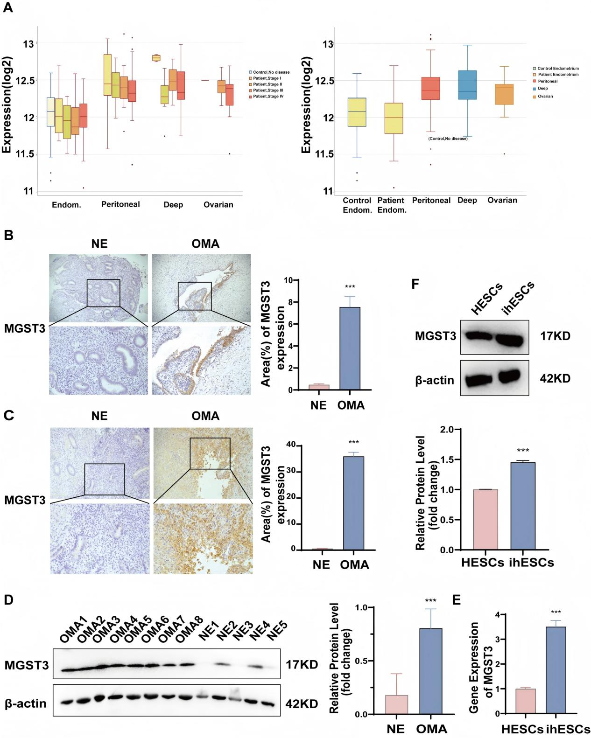
Fig. 1 Microsomal glutathione S-transferase 3 (MGST3) expression is upregulated in EMs A. Differential expression analysis using EndometDB. B. Immunohistochemical (IHC) analysis of MGST3 expression. Representative images (200× and 400×) showing MGST3 immunoreactivity in control endometrium and ectopic epithelial tissue (n = 8). C. MGST3 expression in normal endometrium (NE) and ovarian EM (OMA). Representative IHC images showing MGST3 immunoreactivity in normal endometrial stroma and ectopic ovarian lesions (200× and 400×; n = 8). D. Western blot analysis of MGST3 protein expression in NE and OMA tissues. E. MGST3 mRNA expression in immortalized human endometrial stromal cells (ihESCs) and human endometrial stromal cells (HESCs) determined by reverse transcription quantitative real-time polymerase chain reaction (RT-qPCR). F. Western blot analysis of MGST3 protein expression in HESCs and ihESCs. Statistical significance is indicated as **p < 0.01 and ***p < 0.001.

MGST3 enhances cell survival and migration while inhibiting apoptosis in ihESCs
Following transfection of ihESCs with MGST3-targeting siRNAs or plasmids, knockdown and overexpression efficiencies were validated by RT-qPCR and Western blotting (Figs. 2A and B). These initial validations confirmed the reliability of the selected sequences for subsequent functional analyses. Among the tested siRNAs, si-MGST3-003 exhibited the highest knockdown efficiency and was therefore used in subsequent experiments. Subsequently, ihESCs were transfected with an MGST3 overexpression plasmid, and transfection efficiency was confirmed by RT-qPCR and Western blotting (Figs. 2C and D). Cell viability was then assessed at 0, 24, 48, and 72 h. MGST3 knockdown significantly reduced ihESC viability compared with the untreated group (Fig. 2F), whereas MGST3 overexpression significantly increased cell viability (Fig. 2E). Flow cytometry analysis showed that, compared with the control group, the proportion of apoptotic cells was increased in MGST3-knockdown ihESCs and decreased in MGST3-overexpressing ihESCs (Fig. 2G). Transwell assay was used to evaluate the longitudinal migratory capacity of cells. MGST3 knockdown significantly inhibited the longitudinal migration of ihESCs, whereas MGST3 overexpression markedly enhanced their migratory capacity (Fig. 3A). Scratch assays were used to evaluate the lateral migratory capacity of cells. MGST3 knockdown reduced the lateral migratory capacity of ihESCs, whereas MGST3 overexpression enhanced this capacity (Fig. 3B). Taken together, these results indicate that MGST3 plays a critical role in regulating the survival and migratory capacity of ihESCs.
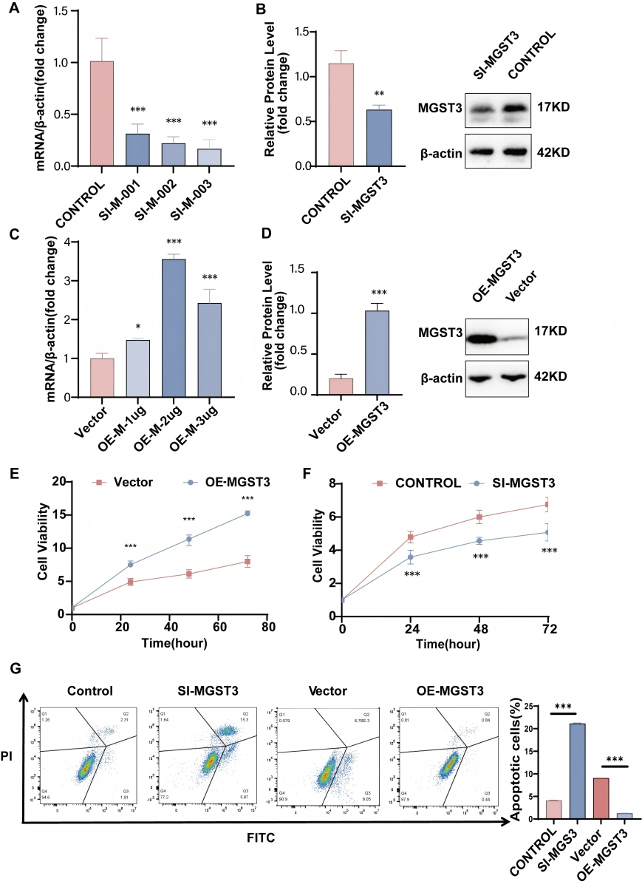
Fig. 2 Microsomal glutathione S-transferase 3 (MGST3) enhances cell survival and inhibits apoptosis in ihESCs. A and B. Reverse transcription quantitative polymerase chain reaction (RT-qPCR) and Western blot were used to detect MGST3 mRNA and protein levels in ihESCs after transfection with siMGST3 (50 nM) or siCON (50 nM) for 24 h. C and D. RT-qPCR and Western blot were used to detect MGST3 protein level in ihESCs 48 h after plasmid (2 μg/μL) transfection. E. ihESCs were treated with the indicated concentration of plasmid for different durations (24, 48, and 72 h), and cell viability was measured using the Cell Counting Kit-8 (CCK-8) assay. F. ihESCs were treated with siMGST3 at the indicated concentration for different durations (24, 48, and 72 h), and cell viability was assessed using the CCK-8 assay. G. Apoptosis was analyzed by flow cytometry in ihESCs transfected with plasmids and/or siRNA to evaluate the effect of MGST3 on apoptotic rate. Statistical significance is indicated as *p < 0.05, **p < 0.01, and ***p < 0.001.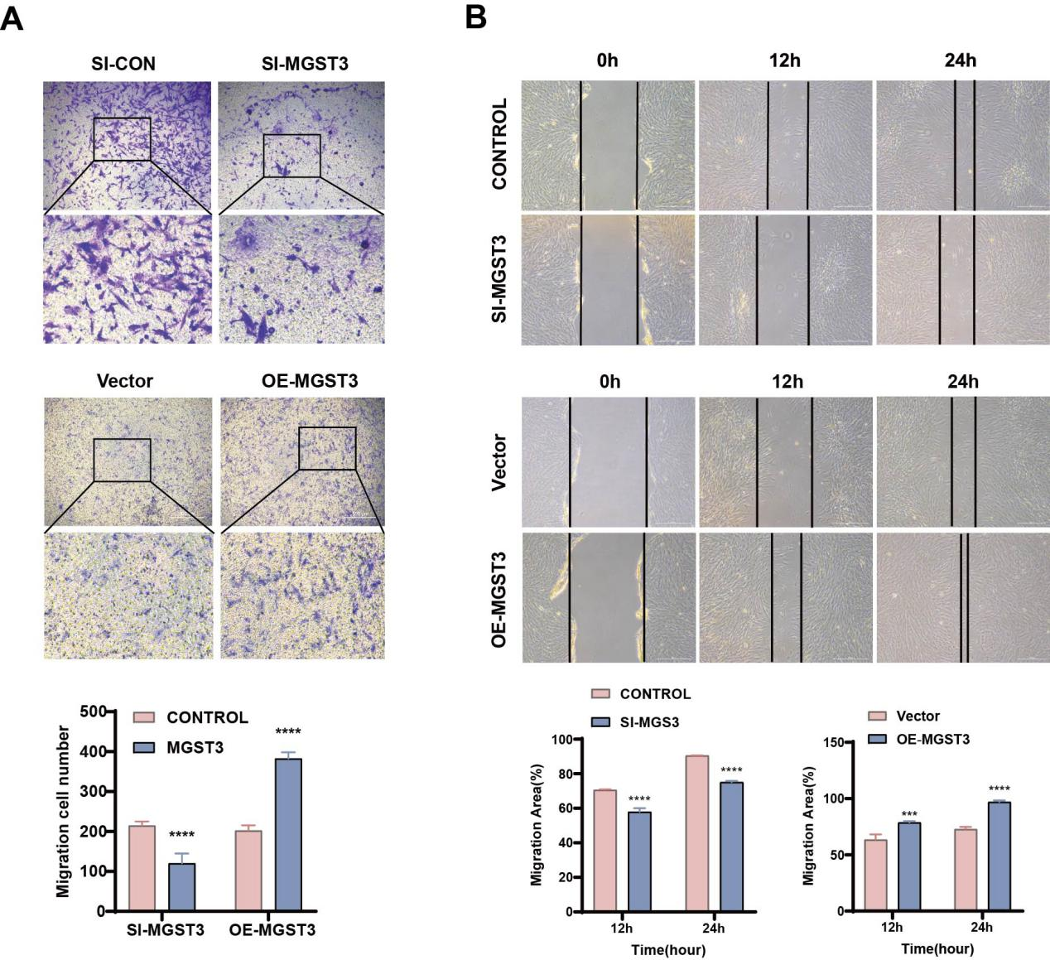

Fig. 3 Microsomal glutathione S-transferase 3 (MGST3) promotes migration of ihESCs. A. ihESCs were transfected with plasmids (2 μg/μL) and/or siRNA (50 nM), and migration was assessed using Transwell chambers at 48 h (n = 3; scale bar = 500 μm). B. Wound healing assays were performed in ihESCs transfected with plasmids (2 μg/μL) and/or siRNA (50 nM), along with control groups (original magnification 20×). Quantitative analysis was performed using Student’s t-test based on three independent biological replicates, with data presented as mean ± SD. Statistical significance is indicated as **p < 0.01, ***p < 0.001, and ****p < 0.0001.

MGST3 suppresses ferroptosis in ihESCs
To further elucidate the specific role of MGST3 in the regulation of ferroptosis, gain- and loss-of-function experiments were performed. First, MGST3 expression was silenced in ihESCs using siRNA, followed by systematic evaluation of key ferroptosis-related indicators. Compared with the control group, MGST3-knockdown cells exhibited a significant increase in MDA levels, reflecting enhanced lipid peroxidation. Concurrently, intracellular GSH levels were markedly reduced, whereas ROS levels and lipid peroxidation were significantly increased, indicating impairment of the cellular antioxidant defense system (Figs. 4A, C, E, and F). Furthermore, transmission electron microscopy revealed characteristic ferroptosis-associated mitochondrial morphological changes in MGST3-knockdown cells, including mitochondrial shrinkage and increased membrane density (Fig. 4G). These findings collectively indicate that MGST3 depletion promotes ferroptosis in ihESCs. Interestingly, the intracellular labile Fe²⁺ pool was reduced following MGST3 knockdown (Fig. 4B). Although this observation appears inconsistent with the conventional iron accumulation model of ferroptosis, it may reflect rapid consumption of free iron during intensified Fenton reactions, as well as dynamic compensatory changes in iron metabolism under conditions of severe oxidative stress. In contrast, MGST3 overexpression reversed these biochemical alterations, restoring GSH levels and enhancing resistance to lipid peroxidation (Fig. 4D).
To determine whether the reduction in cell viability induced by MGST3 depletion was specifically mediated by ferroptosis, rescue experiments were conducted using selective cell death inhibitors. Notably, only the ferroptosis inhibitor Ferrostatin-1 significantly restored the viability of si-MGST3-transfected ihESCs. In contrast, the apoptosis inhibitor Z-VAD-FMK exerted only a modest effect, and the necroptosis inhibitor Necrostatin-1 showed minimal protection (Fig. 4H), indicating that ferroptosis is the primary mode of cell death under these conditions. Finally, to investigate the molecular basis underlying these phenotypic changes, RT-qPCR and Western blot analyses were performed. MGST3 knockdown markedly reduced the expression of key antiferroptotic regulators, including GPX4 and SLC7A11, accompanied by corresponding alterations in the NRF2 signaling pathway (Fig.4I and J). Collectively, these results identify MGST3 as a critical negative regulator of ferroptosis in ihESCs.
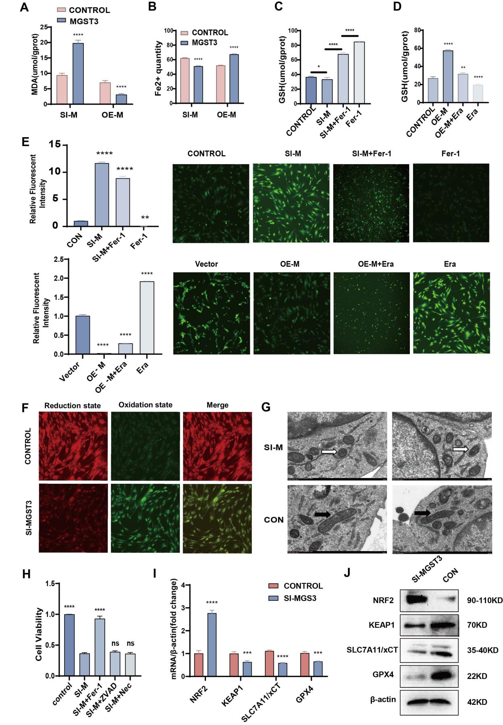
Fig. 4 Microsomal glutathione S-transferase 3 (MGST3) suppresses ferroptosis in ihESCs. A. Intracellular malondialdehyde (MDA) levels in ihESCs at 48 h after transfection with MGST3 siRNA (knockdown) or MGST3 overexpression plasmid.
B. Relative intracellular labile iron (Fe²⁺) levels measured using the FerroOrange probe in control and MGST3-knockdown ihESCs. C, D. Intracellular glutathione (GSH) levels at 48 h following MGST3 knockdown (C) or MGST3 overexpression (D). E. Representative images of intracellular reactive oxygen species (ROS) levels detected by 2′,7′-dichlorodihydrofluorescein diacetate staining (original magnification 20×). Left panels (a): ROS levels in control and MGST3-knockdown cells treated with or without the ferroptosis inhibitor Ferrostatin-1 (Fer-1, 1 μM). Right panels (b): ROS levels in vector control and MGST3-overexpressing cells treated with or without the ferroptosis inducer erastin (10 μM). F. Lipid peroxidation assessed by C11-BODIPY 581/591 staining in control and si-MGST3 groups. Red fluorescence indicates nonoxidized lipids, whereas green fluorescence indicates oxidized lipids (original magnification 20×). G. Representative transmission electron microscopy (TEM) images showing mitochondrial morphology in control and MGST3-knockdown ihESCs. Black arrows indicate normal mitochondria, whereas white arrows indicate shrunken mitochondria with increased membrane density characteristic of ferroptosis. Scale bar = 2.0 μm. H. Cell viability [Cell Counting Kit-8 (CCK-8) assay] of MGST3-knockdown ihESCs co-treated for 24 h with specific cell death inhibitors: Ferrostatin-1 (ferroptosis inhibitor, 1 μM), Z-VAD-FMK (apoptosis inhibitor, 10 μM), or Necrostatin-1 (necroptosis inhibitor, 10 μM). I. Relative mRNA expressions of ferroptosis-related genes in ihESCs at 24 h after transfection with si-Control or si-MGST3. J. Western blot analysis of key ferroptosis regulatory proteins in ihESCs at 48 h after transfection with si-Control or si-MGST3. Statistical significance is indicated as *p < 0.05, **p < 0.01, ***p < 0.001, and ****p < 0.0001).

Pharmacological inhibition of the GST family or activation of ferroptosis attenuates the development of EMs
Currently, highly selective pharmacological inhibitors specifically targeting MGST3 are not available. Therefore, to evaluate the broader therapeutic potential of disrupting the GST-mediated ferroptosis defense network, we employed GSTO-IN-2, a well-characterized broad-spectrum GST inhibitor. Initially, ihESCs were treated with increasing concentrations of GSTO-IN-2 in vitro. The results showed that the IC50 (inhibitory concentration 50) of GSTO-IN-2 in ihESCs was 12.62 μM. Based on these findings, an appropriate dosage range was estimated for subsequent in vivo experiments. A mouse model of EMs was then successfully established, and animals were divided into seven groups: erastin, Ferrostatin-1, DMSO, corn oil, low-dose GSTO-IN-2, medium-dose GSTO-IN-2, and high-dose GSTO-IN-2 (Fig. 5A). Notably, treatment with the ferroptosis inducer erastin significantly delayed disease progression, whereas the ferroptosis inhibitor Ferrostatin-1 promoted lesion growth (Fig. 5B). Mice were sacrificed 2 weeks after drug administration, and ectopic lesions were collected for analysis. Key ferroptosis-related indicators were systematically evaluated. We found that compared with the control group, GSTO-IN-2 treatment at different concentrations significantly increased MDA levels, reflecting enhanced lipid peroxidation. Meanwhile, GSH levels significantly decreased, indicating impairment of the antioxidant defense system (Figs. 5C and D). Terminal deoxynucleotidyl transferase dUTP nick end labeling staining showed no significant differences in apoptosis among the GSTO-IN-2 treatment groups (Fig. 5E). To evaluate the potential toxicity and overall safety of the treatment strategy, body weight changes in mice were systematically monitored following establishment of the EM model. The experimental period lasted 33 days, and no significant differences in initial body weight were observed among the groups. Compared with the control group, body weight change curves in the treatment groups were largely comparable. Notably, two transient decreases in body weight were observed during the study, which may be attributable to laparotomy. Hematoxylin and eosin staining of heart, liver, lung, and kidney tissues from GSTO-IN-2-treated mice showed no obvious pathological lesions or adverse effects on major organs (Fig. 5F).
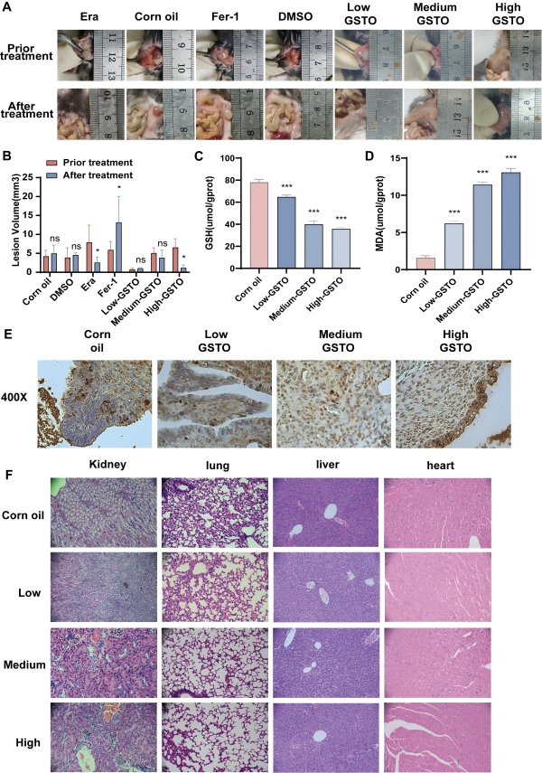
Fig. 5 Pharmacological inhibition of the glutathione S-transferase (GST) family or activation of ferroptosis attenuates the development of endometriosis. A. Representative images of ectopic lesions in seven groups of mice before and after treatment (n = 5). B. Comparison of lesion volume among the seven groups after treatment. Lesion volume was calculated using the formula V = 1/2 × A × a² (A: long radius; a: short radius）. C. GSH levels in ectopic lesions after treatment with different concentrations of GSTO-IN-2 in mice. D. MDA levels in ectopic lesions after treatment with different concentrations of GSTO-IN-2 in mice. E. Representative terminal deoxynucleotidyl transferase dUTP nick end labeling staining images of ectopic lesions from GSTO-IN-2-treated groups (original magnification 20×). F. Representative hematoxylin and eosin (H&E) staining images of heart, liver, kidney, and lung tissues from GSTO-IN-2-treated mice (original magnification 200×). Data are presented as mean ± SD from three independent biological replicates. Statistical analyses were performed using Student’s t-test for two-group comparisons and one-way analysis of variance followed by Tukey’s multiple comparisons test for multiple-group comparisons. Probability values of p < 0.05, p < 0.01, and p < 0.001 are indicated by *, **, and ***, respectively.

Discussion

To the best of our knowledge, this study is the first to reveal the important modulatory role of MGST3 in the development of EMs at the molecular level. Our data demonstrate that MGST3 is significantly upregulated in ectopic lesions and stromal cells compared with eutopic endometrium. Through a series of in vitro gain- and loss-of-function experiments, we found that MGST3 functions not only as a potential biomarker of disease progression but also as a key regulator of the pathological phenotype of ihESCs. Specifically, MGST3 silencing markedly inhibited proliferation and migration of ihESCs and induced cell death, whereas its overexpression conferred a pronounced survival advantage. These findings suggest that aberrant upregulation of MGST3 may represent an adaptive mechanism that enables ectopic endometrial cells to establish and maintain lesions within the heterogeneous microenvironment of the peritoneal cavity and ovary.
The GST superfamily has long been regarded as a central component of the cellular antioxidant defense system, mitigating oxidative stress by catalyzing the conjugation of reduced GSH to electrophilic substrates. Previous studies have primarily focused on cytosolic (GST subfamilies; for example, GSTM2 has been implicated in the regulation of redox homeostasis and aging^{[20]}, while deletion of GSTM1 and GSTT1 genes has been associated with increased susceptibility to EMs due to impaired detoxification ability^{[24]}. In contrast, MGST3 belongs to the membrane-associated proteins in eicosanoid and glutathione metabolism family. Its upregulated expression has been linked to chemoresistance and poor prognosis in hepatocellular carcinoma, ovarian cancer, and testicular cancer, indicating a broad cytoprotective role^{[8][12][21]}. However, the function of MGST3 in EMs remains unclear. Using EndometDB, we confirmed that MGST3 is significantly upregulated in deep infiltrating, peritoneal, and OMA. Unlike cytosolic GSTs, MGST3 is localized to the endoplasmic reticulum and the outer mitochondrial membrane. This subcellular localization enables MGST3 to act directly at sites of lipid peroxidation, facilitating the detoxification of membrane lipid peroxides through its GSH-dependent activity. These findings extend current understanding of antioxidant mechanisms in EMs, suggesting that ectopic lesions rely not only on cytosolic detoxification systems but also on membrane-associated defense mechanisms to preserve organelle integrity.
Endometriotic lesions are characterized by an iron-overloaded microenvironment resulting from repeated hemorrhage, which promotes lipid peroxidation via Fenton chemistry and thereby induces ferroptosis^{[12][16]}. However, ectopic endometrial stromal cells exhibit increased tolerance to this process^{[17]}. In EMs, the ATF4–xCT signaling axis is significantly upregulated, enhancing antioxidant defenses and sustaining cell survival under iron-overloaded conditions^{[25]}. Fibrillin-1 has also been identified as a key mediator that promotes proliferation and migration by suppressing ferroptosis^{[28]}. Ferroptosis resistance is not only critical for the persistent progression of endometriotic lesions but also contributes to impaired ovarian function and abnormal embryonic development, ultimately leading to infertility^{[26][27]}. Similarly, in endometrial cancer, SENP5 stabilizes β-catenin through deSUMOylation, thereby enhancing GPX4 transcription, strengthening antioxidant defenses, and inhibiting ferroptosis^{[29]}. In addition, ACAA1, a mitochondrial fatty acid β-oxidation enzyme, promotes Nrf2 nuclear translocation, enabling cancer cells to survive under iron-overloaded conditions while supporting metabolic reprogramming and tumor growth^{[30]}. Collectively, these studies highlight that ferroptosis resistance confers a significant survival advantage in uterine-derived diseases, particularly EMs. However, the precise regulatory mechanisms of ferroptosis in EMs remain insufficiently characterized and warrant further systematic investigation.
Our data support that MGST3 plays a critical role in the regulation of ferroptosis in ihESCs, and that Ferrostatin-1 effectively rescues the growth inhibition induced by si-MGST3. MGST3 knockdown induced ferroptosis, as evidenced by increased lipid peroxidation products and ROS levels, depletion of GSH, and mitochondrial structural damage; these effects were partially reversed by Ferrostatin-1. Conversely, MGST3 overexpression inhibited erastin-induced ferroptosis. Interestingly, although NRF2 expression was increased and KEAP1 expression was decreased following MGST3 knockdown, the downstream ferroptosis-protective proteins SLC7A11 and GPX4 were both reduced. This pattern suggests that NRF2 activation represents a compensatory response to excessive oxidative stress rather than an effective restoration of antioxidant capacity. In other words, despite activation of the NRF2 stress response, the SLC7A11/GSH/GPX4 axis remained functionally impaired, thereby promoting lipid peroxidation and ferroptosis. This observation may also explain why ferroptotic features were enhanced despite a reduction in measured Fe²⁺ levels at the examined time point. Collectively, these findings indicate that MGST3 contributes to the establishment of an antiferroptotic environment in ectopic endometrial cells by suppressing the ferroptotic pathway. This observation is consistent with previous studies showing that enhanced antioxidant defenses promote tumor growth in endometrial cancer^{[15][17][25]}, and further identifies MGST3 as an important molecular link between dysregulated iron metabolism and the survival of endometriotic lesions.
Another notable finding of this study is that treatment with GSTO-IN-2, a broad-spectrum GST inhibitor, significantly reduced the viability of ihESCs in vitro in a dose-dependent manner. This is consistent with previous reports demonstrating that erastin promotes ferroptosis in ihESCs and attenuates EMs progression^{[15][18]}. In oncology, ferroptosis induction has emerged as a promising therapeutic strategy. For example, Yang et al. reported that ferroptosis inducers inhibit the growth of liver cancer cells^{[12]}, and Niu et al. demonstrated that ferroptosis induction enhances tumor sensitivity to immunotherapy^{[19]}. Antioxidant-based approaches have also shown therapeutic potential in EMs, including supplementation with exogenous antioxidants, use of natural compounds with anti-inflammatory and antioxidant properties^{[31]}, correction of metabolic abnormalities to reduce oxidative stress^{[32]}, and modulation of the microbiome to indirectly enhance antioxidant defense^{[33]}. Here, we propose that disrupting the ferroptosis defense system, particularly the GST family, represents a potential therapeutic strategy for EMs. Inhibition of MGST3 reduces the tolerance of ihESCs to ferroptosis and also promotes ferroptotic cell death in ihESCs.
To further evaluate this concept in vivo, we established a mouse model of EMs and administered erastin or varying doses of GSTO-IN-2. Broad inhibition of GST activity by GSTO-IN-2 significantly suppressed lesion growth, demonstrating an in vivo efficacy comparable to that of erastin. Currently, clinical management of EMs relies predominantly on hormone therapy, which is often limited by adverse effects such as hot flashes, night sweats, and bone loss. While antioxidant-based therapies can alleviate disease progression, our findings propose a distinct therapeutic paradigm: actively inducing ferroptosis by disrupting endogenous defense mechanisms. Importantly, although our in vitro genetic experiments identify MGST3 as a key regulatory node, our in vivo pharmacological data demonstrate that targeting the broader GST-mediated ferroptosis defense network is therapeutically effective. Therefore, targeting the GST–ferroptosis axis, particularly MGST3, pending the development of highly selective inhibitors, represents a promising therapeutic strategy for EMs, especially in hormone-resistant or recurrent cases.
In conclusion, this study identifies MGST3 as a key negative regulator of ferroptosis in EMs, linking antioxidant defense mechanisms to ferroptotic cell death in EMs. While previous studies have implicated MGST3 in ferroptosis regulation in other biological contexts^{[35]}, our findings extend this role to EMs and highlight MGST3 as a previously under-recognized mediator of ferroptosis resistance in ectopic endometrial stromal cells.
Limitations
Although our in vitro data strongly support MGST3 as a specific therapeutic vulnerability, several limitations of the present study should be acknowledged. First, with respect to in vivo validation, MGST3 remains a relatively novel target in the ferroptosis field, and highly selective small-molecule inhibitors specifically targeting MGST3 are not yet available. Consequently, the use of the broad-spectrum GST inhibitor GSTO-IN-2 primarily reflects the effect of disrupting the broader GST-mediated antioxidant defense network, rather than selective inhibition of MGST3. Second, although we established an MGST3-mediated antiferroptotic phenotype, the underlying molecular mechanisms remain incompletely defined. In particular, the precise regulatory interactions between MGST3 and key signaling pathways, such as the NRF2/GPX4 axis or lipid metabolic remodeling networks, require further detailed investigation. Finally, although our analysis of human tissues provides important translational relevance, the clinical sample size remains relatively limited.
Future studies should adopt a multifaceted approach to facilitate clinical translation. These include the use of Mgst3 knockout mouse models and the development of highly selective MGST3 inhibitors for precise in vivo validation, as well as in-depth characterization of the molecular signaling pathways linking MGST3 to ferroptosis. In addition, validation in larger, multicenter clinical cohorts will be necessary. Collectively, these efforts will advance the development of precise targeted therapies for EMs.
Conclusion
In summary, we demonstrate for the first time that MGST3 regulates ferroptosis and promotes the development of EMs. We identify the MGST3–ferroptosis axis as a potential therapeutic target for EMs, providing new insights into the molecular mechanisms underlying EMs and offering a foundation for the development of novel treatment strategies.

Declarations
Ethics approval and consent to participate
This research protocol has been approved by the Ethics Committee of Shenzhen Maternity and Child Care Hospital, Women and Children 's Medical Center of Southern Medical University ( ethics number : SFYLS [ 2024 ] 060 ).All animal studies were conducted in accordance with the principles and procedures outlined in the Southern Medical University Guide.The reporting of the animal study was revised with reference to the ARRIVE guidelines.Animal ethics number : [ Ethical No. : SZMCHH 21-2509-23 ]
Consent for publication
Not applicable
Availability of data and materials
The data analyzed in this study are included in this published article and accompanying supplementary information files.
Competing interests
The authors declare that they have no competing interests.
Funding
This work was supported by the Sanming Project of Medicine in Shenzhen (No.SZSM202211020).
Acknowledgments
Not applicable
Authors' contributions
Y-B H: Conceptualization, Methodology, Formal analysis, Data Curation, Writing-Original Draft, Visualization.
LZ: Methodology, Validation, Writing-Original Draft, Visualization.
- T Z: Methodology, Validation, Writing-Original Draft.
NC: Formal analysis, Validation.
G-Y Y: Methodology, Validation.
Y-J F:Validation.
JP: Conceptualization, Writing - Review & Editing, Supervision, Project administration, Funding acquisition.

Reference
- Chapron C, Marcellin L, Borghese B, Santulli P. Rethinking mechanisms, diagnosis and management of endometriosis. Nat Rev Endocrinol. 2019 Nov;15(11):666-682. doi: 10.1038/s41574-019-0245-z.
- Ye L, Whitaker LHR, Mawson RL, Hickey M. Endometriosis. BMJ. 2022 Nov 28;379:e068950. doi: 10.1136/bmj-2021-068950.
- Ochoa Bernal MA, Fazleabas AT. The Known, the Unknown and the Future of the Pathophysiology of Endometriosis. Int J Mol Sci. 2024 May 27;25(11):5815. doi: 10.3390/ijms25115815.
- Saunders PTK, Horne AW. Endometriosis: Etiology, pathobiology, and therapeutic prospects. Cell. 2021 May 27;184(11):2807-2824. doi: 10.1016/j.cell.2021.04.041.
- Vallvé-Juanico J, George AF, Sen S, Thomas R, Shin MG, Kushnoor D, Vásquez JJ, Vo KC, Irwin JC, Roan NR, Combes AJ, Giudice LC. Deep immunophenotyping reveals endometriosis is marked by dysregulation of the mononuclear phagocytic system in endometrium and peripheral blood. BMC Med. 2022 Apr 15;20(1):158. doi: 10.1186/s12916-022-02359-4.
- Van Langendonckt A, Casanas-Roux F, Donnez J. Oxidative stress and peritoneal endometriosis. Fertil Steril. 2002 May;77(5):861-70. doi: 10.1016/s0015-0282(02)02959-x.
- Steinmetz-Späh J, Liu J, Singh R, Ekoff M, Boddul S, Tang X, Bergqvist F, Idborg H, Heitel P, Rönnberg E, Merk D, Wermeling F, Haeggström JZ, Nilsson G, Steinhilber D, Larsson K, Korotkova M, Jakobsson PJ. Biosynthesis of prostaglandin 15dPGJ2 -glutathione and 15dPGJ2-cysteine conjugates in macrophages and mast cells via MGST3. J Lipid Res. 2022 Dec;63(12):100310. doi: 10.1016/j.jlr.2022.100310.
- Garcia SL, Lauritsen J, Christiansen BK, Hansen IF, Bandak M, Dalgaard MD, Daugaard G, Gupta R. Predicting Hearing Loss in Testicular Cancer Patients after Cisplatin-Based Chemotherapy. Cancers (Basel). 2023 Aug 1;15(15):3923. doi: 10.3390/cancers15153923.
- Liu X, Hong R, Du P, Yang D, He M, Wu Q, Li L, Wang Y, Chen J, Min Q, Li J, Zhang W, Zhan Q. The metabolic genomic atlas reveals potential drivers and clinically relevant insights into the etiology of esophageal squamous cell carcinoma. Theranostics. 2022 Aug 21;12(14):6160-6178. doi: 10.7150/thno.70814.
- Schröder O, Sjöström M, Qiu H, Jakobsson PJ, Haeggström JZ. Microsomal glutathione S-transferases: selective up-regulation of leukotriene C4 synthase during lipopolysaccharide-induced pyresis. Cell Mol Life Sci. 2005 Jan;62(1):87-94. doi: 10.1007/s00018-004-4366-7.
- Yang SL, Lou YJ. Sodium nitroprusside decreased leukotriene C4 generation by inhibiting leukotriene C4 synthase expression and activity in hepatic ischemia-reperfusion injured rats. Biochem Pharmacol. 2007 Mar 1;73(5):724-35. doi: 10.1016/j.bcp.2006.11.011.
- Yang R, Gao W, Wang Z, Jian H, Peng L, Yu X, Xue P, Peng W, Li K, Zeng P. Polyphyllin I induced ferroptosis to suppress the progression of hepatocellular carcinoma through activation of the mitochondrial dysfunction via Nrf2/HO-1/GPX4 axis. Phytomedicine. 2024 Jan;122:155135. doi: 10.1016/j.phymed.2023.155135.
- Iwabuchi T, Yoshimoto C, Shigetomi H, Kobayashi H. Oxidative Stress and Antioxidant Defense in Endometriosis and Its Malignant Transformation. Oxid Med Cell Longev. 2015;2015:848595. doi: 10.1155/2015/848595. Epub 2015 Jun 21.
- Kobayashi H, Yamashita Y, Iwase A, Yoshikawa Y, Yasui H, Kawai Y, Uchida K, Uno N, Akatsuka S, Takahashi T, Kikkawa F, Toyokuni S. The ferroimmunomodulatory role of ectopic endometriotic stromal cells in ovarian endometriosis. Fertil Steril. 2012 Aug;98(2):415-22.e1-12. doi: 10.1016/j.fertnstert.2012.04.047.
- Wu Q, Liang Z, Jiang J, Feng X, Liu J, Zhang Z, Wang H, Wang N, Gou Y, Li Z, Cao Y. Macrophages originated IL-33/ST2 inhibits ferroptosis in endometriosis via the ATF3/SLC7A11 axis. Cell Death Dis. 2023 Oct 11;14(10):668. doi: 10.1038/s41419-023-06182-4. Erratum in: Cell Death Dis. 2025 Mar 27;16(1):212. doi: 10.1038/s41419-025-07484-5.
- Tang D, Kang R, Berghe TV, Vandenabeele P, Kroemer G. The molecular machinery of regulated cell death. Cell Res. 2019 May;29(5):347-364. doi: 10.1038/s41422-019-0164-5. Epub 2019 Apr 4.
- Wan Y, Song Y, Chen J, Kong J, Gu C, Huang J, Zuo L. Upregulated Fibulin-1 Increased Endometrial Stromal Cell Viability and Migration by Repressing EFEMP1-Dependent Ferroptosis in Endometriosis. Biomed Res Int. 2022 Jan 28;2022:4809415. doi: 10.1155/2022/4809415.
- Li G, Lin Y, Zhang Y, Gu N, Yang B, Shan S, Liu N, Ouyang J, Yang Y, Sun F, Xu H. Endometrial stromal cell ferroptosis promotes angiogenesis in endometriosis. Cell Death Discov. 2022 Jan 17;8(1):29. doi: 10.1038/s41420-022-00821-z. PMID: 35039492; PMCID: PMC8763888.
- Niu X, Chen L, Li Y, Hu Z, He F. Ferroptosis, necroptosis, and pyroptosis in the tumor microenvironment: Perspectives for immunotherapy of SCLC. Semin Cancer Biol. 2022 Nov;86(Pt 3):273-285. doi: 10.1016/j.semcancer.2022.03.009.
- Fafián-Labora JA, Rodríguez-Navarro JA, O'Loghlen A. Small Extracellular Vesicles Have GST Activity and Ameliorate Senescence-Related Tissue Damage. Cell Metab. 2020 Jul 7;32(1):71-86.e5. doi: 10.1016/j.cmet.2020.06.004.
- Shi Y, Xu N, Liu B, Ma Y, Fu X, Shang Y, Huang Q, Yao Q, Chen J, Li H. Mifepristone protects acetaminophen induced liver injury through NRF2/GSH/GST mediated ferroptosis suppression. Free Radic Biol Med. 2024 Sep;222:229-243. doi: 10.1016/j.freeradbiomed.2024.06.014.
- Settivari R, VanDuyn N, LeVora J, Nass R. The Nrf2/SKN-1-dependent glutathione S-transferase π homologue GST-1 inhibits dopamine neuron degeneration in a Caenorhabditis elegans model of manganism. Neurotoxicology. 2013 Sep;38:51-60. doi: 10.1016/j.neuro.2013.05.014.
- Dinkova-Kostova AT, Abramov AY. The emerging role of Nrf2 in mitochondrial function. Free Radic Biol Med. 2015 Nov;88(Pt B):179-188. doi: 10.1016/j.freeradbiomed.2015.04.036. Epub 2015 May 11. PMID: 25975984; PMCID: PMC4726722.
- Chen XP, Xu DF, Xu WH, Yao J, Fu SM. Glutathione-S-transferases M1/T1 gene polymorphisms and endometriosis: a meta-analysis in Chinese populations. Gynecol Endocrinol. 2015;31(11):840-5. doi: 10.3109/09513590.2015.1080681. Epub 2015 Sep 15. PMID: 26370772.
- Dong X, Xu L, Wang S, Jiao X, Yan S, Huang Y, Yuan M, Wang G. Endometrial stromal cell autophagy-dependent ferroptosis caused by iron overload in ovarian endometriosis is inhibited by the ATF4-xCT pathway. Mol Hum Reprod. 2023 Dec 24;30(1):gaad046. doi: 10.1093/molehr/gaad046.
- Peiyin F, Yuxian W, Jiali Z, Jian X. Research progress of ferroptosis in female infertility. J Ovarian Res. 2024 Sep 12;17(1):183. doi: 10.1186/s13048-024-01508-y.
- Ye R, Mao YM, Fei YR, Shang Y, Zhang T, Zhang ZZ, Liu YL, Li JY, Chen SL, He YB. Targeting ferroptosis for the treatment of female reproductive system disorders. J Mol Med (Berl). 2025 Apr;103(4):381-402. doi: 10.1007/s00109-025-02528-x.
- Kobayashi H, Yoshimoto C, Matsubara S, Shigetomi H, Imanaka S. Current Understanding of and Future Directions for Endometriosis-Related Infertility Research with a Focus on Ferroptosis. Diagnostics (Basel). 2023 May 31;13(11):1926. doi: 10.3390/diagnostics13111926.
- Wang Z, Zhang Y, Zhang Y, Deng Q, Xi Y, He W, Ma X. SENP5 promotes endometrial cancer cell growth by regulating β-catenin deSUMOylation to enhance GPX4-resistance to ferroptosis. Eur J Med Res. 2025 May 24;30(1):411. doi: 10.1186/s40001-025-02662-9.
- Lang T, Xiao P, Hua S, Liang X, Yang Y. Turning off the ferroptosis switch: ACAA1-Driven PI3K/AKT/Nrf2 signaling as a novel driver of endometrial cancer progression. Free Radic Biol Med. 2025 Oct 4;241:587-598. doi: 10.1016/j.freeradbiomed.2025.09.054.
- Cirillo M, Argento FR, Becatti M, Fiorillo C, Coccia ME, Fatini C. Mediterranean Diet and Oxidative Stress: A Relationship with Pain Perception in Endometriosis. Int J Mol Sci. 2023 Sep 27;24(19):14601. doi: 10.3390/ijms241914601.
- Clower L, Fleshman T, Geldenhuys WJ, Santanam N. Targeting Oxidative Stress Involved in Endometriosis and Its Pain. Biomolecules. 2022 Jul 29;12(8):1055. doi: 10.3390/biom12081055.
- Cuffaro F, Russo E, Amedei A. Endometriosis, Pain, and Related Psychological Disorders: Unveiling the Interplay among the Microbiome, Inflammation, and Oxidative Stress as a Common Thread. Int J Mol Sci. 2024 Jun 12;25(12):6473. doi: 10.3390/ijms25126473.
- Gabriel M, Fey V, Heinosalo T, Adhikari P, Rytkönen K, Komulainen T, Huhtinen K, Laajala TD, Siitari H, Virkki A, Suvitie P, Kujari H, Aittokallio T, Perheentupa A, Poutanen M. A relational database to identify differentially expressed genes in the endometrium and endometriosis lesions. Sci Data. 2020 Aug 28;7(1):284. doi: 10.1038/s41597-020-00623-x.
- Dibra D, Xiong S, Moyer SM, El-Naggar AK, Qi Y, Su X, Kong EK, Korkut A, Lozano G. Mutant p53 protects triple-negative breast adenocarcinomas from ferroptosis in vivo. Sci Adv. 2024 Feb 16;10(7):eadk1835. doi: 10.1126/sciadv.adk1835. Epub 2024 Feb 14. PMID: 38354236; PMCID: PMC10866549.

