Supplementary data

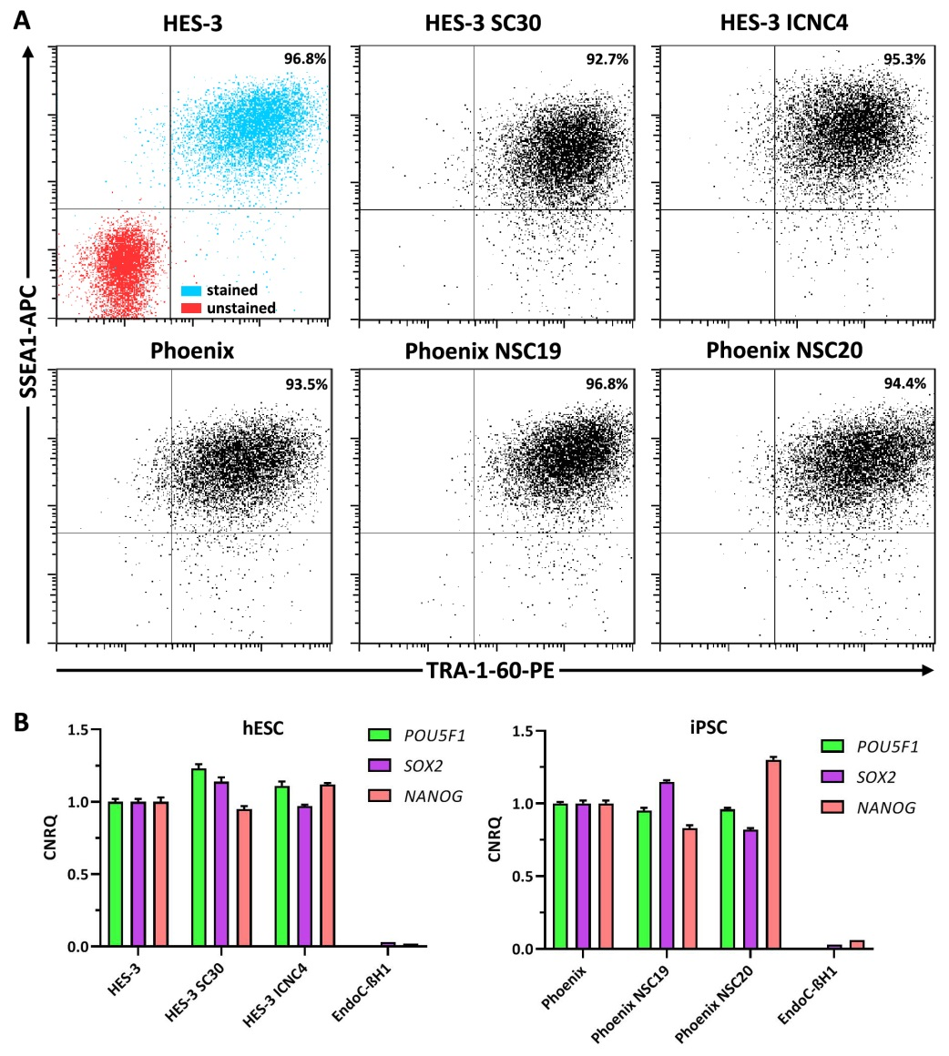
Supplementary figure 1. Characterization of the generated clonal cell lines. (A) Flow cytometric quantification of SSEA1-APC (allophycocyanin) and TRA-1-60-PE (phycoerythrin) in hESC (HES-3) and iPSC (Phoenix) and the cell clones derived therefrom. (B) Relative gene expression of POU5F1 (Oct4), SOX2, and NANOG in hESC and iPSC and the cell clones derived therefrom compared to the non-pluripotent insulin-producing cell line EndoC-βH1. Data are means ± SEM from a triplicate measurement.
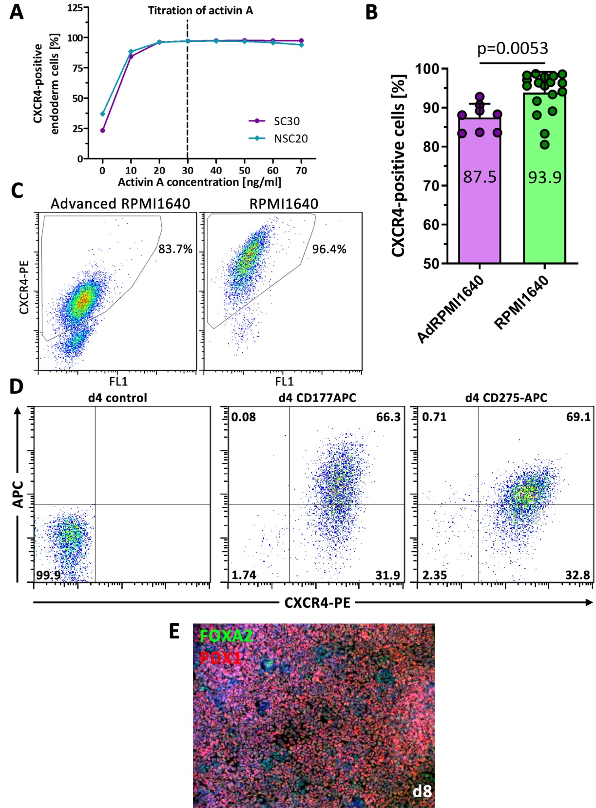
Supplementary figure 2. Endoderm and pancreatic-duodenal differentiation efficiency. (A) Titration of the optimal activin A concentration for differentiation of hPSC into CXCR4-positive endoderm cells. (B) Flow cytometric quantification of CXCR4 at d4 of endoderm differentiation. Data are means ± SEM, n= 8-18, two-tailed Student's t-test, ** p < 0.01. Differentiation protocol based on [9]. (C) Representative flow cytometry dot plots of CXCR4 staining in two endoderm differentiation media. (D) Double flow cytometric staining of CD177-APC/CXCR4-PE and CD275-APC/CXCR4-PE at d4 of endoderm differentiation. (E) PDX1/FOXA2 double-positive pancreatic duodenal cells at d8 of differentiation. Differentiation protocol based on [7] and [8].
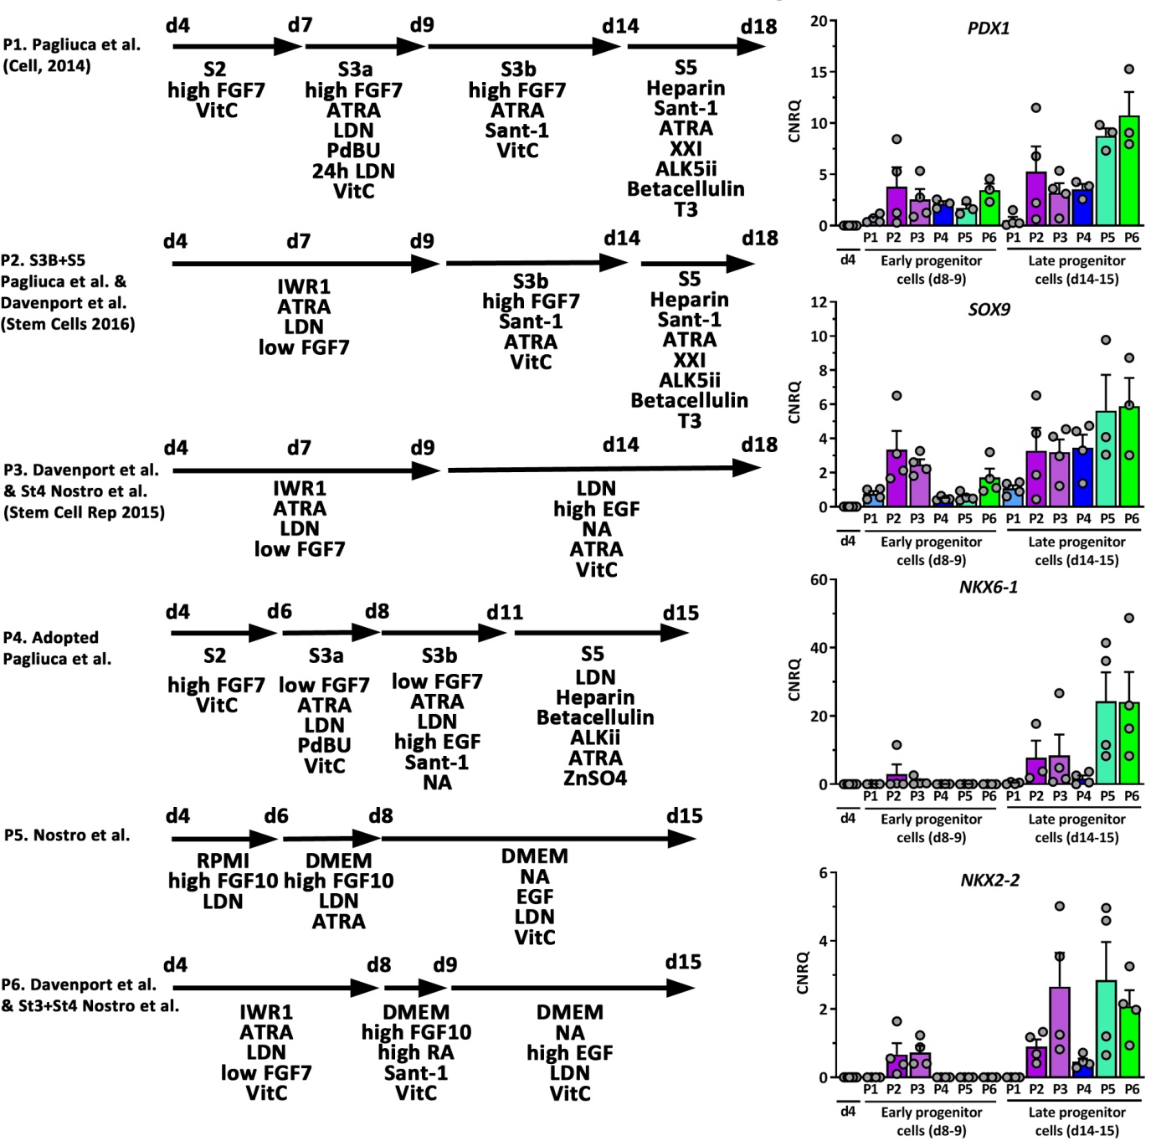
Supplementary figure 3. Comparison of six adopted differentiation protocols for the generation of MPCs from hPSC.
Depicted is the relative gene expression of PDX1, SOX9, NKX6-1, and NKX2-2. Data are means ± SEM. n= 3-4. The differentiation protocols were adopted from [7], [8], [11] and [14].
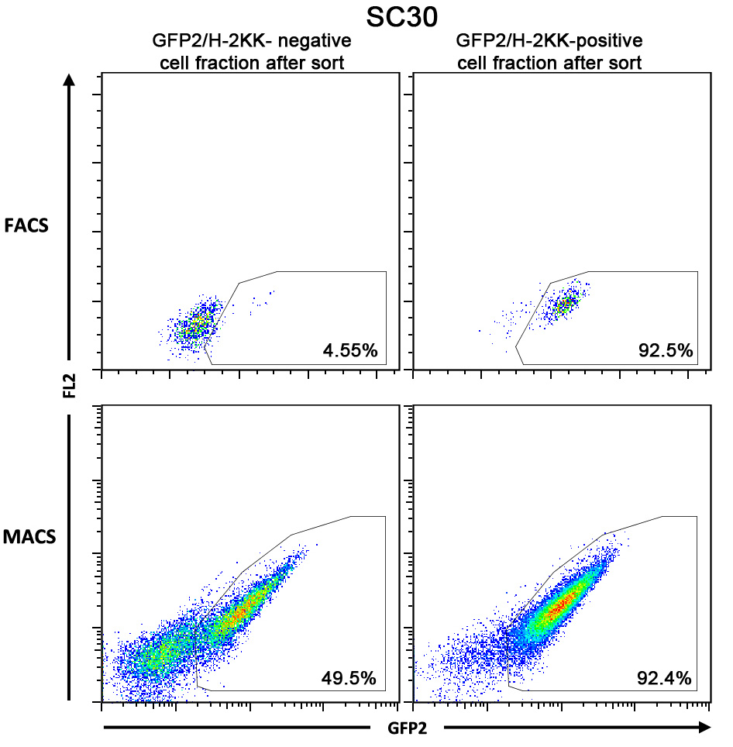
Supplementary figure 4. Representative dot plot presentation of cell sorting experiments using the SC30 cell clone. GFP2⁺ pancreatic progenitors can be sorted by FACS (upper images) or MACS (upper images) with comparable efficiencies.

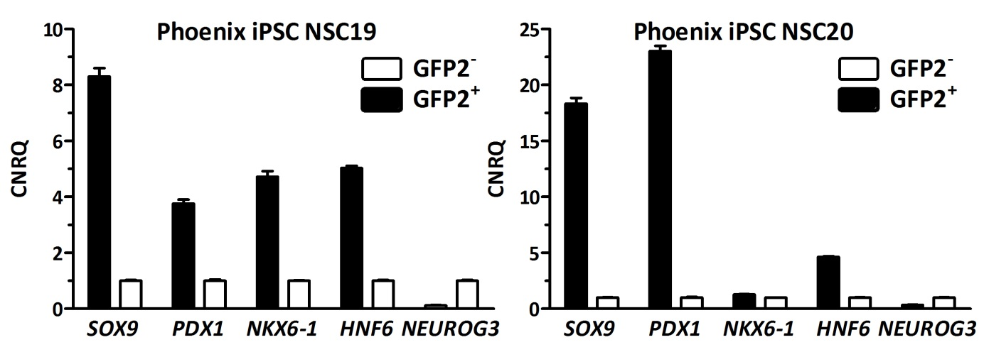
Supplementary figure 5. RT-qPCR analysis of sorted NSC19 and NSC20 derived GFP2⁺ and GFP2⁻ cells at d12 of differentiation. Depicted is the relative gene expression of SOX9, PDX1, NKX6-1, HNF6, and NEUROG3. Data are means ± SD from a single sorting experiment measured in triplicate.

Supplementary figure 6. RT-qPCR analysis of sorted GFP2⁺ cells after MACS at day 12 of differentiation using the SC30 cell clone. Further differentiation was conducted according to the 2D experimental protocol. Depicted is the relative gene expression of the transcription factors, SOX9, PDX1, NKX6-1 and NEUROG3, the islet hormones somatostatin (SST), glucagon (GCG) and insulin (INS), the exocrine marker genes amylase 2 (AMY2AB) and carbonic anhydrase 2 (CA2) and the endocrine marker genes glucokinase (GCK), KIR6.2, SUR1 and GLUT2. Data are means ± SEM, n= 2-4. Data are normalized to housekeeping genes and d15 samples scaled to 1.
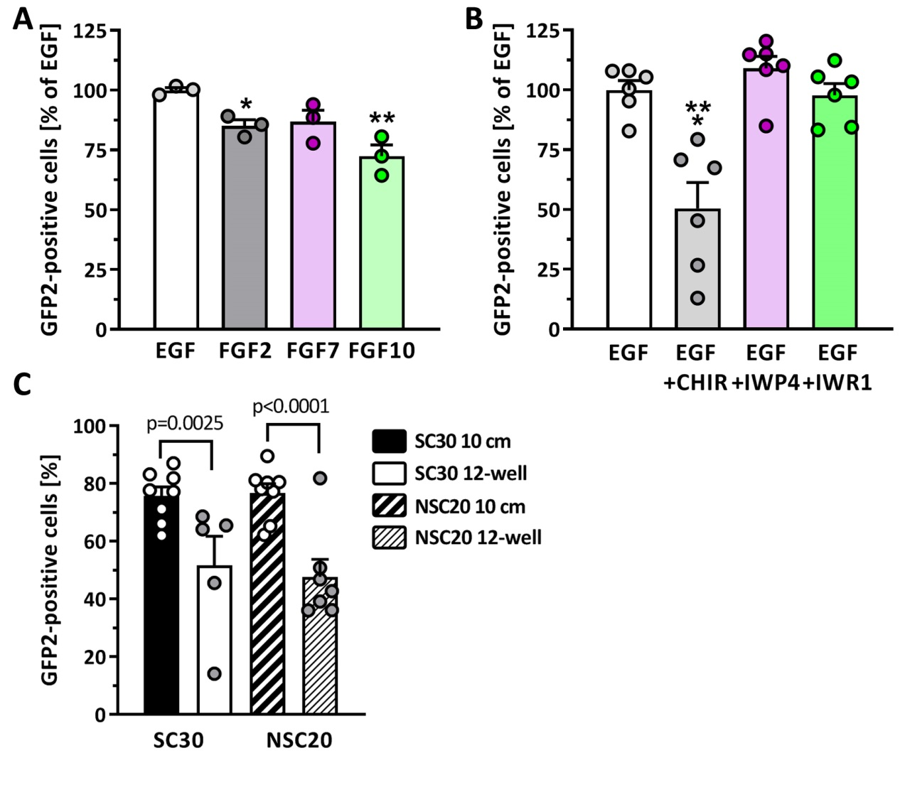
Supplementary figure 7. Effect of growth factors, Wnt/beta-catenin signaling and upscaling on the generation of GFP2⁺ pancreatic progenitors.
(A) Effect of different growth factors each used at 100 ng/ml on GFP2 expression in NSC20 cells. Data are means ± SEM. n= 3, ANOVA plus Dunnett’s post-hoc test, ** p < 0.01, * p < 0.05. (B) Effect of canonical Wnt-signaling on GFP2 expression in NSC20 cells. The pathway was activated by CHIR (3 µM) or inhibited by IWP4 (1 µM) or IWR-1 (2 µM). Data are means ± SEM, n= 6, ANOVA plus Dunnett’s post-hoc test, *** p < 0.01 (C) Flow cytometric quantification of GFP2⁺ pancreatic progenitors from the cell lines SC30 and NSC20 at d12 of differentiation differentiated in 12-well plate cavities or 10 cm cell culture dishes. Data are means ± SEM, n= 8-11. Two-tailed Student’s t-test.
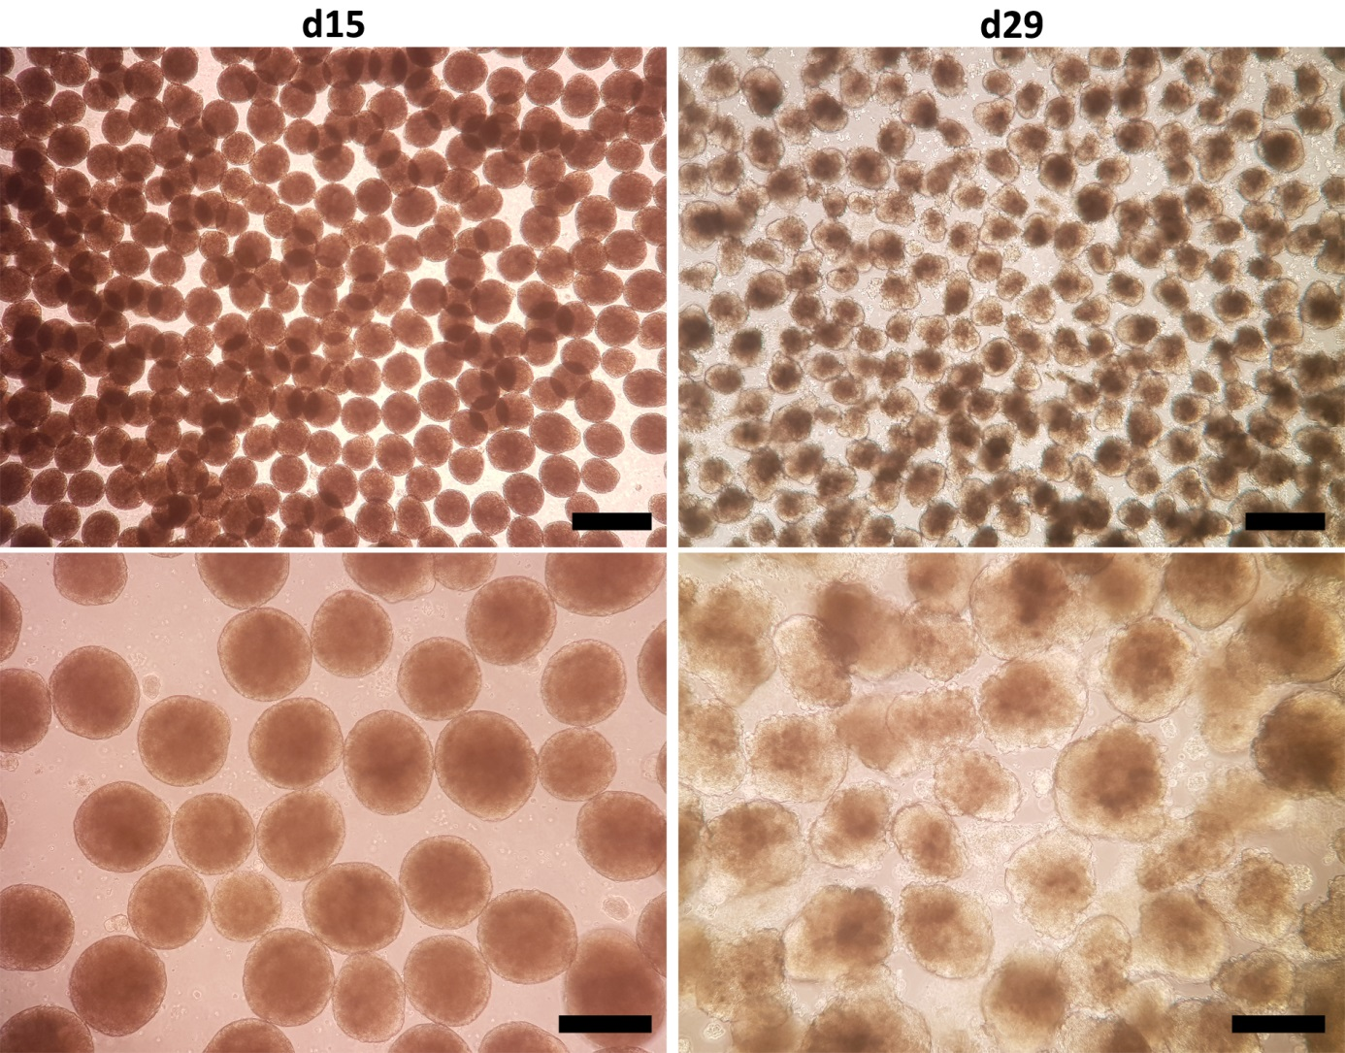
Supplementary figure 8. Generation of pancreatic spheroids (left images) and stem cell-derived organoids (right images) by 3D shaking culture. Shown are representative images of cell spheroids 3 days (left) and organoids 17 days (right) after transfer from 2D adherent culture to 3D orbital suspension culture at 100 rpm. Scale bar for lower magnification image = 500 µm. Scale bar for higher magnification image = 200 µm.
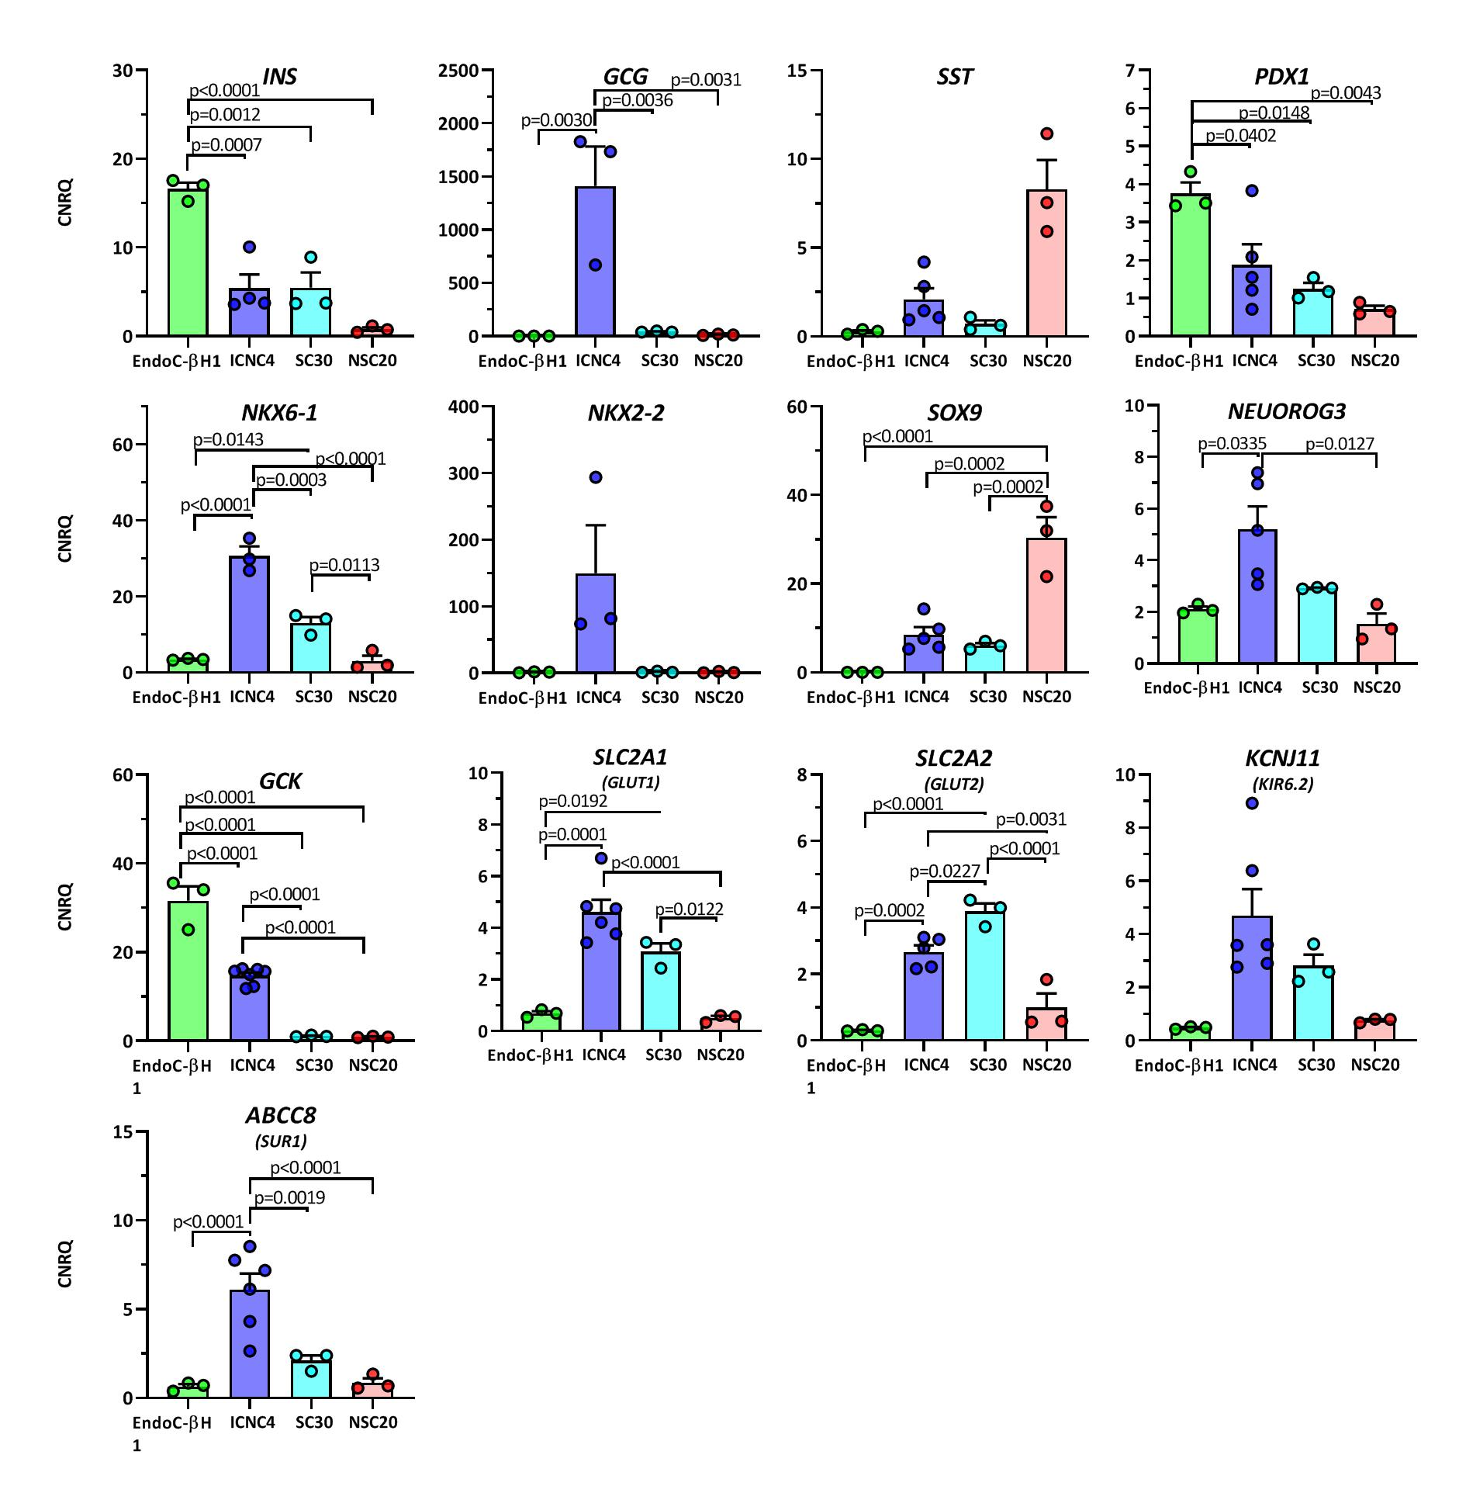
Supplementary figure 9. Relative gene expression of pancreatic and endocrine genes in NSC20-, ICNC4- and SC30-derived organoids after 3D differentiation compared to EndoC-βH1 cells. Data are means ± SEM. ANOVA one-way analysis of variance.

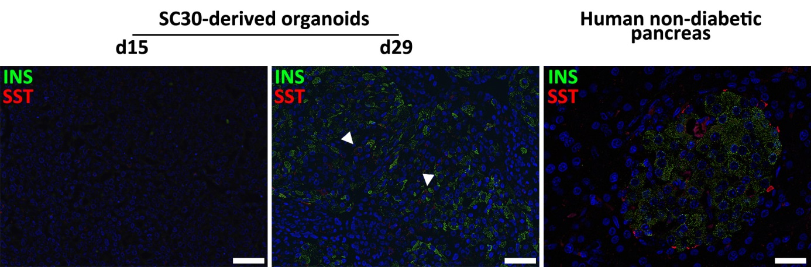
Supplementary figure 10. Immunhistochemical analysis of SC-derived pancreatic organoids. D15 spheroids and d29 stem cell-derived organoids derived in 3D from the SC30 clone were fixed, sectioned and double-stained for somatostatin (red) and insulin (green). A human non-diabetic pancreas was taken as control. Arrowheads mark polyhormonal cells. Scale Bar = 50 µm.

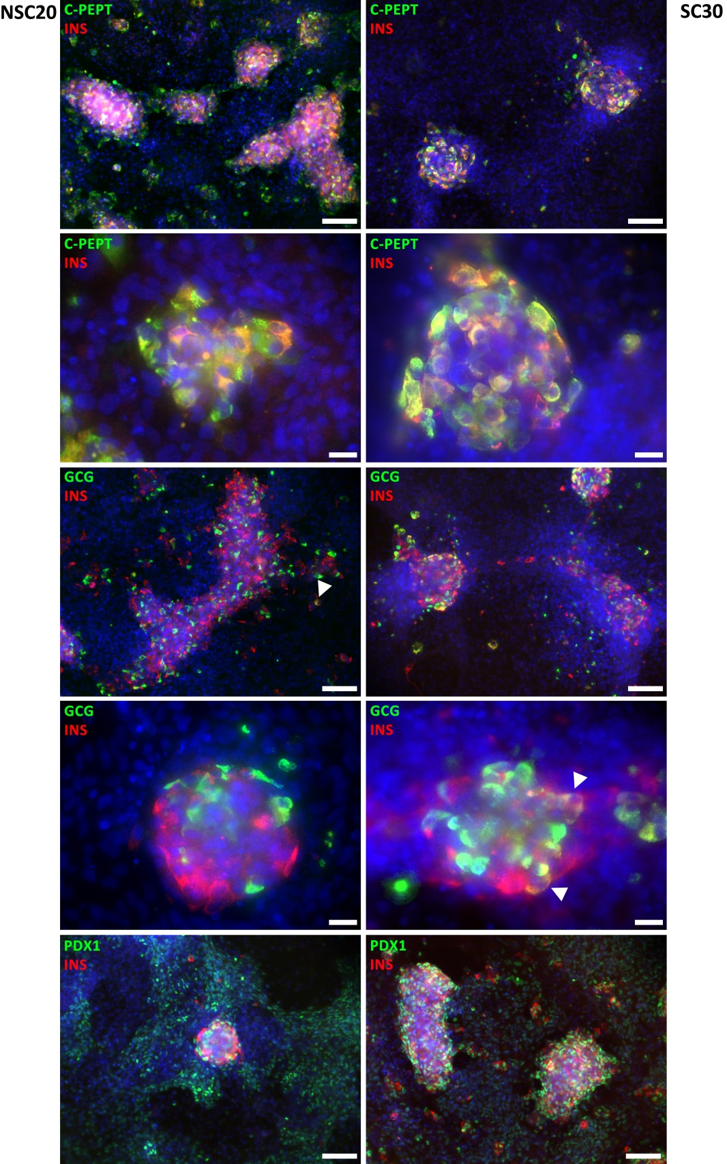
Supplementary figure 11. Immunofluorescence staining of NSC20-derived (left images) and SC30-derived (right images) pancreatic and endocrine cells at d29 using the production protocol in 2D. Double staining of insulin (red) and C-peptide, glucagon and PDX1 (all in green). Counterstaining with DAPI. Scale bar for lower magnification image = 100 µM, scale bar for higher magnification images = 20 µM. Arrowheads indicate polyhormonal insulin and glucagon co-expressing cells.

Supplementary figure 12. Recording of the Fura-2/AM emission ratio at 340 and 380 nm over 13 minutes. NSC20-derived organoids were dissociated, seeded on glass slides for 24 h and loaded with Fura-2/AM. Then the cells were stimulated with basal KR ∅ glucose, 20 mM glucose in KR, basal KR ∅ glucose and finally KR plus 40 mM KCl. Mean value of all 15 cells in bold red.

Supplementary Table 1: sgRNAs for HDR
Gene Symbol/  Cas type | Orientation | Primer Sequence 5’-3’
SOX9  Cas9  T5 | Forward cloning primer | CACCGACACAGCTCACTCGACCTTGAGG
SOX9  Cas9  T5 | Reverse cloning primer | AAACCAAGGTCGAGTGAGCTGTGTC
INS  Cas9n  #1  Nickase pair 1 | Forward cloning primer | CACCGTGCAACTAGACGCAGCCCGC
INS  Cas9n  #1  Nickase pair 1 | Reverse cloning primer | AAACGCGGGCTGCGTCTAGTTGCAC
INS  Cas9n  #23  Nickase pair 1 | Forward cloning primer | CACCGCTGGTAGAGGGAGCAGATGC
INS  Cas9n  #23  Nickase pair 1 | Reverse cloning primer | AAACGCATCTGCTCCCTCTACCAGC
INS  Cas9n  #10  Nickase pair 2 | Forward cloning primer | CACCGCCTCCTGCACCGAGAGAGA
INS  Cas9n  #10  Nickase pair 2 | Reverse cloning primer | AAACTCTCTCTCTGGTGCAGGAGGC
INS  Cas9n  #7  Nickase pair 2 | Forward cloning primer | CACCGAGTTGCAGTAGTTCTCCAGC
INS  Cas9n  #7  Nickase pair 2 | Reverse cloning primer | AAACGCTGGAGAACTACTGCAACTC
sgRNA sequences marked in bold

Supplementary Table 2: Primer pairs for gene expression analysis.
Gene | Primer Sequence 5’-3’ | Accession #
ABCC8  (SUR1) | Fw: tcacaccgctgttcctgct  Rev: agaaggagcgaggacttgcc | NM_001287174.2
CPA1 | Fw: caggctccctctgtattggc  Rev: ggacttgacctccacttcgg | NM_001868.4
G6PD | Fw: aggccgtcaccaagaacattca  Rev: cgatgatgcggttccagcctat | NM_000402
GCG | Fw: aagcatttactttgtggctggatt  Rev: tgatctggatttctcctctgtgtct | NM_002054.5
GCK | Fw: cctgggtggcactaacttcag  Rev: tagtcgaagagcatctcagca | NM_000162.5
INS | Fw: gccccgagatacatcagagg  Rev: ccaggtcacccaggactttac | NM_000207.3
KCNJ11  (KIR6.2) | Fw: aaggaagagtctggtgggga  Rev: tagggcctcactgcagagtc | NM_000525.4
NANOG | Fw: aatacctcagcctccagcagatg  Rev: tgcgtcacaccattgctattcttc | NM_024865
NEUROG3 | Fw: gcgaccagaagcccgctg  Rev: ggcgtcatcctttctaccggc | NM_020999.4
NKX2-2 | Fw: aaccccttctacgacagcagcg  Rev: acttggagcttgagtcctgagggg | NM_002509
NKX6-1 | Fw: ggcccggagtgatgcagagc  Rev: tcttcccgtctttgtccaac | NM_006168.3
ONECUT1  (HNF6) | Fw: cgctccgcttagcagcatgc  Rev: gtgtgttgcctctatccttcccatg | NM_004498
PDX1 | Fw: cgttccagctgcctttcccat  Rev: ccgtgagatgtacttgttgaatagga | NM_000209
POU5F1 | Fw: cttgctgcagaagtgggtggagg  Rev: ctgcagtgtgggtttcgggca | NM_002701
SLC2A1  (GLUT1) | Fw: cctgcagtttggctacaaca  Rev: aggatgctctccccatagcg | NM_006516
SLC2A2  (GLUT2) | Fw: actgggaccctggttttca  Rev: ccagtggaacacccaaaaca | NM_000340
SOX2 | Fw: agctacagcatgatgcagga  Rev: ggtcatggagttgtactgca | NM_003106
SOX9 | Fw: gcggaggaagtcggtgaagaacg  Rev: ctgggattgccccgagtgctc | NM_000346
SST | Fw: cccagactccgtcagtttc  Rev: tccgtctggttgggttag | NM_001048.4
TBP | Fw: caacagcctgccaccttacgctc  Rev: aggctgtggggtcagtccagtg | NM_003194
TUBA1A | Fw: ggcagtgtttgtagacttggaaccc  Rev: tgtgataagttgctcagggtggaag | NM_006009

Supplementary Table 3: Primary and conjugated antibodies used in this study.
Protein | Supplier | Cat # | Dilution
CPA1 | Origene | TA500053 | 1:100
CK19 | R&D systems | AF3506 | 1:300
C-peptide | Thermo Fisher | MA1-19159 | 1:400
Glucagon | Abcam | ab10988 | 1:300 – 1:2000
Insulin | Agilent DAKO  Abcam | A564  ab7842 | 1:100  1:100
NEUROG3 | R&D systems | AF3444 | 1:200
NKX6-1 | R&D systems | AF5857 | 1:100 – 1:300
ONECUT1  (HNF6) | R&D systems | AF6277 | 1:100
PDX1 | R&D systems | AF2419 | 1:300
Somatostatin | Abcam | ab22682 | 1:500 - 1:1000
SOX9 | R&D systems | AF3075 | 1:300
Anti-SSEA4-APC | Miltenyi Biotec | 130-098-347 | *
Anti-Tra-1-60-PE | Miltenyi Biotec | 130-122-965 | *
anti CXCR4-PE | Neuromics | FC15004 | *
anti CXCR4-APC | Miltenyi Biotec | 130-098-357 | *
Anti-CD177-APC | Miltenyi Biotec | 130-101-512 | *
Anti-CD275-APC | Miltenyi Biotec | 130-098-738 | *
anti-CD200-APC | Miltenyi Biotec | 130-118-203 | *
anti-CD142-PE-Vio616 | Miltenyi Biotec | 130-115-720 | *
Anti-GP2 | MBL international | D277-3 | 1:500
*according to manufacturer specifications

Supplementary Table 4: Data on the non-diabetic human pancreas organ donors.

 | Donor 1 | Donor 2 | Donor 3 | Donor 4
Age (years) | 60 | 47 | 64 | 52
Gender | female | male | male | female
Cause of pancreas removal | Donor organ | Pancreas resection | Pancreas resection | Pancreas resection
Blood glucose conc. (mmol/l) before organ collection | 5.7 | 6.2 | 5.8 | 5.3
Pancreases from non-diabetic Caucasian donors (55.8 + 3.8 years; 2 male, 2 female) were obtained in Hannover from an organ donor (#1) in 2007 and from three patients (#2 - #4) between 2009 and 2013 during surgery for organ resection. Tissue was handled and processed according to the recommendations of the Hannover Medical School Ethics Committee.

