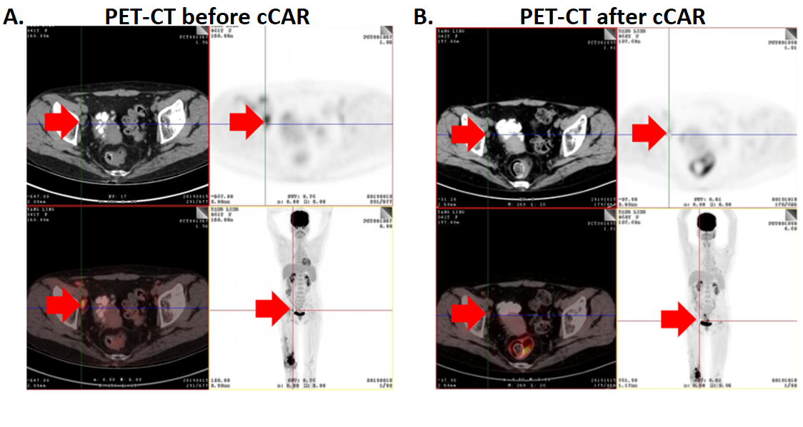
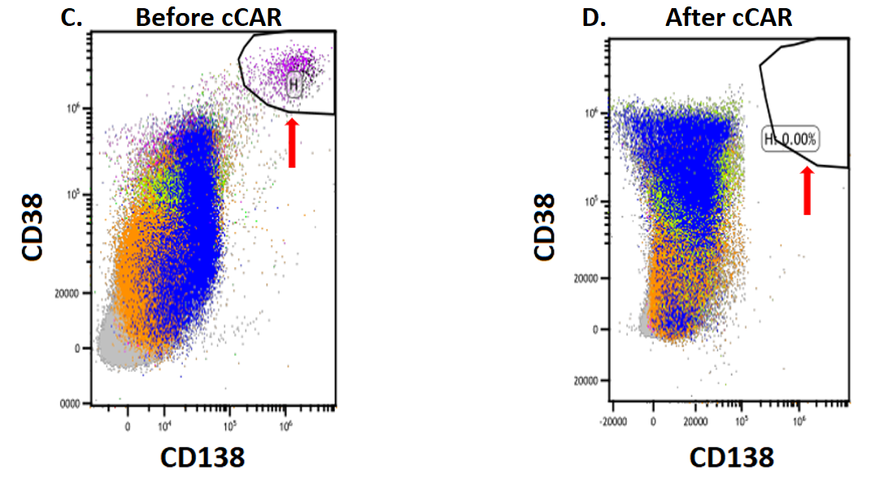
Supplementary Figure 1- cCAR T cell infusion leads to complete remission of stage IV diffuse large B cell lymphoma (DLBCL). (A.) Patient was diagnosed with stage IV diffuse large B cell lymphoma (tumor in bone, inguinal lymph nodes, and bone marrow). Fluorodeoxyglucose uptake on positron-emission tomography computed tomography (PET-CT) demonstrate the sites of tumor. Red arrows point to right external iliac lymph node tumor. (B.) Patient received 5.3 x 10⁶/kg cCAR T cells and a repeat PET-CT was performed four months later. This showed an absence of lesions, indicating a complete remission. Red arrows point to same locations as in (A.). (C.) Bone marrow aspirate was performed and analyzed by flow cytometry. A population of plasma cells expressing CD38 and CD138 was detected before cCAR therapy. (D.) 5 weeks after cCAR therapy, a repeat bone marrow aspirate and analysis by flow cytometry was performed. The plasma cell population was undetected at this time point. Arrows indicate the plasma cell population.

